Please ignore the b' at the beginning of words. When reading string from

files, numpy.loadtxt() reads as byte strings.

**4.3 a)**

>>> UnigramStartsWith('A')

[WORD, UNIGRAM_PROBABILITY]

["b'A'", '0.018407244690712494'],

["b'AND'", '0.017863233925020615'],

["b'AT'", '0.004312974000612439'],

["b'AS'", '0.003991797167406474'],

["b'AN'", '0.002999256673943544'],

["b'ARE'", '0.0029896926709136874'],

["b'ABOUT'", '0.0019256178376532746'],

["b'AFTER'", '0.0013465675979453587'],

["b'ALSO'", '0.0013100115812493978'],

["b'ALL'", '0.001181814804064031'],

["b'A.'", '0.0010256109080316418'],

["b'ANY'", '0.0006318601694814718'],

["b'AMERICAN'", '0.0006120961939108219'],

["b'AGAINST'", '0.000595964582662253'],

["b'ANOTHER'", '0.0004283866165304179'],

["b'AMONG'", '0.00037429251755208585'],

["b'AGO'", '0.0003565709825261751'],

["b'ACCORDING'", '0.0003475451075440342'],

["b'AIR'", '0.00031100132103097604'],

["b'ADMINISTRATION'", '0.0002915186396670866'],

["b'AGENCY'", '0.0002796553622515356'],

["b'AROUND'", '0.00027685465036683335'],

["b'AGREEMENT'", '0.00026278994002880895'],

["b'AVERAGE'", '0.00025907196442640943'],

["b'ASKED'", '0.00025822808180612795'],

["b'ALREADY'", '0.0002490799049949608'],

["b'AREA'", '0.0002310893059451922'],

["b'ANALYSTS'", '0.00022603824040640604'],

["b'ANNOUNCED'", '0.00022715118705054536'],

["b'ADDED'", '0.00022121954834276986'],

["b'ALTHOUGH'", '0.00021426057427117345'],

["b'AGREED'", '0.00021177784714193957'],

["b'APRIL'", '0.00020669009105444552'],

["b'AWAY'", '0.00020205485173434878']

**4.3 b)**

>>> BigramNext('THE', 5)

["b'<UNK>'", '0.6150198100055118'],

["b'U.'", '0.013372499432610317'],

["b'FIRST'", '0.011720260675031612'],

["b'COMPANY'", '0.011658788055636611'],

["b'NEW'", '0.009451480076516552']

**4.3 c)**

>>> UnigramSentence('last week the stock market fell by one hundred points')

-64.50944034364878

>>> BigramSentence('last week the stock market fell by one hundred points')

-44.74046921340373

The Bigram model yields the higher Loglikelihood for this sentence compared to Unigram model.

**4.3 d)**

>>> UnigramSentence('the nineteen officials sold fire insurance')

-41.64345971649364

>>> BigramSentence('the nineteen officials sold fire insurance')

b'NINETEEN' b'OFFICIALS'

b'SOLD' b'FIRE'

-inf

In the bigram model, the two pairs listed above are not observed together in the corpus. Therefore, the likelihood of them appearing together in a sentence is 0, hence loglikelihood of such a sentence tends to -inf (log 0).

**4.4 e)**

>>> lmbdFunc ('the nineteen officials sold fire insurance', .0001)

Optimum lambda: 0.4126

Maximum Likelihood: -39.9536375037

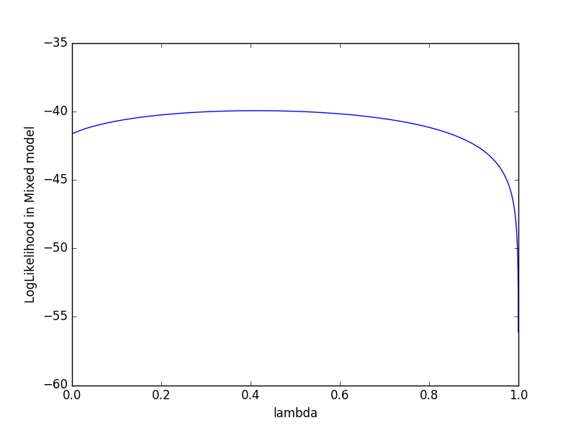

**4.4 e)**

"""

Created on Sun Oct 23 00:32:51 2016

@author: gopal

"""

**import** numpy **as** np**;**

**import** math**;**

**import** matplotlib**.**pyplot **as** plt**;**

vocab **=** np**.**loadtxt**(**'vocab250A.txt'**,** dtype**=**str**,** unpack**=True)**

vocabCount **=** np**.**loadtxt**(**'unigram.txt'**,** dtype**=**float**,** unpack**=True)**

preWordId**,** nextWordId**,** followCount **=** np**.**loadtxt**(**'bigram.txt'**,** dtype**=**int**,** unpack**=True)**

#returns index of a word in vocab. fixes the byte encoding b' match.

**def** WhatIndex**(**s**):**

s **=** "b'" **+** s **+** "'"

result **=** np**.**where**(**vocab**==**s**)[**0**]**

**if** len**(**result**)** **==** 0 **:**

**return** **-**1

**else:**

**return** result**[**0**]**

lenVocab **=** np**.**size**(**vocab**);**

totalWords **=** np**.**sum**(**vocabCount**)**

unigramP **=** np**.**divide**(**vocabCount**,** totalWords**)**

bigramP **=** np**.**zeros**(**shape**=(**lenVocab**,** lenVocab**),** dtype**=**float**)**

**for** i **in** range**(**len**(**preWordId**)):**

bigramP**[**preWordId**[**i**]-**1**][**nextWordId**[**i**]-**1**]** **=** followCount**[**i**]**

bigramP **=** bigramP**/**bigramP**.**sum**(**axis**=**1**,** keepdims**=True)**

**def** UnigramStartsWith**(**s**):**

s **=** s**.**upper**()**

result1Index **=** np**.**array**([**i **for** i **in** range**(**lenVocab**)** **if** vocab**[**i**][**2**]==**s**])**

result **=** np**.**column_stack**((**vocab**[**result1Index**],** unigramP**[**result1Index**]))**

**return** result

**def** BigramNext**(**prevWord**,** howMany**):**

prevWord **=** prevWord**.**upper**()**

prevIndex **=** WhatIndex**(**prevWord**)**

**if** prevIndex **!=** **-**1 **:**

nextWord **=** bigramP**[**WhatIndex**(**prevWord**)]**

result2Index **=** np**.**argsort**(**nextWord**)[::-**1**]**

result **=** np**.**column_stack**((**vocab**[**result2Index**][:**howMany**],** nextWord**[**result2Index**][:**howMany**]))**

**return** result

**else:**

**return** "Word not found!"

**def** UnigramSentence**(**s**):**

s **=**s**.**upper**();**

logLikelihood **=** 0.0

**for** w **in** s**.**split**():**

indexS **=** WhatIndex**(**w**)**

**if** indexS **!=** **-**1**:**

logLikelihood **+=** math**.**log**(**unigramP**[**indexS**])**

**else:**

logLikelihood **-=** math**.**inf

**print** **(**w**)**

**return** logLikelihood**;**

**def** BigramSentence**(**s**):**

s **=**s**.**upper**();**

logLikelihood **=** 0.0

s **=** '<s> ' **+** s

splitS **=** s**.**split**();**

indices **=** np**.**array**([**WhatIndex**(**w**)** **for** w **in** splitS**])**

**for** i **in** range**(**1**,**len**(**splitS**)):**

**if** indices**[**i**]!=-**1 **and** indices**[**i**-**1**]!=** **-**1**:**

**if** bigramP**[**indices**[**i**-**1**]][**indices**[**i**]]** **>** 0.0**:**

logLikelihood **+=** math**.**log**(**bigramP**[**indices**[**i**-**1**]][**indices**[**i**]])**

**else:**

logLikelihood **-=**math**.**inf

**print** **(**vocab**[**indices**[**i**-**1**]],** vocab**[**indices**[**i**]])**

**else** **:**

logLikelihood **-=**math**.**inf

**print** **(**vocab**[**indices**[**i**-**1**]],** vocab**[**indices**[**i**]])**

**return** logLikelihood

**def** MixedSentence**(**s**,** lmda**):**

s **=** s**.**upper**()**

s **=** '<s> ' **+** s

logLikelihood **=** 0.0

splitS **=** s**.**split**();**

indices **=** np**.**array**([**WhatIndex**(**w**)** **for** w **in** splitS**])**

**for** i **in** range**(**1**,**len**(**splitS**)):**

**if** indices**[**i**]!=-**1 **and** indices**[**i**-**1**]!=** **-**1**:**

Pb **=** bigramP**[**indices**[**i**-**1**]][**indices**[**i**]]**

Pu **=** unigramP**[**indices**[**i**]]**

mixedP **=** **(**1**-**lmda**)\***Pu **+** lmda**\***Pb

**if** mixedP **>** 0.0**:**

logLikelihood **+=** math**.**log**(**mixedP**)**

**else:**

logLikelihood **-=** math**.**inf

**else:**

logLikelihood **-=**math**.**inf

**print** **(**vocab**[**indices**[**i**-**1**]],** vocab**[**indices**[**i**]])**

**return** logLikelihood

**def** lmbdFunc**(**s**,** step**):**

xRange **=** np**.**arange**(**0**,**1**,**step**)**

y **=** np**.**array**([**MixedSentence**(**s**,** x**)** **for** x **in** xRange**])**

**print** **(**'Optimum lambda:'**,** xRange**[**np**.**argmax**(**y**)])**

**print** **(**'Maximum Likelihood: ' **,** np**.**max**(**y**))**

plt**.**plot**(**xRange**,** y**)**

plt**.**xlabel**(**'lambda'**)**

plt**.**ylabel**(**'LogLikelihood in Mixed model'**)**