**6.2 d) & e)**

|  |  |  |
| --- | --- | --- |
| iteration | number of mistakes | M log-likelihood L |
| 0 | 195 | -1.044559748 |
| 1 | 60 | -0.50494051 |
| 2 | 43 | -0.410763774 |
| 4 | 42 | -0.365127174 |
| 8 | 44 | -0.347663212 |
| 16 | 40 | -0.334676667 |
| 32 | 37 | -0.322592689 |
| 64 | 37 | -0.314831062 |
| 128 | 36 | -0.311155817 |
| 256 | 36 | -0.310161104 |

**import** numpy **as** np

OX **=** np**.**loadtxt**(**'spectX.txt'**,** dtype**=**int**)**

OY **=** np**.**loadtxt**(**'spectY.txt'**,** dtype**=**int**)**

PZ_X **=** np**.**zeros**(**OX**.**shape**[**1**],** dtype**=**int**)**

PZ_X **=** PZ_X **+** **(**1**/**len**(**PZ_X**))**

#P(Y|X)

**def** getPY_X**(**PZ_X**,** X**,** Y**):**

result **=** 1.0

**for** i **in** range**(**len**(**PZ_X**)):**

result **=** result **\*** **(**np**.**power**((**1**-**PZ_X**[**i**]),** X**[**i**]))**

**if(**Y**==**1**):**

result **=** 1**-**result

**return** result

**def** LLhood**(**OX**,** OY**,** PZ_X**):**

llhood **=** 0.0

**for** i **in** range **(**len**(**OX**)):**

llhood **=** llhood **+** np**.**log**(**getPY_X**(**PZ_X**,** OX**[**i**],** OY**[**i**]))**

llhood **=** llhood**/**len**(**OX**)**

**return** llhood

**def** countMistakes**(**PY_X**):**

**return** np**.**count_nonzero**(**PY_X**<**0.5**)**

**def** run**(**OX**,**OY**,**PZ_X**):**

#PZX_XY E-step

**for** loop **in** range**(**257**):**

PY_X **=** np**.**array**([**getPY_X**(**PZ_X**,** OX**[**i**],**OY**[**i**])** **for** i **in** range**(**len**(**OX**))])**

a **=** **(**OX**.**T**/**PY_X**).**T **\*** PZ_X

PnewZ_X **=** np**.**inner**(**OY**,** a**.**T**)**

PnewZ_X **=** np**.**array**([**PnewZ_X**[**i**]/**np**.**count_nonzero**(**OX**.**T**[**i**])** **for** i **in** range**(**len**(**PnewZ_X**))])**

**if** **(**loop **&** loop**-**1**)** **==** 0**:**

**print** **(**loop**,** countMistakes**(**PY_X**),** LLhood**(**OX**,** OY**,** PZ_X**))**

PZ_X **=** PnewZ_X #M-step

**6.3 c)**

**>>>** plot**(-**10**,**10**,** 0.001**,** f**)**

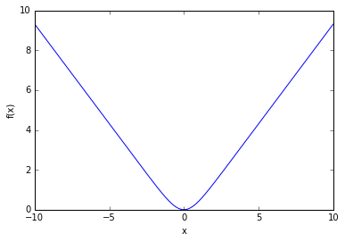

**>>>** plot**(-**10**,**10**,** 0.001**,** Q**,** **-**2**)**

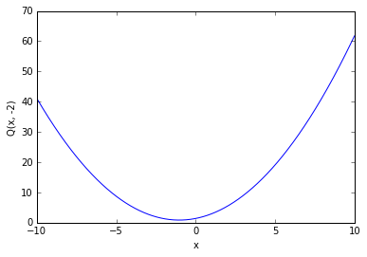

**>>>** plot**(-**10**,**10**,** 0.001**,** Q**,** 1**)**

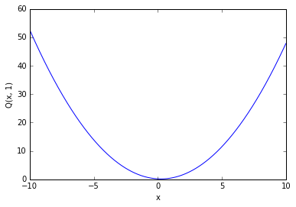

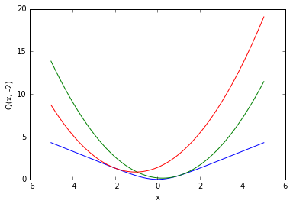

**6.3 f)**

**>>>** ConvergerAux**(**-2**,** 10**,** f**,** fd**)**

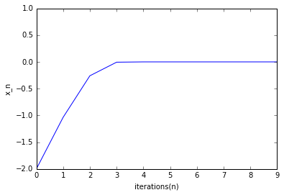

Table showing values of x_n after every update, with respect to minimizing Q(x, y). It converges to 0 after 5 iterations. We start at x_0 = -2.

|  |  |
| --- | --- |
| iteration | x_n |
| 0 | -2 |
| 1 | -1.03597 |
| 2 | -0.25968 |
| 3 | -0.00568 |
| 4 | -6.12E-08 |
| 5 | -7.94E-23 |
| 6 | 0 |
| 7 | 0 |
| 8 | 0 |
| 9 | 0 |

**>>>** ConvergerAux**(**1**,** 10**,** f**,** fd**)**

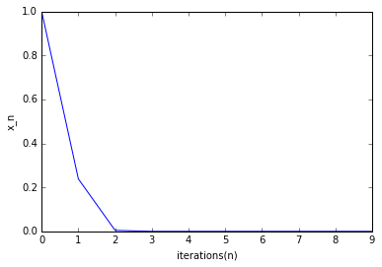

Table showing values of x_n after every update, with respect to minimizing Q(x, y), It converges to zero after 5 iterations. We start at x_0 = 1.

|  |  |
| --- | --- |
| iteration | x_n |
| 0 | 1 |
| 1 | 0.238406 |
| 2 | 0.004416 |
| 3 | 2.87E-08 |
| 4 | 6.62E-24 |
| 5 | 0.00E+00 |
| 6 | 0 |
| 7 | 0 |
| 8 | 0 |
| 9 | 0 |

**6.3 g)**

**>>>** ConvergerNewton**(**1**,** 10**)**

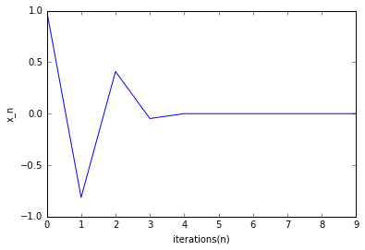

Table showing values of x_n after every update, with respect to minimizing f(x) using Newton method with x_0 = 1. It converges to zero after 5 iterations.

|  |  |
| --- | --- |
| iteration | x_n |
| 0 | 1 |
| 1 | -0.81343 |
| 2 | 0.409402 |
| 3 | -4.73E-02 |
| 4 | 7.06E-05 |
| 5 | -2.35E-13 |
| 6 | 0 |
| 7 | 0 |
| 8 | 0 |
| 9 | 0 |

**>>>** ConvergerNewton**(-**2**,** 10**)**

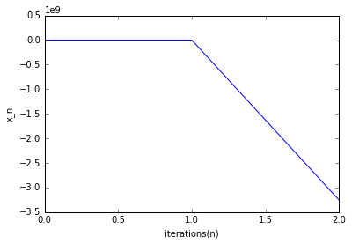

After 2 iteration values goes out of bound. So not shown on graph. (not converging)

Table showing values of x_n after every update, with respect to minimizing f(x) using Newton method with x_0 = -2. Values are not defined after 3 iteration as it never converges.

|  |  |
| --- | --- |
| iteration | x_n |
| 0 | -2 |
| 1 | 11.64496 |
| 2 | -3.3E+09 |
| 3 | inf |
| 4 | nan |
| 5 | nan |
| 6 | nan |
| 7 | nan |
| 8 | nan |
| 9 | nan |

**6.3 h)**

**>>>** plot**(-**10**,**10**,** 0.001**,** g**)**

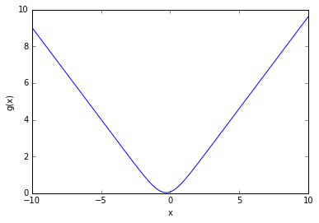

**>>>** plot**(-**0.5**,**0**,** 0.001**,** g**)**

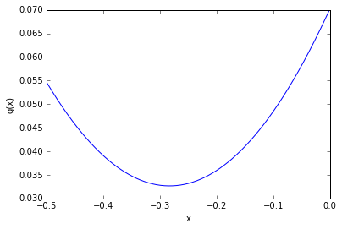

A closer look to g(x)

**6.3 k)**

**>>>** ConvergerAux**(**1**,** 10**,** g**,** gd**)**

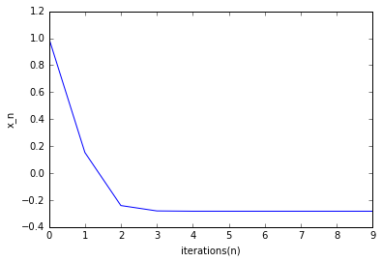

$$x^{*}= -0.283027022745$$

$$g_{min}= {g(x}^{*})= 0.0326571259075$$

Table showing values of x_n after every iteration with respect to minimizing R(x, y), with x_0 =1.

|  |  |
| --- | --- |
| iteration | x_n |
| 0 | 1 |
| 1 | 0.152599478 |
| 2 | -0.240966615 |
| 3 | -0.280717926 |
| 4 | -0.28289933 |
| 5 | -0.283019955 |
| 6 | -0.283026632 |
| 7 | -0.283027001 |
| 8 | -0.283027022 |
| 9 | -0.283027023 |

**import** numpy **as** np

**import** matplotlib**.**pyplot **as** plt

**def** g**(**x**):**

result **=** 0.0

**for** k **in** range**(**10**):**

result **+=** np**.**log**(**np**.**math**.**cosh**(**x**+** **(**1**/(**k**+**1**))))**

**return** result**/**10**;**

**def** gd**(**x**):**

result**=**0.0

**for** k **in** range**(**10**):**

result **+=** np**.**tanh**(**x **+** **(**1**/(**k**+**1**)))**

**return** result**/**10**;**

**def** f**(**x**):**

**return** np**.**log**(**np**.**cosh**(**x**));**

**def** fd**(**x**):**

**return** np**.**tanh**(**x**);**

**def** fdd**(**x**):**

**return** 1**/(**np**.**cosh**(**x**)** **\*** np**.**cosh**(**x**))**

**def** Q**(**x**,**y**):**

**return** f**(**y**)+**fd**(**y**)*(**x**-**y**)** **+** np**.**power**((**x**-**y**),**2**)/**2

**def** ConvergerAux**(**x0**,** loops**,** func**,** funcd**):**

x **=** x0**;**

it **=** np**.**zeros**(**loops**,** dtype**=**int**)**

xVal **=** np**.**zeros**(**loops**)**

**for** i **in** range**(**loops**):**

xVal**[**i**]=** x

it**[**i**]** **=** i

**print** **(**it**[**i**],** x**)**

x **=** x **-** funcd**(**x**)**

plt**.**plot**(**it**,** xVal**)**

plt**.**xlabel**(**"iterations(n)"**)**

plt**.**ylabel**(**"x_n"**)**

**print** **(**x**,** func**(**x**))**

**def** ConvergerNewton**(**x0**,** loops**):**

x **=** x0**;**

it **=** np**.**zeros**(**loops**,** dtype**=**int**)**

xVal **=** np**.**zeros**(**loops**)**

**for** i **in** range**(**loops**):**

xVal**[**i**]=** x

it**[**i**]** **=** i

**print** **(**it**[**i**],** x**)**

x **=** x **-** **(**fd**(**x**)/**fdd**(**x**))**

plt**.**plot**(**it**,** xVal**)**

plt**.**xlabel**(**"iterations(n)"**)**

plt**.**ylabel**(**"x_n"**)**

**print** **(**x**,** f**(**x**))**

**def** plot**(**l**,**r**,**step**,**func**,** y0**=**0**):**

xRange **=** np**.**arange**(**l**,**r**,**step**)**

**if** func**==**Q**:**

y **=** np**.**array**([**func**(**x**,**y0**)** **for** x **in** xRange**])**

**else:**

y **=** np**.**array**([**func**(**x**)** **for** x **in** xRange**])**

plt**.**plot**(**xRange**,**y**)**

plt**.**xlabel**(**"x"**)**

ylabel **=** func**.**__name__ **+** '(x'

**if** y0**!=**0**:** ylabel**+=** **(**', '**+**str**(**y0**))**

ylabel **+=** ')'

plt**.**ylabel**(**ylabel**)**