**Computer Network Lab**

**Assignment - 1**

**NAME:**  Gopal Vilas Shendge

**PRN:** 2020BTECS00061

**BATCH:** S4

**Q.1** Study the OSI model and write the layer by layer working of it

**OSI model**

OSI stands for open system inetconnection.It describes the seven layers which computer systems use to connect the network.It was first standard model of network used by major telecommunication companies in the 1980's.It has been developed by ISO(International organisation for standardisation) in the year 1984.

Today's internet does not work on the OSI network model but it helps to understand ,visualise how a network actually works and how it is operated.

As OSI made up of total 7 layers,namely

1. **Physical layer**
2. **Data link layer**
3. **Transport layer**
4. **Network layer**
5. **Session layer**
6. **Presentation layer**
7. **Application layer**

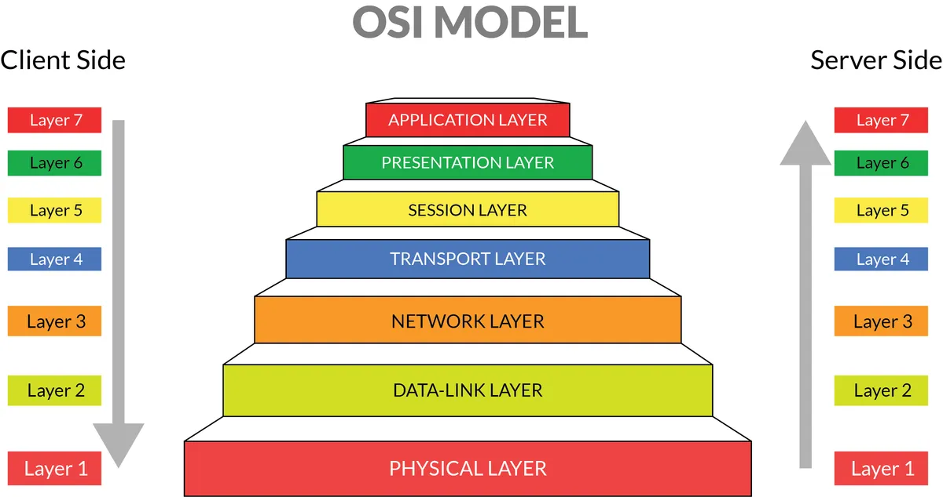

**OSI Model layers**

As every layer has different functions and and all they are depends on each other for their working.Lets see one one by one working of each layer

1.**Physical Layer**

Physical Layer lowest layer in osi model.As word suggests it has actual existence in network.It’s main function is to connect network through actual physical medium like coaxial cable,twisted pair cable or optic fiber.It contains the information in the form of bits.

It transmits information in the form of bits from one node to another node via the next layer named data link layer which puts the frame back together.

Physical responsible for the below functions

1.Bit synchronisation:

It task is to make boundary/frame for the bit sequence.It provides synchronisation for the bits

2.Bit rate control :

Which decides the rate of transfer of bits. i.e bits per second

3.Physical Topologies:

It specifies that node devices can be connected in how many different types in networks like mesh,star,bus.

4.Transmission mode:

Physical layer also decides how data will flow between two connected device.The various transmission modes possible are Simplex, half-duplex and full-duplex.

**2.Data link layer**

It is the second layer in the osi model.It is responsible to node to node transmission of messages.This layer assure that data transfer is error free from one node to another node over physical layer.It uses MAC address of host for every transmission of data packet.It handled by the NIC(Network interface card).Switches and bridges are the Data link layer devices.

It further divided into two parts

1.Logical link control(LIC)

2.Media access control(MAC)

The packet received is further divided into frames depending on the size if NIC.It encapsulates the sender and receiver data in the part of header.

The data has following two functions:

1.Framing-

It's the main task of the Data link layer.It makes a frame of a set of bits so that it will be meaningful to the receiver.This can be accomplished by attaching special bit patterns to the beginning and end of the frame.

2.Physical addressing-

It adds the MAC address of hot to the receiver and sender message and adds it to the header farme.

3.Error control:

It detects the error in the data and retransmits it to the sender for ressilving that error.

4.Flow control

The flow of data must constant.It assures that data rate must be same throughout the transmission so that no packet will droped.

**3.Network Layer**

Transmission of data from the host network to another network is done through the network layer.

It looks for the shortest path for transmission of data with the help of routing.It includes sender and receiver IP on header.It implements by using devices like routers.

Main functions are

1.Routing:

It specifies which route will suitable for transmission of packet using network layer protocols.

2.Logical addressing: To identify each device on a network uniquely the network layers define the addressing scheme.The address will be identified using header.

**4.Transport layer:**

It is responsible for giving service to the application layer.It will send acknowledgment for successful transmission or through error for unsuccessful transmission and ask for resent that particular data.

There are some transport protocols

TCP is first protocol that establishes logical connection between transfer port layer at two different levels before transfering.

:

**5]Session Layer**

The session layer controls the conversations between different computers. A session or connection between machines is set up, managed, and termined at layer 5. Session layer services also include authentication and reconnections. 6]Presentation Layer The presentation layer formats or translates data for the application layer based on the syntax or semantics that the application accepts. Because of this, it at times also called the syntax layer. This layer can also handle the encryption and decryption required by the application layer.

**6]Presentation Layer**

The presentation layer formats or translates data for the application layer based on the syntax or semantics that the application accepts. Because of this, it at times also called the syntax layer. This layer can also handle the encryption and decryption required by the application layer.

**5.Application layer:**

Process to process is the many duty of application layer.It communicate between two process by send request to the other process and receives a response.Two applications are responsible two to exchange the message between each other as though there is bridge between layer. The application layer identifies communication partners, resource availability, and synchronises communication. There are already defined protocol but we can also protocols by our own.HTTP is one of the protocol for accessing www.

**Q.2.** Study and prepare document on various networking Devices used for networking communication. Write its information, working and include images of it.

**Networking Devices**

**1.Repeater:**

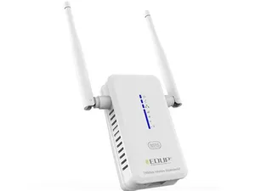

**Wifi Repeater**

It’s used in the physical layer.It will retransmit the signal with more strength to extend its range so that it can reach to destination.If it loses the strength while transmitting signal somewhere in between then repeater will retransmit.It comes to existence due to limitation of a signal in propagating over a longer distance and now are a common installation in wireless networks for expanding cell size.It is also known by name **signal boosters.**

Repeaters support both analog as well as digital signals and can repeat electrical signals.

As there may be confusion between amplifiers and repeaters .But amplifiers strengthen the signal but at the same frequency while repeater is not necessary to do so.

Types of repeaters:

1.Microwave repeater

2.Satellite repeater

3.WLAN repeater

4.LTE repeater

5.Optical repeater

**2.Amplifier:**

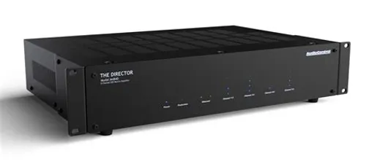

**Amplifier**

As word suggests it amplifies the signal.Means it will strengthen the strength of signal with keeping frequency as constant. It takes low input power and provides high output power.It is generally used in mobile and remote network.When signal strength is going on increasing along with this noise also getting added.It is generally used in wireless communication.

Types of amplifiers:

1. Current amplifier
2. Voltage amplifier
3. Transconductance amplifier
4. Transresistance amplifier

3.Switch:

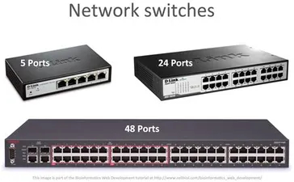

It is a multipoint input,output device that transfers data packets from source to destination.As it minimises the requirements of wire medium because it can connect a number of systems just by switching.

We can connect switches to each other and to hosts using point-to-point links, which typically means that we can build networks of large geographic scope.Adding a new host to the network by connecting it to a switch does not necessarily reduce the performance of the network for other hosts already connected.

It is a collection of links where each link has appropriate data data link protocol which will connect to that node.It is a data link layer device.

**4.Routers:**

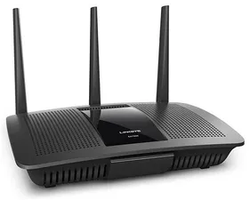

It is used in network layer of osi model.Task of router is to find best way by using router tables to transfer the packet over the network so that it can transfer without any loss of packets and in time.There are some popular companies that develop routers; such are Cisco, 3Com, HP, Juniper, D-Link, Nortel, etc. It shares information with other routers in networkingIt uses the routing protocol to transfer the data across a network.There are several types of routers, but most routers pass data between LANs & WANs.

5.Bridges:

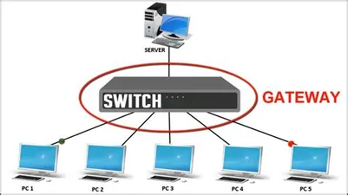

It belongs to the data link layer.Its a network device which is used to connect two or more communication networks or network segments and creates a single network.The multiple lan can be connected to form a big lan. A bridge in computer networks is defined as, the network device that provides a connection between two local area networks (LANs) or two segments of the same local area network.

.

6.Gateway:

It is not any specific kind of networking device.We can say it can be modem,router etc.It's kind of door which allows data from one discrete network to another.In a workplace, the gateway is the computer that routes traffic from a workstation to the outside network that is serving up the Web pages.

