Assignment: Kalah Game

**Application Requirement:**

1. Kalah web application with Java8 And Spring rest controller
2. User interface with Angular JS and bootstrap for Kalah Game
3. Write down Junit test cases to test functionality
4. Use Maven to build war file
5. Use Apache Tomcat server to deploy Kalah web application

|  |  |
| --- | --- |
| **Tech Stack:** | |
| **Sr. No** | **Technical stack** |
| 1 | Java 1.8 |
| 2 | Spring 4 |
| 3 | Maven |
| 4 | Angular js |
| 5 | Bootstrap 3 |
| 6 | Apache Tomcat 8 |

|  |  |  |
| --- | --- | --- |
| **Implementation Steps and Efforts** | | |
| **Sr. No** | **Task** | **Efforts in Hr.** |
| 1 | Requirement Analysis | 2 |
| 2 | Project Design | 2 |
| 3 | Environment Setup - Initial Kalah Application environment setup with Java 1.8 + Spring Rest Controller + Maven + Angular JS + Bootstrap + Junit Test Cases Implemented Spring framework + Junit | 2 |
| 4 | Implementation - Kalah Game Rules | 2 |
| 5 | Kalah Service Implementation - Initialization of game | 2 |
| 6 | Kalah Service Implementation - Move stones for current selected pit. | 1 |
| 7 | Kalah Validations Implementation | 1 |
| 8 | UI design and Implementation | 2 |
| 9 | UI Testing | 0.5 |
| 10 | Documentation and Build & Deployment | 0.5 |
|  | **Total** | **15** |

**Application URL:**

<http://localhost:8080/kalah>

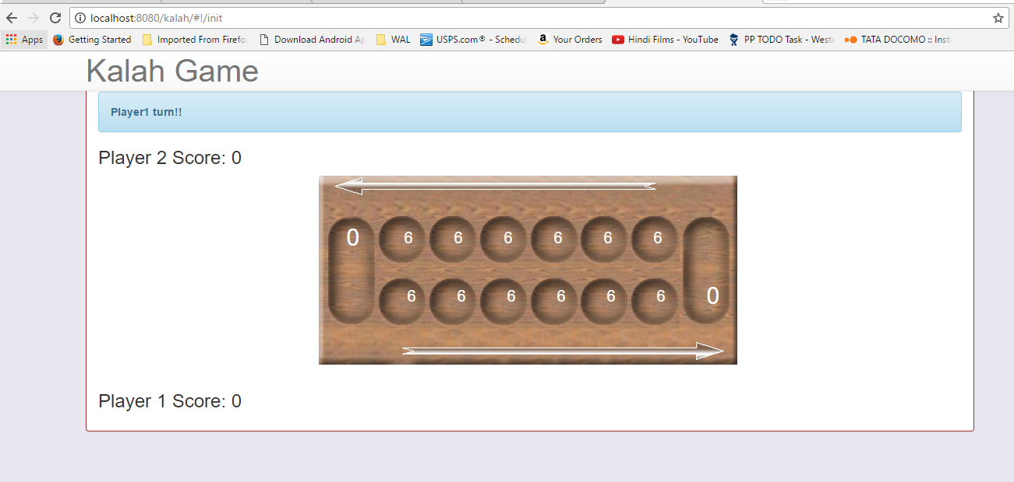

|  |  |
| --- | --- |
| **Reference:** | |
| **Sr. No.** | **URL** |
| 1 | https://spring.io/guides/gs/consuming-rest-angularjs/ |
| 2 | https://dzone.com/articles/putting-java-rest |
| 3 | https://spring.io/guides/tutorials/bookmarks/ |