AI-BASED DISASTER RELIEF
MANAGEMENT SYSTEM
A Project Based Learning Report Submitted in partial fulfilment of the requirements for the award of the degree
BACHELOR OF TECHNOLOGY
Course: Database Engineering & Database Systems Design

Submitted by
2510030417 – Srianish Saravan
2510030339 – Vinay Goud
2510030365 – G. Akshith
2510030353 – Numairuddin
2510030336 – Mohit
Under the guidance of
Dr. Md. Rafeeq


Department / Institution
Koneru Lakshmaiah Education Foundation (K L University), Hyderabad
Academic Year 2026–2027

ABSTRACT

Disaster response depends on timely information about incidents, affected people, shelters, relief supplies and delivery status. When these records are maintained in disconnected files or handled manually, responders may struggle to identify urgent needs, check stock availability and confirm whether aid has reached its destination. The AI-Based Disaster Relief Management System presented in this report is a centralized web-based prototype intended to organize these operational records and support a traceable relief workflow.
The project brings together incident management, victim and needs records as a planned domain capability, shelter coordination, resource inventory, allocation and dispatch, and audit tracking. The review presentations describe a frontend based on HTML, CSS and JavaScript, a Python backend/API layer, and a relational database architecture targeting MySQL 8 with InnoDB. The supplied Review 4 demonstration package is deliberately portable: it runs a local Python HTTP server and uses SQLite so that the prototype can be executed without installing external packages. This distinction is important: SQLite is the demo database, while MySQL/InnoDB remains the target deployment architecture.
The implementation supplied in the ZIP supports administrator login, an operations dashboard, incident creation and status updates, inventory viewing, allocation/dispatch, and an audit log. The code checks available resource quantity before dispatch, reduces inventory when a dispatch is accepted, and records key actions with a timestamp and actor. The Review 4 presentation reports five out of five functional smoke tests passed and a 50-request local dashboard benchmark with an average response time of 1.78 ms, median of 1.70 ms, maximum of 2.90 ms and a smoke-test error rate of 0%. These measurements apply only to the local demonstration environment and must not be interpreted as production-scale performance.
The project demonstrates the core data-to-action loop: record a need, inspect available stock, dispatch a permitted quantity and retain an audit trail. Rule-based prioritization is described in the design, while AI-based demand prediction, GPS tracking, mobile access, notifications and cloud deployment are future enhancements. The report follows the supplied project documentation template and organizes the material across the review topics: problem and objectives, literature and data sources, methodology, system design, implementation, experiments, results and analysis, conclusion, future work and references.

LIST OF FIGURES
Figure 1. Project workflow 14
Figure 2. System architecture 17
Figure 3. Allocation validation and dispatch flow 19
Figure 9. Administrator login page 34
Figure 10. Operations dashboard 34
Figure 11. Incident management 35
Figure 12. Resource inventory 35
Figure 13. Allocation and dispatch 36
Figure 14. Audit trail 36
Figure 15. Incident creation confirmation 37

LIST OF TABLES
Table 1. Project objectives and indicators 9
Table 2. Stakeholders and responsibilities 10
Table 3. Review requirements mapped to report sections 38
Table 4. Data sources and their contribution 11
Table 5. Data preprocessing rules 12
Table 6. Functional modules 15
Table 7. Technology stack: target architecture and portable demo 13
Table 8. Core database tables in the demo 18
Table 9. Main API routes 33
Table 10. Test cases and reported outcomes 23
Table 11. Performance measurements reported in Review 4 25
Table 12. Risks and mitigation measures 29
Table 13. Limitations and future enhancements 29
Table 14. Literature and technical-source review 8

TABLE OF CONTENTS
Abstract 2
1. Introduction 5
1.1 Background 5
1.2 Motivation 5
1.3 Project Overview 5
1.4 Need for a Centralized System 5
1.5 Report Organization 5
1.6 Project Context and Operational Setting 6
1.7 Expected Benefits 6
1.8 Operational Assumptions and Success Conditions 6
2. Literature Review and Existing Approaches 7
2.1 Introduction 7
2.2 Existing Disaster Information Sources 7
2.3 Existing System Patterns 7
2.4 Database Technology Considerations 7
2.5 Comparative Literature Matrix 8
2.6 Research/Project Gap 8
2.7 Critical Review 8
2.8 Summary 8
3. Problem Definition, Objectives and Scope 9
3.1 Problem Statement 9
3.2 Aim 9
3.3 Specific Objectives 9
3.4 Scope Included in the Demonstration 9
3.5 Planned or Target Scope 10
3.6 Out of Scope and Important Boundaries 10
3.7 Stakeholders 10
4. Data Sources and Data Preparation 11
5. Proposed Methodology 13
6. System Analysis and Requirements 15
7. System Architecture and Database Design 17
8. Algorithm and Operational Logic 19
9. Implementation Details 21
10. Experiments, Testing and Validation 23
11. Results and Performance Analysis 25
12. Deployment, Security and Maintenance 27
13. Limitations and Future Scope 28
14. Conclusion 30
References 31
Appendix A. Demo Execution Guide 32
Appendix B. API and Database Reference 33
Appendix C. Review Evidence and Screenshots 34
Appendix D. Review-to-Report Traceability 38
Appendix E. Extended Validation and Acceptance Protocol 39
Appendix F. Operational Scenarios and Handover Checklist 40
Appendix G. Data Quality, Governance and Privacy 41
Appendix H. Operational Metrics, Service Levels and Risk Review 42
Appendix I. Incident and Inventory Reconciliation Worksheet 43

1. INTRODUCTION

1.1 Background
Natural disasters such as floods, earthquakes, cyclones and landslides can affect large populations within a short period. Relief operations may require food, drinking water, medicines, temporary shelter, rescue assistance and volunteers to be coordinated across several locations. A response team must understand not only where an incident has occurred, but also how severe it is, how many people are affected, what needs have been verified, which supplies are available and whether a dispatch has been completed.
The project addresses the information-management aspect of disaster response. It does not replace emergency services, field judgement or official warning systems. Instead, it proposes a shared operational record through which authorized personnel can maintain incident details, resource quantities, allocations and delivery events. This makes it easier to view a consistent state of the operation and to trace changes after they occur.

1.2 Motivation
In a fragmented process, incident details may be copied between spreadsheets, phone messages and separate agency records. The same incident can be reported more than once, inventory quantities can become outdated, and relief allocations may be made without a clear record of the approving person. A centralized application can reduce these coordination difficulties by providing a structured place for records and by connecting the incident, resource and dispatch stages.
The supplied Review 1/2 presentation emphasizes a centralized database, resource tracking, shelter management, volunteer assignments, agency coordination and report generation. The later reviews narrow the demonstrable prototype around incident records, inventory, allocation/dispatch and audit. This report distinguishes the broad intended project scope from features actually visible in the supplied running demo.

1.3 Project Overview
The AI-Based Disaster Relief Management System is designed as a web application. Users interact with a browser-based interface; requests are handled by a Python server; records are stored in a relational database; and the interface presents dashboard counts, incident status, available inventory, dispatch records and audit events. The design describes role-specific access for administrators/agencies, field teams and shelter/NGO stakeholders. The supplied demonstration implements an administrator login and a single admin actor for recorded actions.

1.4 Need for a Centralized System
- A single operational view for incident and resource records.
- Structured records for incident type, location, severity, affected people and status.
- Visibility of resource quantity, unit and storage location.
- A controlled allocation step that rejects quantities greater than available stock.
- A history of important actions with timestamps and actor information.
- A foundation that can later integrate official feeds, GPS, notifications and predictive analysis.

1.5 Report Organization
Chapter 2 reviews relevant system patterns and the sources identified in the presentations. Chapters 3 and 4 define the problem, objectives, scope and data preparation. Chapters 5 to 9 explain the methodology, requirements, architecture, database and implementation. Chapters 10 and 11 document the reported tests and performance measurements. Chapters 12 to 14 cover deployment, security, limitations, future scope and conclusions. The appendices provide practical instructions for running the supplied demo and a concise reference to its API routes.

1.6 Project Context and Operational Setting
The operational setting involves multiple actors who may update information from different locations. Incident commanders need a high-level view of current incidents and escalation status. Relief coordinators need to compare verified requests against inventory and approve allocations. Shelter managers need to maintain capacity and occupancy information. Field responders need to report conditions and needs. Administrators or auditors need to review access and traceability. These roles are specified in the Review 2 design; their full role-specific access control is a target requirement rather than a claim that every role is implemented in the demo.

1.7 Expected Benefits
Benefit | How the system supports it | Evidence/qualification
Centralized records | Shared relational records for incidents, resources, allocations and audit events. | Implemented in the local prototype for these entities.
Improved visibility | Dashboard summaries and separate incident, resource and allocation views. | Demonstrated in the supplied screenshots.
Stock control | Allocation checks available quantity and decreases stock on successful dispatch. | Implemented in server.py.
Traceability | Important actions are inserted into an audit table with time and actor. | Implemented for login, incident create/update and dispatch.
Better prioritization | Severity, affected population, urgency, access and capacity are proposed as factors. | Rule-based concept; advanced optimization is future work.
Scalable operations | Target architecture identifies MySQL/InnoDB and possible cache/event channel. | Deployment-scale performance has not been demonstrated.

1.8 Operational Assumptions and Success Conditions
The system depends on incident and inventory records being maintained by authorized staff. A dashboard can only be as reliable as the source data behind it, so every record should have a clear owner and a last-updated time. A displayed severity value should be treated as a triage aid rather than a replacement for field verification. Resource quantities must remain tied to explicit units and locations, and any reserved quantity should be distinguished from stock that can be dispatched immediately.
The prototype’s practical success can be evaluated through task completion and record consistency: an operator should be able to find an incident, inspect the appropriate resource, request a valid quantity and later locate the corresponding audit event. These actions should remain understandable when a request fails. The system should not present sample figures as current emergency facts, and future integrations should retain their source and retrieval time. These assumptions define the boundary between a useful demonstration and a service that is ready for real relief operations.

2. LITERATURE REVIEW AND EXISTING APPROACHES

2.1 Introduction
A literature review examines existing systems, database approaches and technical documentation to understand what has already been developed, what works well, and what limitations remain. The supplied literature-review guide recommends examining the application domain and the data/database aspects together: data requirements, relationships, database technology, normalization, keys, indexing, transactions, concurrency, caching, scalability and security. This project follows that analytical structure.

2.2 Existing Disaster Information Sources
The Review 3 presentation identifies four public information sources used while preparing the database: National Center for Seismology (NCS) earthquake records, NDMA SACHET disaster alerts, Open Government Data/IMD rainfall data, and Census of India population and household information. These sources serve different purposes. Earthquake records provide event observations; SACHET provides official multi-hazard alert information; rainfall data provides weather context; and census information can provide population context for affected areas.
Source | Information described in review | Potential use in the system
National Center for Seismology | Earthquake time, location, depth, magnitude and status. | Seed or cross-check earthquake incident records.
NDMA SACHET | Location-based multi-hazard alerts; CAP/RSS and multilingual dissemination. | Alert context and incident verification.
OGD / IMD | Rainfall data and dataset metadata. | Understand rainfall-related risk and affected areas.
Census of India | Population and household context. | Support planning estimates for affected zones.

2.3 Existing System Patterns
The project presentations contrast the proposed centralized approach with fragmented/manual record keeping. Existing operational tools may specialize in warnings, incident reporting, inventory management, shelter management or volunteer coordination. A warning portal is valuable for alert dissemination but does not by itself maintain the relief organization's stock ledger. A spreadsheet may be easy to start with but provides limited transaction control and audit consistency when multiple people update it. A standalone inventory tool may track supplies but not connect each issue to a verified incident and a delivery record.
The project therefore focuses on integration of records across a relief workflow. Its intended contribution is not the claim that no disaster-management systems exist. Rather, it is a student prototype that combines a defined set of operational entities and demonstrates a traceable flow from incident to resource dispatch.

2.4 Database Technology Considerations
A relational database is appropriate for the core entities because incidents, resource items, inventory quantities, allocations and audit entries have structured fields and relationships. Transactions are particularly important when dispatching stock: a successful operation must reduce the resource quantity and create an allocation record as one logical operation. In a production deployment, MySQL 8 with InnoDB is the stated target because the reviews identify relational storage, transactions and indexing as key requirements.
The portable demonstration uses SQLite. This choice is documented in Review 4 and the ZIP README: it avoids setup friction for the reviewer. It should not be confused with the target production stack. Before production use, database migration, concurrency behavior, authentication security, schema constraints, backups and load tests would need to be completed.

2.5 Comparative Literature Matrix
Approach/source | Strength | Limitation relative to this project | Project implication
Official earthquake records (NCS) | Provides structured event observations. | Not a complete relief inventory or delivery-management application. | Use as an event-data source, not as the entire operational system.
NDMA SACHET alerts | Official multi-hazard alerts and dissemination ecosystem. | Alert publication alone does not record local stock allocation and handoff. | Keep alert information distinct from verified operational incident records.
Rainfall datasets (OGD/IMD) | Adds environmental context for rainfall-related events. | Does not alone describe household needs, shelter occupancy or dispatches. | Use as contextual data after validation and attribution.
Census data | Population and household context for planning. | May not represent current, incident-specific needs. | Treat as planning context; verify actual needs in the field.
Manual files/spreadsheets (problem context) | Low initial setup cost and familiar workflow. | Fragmentation, duplicate records and weak transaction/audit controls may occur. | Centralize related records and log important changes.
Proposed centralized prototype | Connects incidents, inventory, allocation and audit in one demo. | Current demo is local and has a limited actor model. | Extend validation, access control, integrations and deployment before operational use.

2.6 Research/Project Gap
Based on the project materials, the gap is framed as an integration and traceability problem: operational information about incidents, needs, available supplies and dispatch outcomes can be separated across tools or manual processes. The proposed system brings selected records into one relational workflow and checks inventory before dispatch. This gap statement is based on the project framing in the reviews; it is not a claim that all existing disaster platforms lack these capabilities.

2.7 Critical Review
The proposed design is suitable for structured entities and transaction-oriented operations. A relational model supports clear links between incident and allocation records and makes it possible to query the current state. A single local demo is, however, not sufficient to prove scalability, multi-agency availability or reliable field operation under network outages. Similarly, a priority rule can make decisions more consistent, but its fairness depends on how factors and weights are chosen and whether field data is accurate. The system should therefore preserve human approval, record overrides and make the reason for a priority decision inspectable.

2.8 Summary
The reviewed sources support a design in which official hazard information is treated as an input, while the project database remains the operational system of record for incidents, inventory, allocation and audit. The main engineering priorities are data validation, relational consistency, transaction-safe stock updates, access control, auditability and measurable testing.

3. PROBLEM DEFINITION, OBJECTIVES AND SCOPE

3.1 Problem Statement
Natural disasters can create urgent and geographically distributed needs for food, water, medicine, shelter and rescue support. If agencies rely on manual records or disconnected applications, they may have difficulty determining which incidents are verified, which requests are most urgent, how much stock remains and whether allocated relief has been delivered. The project problem is to design and demonstrate a centralized information system that links incident records with resource availability and allocation activity, while preserving a traceable record of important actions.

3.2 Aim
To develop a web-based Disaster Relief Management System prototype that centralizes incident and resource records, supports controlled allocation/dispatch, and provides operational visibility and an audit trail.

3.3 Specific Objectives
No. | Objective | Success indicator used in this project
1 | Centralize relief data. | Incidents, resources, allocations and audit records are queryable through the demo.
2 | Support faster prioritization. | Dashboard orders incident records by severity; priority factors are defined for future rule refinement.
3 | Control allocation. | Requests exceeding available resource quantity are rejected.
4 | Keep actions traceable. | Key login, create, update and dispatch actions create audit records.
5 | Provide a usable interface. | Login, dashboard, incidents, resources, allocation and audit views are available.
6 | Prepare for wider deployment. | Target MySQL/InnoDB architecture and maintenance considerations are documented.

3.4 Scope Included in the Demonstration
- Administrator login validation using the seeded demo account.
- Dashboard counts for open incidents, affected people, resource quantities and allocation count.
- Incident list, incident creation and status update to Assessed.
- Resource inventory list showing item, quantity, unit and location.
- Allocation/dispatch form linking an incident and resource with a requested quantity.
- Stock validation that rejects a dispatch when the resource is missing or quantity is insufficient.
- Audit log for successful login, incident creation, incident status update and dispatch.
- SQLite persistence in the local demo database.

3.5 Planned or Target Scope
- Full role-specific permissions for agency, field team, shelter and NGO users.
- Victim/household registration and needs assessment.
- Shelter capacity and occupancy management.
- Integration with NCS, SACHET, OGD/IMD and Census data feeds.
- Priority scoring that combines severity, affected population, urgency, access conditions and capacity.
- MySQL 8/InnoDB production deployment, backup/replication and larger-scale testing.
- GPS tracking, mobile application, SMS/email notifications and AI-based demand prediction.

3.6 Out of Scope and Important Boundaries
The supplied demo is a prototype, not a certified emergency dispatch platform. It does not autonomously contact emergency services, independently verify field reports, provide guaranteed real-time integrations with government feeds, or implement a trained AI prediction model. The phrase “AI-Based” in the project title reflects the intended direction; Review 4 explicitly states that current prioritization is rule-based and AI demand prediction is future scope.

3.7 Stakeholders
Stakeholder | Primary responsibility | Information need
Incident commander | Monitor incidents and escalate urgent cases. | Incident status, severity, affected people and progress.
Relief coordinator | Review requests and approve allocations. | Priority, stock, destination and dispatch state.
Field responder | Report incident conditions and needs. | Simple incident/needs submission and update workflow.
Shelter manager / NGO | Maintain shelter and aid information in the planned scope. | Capacity, occupancy, services and incoming demand.
Administrator / auditor | Manage records and review actions. | Access, approvals, changes and audit history.
Affected people | Receive relief through operational teams. | Fair, timely and traceable assistance.

4. DATA SOURCES AND DATA PREPARATION

4.1 Data Sources
The Review 3 slides describe public information sources rather than a single packaged training dataset. NCS earthquake records, NDMA SACHET alerts, OGD/IMD rainfall information and Census of India population/household data were checked while preparing the database design. The review gives examples of NCS earthquake records dated 16 September 2026, including time, latitude, longitude, depth, magnitude and location descriptions. These are examples shown in the presentation, not a complete or automatically synchronized live feed.

4.2 Data Ingestion Pipeline
Stage | Action | Validation concern
1. Source | Identify the official source and its intended use. | Source identity and permitted use are clear.
2. Collect | Obtain data through API, CSV or structured feed where available. | Record collection time and source event ID.
3. Clean | Check missing fields and duplicate records. | Do not silently invent missing values.
4. Organize | Map information into incident, location, victim, shelter and resource concepts. | Use consistent field names and units.
5. Check | Validate timestamp, source, verification and approval status. | Separate reported information from verified information.
6. Store | Save records in the relational database with audit fields. | Preserve provenance and change history.

4.3 Data Cleaning
Data cleaning is necessary because public feeds and field reports can use different labels, formats and levels of completeness. A hazard might be described as a flood in one source and heavy rainfall in another. Locations may be represented as place names, coordinates or administrative regions. Event timestamps may use different time zones. Resource quantities can be measured in litres, kits, units or kilograms. The system should standardize these values without removing the original source reference.
- Trim unnecessary whitespace and normalize case where appropriate.
- Convert timestamps into a documented common format while retaining source timestamps.
- Validate latitude and longitude ranges when coordinates are supplied.
- Normalize hazard categories to an agreed vocabulary while preserving source text.
- Use explicit units for inventory quantities and reject negative stock values.
- Flag possible duplicate reports using source event ID, time and location; require review rather than deleting automatically.
- Record verification status, verified_by, created_at and updated_at where applicable.

4.4 Missing Values and Duplicate Handling
Missing values should be treated according to field meaning. A missing severity value should not be silently assigned a high or low priority; it should be marked as pending assessment. Missing coordinates may be allowed temporarily if a textual location is available, but the record should be marked for location verification. A duplicate candidate should be flagged using source ID, time and location similarity. Because two genuine incidents can occur near each other, automatic merging without review would be unsafe.

4.5 Normalized Incident Record
The Review 3 presentation gives an example normalized incident record with the fields incident_id, source, source_event_id, hazard_type, event_time, latitude, longitude, severity, affected_area and verification_status. It also identifies governance fields such as created_at, updated_at, source_timestamp, verified_by, approval_status, allocation_status and delivery_proof. These fields describe the intended operational data model; the portable demo implements a smaller incident table with title, hazard, location, severity, people, status and created_at.

4.6 Data Quality Rules
Data element | Rule | Reason
Incident title | Required and meaningful. | Makes records identifiable in lists.
Hazard | Selected from a known category or explicitly recorded. | Supports filtering and analysis.
Location | Required for operational dispatch; demo stores a text location. | Prevents untraceable incident records.
Severity | Use the defined 1–5 scale in the demo UI. | Allows consistent dashboard sorting.
People affected | Non-negative integer. | Avoids invalid aggregate counts.
Resource quantity | Non-negative integer in the demo; unit is stored separately. | Supports safe stock arithmetic.
Allocation quantity | Positive and no greater than available quantity. | Prevents over-allocation.
Audit event | Store action, actor, detail and timestamp. | Supports accountability.

4.7 Data Provenance and Governance
Each imported record should preserve where it came from and when it was observed. Source timestamps and local ingestion timestamps are not interchangeable: the first indicates when the event or observation was recorded by the source, while the second indicates when the project system collected it. Verification fields distinguish unconfirmed reports from records approved for operational decisions. This distinction is important when information from official alerts is combined with field observations.

5. PROPOSED METHODOLOGY

5.1 Methodology Overview
The project methodology follows the stages required by the Review 3 instructions: problem identification, data collection, preprocessing, system design, algorithm/technology selection, workflow, implementation, testing and deployment planning. Review 4 adds practical demonstration and measurable results. The approach is incremental: define the information problem, establish the data model, build the user interface and server routes, validate the core operations, and document what is demonstrated versus what remains future work.

5.2 Problem Identification
The initial analysis identifies four connected operational questions: where has a disaster occurred, who or what is affected, which supplies are available, and which dispatches have been completed. A useful prototype must connect these questions through stable identifiers rather than storing each as an isolated record. It must also prevent a dispatch from reducing stock below zero and provide a record of the operation.

5.3 Requirement Analysis
Functional requirements describe actions users can perform, such as logging in, creating incidents, updating status, viewing stock and creating a dispatch. Non-functional requirements describe qualities such as consistency, response time, security, maintainability and availability. The Review 2/3 materials call out transaction integrity, indexing, scalability, validated APIs, backup, offline-friendly capture, role-based access, protected personal data and auditability.

5.4 System Design
The system is divided into a frontend, server/API layer, operational processing logic and database. The frontend presents forms and views. The server validates requests and applies business rules. The database stores the authoritative state. The operational processing logic handles incident ordering, allocation checks and audit event creation. The design allows future integrations to be added behind APIs rather than embedding every data source directly into the browser.

5.5 Technology Selection and Justification
Layer | Target direction in reviews | Portable demo implementation | Reason
Frontend | HTML5, CSS3, JavaScript | HTML/CSS/JavaScript embedded in server.py | Runs in a browser and supports forms and tables.
Backend | Python + Flask / API layer | Python standard-library HTTP server | Keeps the demo zero-dependency and easy to execute.
Database | MySQL 8 / InnoDB | SQLite database file relief.db | Provides portable execution; target DB remains MySQL.
Development | VS Code and local runtime | Python 3.10+ per README | Simple local testing and debugging.
Testing | Unit, integration, performance and integrity checks | Functional smoke test and local dashboard benchmark reported in Review 4 | Checks the main workflow before deployment planning.

5.6 Workflow
Official / Field Data
↓
Collect and Validate
↓
Normalize Records
↓
Store in Relational Database
↓
Review Incident and Needs
↓
Check Resource Availability
↓
Approve and Dispatch
↓
Update Inventory and Audit Trail
↓
Dashboard / Operational Reports
Figure 1. Project workflow .................................... 14

5.7 Implementation Steps
- Requirement analysis and definition of operational entities.
- Database setup and initialization of sample records.
- Frontend development for login, dashboard and operational screens.
- Backend/API implementation for login, incident, resource, allocation and audit routes.
- Testing and debugging of the core data-to-action workflow.
- Deployment preparation, backup planning and maintenance documentation.

5.8 Validation Strategy
Validation is performed at several levels. Input validation checks that required values are present and quantities are sensible. Functional checks confirm that the expected page or API behavior occurs. Database checks confirm that records persist and stock is updated. Integration checks follow a workflow across several modules. Performance checks measure response times in a specified environment. The review presentation reports smoke tests and a dashboard benchmark; broader stress testing and production database benchmarks remain necessary.

6. SYSTEM ANALYSIS AND REQUIREMENTS

6.1 Functional Requirements
ID | Requirement | Implementation status
FR-01 | Validate administrator login. | Implemented in demo.
FR-02 | Show dashboard summary counts. | Implemented in demo.
FR-03 | List incidents and create a new incident. | Implemented in demo.
FR-04 | Update incident status to Assessed. | Implemented in demo.
FR-05 | Display resource quantity, unit and location. | Implemented in demo.
FR-06 | Allocate a quantity of a selected resource to an incident. | Implemented in demo.
FR-07 | Reject an allocation when stock is insufficient. | Implemented in demo.
FR-08 | Reduce resource quantity after successful dispatch. | Implemented in demo.
FR-09 | Record key actions in audit log. | Implemented for selected actions.
FR-10 | Manage victim, volunteer, shelter and NGO roles. | Planned/target scope; not demonstrated in supplied ZIP.
FR-11 | Integrate live official data feeds. | Identified as data sources; live synchronization not demonstrated.
FR-12 | AI-based demand prediction. | Future scope.

6.2 Non-Functional Requirements
Requirement | Design response | Current evidence / gap
Consistency | Transaction-aware updates for inventory and allocations. | SQLite code commits changes; production concurrency needs further testing.
Performance | Index frequent search and status fields in target database. | Local dashboard benchmark only.
Scalability | Target MySQL/InnoDB and potential cache/event channel. | No production-scale deployment evidence.
Security | Role-based access, least privilege and protected personal data. | Demo login is basic and not production-secure.
Availability | Backups, replication and offline-friendly capture are proposed. | Local demo; backup procedure is a deployment requirement.
Auditability | Record approvals, overrides, state changes and delivery proof. | Selected login/create/update/dispatch events are recorded.
Usability | Role-specific interface, dashboard and operational tables. | Screenshots demonstrate the main admin interface.
Maintainability | Separate route handlers and explicit data functions. | Single-file prototype; production refactoring is recommended.

6.3 Hardware and Software Requirements
Type | Requirement
Hardware | Laptop or desktop computer; internet connection when accessing external data sources.
Operating system | Windows, Linux or another platform with a compatible Python runtime.
Runtime | Python 3.10+ as stated in the demo README.
Browser | Modern browser supporting JavaScript and Fetch API.
Editor | Visual Studio Code or another Python-capable editor.
Database for demo | SQLite file created/used by the application.
Target database | MySQL 8 with InnoDB, as specified by the review materials.

6.4 Use-Case Summary
Actor | Use case | Result
Administrator | Sign in | Operational pages become accessible in the browser.
Administrator | View dashboard | Summary counts and priority incidents are displayed.
Administrator | Create incident | New incident is stored and an audit event is recorded.
Administrator | Assess incident | Incident status is updated and audit event is recorded.
Administrator | View inventory | Available quantities and locations are shown.
Administrator | Approve and dispatch | Stock is checked, reduced and a dispatch record is created.
Administrator | Review audit | Recent recorded actions can be inspected.

6.5 Assumptions and Constraints
The demo assumes a local, trusted evaluation environment and seeded sample data. It uses one administrator account and does not implement a complete identity-management system. The demonstration database is SQLite, so production behavior under concurrent users and MySQL-specific constraints has not been established. The report uses the screenshots and performance values supplied in Review 4 rather than fabricating new measurements.

7. SYSTEM ARCHITECTURE AND DATABASE DESIGN

7.1 Architecture Overview
The review architecture follows the flow User → Frontend → API/Backend → Database → Response. The browser sends requests to the local Python server. The server reads or writes database records and returns JSON for API routes. The frontend uses the returned data to render the dashboard and tables. The design identifies operational modules for incidents, inventory, allocation, delivery and audit.
USERS / ACTORS
(Admin / Agency • Field Team • Shelter / NGO)
↓
FRONTEND — HTML5 / CSS3 / JavaScript
↓
PYTHON SERVER / API LAYER
Validation • Business Rules • Allocation Logic
↓
DATABASE — SQLite (portable demo)
MySQL 8 / InnoDB (target architecture)
↓
RESPONSE — Dashboard • Status • Records • Audit
Figure 2. System architecture .................................... 17

7.2 Frontend Layer
The frontend is delivered as an HTML document containing CSS and JavaScript. It includes a login view and a navigation sidebar for Dashboard, Incidents, Resources, Allocation and Audit Log. The visual design uses cards for summary values, tables for operational records, forms for new incidents and dispatches, and toast messages for action feedback. JavaScript functions call the API routes with Fetch and update the current view.

7.3 Backend Layer
The supplied demo uses Python's standard-library http.server implementation rather than Flask. The Handler class serves the HTML page and exposes JSON routes. Helper functions open SQLite connections, return rows as dictionaries and write audit records. Request handlers process login, dashboard data, incident creation, incident status changes, resource lists, allocations and audit queries. This implementation choice matches the README's zero-dependency portability goal. Flask is the stated target backend direction in the review materials.

7.4 Database Layer
The SQLite database contains users, incidents, resources, allocations and audit tables. The users table stores a username, password and role. Incidents contain title, hazard, location, severity, number of people affected, status and creation timestamp. Resources store name, quantity, unit and location. Allocations link incident and resource identifiers with quantity, status and timestamp. Audit entries store action, actor, detail and timestamp.
Table | Key fields in demo | Purpose
users | id, username, password, role | Seeded administrator account and login validation.
incidents | id, title, hazard, location, severity, people, status, created_at | Operational incident records.
resources | id, name, quantity, unit, location | Available relief stock.
allocations | id, incident_id, resource_id, quantity, status, created_at | Dispatch/allocation history linked to incidents and resources.
audit | id, action, actor, detail, created_at | Traceable log of selected actions.

7.5 Entity Relationships
Each allocation references an incident and a resource. The demo queries allocations by joining allocations to incidents and resources to show the incident title and resource name. This is the central relationship required to explain which resource was dispatched for which incident. Audit events are currently linked through descriptive text and actor rather than enforced foreign keys to every operational entity; a production schema could add structured entity_type and entity_id fields.

7.6 Data Integrity Considerations
- Use primary keys to identify records consistently.
- Use foreign-key constraints in the target relational schema for allocation-to-incident and allocation-to-resource links.
- Validate quantities before updating stock.
- Commit related writes as one transaction where supported.
- Use explicit status values and document allowed transitions.
- Keep an audit entry for changes that affect operational decisions.
- Use indexes for frequently queried status, location, item and priority fields in a production deployment.

7.7 Proposed Production Schema Enhancements
For MySQL/InnoDB deployment, the data model should add constraints, indexes and explicit foreign keys. A normalized production model may include separate tables for disaster events, incident reports, beneficiaries or households, shelters, resource items, inventory batches, allocations, deliveries, users, roles, approvals and audit events. Inventory batches should capture source, storage location and expiry where applicable. Personal data should be minimized and access-controlled. These additions are design recommendations based on the review requirements and should not be read as tables already present in the supplied SQLite demo.

8. ALGORITHM AND OPERATIONAL LOGIC

8.1 Incident Ordering
The dashboard endpoint retrieves incidents ordered by severity in descending order and then by identifier. This provides a simple severity-first view. The review design proposes a broader priority rule that can consider severity, number of people affected, urgency, travel/access conditions and destination capacity. The current demo does not calculate a weighted AI score; its dashboard ordering is a simple database sort.

8.2 Proposed Priority Model
For a later version, a transparent rule-based score could combine normalized severity, affected population, urgency and access difficulty while applying a capacity/feasibility check. The review materials specify these factors but do not provide validated numeric weights. Therefore, no exact weighted formula is asserted here. Weights should be developed with domain experts, documented, tested against historical or simulated cases and reviewed for unintended bias.
Factor | Meaning | Potential validation
Severity | How serious the event or need is. | Use an agreed scale and authorized review.
People affected | Scale of population requiring support. | Check source and avoid double counting.
Urgency | Time sensitivity of the need. | Use explicit urgency categories.
Access conditions | Road access or other dispatch constraints. | Update from field reports and routing data.
Destination capacity | Whether a shelter or receiving point can accept the allocation. | Reject allocations that exceed verified capacity.

8.3 Allocation and Stock Validation
The supplied allocation route accepts incident_id, resource_id and quantity. It retrieves the resource record and checks whether the record exists and whether its quantity is at least the requested amount. If either check fails, it returns an error response with HTTP status 400 and the message “Insufficient stock”. Otherwise it subtracts the quantity from the resource record, inserts an allocation with status Dispatched, commits the database changes and writes a DISPATCH audit event.
Select incident + resource + quantity
↓
Does resource exist and stock ≥ requested quantity?
↙ NO YES ↘
Reject request Reduce stock
↓
Insert dispatch record
↓
Write audit event
↓
Return success
Figure 3. Allocation validation and dispatch flow .................................... 19

8.4 Transactional Considerations
The demo commits stock reduction and allocation insertion together on the same SQLite connection. The audit event is written through a separate connection after that commit. For a production implementation, the inventory update and allocation insertion should be protected against concurrent dispatches and should use a transaction that prevents two users from consuming the same remaining stock. Audit handling should also be designed so a successful dispatch cannot silently lose its audit event. MySQL/InnoDB row locking or conditional updates and appropriate constraints can help achieve this.

8.5 Duplicate Incident Detection
The Review 3 presentation suggests comparing source ID, time and location to identify reports that may refer to the same incident. This is a candidate-detection rule rather than proof of duplication. The system should preserve the original reports and allow an authorized reviewer to confirm a merge or mark reports as related. This avoids losing distinct incidents that happen in the same region or close in time.

8.6 Data-to-Action Loop
The principal operational loop begins with a report, validates the record, checks the available stock, dispatches an approved quantity, updates inventory and exposes the resulting state in the dashboard. This loop is demonstrated in the Review 4 prototype. Advanced routing, prediction and external alert ingestion are not necessary for the core loop but are important potential extensions.

8.7 Decision Boundaries and Operator Review
Operational rules should be transparent enough for a coordinator to explain why an incident appears above another incident or why a dispatch request was rejected. A severity score can help order a queue, but it should not be the sole determinant of assistance. The number of people affected may be uncertain, a remote community may have limited reporting access, and a high-need incident may have a lower numeric count than a better-documented incident. A coordinator should therefore consider verified needs, vulnerability, access constraints and official response priorities before approving a distribution decision.
When the application cannot verify a resource balance or incident state, it should stop short of making an irreversible change. It should display the reason, preserve the current record and direct the operator to reconcile the data or contact the responsible supervisor. Any manual override should be permission-controlled and recorded with a reason. This boundary reduces the risk that a convenient user interface is mistaken for an autonomous authority over life-critical allocation decisions.

9. IMPLEMENTATION DETAILS

9.1 Development Environment
The supplied README states that the demonstration runs with Python 3.10+ and has zero external dependencies. It is started by running python server.py from the disaster_relief_demo folder and then opening http://127.0.0.1:8000. The documented demo credentials are admin / admin123. The project reviews identify VS Code, Python, HTML5, CSS3, JavaScript, Flask and MySQL 8/InnoDB as the intended engineering environment and target stack.

9.2 Portable Demo vs Target Architecture
Component | Review target | ZIP demo
Frontend | HTML5, CSS3, JavaScript | HTML/CSS/JavaScript embedded in server.py
Backend | Python + Flask/API layer | Python standard-library ThreadingHTTPServer
Database | MySQL 8 / InnoDB | SQLite file relief.db
Runtime setup | Local development; later cloud hosting possible | Local server at port 8000
Authentication | Role-based access and least privilege | Seeded admin login; limited role implementation
Operational modules | Incident, victim, shelter, inventory, allocation, delivery and audit | Dashboard, incidents, resources, allocation/dispatch and audit

9.3 Application Initialization
On startup, the init function creates the required tables if they do not exist. It inserts the administrator record if it is absent. If the incidents table is empty, it inserts three sample incidents. If the resources table is empty, it inserts four sample resource items: drinking water, food kits, first-aid kits and blankets. This seed data gives the dashboard and operational tables content for demonstration.

9.4 Login
The login page presents username and password fields prefilled with the demo credentials for evaluation convenience. The frontend sends a POST request to /api/login. The server checks the supplied username and password against the users table. On success, it writes a LOGIN audit record and returns the user's role; on failure it returns HTTP 401. The frontend stores a simple logged-in marker in localStorage and renders the main application.
Security note: this login design is suitable only for a controlled classroom demo. The stored password is plain text, the browser-side marker is not a secure session, and the backend routes do not enforce a robust authenticated session on every request. Before deployment, passwords must be hashed, sessions or tokens must be validated server-side, and permissions must be checked on every protected operation.

9.5 Dashboard
The dashboard endpoint calculates the count of incidents not marked Closed, sums the people field across incidents, sums quantities across resources and counts allocation records. It also returns the five highest-severity incidents and a resource breakdown. The frontend renders these values as cards and uses a table for priority incidents. These are useful operational summaries but are not a substitute for a verified needs assessment or a comprehensive situation report.

9.6 Incident Management
The incident screen lists the title, hazard, location, affected people, severity and status. The Add Incident form collects a title, hazard, location, people count and severity. A successful POST inserts an incident with status Open and a timestamp, then records CREATE_INCIDENT in the audit log. The Assess action sends a PUT request to /api/incidents/{id} and updates the status to Assessed. The demo records UPDATE_INCIDENT in the audit log.

9.7 Resource Inventory
The resource screen reads the resources table and displays item name, quantity, unit and storage location. In the current demo, resources are seeded during initialization and can be consumed by dispatch. A production version should include authorized receipt, adjustment, expiry management, reconciliation and stock-count workflows, with an audit event for each change.

9.8 Allocation and Dispatch
The allocation screen retrieves incidents and resources for dropdown menus and lists recent allocations. The user selects an incident, resource and quantity, then invokes Approve & Dispatch. The backend checks stock, reduces the quantity, creates a Dispatched allocation record and records a dispatch audit event. This is the most important transactional behavior in the demonstration because it links an operational need to a concrete stock movement.

9.9 Audit Log
The audit screen retrieves the latest 30 audit records in reverse identifier order. Each record contains the timestamp, action, actor and descriptive detail. The log provides visibility into selected changes. In a production system, audit logs should be protected against unauthorized modification, include entity identifiers and request correlation IDs, and record both successful and rejected high-impact actions where appropriate.

9.10 Main API Routes
Method and route | Purpose | Successful/failed behavior
GET / | Serve the web interface. | Returns HTML.
POST /api/login | Validate login. | Returns role on success; HTTP 401 on invalid credentials.
GET /api/dashboard | Return summary metrics, priority incidents and resource breakdown. | JSON response.
GET /api/incidents | List incidents. | JSON array ordered by identifier descending.
POST /api/incidents | Create an incident. | Returns the new record ID and logs the action.
PUT /api/incidents/{id} | Update incident status. | Returns success and logs the update.
GET /api/resources | List resources. | JSON array of stock records.
GET /api/allocation | Return incidents, resources and allocation history. | JSON object for allocation screen.
POST /api/allocation | Validate stock and dispatch resources. | Returns success or HTTP 400 for insufficient stock.
GET /api/audit | Read recent audit records. | JSON array of recent events.

10. EXPERIMENTS, TESTING AND VALIDATION

10.1 Testing Objective
Testing checks whether the implemented prototype performs the essential workflow correctly: login, incident creation, status update, API response, allocation and audit. The Review 4 presentation identifies a functional smoke test and reports five of five functional checks passed. It also notes that insufficient-stock allocation is rejected and successful actions generate audit records.

10.2 Test Environment
The reported demonstration was run in a local development environment using the portable SQLite version. The dashboard benchmark used 50 requests. Review 4 explicitly warns that the measurements are not production-scale benchmarks and recommends repeating the performance evaluation on the target MySQL/server environment.

10.3 Functional Test Cases
Test case | Expected result | Reported actual result | Status
Login | Successful login with valid demo credentials. | Successful login. | PASS
Add Record | New incident is stored. | Incident created. | PASS
Update Record | Incident status changes. | Status = Assessed. | PASS
API Request | Correct response from tested API. | HTTP 200. | PASS
Allocation | Stock is updated and dispatch recorded. | Dispatch recorded. | PASS

10.4 Negative Test: Insufficient Stock
The allocation handler checks that a resource exists and that its available quantity is not less than the requested quantity. When stock is insufficient, the server returns HTTP 400 and an error message. The Review 4 slides explicitly state that insufficient-stock allocation is rejected. This is a key validation rule because an accepted allocation must not produce negative stock.

10.5 Audit Verification
Successful login, incident creation, incident status update and dispatch call the audit-writing function. The audit page queries recent events and displays time, action, actor and detail. The Review 4 slides report that successful actions generate audit records. A fuller validation suite should check that each action creates exactly one expected event, that timestamps are present, and that rejected actions do not create misleading success records.

10.6 Test Coverage Boundaries
The five smoke tests confirm the core demonstration path but do not establish full unit-test coverage, security assurance, concurrency safety, long-duration reliability or production-scale performance. The review materials mention unit testing, integration testing, performance evaluation, access-control testing and database integrity checks as relevant categories. These should be expanded into automated tests as the prototype moves toward deployment.

10.7 Suggested Extended Test Suite
Area | Additional test | Acceptance expectation
Input validation | Submit missing title or invalid severity. | Request is rejected with a clear error; no partial record.
Quantity validation | Submit zero, negative or non-integer quantity. | Request is rejected; inventory remains unchanged.
Concurrency | Two requests attempt to dispatch the same remaining stock. | Combined successful dispatch quantity never exceeds stock.
Authorization | Call a protected route without a valid session. | Request is rejected.
Audit | Perform create, update, dispatch and rejected dispatch. | Audit records match defined policy.
Persistence | Restart the local server after a successful operation. | Committed records remain available.
Database migration | Run the workflow against MySQL/InnoDB. | Results match expected behavior and constraints.
Load | Increase dashboard and allocation request volume. | Latency and error rate remain within a defined service target.

11. RESULTS AND PERFORMANCE ANALYSIS

11.1 Functional Results
The supplied Review 4 material reports that the end-to-end operational workflow is demonstrable. Incident status changes persist, resource quantity decreases after dispatch, audit records capture important actions and the dashboard reflects operational data. The evidence also reports that records remain queryable after updates and that insufficient-stock allocation is rejected.

11.2 Measured Dashboard Performance
Metric | Reported value | Interpretation
Dashboard API requests | 50 | Number of requests in the local benchmark.
Average response time | 1.78 ms | Mean response time for the tested dashboard requests.
Median response time | 1.70 ms | Middle response-time value in the reported run.
Maximum response time | 2.90 ms | Largest response time reported for the test.
Smoke-test error rate | 0% | No errors reported in the smoke-test benchmark.

These values are reproduced from the Review 4 presentation. They describe a local demonstration environment and should not be compared directly with a cloud-hosted or production deployment. The benchmark details supplied do not specify hardware configuration, concurrent user count, network conditions, warm-up strategy or repeated-run variation. Those details should be captured in future performance reports.

11.3 Interpretation
The reported results support the claim that the prototype can execute its main local workflow and respond quickly to a small dashboard benchmark. Five of five smoke tests passed, and the stock check provides a meaningful negative-case control. The results do not prove AI prediction accuracy because the current prioritization is rule-based and demand prediction is explicitly listed as future scope.

11.4 Results Against Objectives
Objective | Evidence from the supplied demo/review | Assessment
Centralize relief data | Incidents, resources, allocations and audit records stored in SQLite. | Achieved for demo entities.
Support prioritization | Dashboard sorts incidents by severity; review proposes additional factors. | Partially achieved; broader scoring is planned.
Control allocation | Insufficient stock is rejected and quantity is reduced on dispatch. | Demonstrated in review results/code.
Trace actions | Selected actions create timestamped audit records. | Demonstrated for selected actions.
Provide usable interface | Login, dashboard, incident, resource, allocation and audit screens. | Demonstrated by screenshots.
AI demand prediction | Listed as a future enhancement. | Not implemented in the supplied demo.

11.5 Limitations of the Evaluation
The evaluation is a functional smoke test rather than a formal benchmark campaign. The prototype uses sample records and a local SQLite database. There is no evidence in the supplied materials of a live multi-user deployment, a large historical disaster dataset, measured prediction accuracy, GPS routing evaluation or SMS/email delivery. These items must remain future work and should not be reported as achieved results.

11.6 Results Summary
The central contribution demonstrated by the current build is an operational data-to-action loop: incidents can be recorded and assessed, inventory can be inspected, dispatch can consume stock only when enough quantity is available, and selected actions can be reviewed in an audit view. The measured local response times are encouraging for the prototype but require controlled repeat testing before any production claim.

11.7 Operational Lessons and Next Evaluation Step
The reported smoke-test results show that the demonstration path is feasible in the local environment, but the next evaluation should focus on integrity rather than simply increasing the number of visible screens. The most important cases are concurrent dispatches, duplicate requests after a timeout, rejected quantities, permission failures, audit completeness and recovery after a database interruption. These cases exercise the boundary between a user action and a committed operational record.
A controlled pilot should begin with synthetic or low-risk test data and a small set of trained users. The team should compare the application’s resource balance with an independent count, record the time required to complete common tasks and collect feedback on labels, error messages and the clarity of status transitions. Results should include the build identifier, test environment and repeated measurements. Only after these checks should the project consider connecting trusted external feeds or adding AI-assisted forecasting.

12. DEPLOYMENT, SECURITY AND MAINTENANCE

12.1 Current Local Deployment
The README directs the reviewer to open a terminal in the disaster_relief_demo folder, run python server.py and visit http://127.0.0.1:8000. The server prints a startup message and listens on port 8000. The portable demo is designed to start without installing dependencies. It should be used only in a controlled local environment because the authentication model is not production-ready.

12.2 Target Deployment
The reviews describe local development followed by possible cloud hosting for wider access. The target architecture is Python/Flask with MySQL 8/InnoDB, validated APIs and role-based user access. A production deployment should use a secure configuration, HTTPS, a managed database or appropriately hardened database server, centralized logs, backup monitoring and a documented recovery process.

12.3 User Access Process
- User opens the web application and submits credentials.
- The server validates the identity and establishes a secure session or token.
- The server checks the user's role and permissions for every protected action.
- The interface presents permitted modules and operations.
- High-impact actions such as approvals and dispatches are validated server-side.
- The system records relevant changes and outcomes in the audit log.

12.4 Security Considerations
The demo uses a hard-coded seed administrator with a plain-text password and a localStorage flag in the browser. These are implementation facts from the ZIP and are not safe production practices. The target system should hash passwords with a suitable password-hashing algorithm, use secure server-side sessions or signed tokens, enforce role permissions on every route, validate all inputs, apply CSRF protections where relevant, restrict database privileges, protect personal information and use TLS for network access.

12.5 Backup and Recovery
The Review 3 materials recommend regular backups and describe backups as part of deployment and maintenance. A practical plan should define backup frequency, retention, storage location, encryption, restore testing and recovery objectives. A backup is useful only if it can be restored. Before a deployment is considered operational, the team should rehearse recovery from a database failure and document how recently committed allocations and audit entries are protected.

12.6 Maintenance Strategy
- Review application logs and database health regularly.
- Back up the database and test restoration at planned intervals.
- Apply security patches to the runtime, server and database.
- Test changes in a separate environment before release.
- Monitor failed login attempts, rejected allocations and unusual update patterns.
- Review data quality and remove or archive records only under an approved retention policy.
- Document schema migrations and retain a rollback plan.
- Re-run functional and performance tests after significant changes.

12.7 Availability and Field Constraints
Disaster sites may have intermittent connectivity and power. The review identifies offline-friendly field capture as a design requirement, but the supplied demo does not implement offline synchronization. A future field application should queue signed records locally, show whether data is pending synchronization and resolve conflicts explicitly when connectivity returns. Critical dispatch decisions should not depend on stale stock information.

13. LIMITATIONS AND FUTURE SCOPE

13.1 Current Limitations
Limitation | Why it matters | Recommended action
Portable single-file server | Makes the demo simple but couples UI, routes and data logic. | Refactor into modules/blueprints for maintainability.
SQLite demo database | Not the stated production database and not benchmarked for target workload. | Migrate and test on MySQL 8/InnoDB.
Basic login | Plain-text seeded password and browser-side login marker are insecure. | Implement password hashing, secure sessions and server-side authorization.
Limited actor roles | Admin is the principal demonstrated actor. | Add tested permissions for agency, field team, shelter and NGO roles.
Limited operational entities | Victim, volunteer, shelter and full delivery management are planned but not fully demonstrated in the ZIP. | Implement schema and workflows with validation and audit.
Rule-based prioritization | No trained predictive model or measured AI accuracy. | Define features, obtain suitable data, evaluate and keep human oversight.
Local performance test | 50 dashboard requests do not represent production scale. | Repeat controlled load tests on target infrastructure.
No demonstrated live feed sync | Public sources are identified but automatic ingestion is not established. | Build resilient connectors with provenance, retry and validation.

13.2 GPS Tracking and Route-Aware Dispatch
GPS tracking could help responders report location and help coordinators understand access conditions. Route-aware dispatch could consider road closures, vehicle capacity, travel distance and destination limits. Such a feature requires reliable geospatial data, update timestamps, privacy controls and fallback behavior when location data is unavailable. Routing recommendations should remain reviewable by authorized coordinators.

13.3 Mobile Application
A mobile application could simplify field reporting and allow responders to submit incident observations, needs and delivery confirmation from the field. Important design requirements include large touch targets, low-bandwidth operation, local drafts, secure authentication, clear synchronization status and minimal collection of personal information. Offline functionality must be designed and tested rather than assumed.

13.4 SMS and Email Alerts
Notifications could inform authorized coordinators when an incident is verified, stock falls below a threshold, an allocation is approved or a dispatch is overdue. Messages should contain only necessary information and should avoid exposing sensitive personal details. Delivery status, retries and provider failures should be logged.

13.5 AI-Based Demand Prediction
Demand prediction is explicitly identified as future scope in Review 4. A future model could estimate demand for water, food kits, medical supplies or shelter capacity using incident history, rainfall, population context, event severity and verified field needs. The model would require a clearly defined prediction target, reliable historical labels, temporal validation and metrics such as MAE or RMSE for numeric forecasts. If classification is used, precision, recall and calibration should be evaluated. Predictions should support human planning, not automatically override verified requests.

13.6 Cloud Deployment and Scale
A cloud deployment could support multiple agencies and disaster zones, but it would also introduce requirements for secure networking, identity management, monitoring, backups, database availability and incident response. A production readiness review should include database migration, schema constraints, indexing, load testing, recovery testing and security review.

13.7 Future Roadmap
Phase | Enhancement | Completion evidence
Phase 1 | Secure authentication and role-based permissions. | Automated authorization tests pass for each role.
Phase 2 | Migrate to MySQL/InnoDB and add constraints/indexes. | Migration and transaction tests pass on target database.
Phase 3 | Implement full shelter, beneficiary, volunteer and delivery workflows. | Demonstrated end-to-end scenarios with audit records.
Phase 4 | Add official-feed ingestion and provenance controls. | Source records are validated, attributed and retried safely.
Phase 5 | Add GPS, route-aware dispatch and notifications. | Integration tests and failure-handling evidence.
Phase 6 | Evaluate AI-based demand prediction. | Documented dataset, baselines, validation metrics and human review.

14. CONCLUSION
The AI-Based Disaster Relief Management System addresses the operational challenge of coordinating incident information, relief inventory and dispatch activity through a centralized application. The project reviews establish the intended domain scope, stakeholder roles, data sources, database requirements and target technology direction. The supplied Review 4 demo converts a portion of that design into a runnable local prototype.
The implementation demonstrates administrator login, dashboard summaries, incident creation and status updates, resource viewing, allocation/dispatch and an audit trail. Its allocation route checks available stock before dispatch and records successful stock movement. The Review 4 evidence reports five of five smoke tests passed and a local 50-request dashboard benchmark with an average response time of 1.78 ms. Those measurements are specific to the local demo and do not establish production readiness.
The report also identifies important boundaries. The demo uses SQLite and Python's standard-library HTTP server for portability, while MySQL 8/InnoDB and Flask are the target architecture described in the reviews. The current priority ordering is rule-based, and AI demand prediction, GPS tracking, mobile access, notifications and cloud deployment remain future enhancements. The next engineering priorities are secure authentication, server-side role enforcement, a production database migration, broader test coverage, stronger audit integrity and controlled performance evaluation.
Overall, the project establishes a practical foundation for traceable relief operations by connecting incident records, inventory availability, dispatch updates and audit events. With the planned improvements and careful validation, the prototype can be developed into a more complete decision-support platform for coordinated disaster response.
The broader value of the project is its emphasis on a traceable operational process. A relief allocation is not complete merely because a form accepts a quantity; the quantity must be available, the incident must be valid, the stock change must persist and the action must be reviewable later. Treating these as connected requirements provides a clear foundation for future testing and implementation work.
Future development should proceed in controlled increments: first strengthen authentication, authorization and transactional stock updates; then establish reliable data governance, backup recovery and operational monitoring; and only then evaluate external data integration, routing or predictive features. This sequence prioritizes correctness and accountability before adding complexity. The resulting system can evolve from a classroom prototype into a more dependable coordination tool while keeping its limits visible to users.

REFERENCES
[1] National Center for Seismology, Ministry of Earth Sciences, “Recent Earthquake Records.” https://riseq.seismo.gov.in/riseq/earthquake/recent_earthquake (accessed as a source identified in the project Review 3 presentation).
[2] National Disaster Management Authority, SACHET, “National Disaster Alert Portal.” https://sachet.ndma.gov.in/
[3] Open Government Data Platform India, “Rainfall India” catalogue. https://data.gov.in/catalog/rainfall-india
[4] Census of India, official portal. https://censusindia.gov.in/
[5] Oracle, MySQL 8.4 Reference Manual, documentation on transactions and indexes. https://dev.mysql.com/doc/refman/8.4/en/
[6] Pallets Projects, Flask Documentation. https://flask.palletsprojects.com/
[7] Google for Developers, OR-Tools Routing documentation. https://developers.google.com/optimization/routing
[8] scikit-learn developers, scikit-learn documentation. https://scikit-learn.org/stable/
[9] Python Software Foundation, Python documentation. https://docs.python.org/3/
[10] SQLite, SQLite Documentation. https://www.sqlite.org/docs.html
[11] Project-Based Learning Review 2 presentation, “AI-Based Disaster Relief Management System,” Group 10, K L University, Hyderabad, 2026.
[12] Project-Based Learning Review 3 presentation, “AI-Based Disaster Relief Management System: Proposed Methodology, Research, Data Ingestion, System Design & Implementation,” Group 10, K L University, Hyderabad, 2026.
[13] Project-Based Learning Review 4 presentation, “AI-Based Disaster Relief Management System – Results & Analysis, Implementation & Working Demonstration,” Group 10, K L University, Hyderabad, 2026.
[14] Disaster Relief Management System Review 4 Demo, source package: server.py, README.md, requirements.txt, SQLite database and screenshots, supplied project ZIP.
[15] “Literature Review for Database Engineering Projects,” course guidance document supplied with the project materials.

APPENDIX A. DEMO EXECUTION GUIDE

A.1 Prerequisites
Install Python 3.10 or later. The supplied demo README states that no external package installation is required. Extract the ZIP archive to a writable folder and open a terminal in the disaster_relief_demo directory.

A.2 Run the Application
- Open a terminal in the extracted disaster_relief_demo folder.
- Run: python server.py
- Wait for the message indicating the server is running at http://127.0.0.1:8000.
- Open http://127.0.0.1:8000 in a browser.
- Sign in using the documented demo credentials: admin / admin123.
- Use Dashboard, Incidents, Resources, Allocation and Audit Log from the sidebar.

A.3 Suggested Demonstration Sequence
- Sign in and show the dashboard summary.
- Open Incidents and add a sample incident with a title, hazard, location, people count and severity.
- Use Assess to update the new incident status.
- Open Resources and show available quantities and storage locations.
- Open Allocation, select an incident and a resource, then dispatch a quantity below the available stock.
- Return to Resources and show the reduced quantity.
- Open Audit Log and show the login, create/update and dispatch records.
- If demonstrating the negative case, request more than the available stock and show that the server rejects it.

A.4 Demo Safety Note
Use sample data only. Do not expose the demo server to an untrusted network. The seeded credentials and basic browser login marker are not suitable for production.

APPENDIX B. API AND DATABASE REFERENCE

B.1 API Request Summary
Route | Request body / query | Result
POST /api/login | username, password | Role response or HTTP 401.
GET /api/dashboard | None | Counts, incidents and resource breakdown.
GET /api/incidents | None | Incident records.
POST /api/incidents | title, hazard, location, people, severity | Creates an Open incident.
PUT /api/incidents/{id} | status | Updates incident status.
GET /api/resources | None | Resource records.
GET /api/allocation | None | Incidents, resources and allocation history.
POST /api/allocation | incident_id, resource_id, quantity | Dispatch success or insufficient-stock error.
GET /api/audit | None | Latest audit entries.

B.2 Database Initialization
The init function creates users, incidents, resources, allocations and audit tables if they do not exist. It seeds the administrator account and inserts sample incidents/resources only when the corresponding table is empty. This means subsequent runs preserve previously stored records in the SQLite file rather than resetting all operational data each time.

B.3 Important Implementation Notes
- The demo login stores a successful-login marker in browser localStorage; this is not a secure authentication mechanism.
- The dashboard sums people affected across all incident rows, so duplicate or overlapping incident records could inflate totals.
- The resource total on the dashboard sums numeric quantities across different units; this is a simple display metric and should not be interpreted as a physically meaningful combined stock measure.
- The demo's allocation route validates stock but should be strengthened with input validation for positive quantities and valid incident IDs.
- The target production version should enforce foreign keys, authorization, transactional isolation and audit integrity.

APPENDIX C. REVIEW EVIDENCE AND SCREENSHOTS
The following figures document the administrator interface. Figures 10–14 use the updated screenshots supplied for this revision; the login and incident-creation confirmation images remain as supplementary demonstration evidence. Each operational screenshot is followed by an explanation of the visible workflow and the implementation controls needed for a reliable deployment.

Figure 9. Administrator login page .................................... 34
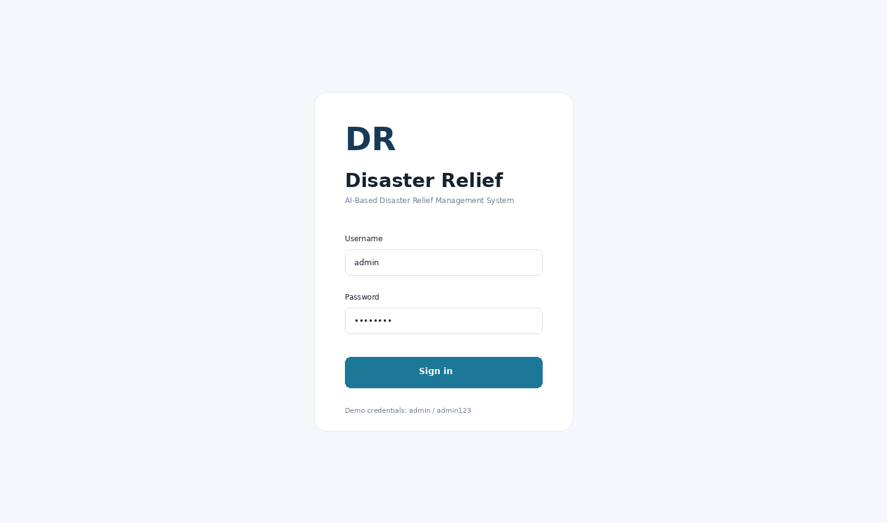

Figure 10. Operations dashboard .................................... 34
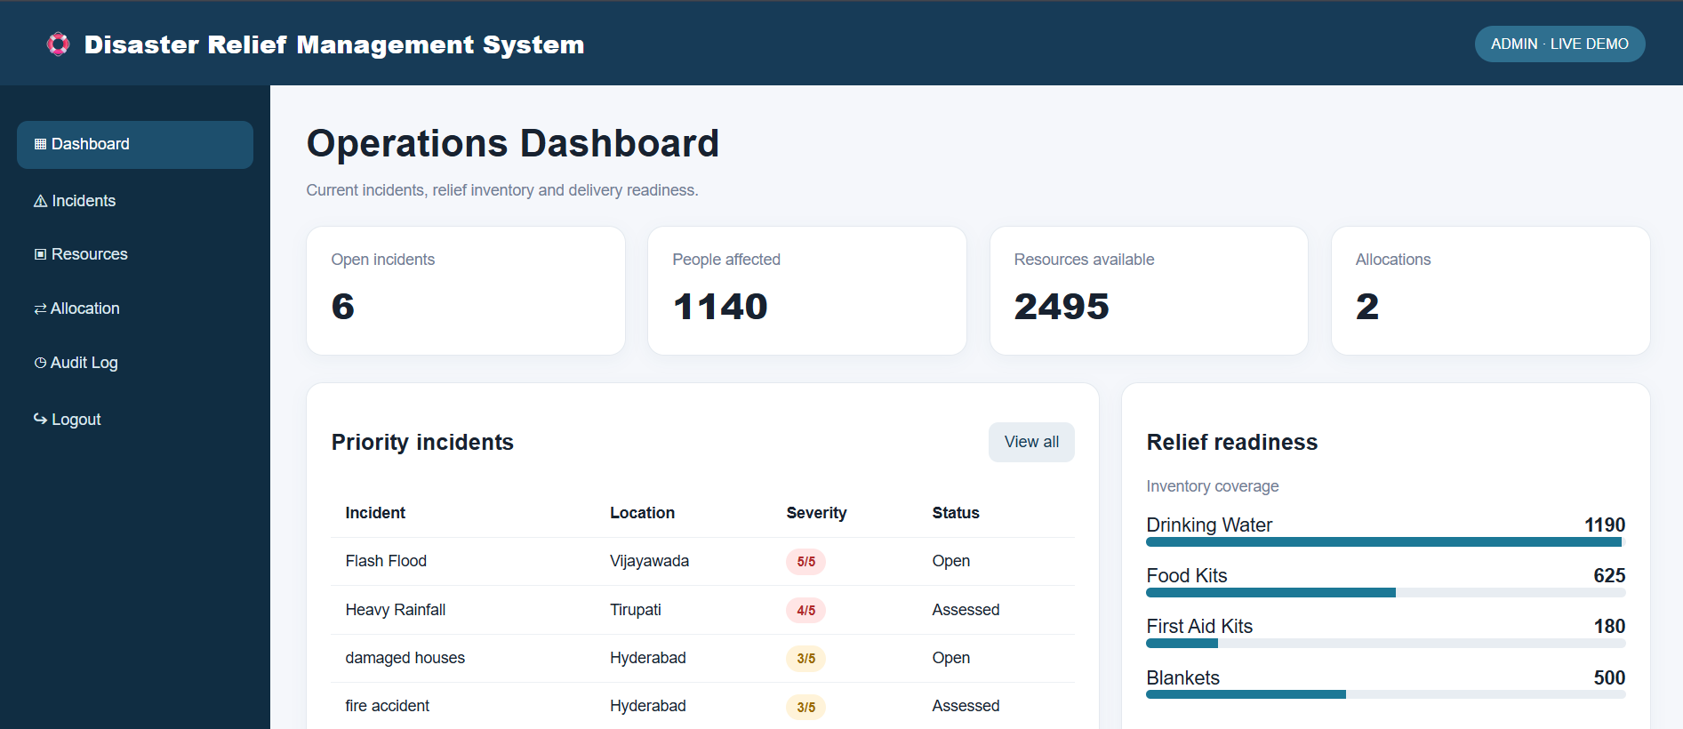
The dashboard consolidates the current demonstration indicators for open incidents, people affected, resources available and allocations. The priority-incidents table surfaces the incident title, location, severity and status, while the relief-readiness panel lists selected stock categories. These elements provide a quick overview before an operator moves into incident assessment or dispatch. The values shown are sample demonstration records, not verified live emergency statistics. In a production deployment, the summary cards should be calculated from the same persistent data source as the incident and inventory tables, and the resource total should not add quantities with incompatible units.

Figure 11. Incident management .................................... 35
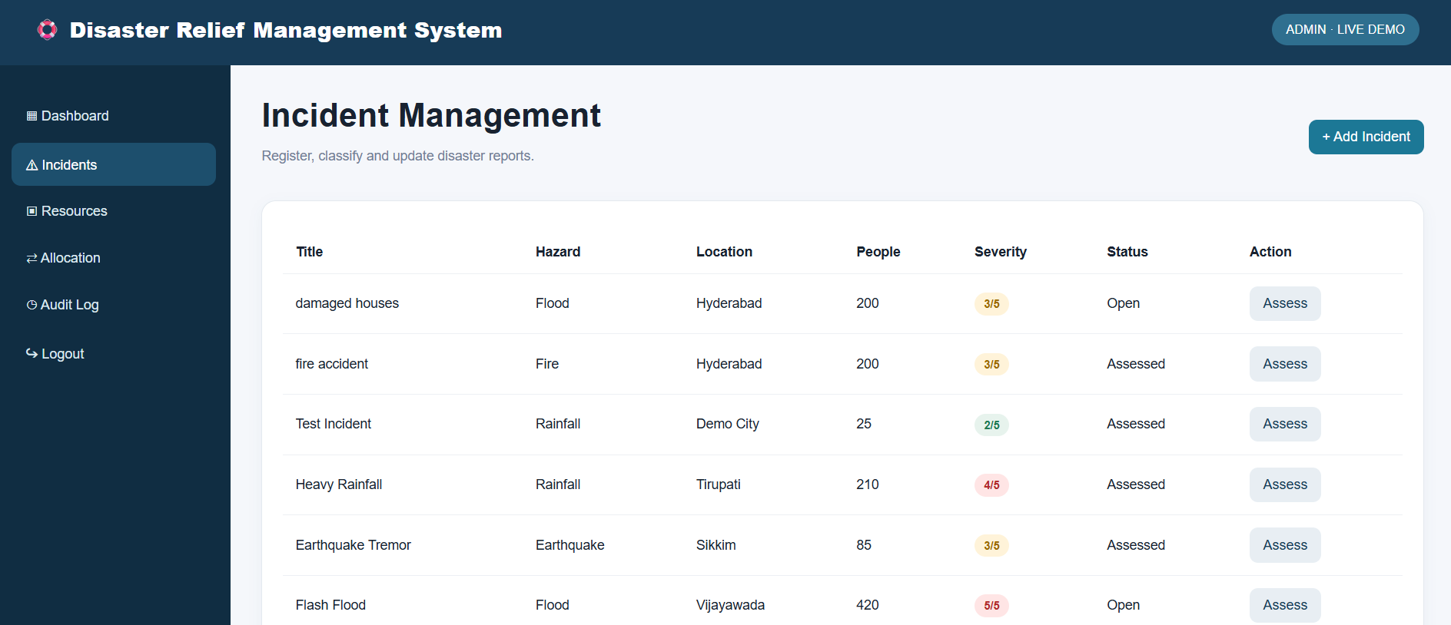
The incident-management view presents each report with a title, hazard category, location, affected-person count, severity rating, status and an Assess action. The fields make it possible to scan the list and identify incidents that require attention. The current screenshot documents the visible interface; it does not alone prove that all server-side validations are enforced. A production version should validate required fields and numeric ranges, maintain defined status transitions, and retain an incident identifier, source, timestamps and verification notes so that updates can be audited.

Figure 12. Resource inventory .................................... 35
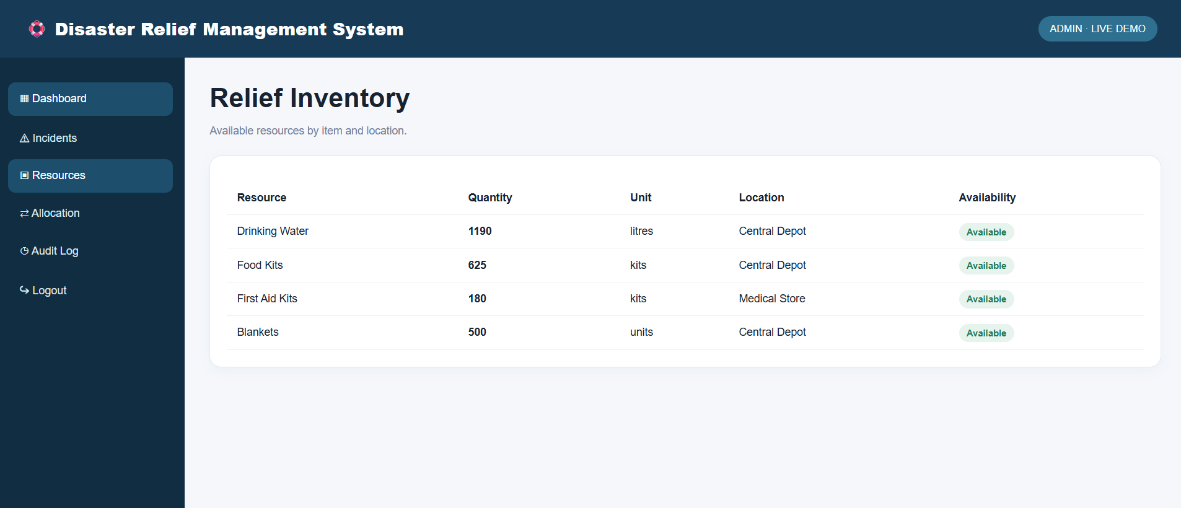
The inventory view shows the relief item, quantity, unit, storage location and availability state. Explicit units are important because litres of water, food kits, first-aid kits and individual blankets cannot be added or compared as if they were interchangeable. Each item should have a stable resource identifier and a current stock balance. In a deployed system, receipts, reservations, dispatches, returns and corrections should be recorded as stock movements. The available quantity should be calculated consistently and refreshed after a confirmed dispatch.

Figure 13. Allocation and dispatch .................................... 36
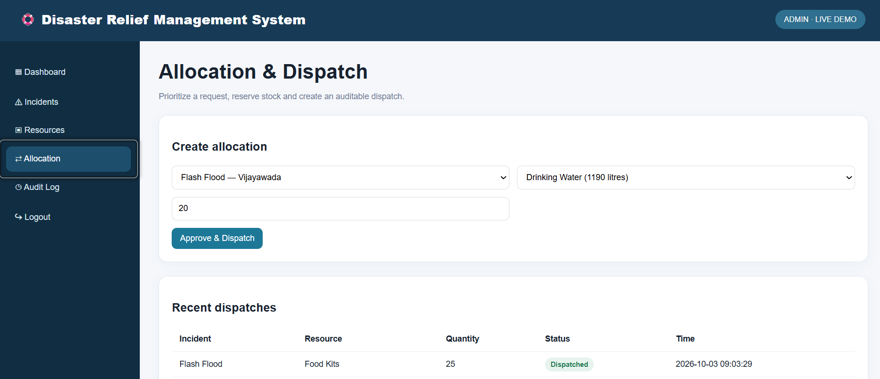
The allocation interface connects a selected incident with a resource item and a requested quantity. The recent-dispatches table provides a compact record of earlier allocations, including status and time. Before approval, the backend should verify that the incident and resource exist, the requested quantity is positive, the unit is compatible and enough unreserved stock remains. The dispatch record, stock movement, balance update and audit event should be committed in one database transaction to avoid partial updates or overselling when multiple coordinators act at once.

Figure 14. Audit trail .................................... 36
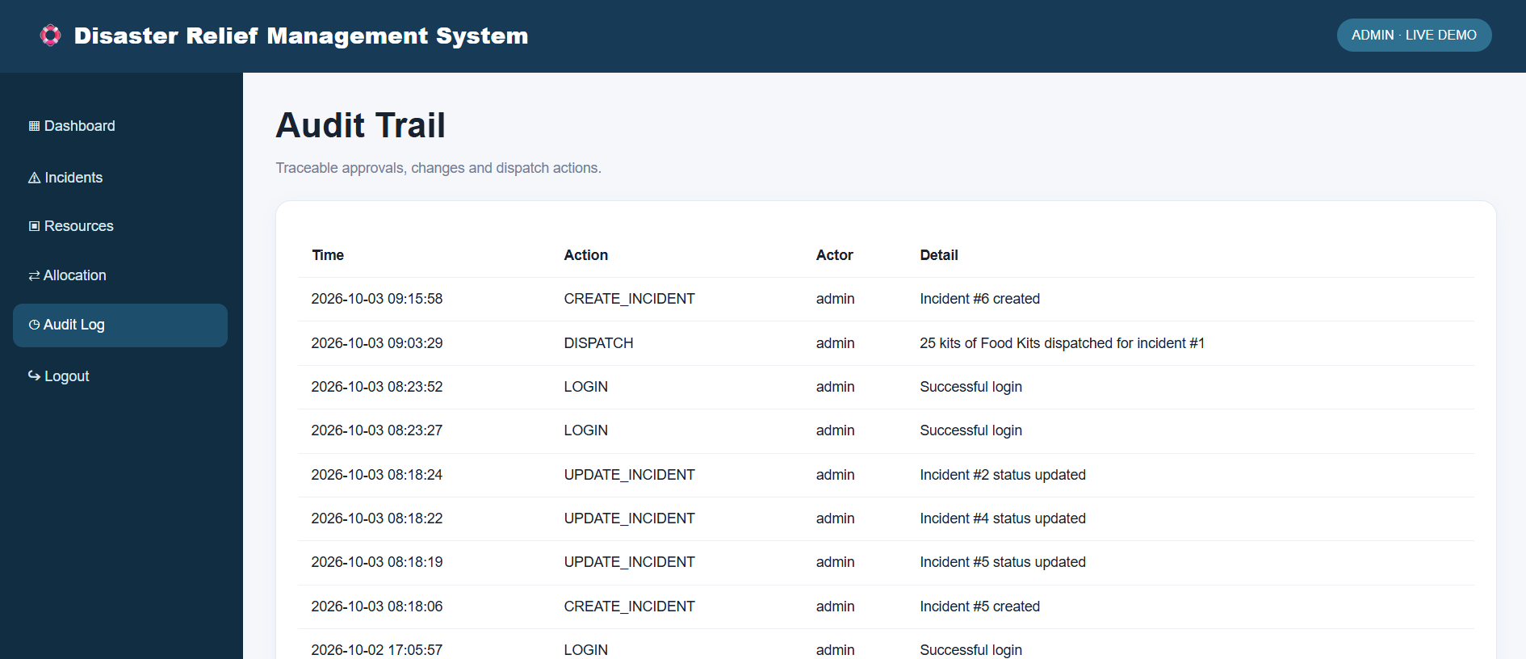
The audit-trail screen displays the time, action, actor and detail associated with operational events such as login, incident creation, status updates and dispatch. This history supports accountability and helps a supervisor reconstruct what happened during a response. In a production system, audit events should be generated by the trusted backend, reference stable record identifiers, use system-generated timestamps and be protected from ordinary modification. Audit details should not contain passwords, session tokens or unnecessary personal information. Retention and access to audit records should follow an approved policy.

Figure 15. Incident creation confirmation .................................... 37
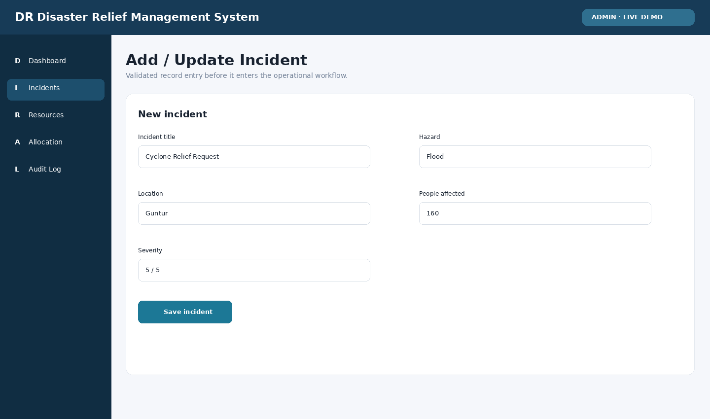
The incident-creation confirmation represents the point at which an operator receives feedback after submitting a new report. A confirmation should appear only after the application validates the submitted fields and the save operation succeeds. If a required value is missing, the interface should identify the field that needs correction without creating a partial record. If the backend or database is unavailable, the user should see a failure message rather than a success notification. For reliable operation, the created incident should receive a stable identifier and server-generated creation timestamp, and the audit trail should record the actor and creation action. After confirmation, the new incident should appear in the incident register and the dashboard should refresh its summary from the persisted record. The operator should be able to reopen the record and verify the saved hazard, location, affected-person count, severity and initial status. This screenshot documents the confirmation state; persistence, validation and audit behavior must still be verified with functional tests.
• Required fields are validated before submission.
• The success message appears only after a confirmed save.
• A stable incident ID and creation timestamp are assigned.
• The incident is visible in the register after refresh.
• A corresponding audit event is available to authorized reviewers.

APPENDIX D. REVIEW-TO-REPORT TRACEABILITY
Review requirement/topic | Report location
Review 1/2: problem, need, objectives, benefits and modules | Chapters 1 and 3.
Review 2: feasibility, database tables, novelty and future scope | Chapters 6, 7 and 13.
Review 3: problem identification and data sources | Chapters 2 and 4.
Review 3: preprocessing, system design and technology selection | Chapters 4, 5 and 7.
Review 3: implementation steps and module implementation | Chapters 5 and 9.
Review 3: testing, validation, deployment and maintenance | Chapters 10 and 12.
Review 4: objectives and development approach | Chapters 3 and 5.
Review 4: implementation and architecture | Chapters 7 and 9.
Review 4: screens and functional results | Chapter 9 and Appendix C.
Review 4: testing and performance analysis | Chapters 10 and 11.
Review 4: conclusion and future scope | Chapters 13 and 14.
Review 1/2: system feasibility and technology selection | Sections 5.5, 6.3 and 12.2.
Review 2: data entities and relational consistency | Sections 6.1–6.6 and Appendix B.
Review 3: data cleaning and missing-value handling | Sections 4.3–4.6.
Review 3: implementation sequence and workflow | Sections 5.6–5.8 and Appendix A.
Review 4: insufficient-stock rejection | Sections 8.3, 10.4 and Appendix E.
Review 4: audit event completeness | Sections 8.5, 9.6, 10.5 and Appendix E.
Review 4: new UI screenshots | Figures 10–14 in Appendix C.
Operational integrity: concurrent dispatch | Sections 8.4 and Appendix E.5.
Operational readiness: backup and recovery | Section 12.5 and Appendix F.4.
Data quality and privacy controls | Sections 4.7, 12.3 and Appendix G.
Service-level and evaluation measures | Sections 11.2–11.6 and Appendix H.
Inventory reconciliation procedure | Appendix I.
Documentation integrity note: This report differentiates the implemented portable demo from the target architecture and planned enhancements. Any future submission edits should preserve that distinction and add only verified implementation details or measured results. The traceability matrix is intended to help reviewers distinguish source-supported implementation evidence from design recommendations. A feature is marked as implemented only where the supplied demo materials or current interface support that statement. Performance values are retained as values reported in the project review and are not presented as independently reproduced measurements. Planned integrations, predictive models, offline synchronization and production-grade access controls remain future work until their code and tests are available.

APPENDIX E. EXTENDED VALIDATION AND ACCEPTANCE PROTOCOL

E.1 Purpose of the Protocol
This appendix defines a repeatable validation protocol for the incident, inventory, allocation and audit workflow. It complements the functional test cases in Chapter 10 by specifying preconditions, actions, evidence and acceptance rules. A test is considered passed only when the actual result matches the expected result in the recorded build. Screenshots of a control alone are not evidence that server-side validation or persistence is correct.

E.2 Incident Lifecycle Validation
Start with a clean test dataset and create incidents that cover the allowed severity range, multiple hazard types, different locations and zero or positive affected-person counts. Verify that required fields cannot be omitted, numeric fields reject invalid values, and status changes follow the defined lifecycle. Attempt an invalid transition through both the interface and the API. Confirm that the rejected request leaves the original record unchanged and that any required audit event records the attempt without storing sensitive input.

E.3 Inventory Reconciliation
For each resource, record the opening balance, unit, location and any reservations. Apply one receipt, one valid dispatch, one cancelled dispatch and one authorized adjustment. Recalculate the expected closing balance independently and compare it with the application. The ledger and displayed quantity must agree. A cancelled dispatch should release a reservation or reverse a prior movement according to the implemented state, but it must not silently erase the historical event. Record the reason for manual adjustments.

E.4 Boundary and Negative Tests
The minimum negative suite should include an empty resource identifier, unknown incident identifier, zero quantity, negative quantity, a quantity larger than available stock, a non-numeric value, an excessive text length, an invalid severity and a request made by a user without permission. For each case, capture the request, response, visible message and before/after database state. Verify that errors do not expose SQL, filesystem paths, credentials, stack traces or session tokens.

E.5 Concurrent Dispatch Test
Seed a resource with a known balance, then submit two dispatch requests at nearly the same time whose combined quantity exceeds that balance. The accepted total must never exceed available stock. Repeat the test with different request ordering and with a simulated retry. If the implementation supports idempotency keys, a repeated key should return the original outcome instead of creating a second dispatch. Save database snapshots or query output that demonstrates the final balance and event count.

E.6 Audit Completeness Test
Perform login, create incident, update incident, dispatch resource, reject an invalid dispatch and log out. Verify that every action designated as auditable has a corresponding record with actor, timestamp, action, target and outcome. Check that timestamps are generated consistently and that records remain available after application restart. Attempt to edit or delete an audit record using an ordinary application account; the request should be denied.

E.7 Acceptance Decision
The release should be accepted only when all critical integrity and authorization tests pass, no unresolved defect can overspend stock or erase audit history, and failures are communicated without falsely reporting success. Non-critical interface defects may be recorded for a later release if they do not obscure information or prevent task completion. The test report should identify the build, environment, database migration version, execution date, tester and evidence location.

APPENDIX F. OPERATIONAL SCENARIOS AND HANDOVER CHECKLIST

F.1 Scenario: Flash Flood with Urgent Water Requirement
A coordinator receives a report of a flash flood and records the affected location, approximate number of people and severity. The report remains an estimate until verified by the responsible field team. The coordinator checks available drinking water and confirms the unit and depot. The requested amount is reviewed against other outstanding reservations before dispatch. Once authorized, the system records the dispatch and reduces the available balance. The audit trail should make the actor, time, quantity and incident reference recoverable for later reconciliation.

F.2 Scenario: Inventory Shortage
If the requested quantity exceeds the available balance, the system should reject the dispatch without partially changing the inventory. The operator should see the quantity available and may reduce the request, choose another depot or escalate the shortage. A failed request should not create a successful dispatch record. If failed attempts are audited, the log should record the outcome and a safe reason, not unnecessary personal information.

F.3 Scenario: Duplicate or Overlapping Incident
Two reports may describe the same flood or fire from different sources. The system should not automatically delete one report based only on matching titles or locations. It can flag potential duplicates using normalized text, hazard, location and time window, then require a coordinator to compare the evidence. If reports are merged, retain a link to the source records and record the actor, time and reason so that the original observations remain traceable.

F.4 Scenario: Network or Database Failure
If the API or database becomes unavailable during dispatch, the interface must not show a success message until the transaction is confirmed. It should present a clear failure state and allow the operator to check the dispatch history before retrying. An idempotency mechanism helps prevent duplicate delivery records when a response is lost after a transaction has committed. Recovery procedures should define who can reconcile paper or offline records once the service returns.

F.5 Operator Handover
At shift handover, the outgoing coordinator should summarize high-severity open incidents, outstanding resource reservations, pending dispatches, unresolved stock discrepancies and recent system failures. The incoming coordinator should acknowledge the handover and confirm the current data timestamp. A handover note should avoid unnecessary personal details and should reference incident IDs rather than relying only on informal titles.

F.6 Pre-Deployment Checklist
Before a real pilot, confirm that the application is served over HTTPS, secrets are outside source control, default credentials have been removed, user roles are tested, stock updates are transactional, audit records are protected, backups can be restored and monitoring alerts reach a responsible operator. Confirm that the application owner, database owner, incident-data owner and support contact are documented. Complete a tabletop exercise before connecting to real operational data.

F.7 Handover and Support Records
The handover package should include a versioned release artifact, setup instructions, environment-variable names without secret values, database migration steps, backup/restore instructions, known limitations, a test report and a contact for incident escalation. Operational staff should know how to distinguish a demonstration dataset from current verified data and how to report a suspected stock discrepancy or unauthorized change.

APPENDIX G. DATA QUALITY, GOVERNANCE AND PRIVACY

G.1 Data Ownership and Source Provenance
Every operational dataset should have a named owner who is responsible for its meaning, update frequency and correction process. Incident records should distinguish information reported by a caller, information imported from an official source and information verified by a field team. Useful provenance fields include source type, source reference, reported time, recorded time, verification state and the identity or role of the reviewer. Imported alerts should retain their source and retrieval timestamp so that a later review can determine whether the alert was current when the decision was made.

G.2 Data Quality Dimensions
Completeness measures whether required fields are present. Validity checks whether values follow the accepted format and range. Consistency checks whether related records agree—for example, whether a dispatch refers to an existing incident and resource. Timeliness measures whether the information is sufficiently current for a decision. Uniqueness helps identify duplicate records, while provenance explains where a value came from. These dimensions should be checked separately because a record can be complete but outdated, or valid in format but inconsistent with another record.

G.3 Duplicate and Conflicting Reports
Potential duplicate incidents can be identified using a combination of normalized title, hazard type, location and time window. Similarity should create a review flag rather than automatically deleting a record. Two reports from the same location may refer to separate events, while one event may be described using different names. If a coordinator links or merges records, the system should preserve the source identifiers, record the reason and actor, and ensure that affected-person totals are not double-counted without an explicit policy.

G.4 Personal and Sensitive Information
The incident workflow should collect only the personal information necessary for response coordination. Public dashboards should normally use aggregated counts rather than names, phone numbers or detailed vulnerability information. Access to sensitive records should be role-limited and logged. Export files should be reviewed before sharing, and test data should use synthetic identities. A retention schedule should define which records must be retained for accountability and which personal details can be removed or anonymized after their operational purpose has ended.

G.5 Data Correction and Reconciliation
Corrections should be made through an explicit workflow rather than silently overwriting values. A correction should identify the affected record, old and new values where appropriate, reason, actor and timestamp. Inventory reconciliation should compare the recorded balance with a physical count or an authorized stock statement. Differences should be investigated and recorded as adjustments, not hidden by directly changing the quantity. Incident corrections should preserve enough history to explain why the current record differs from the original report.

G.6 Governance Review Checklist
Before operational use, confirm that every field has a documented meaning, each controlled list has an owner, timestamps use a consistent timezone, imported information retains provenance, duplicate handling is reviewable, personal data is minimized, and corrections are traceable. Assign responsibility for resolving conflicting reports and stock discrepancies. Review these controls whenever a new data source, user role or automated recommendation is introduced.

APPENDIX H. OPERATIONAL METRICS, SERVICE LEVELS AND RISK REVIEW

H.1 Defining Operational Metrics
A metric is useful only when its definition and data source are explicit. Incident response time can be measured from the first recorded report to the first verified assessment, while dispatch lead time can be measured from approval to recorded dispatch. Stock accuracy can compare the system balance with a verified physical count. Audit completeness can measure the proportion of critical actions that contain every required audit field. Each metric should state its time window, excluded records, units and owner so that different reporting periods can be compared fairly.

H.2 Service-Level Targets
Service-level targets should be agreed after measuring the application under a defined environment. For example, the team may set a target for the percentage of common page requests completed within a specified response time, the maximum acceptable recovery time after a service failure, and the recovery point represented by the most recent successful backup. The report should not invent measured performance values. Targets belong in the deployment plan until tests provide evidence that the application meets them.

H.3 Suggested Operational Dashboard Indicators
Useful indicators include open high-severity incidents, incidents awaiting assessment, dispatches awaiting approval, deliveries awaiting confirmation, resources below a reorder threshold, unresolved stock discrepancies and the time of the latest successful data refresh. The interface should display the meaning of each count and its time window. If data is stale or unavailable, the dashboard should show that condition clearly instead of presenting old values as current. Metrics should avoid summing quantities measured in unrelated units.

H.4 Risk Review and Escalation
A risk review should identify the event, its likelihood, its consequence, the preventive control, the person responsible and the evidence that the control works. High-priority risks include an unauthorized dispatch, a balance becoming negative, duplicate dispatch after a network retry, incorrect incident prioritization, loss of audit history and failure to restore a backup. A defined escalation path should identify who is contacted when a control fails and how a manual fallback is documented while the application is unavailable.

H.5 Human Review of Recommendations
Severity scores, rule-based priorities and future AI-generated recommendations should be treated as decision support rather than unquestionable instructions. The operator needs to see the reason for a recommendation, the data used and any uncertainty or missing information. A human reviewer should be able to override a recommendation with a recorded reason. The system should monitor whether recommendations systematically disadvantage a location or group, and the team should be able to disable an automated feature if its inputs become unreliable.

H.6 Release Readiness Review
Before release, verify that the documented requirements map to tests, the critical tests have passed, unresolved defects have an owner, the deployment configuration is versioned, secrets are managed outside source control, backups are restorable, the support contact is known and the rollback procedure is tested. The release note should identify changes to business rules, schema migrations and known limitations. After deployment, review errors and stock discrepancies during an agreed observation period before treating the release as stable.

APPENDIX I. INCIDENT AND INVENTORY RECONCILIATION WORKSHEET

I.1 Purpose and Frequency
Reconciliation compares the application’s recorded state with an independently verified source. Incident reconciliation confirms that high-priority reports are current, not duplicated without review, and have a clear owner and status. Inventory reconciliation confirms that the quantity recorded by the system agrees with the physical count or an authorized depot statement. The frequency should reflect operational risk: high-turnover relief items may need checks at each shift or dispatch handover, while slower-moving items may follow a scheduled cycle count. Any mismatch affecting an active emergency allocation should be escalated immediately.

I.2 Incident Review Worksheet
For each high-priority incident, the reviewer should confirm the incident identifier, title, hazard, location, report source, first-reported time, latest verification time, affected-person estimate, severity, status and assigned coordinator. If the estimate changes, record the new value and the reason for the revision. If a report is considered a duplicate, preserve its source record and link it to the incident selected as the primary record. If an incident is resolved, record the basis for closure and any outstanding needs that must be transferred to another response team.

I.3 Inventory Review Worksheet
For each selected resource, record the resource identifier, item name, unit, depot, system balance, physical count, reserved quantity and available quantity. Check that the physical count and system balance use the same unit and that packaged items are counted consistently. Review recent receipts, dispatches, cancellations, returns and adjustments. Do not silently overwrite a difference. Create an authorized stock adjustment with a reason and reference, then verify that the balance and stock-movement history reconcile after the adjustment.

I.4 Reconciliation Record
The reconciliation record should be dated and attributable. It should identify the reviewer, the source used for comparison, the records checked, the discrepancy, the corrective action and the person responsible for follow-up. Where the discrepancy cannot be resolved immediately, mark the affected quantity or incident field as under review and prevent the uncertain value from being treated as confirmed. Keep a record of the next review deadline and close the discrepancy only after the corrected state has been independently checked.

I.5 Reconciliation Fields and Expected Actions
Record type | Check | If mismatch is found | Evidence to retain
Incident | Status, source, severity and latest verification | Assign owner; correct with reason; preserve original report | Incident ID, before/after values, reviewer and timestamp
Resource | System balance versus physical count | Pause uncertain allocation if necessary; investigate stock movements | Resource ID, unit, depot, count sheet and adjustment ID
Dispatch | Approved quantity versus stock movement | Reconcile transaction; check duplicate requests and retries | Dispatch ID, idempotency key if used, actor and event time
Audit | Critical action has actor, time, target and outcome | Investigate missing event; check application logs and transaction result | Audit ID, related record ID and protected diagnostic reference
External data | Source timestamp and verification state are present | Refresh from trusted source or mark information stale | Source name, retrieval time and verification note
I.6 Closure Criteria. A reconciliation item is closed only when the correction is authorized, the operational record is consistent with its supporting evidence, the audit trail contains the correction and the responsible reviewer confirms the result. Unresolved discrepancies should remain visible in the handover record rather than disappearing from the dashboard.

