# New Tables and Graphs

## Model Performance for Business X

|  |  |
| --- | --- |
| Metric | Value |
| MAE | 7495123.829848607 |
| RMSE | 9216698.84740932 |
| MAPE | 8.016500612548237 |

## Forecasted Revenue for Business X

|  |  |  |  |
| --- | --- | --- | --- |
| Date | Forecasted Revenue | Lower CI | Upper CI |
| 2023-01-31 00:00:00 | 154774464.2997536 | 134871332.09593707 | 174677596.50357014 |
| 2023-02-28 00:00:00 | 154761822.46907905 | 134824165.32719037 | 174699479.61096773 |
| 2023-03-31 00:00:00 | 154761857.8706281 | 134786586.7531699 | 174737128.98808628 |
| 2023-04-30 00:00:00 | 154761857.77149135 | 134749052.36582562 | 174774663.17715707 |
| 2023-05-31 00:00:00 | 154761857.771769 | 134711588.31717145 | 174812127.22636652 |
| 2023-06-30 00:00:00 | 154761857.7717682 | 134674194.13967633 | 174849521.4038601 |
| 2023-07-31 00:00:00 | 154761857.7717682 | 134636869.44406536 | 174886846.09947106 |
| 2023-08-31 00:00:00 | 154761857.7717682 | 134599613.8444598 | 174924101.69907662 |
| 2023-09-30 00:00:00 | 154761857.7717682 | 134562426.95853996 | 174961288.58499646 |
| 2023-10-31 00:00:00 | 154761857.7717682 | 134525308.40749905 | 174998407.13603738 |
| 2023-11-30 00:00:00 | 154761857.7717682 | 134488257.81599784 | 175035457.7275386 |
| 2023-12-31 00:00:00 | 154761857.7717682 | 134451274.81212077 | 175072440.73141566 |
| 2024-01-31 00:00:00 | 154761857.7717682 | 134414359.02733207 | 175109356.51620436 |
| 2024-02-29 00:00:00 | 154761857.7717682 | 134377510.09643313 | 175146205.4471033 |
| 2024-03-31 00:00:00 | 154761857.7717682 | 134340727.65752017 | 175182987.88601625 |
| 2024-04-30 00:00:00 | 154761857.7717682 | 134304011.35194296 | 175219704.19159347 |
| 2024-05-31 00:00:00 | 154761857.7717682 | 134267360.82426384 | 175256354.71927258 |
| 2024-06-30 00:00:00 | 154761857.7717682 | 134230775.7222177 | 175292939.82131872 |
| 2024-07-31 00:00:00 | 154761857.7717682 | 134194255.69667244 | 175329459.84686399 |
| 2024-08-31 00:00:00 | 154761857.7717682 | 134157800.40159005 | 175365915.14194638 |
| 2024-09-30 00:00:00 | 154761857.7717682 | 134121409.49398845 | 175402306.04954797 |
| 2024-10-31 00:00:00 | 154761857.7717682 | 134085082.63390373 | 175438632.90963268 |
| 2024-11-30 00:00:00 | 154761857.7717682 | 134048819.48435321 | 175474896.0591832 |
| 2024-12-31 00:00:00 | 154761857.7717682 | 134012619.7112989 | 175511095.83223754 |

## Model Performance for Business Y

|  |  |
| --- | --- |
| Metric | Value |
| MAE | 11805784.971716795 |
| RMSE | 14509861.285715168 |
| MAPE | 9.635187818144116 |

## Forecasted Revenue for Business Y

|  |  |  |  |
| --- | --- | --- | --- |
| Date | Forecasted Revenue | Lower CI | Upper CI |
| 2023-01-31 00:00:00 | 191747720.4074261 | 161171174.1802132 | 222324266.63463897 |
| 2023-02-28 00:00:00 | 190538947.0621047 | 159962347.17070824 | 221115546.95350116 |
| 2023-03-31 00:00:00 | 190725916.4778704 | 159778268.45380902 | 221673564.5019318 |
| 2023-04-30 00:00:00 | 190696996.612482 | 159485762.6338453 | 221908230.59111872 |
| 2023-05-31 00:00:00 | 190701469.85004687 | 159214132.69570035 | 222188807.0043934 |
| 2023-06-30 00:00:00 | 190700777.94315022 | 158942021.4810257 | 222459534.40527475 |
| 2023-07-31 00:00:00 | 190700884.96522242 | 158672659.58392277 | 222729110.34652206 |
| 2023-08-31 00:00:00 | 190700868.41137105 | 158405476.09754404 | 222996260.72519806 |
| 2023-09-30 00:00:00 | 190700870.97187084 | 158140495.6003938 | 223261246.34334788 |
| 2023-10-31 00:00:00 | 190700870.57582048 | 157877652.55790287 | 223524088.59373808 |
| 2023-11-30 00:00:00 | 190700870.63708034 | 157616897.92224693 | 223784843.35191375 |
| 2023-12-31 00:00:00 | 190700870.62760484 | 157358182.4013028 | 224043558.85390687 |
| 2024-01-31 00:00:00 | 190700870.6290705 | 157101458.9374392 | 224300282.32070178 |
| 2024-02-29 00:00:00 | 190700870.62884378 | 156846682.20490396 | 224555059.0527836 |
| 2024-03-31 00:00:00 | 190700870.62887886 | 156593808.5790503 | 224807932.67870742 |
| 2024-04-30 00:00:00 | 190700870.62887344 | 156342796.03938353 | 225058945.21836334 |
| 2024-05-31 00:00:00 | 190700870.62887427 | 156093604.08955878 | 225308137.16818976 |
| 2024-06-30 00:00:00 | 190700870.62887415 | 155846193.68087375 | 225555547.57687455 |
| 2024-07-31 00:00:00 | 190700870.62887418 | 155600527.14087224 | 225801214.11687613 |
| 2024-08-31 00:00:00 | 190700870.62887418 | 155356568.1063746 | 226045173.15137377 |
| 2024-09-30 00:00:00 | 190700870.62887418 | 155114281.4606465 | 226287459.79710186 |
| 2024-10-31 00:00:00 | 190700870.62887418 | 154873633.27439108 | 226528107.98335728 |
| 2024-11-30 00:00:00 | 190700870.62887418 | 154634590.75028512 | 226767150.50746325 |
| 2024-12-31 00:00:00 | 190700870.62887418 | 154397122.17080215 | 227004619.08694622 |

## Model Performance for Business Z

|  |  |
| --- | --- |
| Metric | Value |
| MAE | 9686370.248759618 |
| RMSE | 13003541.319535378 |
| MAPE | 13.168785772621172 |

## Forecasted Revenue for Business Z

|  |  |  |  |
| --- | --- | --- | --- |
| Date | Forecasted Revenue | Lower CI | Upper CI |
| 2023-01-31 00:00:00 | 119381997.81138061 | 92850189.77559274 | 145913805.84716848 |
| 2023-02-28 00:00:00 | 119283518.50215214 | 92749895.13514352 | 145817141.86916077 |
| 2023-03-31 00:00:00 | 119284407.42526351 | 92745041.43906659 | 145823773.41146043 |
| 2023-04-30 00:00:00 | 119284399.40140241 | 92739336.90924528 | 145829461.89355955 |
| 2023-05-31 00:00:00 | 119284399.47382978 | 92733641.29373424 | 145835157.65392533 |
| 2023-06-30 00:00:00 | 119284399.473176 | 92727946.83037068 | 145840852.1159813 |
| 2023-07-31 00:00:00 | 119284399.4731819 | 92722253.58842775 | 145846545.35793605 |
| 2023-08-31 00:00:00 | 119284399.47318184 | 92716561.56648824 | 145852237.37987545 |
| 2023-09-30 00:00:00 | 119284399.47318184 | 92710870.76377386 | 145857928.18258983 |
| 2023-10-31 00:00:00 | 119284399.47318184 | 92705181.17950144 | 145863617.76686224 |
| 2023-11-30 00:00:00 | 119284399.47318184 | 92699492.81288868 | 145869306.133475 |
| 2023-12-31 00:00:00 | 119284399.47318184 | 92693805.66315414 | 145874993.28320956 |
| 2024-01-31 00:00:00 | 119284399.47318184 | 92688119.72951716 | 145880679.21684653 |
| 2024-02-29 00:00:00 | 119284399.47318184 | 92682435.01119797 | 145886363.9351657 |
| 2024-03-31 00:00:00 | 119284399.47318184 | 92676751.50741762 | 145892047.43894607 |
| 2024-04-30 00:00:00 | 119284399.47318184 | 92671069.21739796 | 145897729.72896573 |
| 2024-05-31 00:00:00 | 119284399.47318184 | 92665388.14036173 | 145903410.80600196 |
| 2024-06-30 00:00:00 | 119284399.47318184 | 92659708.27553242 | 145909090.67083126 |
| 2024-07-31 00:00:00 | 119284399.47318184 | 92654029.62213443 | 145914769.32422924 |
| 2024-08-31 00:00:00 | 119284399.47318184 | 92648352.17939293 | 145920446.76697075 |
| 2024-09-30 00:00:00 | 119284399.47318184 | 92642675.94653395 | 145926122.99982974 |
| 2024-10-31 00:00:00 | 119284399.47318184 | 92637000.92278431 | 145931798.02357936 |
| 2024-11-30 00:00:00 | 119284399.47318184 | 92631327.10737169 | 145937471.838992 |
| 2024-12-31 00:00:00 | 119284399.47318184 | 92625654.49952456 | 145943144.44683912 |

## Plot: Business X

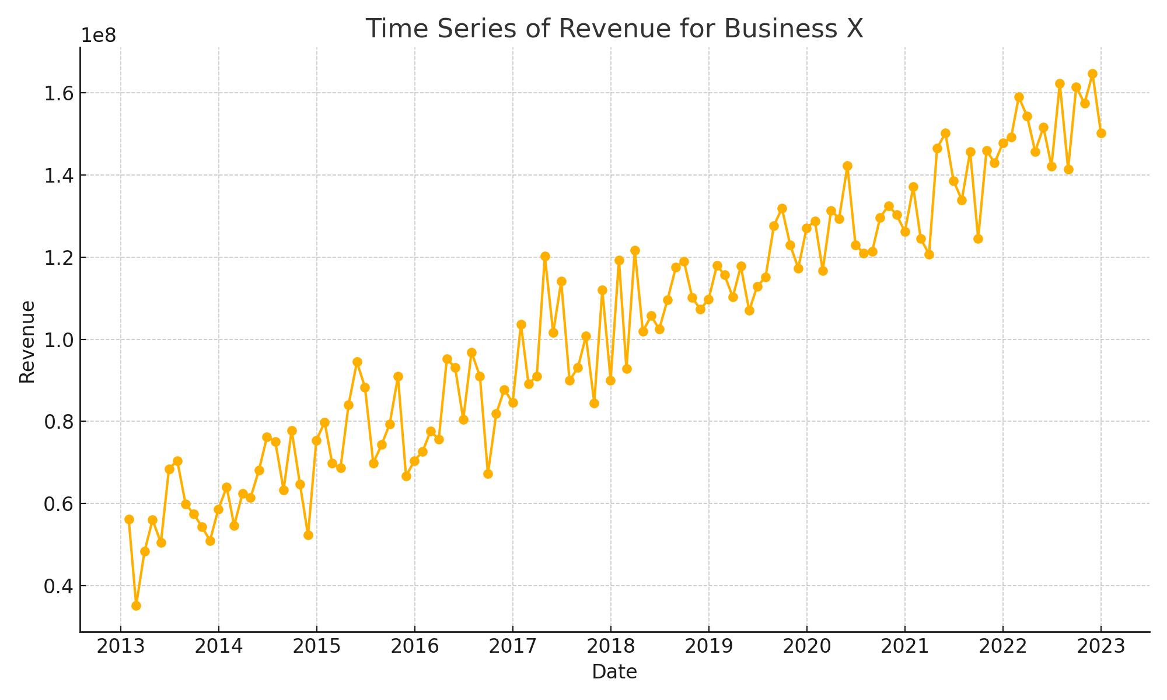

## Plot: Business X

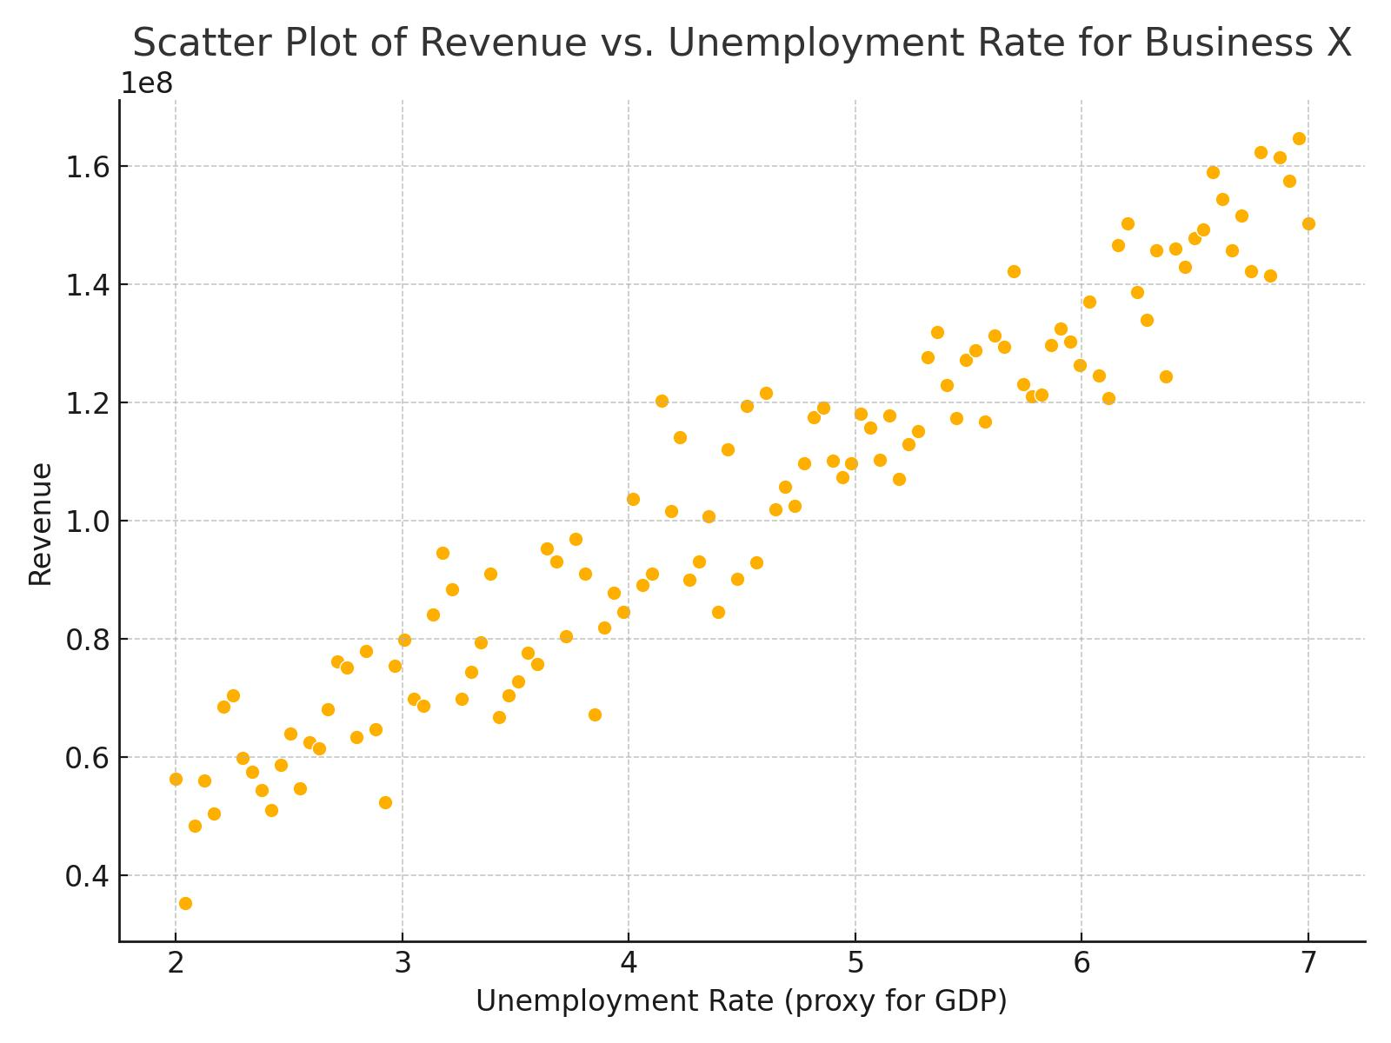

## Plot: Business Y

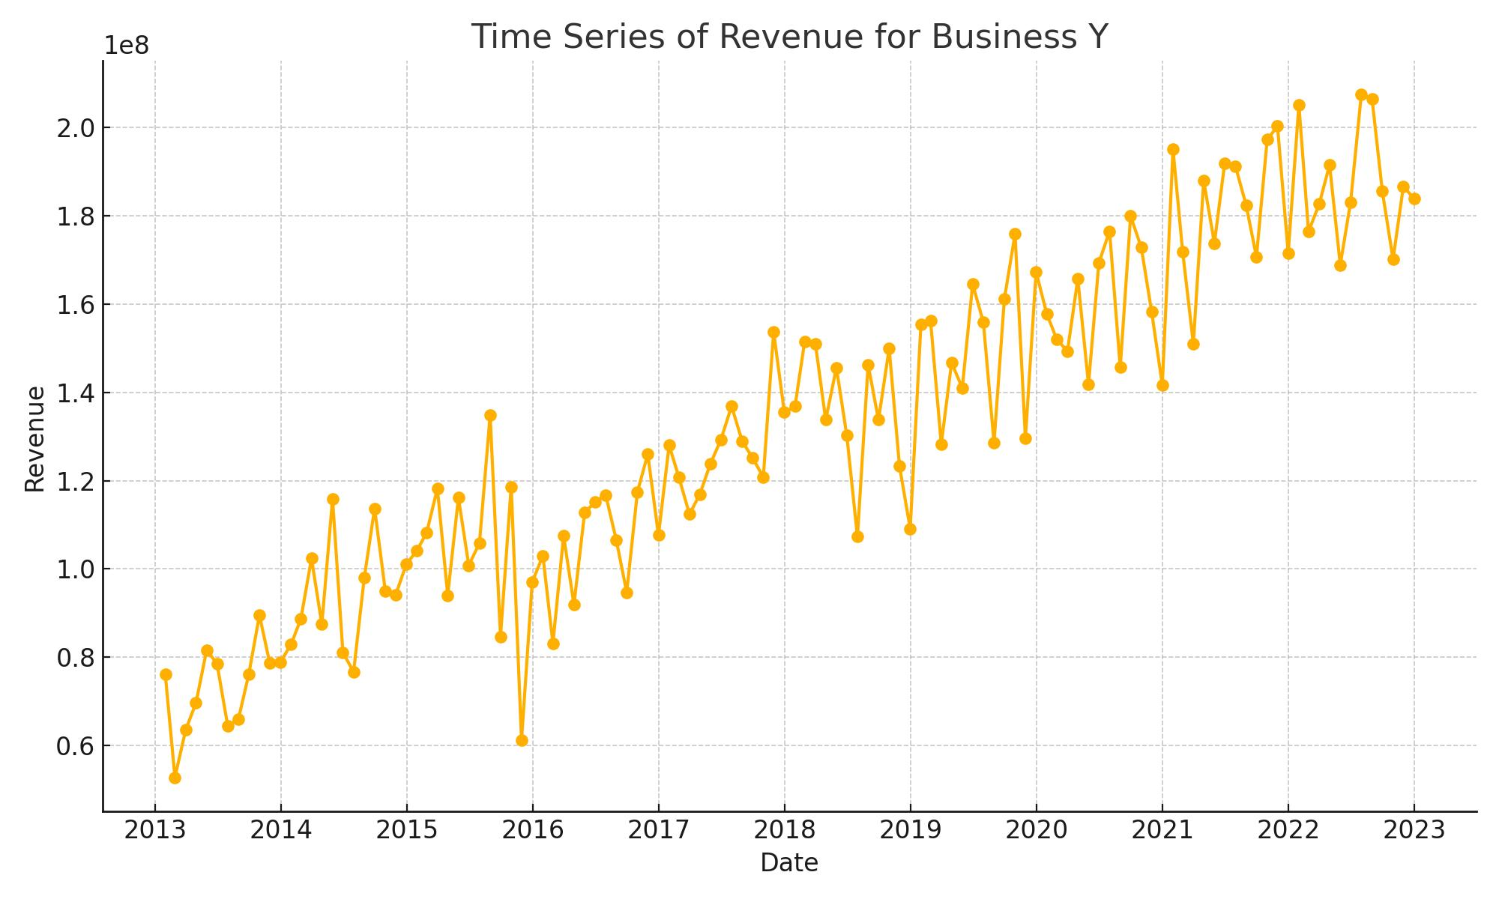

## Plot: Business Y

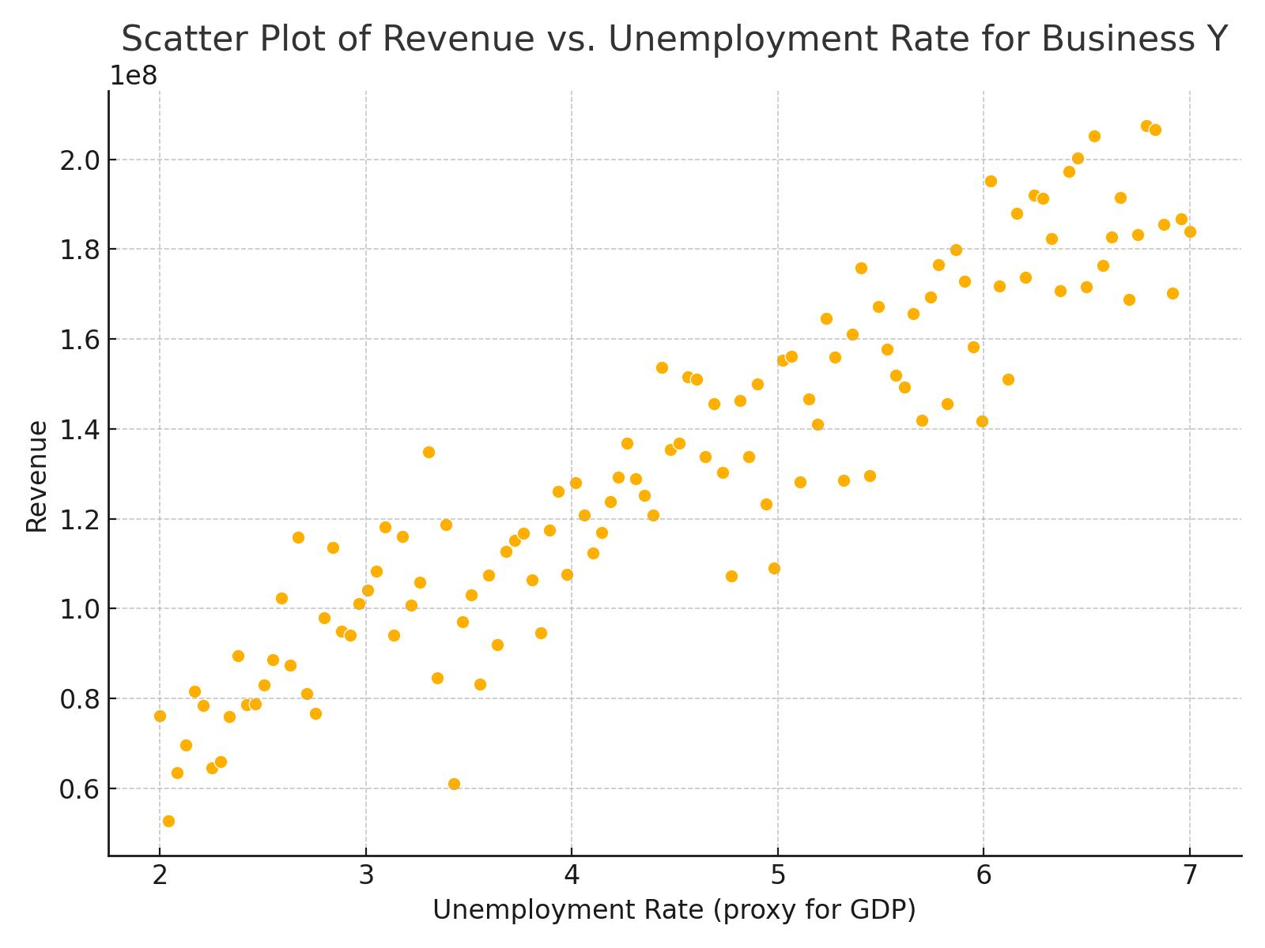

## Plot: Business Z

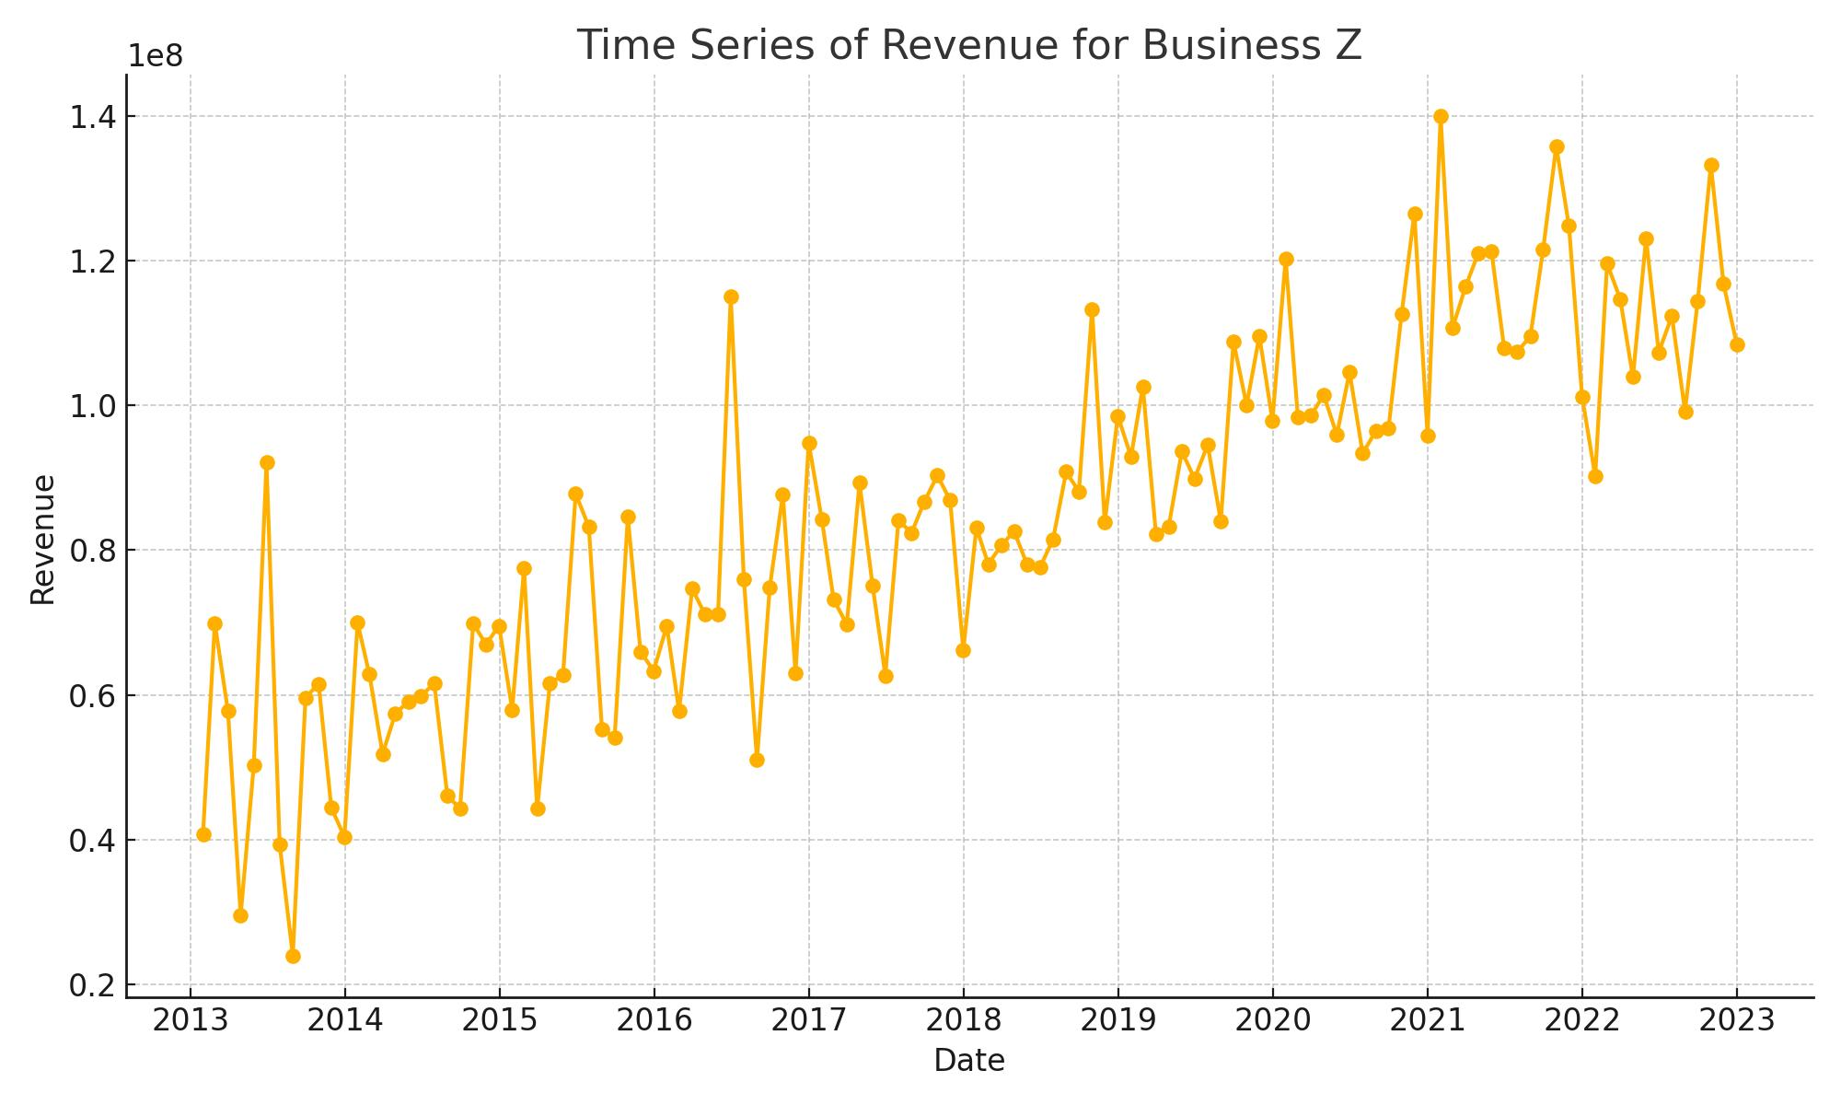

## Plot: Business Z

