

gOpenMol User Guide

Minna Varis 2003
Table of contents
1. Preface 2
2. Introduction 3
3 Description of the menus 6
3.1 File 6
3.2 Edit 13
3.3 View 17
3.4 Calculate 20
3.5 Plot 22
3.6 Trajectory 30
3.7 Run 35
3.8 Tools 37
3.9 Help 39
4. Advanced examples for how to use gOpenMol 40
4.1 Mapping of a contour on a surface 40
4.2 How to glue a surface to certain coordinates. 41
4.3 How to create Connolly type surfaces with the program ProbeSurf 42
4.4 How to trace atoms using Trajectory > Trace 45

1. Preface

The idea to write this handbook came after the web pages for gOpenMol had been updated in the summer 2003 (http://www.csc.fi/gopenmol). The old manual was merely a collection of different help texts that were gathered from the program’s Help menus. Moreover, the old manual had become out-of-date because in autumn 2003 a new version (v. 2.20) of gOpenMol was released. Since I had updated the gOpenMol web pages and had probably the best overview of the program at that time, I was given the task to update the old manual.

This new handbook is intended to new gOpenMol users and many of the features have been given a more thorough description than what was given in the old manual. Hopefully experienced gOpenMol users will also find this new handbook useful. The program has been available for since the middle of the 1990’s. Thus, there is a large gOpenMol community, which shares thoughts and ideas about gOpenMol through their mailing list. To join the mailing list go to http://listserv.funet.fi/archives/gopenmol.html.

My thanks go to Leif Laaksonen, who has helped me in defining the purposes of some of the options and to Juha Haataja, who has helped in revising the language and guiding the process of making a consistent handbook.

Helsinki 3.9.2003
Minna Varis

2. Introduction

This chapter gives a short introduction to gOpenMol, its properties and functions.

The cube file format used by gOpenMol is .plt, if not stated otherwise. All imported data must first be converted to .plt format before they can be displayed in gOpenMol. The tools for these conversions are available in the menu Run. In almost all windows there are present buttons Apply, and Dismiss. Pressing Apply will execute the command, and Dismiss closes the window without change. If the operation needs input files, the names of the files can be typed into boxes reserved for input file names, but more often it is more convenient to click the button Browse and search for the file in that way.

gOpenMol is used through three windows with different properties. In the Graphics window (A) the molecules are displayed. The Graphical user interface (GUI) window (B) is used to control actions in the Graphics window. In the Text output window (C) the output text of executed commands is displayed.

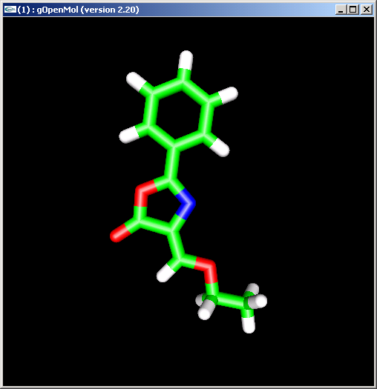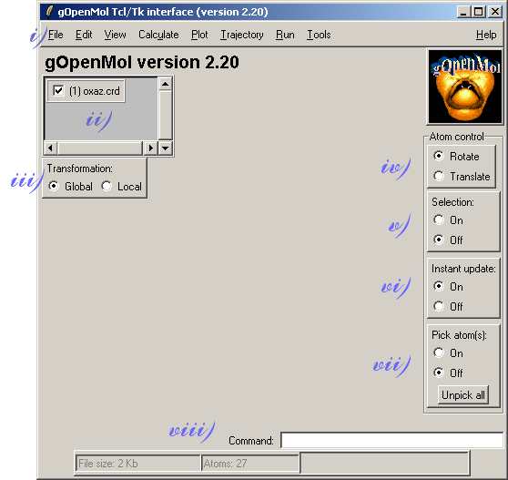

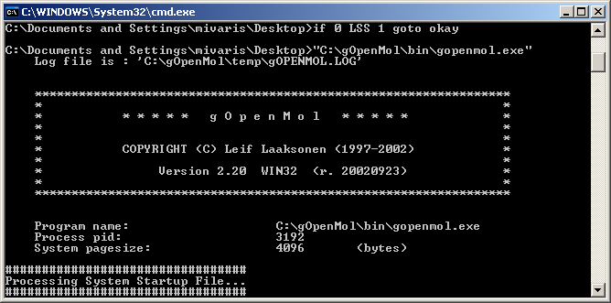
The GUI window (B) can be divided into several sections. In the figure above these sections are numbered and the explanations to the sections are listed below in numerical order.

- Menu bar
- List of structures loaded into gOpenMol
- Transformation: Global → applies the transformation to whole space.
Local → applies the transformation only to the selected atoms or structures.
- Rotate / Translate: when dragging with left mouse button (LMB) and radio button for Rotation is selected, the movement rotates the structure to the wanted direction. Marking of the radio button for Translation, the molecule is translated along Z-plane.
- Selection on/off: This is by default off, but if some specific movements or commands are applied to just a selected subset of atoms, selected through the option select, this must be turned on to be able to do the things a user wants to do.
- Instant update on/off: This option is a remainder of “the old times”. Previously, computers slowed down remarkably, if several heavy tasks were run at the same time, such as rotating a molecule and trying to display the molecule at the same time. By turning the “Instant update” off, a user could, e.g., rotate the molecule more rapidly, and check every now and then in which orientation the molecule was by pressing the gOpenMol logo at the upper right corner of the GUI window. With modern computers, though, this usually is not necessary, since they are powerful enough to cope with several tasks at the same time.
- Pick atoms on/off: Atoms can be picked and the atom info is displayed in the text output window (C), when the mouse is run over an atom.
- The command line interpreter, also a remainder of the old times. gOpenMol can also be run through command lines but, nowadays, the GUI is used for this purpose.

There are also some shortcut buttons included in the mouse and keyboard. Abbreviations used here are: LMB = the left mouse button, MMB = the middle mouse button, RMB = the right mouse button and Ctrl = the Control key.

- LMB rotates and translates the molecule depending on which radio button is selected, the one for rotation or the other for translation.
- Shift and LMB translates the molecule in the XY plane if the rotation mode is selected. If the Shift button is released before LMB, the translation mode will remain turned on. To get back to the rotation mode, just hold down Shift and click with LMB while holding the Shift-button down and then release the Shift-button.
- MMB rotates the molecule around the Z-axis. If no three-button-mouse is available Alt + LMB does the same job.
- RMB is used to zoom in and out of the molecule. To zoom in, hold RMB down and drag the mouse up. To zoom out hold RMB down and drag the mouse down.
- Ctrl pressed down and clicking with LMB is used to pick atoms for importing atom(s) into input windows. Press Ctrl down and click an atom you want to select with LMB. Keeping Ctrl down press LMB down above the selected atom and then drag that atom to a selection box with the mouse pointer To select several atoms, pick them one by one and finally take them into a selection box by holding the Ctrl key down and pressing LMB down above one of the selected atoms and dragging the mouse pointer to an atom selection box.
- To unpick atoms, hold down Ctrl and click the picked atom with LMB. Again, if you release Ctrl button before the mouse, this mode will remain turned on. To get back to the unpicking mode, hold down Ctrl and click with LMB and release Ctrl after you have clicked with LMB.

Sometimes rotating with the mouse can be rather crude. Molecules, which have to be rotated very precisely, can be rotated through the option Rotate/Translate in the menu Edit.

3 Description of the menus

This chapter reviews all the menus in gOpenMol menu bar and the operative functions these menus contain. The menus will be overviewed from left to right and functions belonging to a certain menu will be overviewed from top to bottom.

3.1 File

Open
Read in a previously saved .gom file. The file is an ascii file, which contains information about the molecular display at the time when the file was saved. Currently it will contain information about the atoms, rotation matrix, and contour data. There are still some options which will not be saved but eventually all the information will be saved to continue a session.

Save
Save current display information into the same .gom file.

Save as
Save the current display information into a new .gom file.

Import
Cluster…
Read in a pre-calculated cluster data for display. The cluster data has been calculated using the option Cluster in the menu Calculate.

Coords…
Import molecule coordinates into gOpenMol. The supported coordinate file formats are automatically recognized by the file extension. This option can be turned off by unpicking the box “Select file format by extension”. In this case the supported file formats are listed on the right hand side of the window and the proper file format can be selected by picking the radio button next to it. Click Browse to search the coordinate files. Use “Append structure” to import several structures into the same graphics window. If the box “Calculate connectivity” has not been selected, the program will not draw bonds between any atoms. The imported coordinate file can be viewed by clicking button Peek file before it is processed through the input filter.
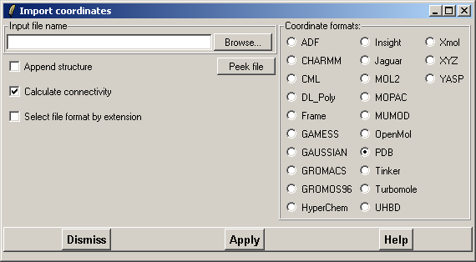

Figure 1: The window for importing coordinates after “Select file format by extension” has been marked off. If the box “Select file format by extension” is marked the coordinate format list on the right hand side will not be visible.

The supported file formats are:
ADF Amsterdam Density Functional program output log files.
CHARMM CHARMM coordinate (crd) file. For the format please look into your QUANTA/CHARMM documentation or the source code.
CML Chemical Markup Language coordinate file.
DL_Poly DL_Poly CONFIG coordinate file.
Frame The coordinates are taken from a trajectory file.
GAMESS The GAMESS PUNCH file (dat) containing the MOLPLT information produced with the MOLPLT=TRUE. option.
GAUSSIAN The coordinates are imported from a GAUSSIANXX formatted checkpoint file.
GROMACS GROMACS gro coordinate file.
GROMOS96 GROMOS96 coordinate data file.
GXYZ Simple xyz coordinate input format specific for gOpenMol.
HyperChem HyperChem input coordinate (hin) file.
Insight Insight coordinate (car) file.
Jaguar Jaguar output log file.
MOL2 Mol2 coordinate file format.
MOPAC Coordinates are imported from a MOPAC unformatted graphics output file.
MUMOD Coordinate format used by the MUMOD program.
OpenMol Formatted coordinate input file to OpenMol.
PDB The standard Brookhaven Protein Data Bank format.
Tinker The Tinker coordinate input format
Turbomole Turbomole coordinate file
UHBD University of Houston Brownian Dynamics (UHBD) qcd coordinate reader.
User User defined coordinate input reader.
Xmol Xmol coordinate file format. The file can contain multiple entries but gOpenMol reads only the first entry.
XYZ Xmol coordinate file format. The file can contain multiple entries but gOpenMol reads only the first entry.
YASP Coordinate input file to the YASP program by Dr. Florian Müller-Plathe.

In this list Chem3D and Spartan coordinate filters are not displayed. If the user has a coordinate file in either of these two coordinate formats, the filters can be turned on through Tools > DLL/SO plug-ins > Enable Chem3D/Spartan coordinate filter. After turning this filter on, these two coordinate formats will be displayed in the coordinate format list of the Import coordinates window.

Dict…
This facility imports a dictionary file. A dictionary file defines the mapping between a residue and atom name into the atom type space (and atom partial charge).

The dictionary file can look like the following:
*Atom dictionary file
ALA N 32 -0.35
ALA HN 1 0.25
ALA CA 10 0.00
ALA HA 3 0.10
ALA CB 10 -0.30

The dictionary file contains a residue name, an atom name and maps these into an atom type in the used force field (CHARMM in this case) and an atom partial charge. This is one of the possibilities to assign an atom type and an atom partial charge to the atoms.

GBasis…
Imports a Gaussian basis set for gOpenMol. There is one sample file named gbl_line_input.data in the data directory . This is a feature reserved for future purposes.

Vector data…
Import Atom vector data. gOpenMol can read in two types of vector data:
- CHARMm data which defines vector properties for atoms in a molecule. The file extension is .crd and the file format is the same as in the CRD files except that the vector directions are defined x, y and z.
- Vector file as a flat formatted text file which contains the vector information.
Tcl script…
With this function user can import, edit, and execute a Tcl/Tk script. After choosing this option, a “Read Tcl file” window opens. Choose the script you want to run by clicking Browse and open it. Before the script can be run, it is imported to a “Display/Edit Tcl script” window, where some last modifications can be done. Click Run Tcl/Tk script to execute. Close window by clicking Dismiss. If the script was modified before execution, it can be saved by clicking button Yes after Dismiss has been pressed. The program automatically asks if you want to save the script of not.

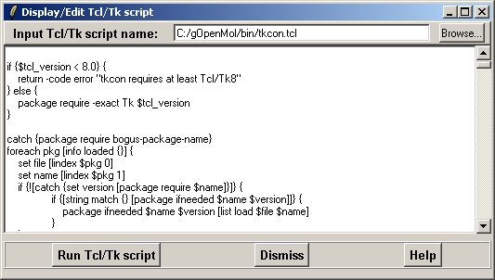

Figure 2: A screen capture of the Display/Edit Tcl/Tk script window, where a sample script is displayed.

Atom charges…
This function imports charges extracted from output files of programs Gaussian, Icon8 and Mopac. It is also possible to import atom charges from output files of a user defined program. From the output file of Gaussian Natural population analysis, Merz-Kollmann, and Chelpg charges can be extracted.

Export
Cluster…
A previously calculated cluster matrix can be exported from gOpenMol to be used by other programs, or to be read back to gOpenMol at a later time. The file will be saved as a .dat file.

Coords…
The coordinates of a selected structure can be exported to another file format. Only one structure can be converted at a time. Type the file name into the text field or select a previous file through Browse. To be sure into which directory the file is saved, click Browse and find the proper directory. The supported file types are: CHARMM, CML, OpenMol, PDB, Tinker, UHBD, VRML, and Xmol/XYZ. Mark the radio button next to the appropriate file format. The exported file format can be automated by marking the box “Select file format by extension” but this will export the structure in the same format as it was imported. The VRML file export facility is very crude. Currently it only supports line drawing, CPK and the licorice display styles.

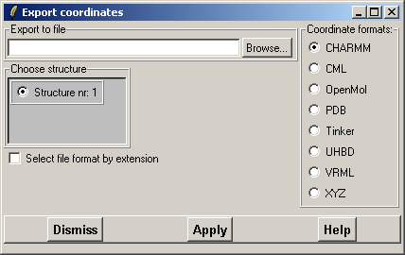

Figure 3: A screen capture of the Export coordinates window.

Correlation…
Writes a correlation data calculated during the time analysis in trajectory analysis for molecular dynamics trajectory files.

Input
Using this widget it is possible to export input files for programs GAMESS, ICON8, , MOPAC6, and Probesurf. There is also a possibility for user defined output rules through option User.
- User
User can make his or her own output rules by modifying the procedure lulMakeUSERinput in the gopenmolrc.tcl script in the data directory. To use this function, programming skills and knowledge of Tcl/Tk scripting language are required and, thus, this function is recommended only for experienced gOpenMol users.
- GAMESS (raw input)
- ICON8 Extended Huckel program (quite complete)
- Mopac6 (raw input)
- Probesurf, a Connolly type of program (complete)

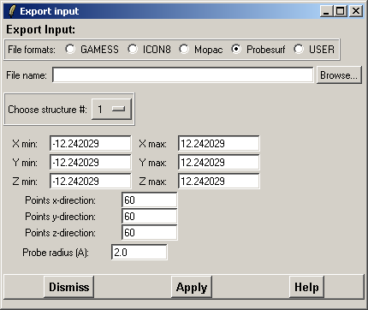

Figure 4: A screen capture of the Export coordinates window.

RDF
Export a radial distribution function file calculated with gOpenMol through the option Calculate > RDF. The file can be displayed in any of the plot programs available, e.g., GNUplot.

Timeseries…
Export time series data into a separate file. Select the type of time series array and the number of the distance, angle or torsion array to be exported to the file. Give the file a name directly or choose a name using the file browser by clicking the Browse button. By clicking Browse you can check into which directory the time series file is being written. To write the information press Apply.

Reset
Atom colors
Resets the atom colors to their original ones.

gOpenMol
Resets gOpenMol and frees all reserved memory as well as destroys all display information and up-loaded structures.

View
Resets the view to the start-up view.

Hardcopy
Creates a picture of the display in the 3D window. The picture can be generated in the following formats: Microsoft Windows bitmap (BMP), PostScript (PS), Silicon graphics RGB, JPG, Targa (TGA) and X-Windows (XWD). On the top of the window there are the radio buttons for the supported formats. Choose the appropriate format, type the name of the file in the “File name” box and press Apply. Click Browse to go to the proper directory. For PostScript format it is possible to choose the orientation of the picture: portrait or landscape.

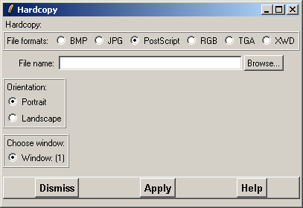

Figure 5: A screen capture of the Hardcopy window. The file formats are listed at the top of the window, PostScript format being marked here. For other file formats the “Orientation:” section of this window will be shaded with grey to indicate that this option is no available.

Exit
Exit the program and destroy all unsaved data.
3.2 Edit

Copy…
This property works only in Windows. The copied properties can be pasted to other documents by pressing Ctrl + V.
- Bitmap Copy current graphics window into clipboard
- Correlation Copy correlation data into the clipboard
- MSD Copy the Mean Square Displacement data into clipboard
- RDF Copy the radial distribution function into clipboard
- Timeseries Copy time series into clipboard.

Cell…
If the user has a molecular dynamics simulation (trajectory), which uses a periodic boundary conditions, a cell that has been defined around a certain area can be helpful. The cell properties and the cell display properties can be defined and edited using this option.

Define the lengths of the edges of the cell, a, b and c (in Ångströms) and angles α, β and γ (in degrees). Currently, the angles can only be 90°. The cell is by default placed at the center of the screen (or around the 0.0, 0.0, and 0.0). However, the cell can be translated by defining the translation distances “X trans”, “Y trans”, or “Z trans”. The cell is displayed by changing the ”Display state” to ON. The color and the width of the cell edge line (in pixels) can be changed. Click on the button Color to change the color of the cell edge (default color is red). To define the thickness of the cell edge, type a value in the box next to text “Line width” (default: 1).

Center…
This option defines a new center of rotation for the system. The system can be centered on a given atom or atoms. Choose the structure (= segment) and a residue or several residues in that structure and a single atom (if only one residue is selected) or multiple atoms to which to center the system. If there are several structures, the segment must be defined in order the center of the rotation to be properly defined. For a single structure, the selected structure is automatically the one which is displayed. The system can also be centered according to absolute x, y, and z values. In that case segment corresponds to x, residue to y and atom to z. Click Apply to center the system.

Identify Atom…
This widget enables the user to identify full properties for an atom by clicking that certain atom. Clicking the ”Identify atom(s)” state ON turns the left mouse button to a pointer with which to pick atoms for identification. Move the arrow over an atom and the window “Identify atom” will be filled with atom information about that particular atom.

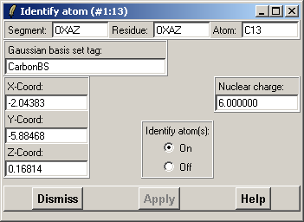

Figure 6: The Identify atom window. In this case the “Segment” and “Residue” contain the same text, because the sample molecule was a chemical compound. In the case of, for example, protein structures, the “Segment” would contain the name of the structure and “Residue” the name and number of an amino acid residue in that structure.

Light Properties…
Edit the light properties, i.e., the color components (RGB) and the position of the light. The color components of the light are adjusted by changing the red, green and blue color intensities using the color sliders. If the atoms are displayed as sticks or a structure as trace, this will not have any visible effect on the light properties. To see the effects, display atoms, for example, as licorice or a structure as any of the other plumbers. The light comes by default along the z-axis (C = centered) but it can be changed to come from the north (up), north east (upper-right corner), east (right), south east (lower-right corner), south (down), south west (lower-left corner), west (left) and north west (upper-left corner). Select the light position by clicking the appropriate radio button.

Material Properties…
With this option it is possible to edit/modify surface material properties. It is possible to change the material specular red, green and blue colors and material shininess. The color components define the color of the reflecting light and the material shininess defines the “width” of the reflecting light (0 = wide and 128 = very concentrated). The new properties are shown immediately while you change the slider values since the radio button “Continuous display” is marked on by default. If “Continuous display” is turned off, the effects of this option are displayed by clicking the Apply.

Merge Structures…
Merges all the structures in the 3D window to one the way they are displayed at that moment. It is not possible to select only some of the molecules for merging.

Molecule…
With this option the molecular geometry can be edited. Currently one can create and break bonds as well as search for disulphide bridges (S-S bonds). Define atoms you want to connect or disconnect in Atom #1 and Atom #2 boxes and click either the Create bond or Break bond button. S-S bond algorithm searches for sulfur atoms inside a radius defined in the “Calculate S-S bonds (Angstroms)” box. The atom around which S-atoms are searched for is defined by Atom #1. It is also possible to delete or create all bonds from a certain atom or certain atoms by defining that atom in Atom #1 and deleting the atom selection input form the Atom #2 list.

Rotate/Translate…
Usually the molecules are rotated and translated with the mouse. If one wants, however, to have very precise rotational or translational movements this option might prove useful. With this option the user can rotate or translate the molecule(s) in the 3D window by single steps defined separately for each axis. Rotation steps are defined as angles and translation steps in Ångströms. The rotation/translation will be applied on the whole display or just to a selected molecule depending on whether the radio buttons of “Apply on” are marked to “Display” or “Selection”, respectively.

Select…
The “Select” command might seem equal to the “Pick” command, but they have distinct properties. On selected atoms different operations, which are not possible for picked atoms, can be done. To select an atom or several atoms, define the atom(s) in the selection boxes; which segment and residue the atoms belong and finally the atoms in the “Atom” box. If there are more than one structure displayed, the structure, where to select the atoms must be defined by marking the appropriate radio button in the structure section of the “Select atoms” window. Selected atoms or groups of atoms can be rotated and translated independent of the rest of the structure if the radio button “on” in the “Selection” section on the right hand side panel of the GUI window is marked.

Stereo…
Pair
Displays the 3D window as a pair wise or “crossed-eye” stereo picture. The structures are duplicated, separated by a user defined distance, and tilted by a user defined angle relative to each other. A positive value for the angle will turn the molecule to the right and a negative value to the left around the y axis. This property does not work as it should, because the distance varies when the view is zoomed in and out. This is the same function as in View > Stereo > Pair.

Display properties…
Defines the display properties in the 3D window, i.e., the background color, the bond display type (Half or Smooth), the color display type (Color or Grayscale), the color mapping type (Texture or Rainbow), the drawing buffer (Front or Back), the cutplane distance, the projection (Perspective or Orthographic and the Viewing angle in degrees), redisplay and scaling types (Fast or Slow, and Global or Local, respectively), the stick display width, the window update (Automatic or Manual) and the windowing type (Single or Multi). The different display properties can be edited according to the alternatives displayed. For the above mentioned options the default display property is marked in italics.

Display list properties…
Defines whether the “Display list state” for this session, the “Default for new type of objects” and the “Use display lists for molecule” are turned on or off. By default all these options are turned off.

3D => 2D
Transforms a 3D structure coordinate file into a 2D coordinate file. This option is useful when, for example, making a database of small molecules. A 2D map does not require as much disc space as a 3D map.

3.3 View

Atom color
The color of individual atoms or atom groups, such as amino acid residues, can be changed with this option. First, the atoms or atom groups are defined, after which the color is picked by clicking the button Choose colour…. If the partial charges for atoms have been defined, it is also possible to color the atoms according to the partial charges. Define the partial atom charge range and press the button Apply. The color ranges from blue (lower limit) to red (upper limit) through green. To reset all atom colors to their default, leave asterisks in the segment, residue and atom boxes and click Reset atom colour. Atom colors can be restored to the original ones also through File > Reset > Atom colours.

Atom label(s)
The selected atoms can be labeled with three types of labels:. Residue displays the residue name with three letter code and the amino acid number, Atom displays the atom type (e.g., C, CA, N, O) and atom number and Full displays the full atom label, which includes the segment number, the residue name and number as well as the atom type and number. If you do not want to display, e.g., residue on each atom on the labeled residue, define an atom to which attach the label, e.g., CA.

Atom tree
Lists the atoms of a structure by different structural levels. For example in a protein structure the atoms are grouped according to the amino acid they compose. The properties of individual atoms can be edited by clicking an atom in the list and editing the properties in the window section on the right by clicking twice on a property. Do not double click. Instead, click rather slowly.

Atom mask
Atom mask is used to display or hide a set of atoms in a structure. Define the section, residue and atom in the appropriate boxes and define the action “On” or “Off” for displaying atoms or hiding atoms, respectively, and press Apply. It is also possible to display or hide all atoms of a particular type within a defined radius around a defined atom or defined atoms. The color of the atoms within that certain radius can be selected through Click to change colour. The atom selection can be based on either atoms inside whole residues or just the atoms that satisfy the selected radius.

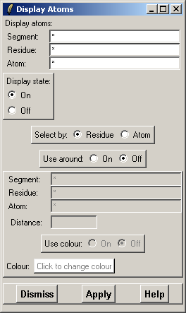

Figure 7: The “Atom mask” window. The different sections in this window are described in the text for “Atom mask”.

Atom type
Edit the display type of the atoms. The options are stick, CPK and licorice. Stick is the default display type and turning this off will hide all the other display types. CPK displays the van der Waals radius of the selected atoms. Licorice displays a molecule as a solid stick or by redefining the cylinder and sphere radius, the molecule can be displayed as ball-and-stick.

Background color
Select the background color of the 3D window.

Color
This option is for Windows. Pick a new color from the basic colors or define a color of your own from the color palette.

RGB
This option, on the other hand, is for other OS versions, because the above mentioned does not work for them. Use the sliders to define a new background color.

Measure
Measure distance(s), angle(s) and/or torsion angle(s) between selected atoms. To define a distance you have to define two atoms, which will only define that distance. An angle will be defined with three atoms and a torsion angle four atoms. The three atoms used to define an angle will also be used define the distances between these atoms. The four atoms used to define the torsion angle will likewise define the distances between these atoms, and, in addition, two angles between two of these atoms. Click on the button Apply and the values for distance, angle, and torsion angle defined by the selected atoms will be shown in the appropriate boxes.

Periodic table
Displays the periodic table of elements. Clicking an element will display a window where the symbol, name, atomic number, Gaussian basis set, Covar radius and other Gaussian data of that element are listed. The Covar radius of the atom can be modified if needed.

Stereo
Pair
Displays the 3D window as a pair wise or “crossed-eye” stereo picture. The structures are duplicated, separated by a user defined distance, and tilted by a user defined angle relative to each other. A positive value for the angle will turn the molecule to the right and a negative value to the left around the y axis. This property does not work as it should, because the distance varies when the view is zoomed in and out. This is the same function as in Edit > Stereo > Pair.

Text output
Displays the output text of gOpenMol. While running the program a great deal of message text or result text from various calculation routines are printed to the output text window, where the text can be seen running. However, if you are running Windows you will not be able to scroll the output text window to the beginning after a while. Moreover, at some times some commands may generate a considerable amount of output text, which can be easily copied from the Text output, and pasted into other applications.

3.4 Calculate

Average structure
Calculates the average structure from a trajectory, which is a molecular dynamics simulation.

Cluster
Calculate and plot cluster matrix from a trajectory file. Calculate a cluster matrix displaying the root mean square (RMS) value for display after a superimposition of the selected atoms over the frames in a trajectory. Select the segment, residue and atoms defining the structure to be superimposed with the equivalent part in the other frames. After selecting the atoms press the Apply button to perform the calculation over the frames. After the calculation the matrix can be displayed by selecting the “Cluster plot on” option. To free the reserved matrix space, press the “Delete cluster data” button.

Connectivity
With this tool user can recalculate atom connections (bonds) if some of the bonds have been deleted or not all hydrogen bonds are displayed in the structure. To calculate possible bonds a very simple algorithm is being used. The algorithm runs over all the atoms in the structure and uses a range (window) of atoms inside which it thinks the bonded atoms are located. The range has a default value, which can be checked by using line command show atom window. The range is defined so that atoms before and after the specified atom in the structure file are checked to find atoms bonded to the specified atom. Some programs place added hydrogen atoms at the end of the file, which might prevent the algorithm from finding the right bonds. To solve this problem redefine the range. Replace the value in the “Atom search window” to one which you think covers the whole structure. It is also possible to recalculate the connectivity only for a set of atoms.

Hydrogen bonds
Calculate hydrogen bonds between atoms according to the structure file. If there are no hydrogen bonds defined in the structure file, the function Calculate hydrogen bonds will not work properly.

Correlation
This tool calculates correlation and autocorrelation functions from two time series. There are three types of time series for which the correlation and autocorrelation functions can be calculated: distance, angle and torsion angle. The time series for these three possibilities are stored with a running number. Choose first the type of time series and then the running number of the time series inside this group. If you choose the same time series for #1 and #2 you calculate the autocorrelation function.

Geometry
Calculate molecular geometry.
Mean sqr displ
Calculate mean square displacement values from a trajectory file.

RDF
Calculate a single or an average radial distribution function (RDF) from a frame or a trajectory. It is possible to calculate a distribution function (g(R)) for an atom using gOpenMol from one frame or as an average from a sequence of frames like a molecular dynamics simulation. It is possible to arbitrarily choose the central atom and the atom(s) around that. If you have only one frame available (you have not defined a trajectory file) and you select Calculate > RDF, you will get a “Select RDF atoms” window.

The different parts of that window stand for:
- The “From (center) atom(s):” define the central atom(s) around which the distribution will be calculated.
- The “To (orbiting) atom(s):” define the atom(s) with which distribution will be calculated.
- The “Rcut:” value defines the distance to which the distribution will be calculated.
- “Nbins:” define the number of intermediate values (bins) for which the distribution will be calculated.

If the periodic cell inside which your atoms and molecules are located (you have most likely been using period boundaries), has not been defined before, it has to be defined here. Pressing now the button Apply button calculates the RDF of the “To (orbiting) atom(s)” around the “From (center) atom(s)” for the structure displayed in the graphics window.

There is now one further entry and button displayed. An entry titled “Number of sets” defining how many structures the RDF has been calculated and accumulated. It is, thus, possible to read by hand more frames into gOpenMol and successively calculate the RDF. After the number of RDFs has been calculated (accumulated) it is possible to calculate the average for these RDFs by pressing the button calc average.

However, if a trajectory file has been defined before the Calculate > RDF has been selected, a different kind of window is displayed. In this case the average calculated for the entire frame is possible to get automatically by pressing the button Calculate average RDF. The program goes through your trajectory file frame by frame and calculates and accumulates the RDF. After the last frame has been calculated and accumulated to the RDF, an average RDF of all the frames is calculated. It is always possible to export the calculated (accumulated) RDF through File > Export > RDF. On Windows platform it is also possible to copy the RDF to the Paste buffer through Edit > Copy > RDF.

Superimpose
Two structures that resemble one another can be superimposed by defining equivalent atoms or residues in the structures. The number of atoms in the two sets must be equal but the atoms itself do not have to be identical. Define the residues and atoms for a protein structure or only atoms for a smaller compound to be superimposed in and press the button Apply. It is possible to display either a short or a long display list of the matching structures. Select the one you want.

Surface centroid
Calculate the centroid for an isosurface.

3.5 Plot

Axis
Using this function it is possible to select atoms and plot the local coordinate system on them. It is also possible to give the x, y and z coordinates where the local coordinate system is placed. Give the atom(s) and press the button Apply. The selection is additive which means that the new set is added to the old set. Moreover, each new atom is in the origo of a new axis system. The whole selection can be deleted by pressing the button Delete.

Clip plane
A clip plane cuts a molecular surface so that the charge distribution inside the surface can be observed. Mark the box next to the plane along which you want to clip the surface.

Colour scale
It is possible to include a color scale into the molecular surfaces. A color scale is used to display a range of values. The color scale has default colors for min. and max. values (blue and red, respectively) as well as for the values in between, which range through green, yellow and orange. For example, if a molecular dynamics trajectory is defined it is possible to plot the Root Mean Square Deviation (RMSD) of a selected set of atoms as ellipsoids. The plot is always in the global x, y, and z coordinate system. Supply the min and max values and the number of steps (bins) by which the color scale is drawn. To display or hide the color scale, choose the proper radio button.

Contour
All contour files must be converted to .plt format using one of the programs in the menu Run before they can be drawn. Moreover, the coordinate file for which the grid data was calculated for must be read in to the program in order to display the isosurface contour. Through window “Contour control” the contour file, isosurface values, surface colors, surface smoothing and many more things can be controlled.

To display a contour surface, do the following steps:
- Read in the atom coordinate information for your molecular system through File > Import > Coords.
- Open the widget “Contour control” from Plot > Contour…
- Click on the button Browse to open the file browser, search for the contour surface file and select it.
- Press the button Import file below the “File name” box to read in the grid data.
- Type the max. isocontour value into the first input field.
- Click on the button Colour(#) to choose a color for the surface
- The contour surface renderer can be used in two different modes:
  - direct (fast) mode where no contour polygon data information is saved or
  - save (slow) mode where the last displayed contour polygon data information is saved in an array and can be retrieved with the show command.
- Press the button Apply!

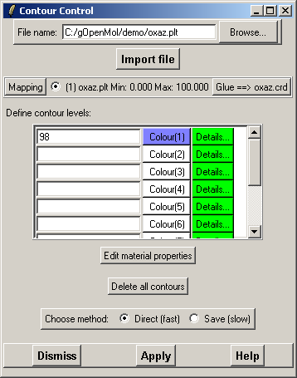

Figure 8: The Contour control main window. The contour file read in this examples is oxaz.plt. The min. and max. isocontour values are 0.0 and 100.0, respectively, of which the isocontour surface corresponding to the value 98 has been selected to be drawn in light blue color..

Surface details
Pressing Details button opens a “Contour Details” window where, from left to right, the display state of the surface, the surface smoothness, the contour type and the cullface state can be detemined. Moreover, the transparency of the surface can be determined in the Opacity section. The lower the opacity value, the more transparent the surface gets. Pressing Apply will execute the changes.

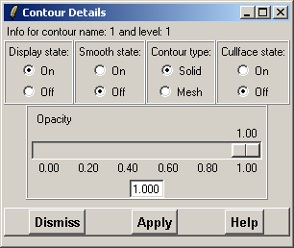

Figure 9: The Contour Details window. See the text above for details.

To delete all data click the button Delete all contours. Unfortunately there is no function to delete contours one by one. The mesh data can also be manipulated with the program “ContMan” in the menu Run > ContMan.

Cutplane

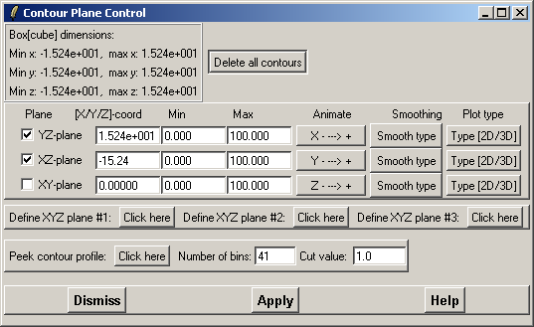

Figure 10: Cutplane main control window. In this example, the yz- and xz-planes are shown, yz-plane starting from x=1.524e+001 and xz-plane starting from y=-15.24.

Cutplane plots a cutplane through a contour surface. First, a contour surface must be read in, but it does not have to be displayed for Cutplane to work. The planes are defined as xy-, xz- and yx-planes. Mark the plane to be displayed and press Apply. The place, where the plane cuts the molecule can be edited to one, which contains most information. Try different coordinates in the box [x/y/z]-coord, where the coordinate for the axis perpendicular to the plane is typed. Determine min. and max. values of the range. by default the absolute min. and max values are given. It is also possible to animate or move the planes “smoothly” using the animate facility. Press one of the three Animate buttons to open the animation control window.

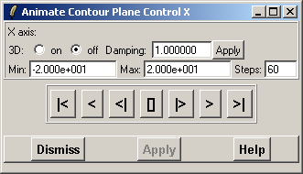

Figure 11: The Cutplane animation control window, named as “Animate contour plane control (axis definition: x, y, or z)”. From left to right, the symbols on the buttons stand for the following: [|<] = “To the beginning of the animation”, [<] = “Play the animation backwards”, [<] = “Play the animation backwards frame by frame”, [] = “Stop the animation”, [|>] = “Play the animation forward frame by frame” [ >] = “Play the animation forward” [ >|] = “To the end of the animation”

To delete all data click the button Delete all contours in the “Cutplane main control” window. Pressing the equivalent button in the “Contour control main window” does the same thing. Unfortunately there is no function to delete contours one by one.

It is not always easy to find the best plane (= plane with most information). To make this procedure a bit easier a ”profile graph” can be generated. The graph is generated by dividing the range of observations in bins where the grid data is then placed. A blue color shows very few observations in that bin, while a read color shows a high number of observations in the bin. The current picture applies a bin cut value of 1.0, which means that the region shown is the region where there is 1 or more values in the bin. This bin cut value can be changed by changing the default value 1.0 in the input widget to another value. Using the value of 1.0 gives already a good insight into the grid space.

LDP
Plot a linear distance plot for selected atoms. Select the atoms to be include in the linear distance plot (LDP), set the LDP plot state to “ON” and press Apply.

Plumber
With this tool protein secondary structures can be displayed as ribbon (α-helix), arrows (β-strands) or tube (both α-helix and β-strands) and also the Cα-trace can be displayed as a single line. The Plumber function consists of three separate windows, the Plumber (main) window, Secondary Structure window and Plumber list.

In the “Plumber” window the user can define which secondary structure is to be displayed as ribbon/arrow/tube/Cα-trace and which atoms in the structure are to be displayed. In the Main window, the buttons for displaying “Secondary Structure window” and “Plumber list” are the buttons Click for more information and List plumber(s), respectively. The color of a particular plumber can be selected from Choose colour. The radius of a tube and the groove of helix minor and major axis can be edited. “Glue to atoms” glues the plumber to the molecule. This is on by default, but if it is not, the plumber and the structure are seen as two separate objects, and when rotating the molecule the plumber and the molecule might get separated. The box for “Append to stack” has to be marked if different kinds of plumbers are drawn for the same molecule, e.g., parts of the molecule are drawn as helix and parts as sheet. Moreover, the display state of the plumber has to be determined. It is off by default, and if the display state is turned on before any plumbers are drawn an error message will be displayed. If this happens, ignore the error message, turn the display state “Off” and draw a plumber. Then turn the display state on.

Secondary structure window displays the secondary structure regions of the structure. The secondary structure information is read directly from the structure coordinate file (usually a PDB file). Regions not determined as either α-helices or β-strands are considered as loops. The option trace determines automatically the Cα-trace of the molecule. To create a single α-helix or β-strand, mark the secondary structure to be displayed, press Select and then click Apply in the “Plumber” window. Pressing Create all plumbers of this kind will create all plumbers of the same sort as the selected one.

Plumber list window: In this window all drawn plumbers are listed. The buttons at the bottom of the window stand for following: Select all: Selects all plumbers, Select none: Unselects all plumbers; Invert selection: Select the unselected plumbers and unselect the selected ones; Select by type: Selects plumbers of the same kind as the one already being selected; Change colour: Change the color of the plumber; Invert colour: Change the color of the selected plumber(s) to their opposite colors; Unglue from atoms: Detaches the plumber from the atoms according to which it was drawn; Destroy: Deletes a selected plumber or selected plumbers. The Plumber list does is not updated automatically. Pressing Update updates the plumber list after actions described above have been executed.

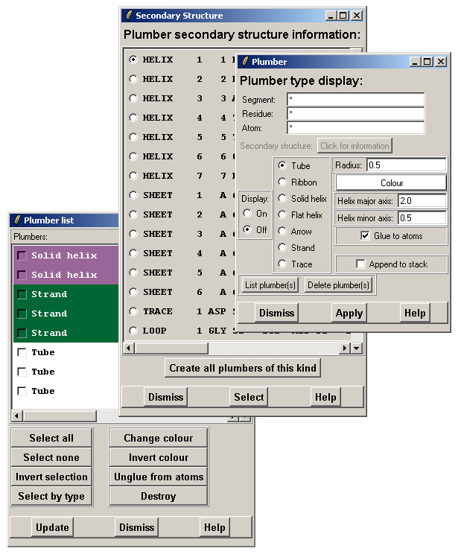

Figure 12: The Plumber windows. From top to bottom, Plumber main window, Secondary structure window and Plumber list. See text for details.

RMSD
This option plots the root mean square deviation (RMSD) of atom movement in a molecular dynamics trajectory. The RMSD is visualized as ellipsoids in the selected atoms. The plot is always in the global x, y, and z coordinate system. The RMSD can be calculated either by superimposing the individual frames on the average structure (= fit) or by not superimposing the individual frames on the average structure (= no fit). This is done by marking either of the radio buttons in the box “Apply fit”: On (= fit) or Off (= no fit). Press Apply to execute the command. The plot can be deleted by pressing Delete. If the fluctuation has small amplitude it is possible to increase the amplitude by increasing the value in the box “Amplifier factor”.

Vector file
With Vector file a set of vectors, which are read from a flat text file, can be plotted. The calculation can come from GaussianXX, Turbomole, or from another program. Enter the name of the file in the box “Vector input text file name” or use Browse to search for the vector file. The vectors can be displayed either as lines or solid tubes. The line drawing is the fastest display mode and it is recommended to use if several vectors are displayed simultaneously. The radius of the solid tubes can be edited in the box “Radius” next to “Line” and “Solid” radio buttons. It is also possible to define the range of the vector length, which determines which vectors are being displayed. Those vectors, which lay within the defined range are displayed. The vector display state can be turned “On” or “Off” by marking the appropriate radio button. If the vector display is not needed, free all the reserved vector space by clicking Click here in the box “Delete all vectors and space” to delete all vectors and space.
3.6 Trajectory

The functions in this menu are used to control and manipulate trajectories. First a trajectory has to be read in through the Main window. Then, before Timeseries option can be used, the distance, angle or torsion arrays must be defined through Monitor > Distance/Angle/Torsion and the time series vector must be filled through Fill > Distance/Angle/Torsion. Only after these steps the time series can be manipulated. A time series vector for distance, angle, or torsion can be deleted through Delete > Distance/Angle/Torsion.

Fill
Distance array
This command fills the time series array for a distance as defined in Monitor > Distance.

Angle array
Fills the time series array for an angle as defined in Monitor > Angle.

Torsion array
Fills the time series array for a torsion angle as defined in Monitor > torsion.

Delete
Distance array
Deletes the distance array information, which has been created through Fill. A distance (or distances) defined in Monitor > Distance will still be visible in the graphics window and it (or they) will change upon playing the trajectory.

Angle array
Deletes the angle array information, which has been created through Fill > Angle. An angle (or angles) defined in Monitor > Angle will still be visible in the graphics window and it (or they) will change upon playing the trajectory.

Torsion array
Deletes the distance array information, which has been created through Fill > Torsion. A torsion angle (or torsion angles) created through Monitor > Torsion will still be visible in the graphics window and it (or they) will change upon playing the trajectory.

Main
This opens the “Trajectory control” window through which the trajectories can be read in to gOpenMol. Moreover, the displaying of the trajectories can be controlled through this window. But before any trajectories can be processed, a structure coordinate file must be read in through File > Import > Coords to define the molecular topology and the atom labels because some trajectory files contain only atom coordinate information.

To read in a trajectory, first select the trajectory file type you want to analyze and visualize from the list on the right in the “Trajectory control” window. Then click Browse and search your trajectory file from your file system. To import the trajectory, press Import. After the trajectory has been completely read in the number of frames will appear to the “Num of Frames” box, which is shaded grey, in the “Trajectory info” section. In that same section also the number of the first frame and the last frame are displayed as well as the number of steps (=frames) by which the trajectory will be displayed. Usually the trajectories are displayed by steps of one frame but the number of steps can be modified to a more suitable value. To execute modifications in the number of first frame and the number of the last frame as well as in the number of steps by which the trajectory is displayed, press Apply at the bottom of the “Trajectory control” window. The time frame at which a certain trajectory is displayed can also be slowed down by a user defined value. To execute this command, press Apply next to the box where the new value was typed.

The supported trajectory formats, which are listed the right on the “Trajectory control” window, are:

AMBER An unformatted binary Amber trajectory file.
AMBER (F) A formatted Amber trajectory file. In the bin directory of gOpenMol for Windows is the program for making the conversion of a formatted ABMER trajectory file into an unformatted one. The name of the program file in the Windows distribution is ambera2b.exe. The program does not work through the GUI, though. It has to be started from the bin directory directly. Then the name of the file to be converted is typed on the screen which pops up and the conversion is executed by pressing enter.
More information about AMBER can be found at the AMBER Web pages at http://www.amber.ucsf.edu/amber/formats.html
Cerius2 An unformatted binary CERIUS2 trajectory file.
CHARMM An unformatted binary CHARMM trajectory file.
Discover An unformatted binary DISCOVER trajectory file.
UDL_Poly
FDL_Poly
Gromacs An unformatted GROMACS trajectory files (trn, trr and xtc).
Gromos An unformatted GROMOS trajectory file.
Gromos96A A formatted ASCII GROMOS96 trajectory file.
HyperChem An unformatted binary HyperChem trajectory file.
MUMOD An unformatted binary MUMOD trajectory file. The MUMOD program is developed by Dr. Olle Teleman.
TINKER A formatted TINKER trajectory file.
XMOL A formatted ASCII XMOL (multi set) trajectory file.
XPLOR An unformatted binary XPLOR trajectory file.
YASP An unformatted binary YASP trajectory file. The YASP program is developed by Dr. Florian Muller-Plathe.

In the “Trajectory control” window, there are also buttons for displaying the trajectory file. These buttons are equivalent to those in “Animate contour plane control (axis definition: x, y, or z)” window on p. 20. They stand for [|<] = go to the first frame; [<] = go backwards one frame; [] = stop the display loop; [|>] = display the frames in a loop by steps defined in the “Step frame(s)” box in the “Trajectory info” section.; [>] = go forward one frame; [>|] = go to the last frame.

Atom connections and hydrogen bonds are not recalculated by default. In the sections to recalculate these connection the radio buttons “Off” are marked. To turn on the recalculation option, mark the radio button “On”.

The formatted trajectory files can be retrieved by two ways, the “Fast” way and the “Slow” way. The “Fast” method uses a pre-calculated index (jump) vector into the trajectory file for the various frames. This method is capable of retrieving a frame at a speed independent of the frame position in the file. However, be careful with this if you move files between Unix and Windows systems! The “slow” method reads all the frames up to the needed frame. This process is very slow for big files but it is not sensitive to the characters at the end of the line.

The number of the frame can be displayed in the upper right corner of the graphics window if the radio button “On” is marked in the “Display frame nr” section at the bottom of the “Trajectory control” window.

Monitor
Monitor the changes in the molecular geometry of a trajectory. Distances between individual atoms in a molecule can also be measured through this function, even if no trajectory is defined.

Distance
Define the atoms for which you want to measure the distance or monitor changes in the distance in the sections “Atom(s) #1” and “Atom(s) #2”. If you want to change the line color, click Line colour, pick a new color and click Ok. Line type can be selected from four alternatives by pressing the button Line type. For displaying the distance vectors in the graphics window, mark the Display state “On” at the first time, the following distance lines are dawn even if the Display state is marked “Off”. When the atoms are defined, press Apply. Each distance line will take its own row in the “Monitor distance” window. On that row, the atoms, which are used to draw that line are given. The line type and color can be changed here, as well. Clicking the Edit button will display “Monitor edit distance” window. Here, the atoms used to draw that line, can be changed. Pressing Delete in this window does no delete the line for which this Edit window was taken for. Instead the lines are deleted one by one in the order they were drawn. Delete all in the “Monitor distance” window will delete all drawn lines.

Angle
Like in the “Distance” window, here the atoms to define an angle (three atoms) must be given in the “Atom(s) #(number)” sections. Likewise, the line color and the line type can be selected before the angle is drawn or they can be edited after the line is drawn. The Display state must be marked “On” for the first angle, but all the subsequent angles are drawn even if the Display state is “Off”. The Delete button in the “Monitor edit angle” window deletes the angles in the order they were drawn, one by one.

Torsion
As for “Distance” and “Angle”, the atoms for a torsion angle have to be defined in the “Atom(s) #(number)” sections, four atoms at this time. The rest of the options equal to those for “Distance” and “Angle”.

Time series
Manipulate the distance, angle and torsion time series through the following operations:

The types of operations (manipulations) available are:
DAVERAGE Q(t) = Q(t) -
SQUARE Q(t) = Q(t) ** 2
COS Q(t) = cos(Q(t))
COS2 Q(t) = 3*cos(Q(t))**2 - 1
SQRT; Q(t) = sqrt(Q(t))
DINITIAL Q(t) = Q(t) - Q(0)
COPY nr; Q(t) = Q2(t)
ADD nr; Q(t) = Q(t) + Q2(t)
LOG ; Q(t) = log(Q(t))
EXP ; Q(t) = exp(Q(t))
POWER REAL Q(t) = Q(t) ** real
MULTREAL Q(t) = real * Q(t)
DIVIDEREAL Q(t) = Q(t) / real
SHIFTREAL Q(t) = Q(t) + real
DMIN Q(t) = Q(t) - Q(min)
ABS Q(t) = abs(Q(t))
DIVFIRST Q(t) = Q(t) / Q(0)
DIVMAXIMUM Q(t) = Q(t) /max(Q(t)) (There is a typo in the “Manipulate timeseries” window, where is says DAVERAGE)
PSPECTRUM Power spectrum
ZERO; Q(t) = 0.0

Mark the radio button next to the desired operation to activate it. If the operation requires further a value or an index, fill the value into the input box. Choose the distance, angle or torsion option from the “Type of time series” section. Those options that have been “filled” through Trajectory > Fill > Distance/Angle/Torsion are visible here. Fill in the number index for the desired time series in the “Destination time series nr:” box.

Trace
With this function the movement of selected atoms in a trajectory file can be traced. Define first the atom(s) to be traced (CA, C, N, O, etc.) and press the button Apply. Put the display state to “On” by clicking the “On” radio button. This has to be done only when the first trace is drawn. The following “traces” are displayed even if the display state is “Off”. By marking the box next to “Append” traces of several atoms can be displayed simultaneously. Pressing Delete will remove all traces.

Make movie
With Make movie .mpeg animations of trajectories can be made. Unfortunately, this will only work on Windows platforms. In other operating systems the single files for an animation can be written, but for making an animation a separate program must be taken into use.

Make an animation by first creating discrete files of each trajectory frame and then by combining these files into a single .mpg file. Currently only files in Targa (.tga) format can be used for the making of .mpeg animations but it is possible to make the screen dumps of the individual trajectory frames also in Bitmap, RGB, and XWD formats. Only small picture sizes can be used so reduce the size of the graphics window to gain a 400 * 400 pixel square before the making the animation. Enter a root file name in the box below the file formats. This root file name will be extended with a serial number of a frame and the file extension. These files will be automatically placed in the temp/ directory. Press Apply and a screen dump of every frame in your trajectory will be made. After all discrete screen dumps have been created, the .mpeg file is generated automatically.

3.7 Run

In this menu, the tools for converting output files from a variety of chemical and physicochemical analysis programs to the gOpenMol cube files (.plt) are listed.

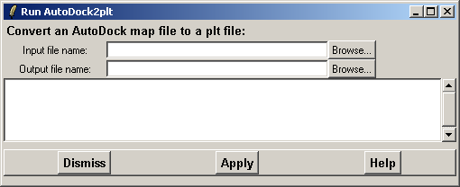

Figure 13: A representative window from one of the conversion tools in the menu Run. This same scheme can be applied to all the other conversion tools in this menu. The number of input files and some options might differ in the other windows.

AutoDock2plt (map)…
Run the AutoDock2plt program to convert an AutoDock map file into the .plt file format (formatted and unformatted). Type the input and output file names or click Browse to find the files and press Apply to convert.

ContMan (plt)…
Runs the contour management program with which two contour files or two .plt grid mesh files can be added or subtracted (A = B + C). Search the input files by clicking Browse and give a name to the output file. Search an appropriate directory though Browse. Otherwise the output file will be written to the same directory from which the second input file was read in. Select from the two radio buttons in the section “Action type (-/+)” if you want to subtract the “Input #2” from “Input#1” or to add the “Input #2” to “Input #1”. The corresponding radio buttons are “Minus (-)” and “Plus (+)”, respectively. The results will be written into a .plt file.

Gamess2plt (cube)…
Gamess2plt converts the “cube” information in a PUNCH file to the .plt format.

gCube2plt/g94cub2p (cube)…l
Run the program gCube2plt/g94Cub2pl to convert a Gaussian cube file into the .plt format. gCube2plt is an old version of the program that converts only one orbital or density at a time. The total number of files to be converted has to be given in the input field. g94Cub2pl is a modified version of the ole program, made by Doug Moffatt, which converts all the information in a Gaussian cube file into separate files in one batch.

Jaguar2plt (cube)…
Run the program Jaguar2plt to convert Jaguar orbital data to the .plt format.

Join Gamess IRC files
Join Gamess IRC files into one.

Kont2plt (grid)…
Run Kont2Plt to convert a grid mesh file from the program Grid into a formatted or unformatted .plt format. Choose the appropriate radio button and execute the conversion.

Pltfile (conversion)…
Pltfile converts a gOpenMol .plt file from binary to ASCII or an ASCII file to .plt binary. The operation is mostly used to move a .plt file between different hardware platforms.

Probesurf (Connolly)…
Run the ProbSurface program to generate a Connolly surface around a molecule. Define the input file in the box for “Input file name” and the output file name in the box for “Output file name”. The ProbeSurf calculation can be done either in foreground or background. The foreground calculation locks gOpenMol until the calculation has been finished. The background mode enables the further usage of gOpenMol while the calculation continues. ProbSurf uses a direct (r) and squared (r**2) distance method for the calculation of the surfaces. Choose the appropriate method and press Apply. After the calculation has been finished it is possible to read in the contour file and display the surface. By answering yes to the question: “Do you want to read in a Connolly surface?” the new surface will be displayed automatically. If you answered no to the question the surface will no be displayed.

Socket server client
Neither Server control nor Client control in this menu work. Socket server client has been added to the Run menu for future purposes

TMole2plt (grid)…
TurboMole2plt converts a TurboMole grid file to the .plt format. The TurboMole grid file can then be displayed using Plot > Contour. Type the input file name in the appropriate box or click Browse to find the file. Enter the output file name in its text filed and press Apply to convert.

UHBD2plt (grid)…
Run the UHBD2plt program to convert a formatted or unformatted UHBD phi grid file to a .plt file. Enter the name of the input file and give the output file a name. Select if the input file is a formatted or an unformatted UHBD file and make the conversion by pressing Apply.

Xvibs (conversion)…
Xvibs, which is created by Bradley A. Smith, can be used to make animations of molecular vibrations in XMOL format using output files from Aces2, Gamess, PC Gamess, Gaussian, and ADF. For each vibration a separate animation can be written. Search the input file through Browse and type the number of the vibration an animation is created for in the text field for “Vibration(s)”. If you want an animation of all the vibrations in the output file, type “all” into the “Vibration(s)” text field. Press Apply to convert. The version of Xvibs distributed together with gOpenMol is not the lastest one. More information about Xvibs can be found at http://xvibs.sourceforge.net.

3.8 Tools

DLL/SO plug-ins
Under this submenu are the extensions that can be implemented as plug-ins to gOpenMol.

Enable ball plug-in
There is no operating function behind this option. For experienced users this option shows how to create their own plug-ins.

Enable Chem3D / Spartan coordinate filter
Selecting this function enables the Chem3D / Spartan coordinate filter, which is not on by default. If you have files in either of these two formats, this plug-in must be first turned on before the files can be read into gOpenMol. After turning on the filter, Chem3D and Spartan appear in the list of coordinate file types that can be imported to gOpenMol. Go to File > Import > Coords and mark off “Select file format by extension” to see the effect.

VRML
VRML plug-in is written by Kevin Boyd for gOpenMol version 2.2. This option can be used to create VRML (virtual reality markup language) files of trajectories displayed in gOpenMol. These VRML files can also be viewed by others through the WWW. To view the VRML animations a VRML plug-in has to be installed. (For more information, visit http://www.chem.utah.edu/chemistry/faculty/anderson/gopen/
tutorial.html#vrml)

AutoDock
This option is used to analyze and to display AutoDock trajectories. At first the ligand structure file, the structure file of the molecule the ligand was docked into, the trajectory file, and the AutoDock log file have to be read in. Press Import buttons after the text fields for each of file names to import the given file. To add ligand structures on top of the first loaded structure, mark the box “Append to structure”. Cruncher option creates files where the original and docked coordinates are separated into different files.

The AutoDock trajectory file is the ligand.tout file, which is the output of an AutoDock run in ASCII format. It is defined in the help pages for AutoDock trajectories (http://www.scripps.edu/pub/olson-web/doc/autodock/trajectories.html) in the following way: “The traj command which is used in the trajectory output, creates trajectories in two formats, one in PDB format which is written to the log file specified by the -l flag, and one in a raw ASCII format which is written to the standard output (ligand.tout). For example, if the command issued was: autodock -p ligand.dpf -l ligand.trj.conv.log -c < trj.conv.com > ligand.tout, the file ligand.trj.conv.log will contain a PDB formatted list of all the trajectory steps, while the ligand.tout file will contain raw ASCII data, with one row for each atom in the ligand, and each column containing data concerning the ligands coordinates, energy states annealing temperature, etc.”

After the structure and trajectory files have been loaded, the number of frames should have appeared in the text field next to the text “Num. of Frames” By default the display goes from the first frame to the last in steps of one frame. This default behavior can be changed by supplying a desired value in a corresponding field (“First frame”, “Last frame”, “Step frame(s)”, or “Current frame”). The trajectory frames are controlled by using the buttons below the section where the frame options were defined. These buttons, [|<], [<], [], [|>], [>], and [>|], stand for: “go to the first frame”, “go back one frame”, “stop the display loop”, “display the frames forward in a loop”, “go forward one frame”, and “go to the last frame”, respectively.

The trajectories can be retrieved with either the two methods, which are defined in the box “Trajectory retrieval”. The “fast” method uses a pre-calculated index (jump) vector into the trajectory file for the various frames. This method is capable of retrieving a frame at a speed independent of the frame position in the file. However, be careful with this if you move files between Unix and Windows systems! The “slow” method reads all the frames up to the needed frame. This process is very slow for big files but it is not sensitive to the characters at the end of the line.

The ligand and system coordinates can be written as *.pdbq files with the options at the bottom of the “Autodock main control” window. This is very handy in case you have imported the atom partial charges and want to write a *.pdbq file with new charge values.
3.9 Help

The help system is built upon a Tcl/Tk based Web browser that has very few features compared to the modern Netscape or Microsoft Internet Explorer Web browsers.

About
Shows the gOpenMol info about the current version, its release date and the programmers as well as the copyright information..

Demo
Gives a list of available demos. There are short demos for Simple molecule display, Molecular dynamics, Orbital and density, Object display, Manipulations and Clip plane. Click on an appropriate button to run a demo.

Help
Shows the help pages for gOpenMol.

Menu help
Shows the information about the pull-down menu system. It is the same page as the “How to begin your gOpenMol session” in the Help pages.

Peek version
This function tells you if the version you are using is the latest release or an older one. Peek version takes an http connection to the gOpenMol distribution site and checks for the latest version available. In the pop-up message the version of the program which you are using at the moment and the latest version as well as to which platforms the latest version is available, are indicated. This feature will help you to upgrade and maintain gOpenMol in the future.

Tutorials
This option gives the list of tutorials for gOpenMol. If you have prepared a good tutorial please let us know and it will be included here. To send it, contact Leif Laaksonen (Leif.Laaksonen@csc.fi)

Scott’s intro
This is a link to Scott Anderson’s tutorials in the gOpenMol web. The same tutorials can be found in the WWW at
http://www.csc.fi/gopenmol/tutorials/scott/ or
http://www.chem.utah.edu/chemistry/faculty/anderson/gopen.html

4. Advanced examples for how to use gOpenMol

For some operations it was appropriate to write more thorough descriptions. Because the use of these operations requires the knowledge of several features in different menus a separate section was made for these functions. For some of the examples, demonstrational files can be found in the gOpenMol demo directory.

4.1 Mapping of a contour on a surface

This can be used if information from a contour or surface file is mapped on another surface or contour file. There are example files in the gOpenMol demo directory. Use density.crd as the coordinate file and density.plt and orbital.plt as the grid files. The idea of this example is to plot the electron density at an isocontour value (0.1) and map the orbital grid values upon this surface.

- Read in the density.plt coordinate file through File > Import > Coords and then two grid files density.plt and orbital.plt through Plot > Contour in this order.
- Mark the radio button next to “(1) density.plt” to select the file.
- Press the button Mapping next to the radio button that was just marked. This will open a “Contour mapping control” window, where the grid data to be mapped on density.plt can be defined. Press the button which says: “1: No mapping” and select from the list “2: orbital.plt”. Press Accept to map orbital.plt to density.plt.
- With the radio button for density.plt marked, type on the first text field in the “Define contour levels:” section “0.1 -0.15 0.15”. The value 0.1 defines the surface for density.plt and the values -0.15 and 0.15 define the minimum and maximum values for orbital.plt.
- Press Apply to see the result in the graphics window.
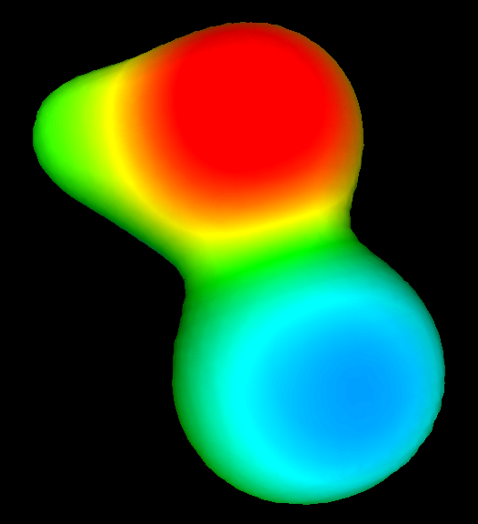

Figure 14: This is an example of what the display in the graphics window should look alike if the example files in the demo directory were used.

The Surface details can be edited the same way as described above in Chapter 3, section 3.5 Plot > Contour > Surface details.

NB:
The two grid files have to have the same number of grid points in the x, y and z directions and the grid data has to be defined in the same x, y and z space for the both grid files. If the grid space of the files is not known, formatted to unformatted *.plt file converter can be run through menu Run > Plt file (conversion) to check the x, y, and z space for the grid files..

4.2 How to glue a surface to certain coordinates.

In the “Contour control” main window there is a button with the text “Glue ==> ‘name of a coordinate file’”. This defines the structure to which the contour file is glued (attached). By default any contour file that is read into gOpenMol is always glued (attached) to the structure that was loaded first. There is no meaning for this function if only one structure is read in or if the transformation is in the “Global” mode (see GUI, section iii) in Chapter 2). This example demonstrates how to glue a contour to the structure where it belongs to. There are model files available in the gOpenMol demo directory.

- Import the coordinate files oxaz.crd and orbital.crd from the demo directory through File > Import > Coords. Remember to mark “Append to structure” so that the previously read structure will stay in the graphics window.
- Mark the radio button for local transformations in the section “Transformation” in the GUI. The two structures have now their own local centers around which to rotate.
- Try rotating and translating both structures individually by emptying the check box next to the structure, which should remain unmoved. Remember, that pressing Shift and LMB simultaneously translates the molecule? Release the LMB before Shift to go back to the “Translation” mode.
- Open the “Contour control” window through Plot > Contour. Import the oxaz.plt (Connolly type of surface) and orbital.plt (molecular orbital) files from the demo directory.
- Now, oxaz.plt should be glued on oxaz.crd (or orbital.plt to density.crd depending on in which order the files were read in). Press the button Glue ==> density.crd on the same line as oxaz.plt to get the “Contour structure combine” window. Press the button with number 1 on it and select from the list oxaz.crd. Press Apply to change the structure where oxaz.plt is glued upon.
- Mark the radio button for oxaz.plt and type the value 40 on the first text field in the section for “Contour levels:”, select a color and press Apply.
- Mark then the radio button for orbital.plt and type on the first text field in the “Contour levels:” section the value 0.1 and on the second text field –0.1, select a color for both values and press Apply.

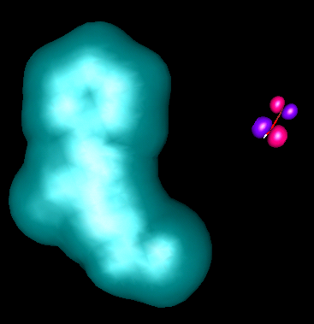

Figure 15: The result of this example should look something like this. The colors may vary depending on which colors you chose for the different surfaces.

4.3 How to create Connolly type surfaces with the program ProbeSurf

The program ProbeSurf in the menu Run can be used to generate a surface of the Connolly type, which is a mesh with grid values from 0 to 100. The value 100 is at the van der Waals value and value 0 is at the van der Waals + max. probe diameter value. The values between 0.0 and 100.0 can be calculated using two methods. The original article describes a method based on the square distance (r²) but the value can now be calculated based on the distance (r) as well. It is possible to generate the surface for different probe values.

The method is based on the article by R. Voorintholt et al. (Voorintholt, R., Koster, M.T., Vegter, G., Vriend, G. and Hol, W.G.J. (1989) A very fast program for visualizing protein surfaces, channels and cavities”, J. Mol. Graphics 7: 243-245.)

- Import a molecule coordinate file through File > Import > Coords.
- Go to File > Export > Input > ProbeSurf where you can write an input file for the ProbeSurf program based on your coordinate file.
- In the “Export input” window which pops up the radio button for “ProbeSurf” is marked on by default. Then type the name of the input file input_file.inp in the text field. To find out to which directory the file input_file.inp is saved, press Browse. In the section “Choose structure #” select the structure for which you want to write the input_file.inp for by pressing the button with number 1 on it and selecting the structure from the list.
- The definitions for the surface can be edited in the text fields for max. and min. values for x, y, and z as well as in the text fields for “Points x/y/z direction”. The probe radius can also be defined, though, usually the default values are ok.
- After all above mentioned has been done, press Apply. Make notice of that in Windows, the input_file.inp must be written into a directory, which name does not contain spaces, because ProbeSurf run through the menu Run will not find the input file if the name of the directory contains spaces, such as C:/Documents and Settings/User/My Documents/gOpenMol/input_file.inp.
- In the following “Display/Edit text” window, where the results of the “Export” command are shown, press Dismiss instead of pressing Save. Pressing Save will give an error message, which can be ignored by pressing Ok, though. Now you should have an input file ready for ProbeSurf and you can close the windows “Export input” and “Display/Edit text”.
- Now go to Run > ProbeSurf and search the input file you just generated through Browse on the line “Input file name”. Then type the name of the output.file in the text field below the input file name and press Apply to run the program.
- To the question “Do you want to read in the contour file?” answer “Yes” if you want to display the contour file and “No” if you want to do it later. If you answered “No”, the surface file can be imported through Plot > Contour. Answering “Yes” will automatically import the surface file and open the “Contour control” window.
- In the “Contour control” window type in the first text field the contour value, e.g., 40 choose a nice color and press Apply to see the newly generated surface in the graphics window.

4.4 How to trace atoms using Trajectory > Trace.

Again, there are model files available in the demo directory.

- Import the opt4pti.crd file through File > Import > Coords and the dyn4pti.dcd trajectory file through Trajectory > Main.
- Display only the backbone atoms of the molecule through View > Atom type
  - Display off all atoms by marking “Display state” “Off” and press Apply.
  - Display only backbone atoms by typing CA,C,N,O to the Atoms-field and marking “Display state” “On”. Press Apply to see the atoms.
  - If extra water molecules are displayed, type HOH into the Residue-field and mark “Display state” to “Off”.
- Open Trajectory > Trace and type into the “Atom” text field CA and press Apply. To display the trace for all CA atoms click the Display state to “On”.

If several traces are to be displayed, mark the box “Append” and do as above in 3) for another atom type. This time the display state can be left “Off” since the second trace will be displayed anyway.

