**Lab Experiment Sheet-1**

School of Engineering and Technology  
Course Code & Name: ENCS351 Operating System

Name: Gopesh Aggarwal

Roll No.: 2301730158

Program Name: B.Tech CSE, (AI-ML) Sec-C, Sem-5

**Task 1:**

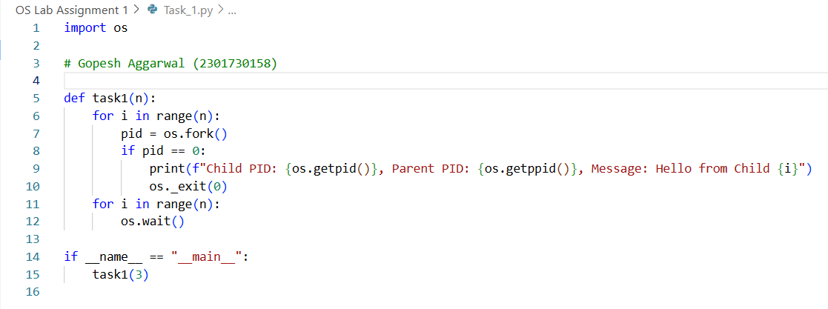

**Output:**



**Task 2:**

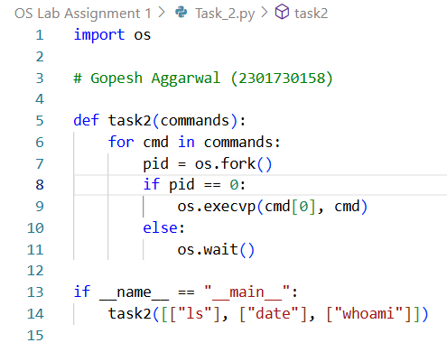

**Output:**



**Task 3:**

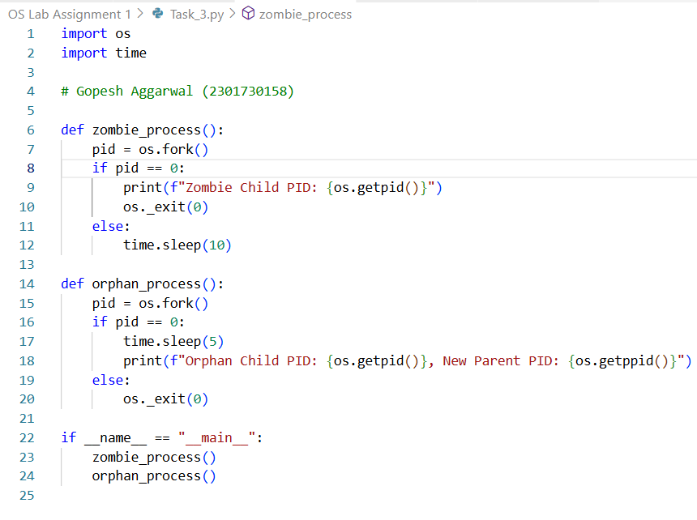

**Output:**



**Task 4:**

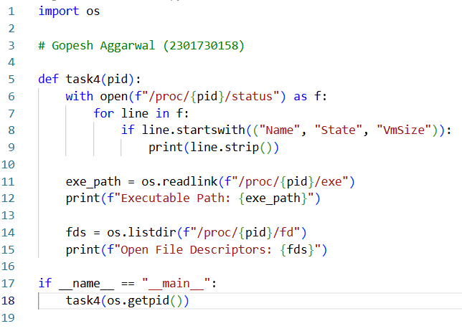

**Output:**

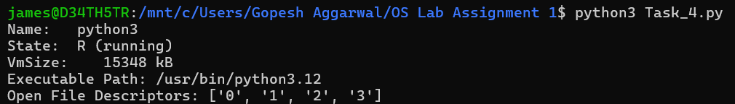

**Task 5:**

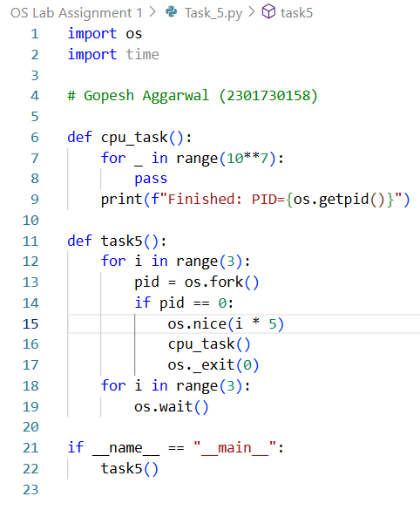

**Output:**

