1. List all the restaurants with THAI cuisine

select r.res_name AS restaurant_name, c.cuisine_name

from restaurant_details r,speciality s,cuisine c

where r.res_id=s.res_id

and s.cuisine_id=c.cuisine_id

and cuisine_name = 'THAI'

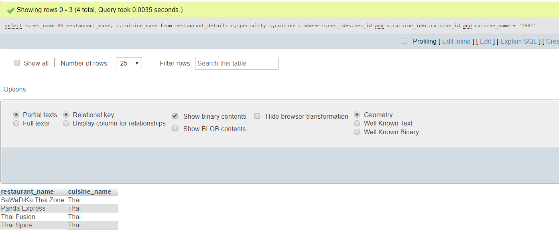

2. List all the restaurants that are closed in Wednesdays or Tuesdays

select r.res_name AS restaurant_name,w.wh_is_closed

from restaurant_details r,schedule s,working_hours w

where r.res_id=s.res_id

and s.wh_id=w.wh_id

and wh_is_closed IN ('Wednesday','Tuesday')

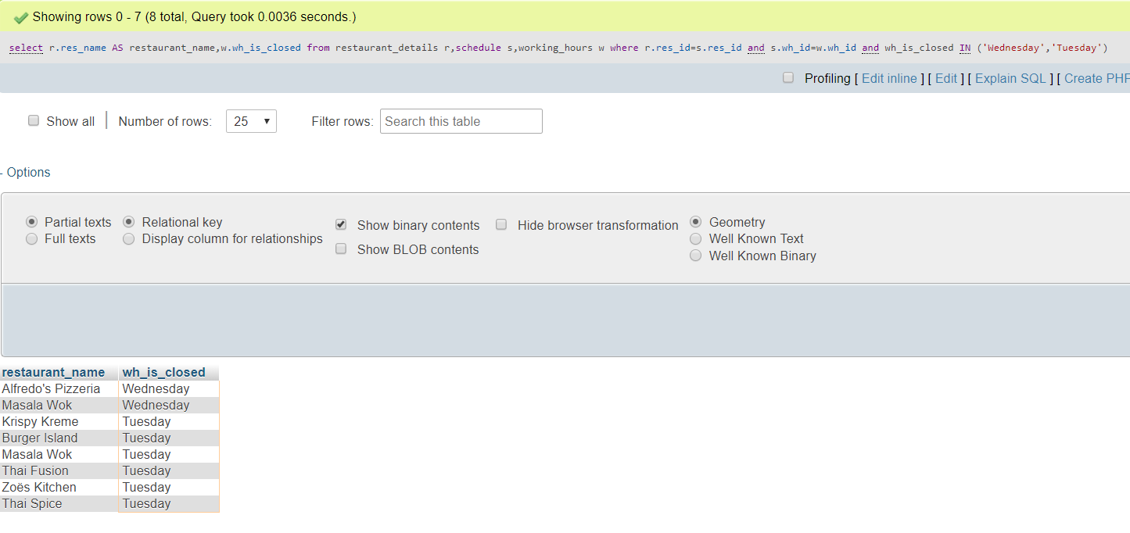

3. Users who paid by cash

SELECT u.first_name, u.last_name, p.payment_type

FROM user AS u, orders as o, checkout AS c, payment AS p

WHERE u.user_id = o.user_id

AND o.Order_id = c.Order_id

AND c.payment_id = p.payment_id

AND p.payment_type = 'Cash'

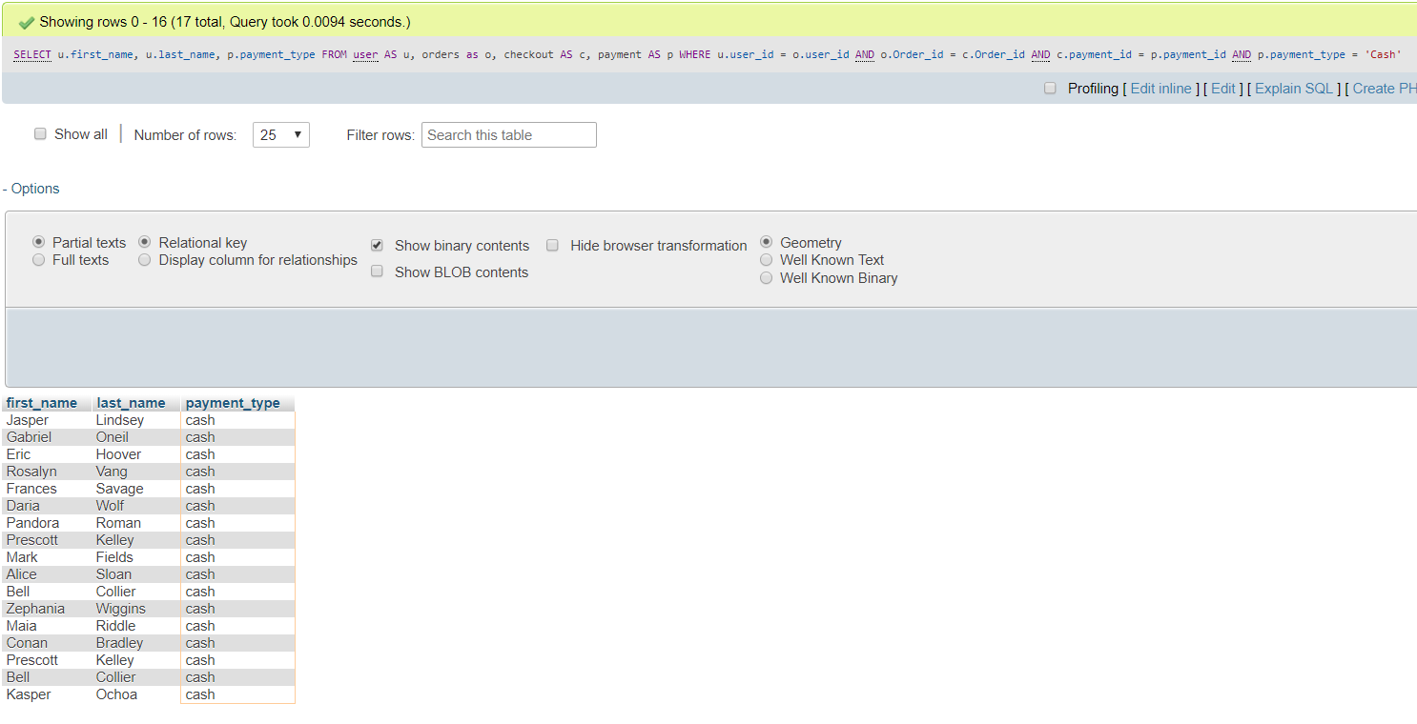

4. List restaurant details having rating greater than 4 and belongs to zip code 75080

SELECT *

FROM restaurant_details

WHERE res_rating > 4

AND res_zip = 75080

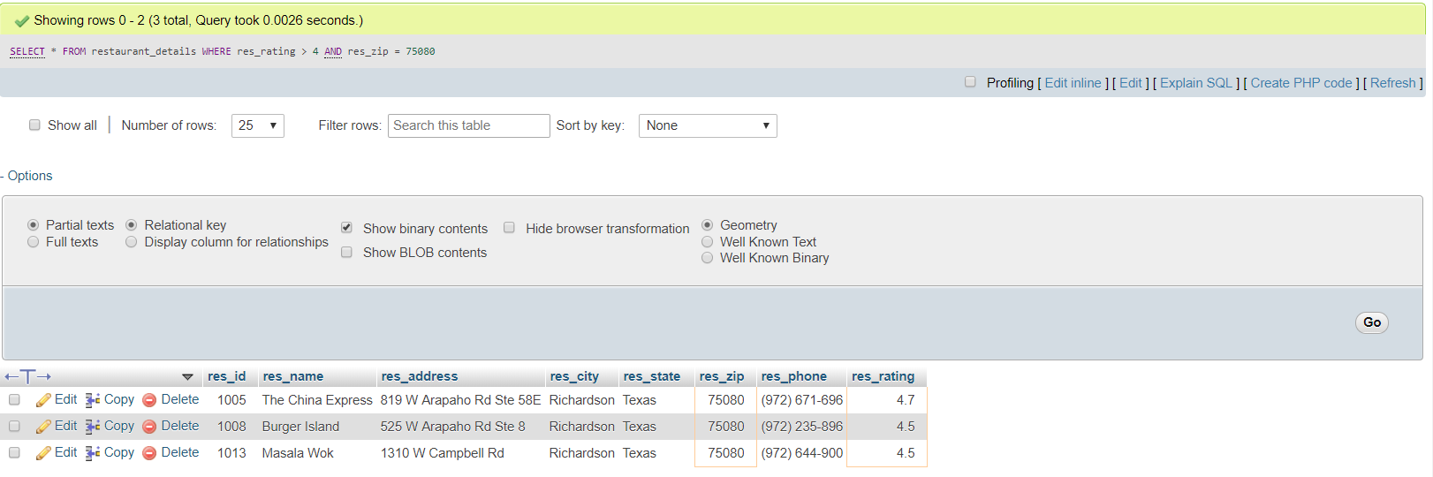

5. List of users who are having order on the way

select u.first_name,u.last_name,d.delivery_status

from user u,delivery d ,orders o,checkout c

where u.user_id=o.user_id

and o.order_id=c.order_id

and d.delivery_status='ON THE WAY';

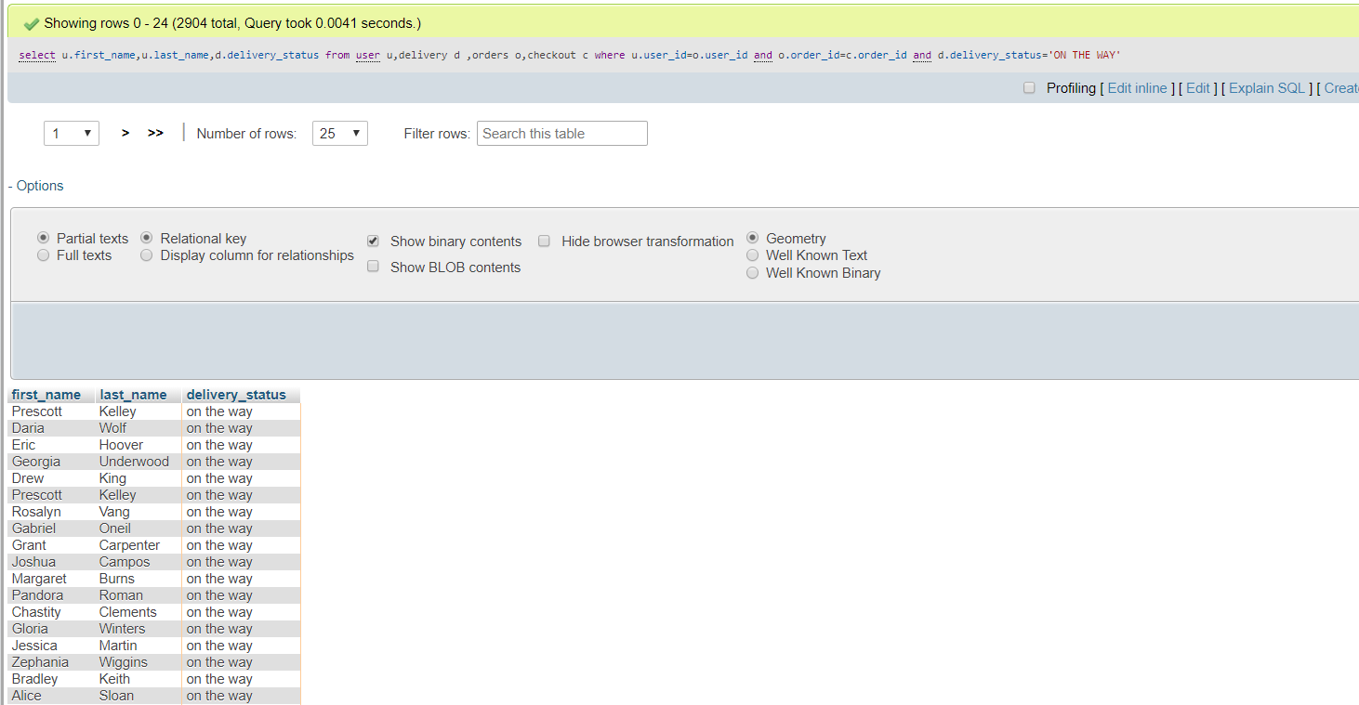

6. Person who paid with highest tip

select u.first_name,u.last_name,t.tip_percent

from user u,orders o,checkout c, payment p,bill b,tip t

where u.user_id=o.user_id

and o.order_id=c.order_id

and c.payment_id=p.payment_id

and p.payment_id=b.payment_id

and b.tip_id=t.tip_id

order by tip_percent desc limit 1;

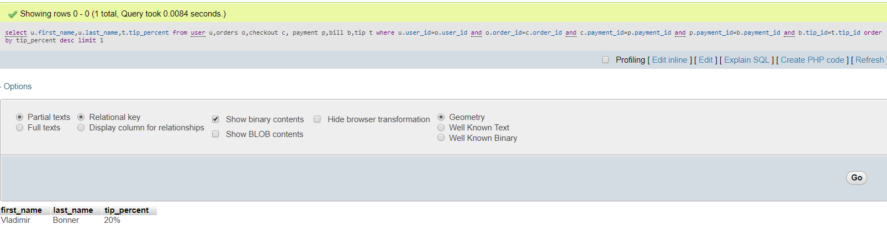

7. City having highest number of restaurants

select res_city, res_zip, COUNT(*) as NoofRestaurants

from restaurant_details

group by res_zip

ORDER BY NoofRestaurants DESC

LIMIT 1;

