1. User

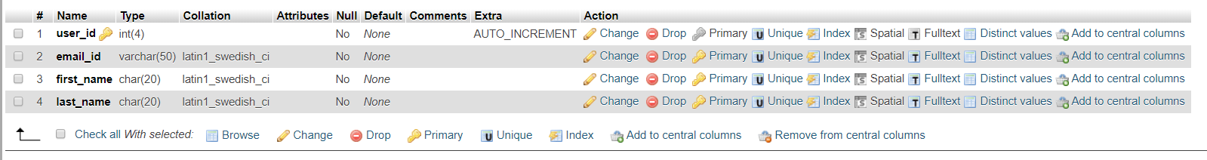

2. Orders

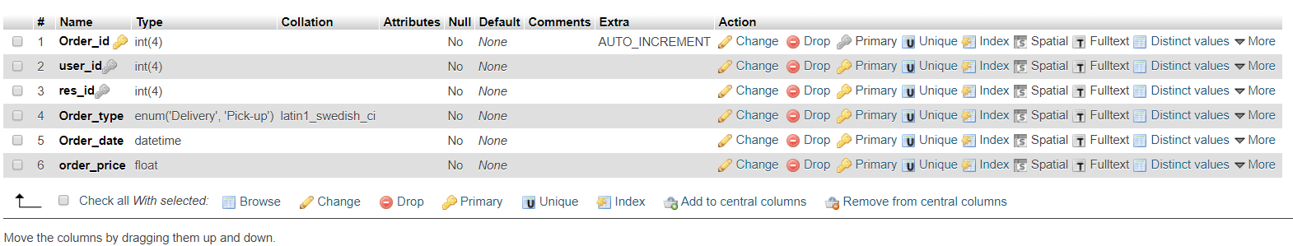

3. Restaurant

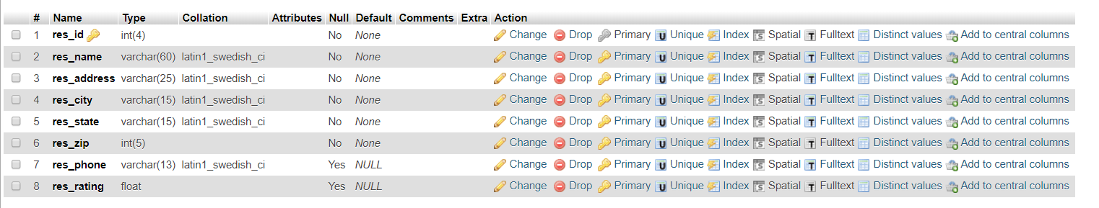

4. Cusine

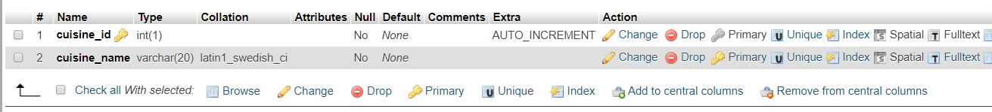

5. speciality



6. Entrée details



7. Menu



8. OrderLine

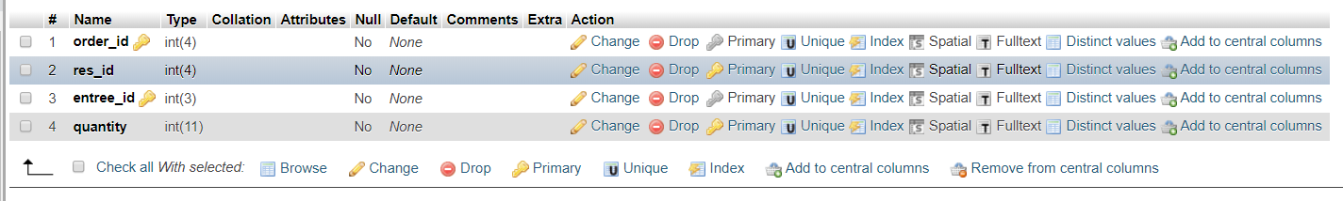

9. Delivery

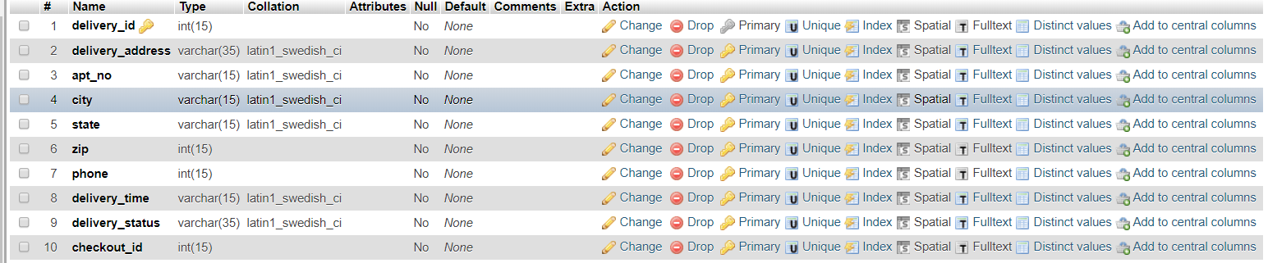

10. Payment



12. Credit card

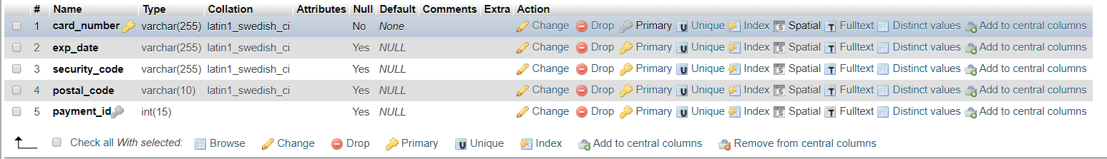

13. Paypal

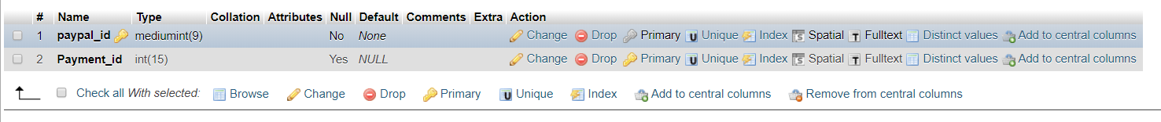

14. Cash

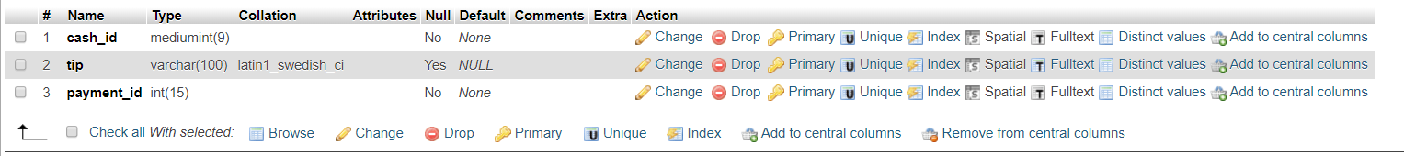

15. Check out

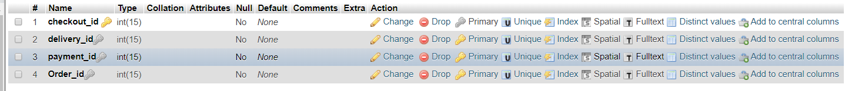

16. Bill

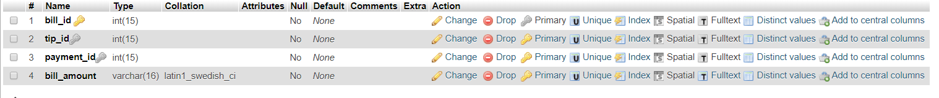

17. Tip



18. Working hours

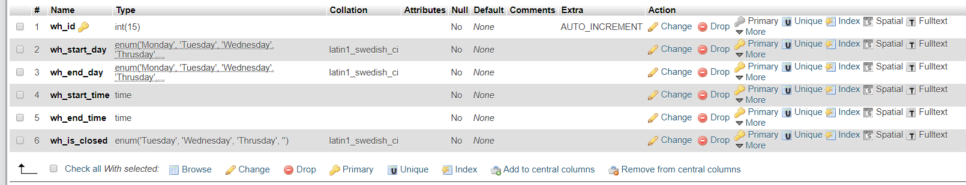

19. Schedule

