CS 3130 Design and Analysis of Algorithms Fall 2018
Q U I Z #2
[6 points]
--------------------------------------------------------------------------------------------
Name: .
1. [3 points] Start your calculations in each problem with a GENERAL FORMULA:
(a) Calculate the sum: 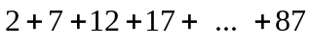=

(b) Find the sum of 10 terms if its first three terms are given as follows:
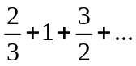{7 more terms}=

\

(c) Find the infinite sum:
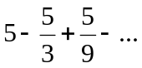=

2. [3 points]
(a) Assuming that 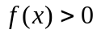and 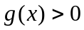, fill in the blanks in the following definition:
 is 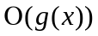if ________________________________ such that ________________
for ____________.

(b) Mark each of the following statements as True or False:
If is 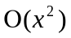, then is 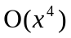 | If is , then is 