CS 3130 Design and Analysis of Algorithms Fall 2018
K E Y T O Q U I Z #4
[14 points]
--------------------------------------------------------------------------------------------
- [1 point] Express 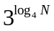 as the power of N  ( that is, N raised to some power).  Answer: =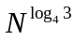 | - [1 point] Express 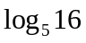 through binary logarithms.  Answer: =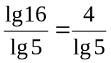
- [4 points] Explain, which function grows faster:
- 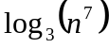 or 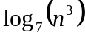  Solution.  Since 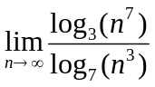= 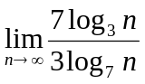=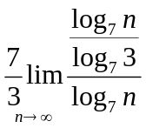=  =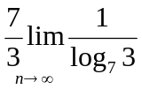=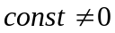,  these two functions have the same order of growth: is 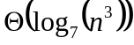 | - 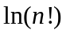 or 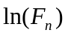, where 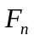 is the n-th Fibonacci number.  Solution.  Since is 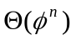  is 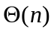.  Also: is 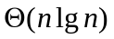. Since grows faster than any linear function, is 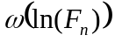,  or: grows faster than .
- [2 points] Fill in blanks in the following definitions:
(a) In a full binary tree, each node has exactly 0 or two children.
(b) In a complete binary tree, all leaves are located at the same depth and each internal node has exactly 2 children.

- [3 points] A complete binary tree has 256 leaves. Find the following:
(a) The number of internal nodes.  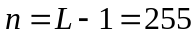 | (b) The height of a tree.  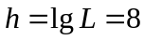 | (c) The total number of links=  =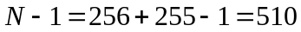
- [3 points] Rank the following functions from the slowest growing to the fastest growing (explanations are not required): 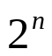, 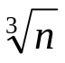, 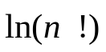, 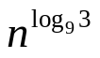, 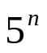, 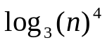, 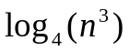
Answer:
     

