CS 3130 Design and Analysis of Algorithms Fall 2018
Q U I Z #6
[6 points]
--------------------------------------------------------------------------------------------

Name: .
Draw a recursion tree representing a recurrence 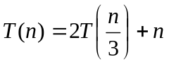. Considering only the exact powers of 3 (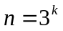), find the height and the number of leaves of this tree as functions of n.

