CS 3130 Design and Analysis of Algorithms Fall 2018
--------------------------------------------------------------------------------------------
KEY TO HOMEWORK #1 [50 points].
Due date: Thursday, September 6, 2018.
A. To do exercises from this part, read a file Finding GCD posted in the folder ‘Handouts’ on MyGateway site.
- (a) Find gcd(213486, 5423) by applying Euclid’s algorithm.
Solution.
gcd(213486, 5423)= gcd(5423, 1989) = gcd(1989,1445) =
= gcd(1445, 544) = gcd(544, 357) = gcd(357, 187) = gcd(187, 170) = gcd(170, 17) = gcd(17, 0) = 17.

- Estimate how many times faster it will be to find gcd(213486, 5423) with the help of the Euclid’s algorithm compared with the algorithm based on checking consecutive integers from min{m, n} down to gcd(m, n) (see the algorithm #2 from the handout).
Solution.
Euclid’s algorithm requires 8 steps. If we only count the number of modulus divisions of the largest number by different divisors, it will be (5423-17+1), or 5407 steps. So, the first algorithms is approximately 677 times faster.

- Prove the formula, on which the Euclid’s algorithm is based:
gcd(m, n)=gcd(n, m mod n) for every pair of positive integers m and n.
One of the possible solutions is:
Let’s write the number m in the form: m=na+r, where a is an integer (quotient) and
r=m mod n (remainder).
- Assume, d divides m and n, which means: m=kd and n=ld, where k and l are integers. Then
r=m-na=kd-lda=d(k-la). It means that d divides r.
- Assume, d is a divisor of r and n, which means: r=dj and n=dl, where j and l are integers. Then: m=na+r=dla+dj=d(la+j). It means that d divides m.
Since both statements are true for any divisor, they are true for the greatest divisor.

B. Read Chapter 1 and sections 2.1 – 2.2 from a textbook. Do the following exercises:
1. 2.1 – 4, p.22.
Solution.
In the fragment of psedocode below, two binary integers are stored in the arrays 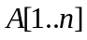 and 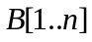, so that the rightmost digit of each binary integer is stored in the element #1 of the corresponding array. Digits are traversed from right to left, which corresponds to traversing each array from the element #1 to the element #n. The result of addition is stored in the array 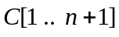.

BinaryAddition(A, B, C)
1 carry = 0
2 for j = 1 to n
3 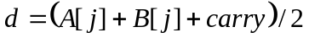
4 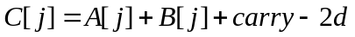
5 carry = d
6 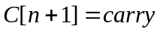

2. Exercise 2.2 – 2, p.29. (Make sure that you answer all FOUR questions in this exercise.).
Solution.
(1)
SELECTION-SORT (A)
1 for j = 1 to A.length -1
2 min = j
3 for i = j + 1 to A.length
4 if 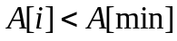
5 min = i
6 exchange 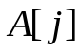with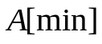

(2) The loop invariant may be stated as follows: before the iteration #j, the subarray consisting of elements 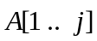constitutes the j smallest elements of the array  in the sorted order (the rest of the array is not sorted yet).

(3) When the algorithm finds the (n-1)th smallest element of the array and exchanges it with the element in the (n-1)th position, the last element will be the largest one, and it will be in the correct position.

(4) The best-case and worst-case running time for the selection sort will be the same (selection sort is not adaptive and performs exactly the same operations for all types of input). For the array of k elements, it takes
k-1 key comparisons to find the minimum element. The total time will be proportional to the number of comparisons, which is:
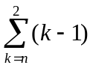=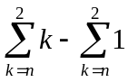=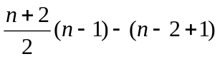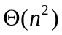

3. Modify the fragment of pseudocode on p.40 so that it will implement bubble sorting algorithm with counting swaps.
Solution.
One of the possible solutions is below:
BUBBLE-SORT-WITH-SWAPS-COUNTING (A)
1 | i = 1
2 | swaps = 0
3 | while 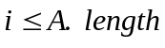 and 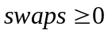
4 | for 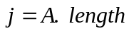 downto 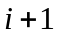
5 | if 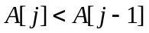
6 | exchange with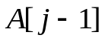
7 | swaps = swaps +1
8 | if 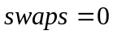
9 | swaps = -1
10 | else swaps = 0

4. Given the following array of characters: R E A L I T Y S H O W
Show how this array will be sorted with the help of : (a) insertion sort; (b) selection sort; (c) bubble sort with swaps counting; (d) bubble sort without swaps counting.
Show the progress of each algorithm in the table (see class notes). For each algorithm listed, find the number of comparisons required to sort the given array.

In all tables below, C is the number of comparisons made on this particular step of the algorithm; S is the number of swaps in the bubble sort.
(a) Insertion sort (double vertical line after the character marks the end of the sorted part of the array).
# of the step |  |  |  |  |  |  |  |  |  |  |  | C
1 | R|| | E | A | L | I | T | Y | S | H | O | W | 1
2 | E | R|| | A | L | I | T | Y | S | H | O | W | 2
3 | A | E | R|| | L | I | T | Y | S | H | O | W | 2
4 | A | E | L | R|| | I | T | Y | S | H | O | W | 3
5 | A | E | I | L | R|| | T | Y | S | H | O | W | 1
6 | A | E | I | L | R | T|| | Y | S | H | O | W | 1
7 | A | E | I | L | R | T | Y|| | S | H | O | W | 3
8 | A | E | I | L | R | S | T | Y|| | H | O | W | 7
9 | A | E | H | I | L | R | S | T | Y|| | O | W | 5
10 | A | E | H | I | L | O | R | S | T | Y|| | W | 2
11 | A | E | H | I | L | O | R | S | T | W | Y||
 | Total number of comparisons |  |  |  |  |  |  |  |  |  |  | 27

(b) Selection sort (double vertical line after the character marks the end of the sorted part of the array; the most recently swapped characters are shown in bold).
# of the step |  |  |  |  |  |  |  |  |  |  |  | C
1 | A || | E | R | L | I | T | Y | S | H | O | W | 10
2 | A | E || | R | L | I | T | Y | S | H | O | W | 9
3 | A | E | H || | L | I | T | Y | S | R | O | W | 8
4 | A | E | H | I || | L | T | Y | S | R | O | W | 7
5 | A | E | H | I | L|| | T | Y | S | R | O | W | 6
6 | A | E | H | I | L | O || | Y | S | R | T | W | 5
7 | A | E | H | I | L | O | R || | S | Y | T | W | 4
8 | A | E | H | I | L | O | R | S|| | Y | T | W | 3
9 | A | E | H | I | L | O | R | S | T || | Y | W | 2
10 | A | E | H | I | L | O | R | S | T | W || | Y | 1
 | Total number of comparisons |  |  |  |  |  |  |  |  |  |  | 55

(c) – (d) Bubble sort with and without swaps counting (double vertical line after the character marks the end of the sorted part of the array; the most recently swapped characters are shown in bold).

# of the step |  |  |  |  |  |  |  |  |  |  |  | C | S
0 | R | E | A | L | I | T | Y | S | H | O | W | 10 | 7
1 | A|| | R | E | H | L | I | T | Y | S | O | W | 9 | 5
2 | A | E|| | R | H | I | L | O | T | Y | S | W | 8 | 3
3 | A | E | H|| | R | I | L | O | S | T | Y | W | 7 | 2
4 | A | E | H | I|| | R | L | O | S | T | W | Y | 6 | 1
5 | A | E | H | I | L|| | R | O | S | T | W | Y | 5 | 1
6 | A | E | H | I | L | O|| | R | S | T | W | Y | 4 | 0
7 | A | E | H | I | L | O | R|| | S | T | W | Y | 3
8 | A | E | H | I | L | O | R | S|| | T | W | Y | 2
9 | A | E | H | I | L | O | R| | S | T|| | W | Y | 1
10 | A | E | H | I | L | O | R|| | S | T | W|| | Y
 | Total number of comparisons without swaps counting |  |  |  |  |  |  |  |  |  |  | 55
 | Total number of comparisons with swaps counting (the algorithm will stop after line #6) |  |  |  |  |  |  |  |  |  |  | 49

- Find how many times the string “CS3130” will be printed in each of the following code fragments:
(a)  i = 0  while i < 3n  print “CS3130”  i = i+3 | (b)  for i = 0 to n  for j = 0 to n  print “CS3130” | (c)  for i = 0 to n  for j = i to n  print “CS3130”
Answers
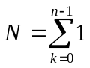=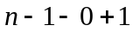=  = | 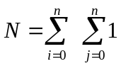=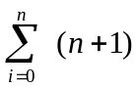=  =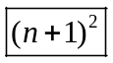 | 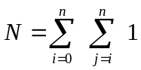=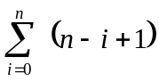=  =1+2+ … +(n+1)=  =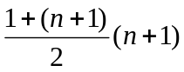=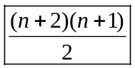
- Problem 2.1 – 3, p. 22.
Solution.
Pseudocode for Linear Search:
LIN-SEARCH (A, v)
1 for i = 1 to A.length
2 if A[i] == v
3 return i
4 return NIL
Loop Invariant:
Just before the iteration #i, the first (i – 1) elements of the array A do not contain v.
Initialization.
When i equals 1, the invariant holds because there are no elements in the array before A[i], which is A[1].
Maintenance.
If the loop invariant holds at the beginning of iteration #i, it means that v is not in A[1 .. i-1]. During iteration #i, the element A[i] is checked: (a) if A[i] is equal to v, the function returns the current index, and a loop terminates when iteration # i is not completed, so the problem will be solved; (b) if the iteration #i does complete, it means that v is neither in A[1 .. i-1] nor in A[i]. Thus, the loop invariant holds.
Termination.
If, after completing the last iteration of a ‘for’ loop the function returns NIL, it means that the value v is not in the entire array. Then, before iteration # A.length+1 (which will not work, of course), the first n= A.length elements of array A do not contain v. It means that the loop invariant holds.

- For the algorithm from the previous problem (linear search), describe the average-case performance in terms of the average number of comparisons used. Assume that the integer v is in the list and it is equally likely that v is in any position.
Solution.
If it is equally likely to find an integer v in some position in the list A[1 .. n], the probability of finding it in any position is 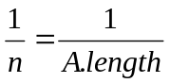. From the table below we see the number of comparisons that we need to find an integer v in the position #i:
i=1 | i=2 | i=3 | i=4 | … | i=n
2 | 4 | 6 | 8 | … | 2n
Calculating the average number of comparisons: 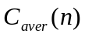=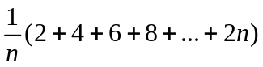=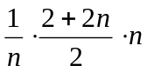=
Problem for 3 extra points.
There are yellow and red apples in a box. You take two random apples from the box. If they are of the same color, you throw them away, and put a red apple into the box. If your apples are of different colors, you throw away the red apple, and put the yellow apple back to the box. Finally, there is just one apple left in the box. Describe how to determine the color of this apple, if you know how many yellow apples were originally in the box.
Solution.
The number of yellow apples may only remain the same or change by 2. The only two possibilities are:
- If the original number of yellow apples was even, then it is impossible to have only one yellow apple left, and the remaining apple is red.
- If originally the number of yellow apples was odd, then the remaining apple will be yellow.

