CS 3130 Design and Analysis of Algorithms Fall 2018
K E Y T O Q U I Z #1
[8 points]
--------------------------------------------------------------------------------------------
1(a) Finish the formula:  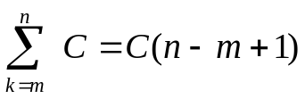 | 1(b) Calculate:  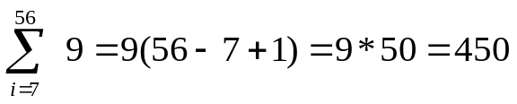
2(a) Finish the formula:  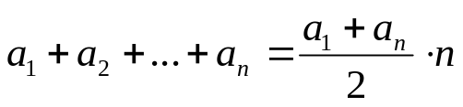  where 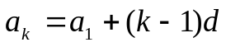, 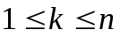  (sum of n terms of arithmetical sequence) | 2(b) Calculate:  5+9+13+ … +205=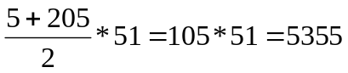
3(a) Finish the formula:  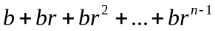=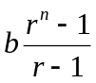 | 3(b) Calculate:  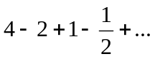=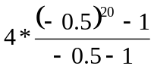=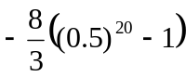  20 terms  (since the power 20 is even)
4(a) Finish the formula:  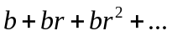=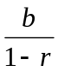  infinite sum; |r|<1 | 4(b) Calculate:  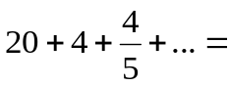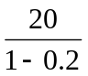=25  infinite sum

