CS 3130 Design and Analysis of Algorithms Fall 2018
K E Y T O Q U I Z #2
[6 points]
--------------------------------------------------------------------------------------------
1. [3 points] Start your calculations in each problem with a GENERAL FORMULA:
(a) Calculate the sum: 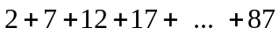=
Solution.
= 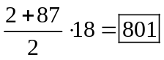 This is a sum of terms of an arithmetical progression with 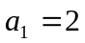, 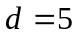, 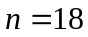 and 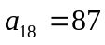.
(b) Find the sum of 10 terms if its first three terms are given as follows:
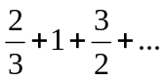{7 more terms}=
Solution.
= 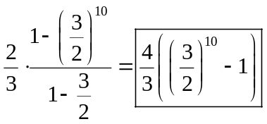
This is a sum of terms of a finite geometrical progression with 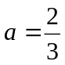, 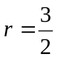 and 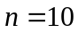.
(c) Find the infinite sum:
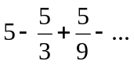=
Solution.
= 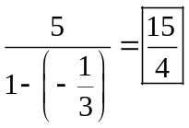 This is a sum of terms of an infinite geometrical progression with 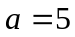 and 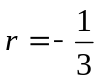. (Note that |r|<1.)
2. [3 points]
(a) Assuming that 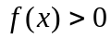and 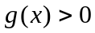, fill in the blanks in the following definition:
 is 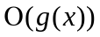if there exist constants and 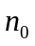 such that 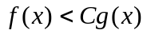for all 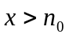.
(b) Mark each of the following statements as True or False:
If is 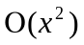, then is 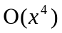 True | If is , then is 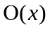 False

