CS 3130 Design and Analysis of Algorithms Fall 2018
K E Y T O Q U I Z #5
[8 points]
--------------------------------------------------------------------------------------------
- [2 points] A binary tree (not necessarily full or complete) has the height 6.
Find the minimum and maximum possible values of each of the following:
The number of internal nodes. |  | The number of leaves. |  | The total number of links.
Max  63  (complete tree) | Min  6  (degenerate tree) | Max  64  (complete tree) | Min  1  (degenerate tree) | Max  126  (complete tree) | Min  6  (degenerate tree)
- [3 points] Rank the following functions from the slowest growing to the fastest growing (explanations are not required):
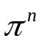, 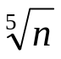, 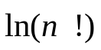, 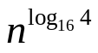, 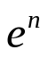, 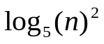, 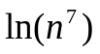, 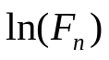
Answer:
{, }, , , , , , .

- [3 points] Use the method of backwards substitution to find the solution of the recurrence:
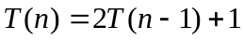; 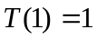.
Solution.
