Example of Using the Recursion Tree Method for Solving Recurrences: 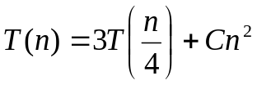
Assume: 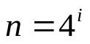 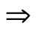 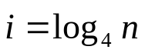 Note that 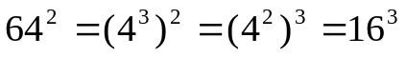.
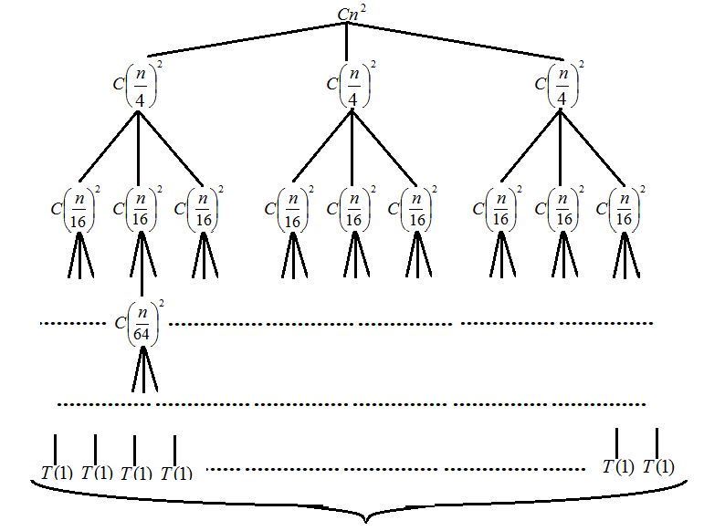 |  | The height  of a tree is:  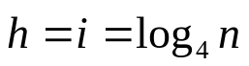
The number of leaves is: 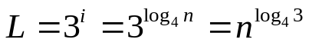. Let T(1)=A
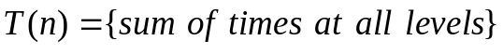=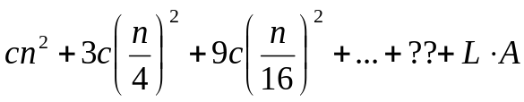=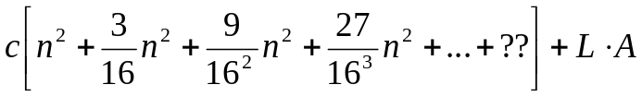=

=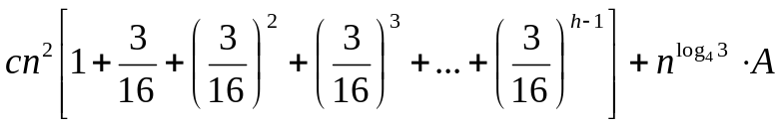=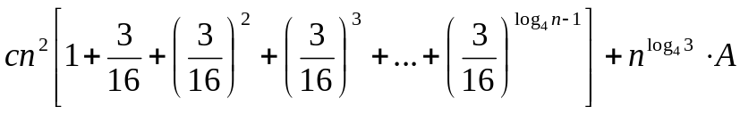=
=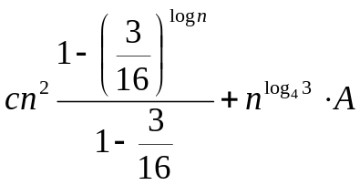.
- Since 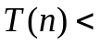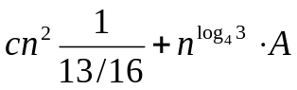=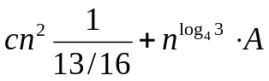=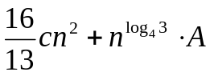<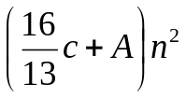, 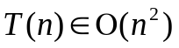.
- On the other hand, 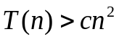, so 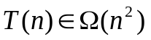.
It means that 