CS 3130 Design and Analysis of Algorithms Spring 2016
K E Y T O Q U I Z #2
[6 points]
--------------------------------------------------------------------------------------------
- [3 points] Assuming that 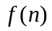>0 and g(n)>0, fill in the blanks in each definition:
- is if there exist constants and 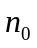 such that f(n)<Cg(n) for all .
~ ~ ~ ~ ~ ~ ~ ~ ~ ~ ~ ~ ~ ~ ~ ~ ~ ~ ~ ~ ~ ~ ~ ~ ~ ~ ~ ~ ~ ~ ~ ~ ~ ~ ~ ~ ~ ~ ~ ~ ~ ~ ~ ~ ~ ~ ~ ~
- is if there exist constants and such that f(n)>Cg(n) for all .
~ ~ ~ ~ ~ ~ ~ ~ ~ ~ ~ ~ ~ ~ ~ ~ ~ ~ ~ ~ ~ ~ ~ ~ ~ ~ ~ ~ ~ ~ ~ ~ ~ ~ ~ ~ ~ ~ ~ ~ ~ ~ ~ ~ ~ ~ ~ ~
- is if there exist constants 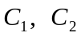and such that for all.
~ ~ ~ ~ ~ ~ ~ ~ ~ ~ ~ ~ ~ ~ ~ ~ ~ ~ ~ ~ ~ ~ ~ ~ ~ ~ ~ ~ ~ ~ ~ ~ ~ ~ ~ ~ ~ ~ ~ ~ ~ ~ ~ ~ ~ ~ ~ ~ ~
- is if for every constant C there exists a constant such that f(n)<Cg(n) for all .
~ ~ ~ ~ ~ ~ ~ ~ ~ ~ ~ ~ ~ ~ ~ ~ ~ ~ ~ ~ ~ ~ ~ ~ ~ ~ ~ ~ ~ ~ ~ ~ ~ ~ ~ ~ ~ ~ ~ ~ ~ ~ ~ ~ ~ ~ ~ ~ ~
- is if for every constant C there exists a constant such that f(n)>Cg(n) for all .
- ~ ~ ~ ~ ~ ~ ~ ~ ~ ~ ~ ~ ~ ~ ~ ~ ~ ~ ~ ~ ~ ~ ~ ~ ~ ~ ~ ~ ~ ~ ~ ~ ~ ~ ~ ~ ~ ~ ~ ~ ~ ~ ~ ~ ~ ~ ~ ~ ~
- [4 points] No proof is required. Given the function 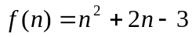, indicate if each of the following statements is true or false:
is 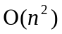 | True | is 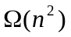 | True | is 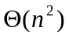 | True
is 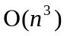 | True | is 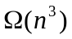 | False | is 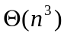 | False
is 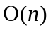 | False | is 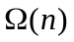 | True | is 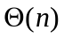 | False
- [1 point] Determine, which function grows faster: 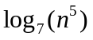or 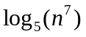. Show your work!
Solution.
Since 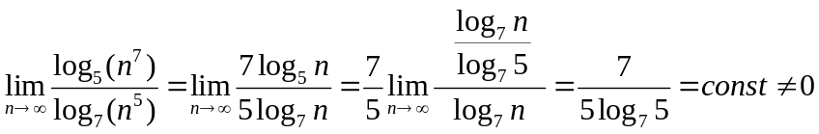, these two functions have the same order of growth.

