CS 3130 Design and Analysis of Algorithms Fall 2018
Q U I Z #3
[8 points]
--------------------------------------------------------------------------------------------
Name: .
- [3 points] Assuming that 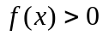and 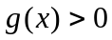, fill in the blanks in the following definitions:
-  is 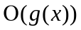if ________________________________ such that ________________
for ____________.
~ ~ ~ ~ ~ ~ ~ ~ ~ ~ ~ ~ ~ ~ ~ ~ ~ ~ ~ ~ ~ ~ ~ ~ ~ ~ ~ ~ ~ ~ ~ ~ ~ ~ ~ ~ ~ ~ ~ ~ ~ ~ ~ ~ ~ ~ ~ ~
- is 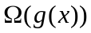if ________________________________ such that ________________
for ____________.
~ ~ ~ ~ ~ ~ ~ ~ ~ ~ ~ ~ ~ ~ ~ ~ ~ ~ ~ ~ ~ ~ ~ ~ ~ ~ ~ ~ ~ ~ ~ ~ ~ ~ ~ ~ ~ ~ ~ ~ ~ ~ ~ ~ ~ ~ ~ ~
- is 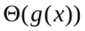if ________________________________ such that ________________
for ____________.
~ ~ ~ ~ ~ ~ ~ ~ ~ ~ ~ ~ ~ ~ ~ ~ ~ ~ ~ ~ ~ ~ ~ ~ ~ ~ ~ ~ ~ ~ ~ ~ ~ ~ ~ ~ ~ ~ ~ ~ ~ ~ ~ ~ ~ ~ ~ ~
- is 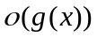if _________________________________ such that ________________
for ____________.
~ ~ ~ ~ ~ ~ ~ ~ ~ ~ ~ ~ ~ ~ ~ ~ ~ ~ ~ ~ ~ ~ ~ ~ ~ ~ ~ ~ ~ ~ ~ ~ ~ ~ ~ ~ ~ ~ ~ ~ ~ ~ ~ ~ ~ ~ ~ ~
- is 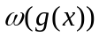if __________________________________ such that ________________
for ____________.
~ ~ ~ ~ ~ ~ ~ ~ ~ ~ ~ ~ ~ ~ ~ ~ ~ ~ ~ ~ ~ ~ ~ ~ ~ ~ ~ ~ ~ ~ ~ ~ ~ ~ ~ ~ ~ ~ ~ ~ ~ ~ ~ ~ ~ ~ ~ ~
- [4 points] No proof is required. Given the function ,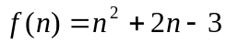indicate if each of the following statements is true or false:
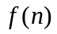 is 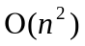 |  | is 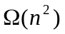 |  | is 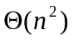
is 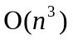 |  | is 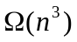 |  | is 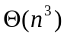
is 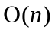 |  | is 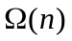 |  | is 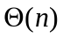
- [1 point] Determine, which function grows faster: 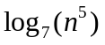or 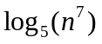. Show your work!

