CS 3130 Design and Analysis of Algorithms Fall 2018
Q U I Z #4
[14 points]
--------------------------------------------------------------------------------------------
Name: .
- [1 point] Express 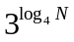 as the power of N  (that is, N raised to some power). | - [1 point] Express 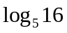 through binary logarithms.
- [4 points] Explain, which function grows faster:
- 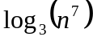 or 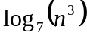 | - 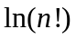 or 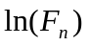, where 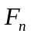 is the n-th Fibonacci number.

- [2 points] Fill in blanks in the following definitions:
(a) In a full binary tree, each node has ___________________________
(b) In a complete binary tree, all leaves _________________________________________ and each internal node
has _______________________________________ .
- [3 points] A complete binary tree has 256 leaves. Find the following:
(a) The number of internal nodes. | (b) The height of a tree. | (c) The total number of links.
[3 points] Rank the following functions from the slowest growing to the fastest growing (explanations are not required):  

