CS 3130 Design and Analysis of Algorithms Fall 2018
Q U I Z #5
[8 points]
--------------------------------------------------------------------------------------------
Name: .
- [2 points] A binary tree (not necessarily full or complete) has the height 6.
Find the minimum and maximum possible values of each of the following:
(a) The number of internal nodes.  max min | (b) The number of leaves  max min | (c) The total number of links.  max min
- [3 points] Rank the following functions from the slowest growing to the fastest growing (explanations are not required): 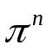, 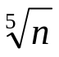, 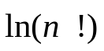, 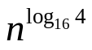, 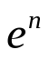, 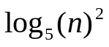, 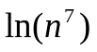, 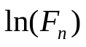

.
- [3 points] Use the method of backwards substitution to find the solution of the recurrence:
 