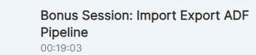
s

- What ever you create in Azure World, there is an ARM template,i.e is an ARM template.
- Inside it (after unzipping) everything is in JSON format
- Even for Datafactory creation also “there is an JSON object get created” and therefor, I can copy this json object and I can go to anywhere else I can try to recreate it
- Note: To recreate any resource ?
Even devops Engineer, they create the templates ie ARM template and with that replication is very easy
- Copy Pipelines from previous account to this account.
- ARM template
- The Azure Resource Manager (ARM) template is a JavaScript Object Notation (JSON) file that defines the infrastructure and configuration for your project. Learn more
- Azure Data Factory can be exported and updated as an ARM template artifact

When migrated to new ADF account, u need to recreate
1)Storage account –adls
2) SQL DB Server
3) SQL DB
4) ADLS – Linked Service
5) SQL – Linked Service

Date 27th & 28th Jan 2024:
Topic ADF Parameterization
 | Example: When you want to pull data from Oracle DB Em table to ADLS locationn  Your steps: 1st check Linked service connect to Oracle DB, if not ask for Uname and pwd(credentials) to your manager | Note: linked service is authentication method to connect to Source (DB)  Linked service is connected to DB Server/DB but not table  No need to create new Linked Service Everytime.  Note: Even for ADLS , u are connecting Linked service to Storage Account Name and Key..  When do we need to change the Linked Service?  Whenever Source changes or Destination changes, then you need new linked service  - When DB server changes  - OR When DB (DB name) changes  - May be username/password is different for a different tables - then we need to change Linked service
 | “For Each” is an Activity | “For Each” is an Activity  Copy is an activity
 | Dataset Paramaterization (to make generic dataset for pipeline):  Dynamic Data ==> Parameters:  No hardcoding  This onlyy works when type of dataset remains same on both sides  I.e it is not changing  Note: Parameterize will work only when Dataset type remains same( is not getting changed)  Ex: IF SQL Dataset is same on Source side- not changing, Becase in Src you are getting as SQL Table dataset as same for customer or product or Address --So only Table names are changing -but not the Datset type(SQL dB table)  Suppose ADLS_CSV_dataset is not changing -- we can use parameterization.  It does not work - if u want to pull 1 dataset as csv, and another as JSON ADLS --because destination dataset type is changing from csv to json etc.  But in src we can change | Dynamic Data ==> Parameters:  Used for dynamic data  Make a Data Set generic ==?>We use paramters schema name  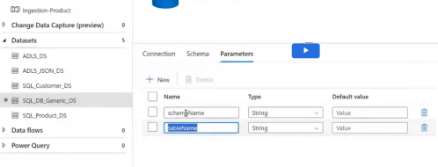  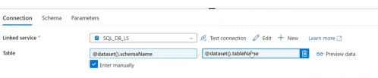  Foldername as parameter generic:  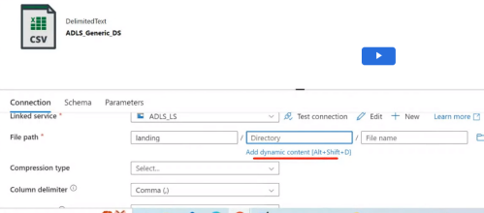  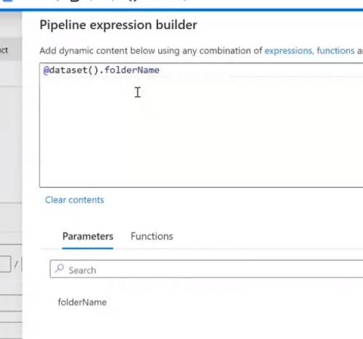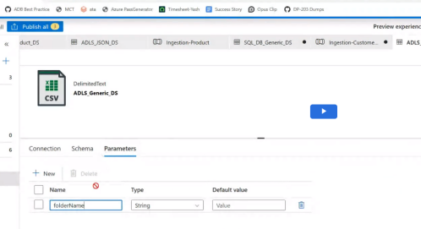  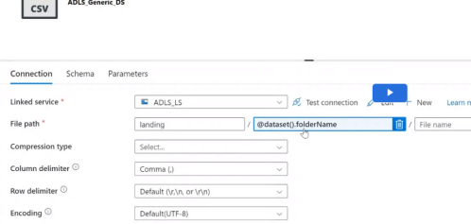
 | Functions: @createArray | Functions: @createArray  All the items in array are Table names
 | When to use ForEach Activity (using arry)?  To run multiple pipelines at once  Time: 1 hr  If you want to pull table data for 100 tables from DB src to 100 destination -- it is not good to have one pipleine, we need to repeat same copy activitiy for 100 times for diff table--  So we use a Loop via “ForEach Activity” Functions + copy Activity  Piple line with For each *item in array[]))  Function used is “createArray” Function  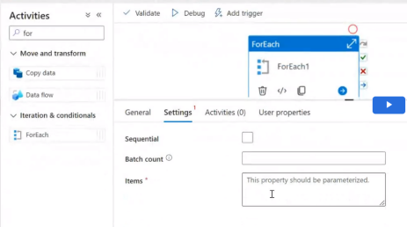  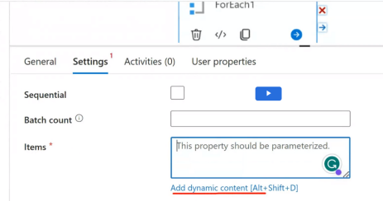  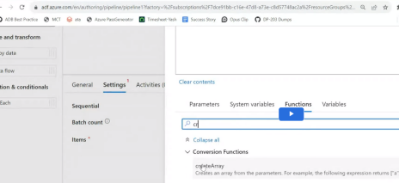  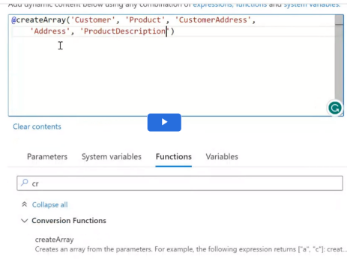  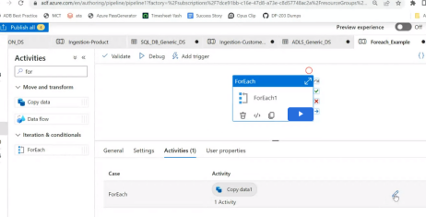  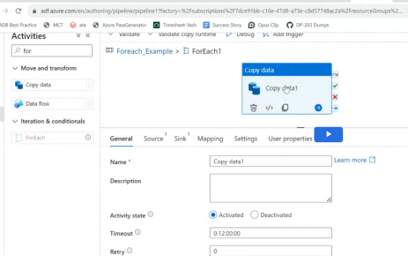  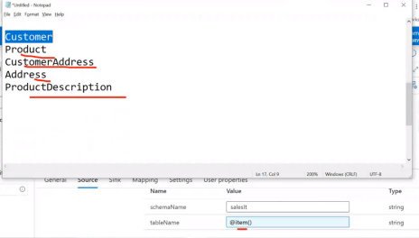  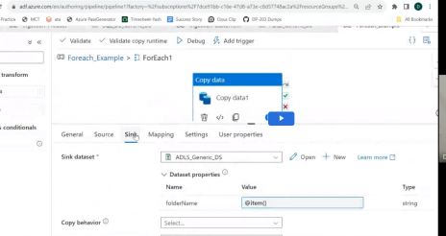  Error Scenario to handle: Run sequentially: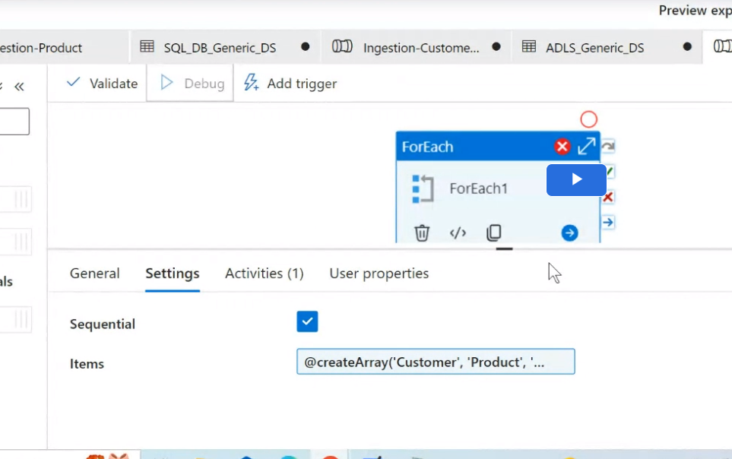  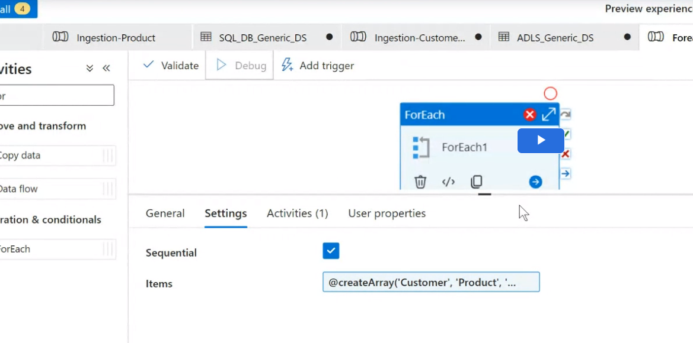  If set to sequential -- iterations runs one by one  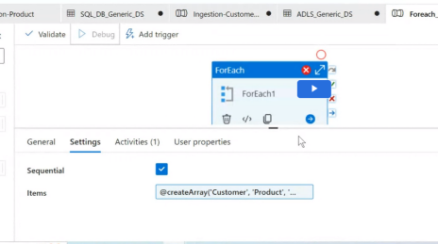  Batch count =2: Runs 2 iterations at once -2 parallelism (by default 5, max 50)  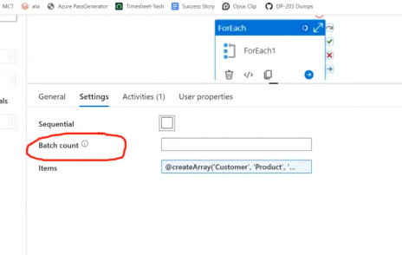  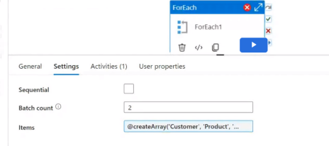  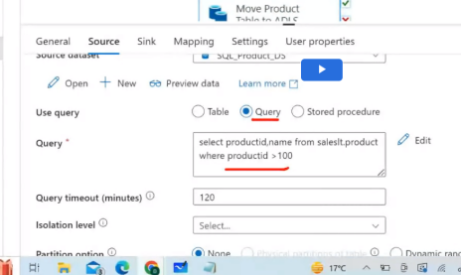  Query used for joins, Filter records etc(instead of complete table pull - if we need specific records) | Problems with “For Each Activity”problems ++ Generic dataset:  It overloads the source ie Database src-- It cannot handle too many requests Because it is on premise (not cloud ie not scalable solution), Source might repsond very very slow.(because pulling happens from source). But it might not be problem on ADF or Destination ADLS (because they are cloud service and computationally high + scalable solutions)  - Performance issues --solved by  a) sequential run - Make For Each sequential one by enabling sequential run, pipeline run one by one(no parallel)  B) Parallels run -using “Batch count” value -- decide how much parallelism is there, how many need to run parallel is decided by setting Batch value  - Maintain issue will be difficult/Error Issue = if something breaks, you need to handle it manually --Single error, run that particular error pipeline separately, instead of re-run all those 4 pipelines (if 100 table pipeline, if 5 fail, you have to re-reun 100 pipeline)  How to solve Error? Run manually  1)Sequential run -- one by one  OR 2) Batch count -- parallelism (Max batch count =50)  Decide based on amount of data?  If you run multiple pull from same activity -- you might encounter performance/Error issue
 |  | You can use Sequential Data?
 | Look up (see/look & get infor) Activity  Look up activity : To give small piece of information which can be used as input to next activity: No need to save it  Ex: Small piece here is record count  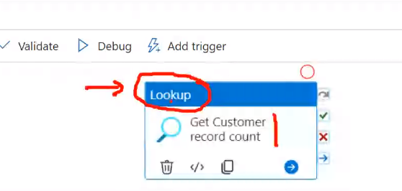  Lookup is done using SQL Query  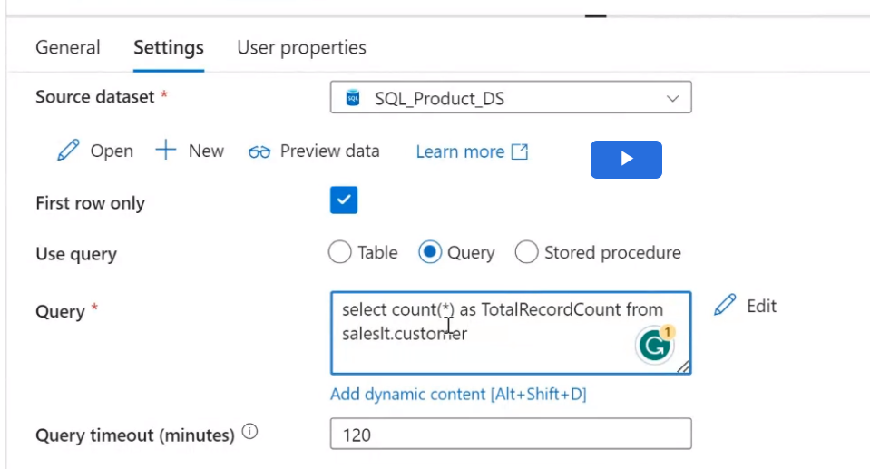 | - Is used to give(fetch) some small piece of information and no need to save,  - Lookup Activity limitation that max 4000 rows or max 4MB data  Note: Copy Activity copies data from src to sink ,It saves data and keep it available to you and you can take next step based on available data.But lookup does not save data in general,it just pul data and make available to you
- 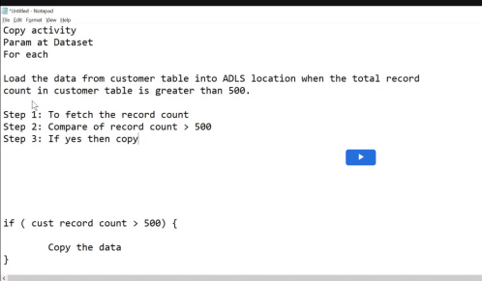

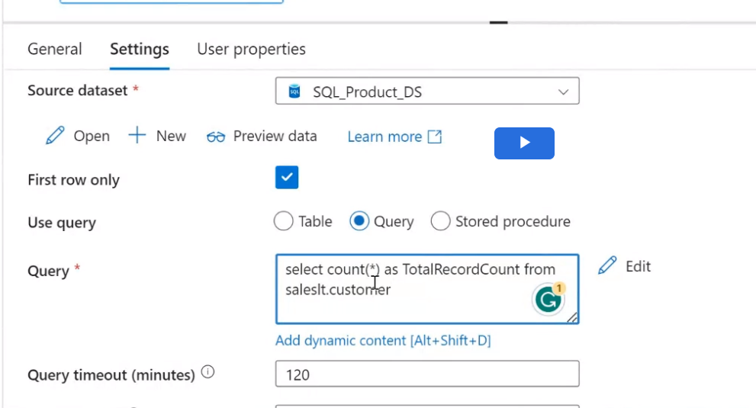

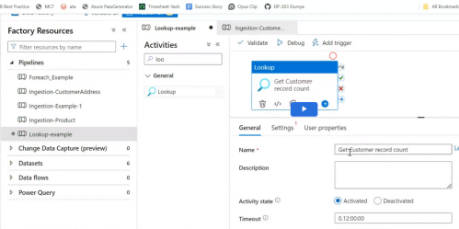

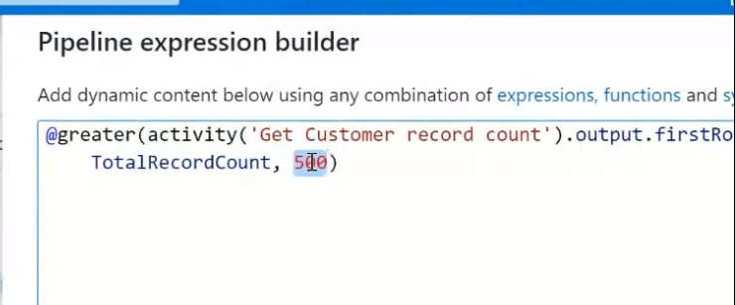



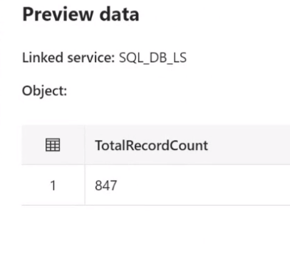

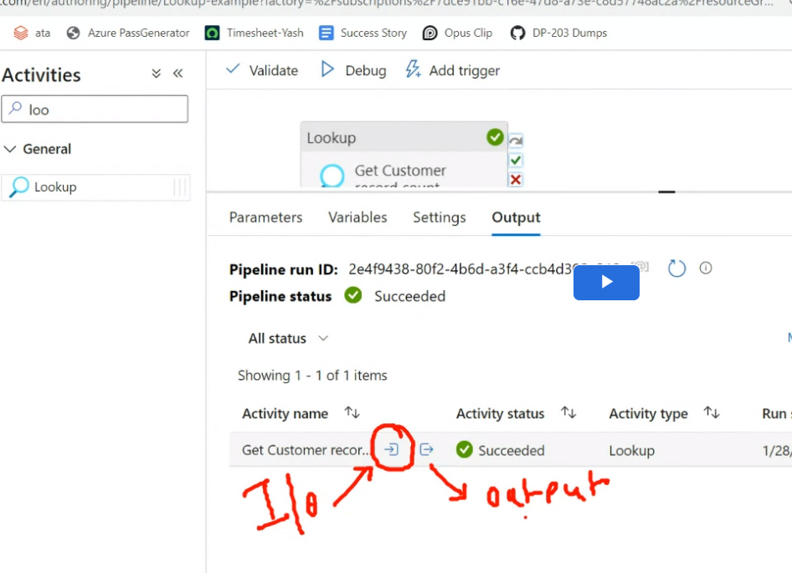

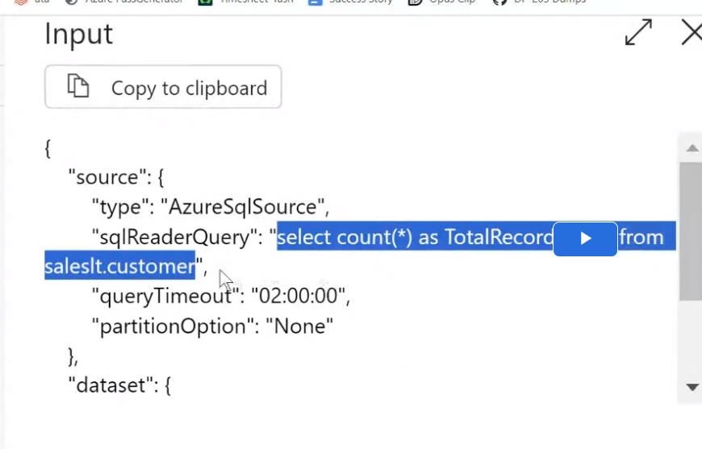

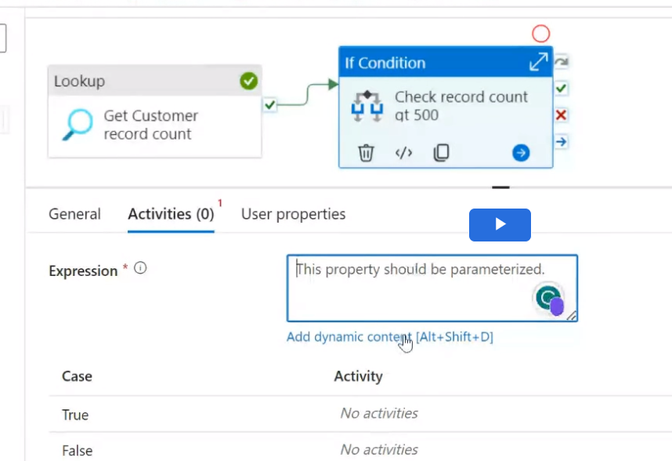
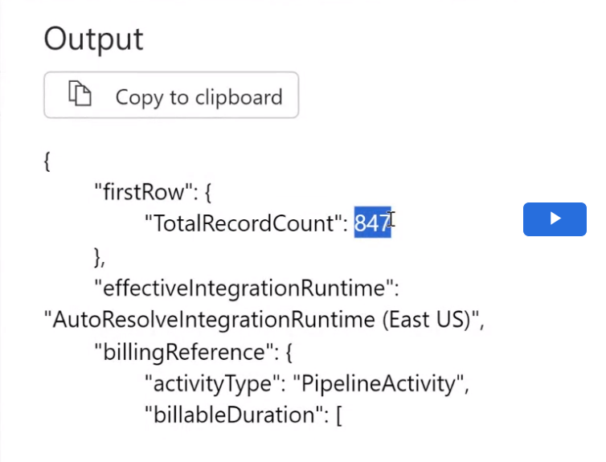


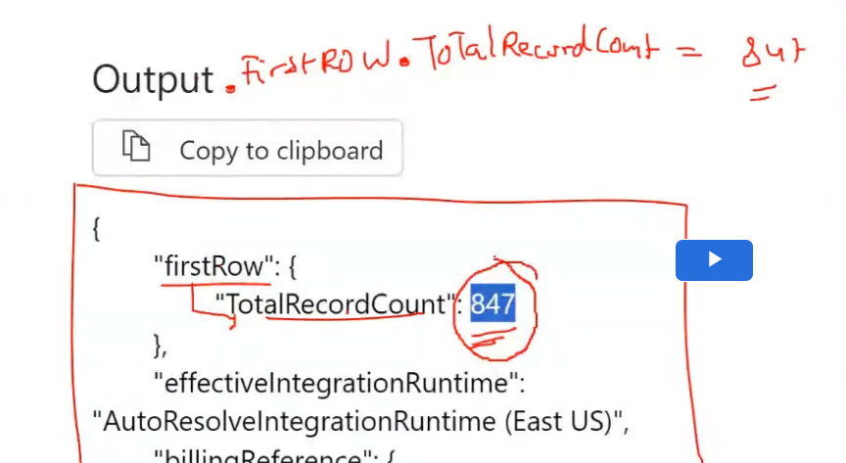

 | IF Activity (To compare)  Note: call if Activity --> only IFFs Lookup activity is successfull  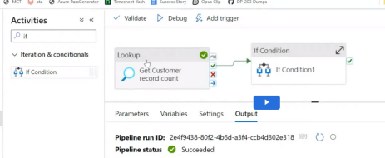  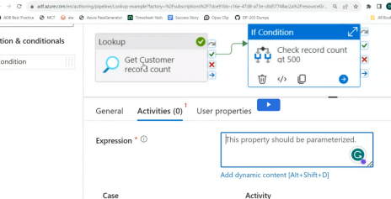  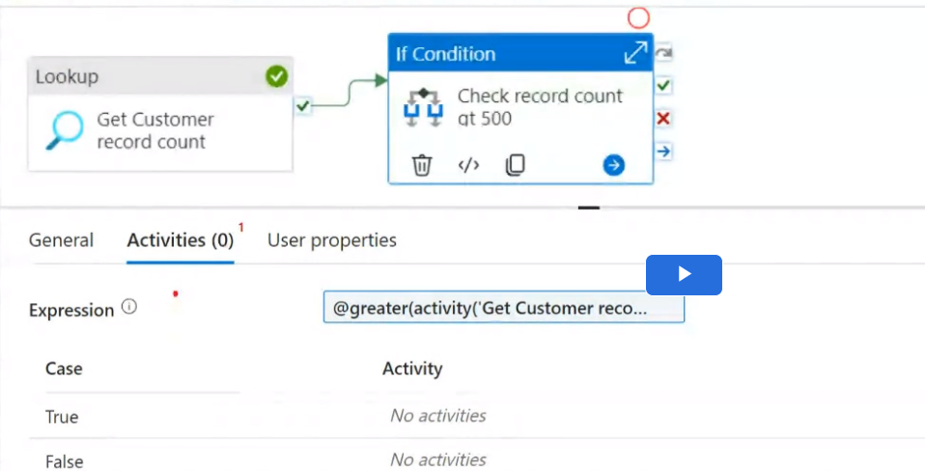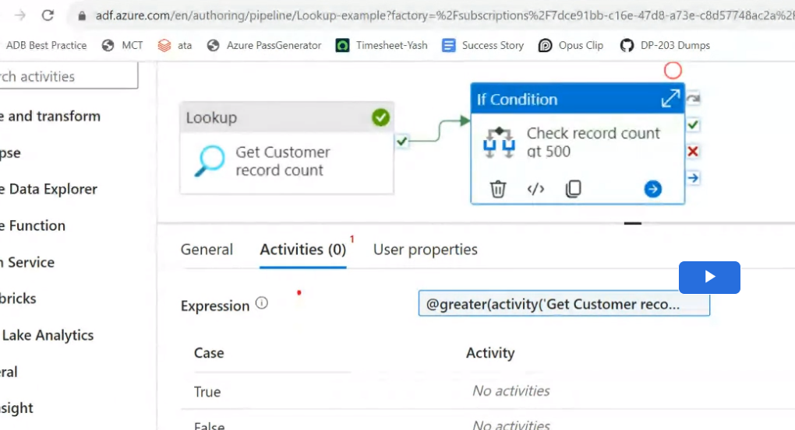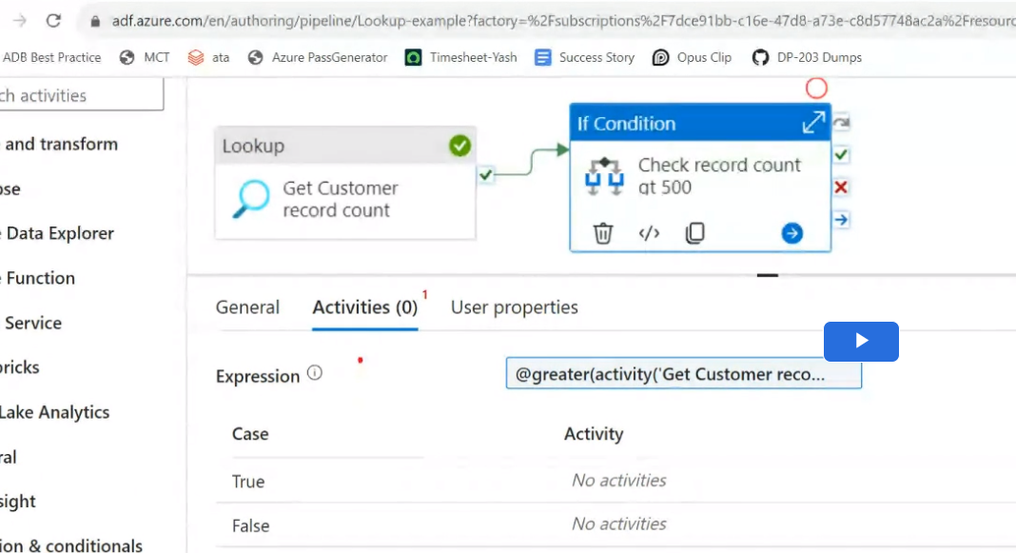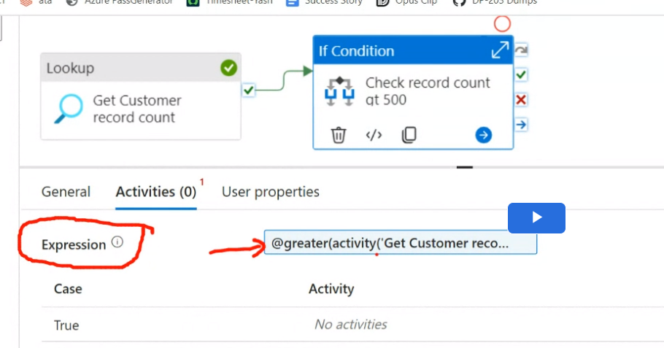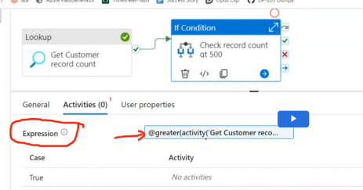  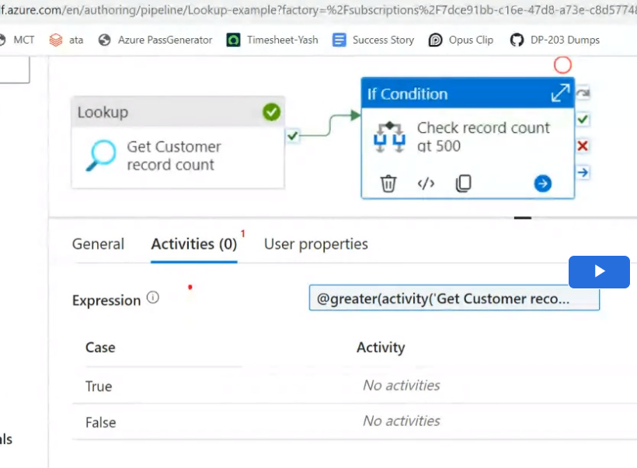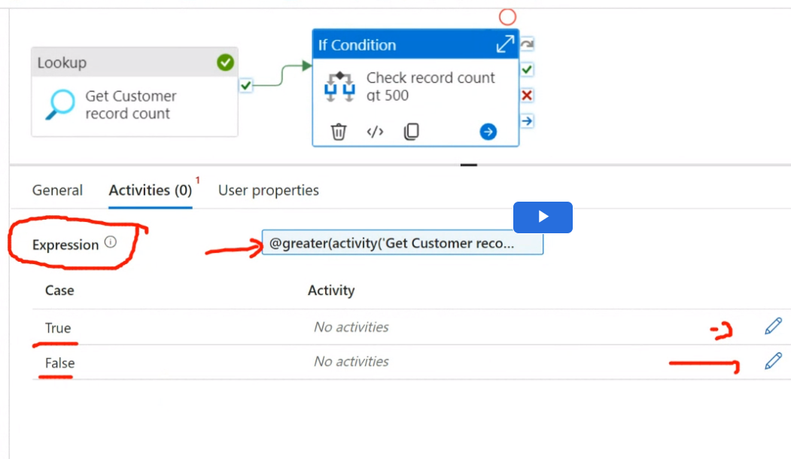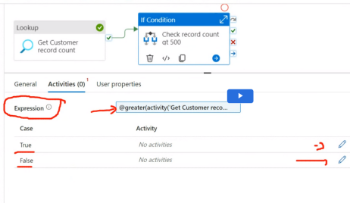  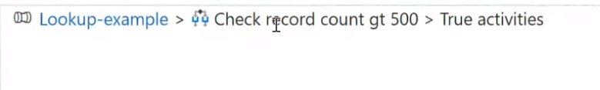  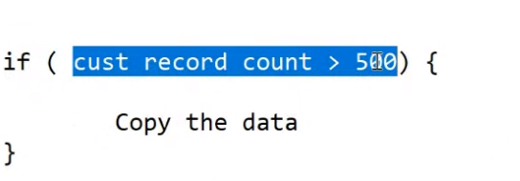  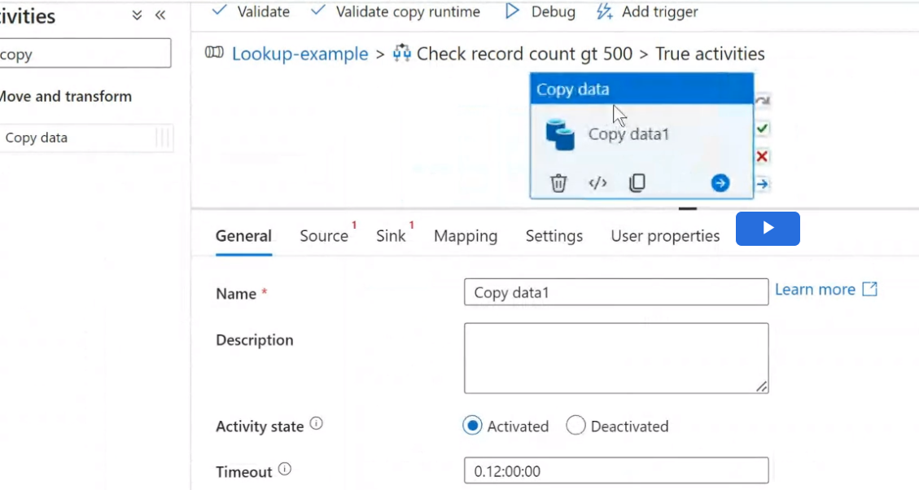  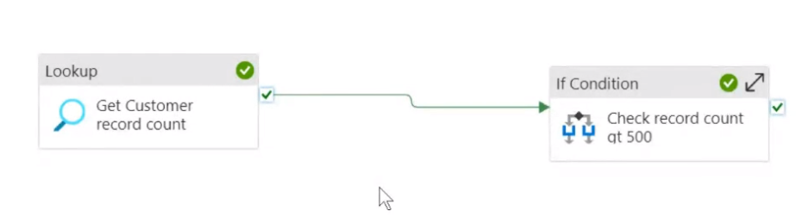  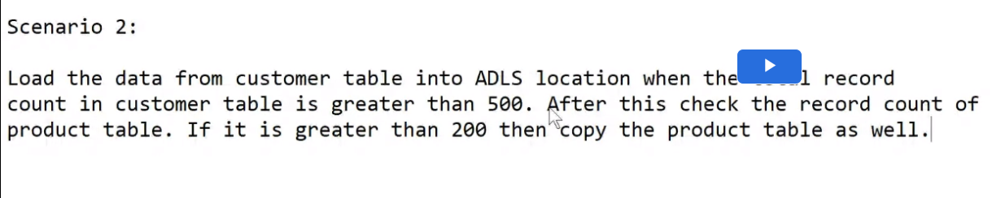 | 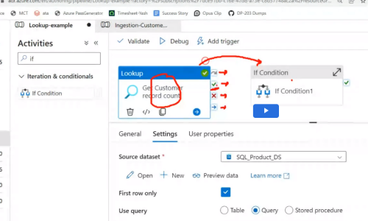  Output of Lookup is:    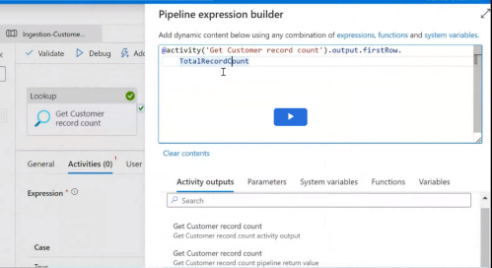  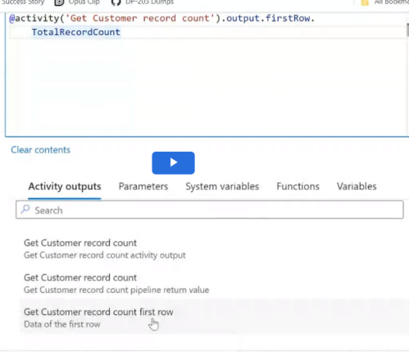  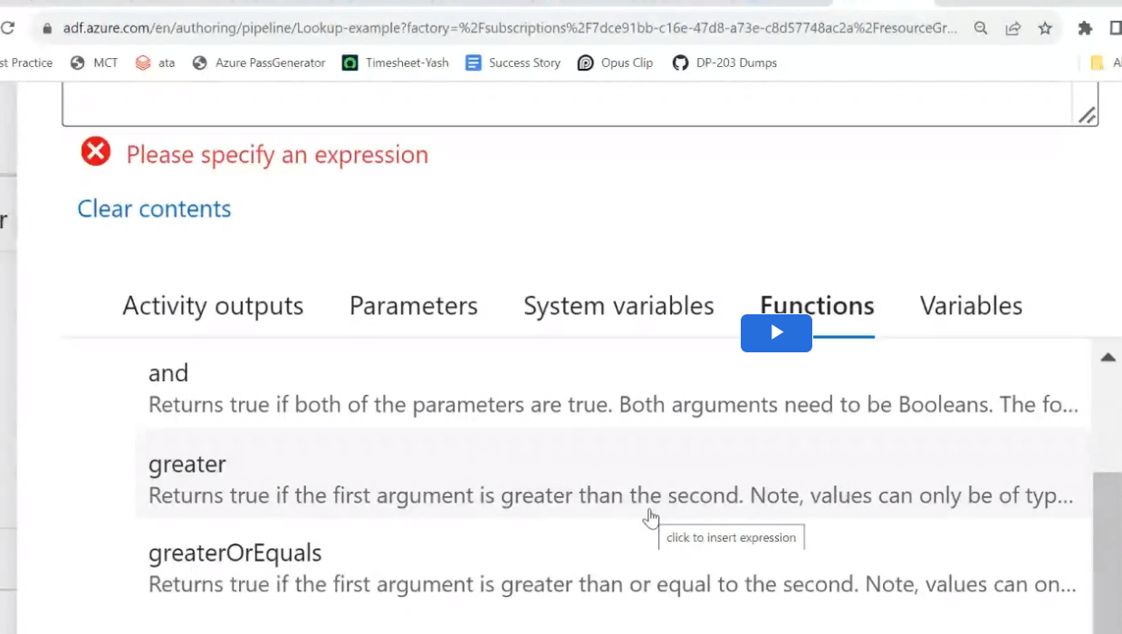    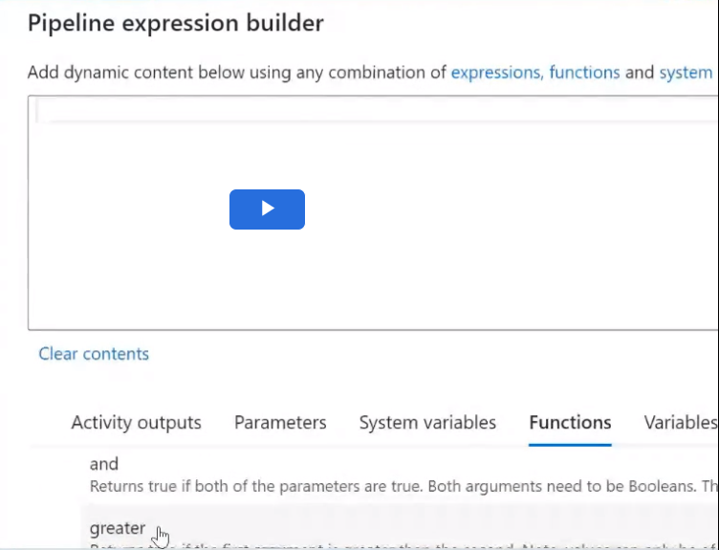  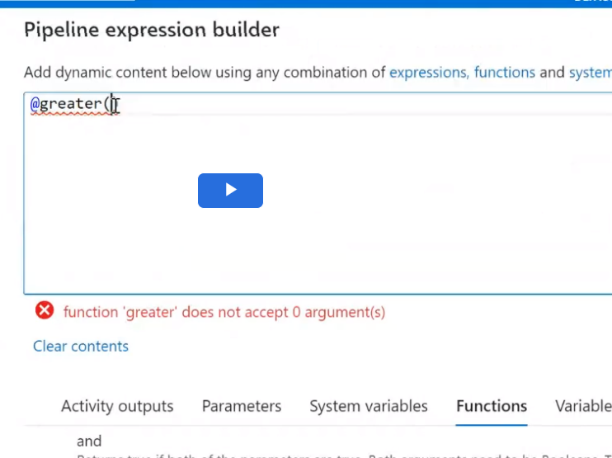  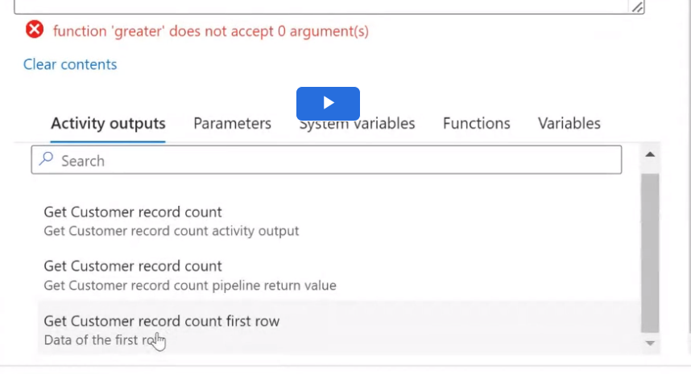  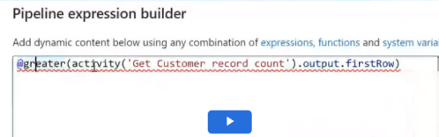  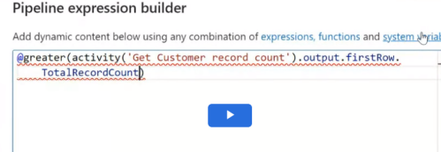  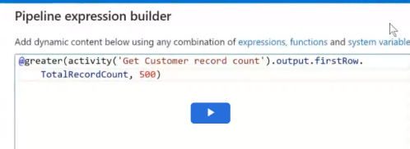
 | “Nested If” - is not allowed in ADF: “Solution”: is you need to “Break the pipeline” (make it 2 pipeline) - Instead of 1 Pipeline make it 2 pipeline and make some connection between them  USE “EXECUTE” PIPELINE  Example: Execute Pipeline  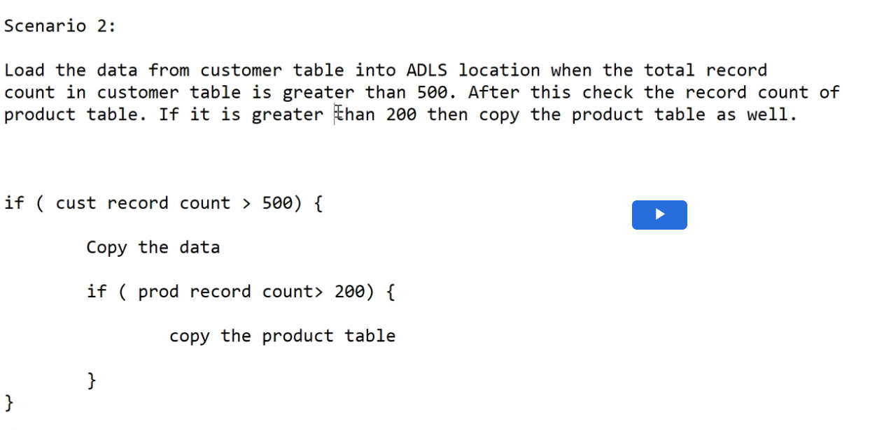  Solution:  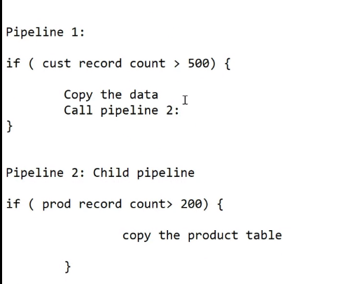 | 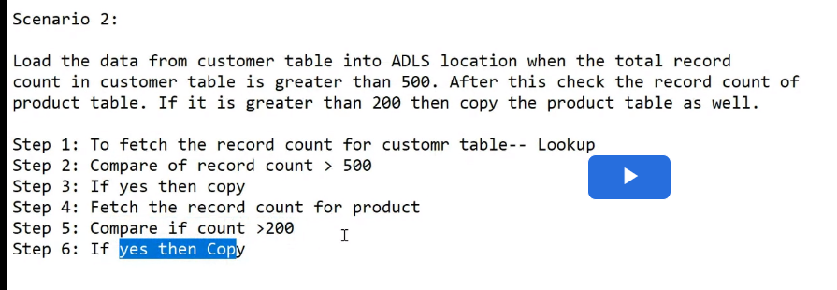  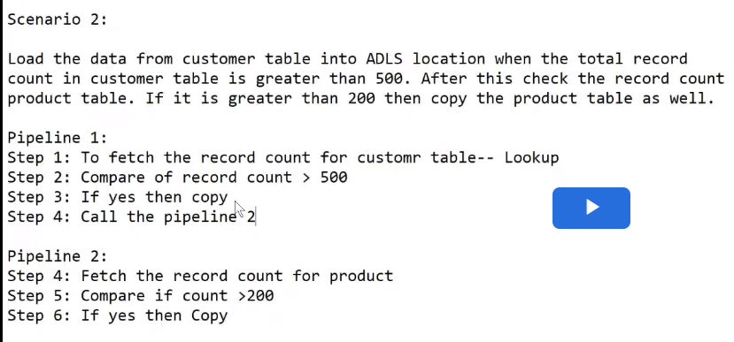  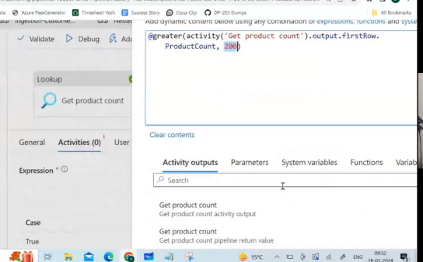  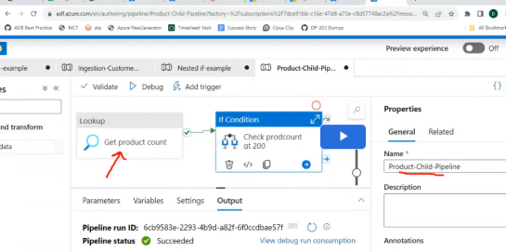  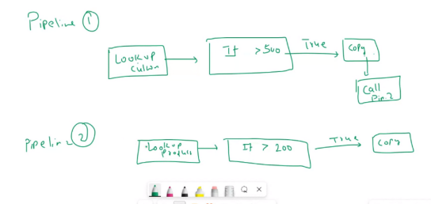  How to call pipeline2?  Use “Execute Pipeline” Activity to call Pipeline 2  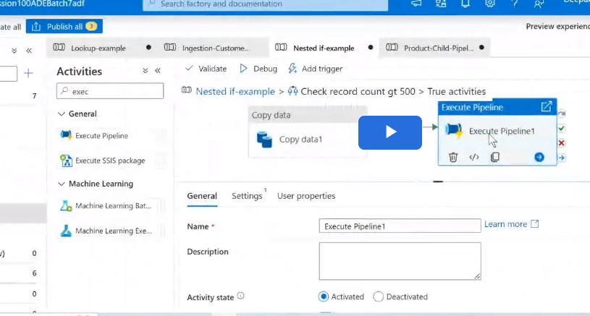  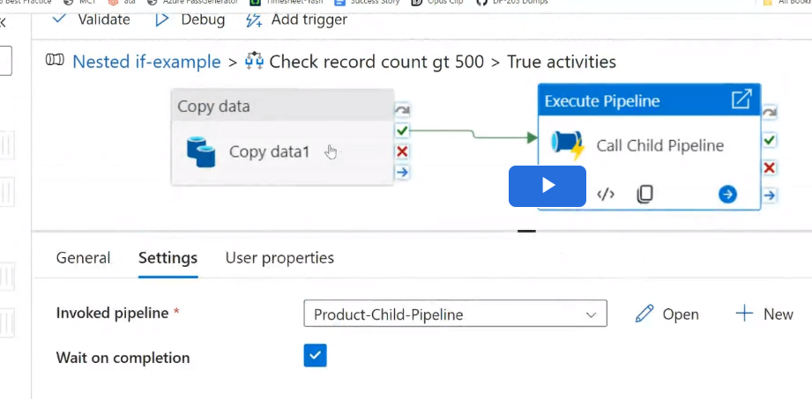  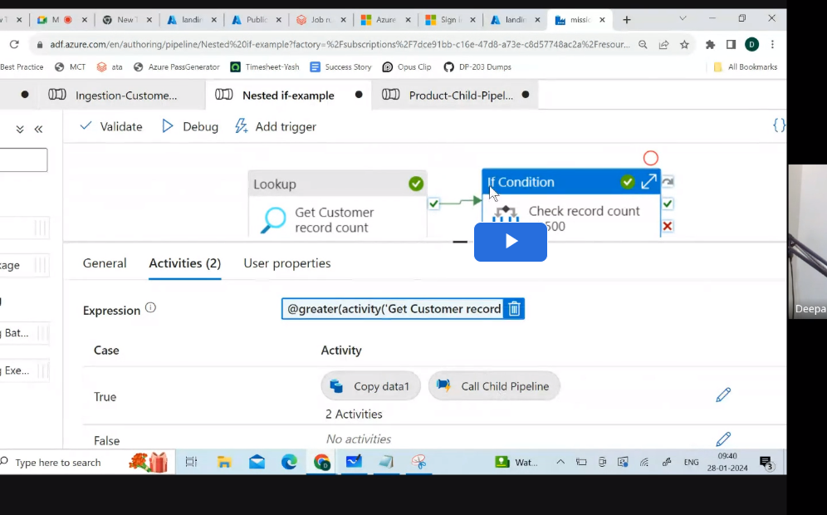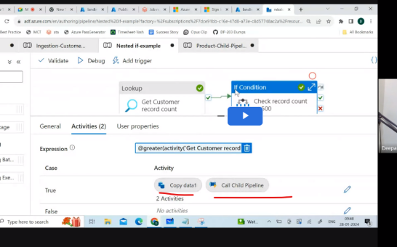  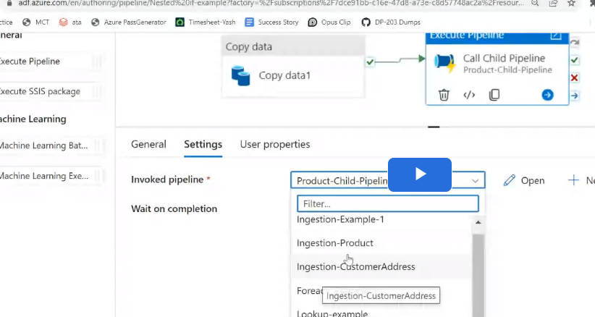    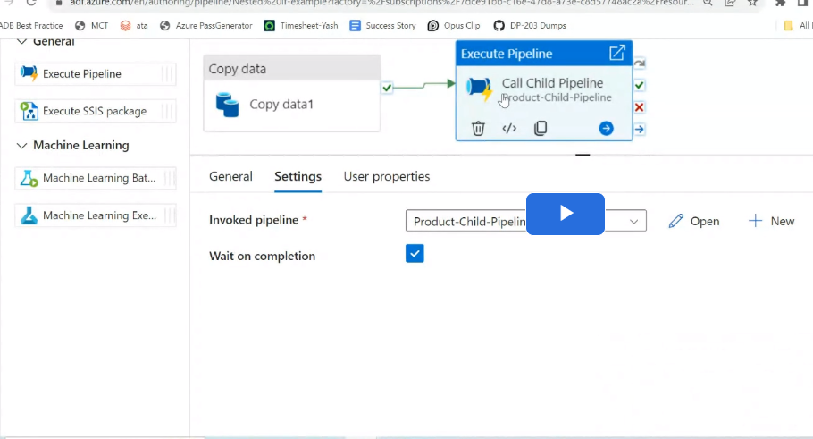
 | Upload a property file:  Upload .txt(or .csv) thereshold value file in landing container  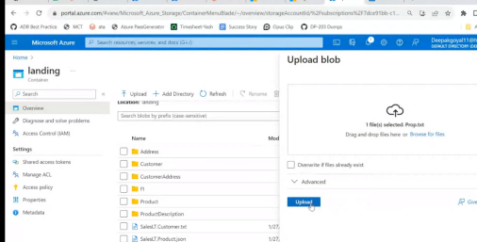 | Instead of reading DB, Read from a .txt file  Lookup for values from .txt file in aDLS location:  Example:This file contains a threshold value.  Create a pipeline  in such a manner that, it will first get the threshold value from this file and then check if the record  count in the customer  table is more than it or not. If yes then copy the customer data from SQL db to ADLS location in JSON  format.  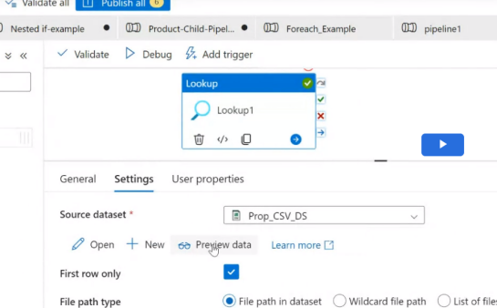  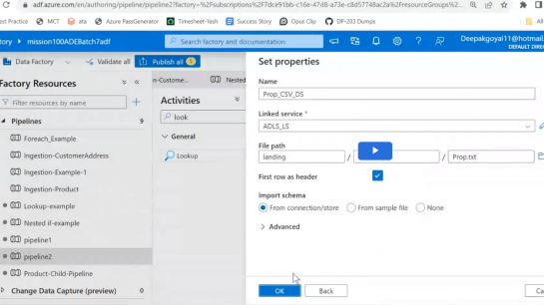  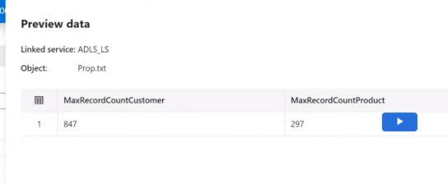  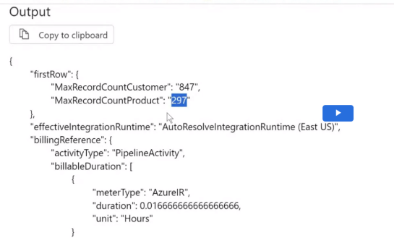
 | Save Data in Dynamic file based on Timestamp -- Do not overwrite same values?  How? Add Dynamic content - using “String Interpolation” method  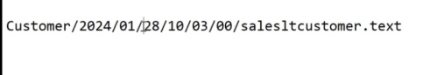  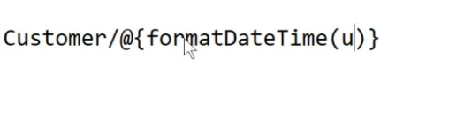  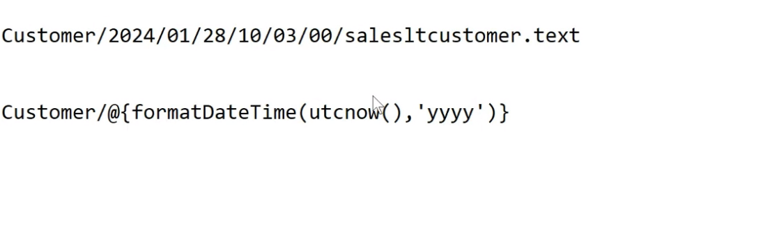  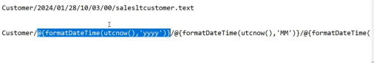  This solves overwriting-- so everytime new folder gets added  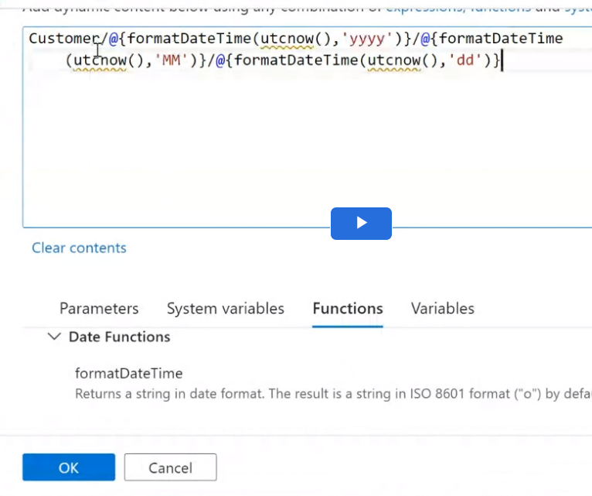 | 