Assignment 5: ADF Pipeline 2
Azurelib Academy

1. Create a pipeline name 'Ingestion_Customer_SQLDB_ADLS' which will copy all the records from Customer table to ADLS account as CSV File.

2. Create a pipeline name 'Ingestion_Customer_SQLDB_ADLS_Folder' which will copy all the records from Address table to ADLS account inside the 'Address' folder as CSV File.

3. Create a Pipeline name 'Ingestion_Customer_JOIN_ADLS' which will copy the all the customer names along with their address into the csv. (Hint Join Customer+ Customer Address table)

4. Create a pipeline name 'Ingestion_Product_To_JSON' which will copy all the product records as JSON only if total number of records >10.

Tough Question

5. Create a pipeline name 'Ingestion_Product_Addres_To_JSON' which will copy all the product records as JSON only if total number of records >10. After that check total record count in address table if they are greater than 100 then copy the adress table data as CSV in ADLS.

Assignment 6: ADF Pipeline 3
Azurelib Academy

Easy Questions:

1. Create a pipeline name 'Without_Foreach_Example' to copy the Customer & Customer address table data into ADLS without using foreach activity.

2. Create a pipeline name 'Foreach_Example' to copy the Customer & Customer address table data into ADLS using the one copy activity.

Tricky Questions:

3. Create a pipeline name 'Foreach_Example_2' which solves the following business use case.

Customer data is very important for our business. Hence whenever we have more than 100 records in the customer table,

we copy the customer data to another table customer_copy within the sql db.

However whenever we do this copy, we first truncate the table 'customer_copy' and then copy the data from 'customer' table

Hint : Use ADF to solve this problem.

4. Business wants to move the data from 3 different tables (Customer, Product, CustomerAddress) to ADLS location in CSV format.

However they want the make a pipeline in such a manner that All these copy happens through an individual pipeline, which is called by

one common pipeline.

5. In the above case problem is that every time the pipeline runs it will overwrite the data. Ensure that all the data goes into

Folder like (Customer/Year/Month/Day) to avoid any overwriting. Please rewrite the pipeline.

6. I am attaching a file, load this file into your ADLS location. This file contains a threshold value. Create a pipeline

in such a manner that, it will first get the threshold value from this file and then check if the record count in the customer

table is more than it or not. If yes then copy the customer data from SQL db to ADLS location in JSON format.

Assignment 5:
1. Create a pipeline name 'Ingestion_Customer_SQLDB_ADLS' which will copy all the records from Customer table to ADLS account as CSV File.

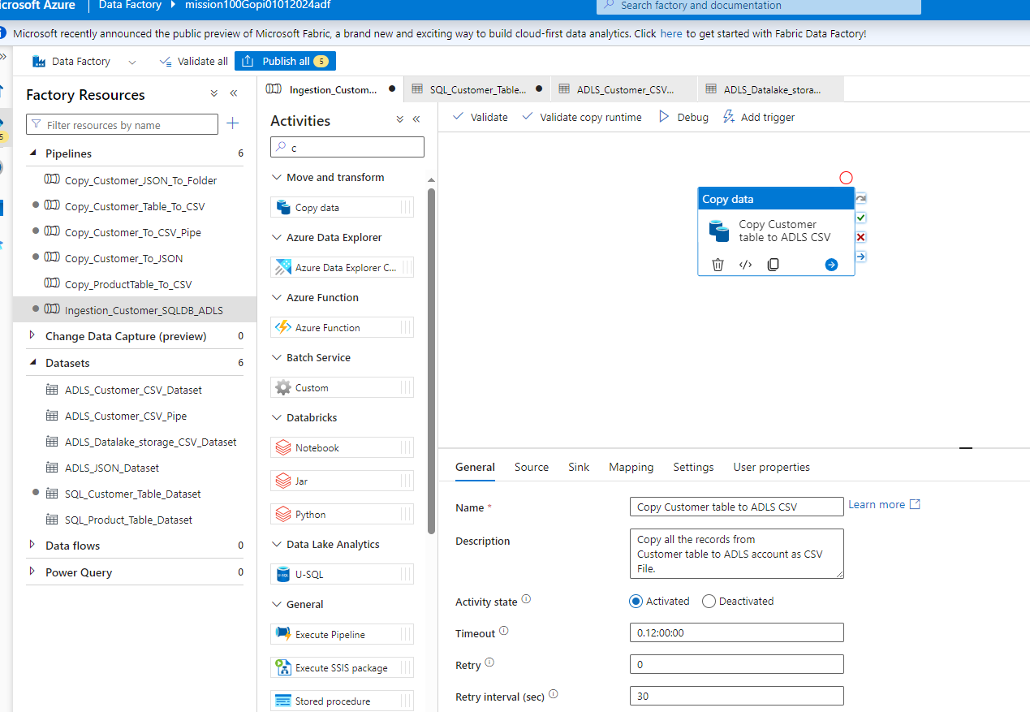

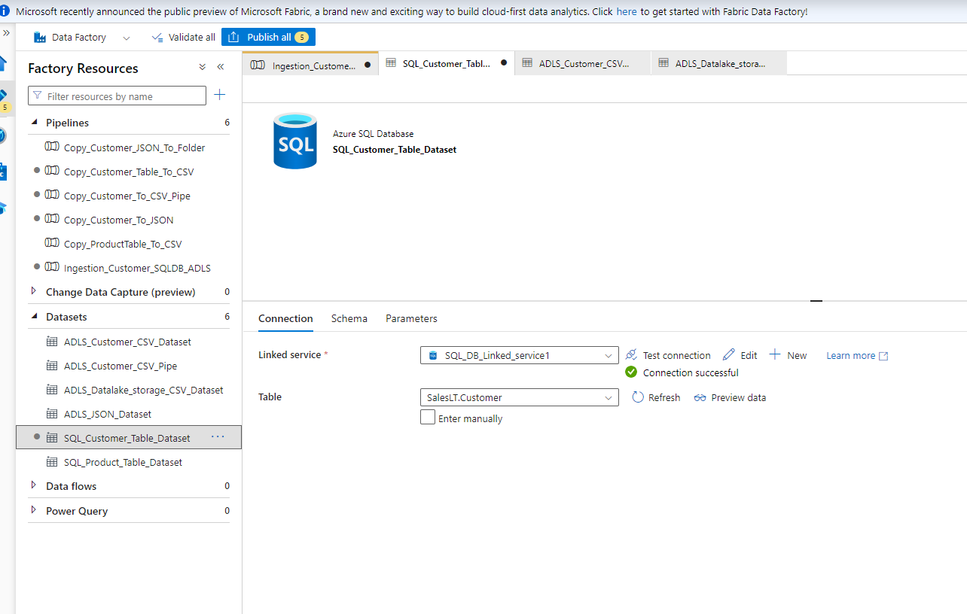

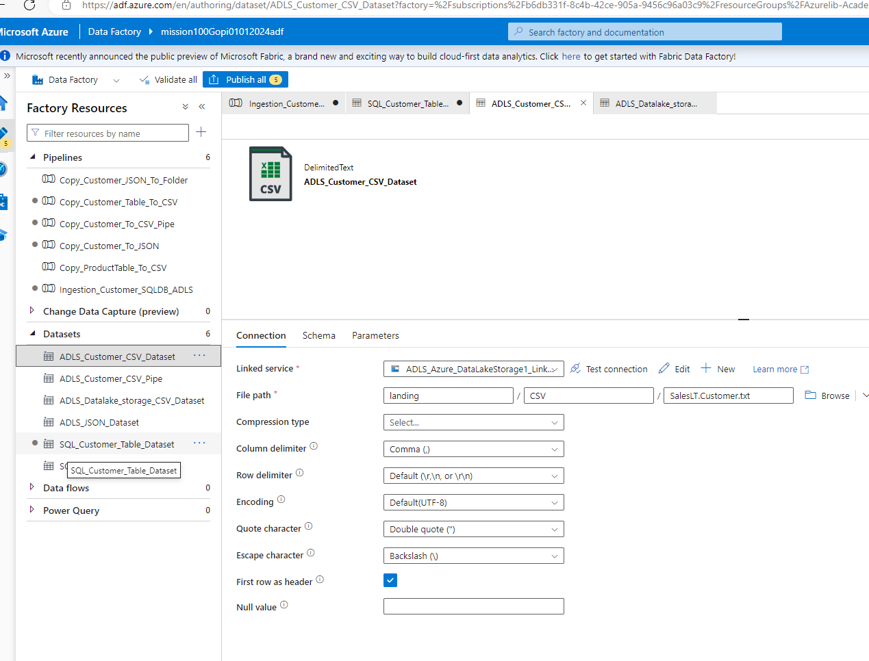

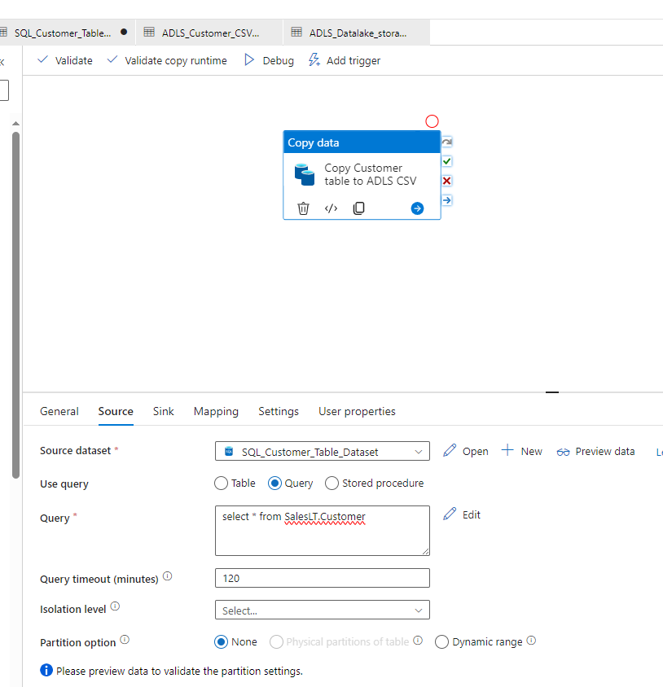

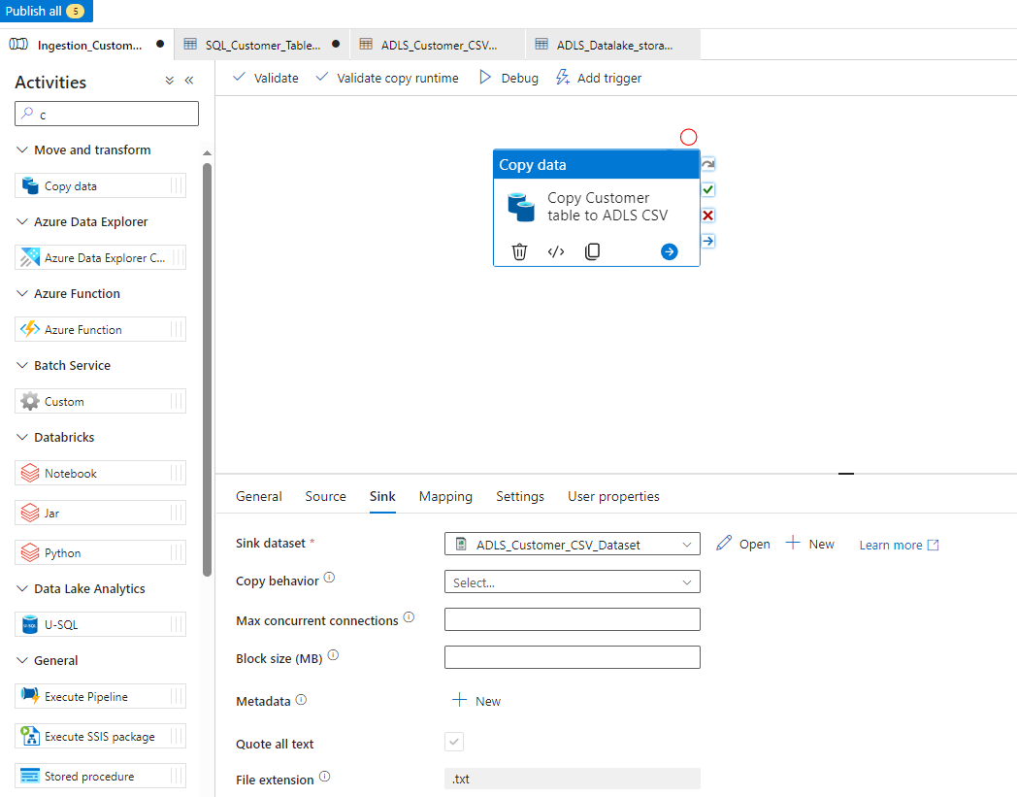

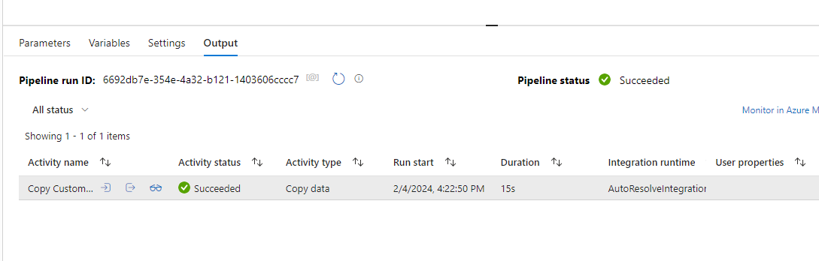

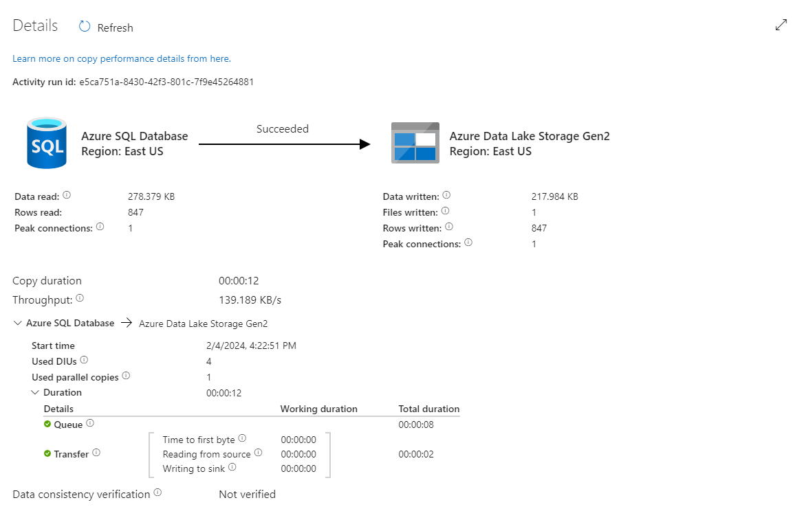

Published
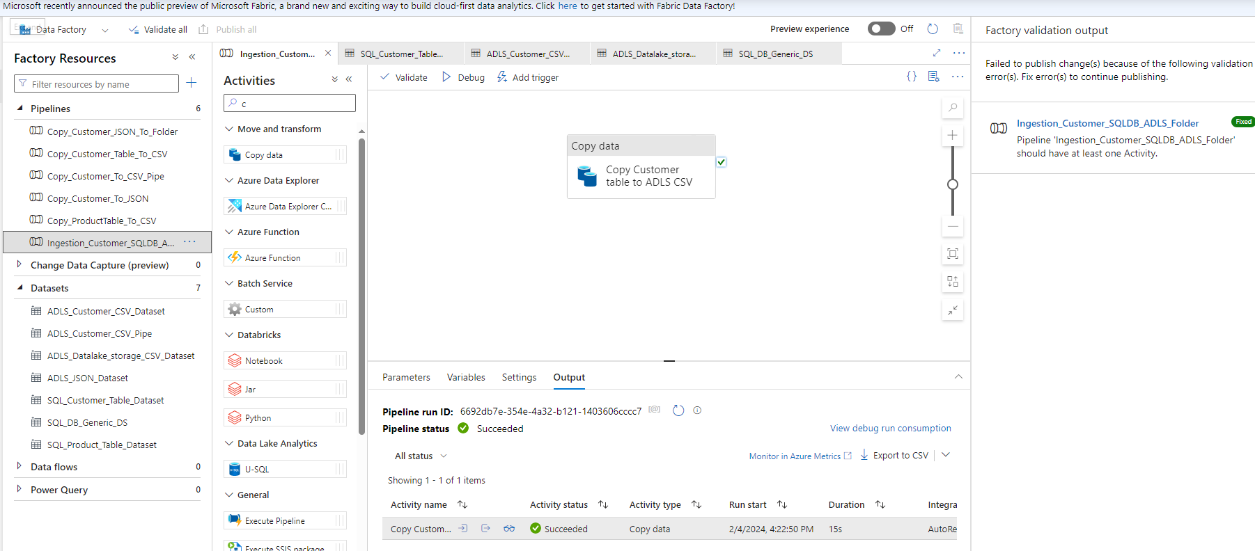

2. Create a pipeline name 'Ingestion_Customer_SQLDB_ADLS_Folder' which will copy all the records
from Address table to ADLS account inside the 'Address' folder as CSV File.

Solution:
We are using Parameterization for creating Dynamic Table , For accessing Source schema and Table and also for pulling into Destination folder

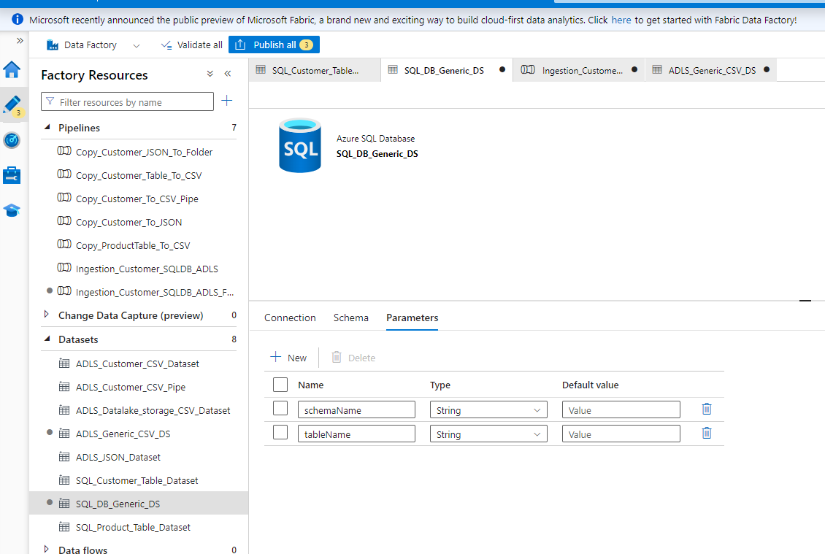

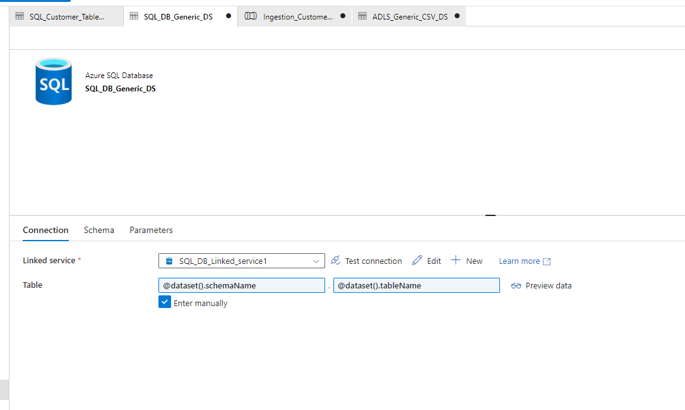

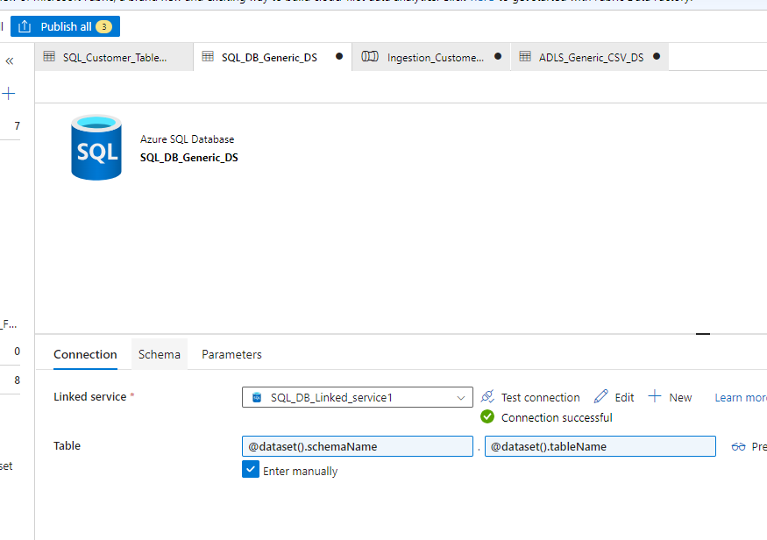

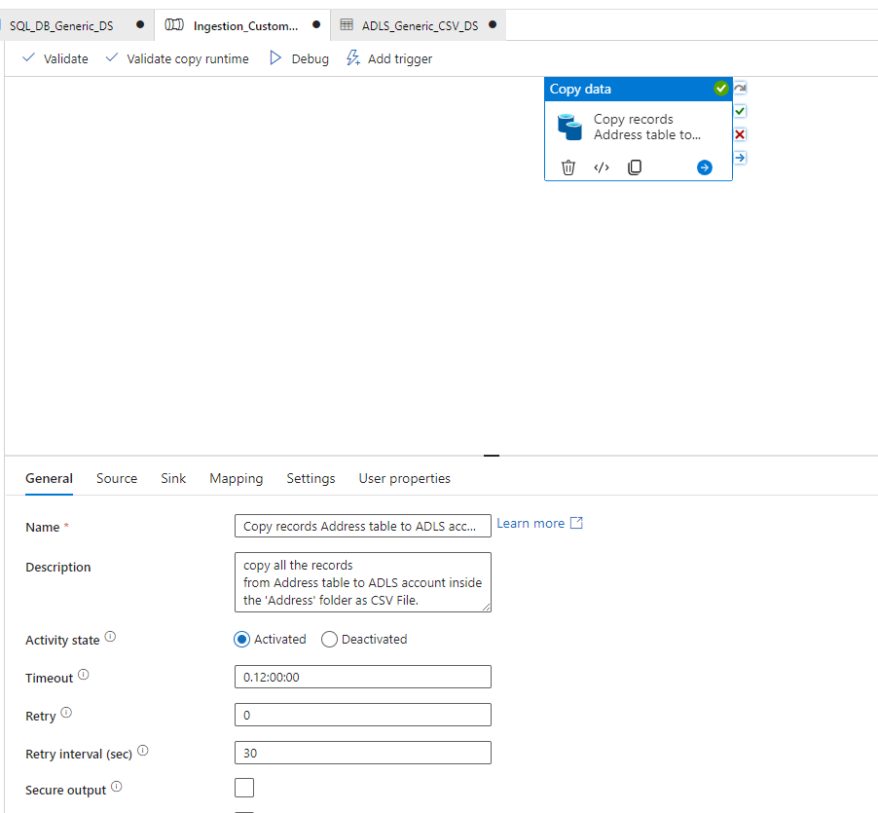

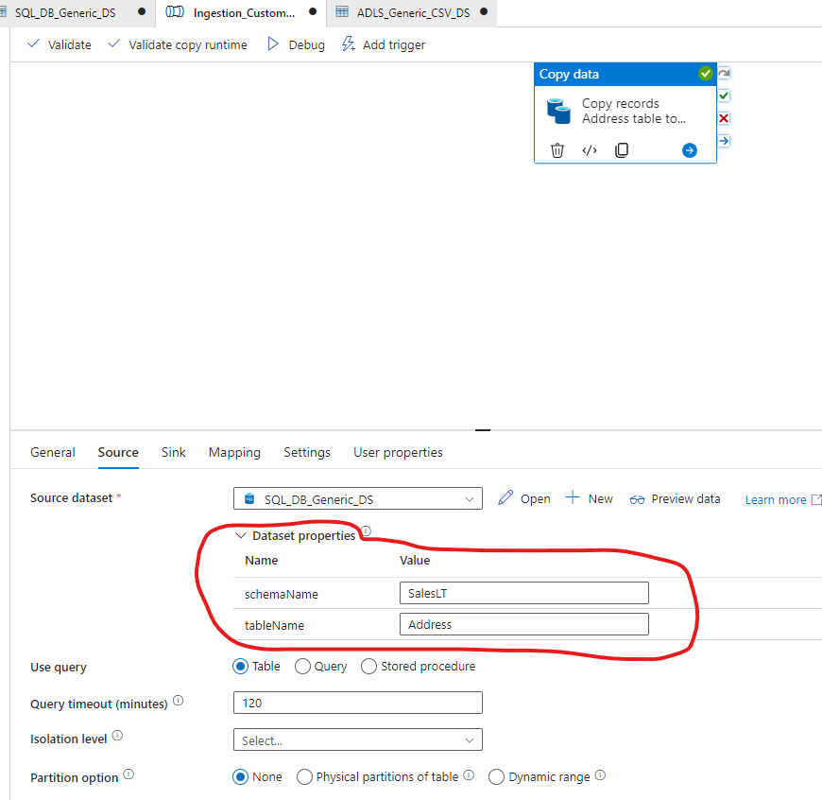

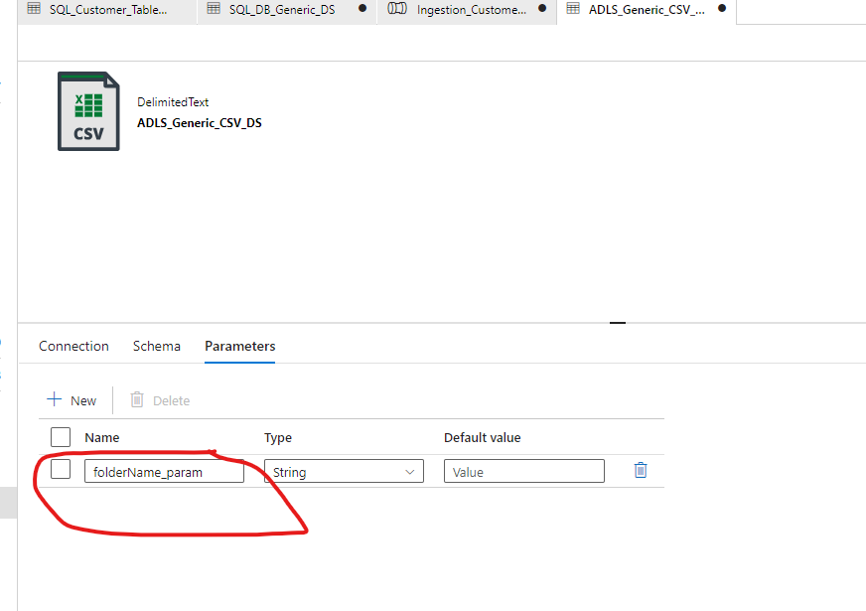

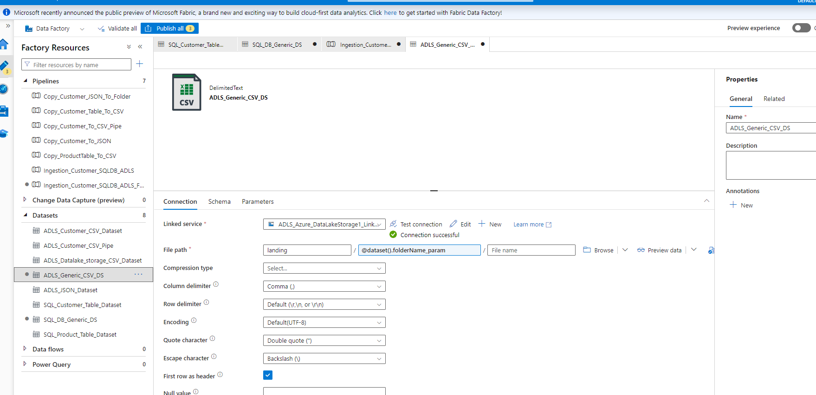

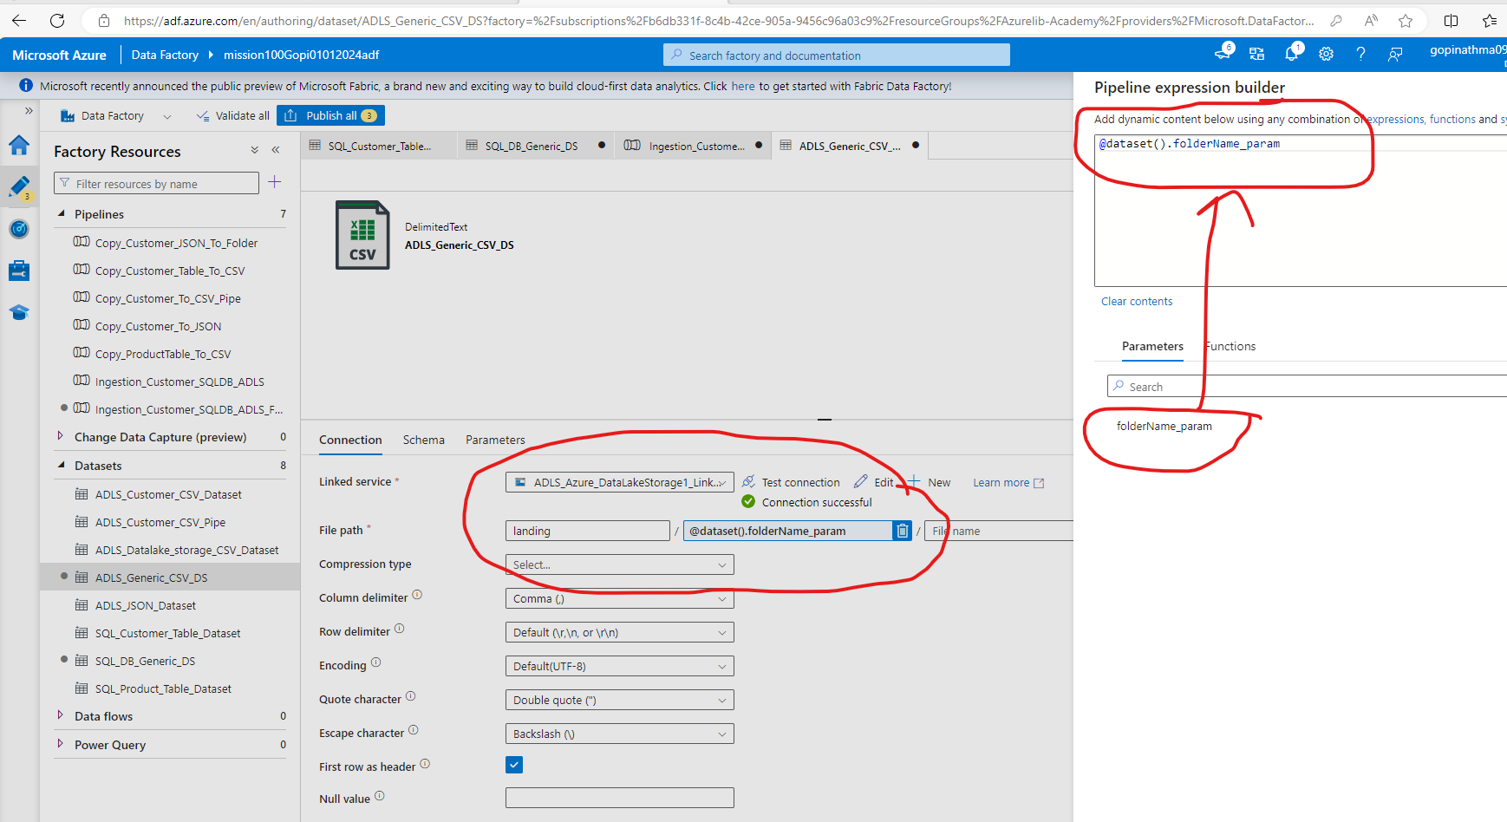

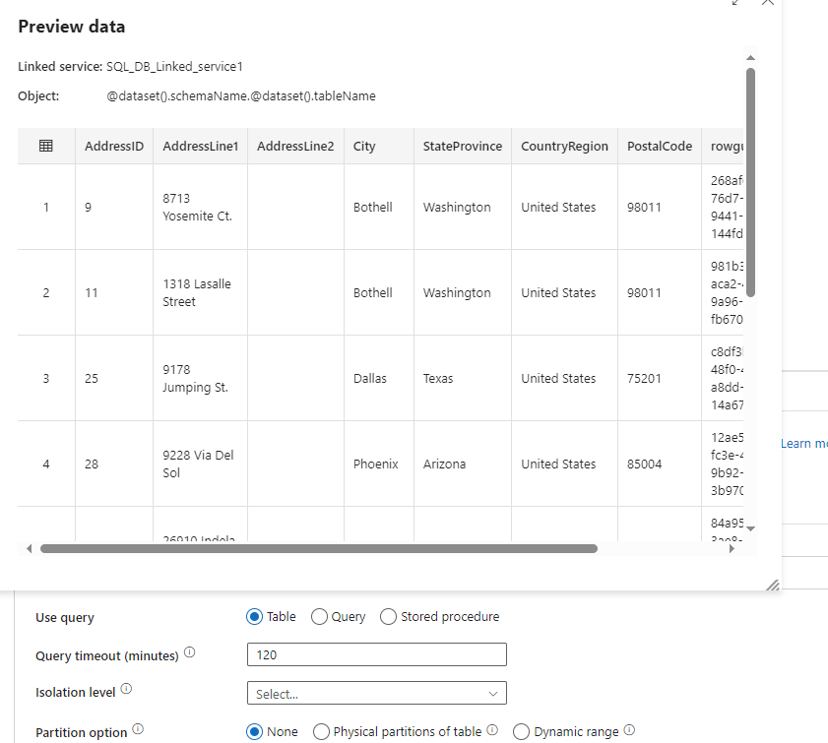

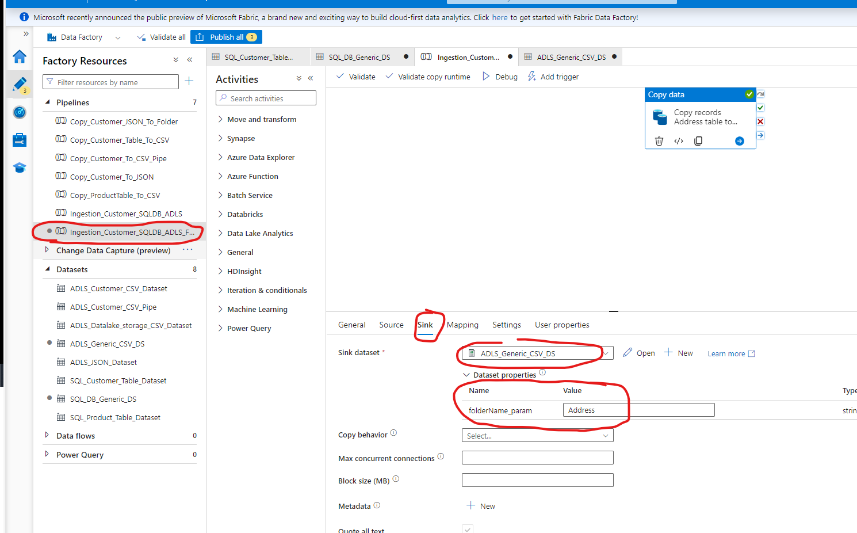

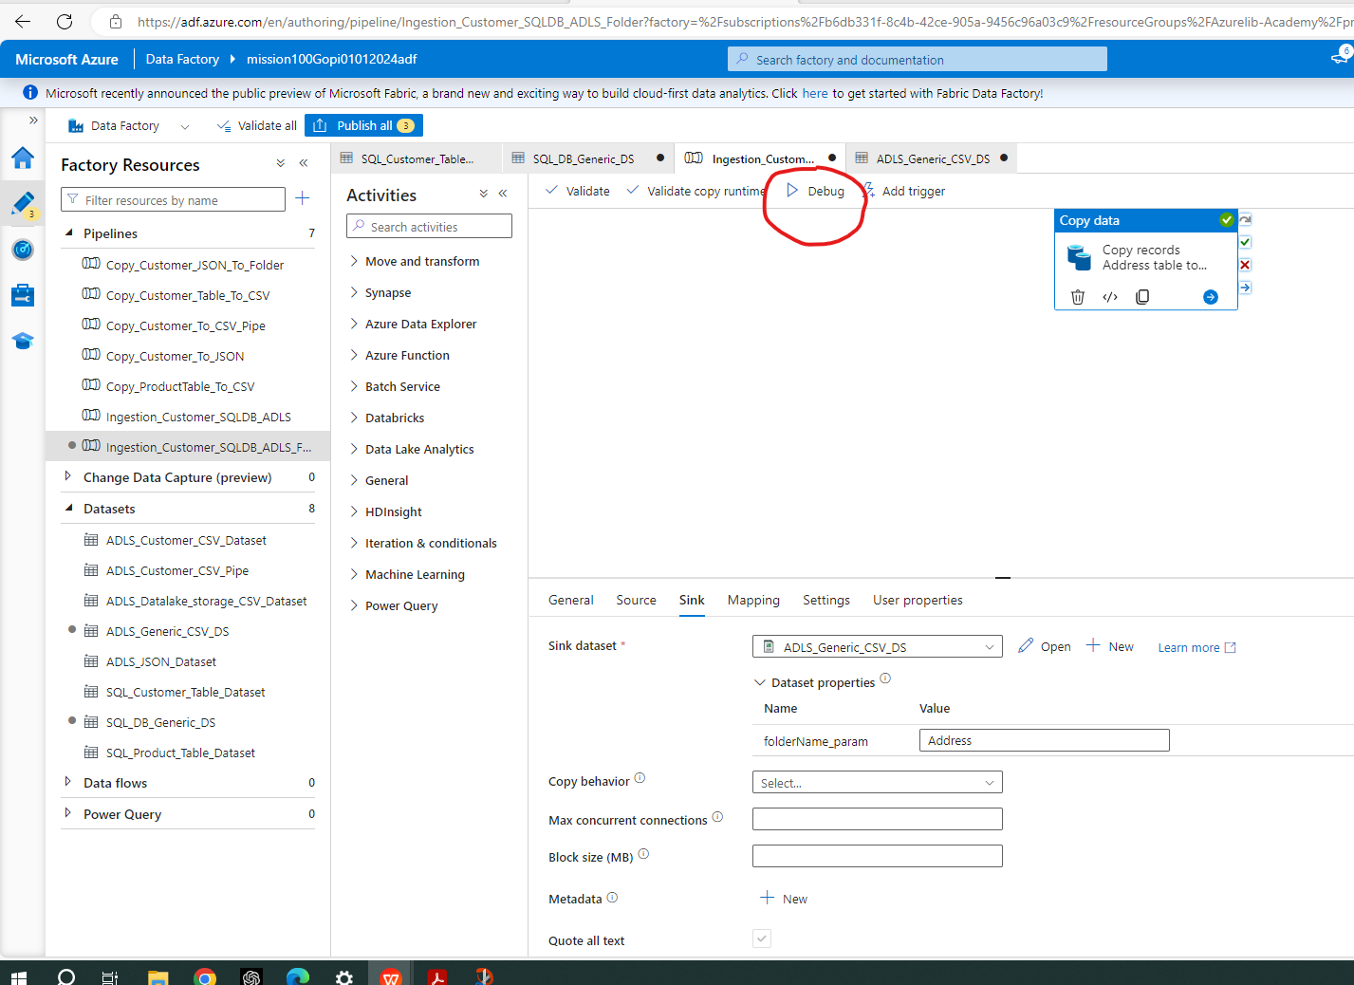

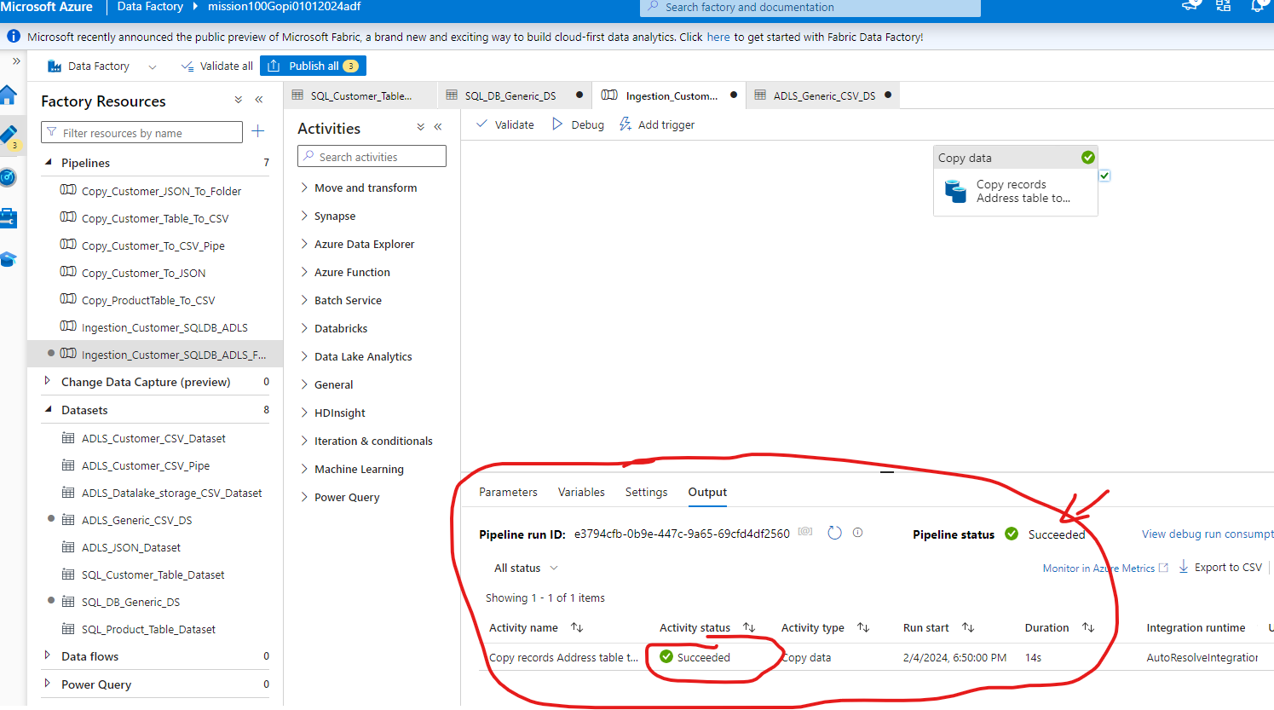

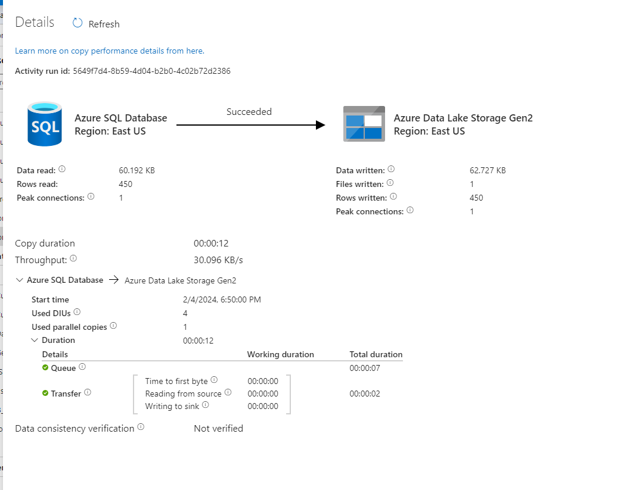

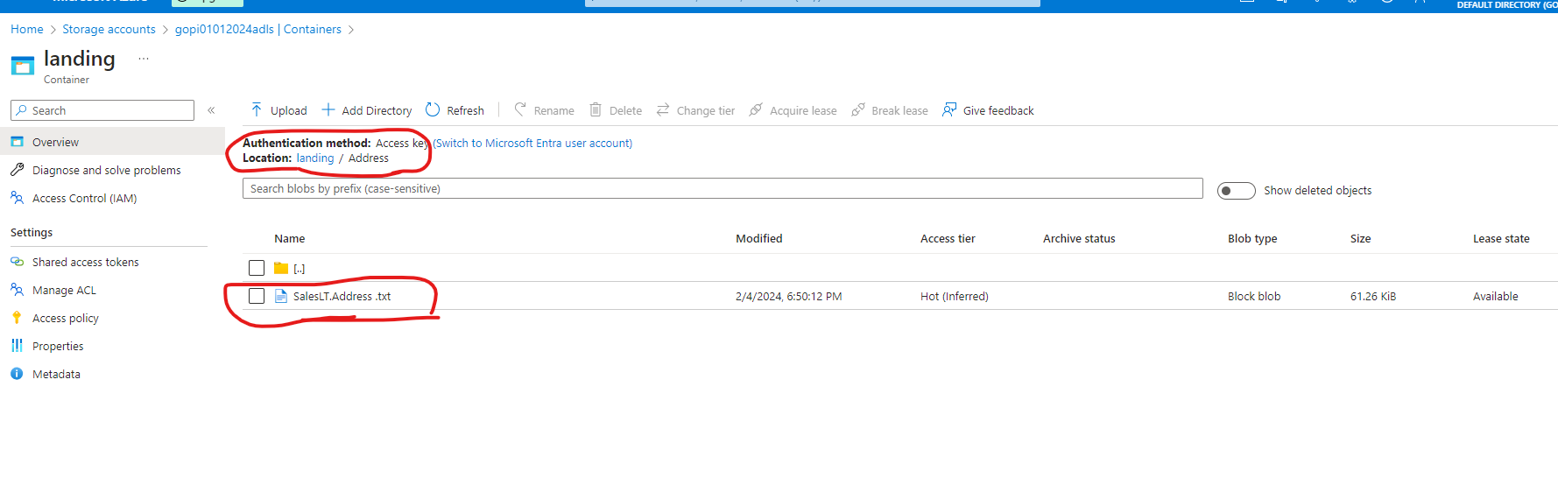

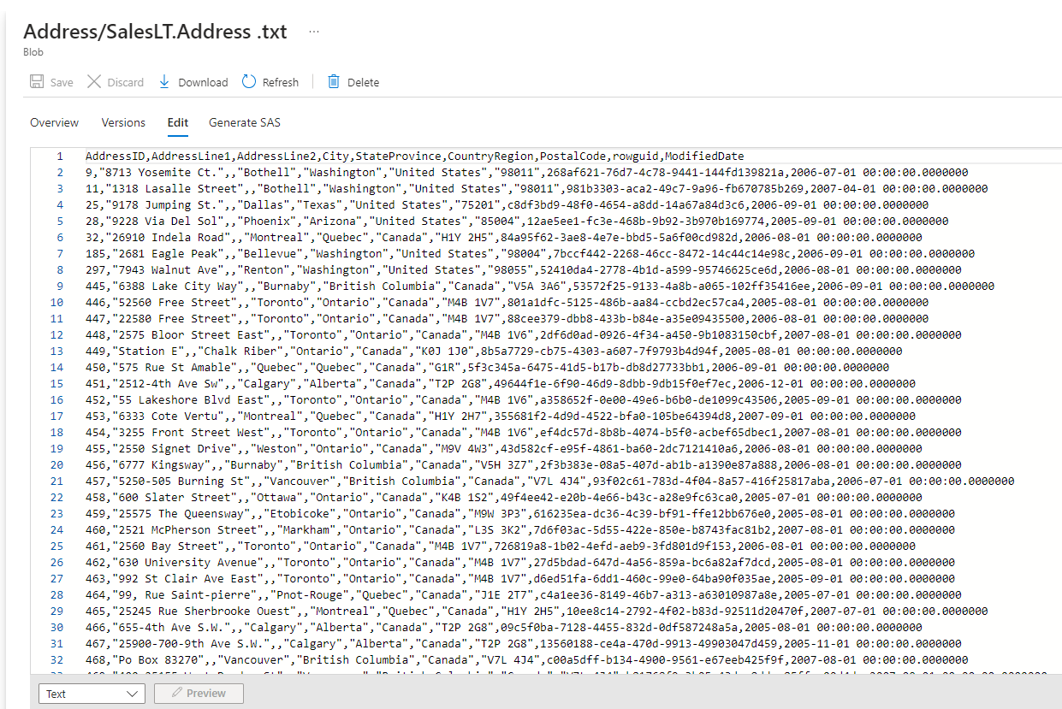

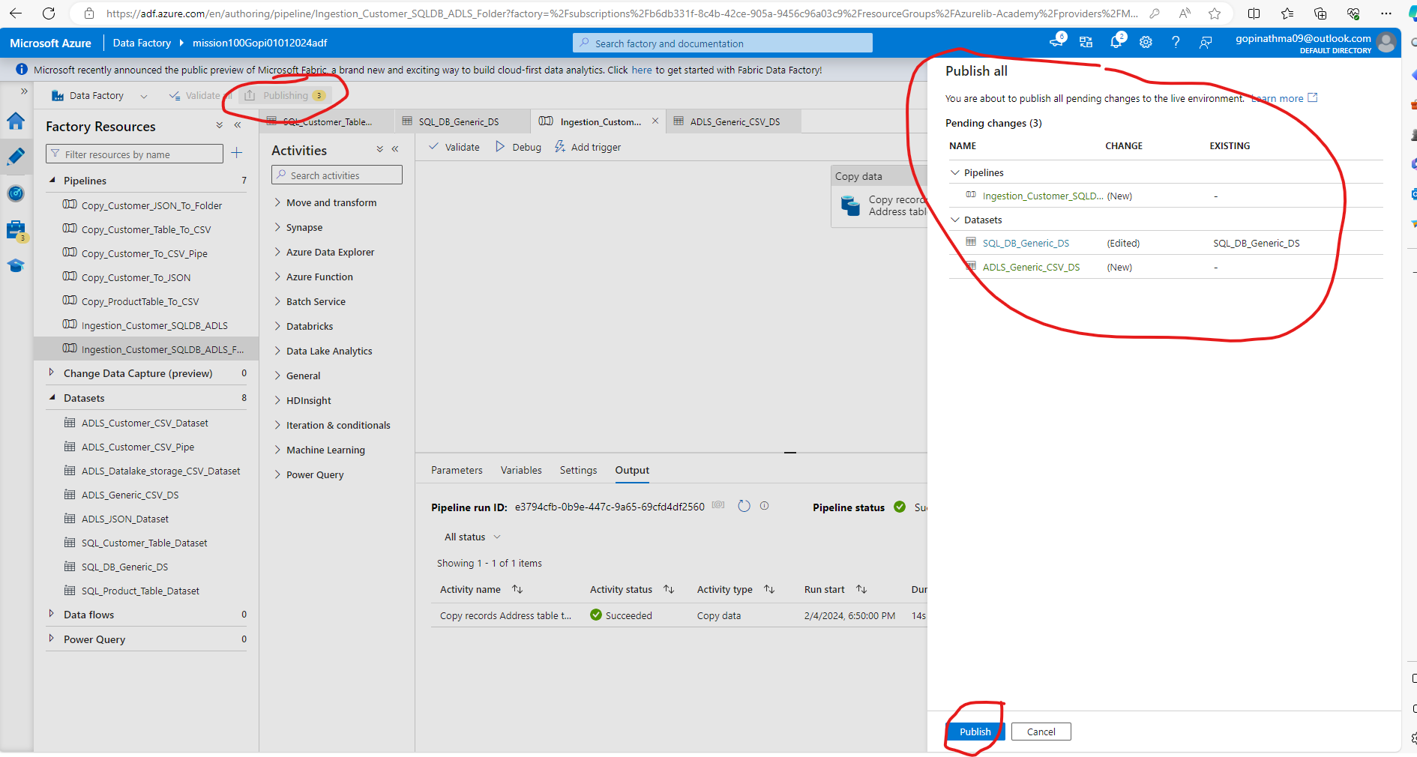

3. Create a Pipeline name 'Ingestion_Customer_JOIN_ADLS' which will copy the all the customer
names along with their address into the csv. (Hint Join Customer+ Customer Address table)

4. Create a pipeline name 'Ingestion_Product_To_JSON' which will copy all the product records as
JSON only if total number of records >10.

Approach:

IF (TotalProductRecordCount > 10) {
Copy Product to JSON
}

Step1: For “TotalProductRecordCount” --> Use “Lookup” Activity to fetch
Step 2: For Compairsion --> use “IF” Activity Condition and “Greater” Function in ADF
Step3: For Copy - use “Copy” Activity with Source as SQL Product DS, and Sink as ADLS JSON Dataset

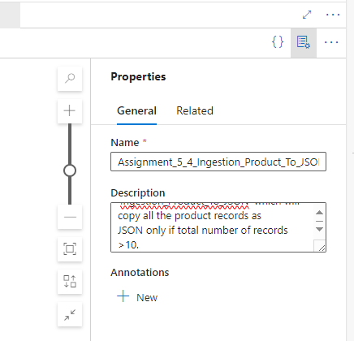

Lookup

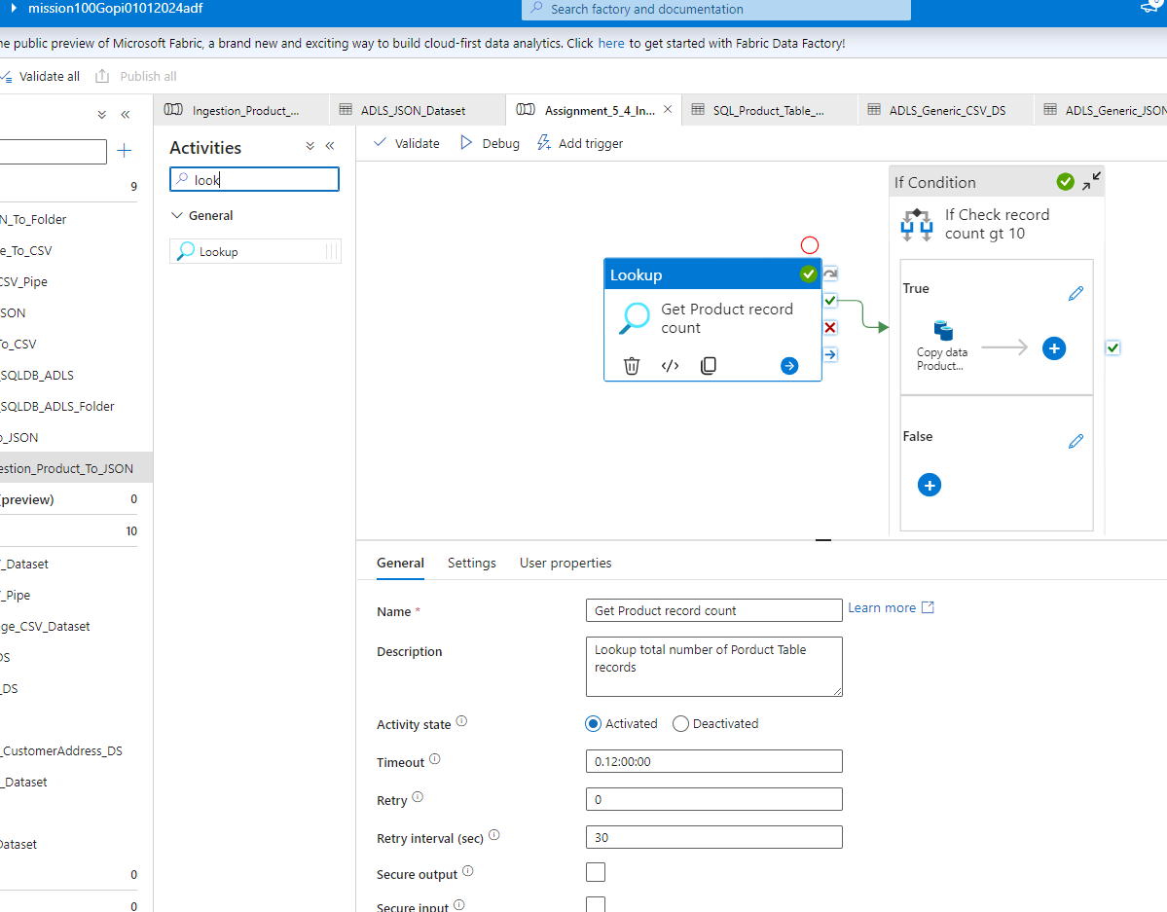

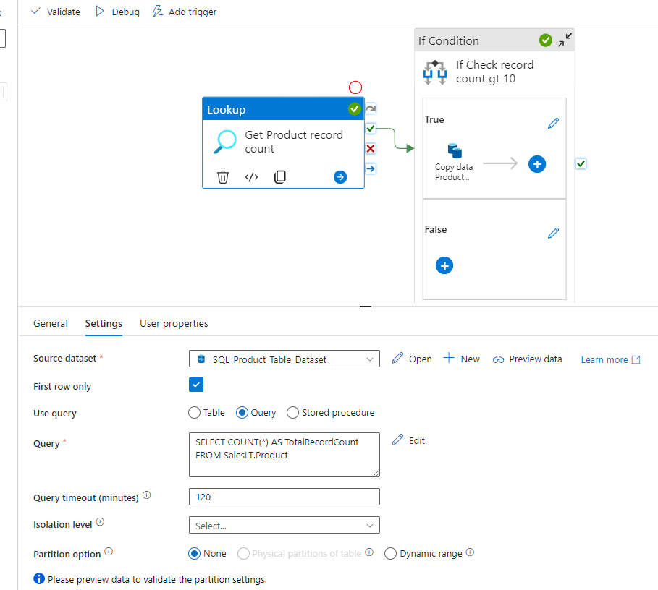

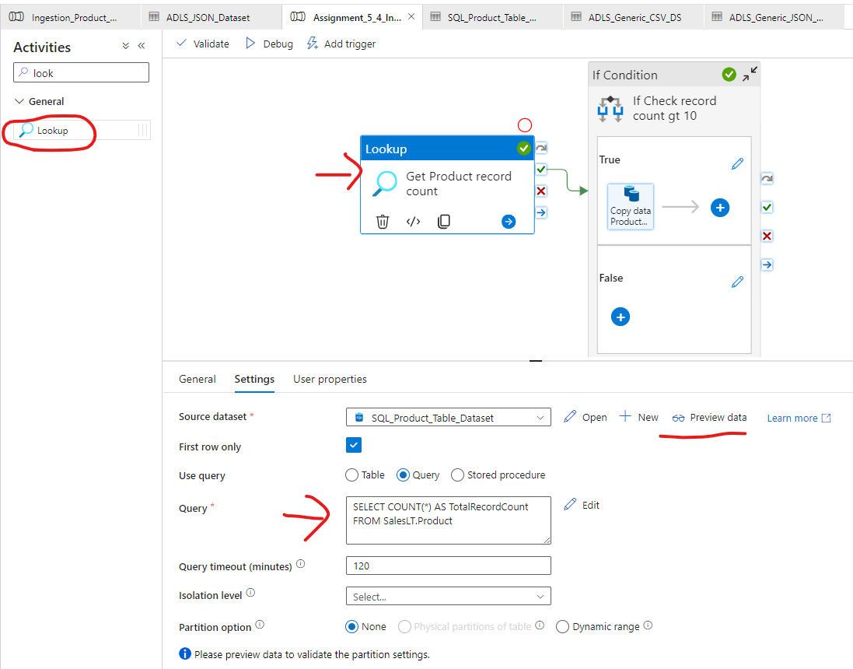

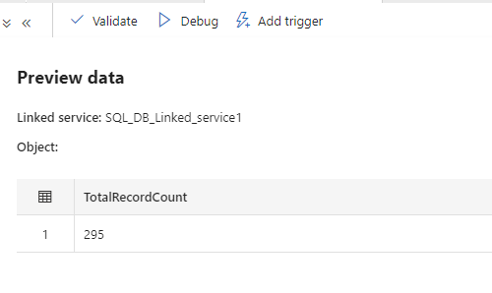

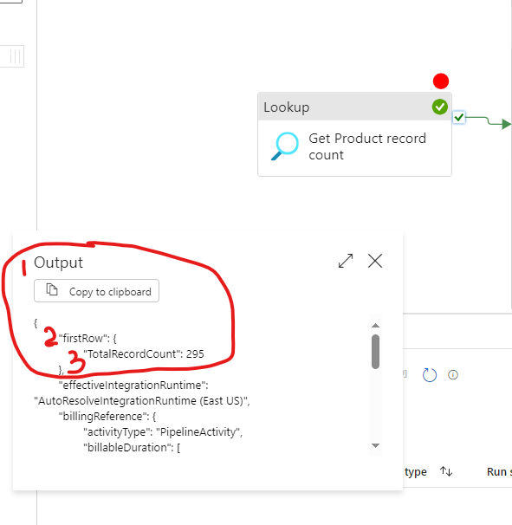

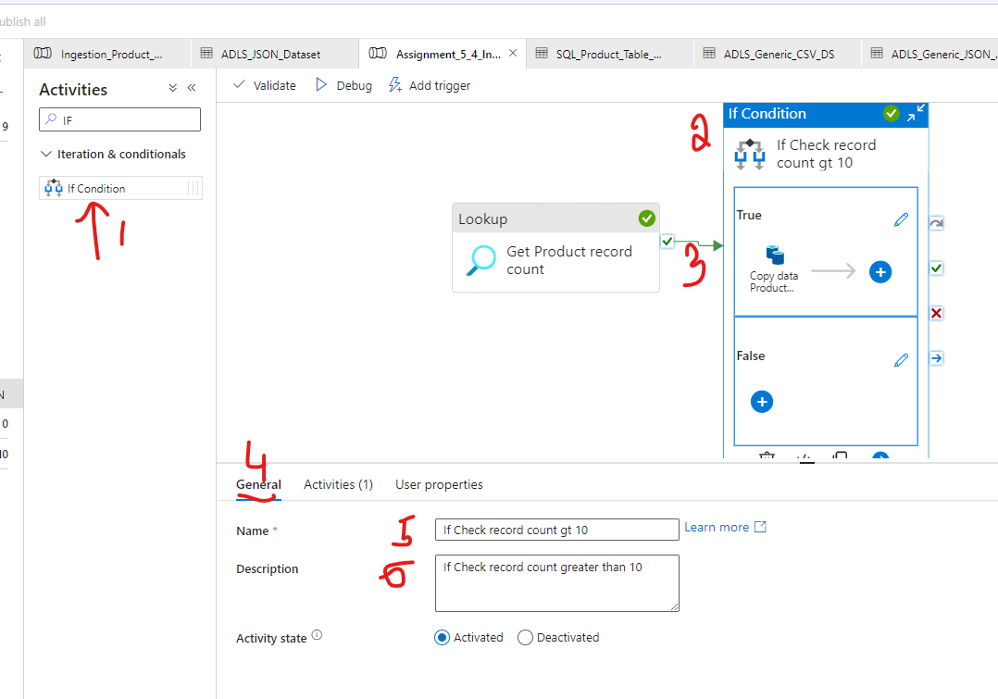

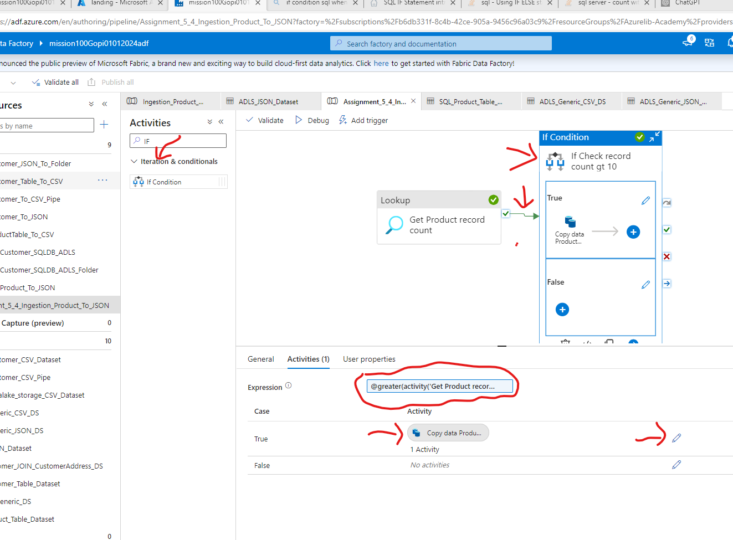

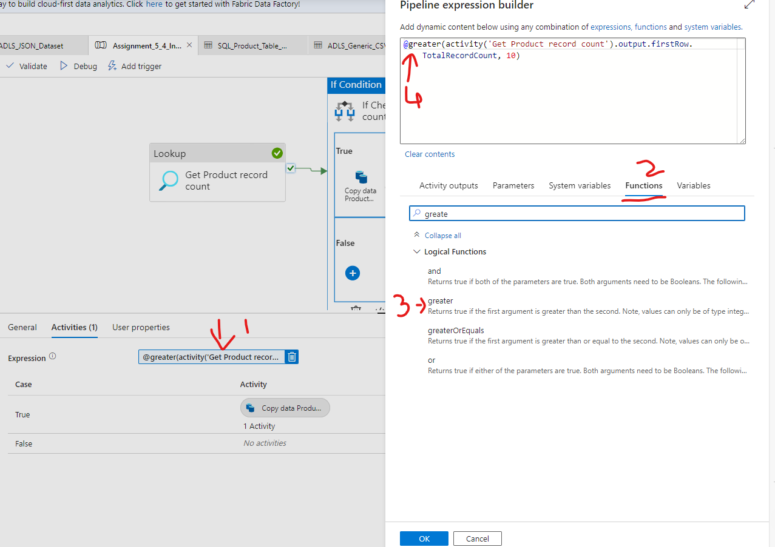

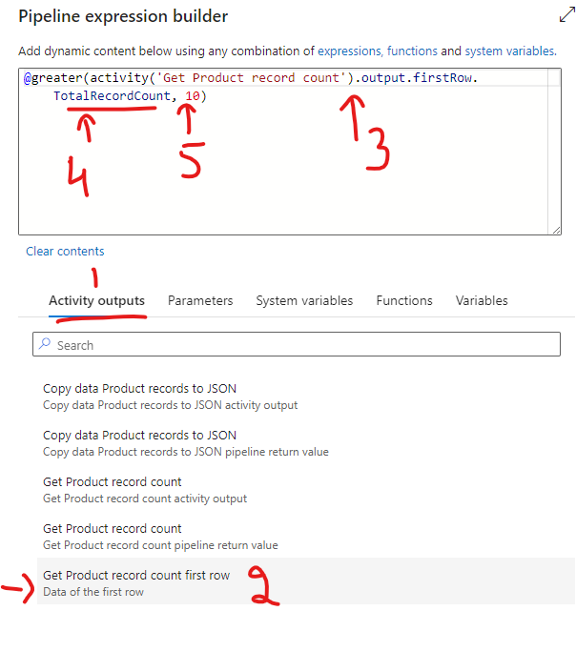

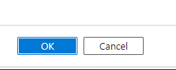

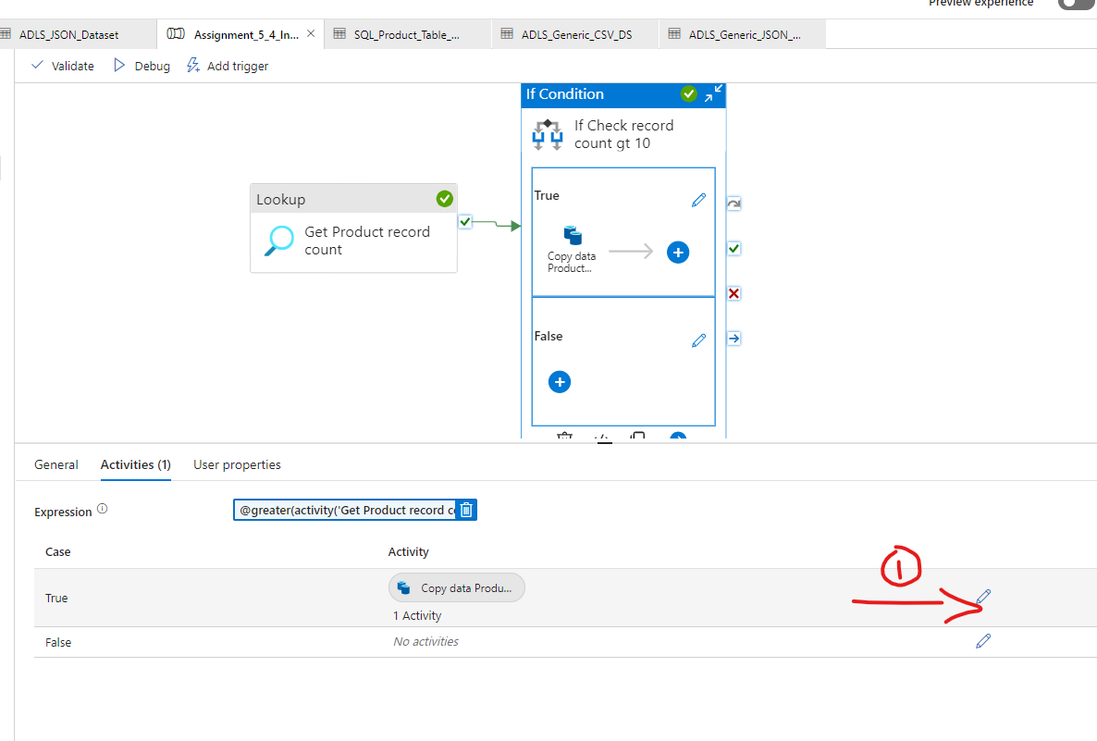

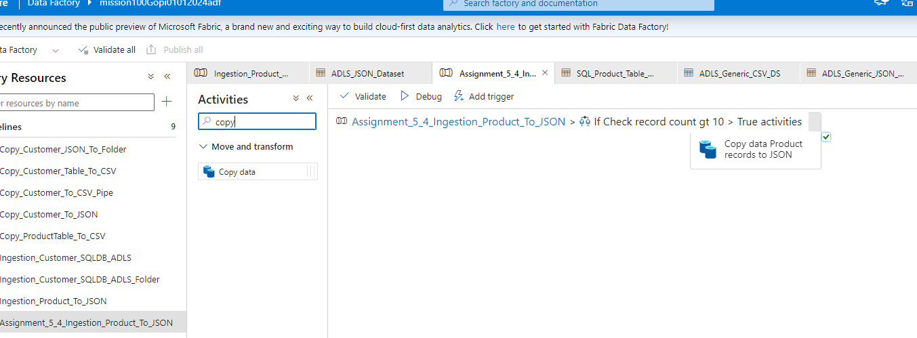

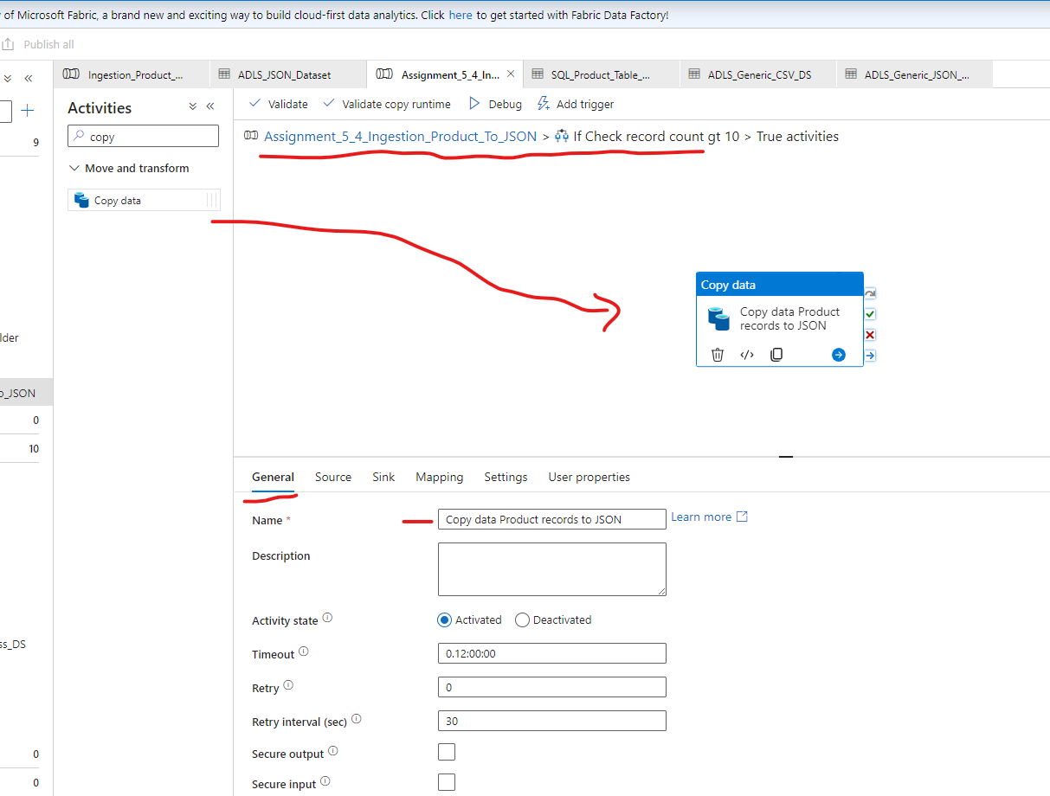

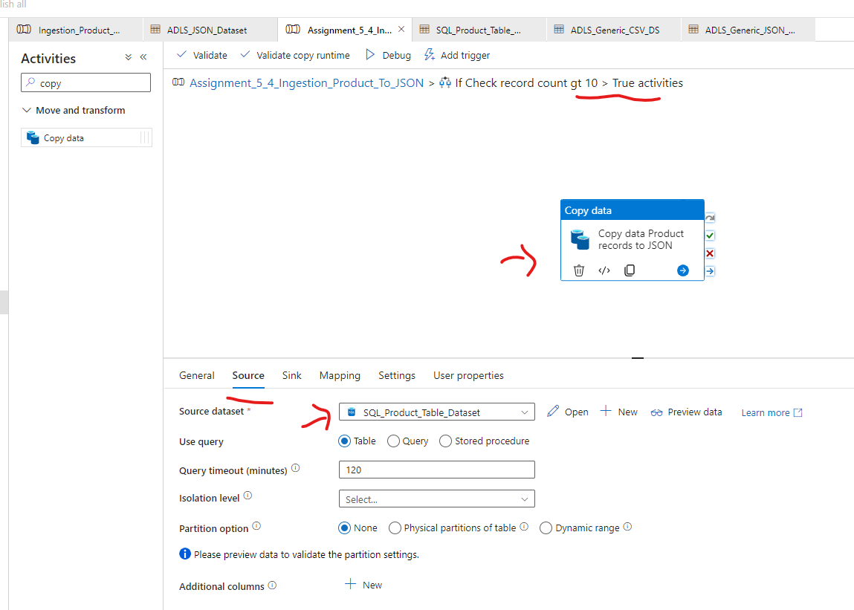

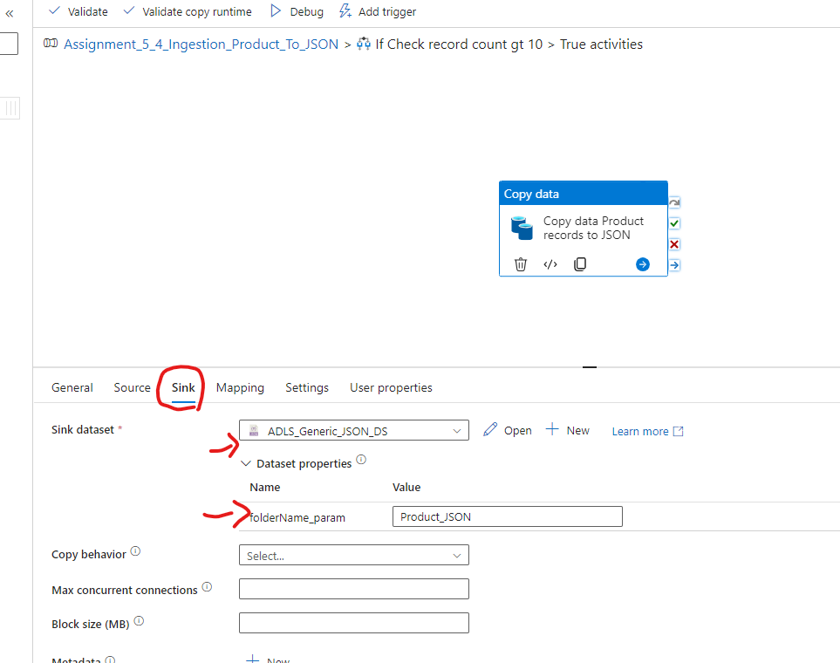

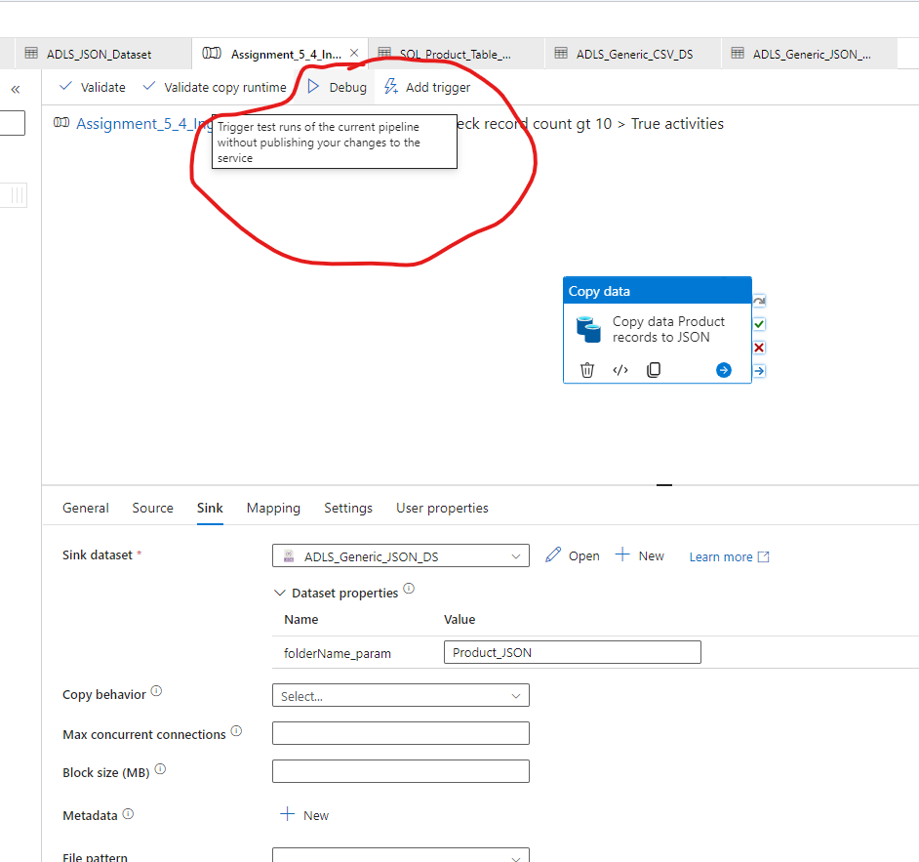

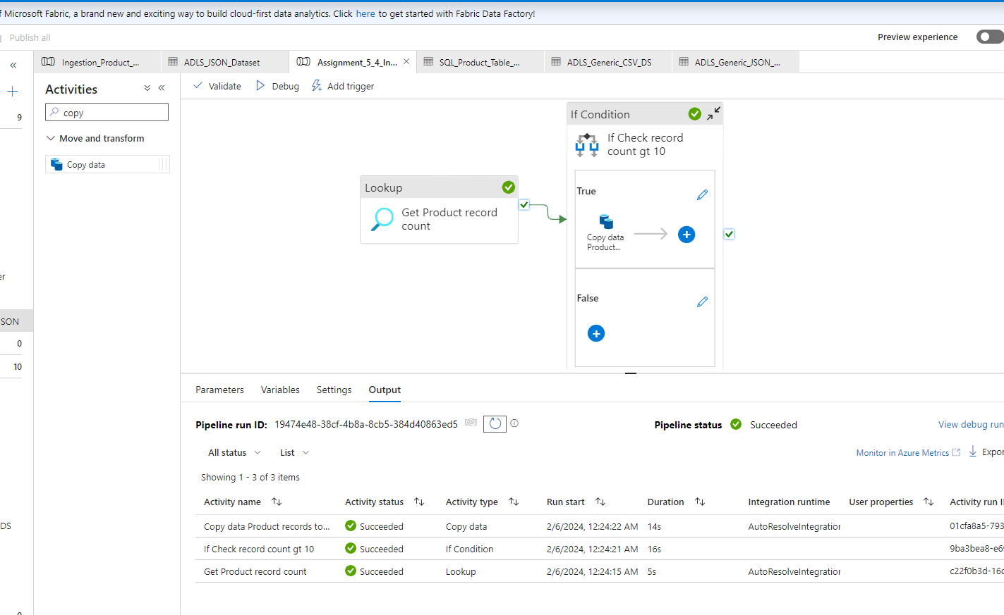

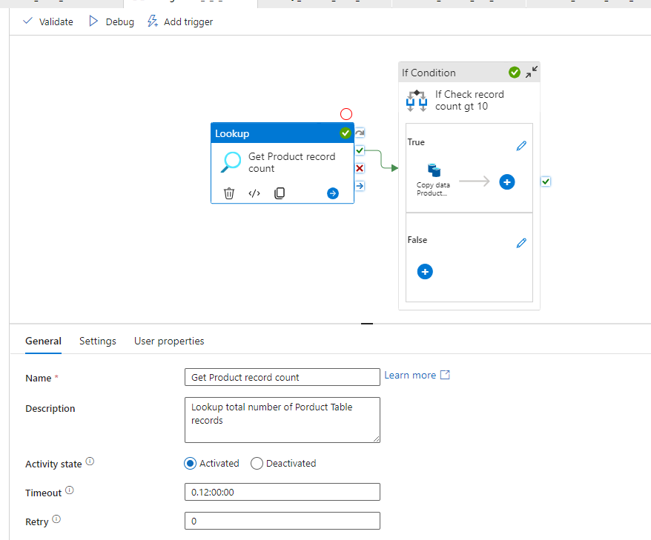

select * from table
where 10 < (select count(*) from table)

-->
Select * from SalesLT.Product
WHERE (Select COUNT(*) from SalesLT.Product ) > 10

Wrong:

IF EXISTS (SELECT * FROM TABLE WHERE COLUMN = 'SOME VALUE')
--INSERT SOMETHING
ELSE
--INSERT SOMETHING ELSE

Query is:
IF EXISTS (Select COUNT(*) from SalesLT.Product ) > 1000)

Select * from SalesLT.Product

OR

SELECT * FROM Customers C
WHERE EXISTS
( SELECT 1 FROM
Orders O
WHERE O.CustomerID = C.CustomerID );

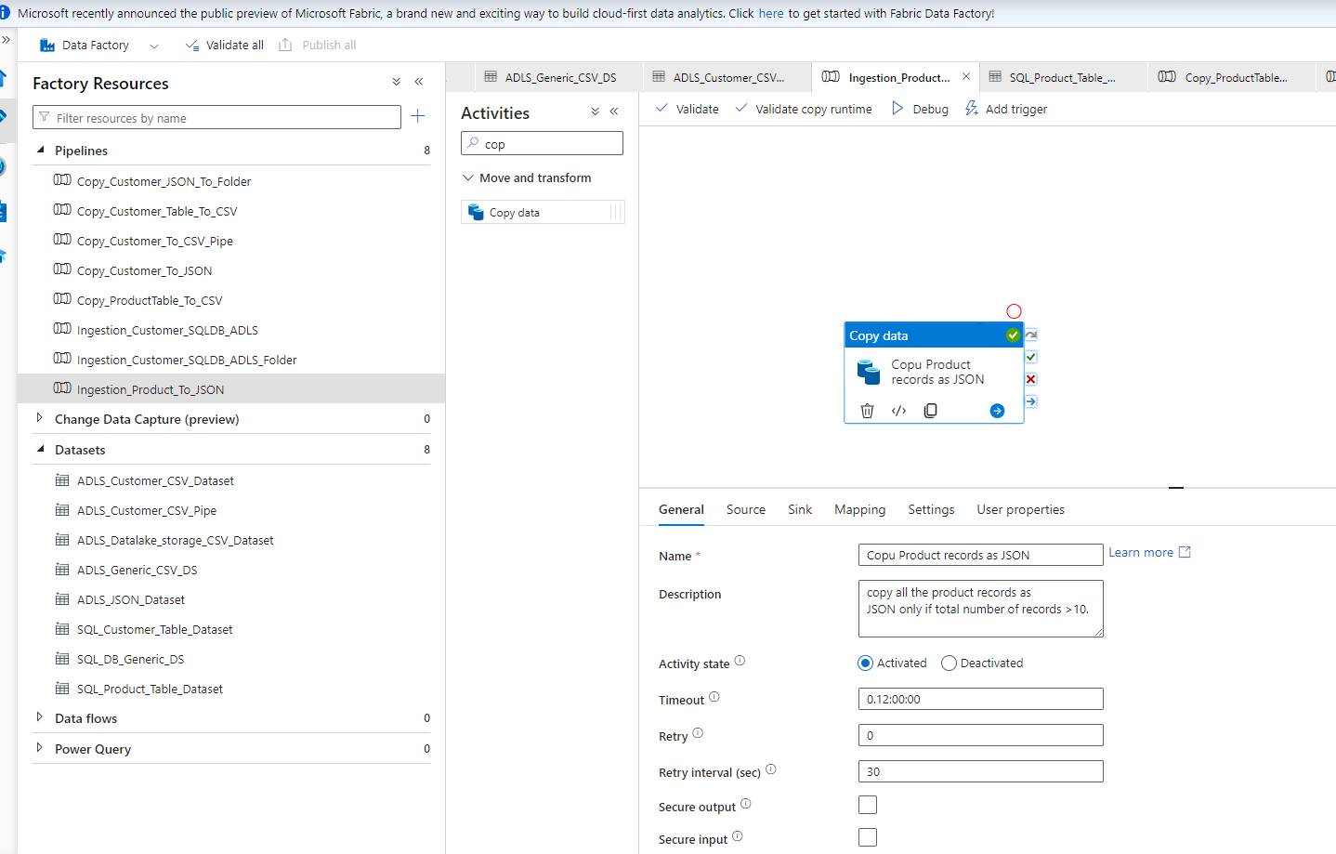

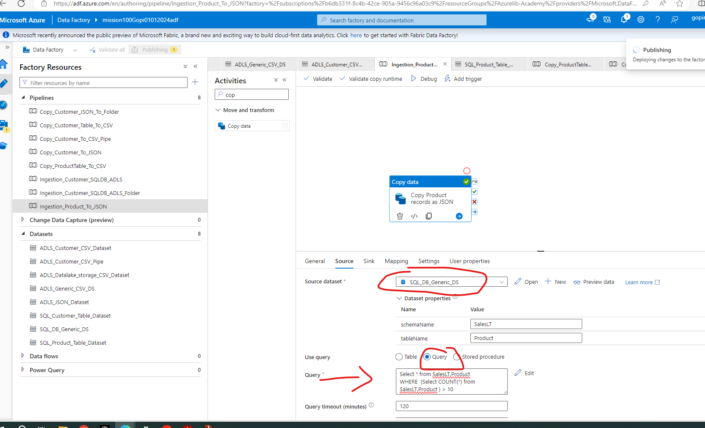

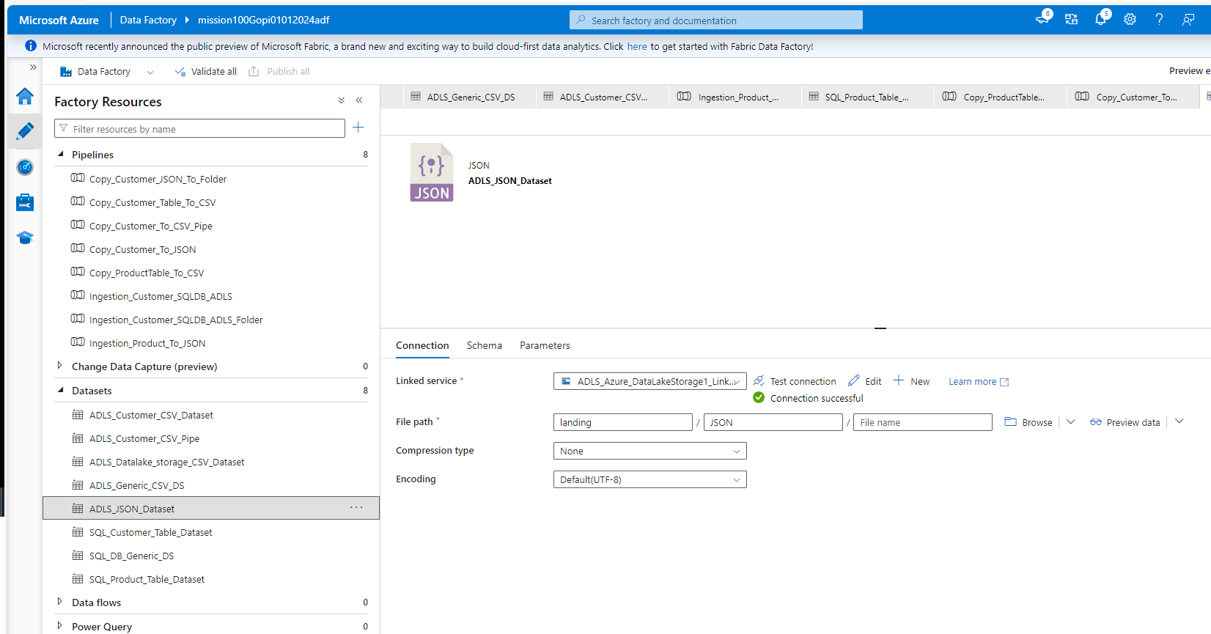

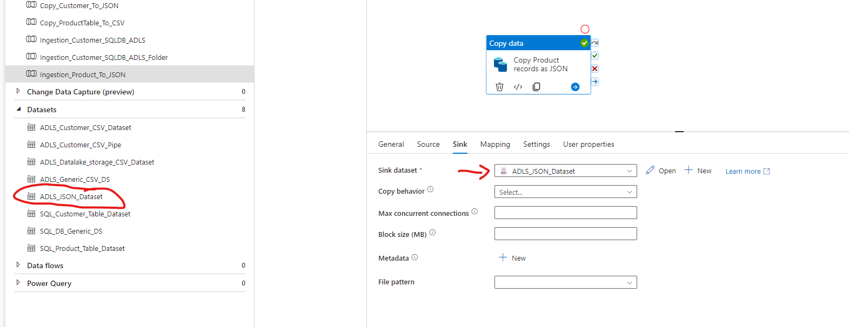

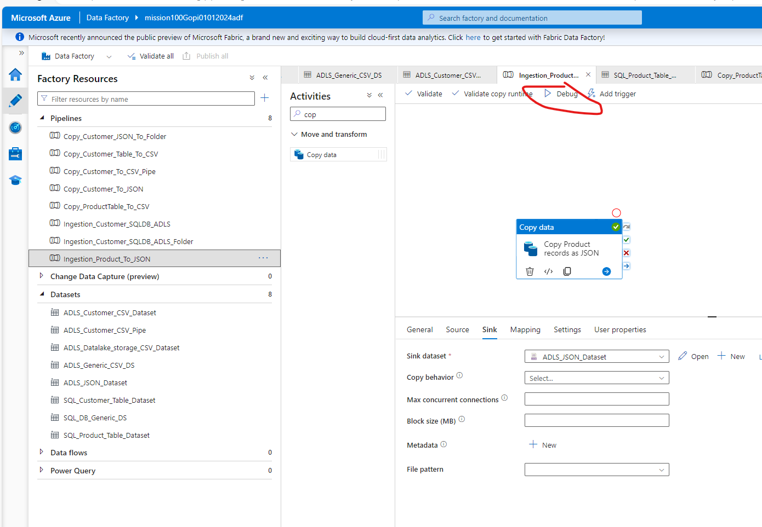

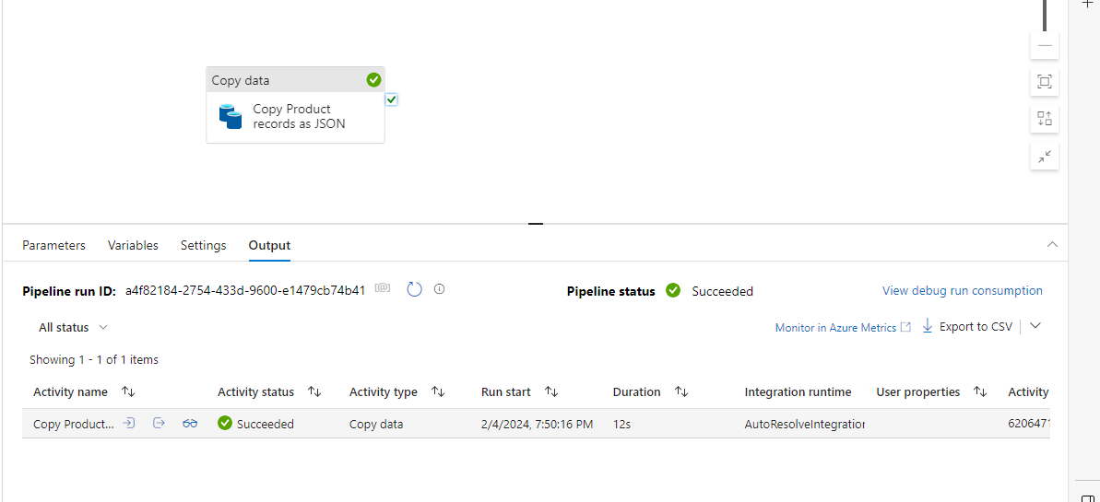

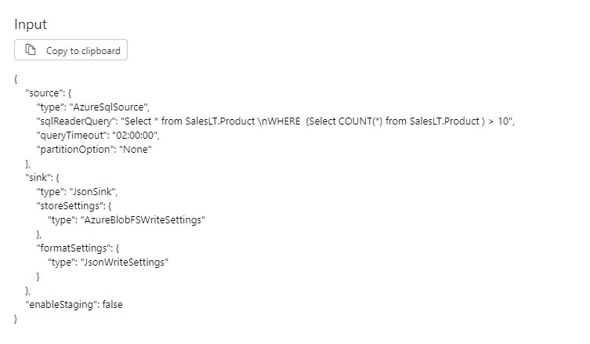

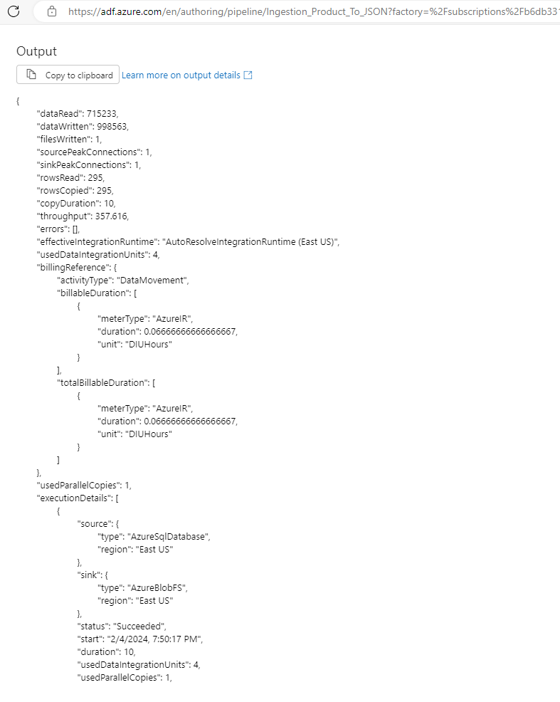

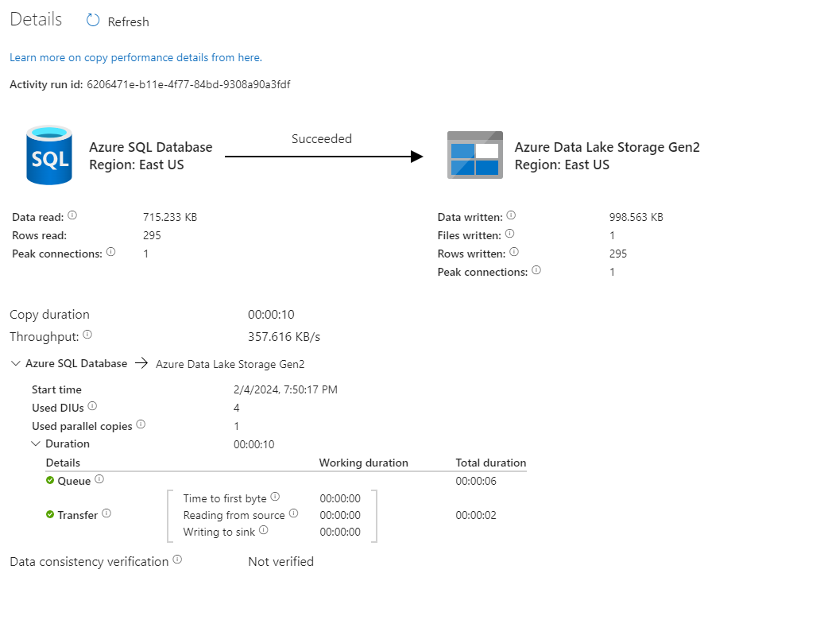

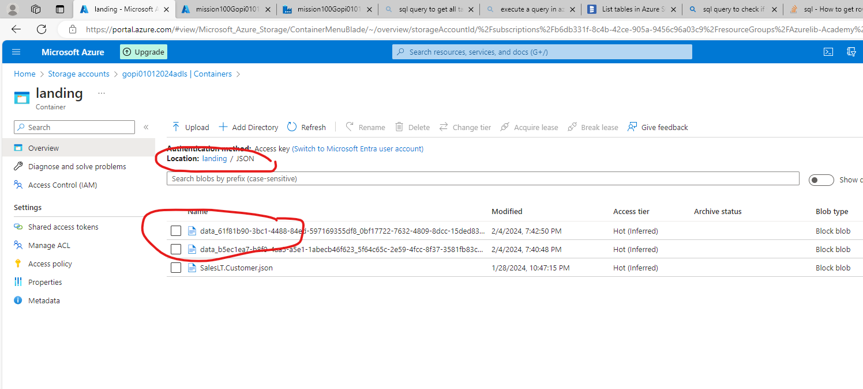

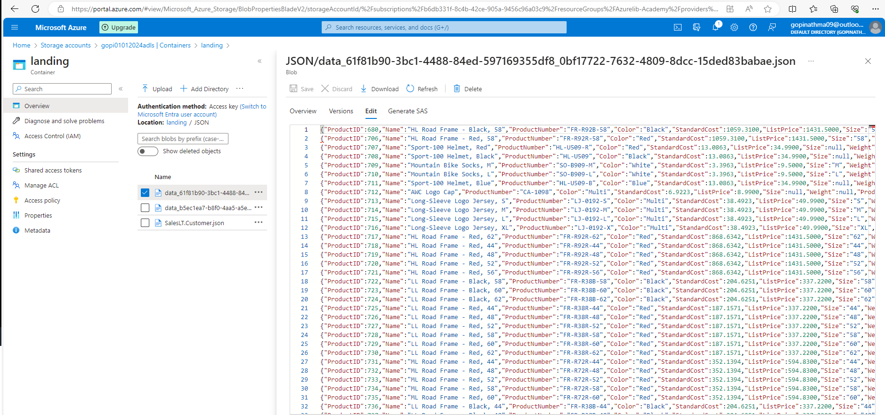

3. Create a Pipeline name 'Ingestion_Customer_JOIN_ADLS' which will copy the all the customer
names along with their address into the csv. (Hint Join Customer+ Customer Address table)

Solution Query:

https://www.databasestar.com/multiple-inner-joins/

Select C.FirstName, C.MiddleName, C.LastName, A.AddressLine1, A.AddressLine2,
A.City, A.StateProvince, A.CountryRegion, A.PostalCode
FROM SalesLT.Customer C
INNER JOIN SalesLT.CustomerAddress CA ON C.CustomerID = CA.CustomerID
INNER JOIN SalesLT.Address A ON A.AddressID = CA.AddressID

The syntax looks like this:
SELECT your_columnsFROM table1
INNER JOIN table2 ON table1.col1 = table2.col1
INNER JOIN table3 ON table2.col2 = table3.col2;

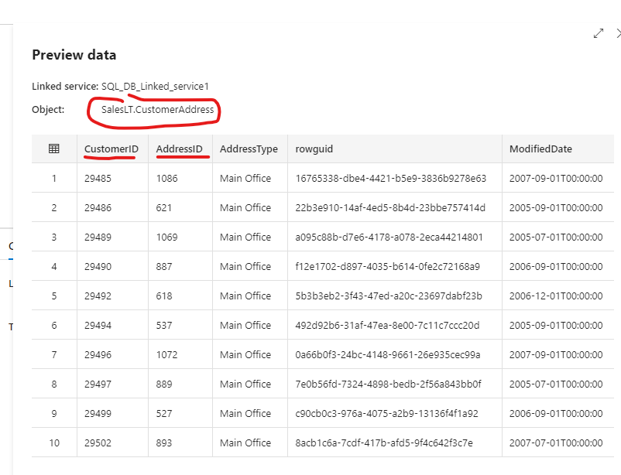

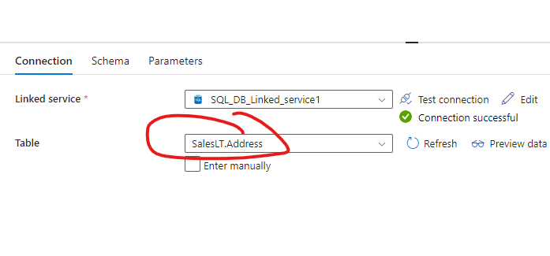

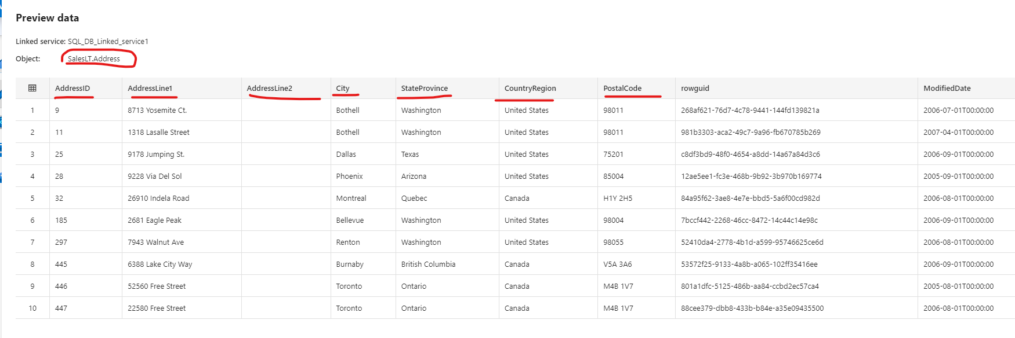

Query:

Select C.FirstName, C.MiddleName, C.LastName, A.AddressLine1, A.AddressLine2,
A.City, A.StateProvince, A.CountryRegion, A.PostalCode
FROM SalesLT.Customer C
INNER JOIN SalesLT.CustomerAddress CA ON C.CustomerID = CA.CustomerID
INNER JOIN SalesLT.Address A ON A.AddressID = CA.AddressID

The syntax looks like this:
SELECT your_columnsFROM table1
INNER JOIN table2 ON table1.col1 = table2.col1
INNER JOIN table3 ON table2.col2 = table3.col2;

bject:SalesLT.Customer
 | CustomerID | NameStyle | Title | FirstName | MiddleName | LastName | Suffix | CompanyName | SalesPerson | EmailAddress | Phone | PasswordHash | PasswordSalt | rowguid | ModifiedDate
1 | 1 | false | Mr. | Orlando | N. | Gee |  | A Bike Store | adventure-works\pamela0 | orlando0@adventure-works.com | 245-555-0173 | L/Rlwxzp4w7RWmEgXX+/A7cXaePEPcp+KwQhl2fJL7w= | 1KjXYs4= | 3f5ae95e-b87d-4aed-95b4-c3797afcb74f | 2005-08-

SalesLT.Address

AddressID | AddressLine1 | AddressLine2 | City | StateProvince | CountryRegion | PostalCode

SalesLT.Customer C

SalesLT.CustomerAddress
 | CustomerID | AddressID | AddressType | rowguid | ModifiedDate
1 | 29485 | 1086 | Main Office | 16765338-dbe4-4421-b5e9-3836b9278e63 | 2007-09-01T00:00:00

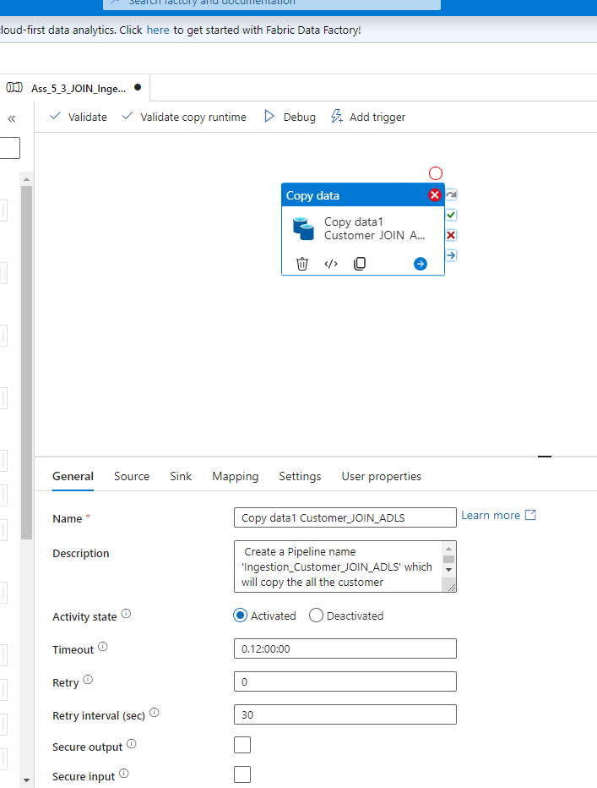
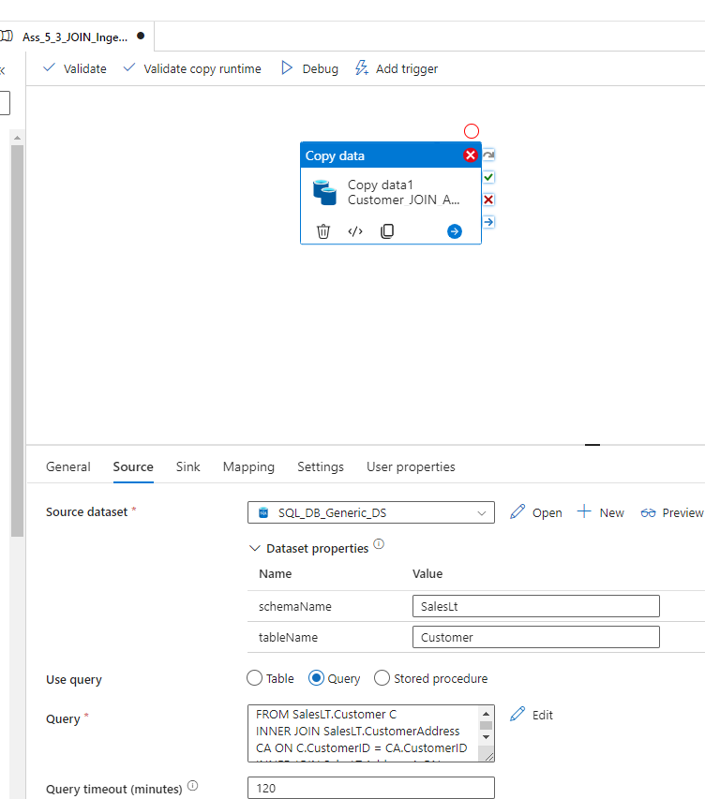

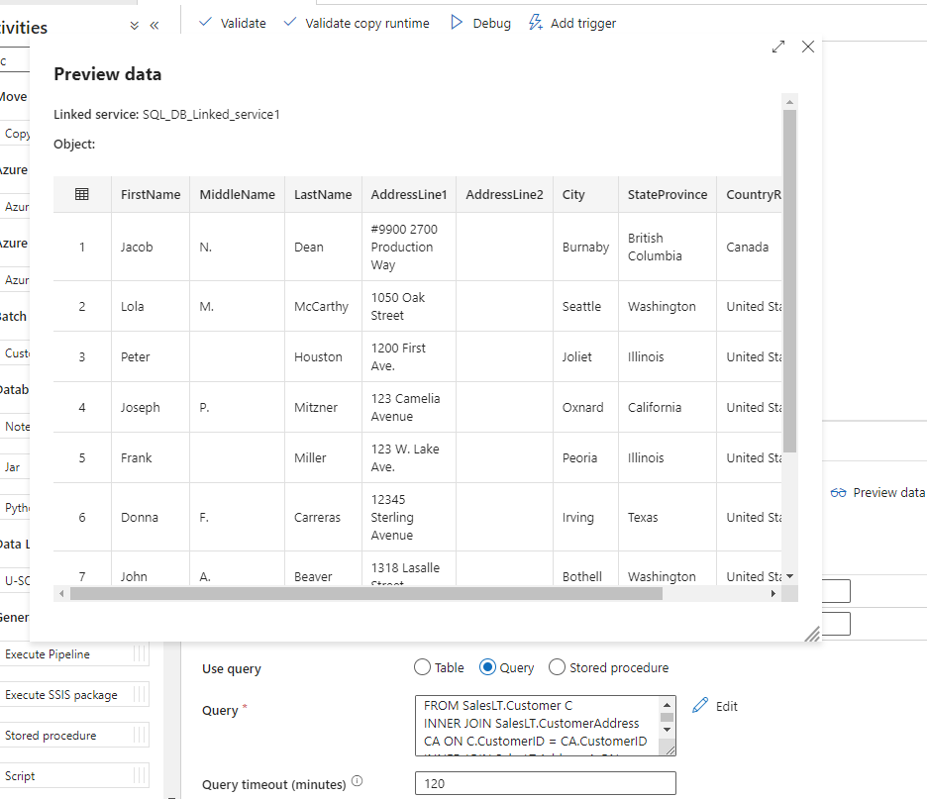

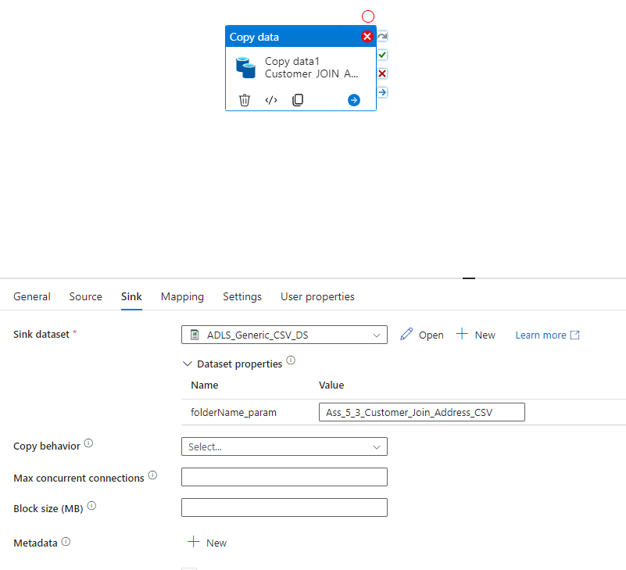

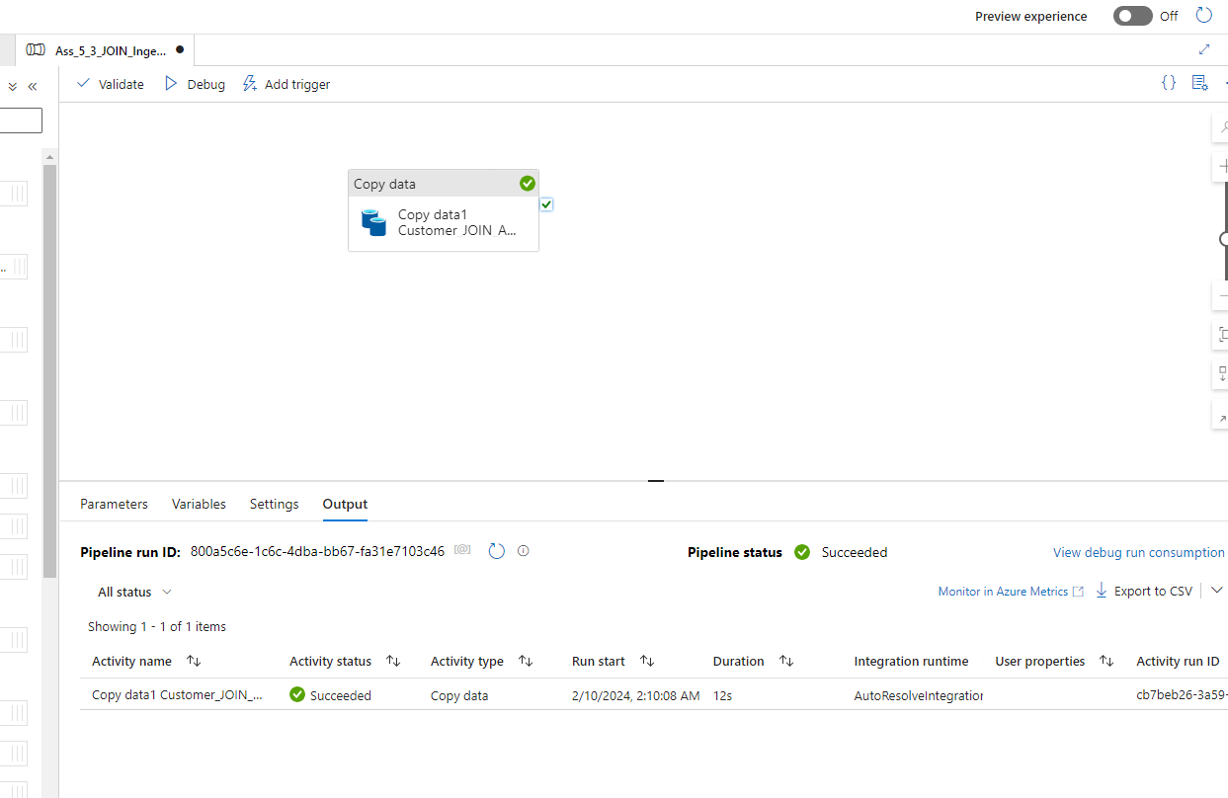

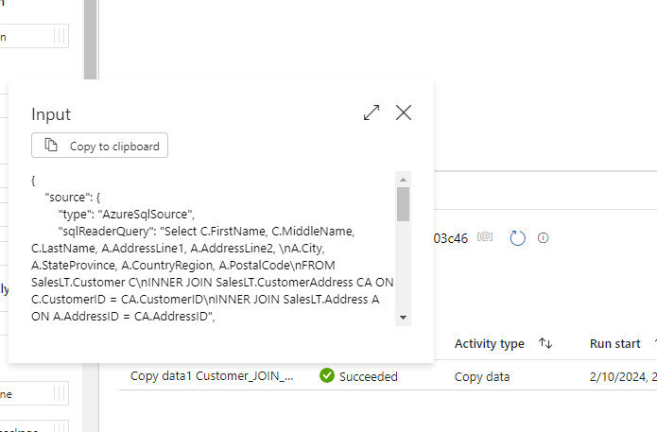

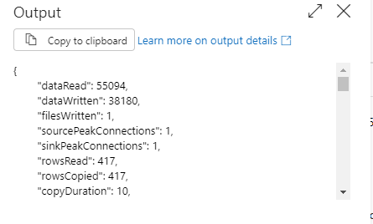

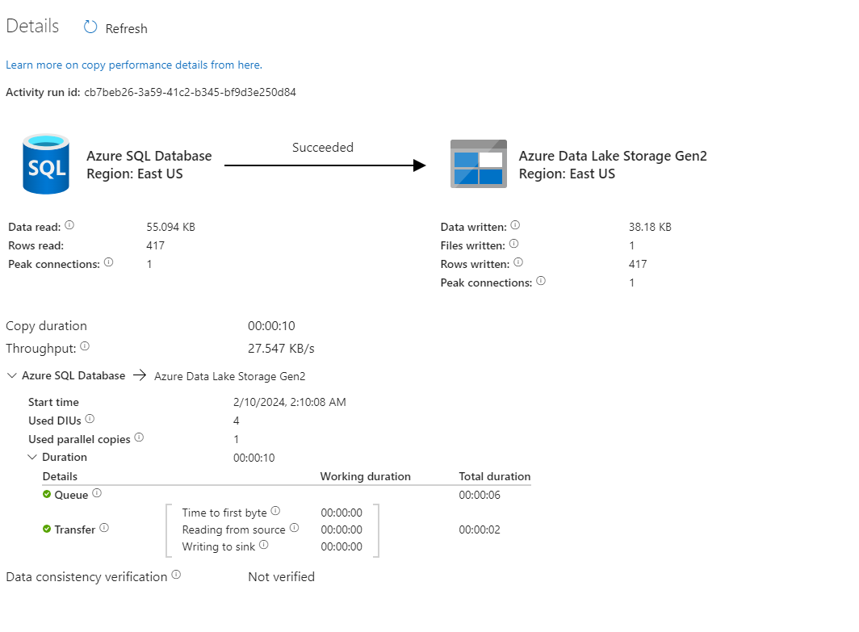

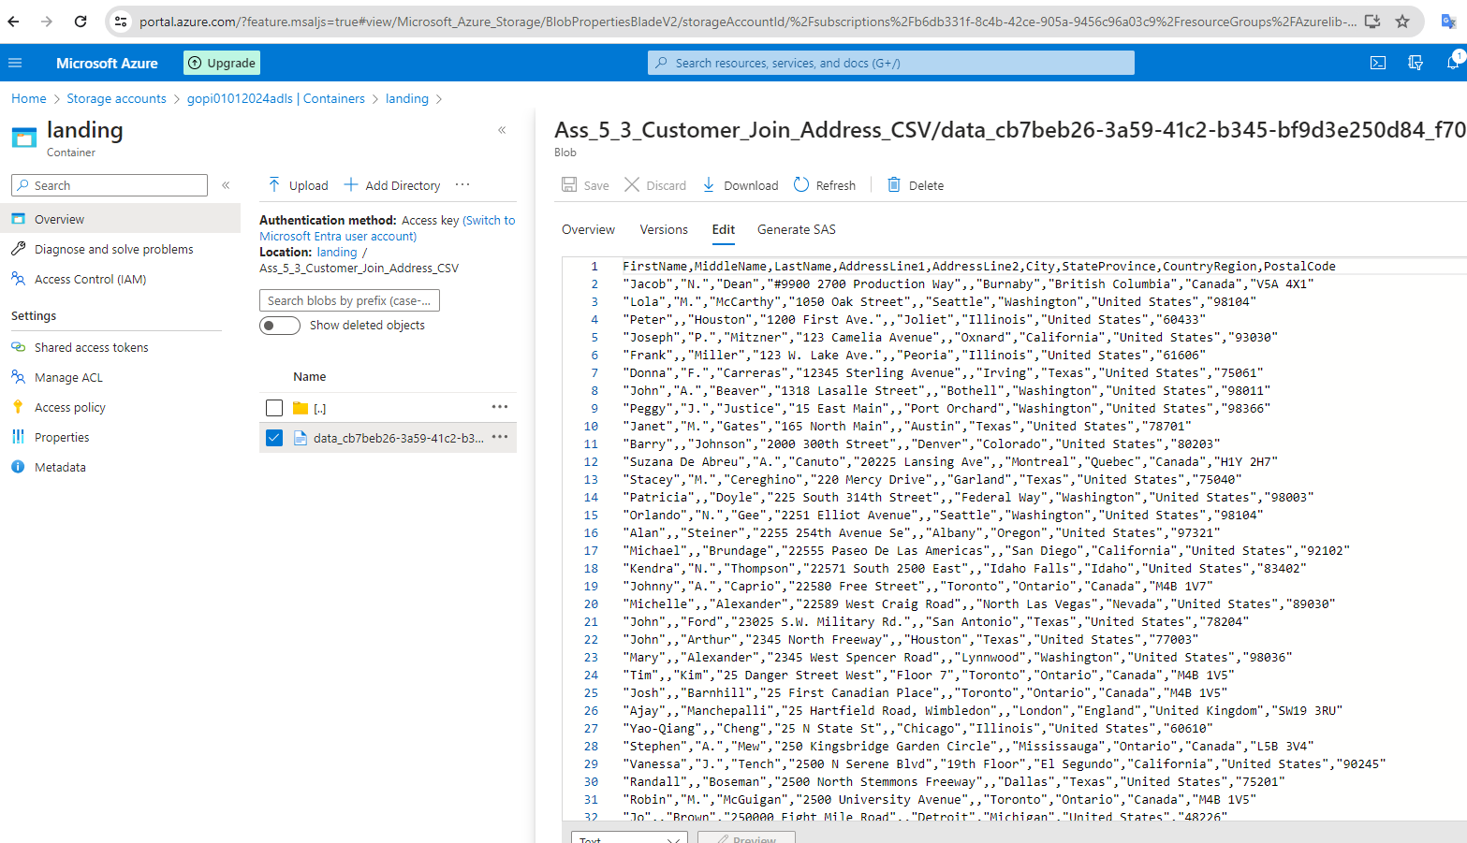

Tough Question

- Create a pipeline name 'Ingestion_Product_Addres_To_JSON' which will copy all the product records as JSON only if total number of records >10. After that check total record count in address table if they are greater than 100 then copy the adress table data as CSV in ADLS

Video : Azurelib Academy (freshlearn.com)

Session 06 (Live): Lookup /If / Execute pipeline activity / Dynamic Date Part 2
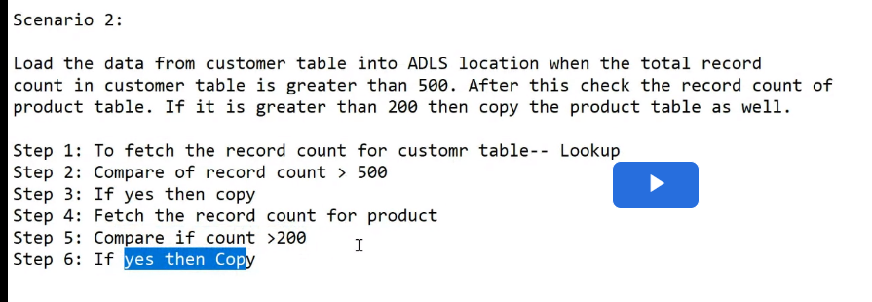

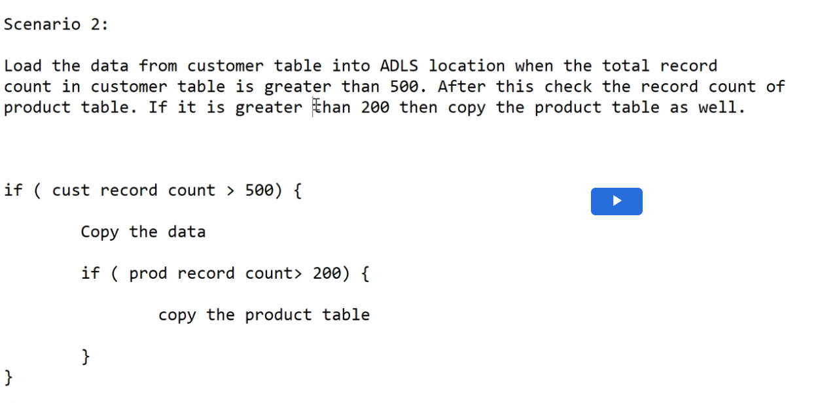
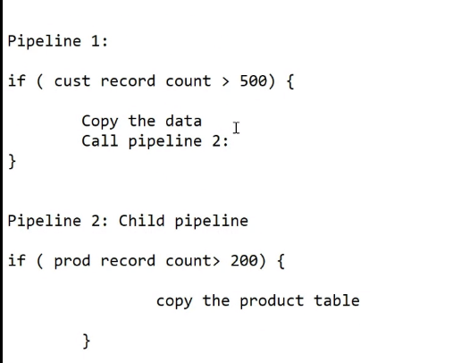

Nested If” - is not allowed in ADF: “Solution”: is you need to “Break the pipeline” (make it 2 pipeline) - Instead of 1 Pipeline make it 2 pipeline and make some connection between them

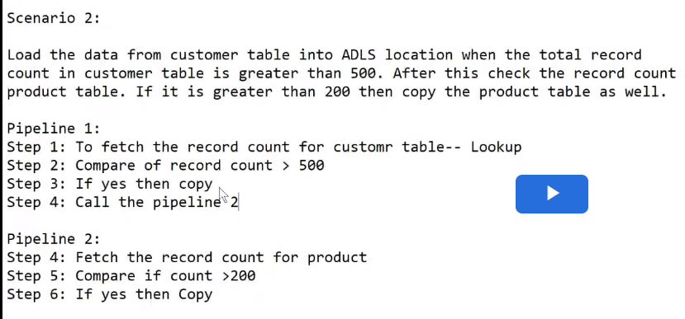

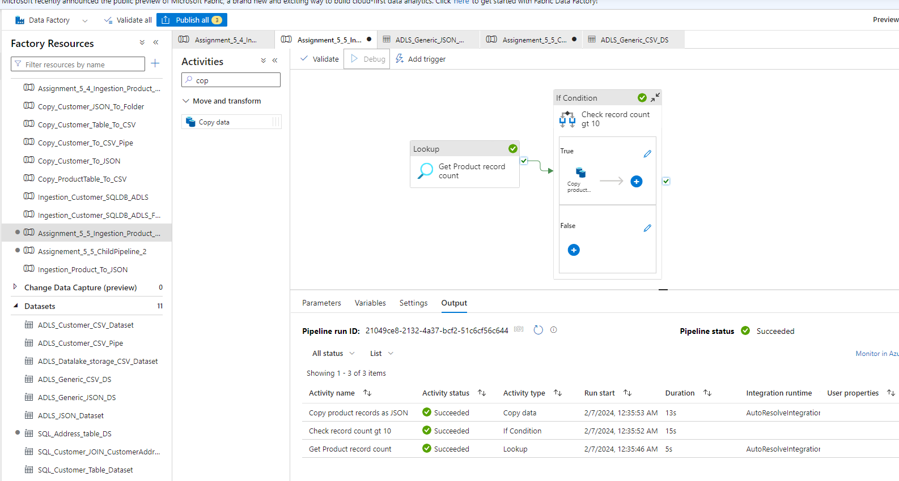

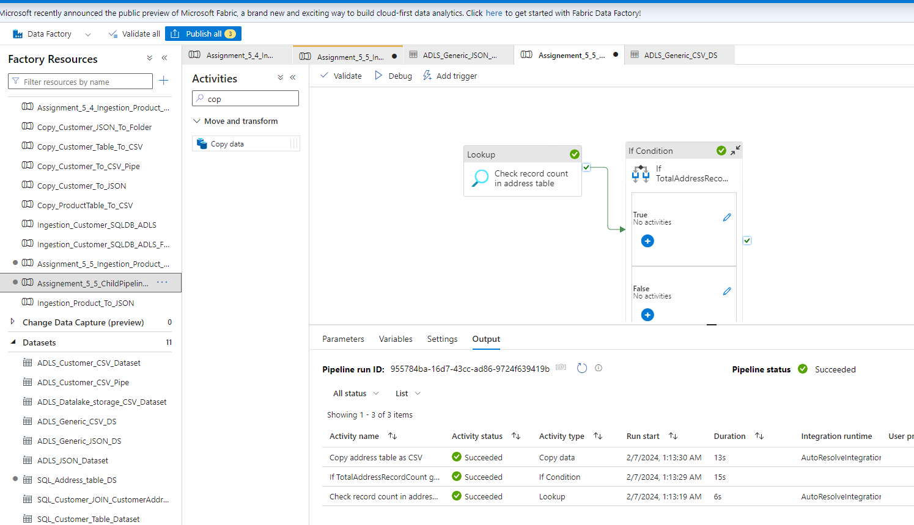

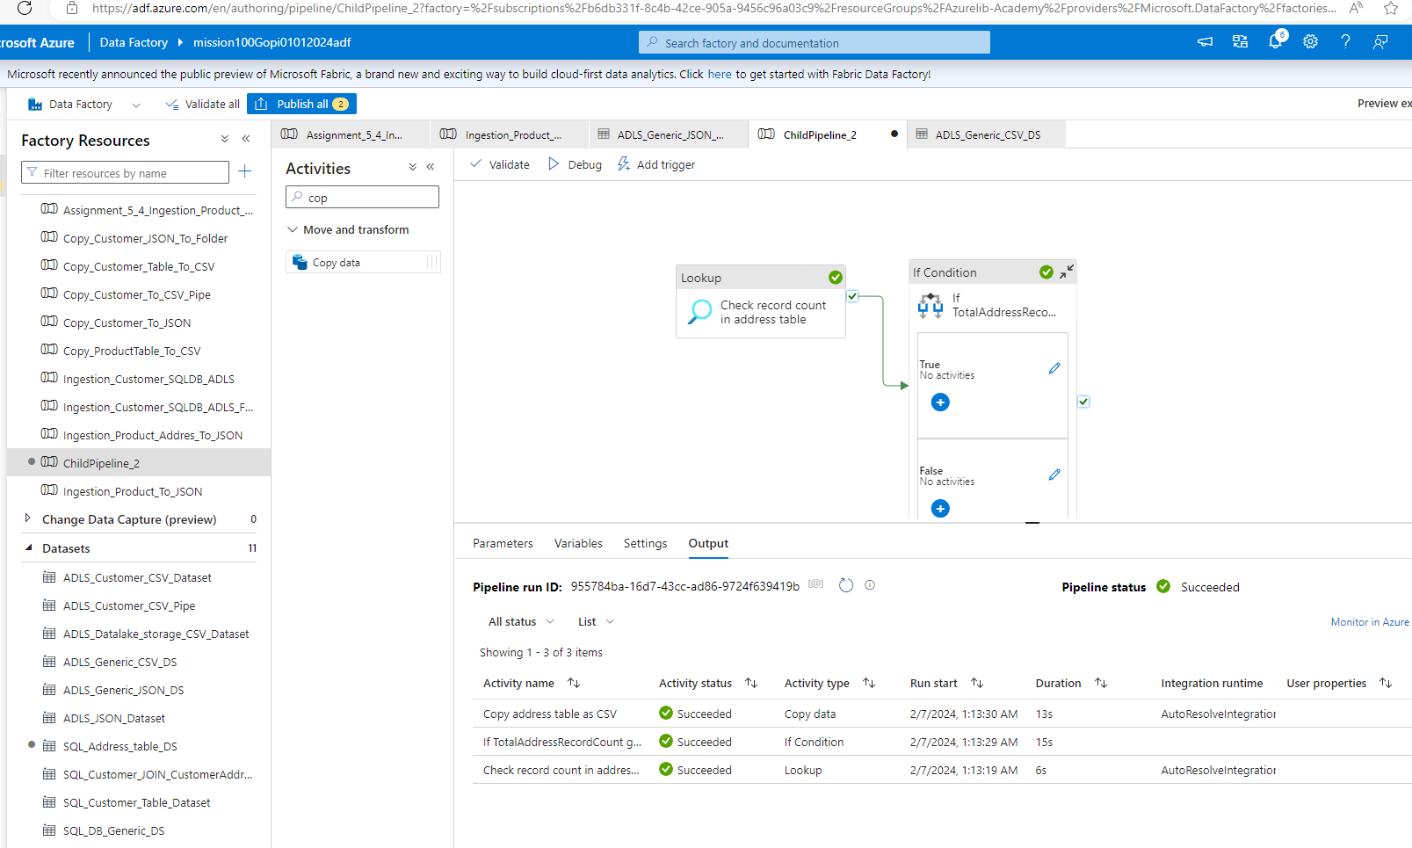

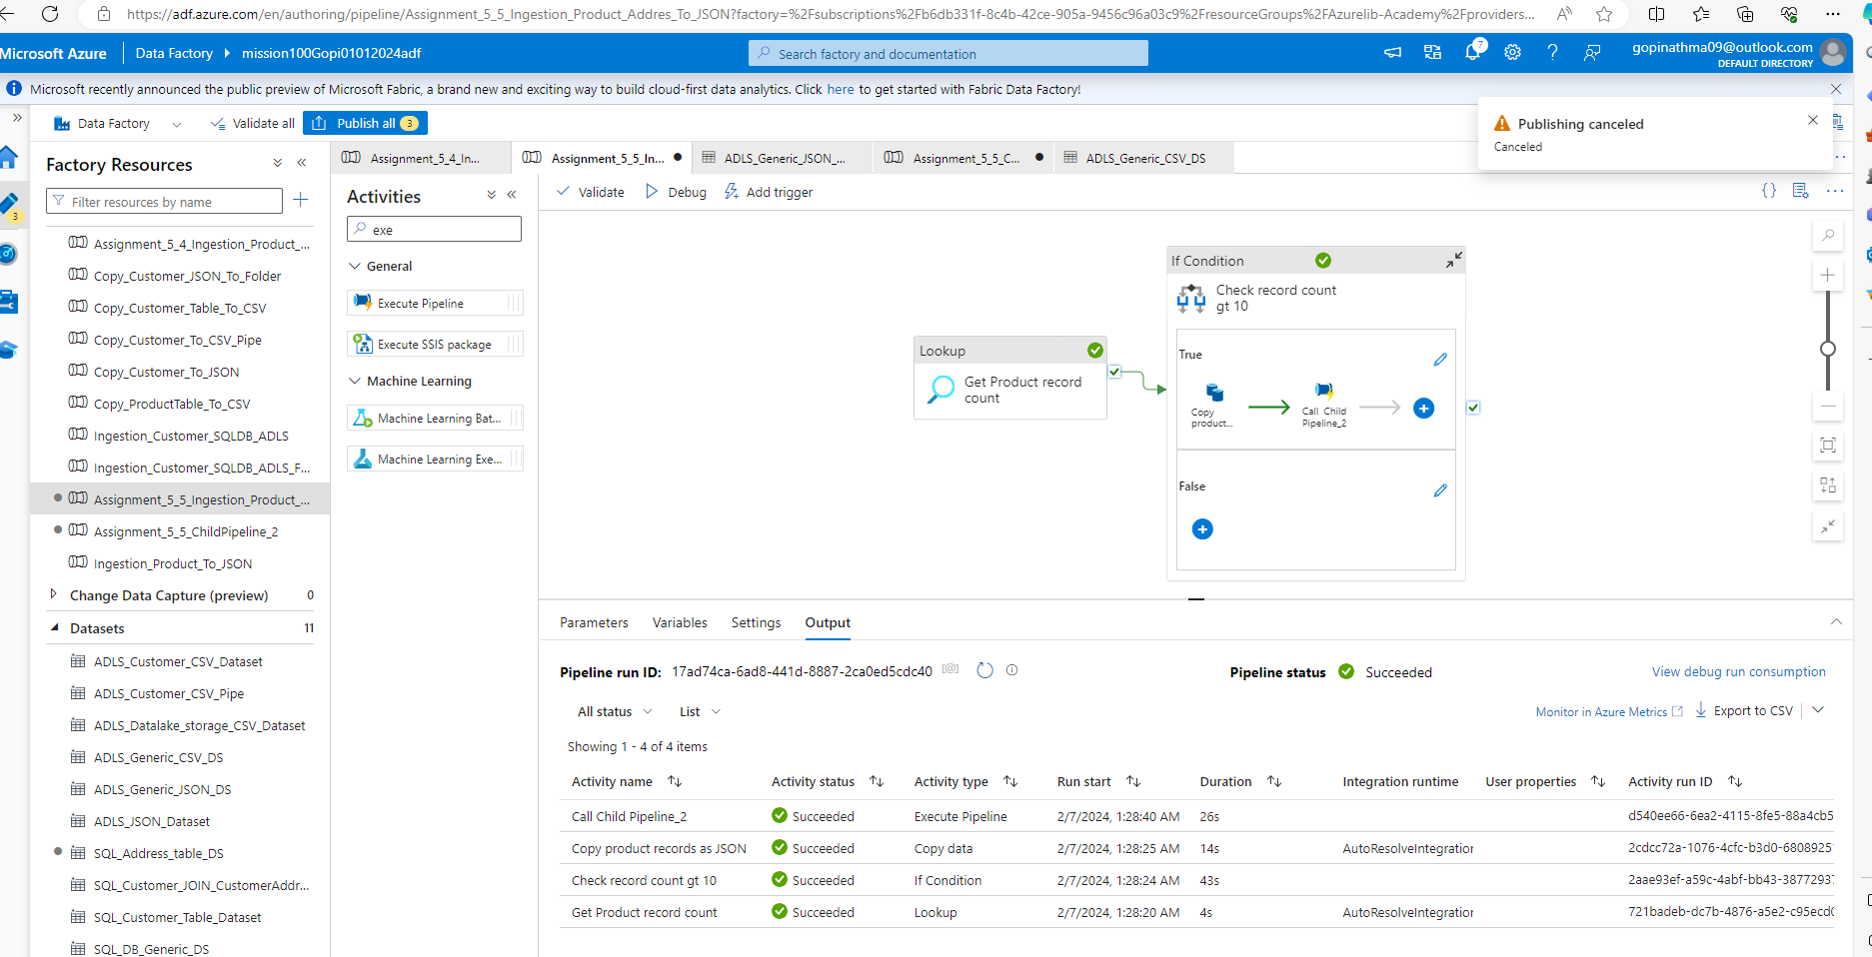

Assignment 6: ADF Pipeline 3
Azurelib Academy
6.I am attaching a file, load this file into your ADLS location. This file contains a threshold value.
Create a pipeline
in such a manner that, it will first get the threshold value from this file and then check if the record
count in the customer
table is more than it or not. If yes then copy the customer data from SQL db to ADLS location in JSON
format.

Solution:
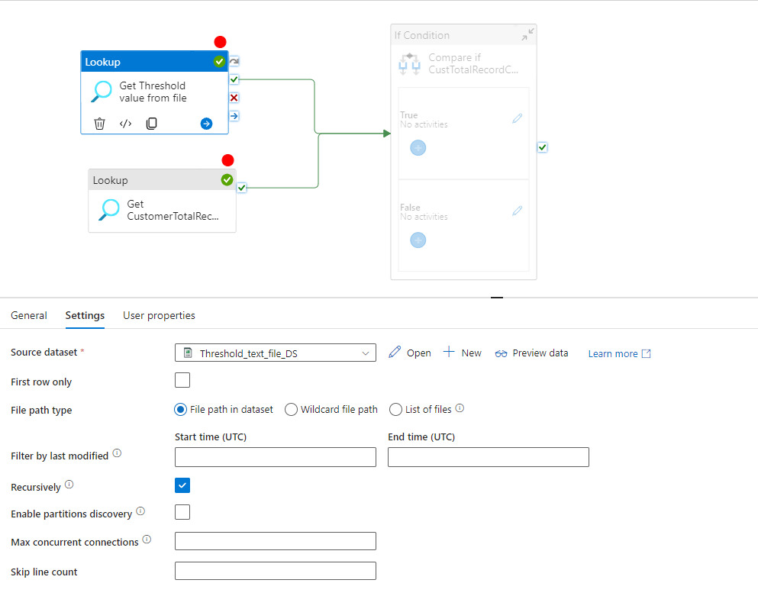

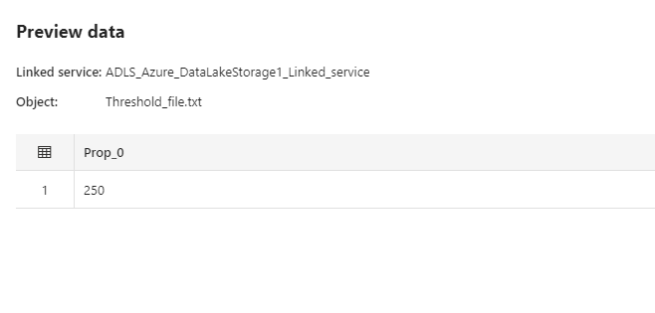

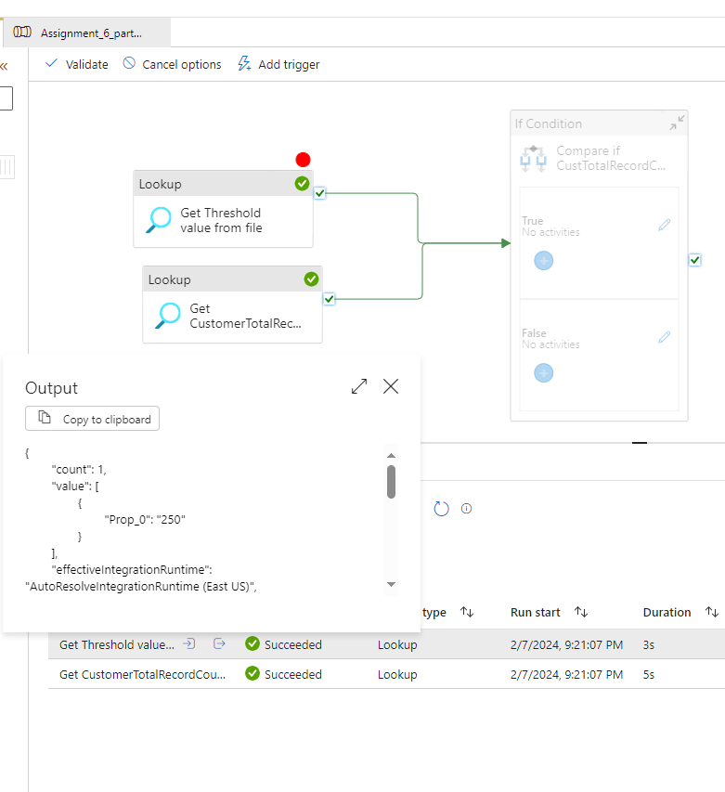

int(activity('Get Threshold value from file').output.value[0].Prop_0)

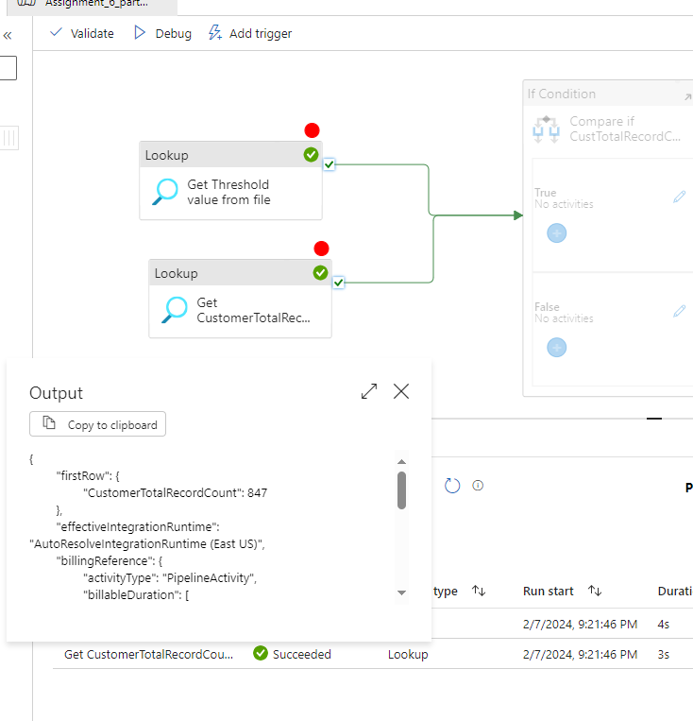

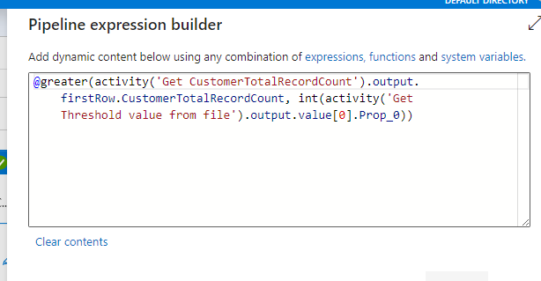

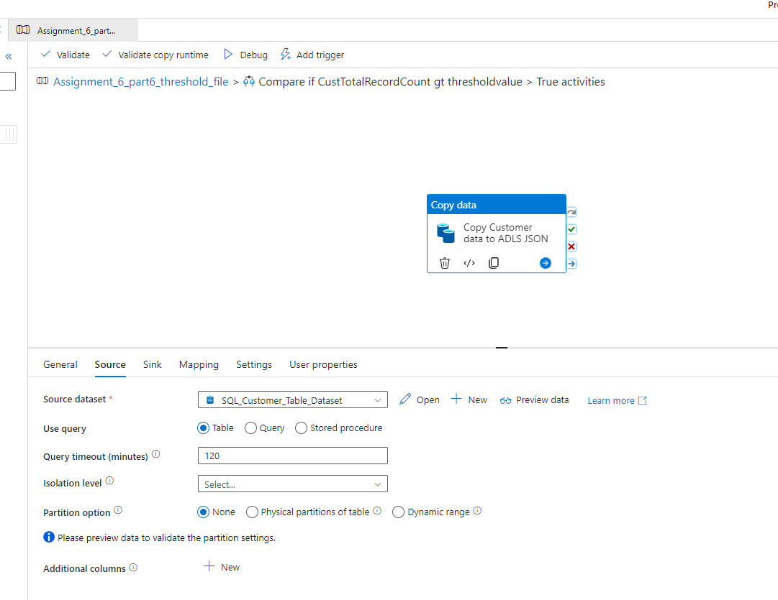

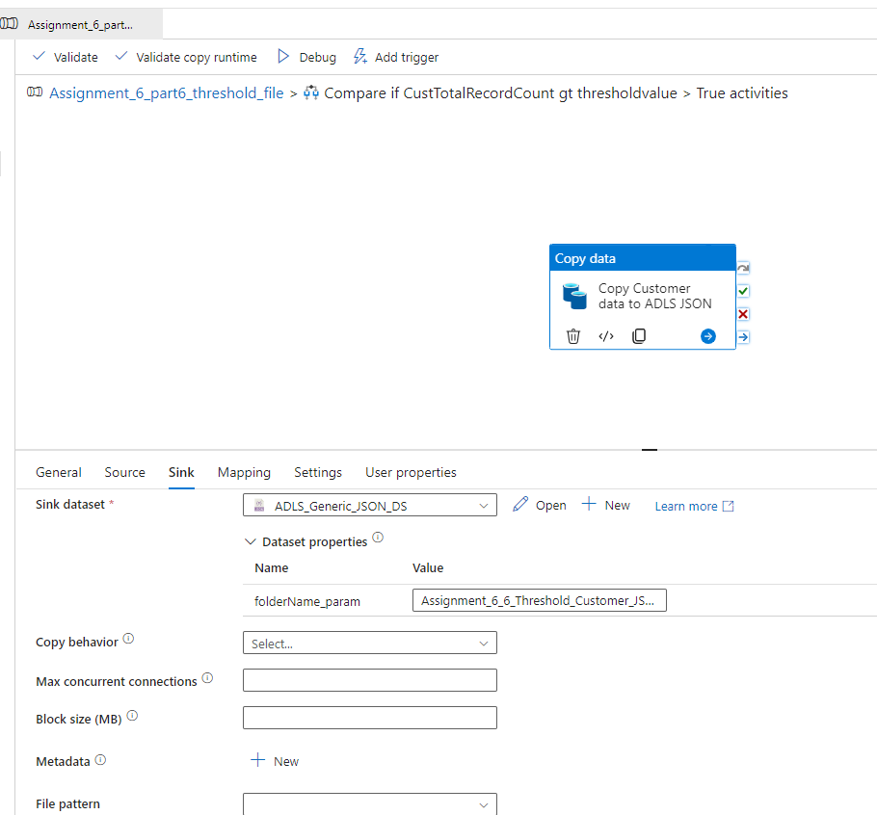

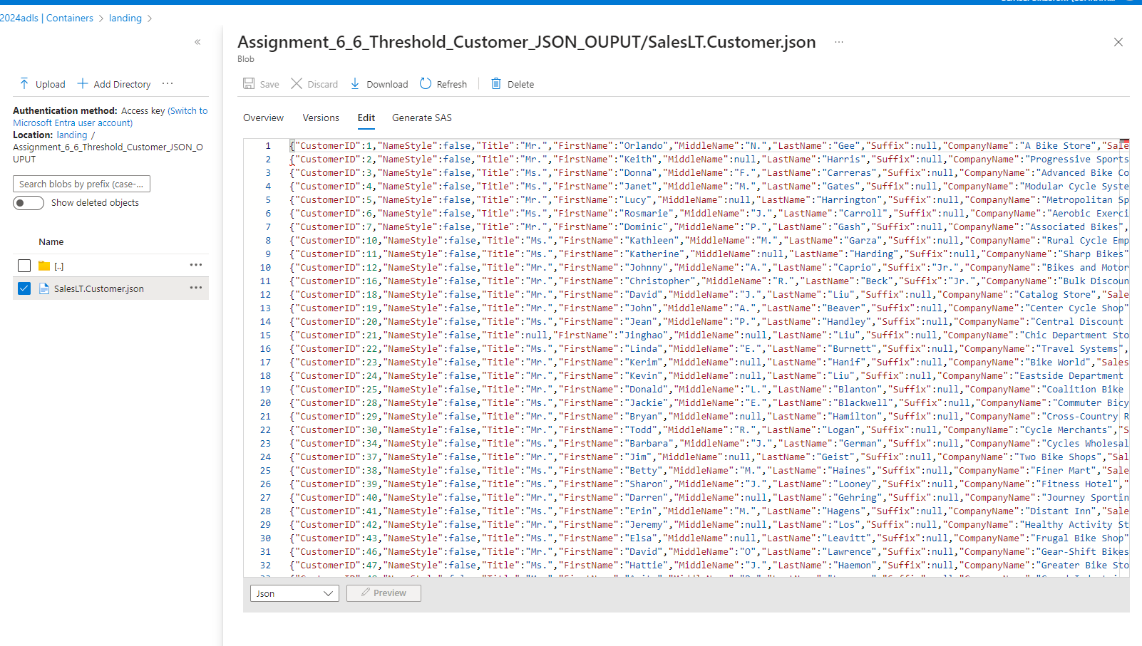
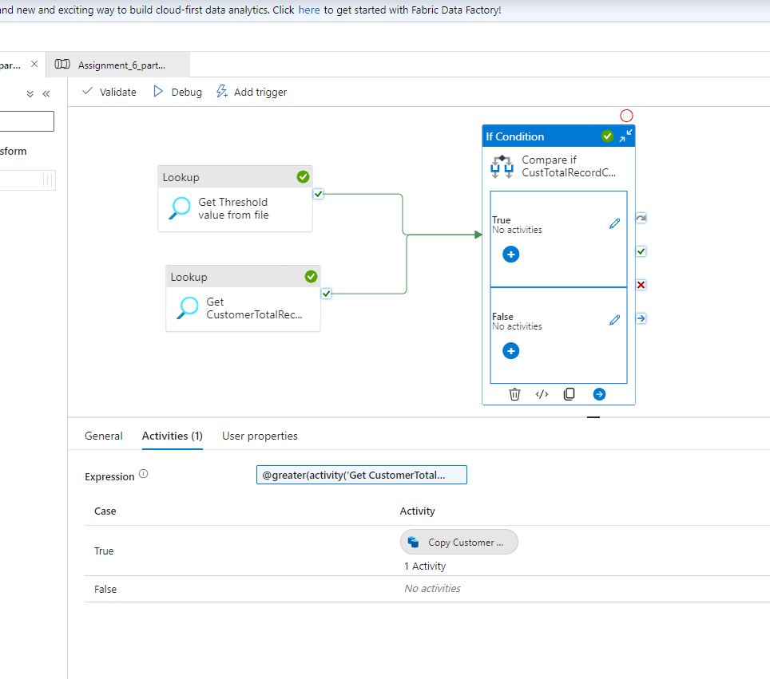

5. In the above case problem is that every time the pipeline runs it will overwrite the data. Ensure that
all the data goes into
Folder like (Customer/Year/Month/Day) to avoid any overwriting. Please rewrite the pipeline

Assignment 6: ADF Pipeline 3
Azurelib Academy
Easy Questions:
1. Create a pipeline name 'Without_Foreach_Example' to copy the Customer & Customer address
table data into ADLS without using foreach activity.

Solution:
Use 2 copy activity : 1 for Customer dAta, 2nd for Customer Address and make connection

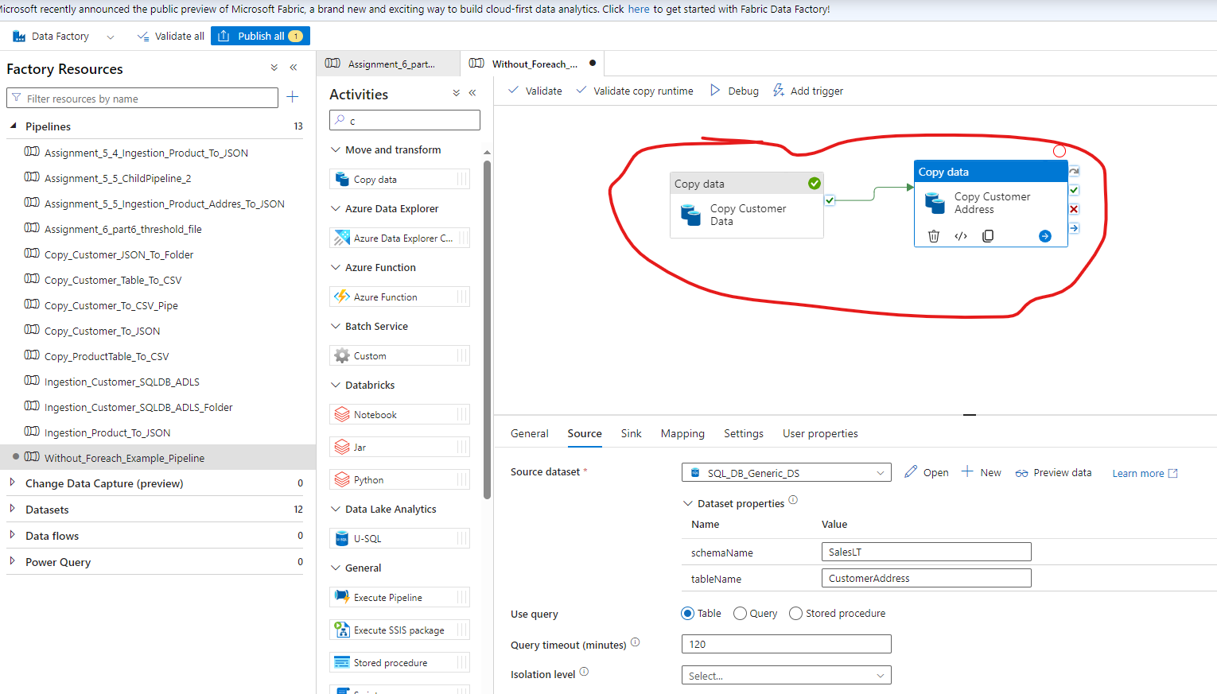

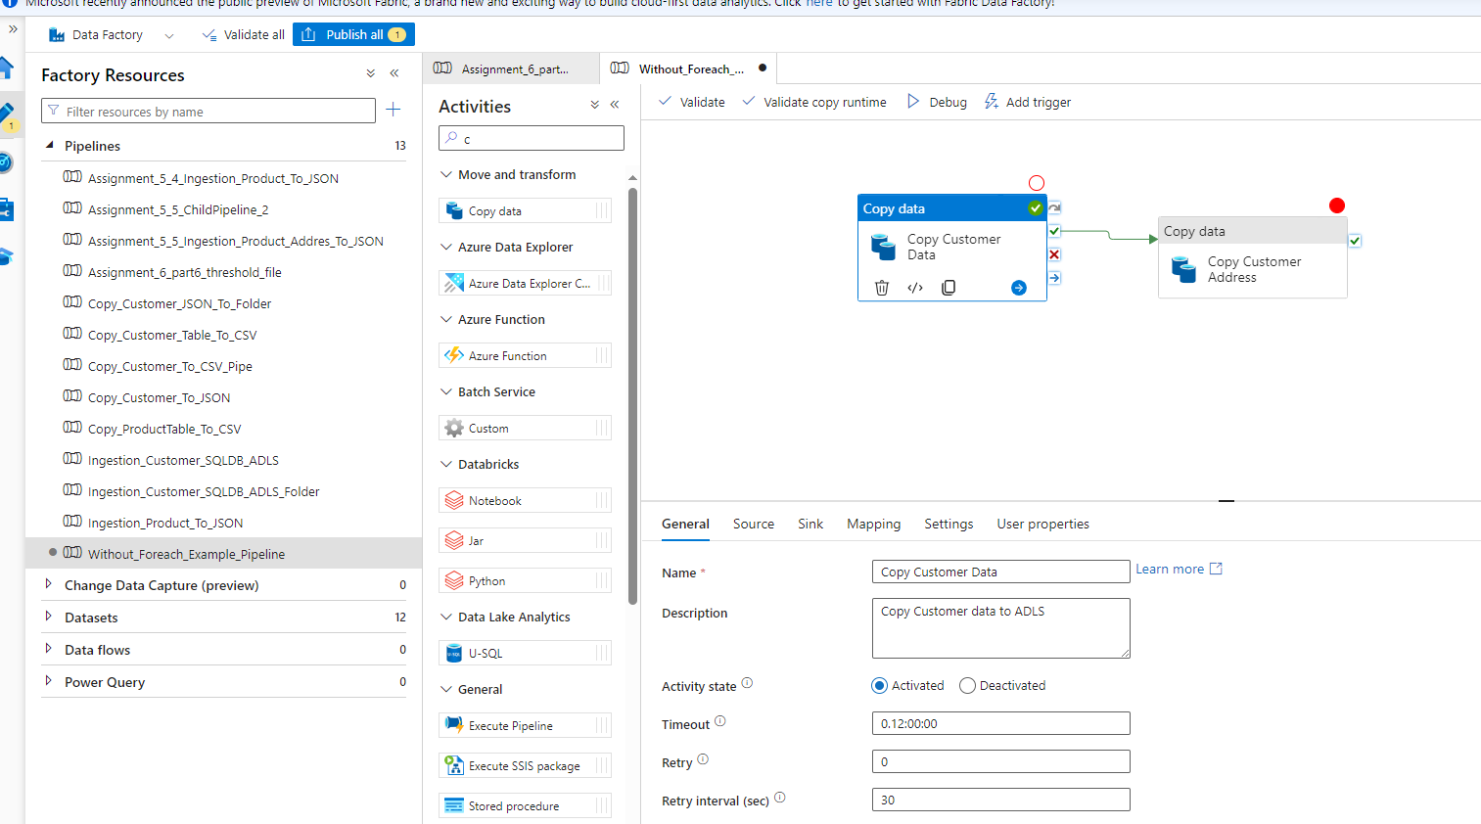
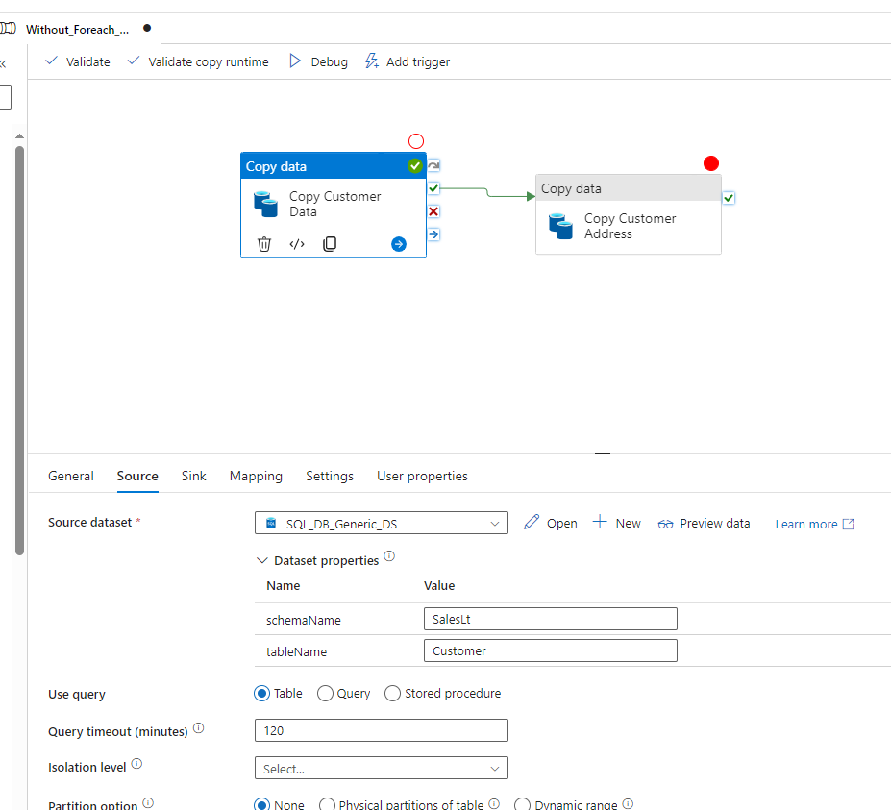

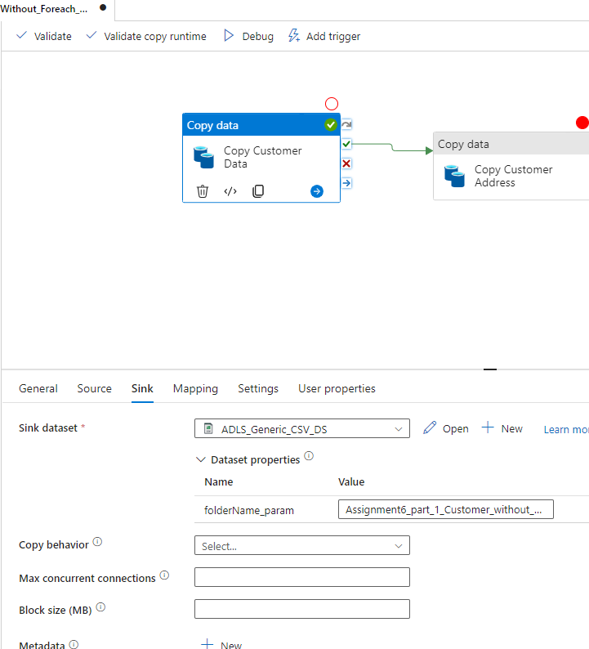

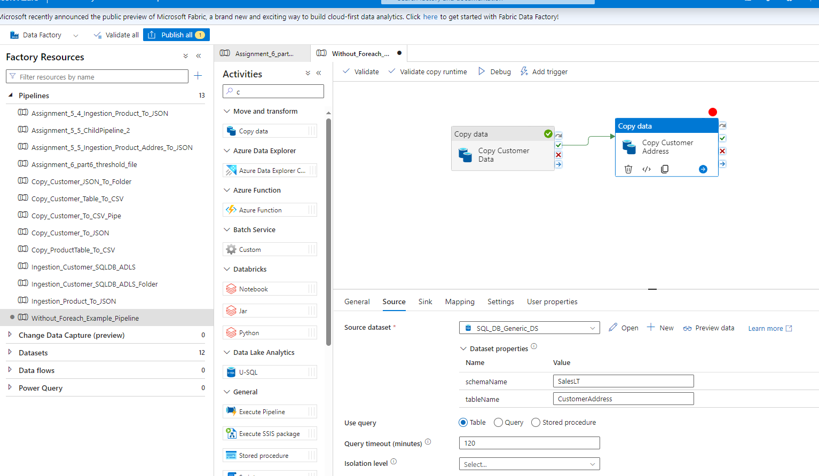

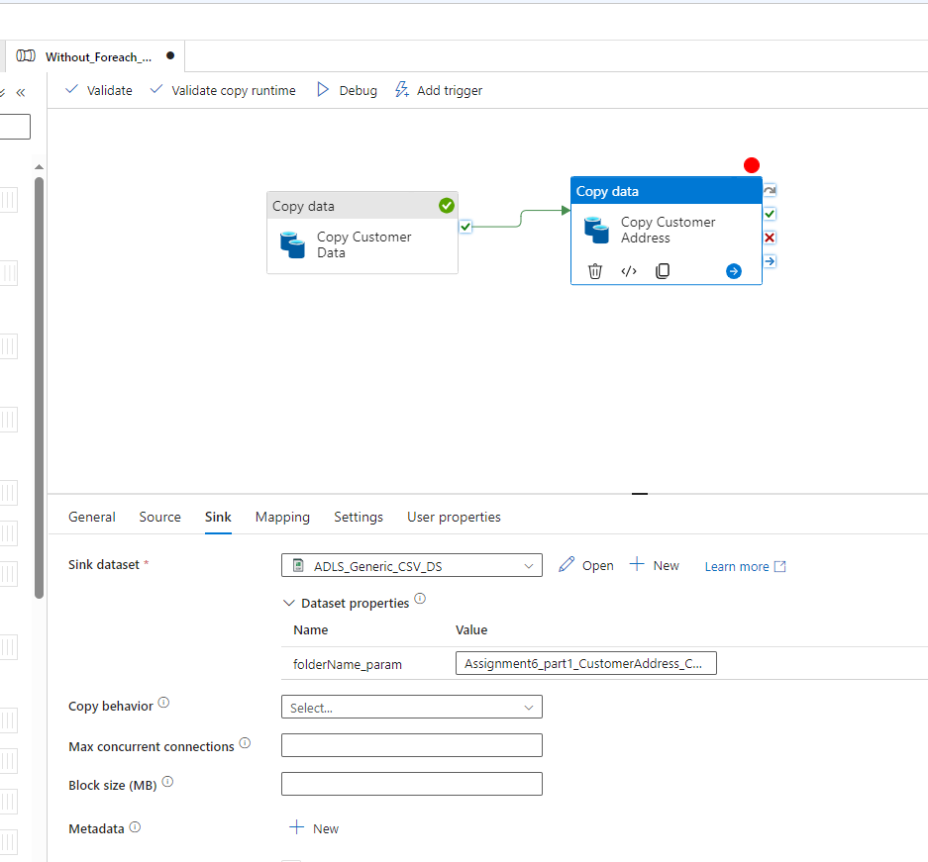

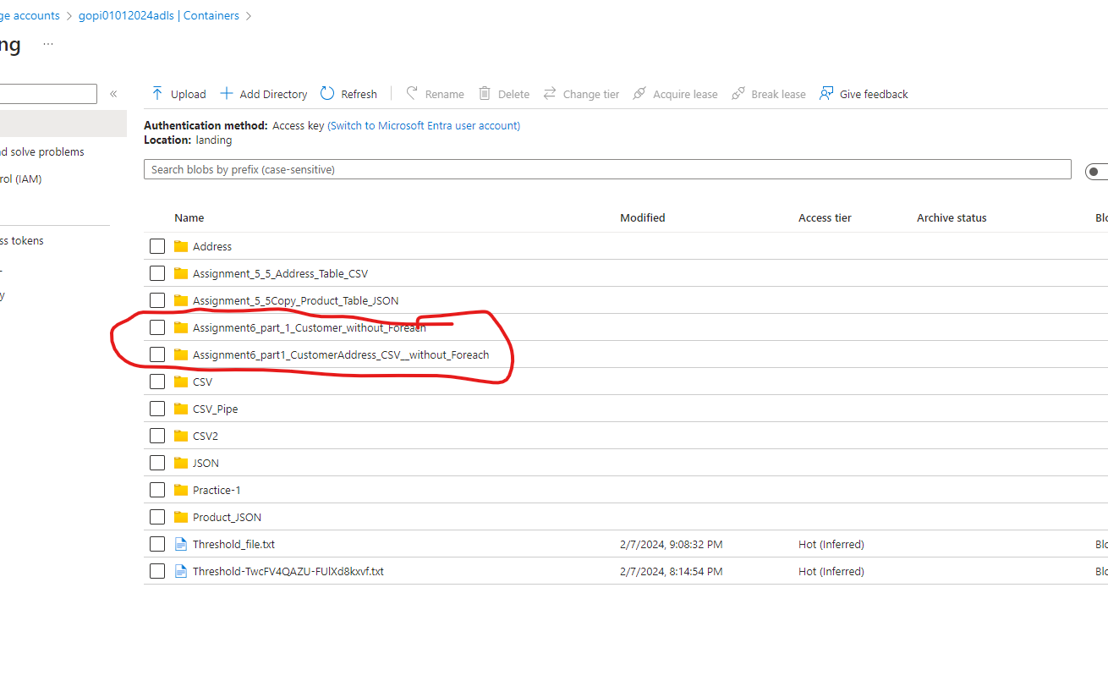

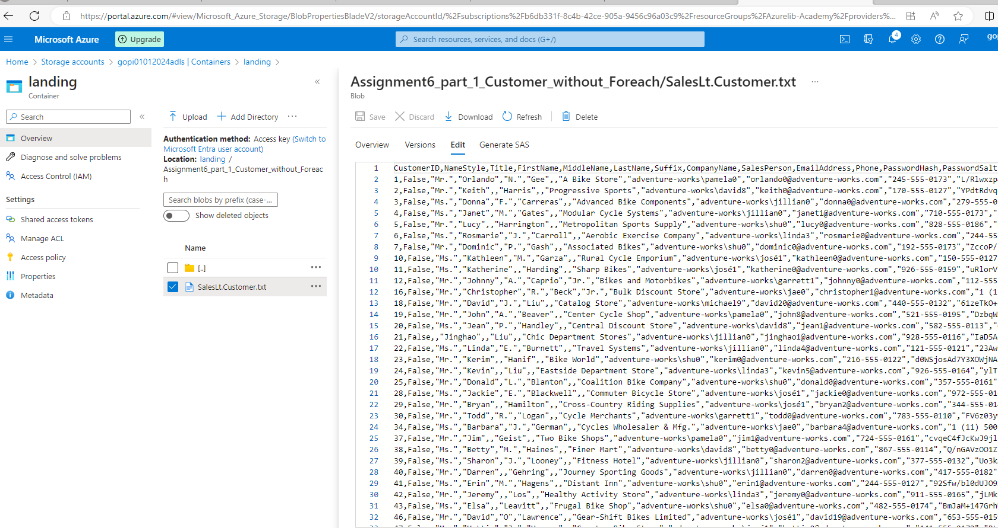

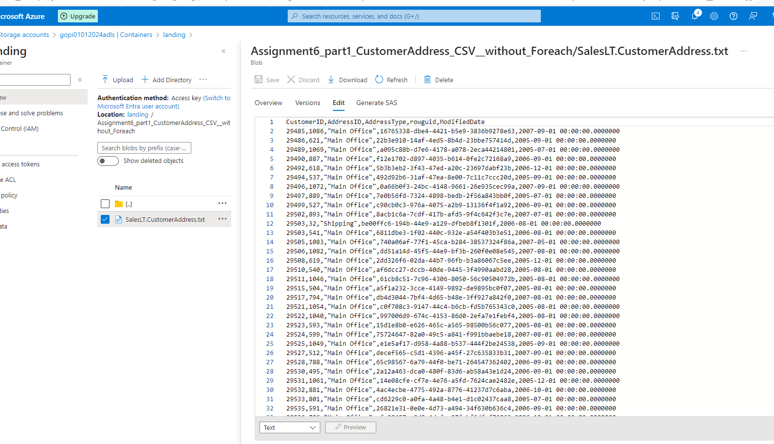

2. Create a pipeline name 'Foreach_Example' to copy the Customer & Customer address table data
into ADLS using the one copy activity.

Solution:
We use “For Each” Activity ++ Copy Activity

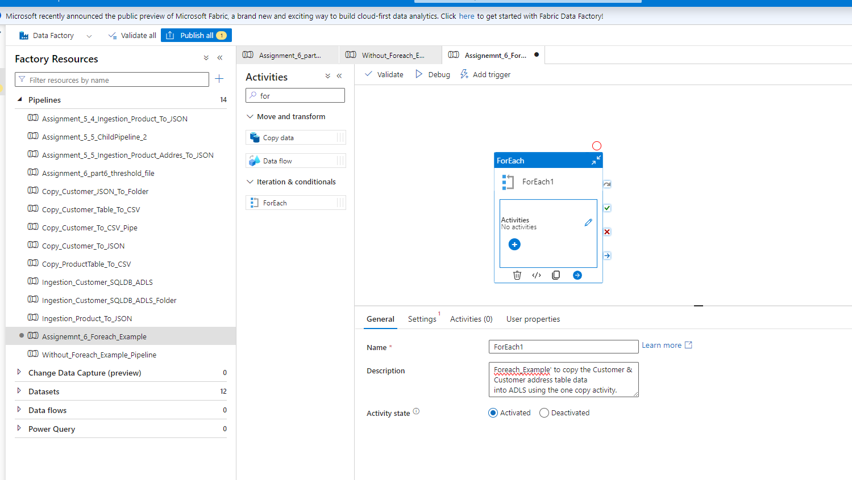

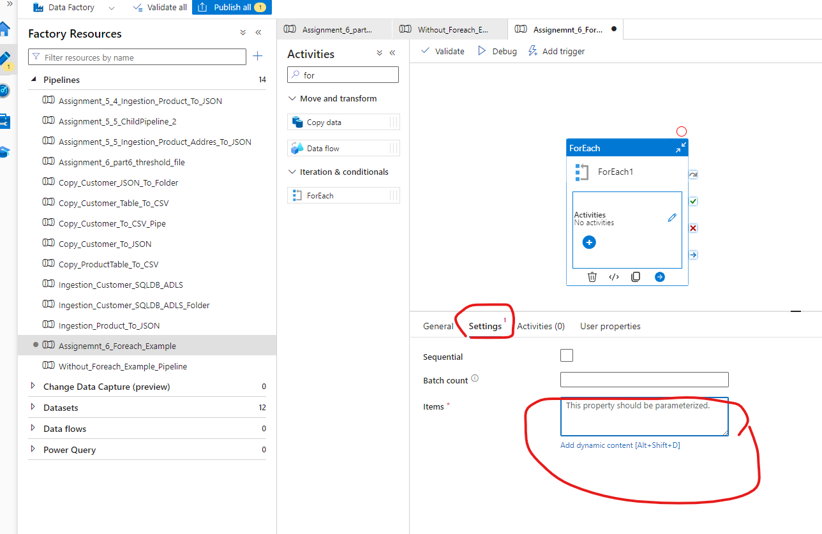

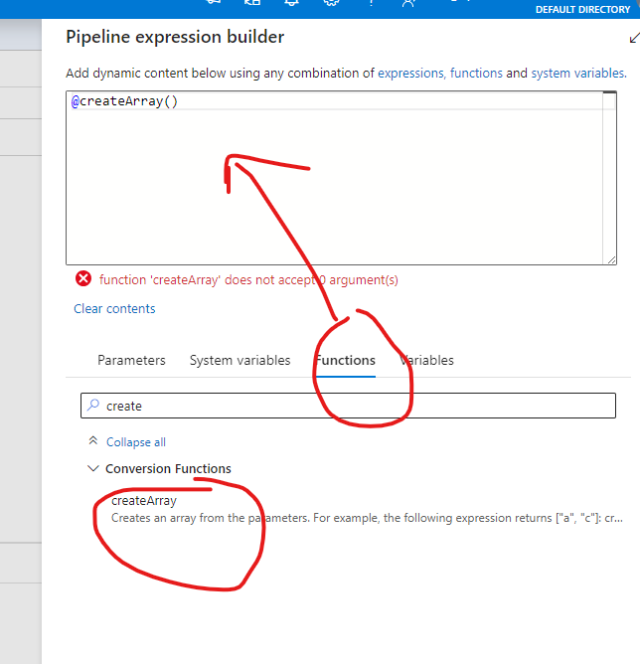

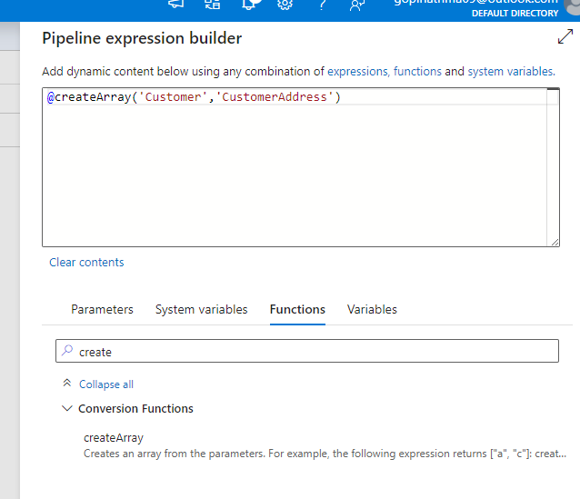

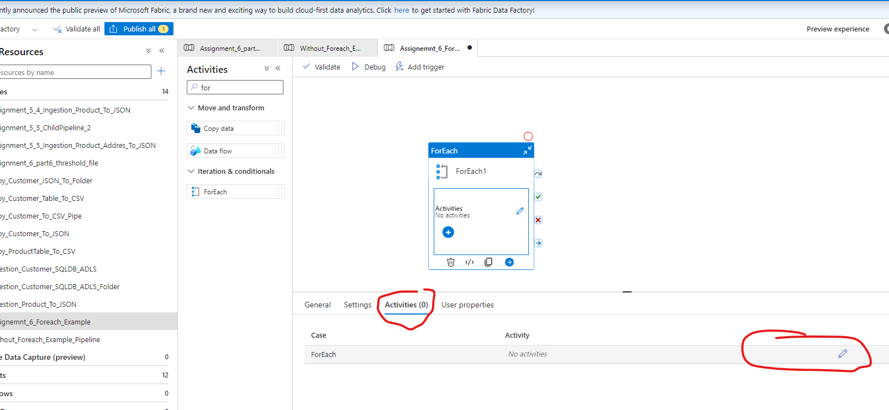

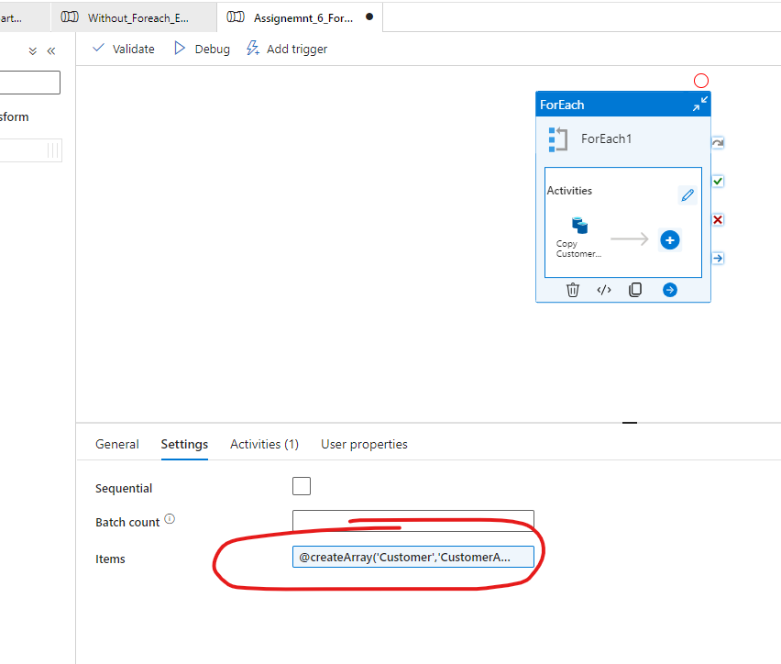

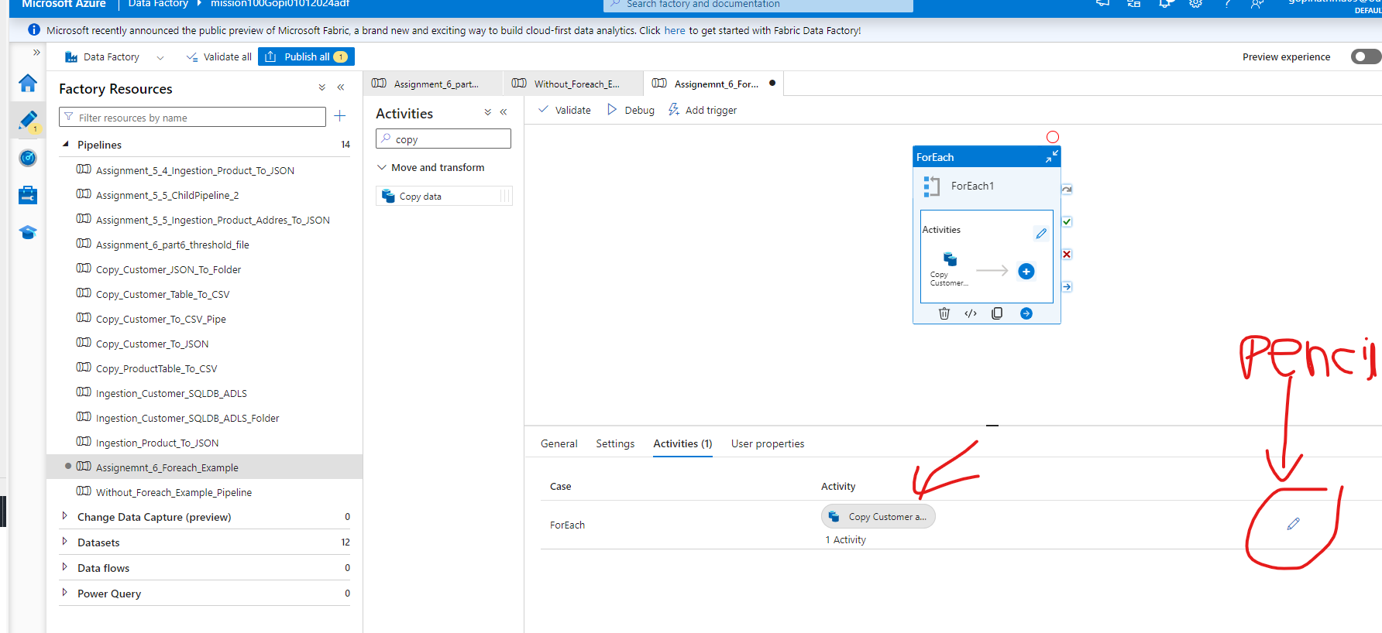

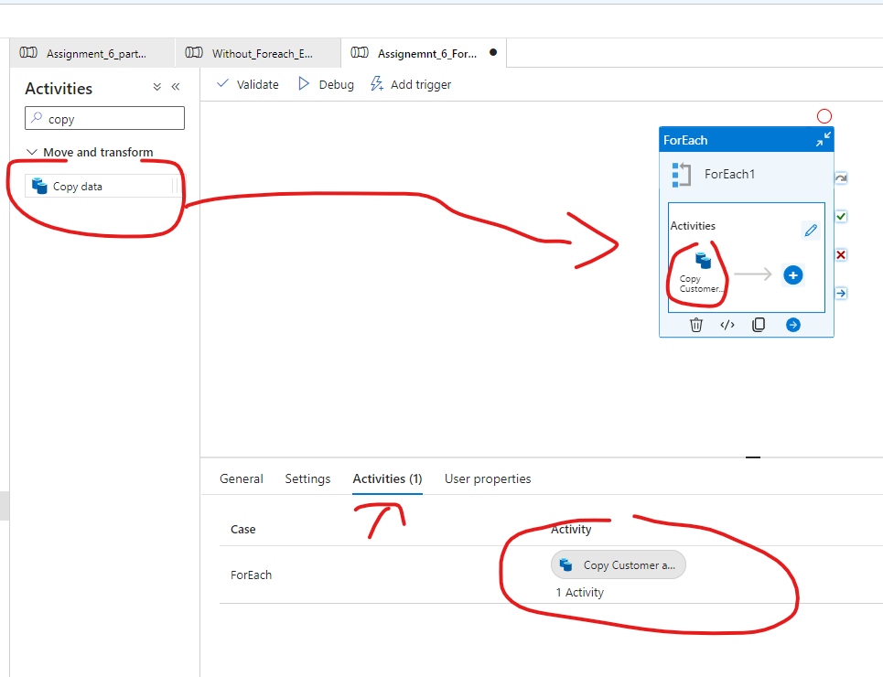

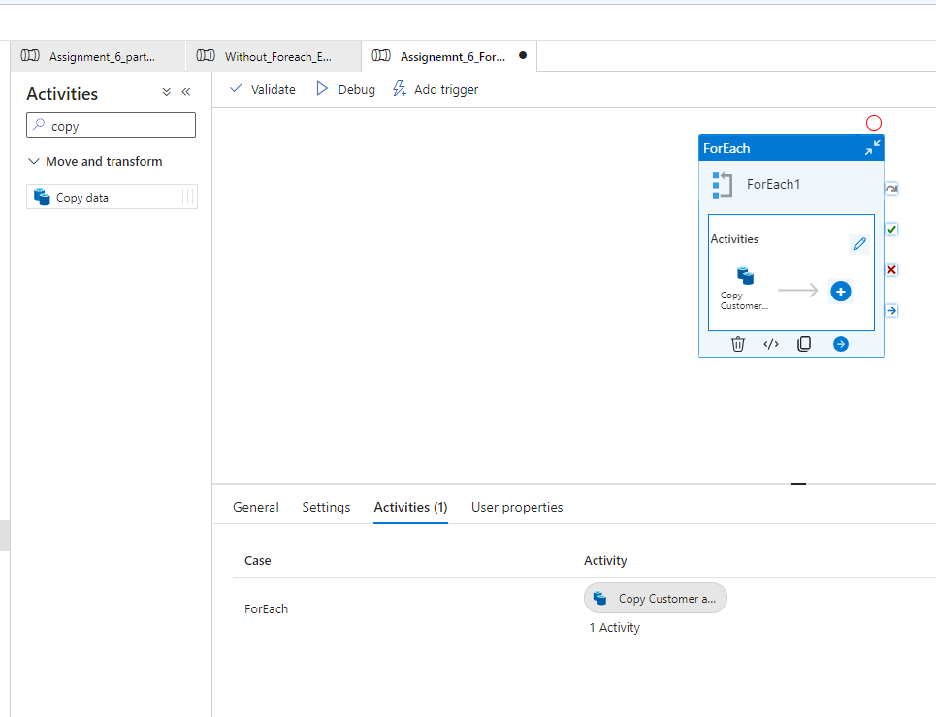

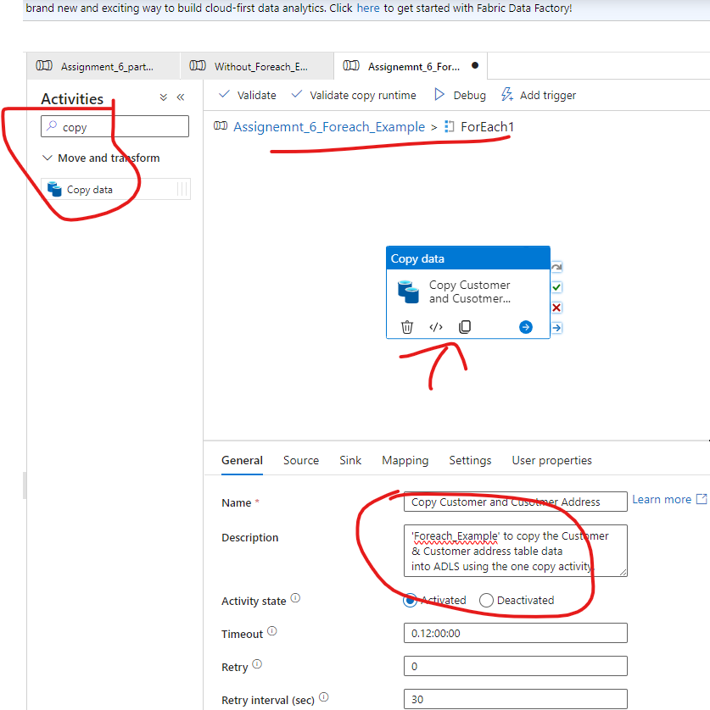

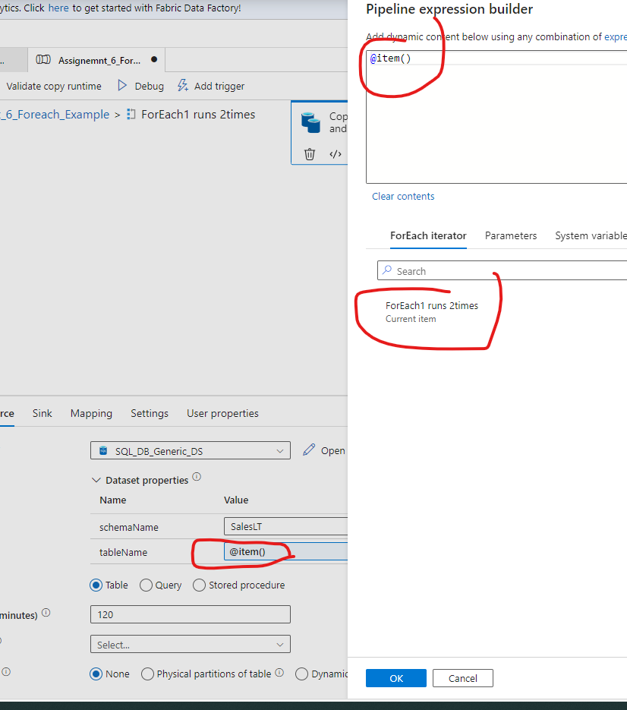

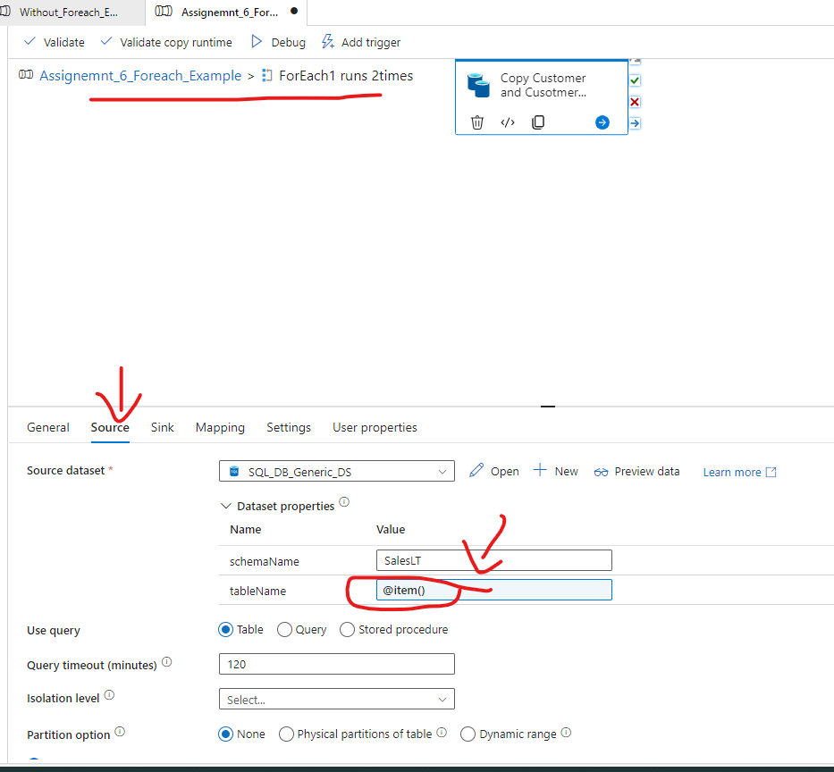

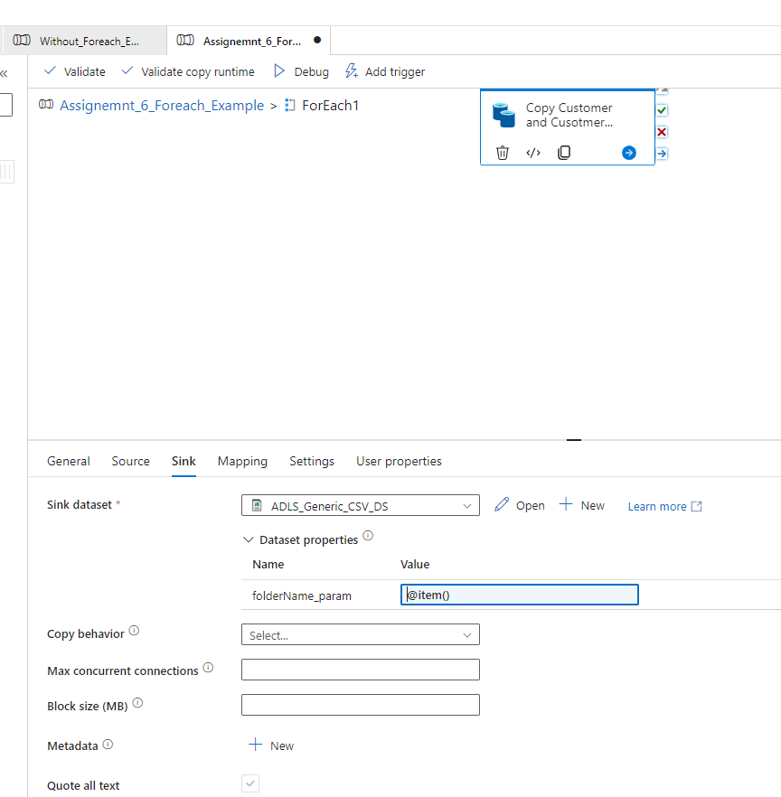

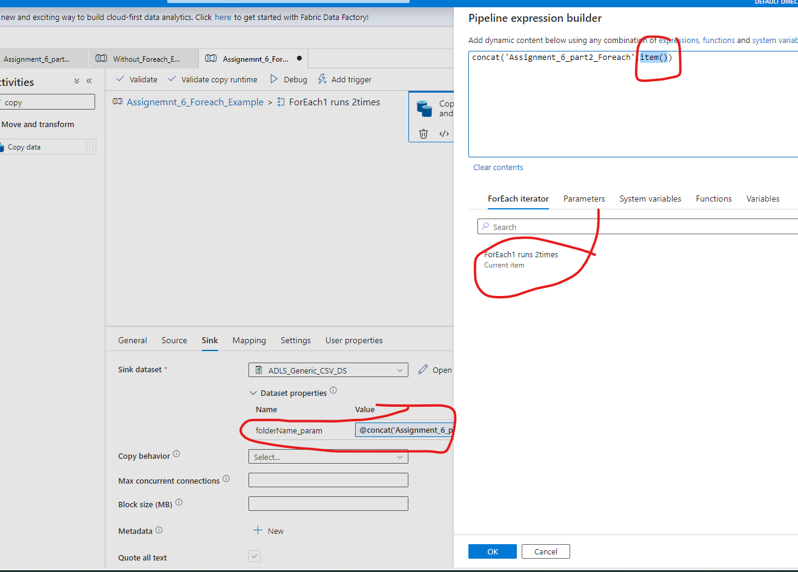

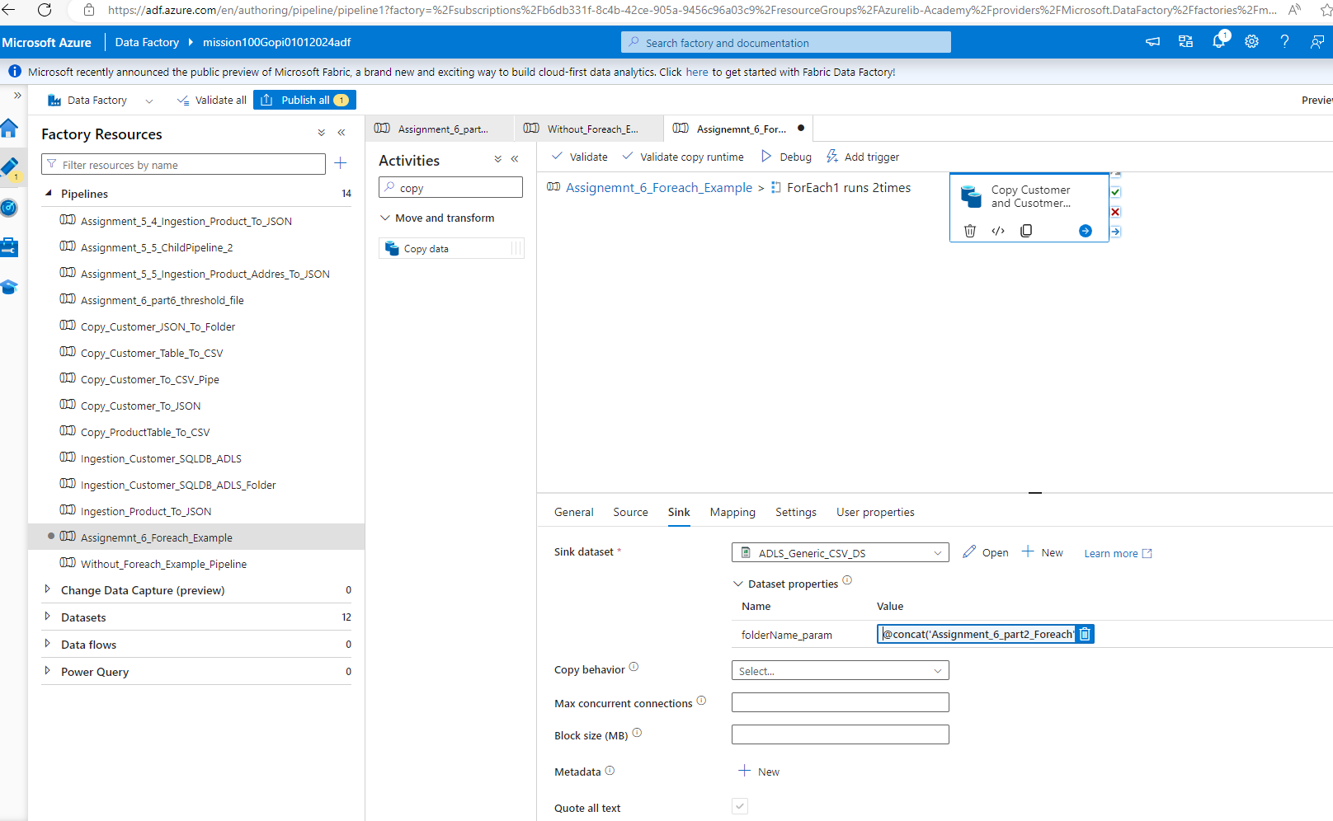

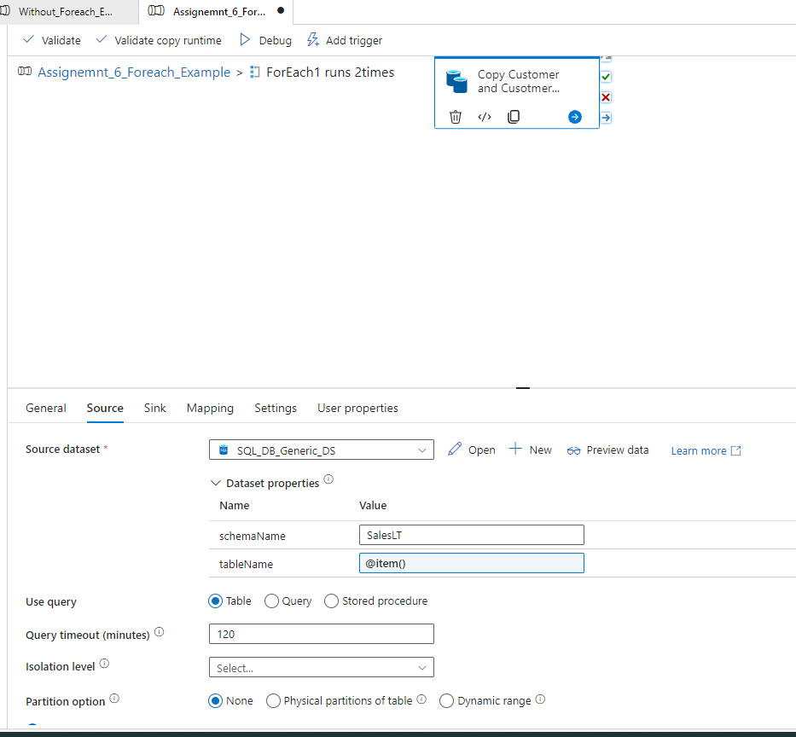

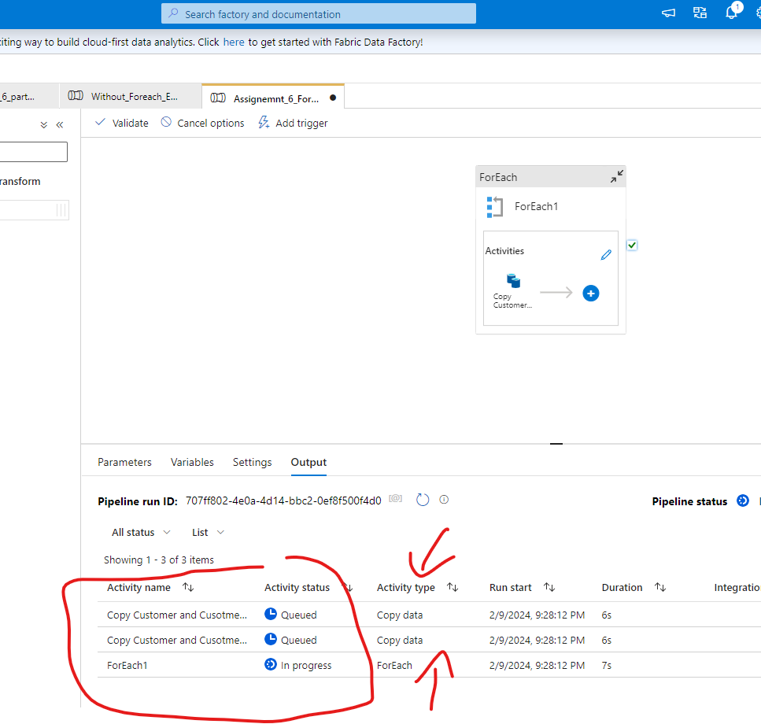

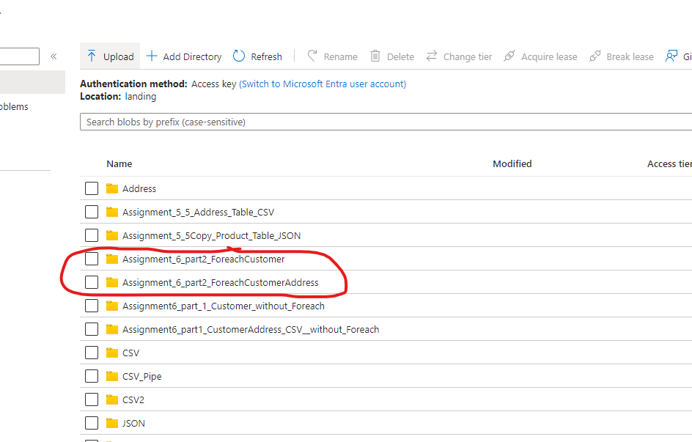

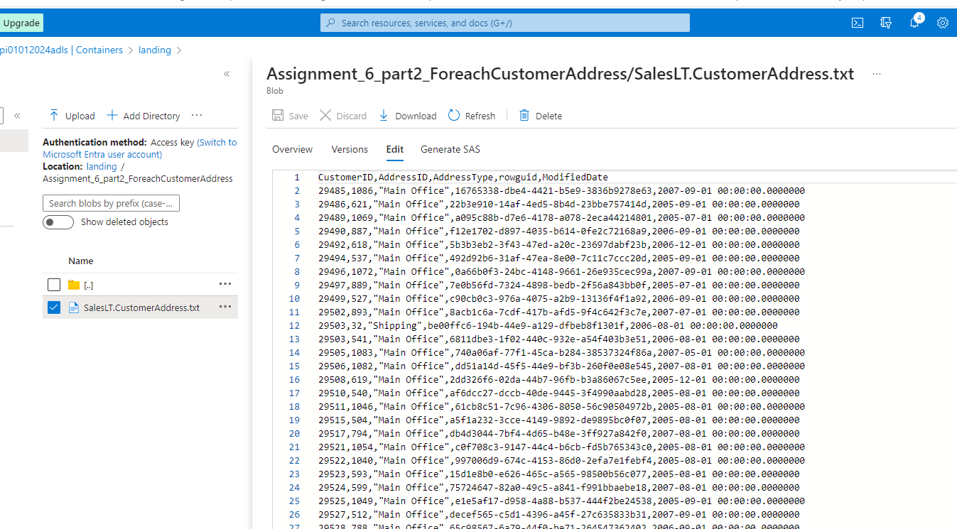

Tricky Questions:
3. Create a pipeline name 'Foreach_Example_2' which solves the following business use case.
Customer data is very important for our business. Hence whenever we have more than 100 records in
the customer table,
we copy the customer data to another table customer_copy within the sql db.
However whenever we do this copy, we first truncate the table 'customer_copy' and then copy the
data from 'customer' table
Hint : Use ADF to solve this problem.

Solution:

1st Lookup Activity to get customer count, -->
IF (Lookp_Custcount >100)

{ Note: In Sink you have to create “Cust_copy”
Pre-script :Truncate Cust_copy table(if exists)
Copy “Cust” to “Cust_copy”
}

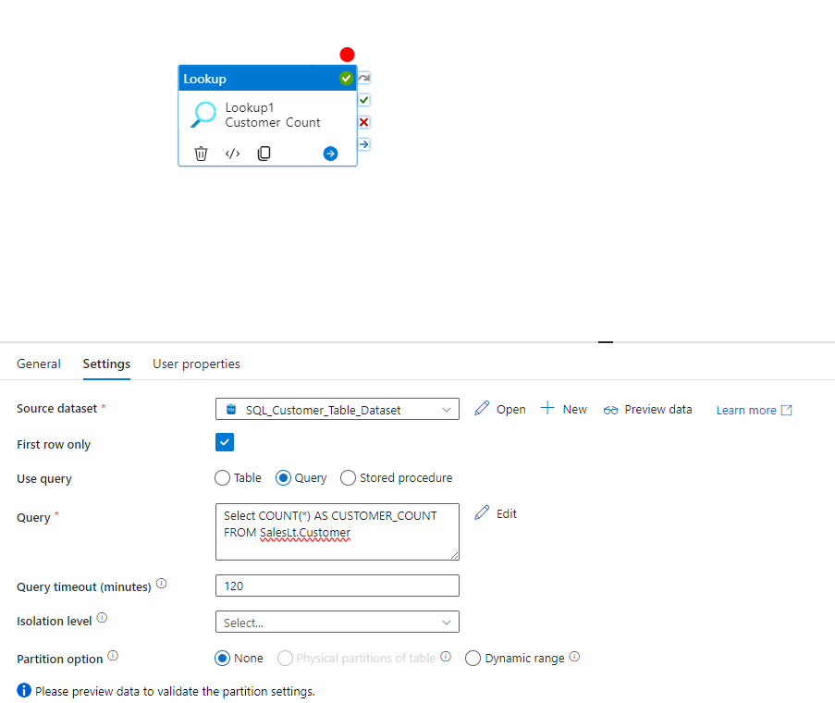

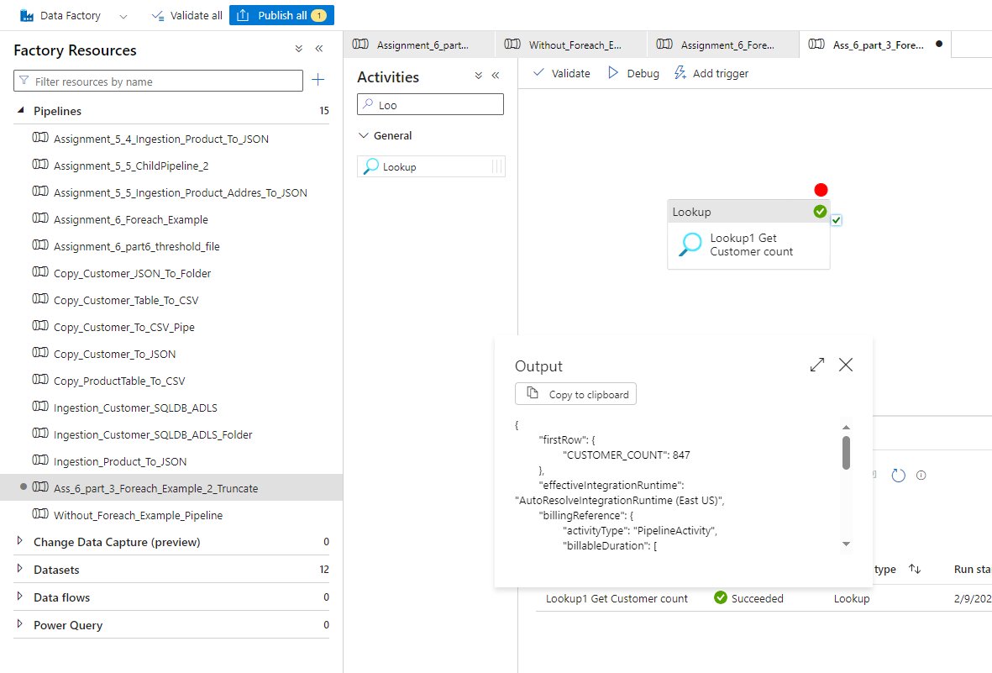

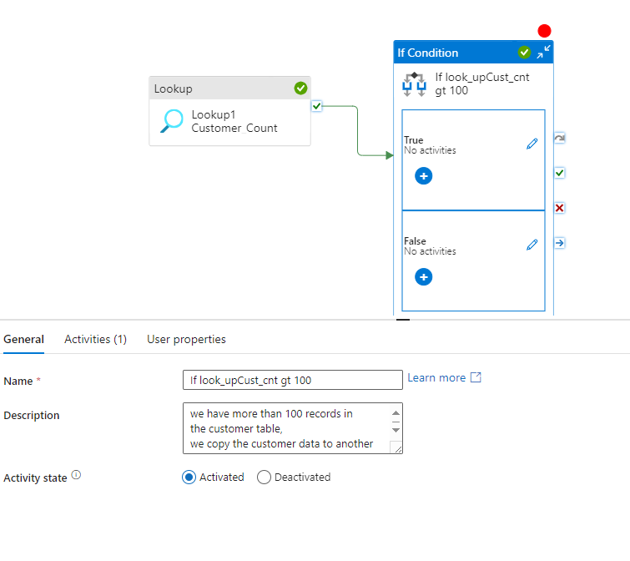

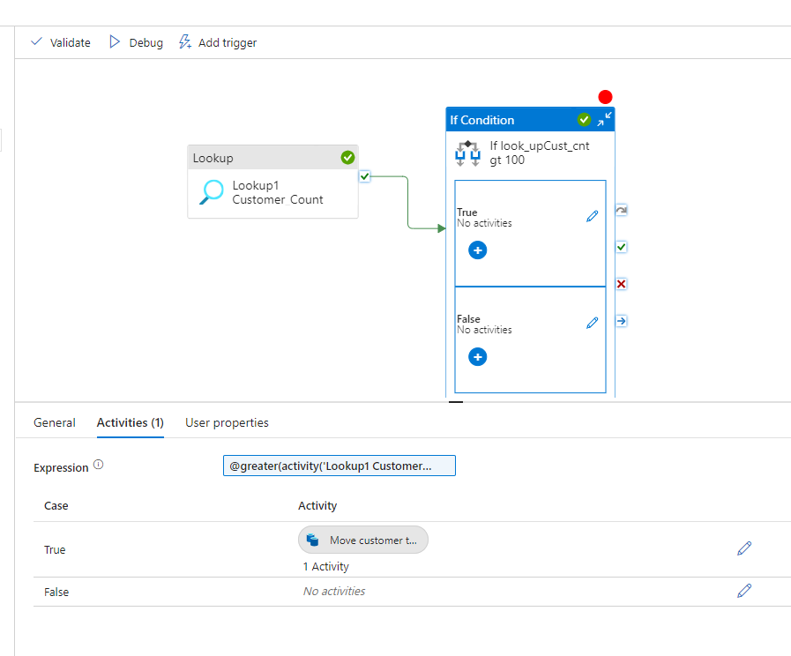

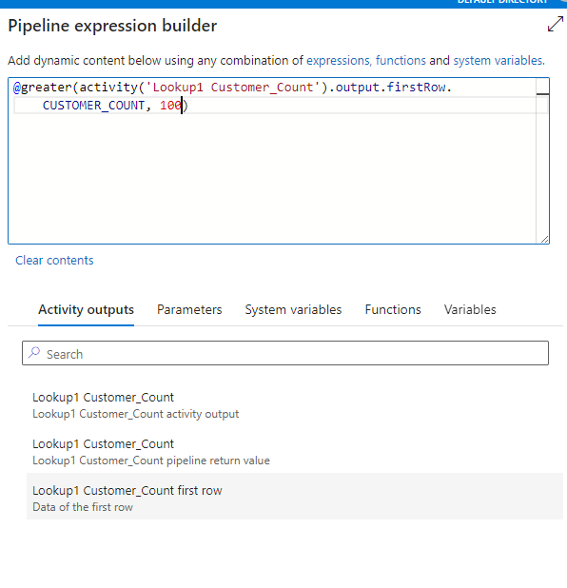

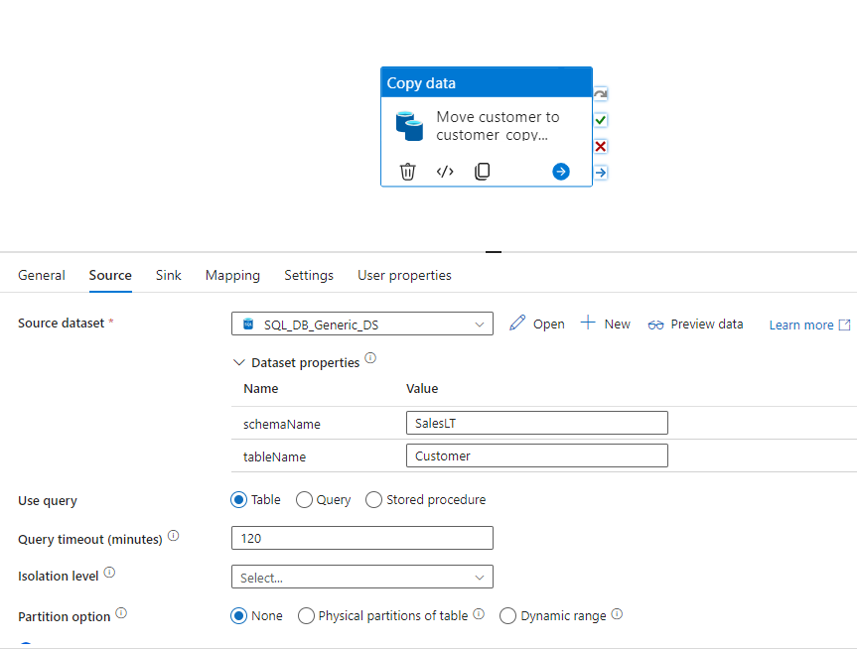

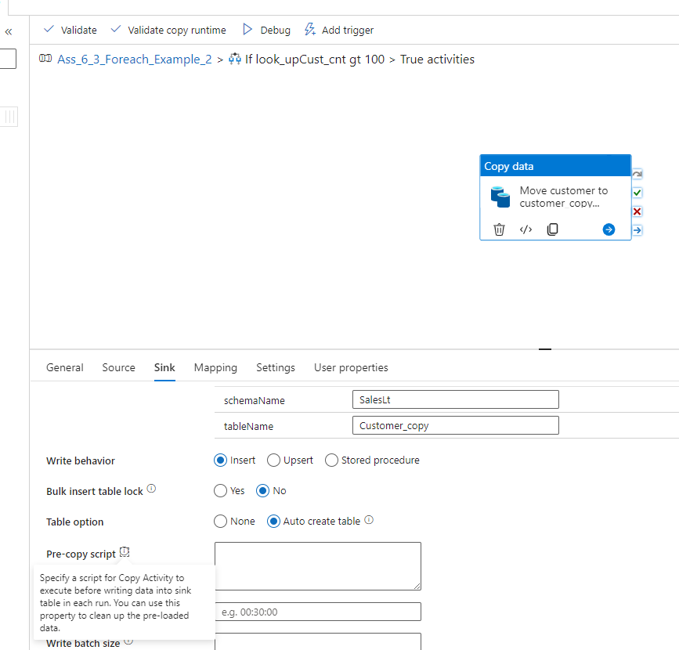

First Run Pipeline : DO not use TRUNCATE Command
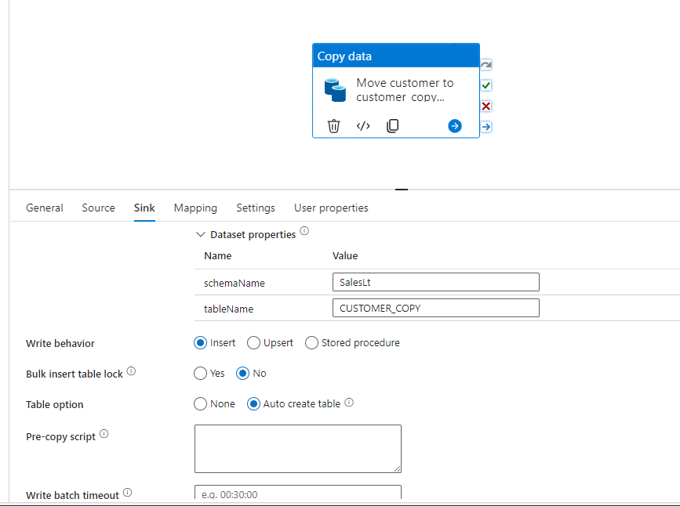

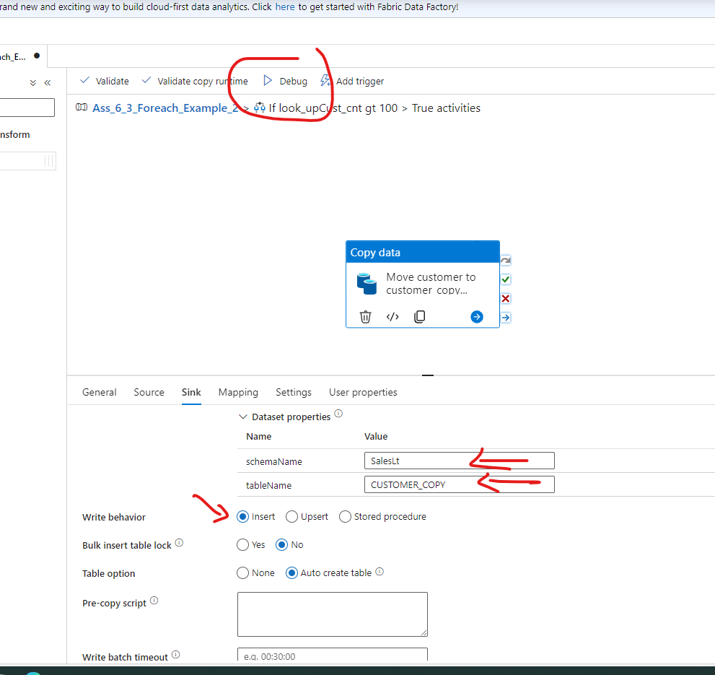

Second time Run Pipeline with TRUNCATE Command:

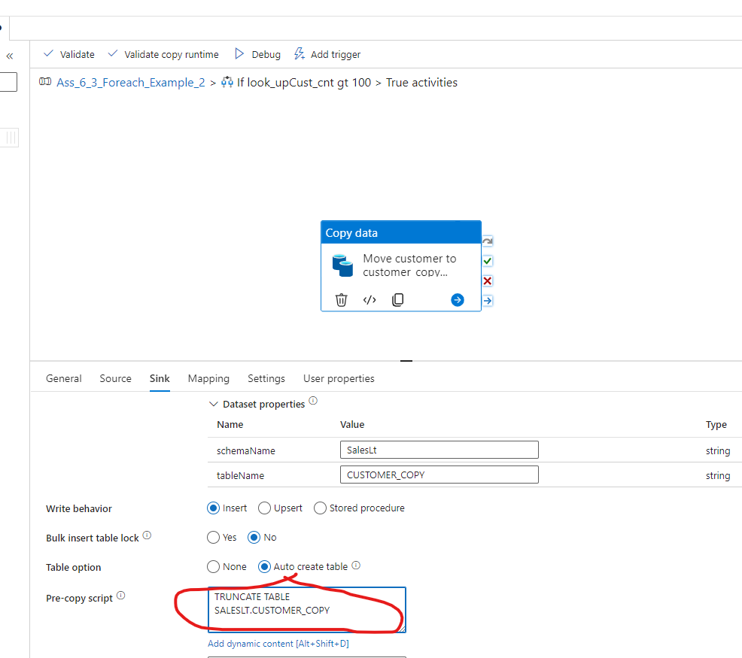

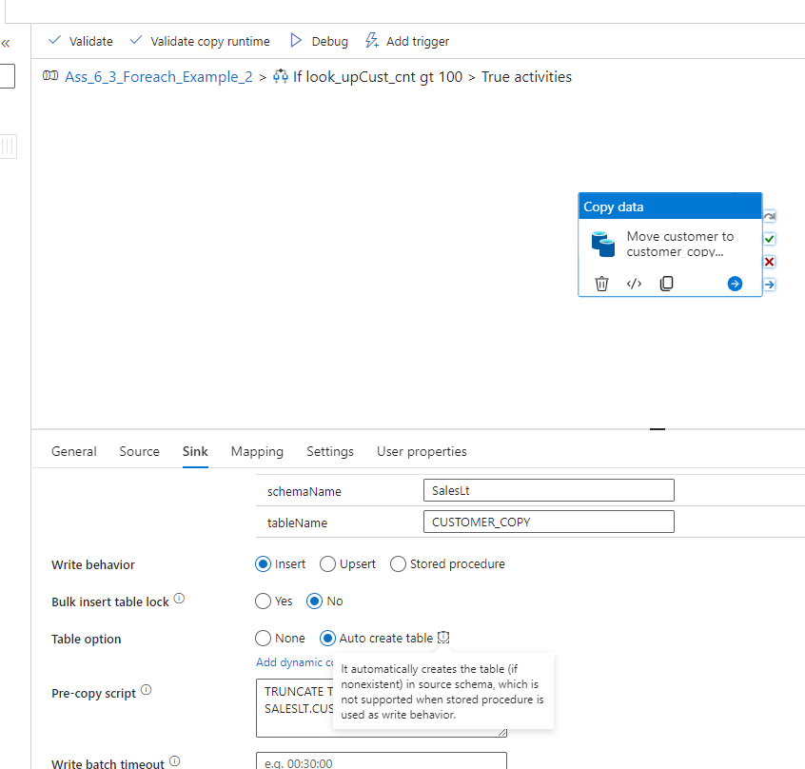

TRUNCATE TABLE
SALESLT.CUSTOMER_COPY

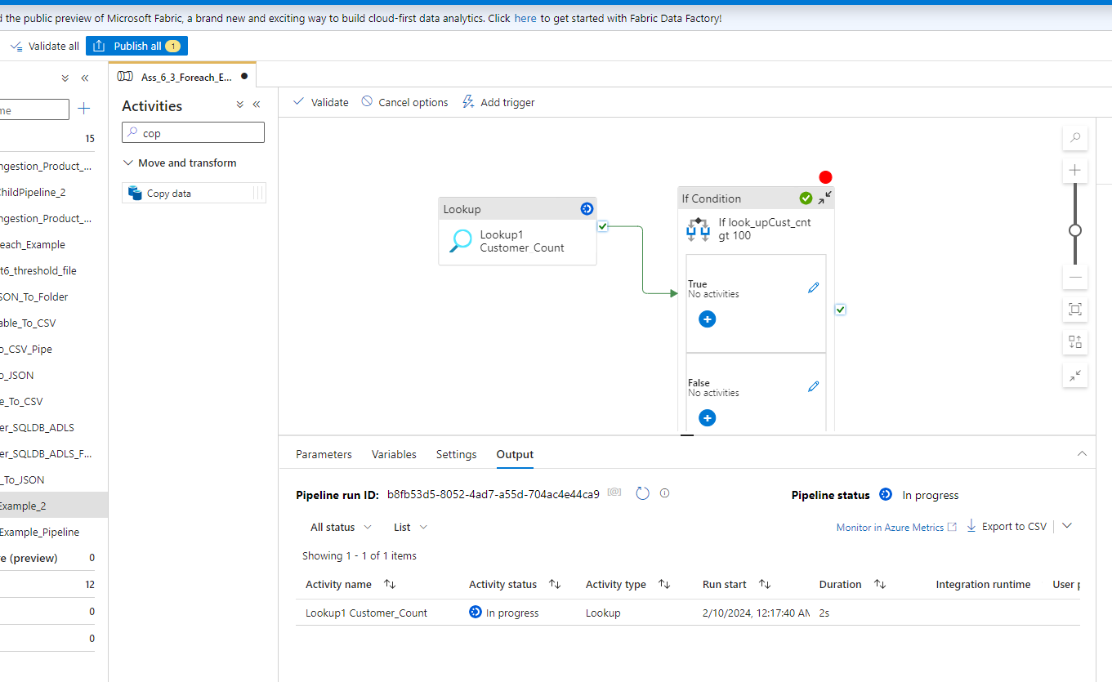
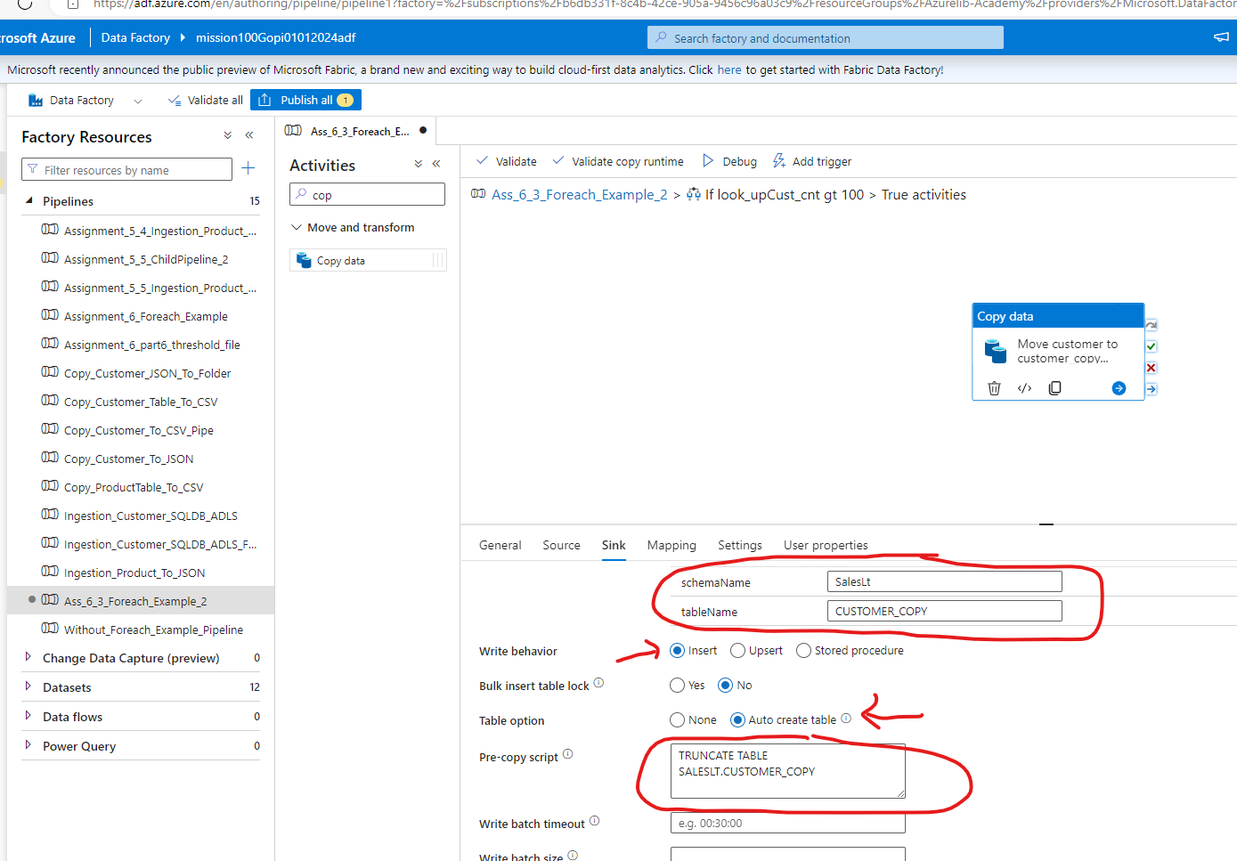
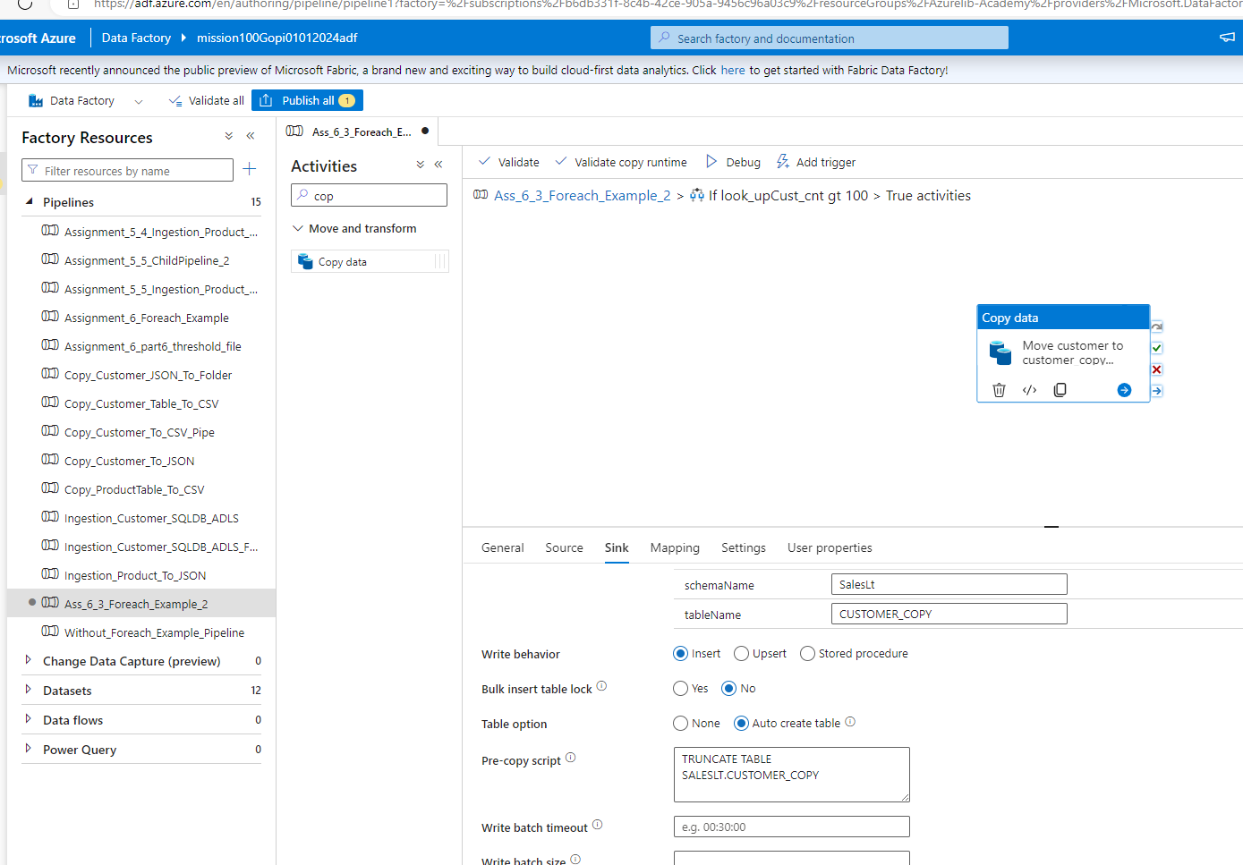

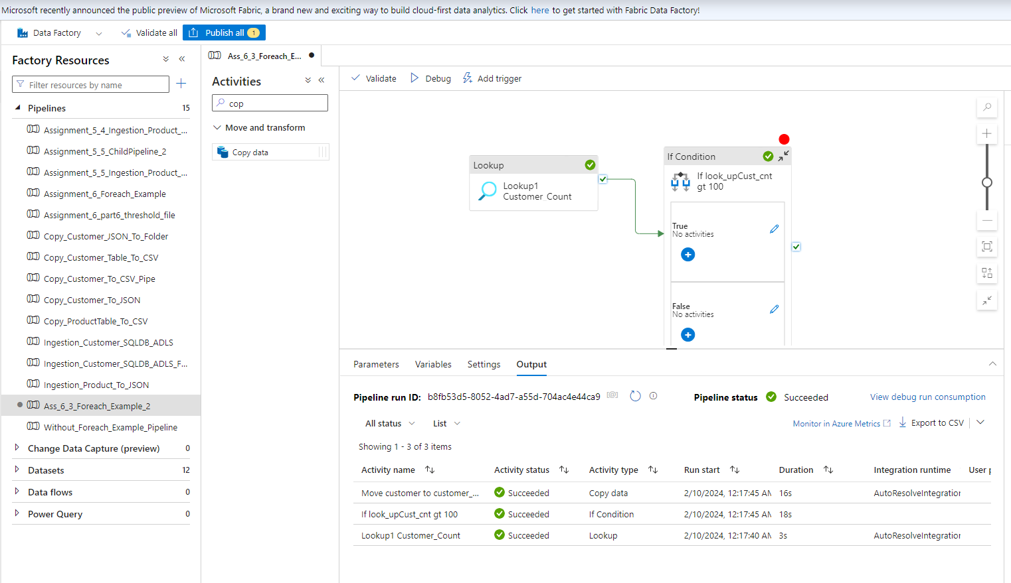

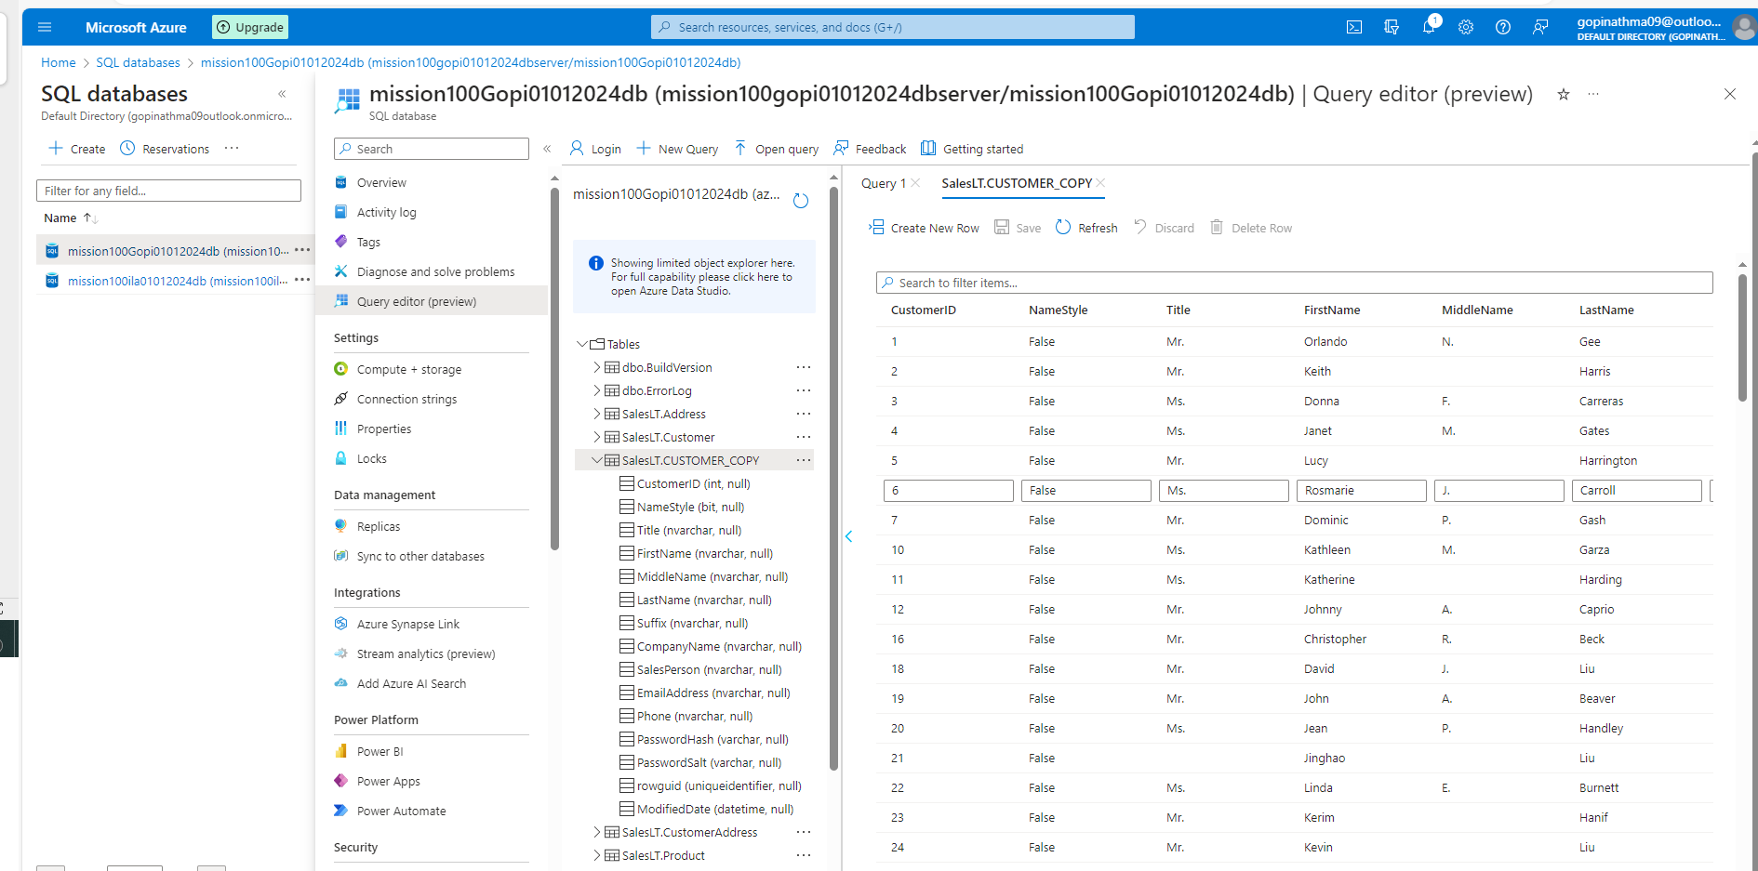

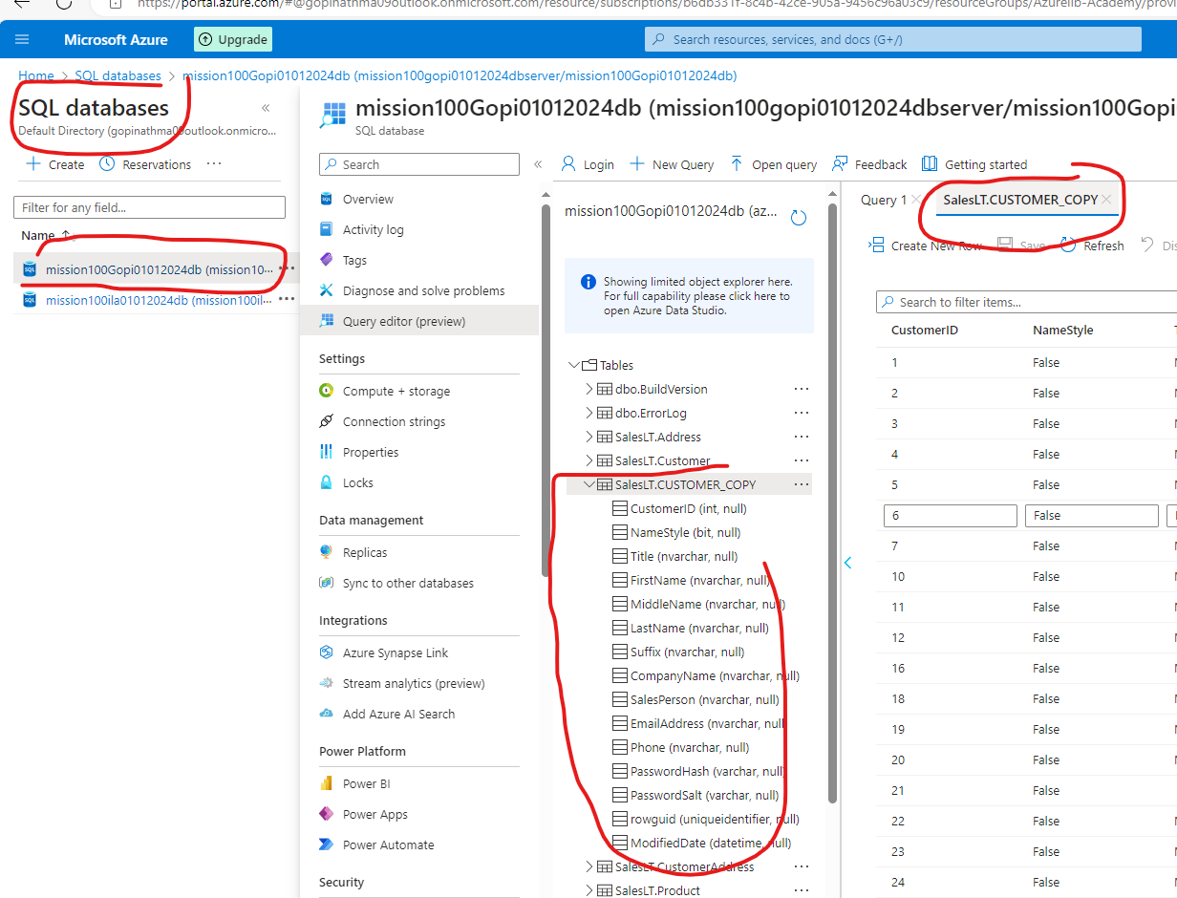

4. Business wants to move the data from 3 different tables (Customer, Product, CustomerAddress) to
ADLS location in CSV format.
However they want the make a pipeline in such a manner that All these copy happens through an
individual pipeline, which is called by
one common pipeline.

Solution: For each with@CreateArray (Customer, Product, CustomerAddress)

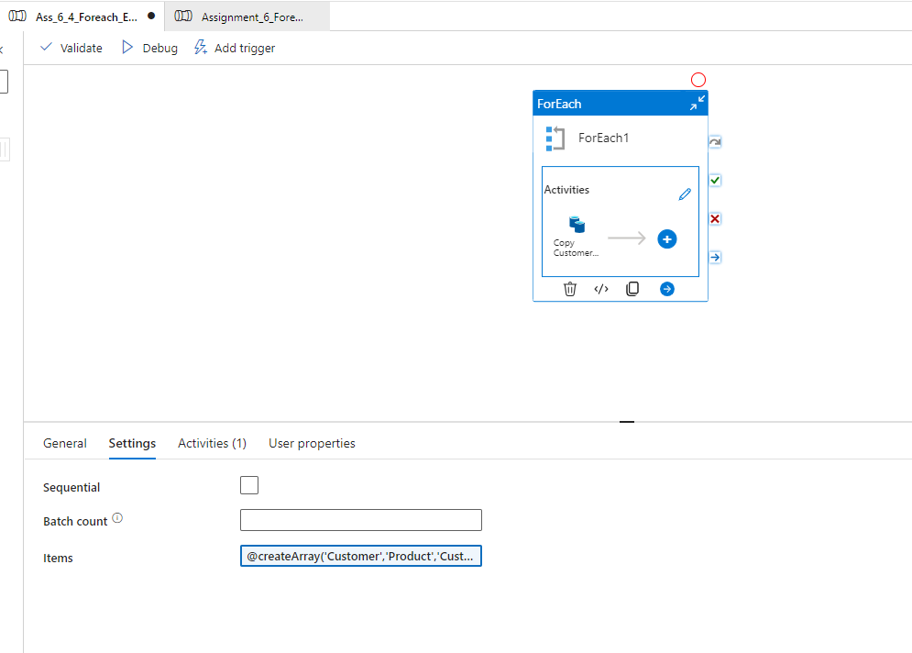

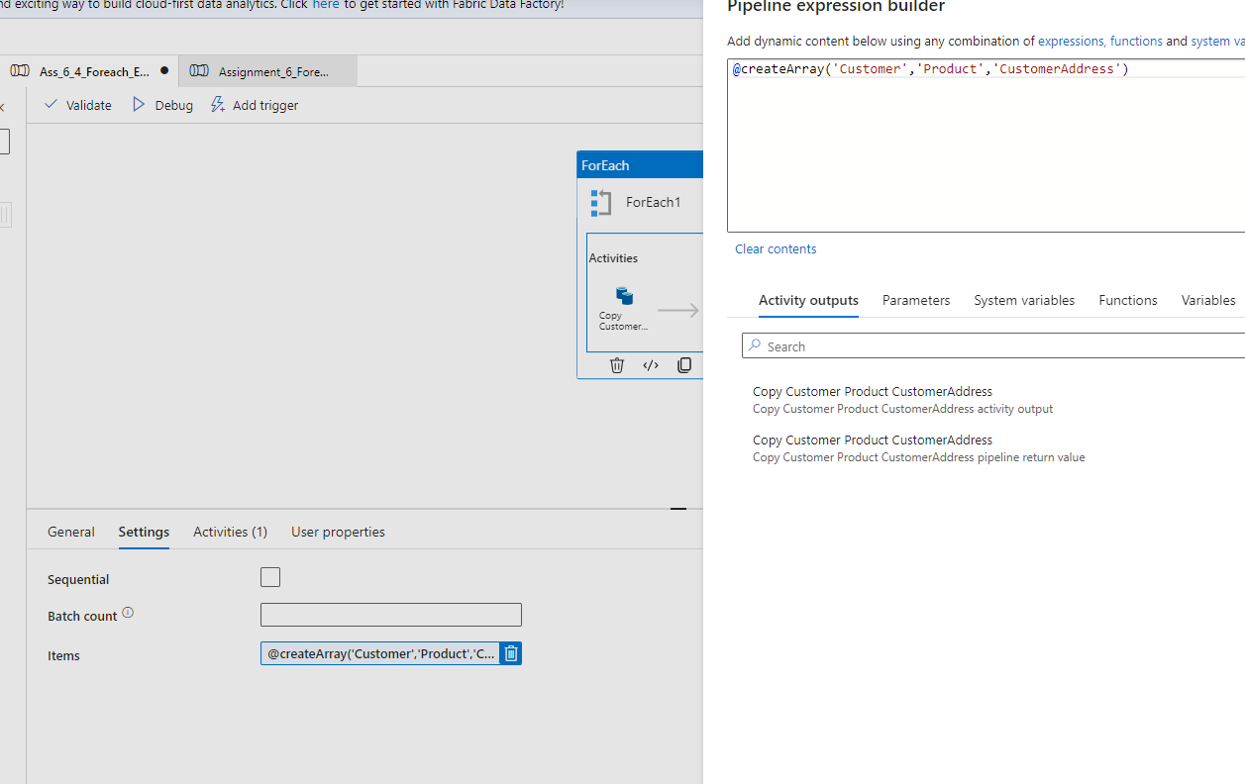

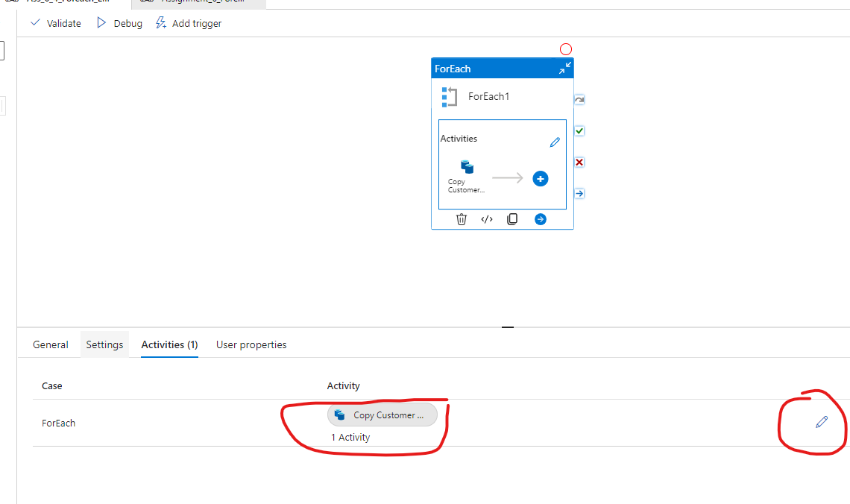

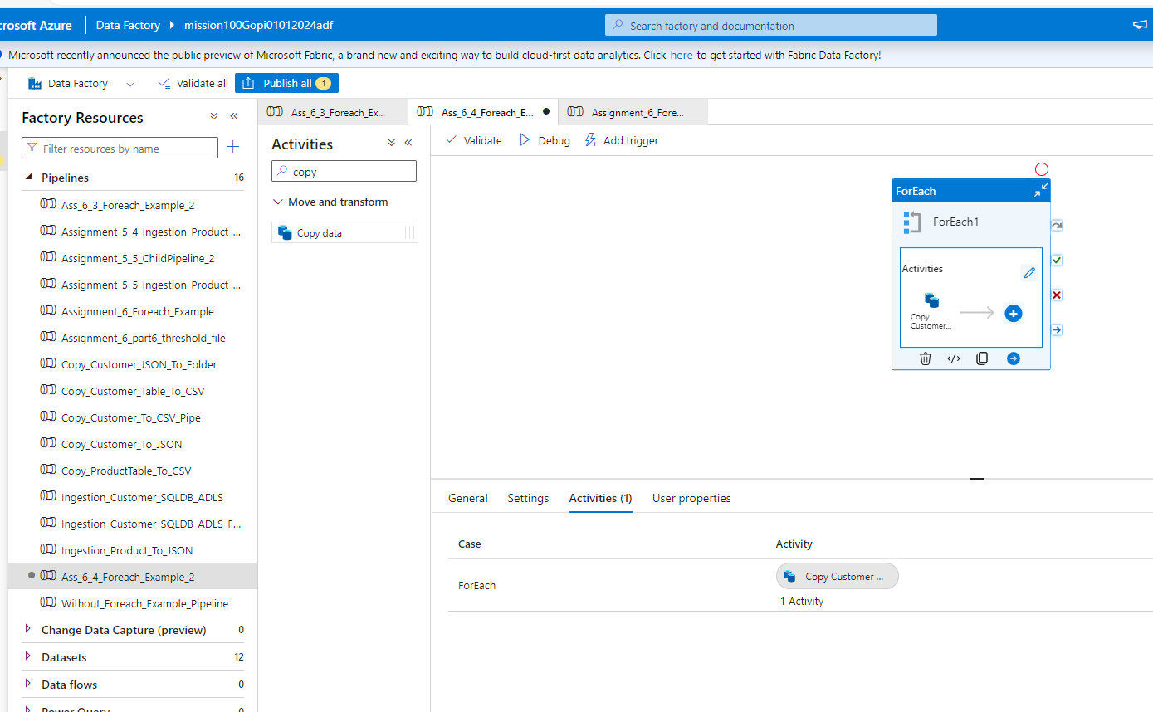

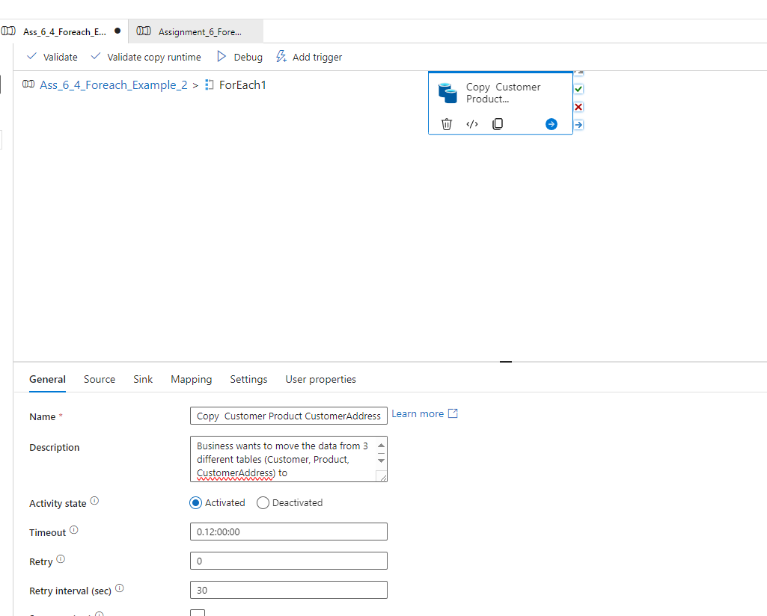

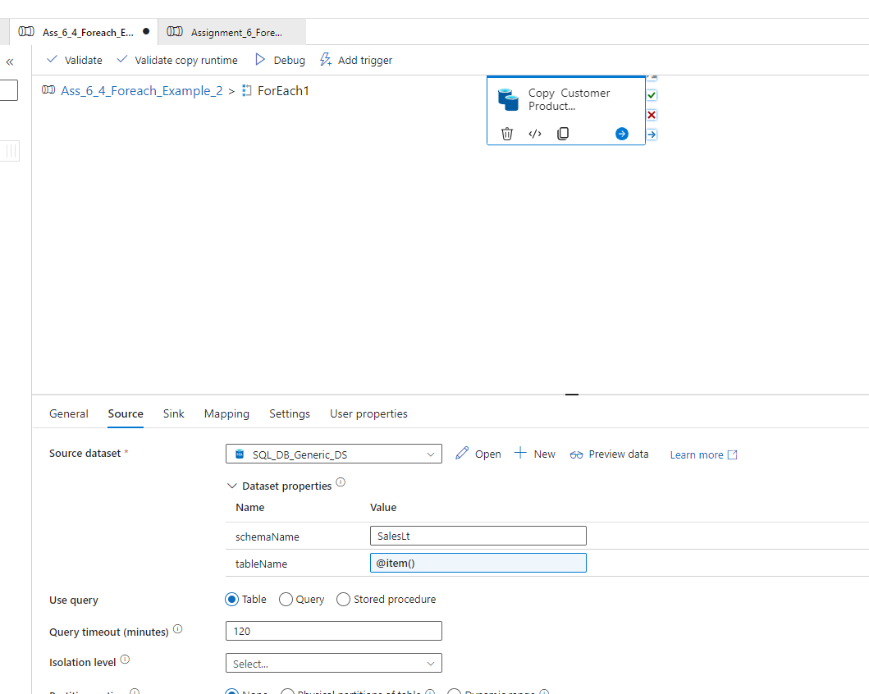

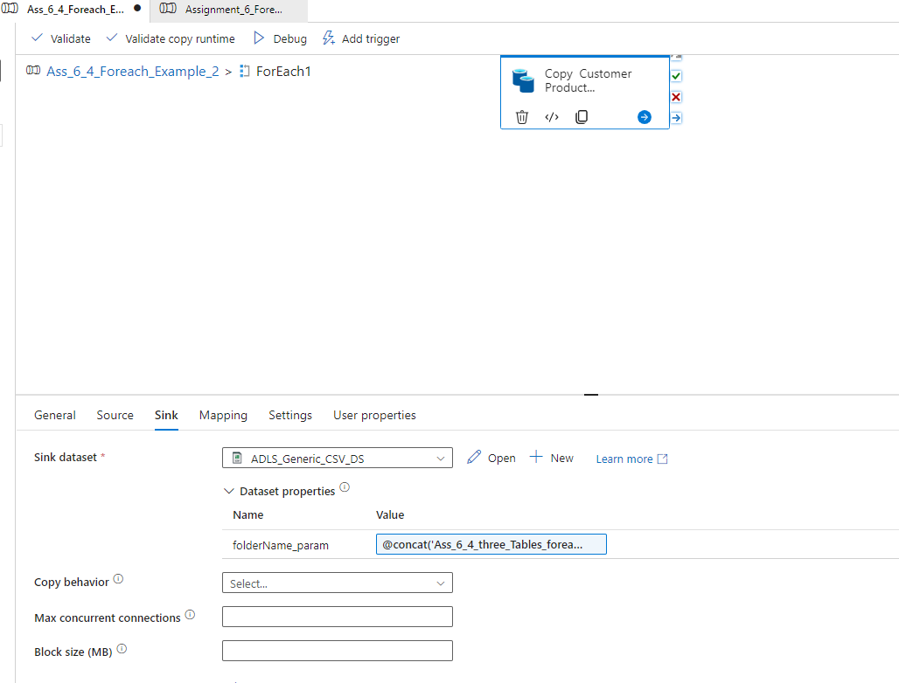



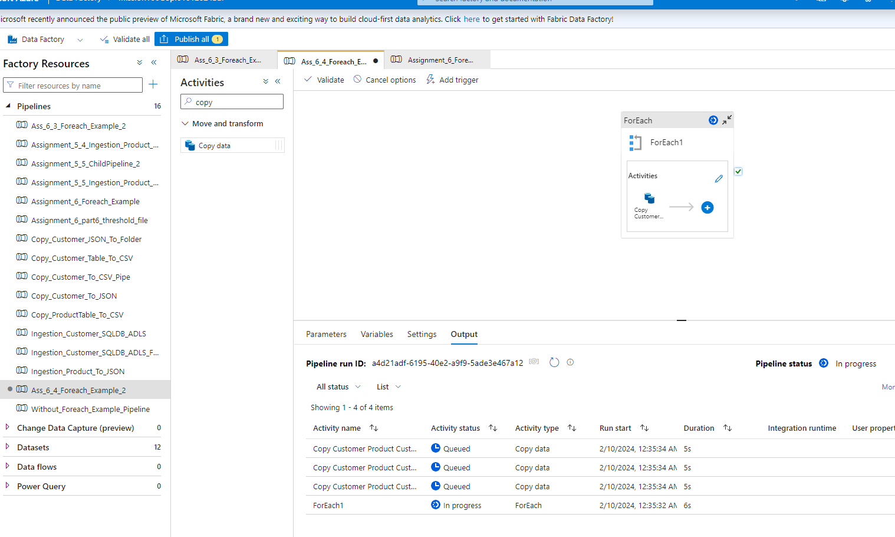

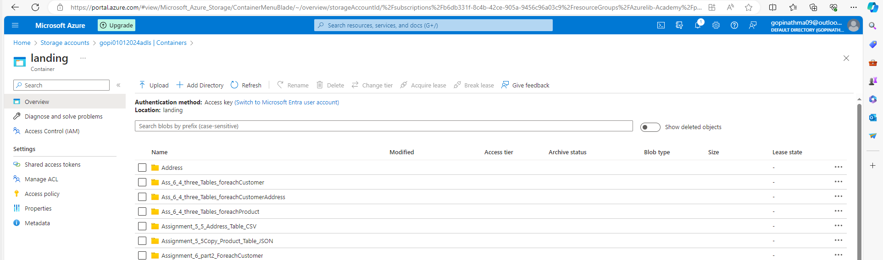

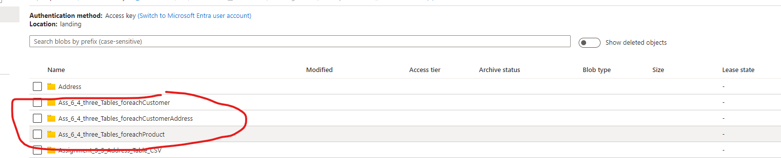

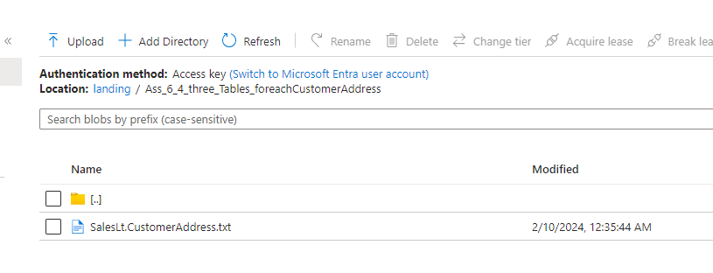

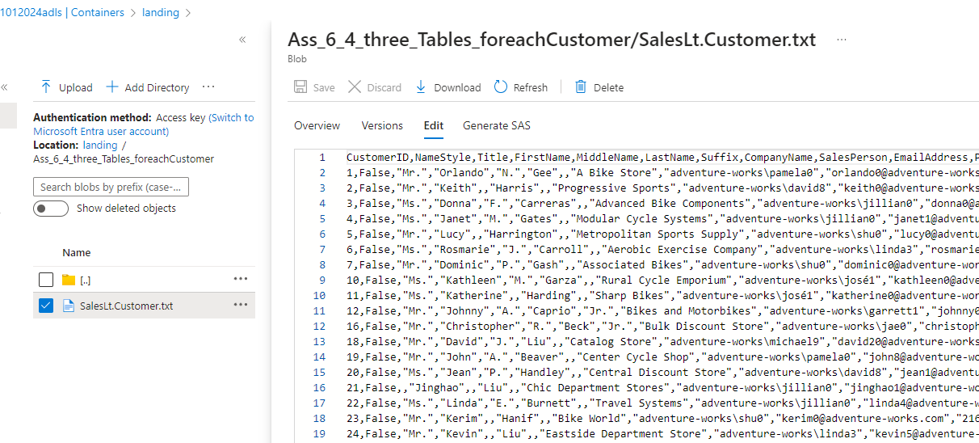

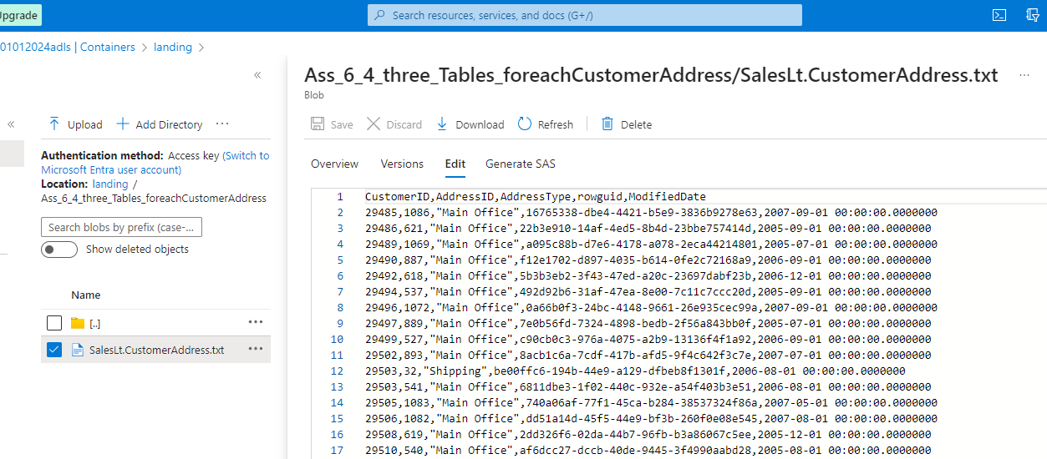

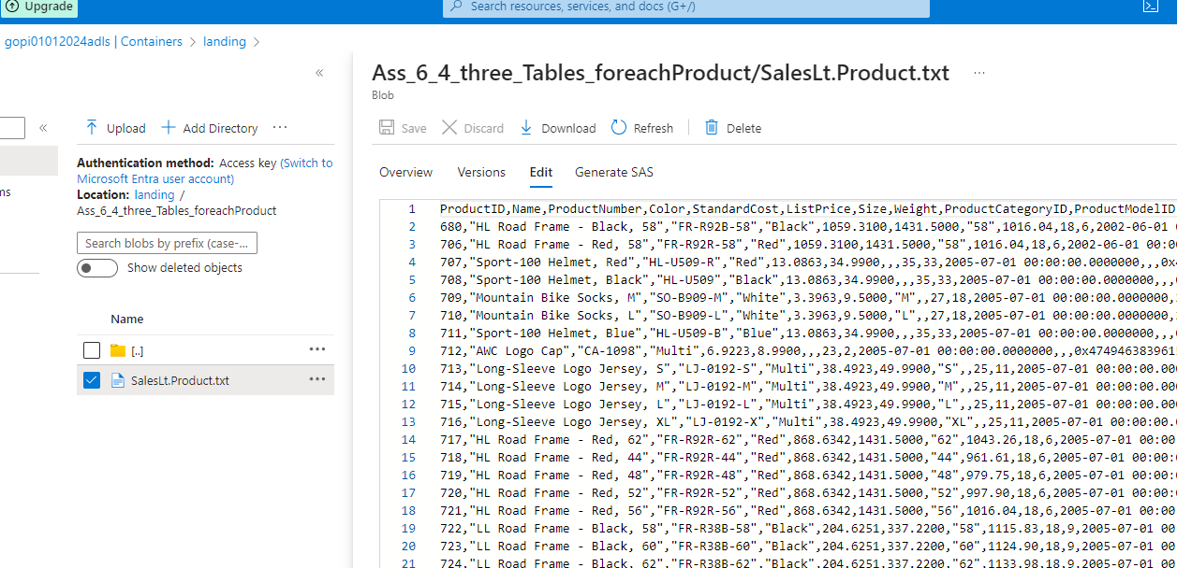

5. In the above case problem is that every time the pipeline runs it will overwrite the data. Ensure that
all the data goes into
Folder like (Customer/Year/Month/Day) to avoid any overwriting. Please rewrite the pipeline.

Solution:
In the Sink Part, in the Dynamic Parameter -- use “formatDateTime()” Function & “utcnow()” method

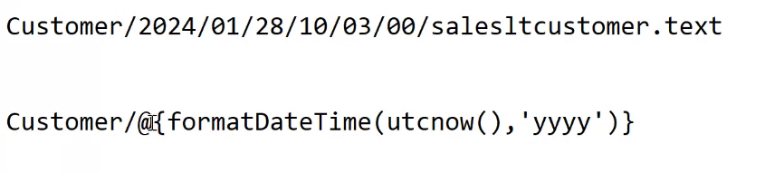

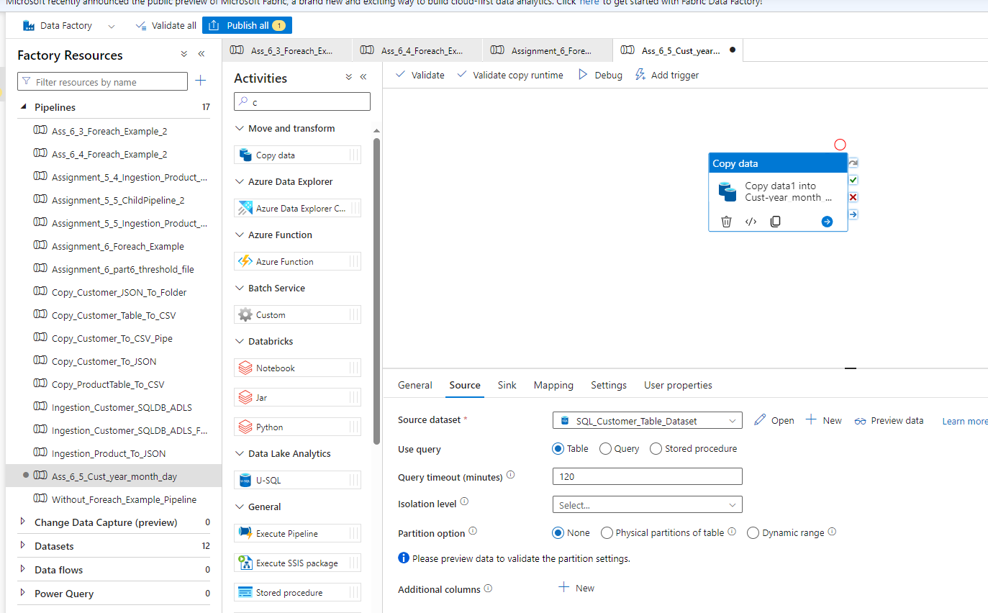

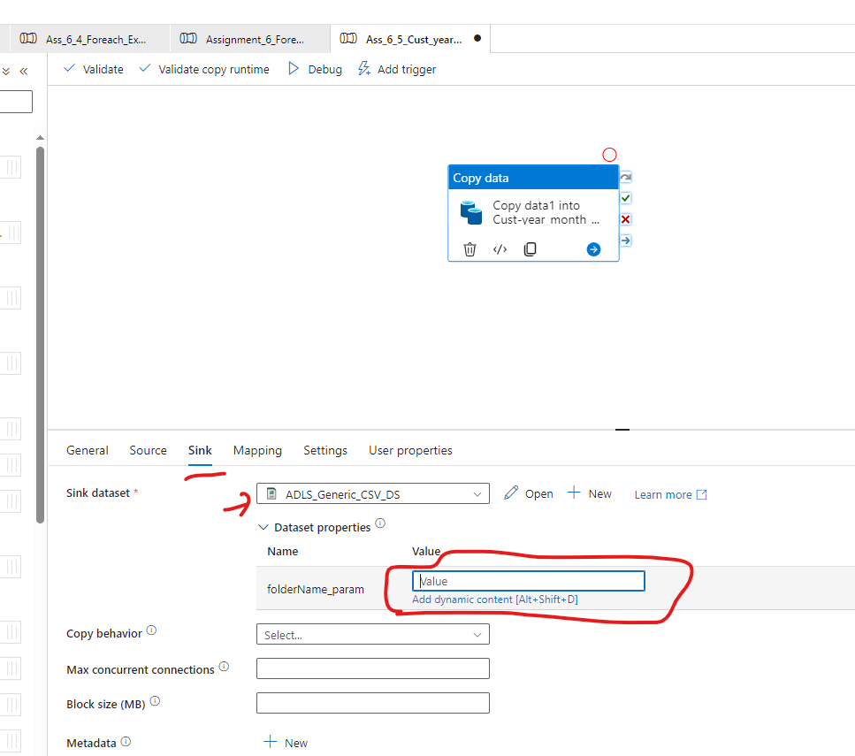

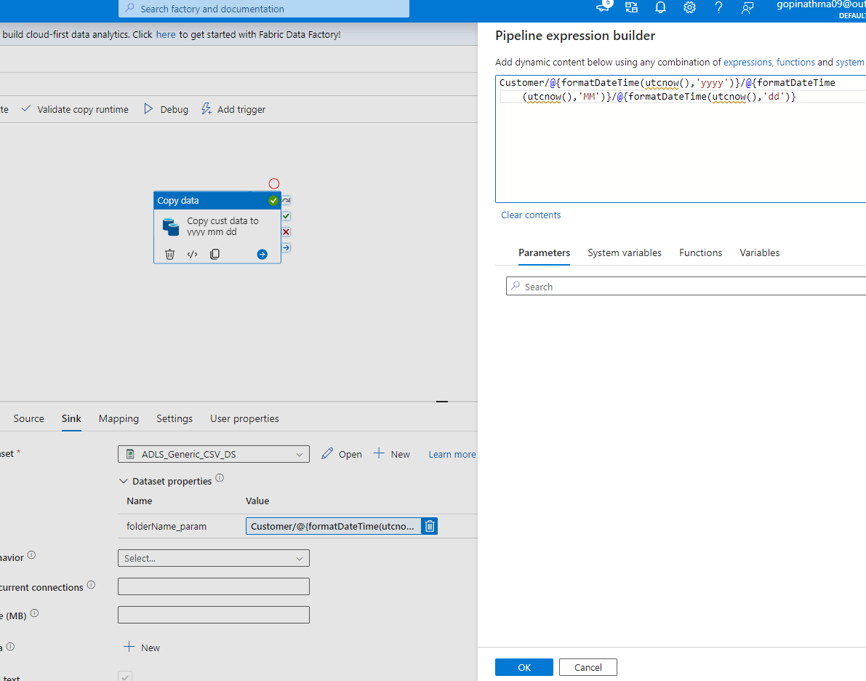

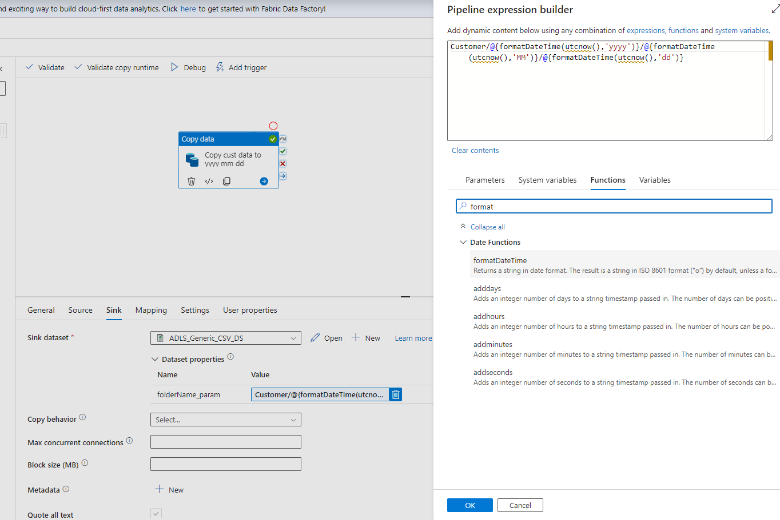

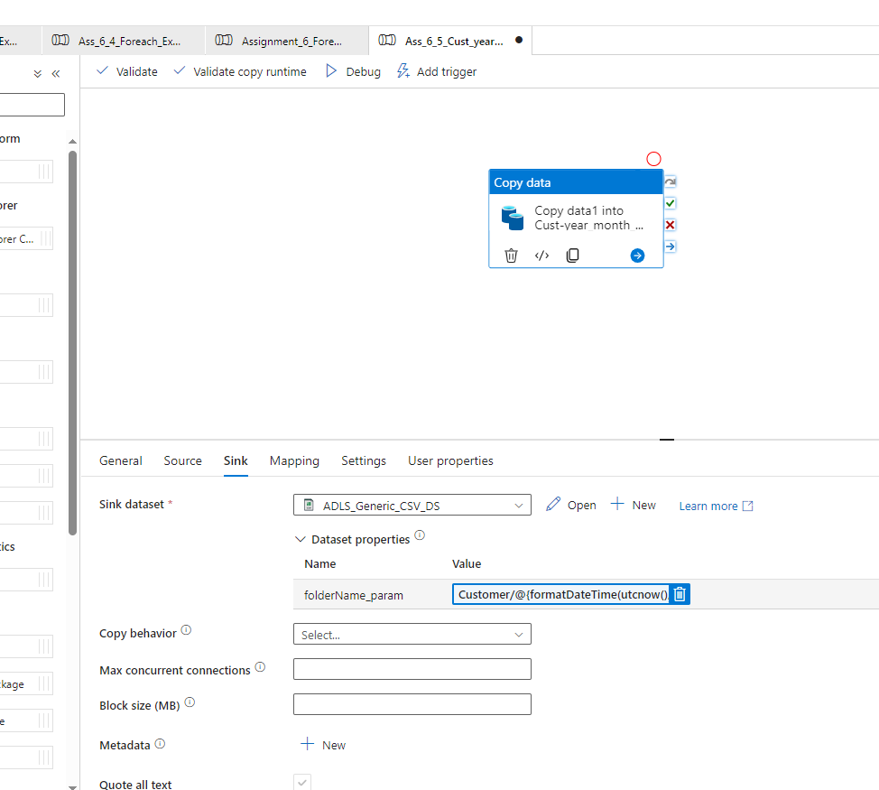

Customer/@{formatDateTime(utcnow(),'yyyy')}/@{formatDateTime(utcnow(),'MM')}/@{formatDateTime(utcnow(),'dd')}

