Notes:

"C:\Users\gopin\Documents\Jobs_2025\Sendcloud\Gan_Send_cloud_Assignment_implementation\Readme.md"

Assumptions made :

“time_left” is displayed in integer seconds for clarity and simplicity. This way, the users of your API can easily understand and work with the value without worrying about fractional seconds.
The code should handle invalid inputs | - handles invalid inputs by returning appropriate error messages and status codes.  - method in TimerView uses TimerSerializer to validate and save the timer data. This ensures that only valid inputs are processed:
Thefiring of the webhook must not be cancelled by process restarts. Any timers that expired while the application was down should be triggered once the application comes back up. | It is working as expected , using celery, redis, celerybeat SCHEDULE tasks  Using function like below , it is handled  check_expired_timers
● Thesolution should support horizontal scalability (running on multiple servers) to handle an increasing number of timers, including their creation and webhook firing. | - Celery supports running on multiple servers, handling an increasing number of tasks. Ensure that your Celery workers are configured properly for distributed execution. It also uses a message broker like Redis for scalable message handling.
Eachtimer must be fired only once. | Yes we ensure this is handled in coding logic using is_fire bool variable
Thesolution must be implemented in Python. Here at Sendcloud we use Django+(Django REST Framework or Django Ninja), FastAPI and Flask. | Yes it is implemented in Django+(Django REST Framework)
Wrapyour application and all its dependencies in Docker container(s). Describe clearly the build steps and how to run your application in a README file. The solution should be easy to run and build for our reviewers | Application and dependencies are wrapped in Docker containers. Include a Dockerfile and a docker-compose.yml  Yes it is wrapped in Docker container. Build steps described in README file
Tests are mandatory. We believe in sensible testing rather than achieving 100% coverage, so make sure the important parts of your solution are tested. | docker-compose run tests  docker-compose exec web python manage.py test  docker-compose exec web coverage report  docker-compose exec web coverage html
Yourcode should be reasonably documented, save for the blocks that are self-explanatory. Usage of docstrings is highly encouraged. | Yes documented with Docstrings, with explaination
Submit your code through the link of the e-mail that we’ve sent (with this doc) | Yes submitted
Assumptions made :  Anyassumptions made. For example, “timers are never scheduled later than X days into the future”. | “time_left” is displayed in integer seconds for clarity and simplicity. This way, the users of your API can easily understand and work with the value without worrying about fractional seconds.
Anychanges you would make (if any) in order to support a high-traffic (e.g. 100 timer creation requests per second) production environment. | - Service Replicas: Deploy multiple replicas of your services to handle increased traffic.  - Scaling your Celery workers and message broker. Using autoscaling and load balancing to handle increased traffic efficiently.  - configure service replicas and potentially use Docker Swarm or Kubernetes for orchestrating multiple containers  - Health Checks: Add health checks to ensure services are running correctly.  - Service Replicas: Use Docker Swarm or Kubernetes for managing service replicas.  Asynchronous Processing  - Celery: Use Celery for handling time-consuming tasks asynchronously. Ensure Celery workers can scale horizontally.  - Task Queues: Use task queues (e.g., RabbitMQ, Redis) to manage and distribute tasks efficiently  Database Optimization  - Connection Pooling: Use connection pooling to manage database connections efficiently.  - Indexes: Ensure proper indexing on frequently queried columns.  - Read Replicas: Use read replicas to distribute read queries and reduce load on the primary database.  Rate Limiting and Throttling  - Rate Limiting: Implement rate limiting to prevent abuse and ensure fair usage. Use Django’s built-in throttling or third-party libraries like django-ratelimit.  - API Gateway: Use an API gateway (e.g., Kong, AWS API Gateway) to manage traffic and enforce rate limits.  Load Balancing  - Load Balancer: Use a load balancer (e.g., AWS ELB, Google Cloud Load Balancer, Nginx) to distribute incoming traffic across multiple server instances.  - Auto-Scaling: Enable auto-scaling to automatically add or remove instances based on traffic load.  . Caching  - Database Query Caching: Use caching mechanisms like Redis or Memcached to cache frequently accessed data and reduce database load.  - HTTP Response Caching: Cache API responses where applicable to reduce repeated processing.  Horizontal Scaling  - Container Orchestration: Use container orchestration platforms like Kubernetes or Docker Swarm to manage and scale containers.  Service Replicas: Deploy multiple replicas of your services to handle increased traffic.  . Monitoring and Logging  - Monitoring: Implement monitoring tools (e.g., Prometheus, Grafana) to track performance metrics and detect issues.  - Logging: Use centralized logging (e.g., ELK stack) to aggregate and analyze logs for troubleshooting
Please write clean & tidy code. Within our backend team, we enforce strict PEP8 compliance. | Yes followed PEP8 , used ruff, black, isor formatting

CMD ["gunicorn", "--bind", "0.0.0.0:8000", "your_project_name.wsgi:application"]

Why Use Gunicorn for Production?

Using Gunicorn is recommended for production environments due to its performance, scalability, and security benefits, while Django's built-in server is best suited for development and testing.
- Performance: Gunicorn is a multi-threaded server that can handle multiple requests concurrently, making it more robust for high-traffic environments.
- Scalability: It’s easier to scale your application using Gunicorn, as it’s designed to work with various process management tools and load balancers.
- Security: The development server is not optimized for security, while Gunicorn provides better security practices out of the box.

It looks like you’re working with Redis and examining its background saving log messages. Redis periodically saves data to disk (called a snapshot) to ensure that you don’t lose data in case of a server failure. The log messages you posted indicate successful background saving operations.
Here's a brief summary of each log entry:
- Background saving started: Indicates when Redis begins the background saving process.
- DB saved on disk: Confirms that the Redis database has been successfully saved to disk.
- Fork CoW (Copy-On-Write): Details on memory usage during the fork process.
- Background saving terminated with success: Indicates that the background saving operation completed successfully.
- Changes in seconds: Shows how many changes were made since the last save.

Requirements Checklist:
- Handle Invalid Inputs:
  - Your post method in TimerView uses TimerSerializer to validate and save the timer data. This ensures that only valid inputs are processed:
python
serializer = TimerSerializer(data=request.data)
if serializer.is_valid():
timer = serializer.save()
...
else:
return Response(serializer.errors, status=status.HTTP_400_BAD_REQUEST)
  - This handles invalid inputs by returning appropriate error messages and status codes.
- Webhook Firing Must Not Be Cancelled by Process Restarts:
  - Celery is designed to handle such scenarios. If a task is scheduled but not yet executed due to a process restart, Celery will ensure that the task is executed once the worker is back up. You can also enable Celery's persistent mode by configuring the CELERY_TASK_ACKS_LATE and CELERY_RESULT_PERSISTENT settings:
python
CELERY_TASK_ACKS_LATE = True
CELERY_RESULT_PERSISTENT = True
- Support Horizontal Scalability:
  - Celery supports running on multiple servers, handling an increasing number of tasks. Ensure that your Celery workers are configured properly for distributed execution. You might also want to look into using a message broker like RabbitMQ or Redis for scalable message handling.
- Each Timer Must Be Fired Only Once:
  - Your fire_webhook function ensures that a timer is marked as fired after the webhook is called:
python
timer.is_fired = True
timer.save()
  - This guarantees that each timer is fired only once.
- Implementation in Python (Django, Django REST Framework):
  - Your solution is implemented in Django with Django REST Framework, meeting this requirement.
- Wrap Application in Docker:
  - Ensure your application and dependencies are wrapped in Docker containers. Include a Dockerfile and a docker-compose.yml file to describe build steps and how to run the application. Provide a README file with clear instructions.
- Tests are Mandatory:
  - Implement tests for the critical parts of your application. Use Django’s testing framework and tools like pytest to write and run tests. Focus on testing the creation of timers, scheduling, and firing of webhooks.
- Reasonably Documented Code:
  - Use docstrings to document your code, explaining the purpose and functionality of each module, class, and function. Ensure that your code is self-explanatory and follows PEP8 guidelines.

Additional Considerations:
- Assumptions:
  - Clearly state any assumptions you made in your README or documentation. For example, "timers are never scheduled later than X days into the future."
- High-Traffic Production Environment:
  - For high-traffic scenarios, consider scaling your Celery workers and message broker. Use autoscaling and load balancing to handle increased traffic efficiently.

Summary:
Your implementation meets most of the requirements. Make sure to focus on Dockerizing your application, writing tests, and documenting your code thoroughly. Consider adding configurations and setups to handle process restarts, horizontal scalability, and high traffic.
If you have any further questions or need additional assistance, feel free to ask!

Great question! Serializers in Django REST Framework (DRF) play an essential role in converting complex data types, like Django models, into native Python data types that can then be easily rendered into JSON, XML, or other content types. They also help with deserialization, allowing parsed data to be converted back into complex types, after first validating the incoming data.

Why Do We Need Serializers?
- Validation:
  - Serializers allow you to define validation rules for your data, ensuring that only valid data is passed through to your views.
- Conversion:
  - They handle the conversion between your Django models and JSON (or other formats) seamlessly. This is particularly important for APIs, which often need to communicate using JSON.
- Consistency:
  - Serializers help ensure consistent formatting of data across different parts of your application, making it easier to maintain and debug.

Example Scenario:
Consider you have a Django model Timer and you want to create an API endpoint that allows users to create timers by sending a POST request with JSON data.
Without Serializers:
- You'd need to manually handle the incoming JSON, validate it, convert it to a Django model instance, and handle any errors.
With Serializers:
- The serializer will automatically validate and convert the incoming JSON to a model instance, simplifying your views.

Your Use Case:
In your case, the TimerSerializer helps with:
- Receiving JSON data containing hours, minutes, seconds, and a URL.
- Validating the data to ensure it's correct (e.g., no negative values, timer duration is not zero).
- Converting the data into a Timer model instance, calculating the scheduled_time.
- Returning the serialized data with the timer ID and time left until the timer expires.

Simplifying Your Views:
With TimerSerializer, your view can focus on handling the HTTP request and response logic, while the serializer manages data validation and conversion.

++++ New terminal : Django run:

PS C:\Users\gopin\Documents\Jobs_2025\Sendcloud\Gan_Send_cloud_Assignment_implementation> .\env\Scripts\activate
(env) PS C:\Users\gopin\Documents\Jobs_2025\Sendcloud\Gan_Send_cloud_Assignment_implementation> ls

(env) PS :\Users\gopin\Documents\Jobs_2025\Sendcloud\Gan_Send_cloud_Assignment_implementation> cd .\schedule_tasks\
(env) PS C:\Users\gopin\Documents\Jobs_2025\Sendcloud\Gan_Send_cloud_Assignment_implementation\schedule_tasks> python manage.py runserver
+++ Note Turn off McAffe Anti virus, Firewall setting etc.

++++ New terminal: Celery run
PS C:\Users\gopin\Documents\Jobs_2025\Sendcloud\Gan_Send_cloud_Assignment_implementation> .\env\Scripts\activate
(env) PS C:\Users\gopin\Documents\Jobs_2025\Sendcloud\Gan_Send_cloud_Assignment_implementation> cd .\schedule_tasks\
(env)PS C:\Users\gopin\Documents\Jobs_2025\Sendcloud\Gan_Send_cloud_Assignment_implementation\schedule_tasks> celery -A schedule_tasks worker --loglevel=info --pool=solo

++++ New Terminal: redis-server
PS C:\Users\gopin\Documents\Jobs_2025\Sendcloud\Gan_Send_cloud_Assignment_implementation> wsl
gopi@GAN:/mnt/c/Users/gopin/Documents/Jobs_2025/Sendcloud/Gan_Send_cloud_Assignment_implementation$
gopi@GAN:/mnt/c/Users/gopin/Documents/Jobs_2025/Sendcloud/Gan_Send_cloud_Assignment_implementation$ redis-server

Optional (Start Redis Server: If Redis is not running, you can start it with:):
gopi@GAN:/usr/bin$ sudo service redis-server start
[sudo] password for gopi:onida---
gopi@GAN:/usr/bin$ redis-cli ping
PONG
Postman:
1. Set Timer example POST- /timer

Example:
POST:
Input: expected request JSON (Body-raw data) ++ Set to POST Request
{
"hours": 0,
"minutes": 10,
"seconds": 0,
"url": "https://twitter.com"
}

http://localhost:8000/timer

Output (screenshot below):
JSON
{"id":"352a5f81-b8f0-436f-b249-757de5c892d4","time_left":599.964175}

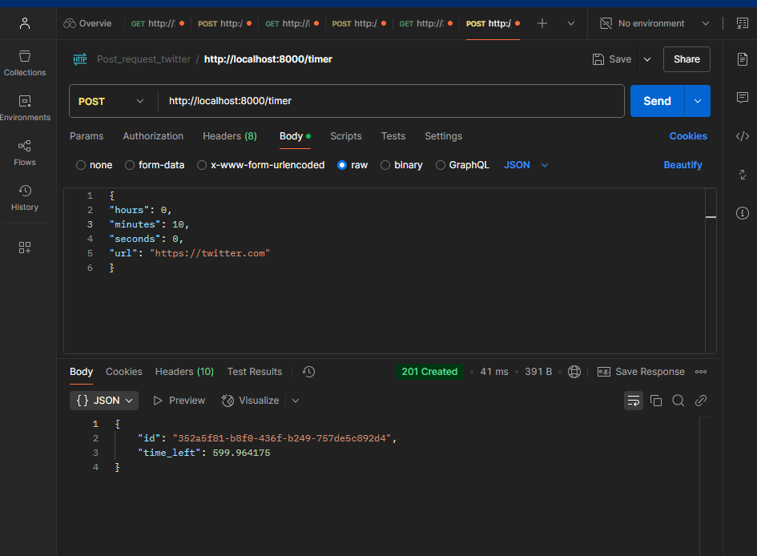

Python terminal output
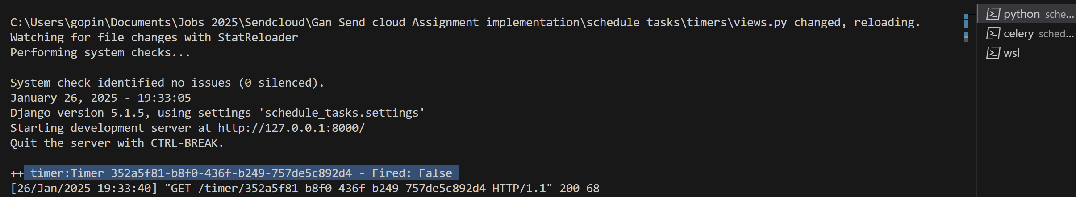

In postman:
Get : Note use same ID in the previous POST OUTPUT generated: id
{"id":"352a5f81-b8f0-436f-b249-757de5c892d4

URL:
http://localhost:8000/timer/352a5f81-b8f0-436f-b249-757de5c892d4

Output (Screenshot below:
{"id":"352a5f81-b8f0-436f-b249-757de5c892d4","time_left":504.019413,"fired":false}

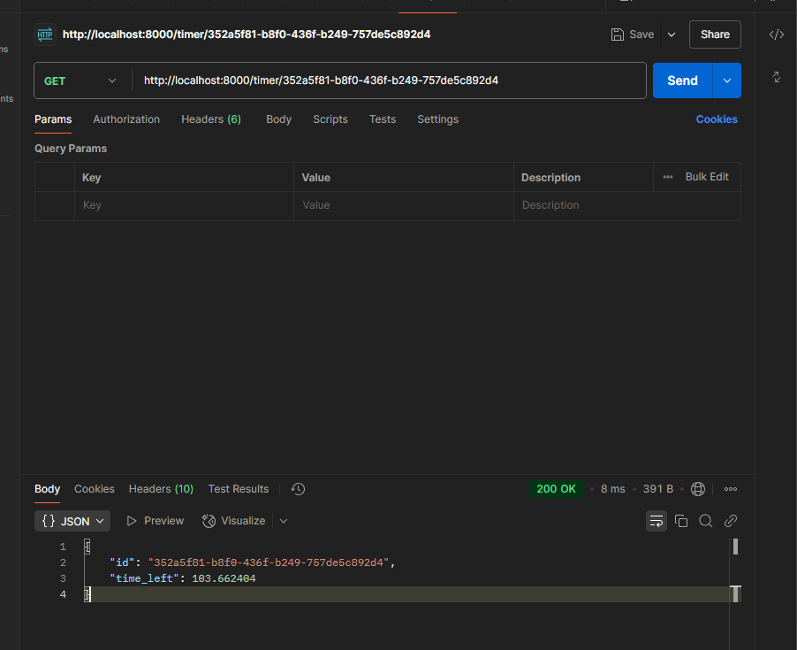

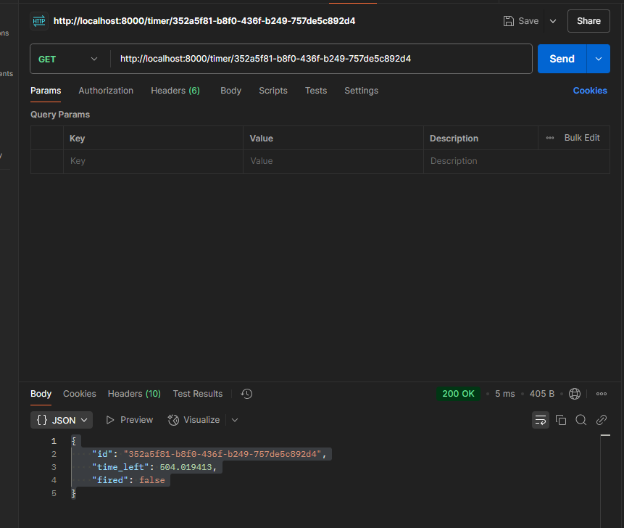

Overall Output:

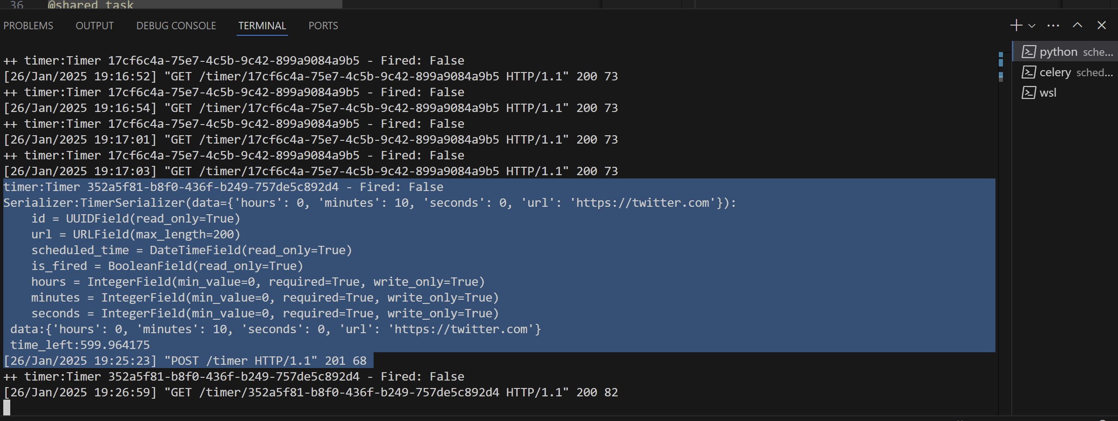

Celery terminal output:
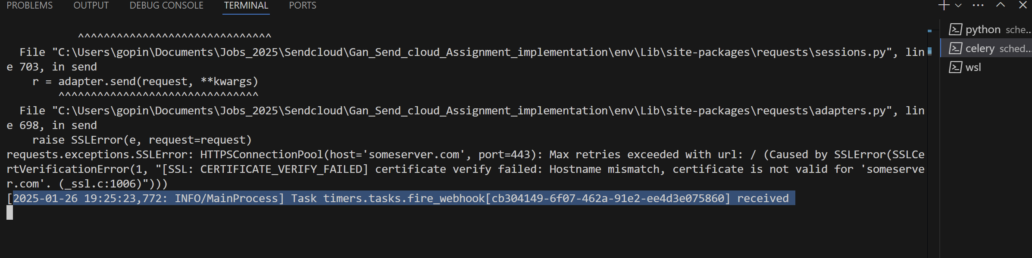
Webhook received at time stamp: 19:25 (screenshot above)
Exactly after 10 mins: WEbhook Fired ,look at timestamp 19:35: succeeded (screenshot below)
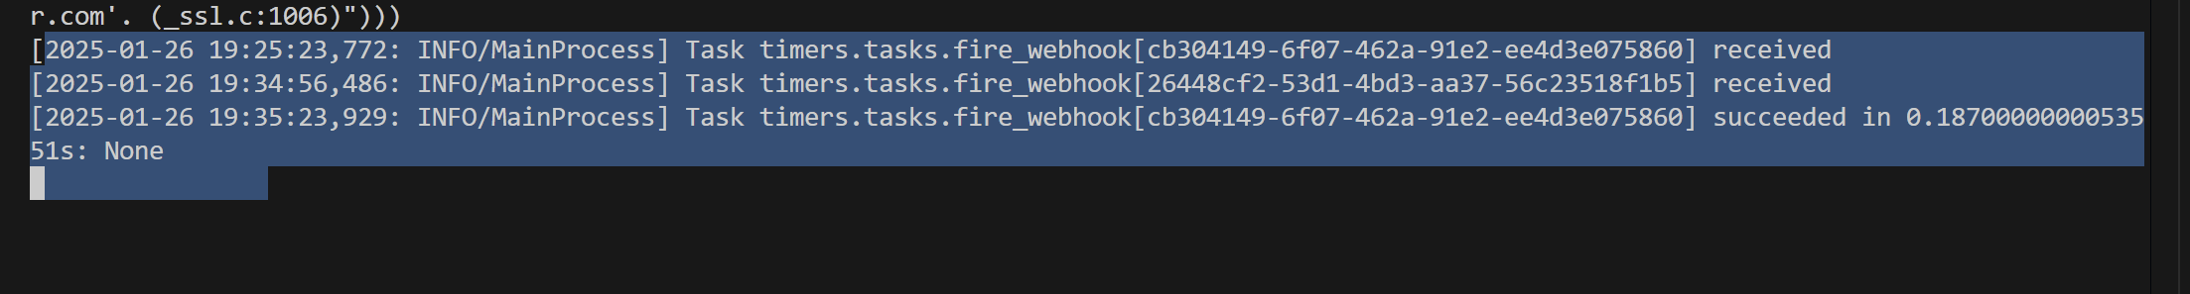

Example 2:

POST:

Input raw:
{
"hours": 1,
"minutes": 0,
"seconds": 1,
"url": "https://twitter.com"
}

POST: http://localhost:8000/timer

OUPUT: {
"id": "e1832a86-da14-4fa9-a1fb-64c0a79f1b58",
"time_left": 3600.90696
}
id e1832a86-da14-4fa9-a1fb-64c0a79f1b58
time_left 3600.90696
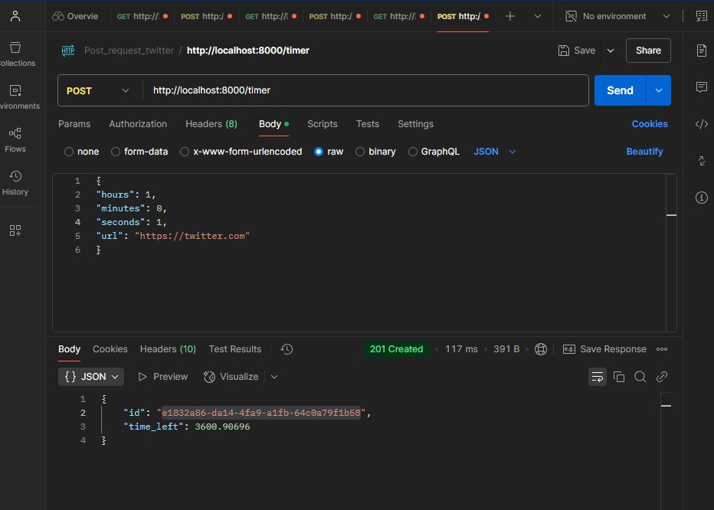

I will go to GET method:
With the above ID: to see the time left
e1832a86-da14-4fa9-a1fb-64c0a79f1b58

Example: GET Request with url below:
http://localhost:8000/timer/e1832a86-da14-4fa9-a1fb-64c0a79f1b58

Output below:
{
"id": "e1832a86-da14-4fa9-a1fb-64c0a79f1b58",
"time_left": 3276.196322
}

Python Terminal output
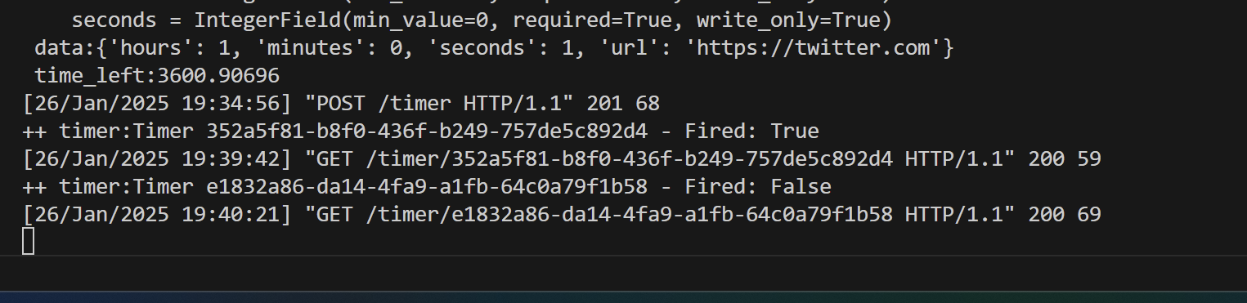
Celery output:
