**Question\_1:**

SELECT orders.orderNumber,products.productName,customers.customerName,

payments.amount,payments.checkNumber FROM orders INNER JOIN orderdetails ON

orders.orderNumber = orderdetails.orderNumber INNER JOIN products ON

orderdetails.productCode = products.productCode INNER JOIN customers ON

orders.customerNumber = customers.customerNumber INNER JOIN payments ON

payments.customerNumber = customers.customerNumber WHERE

orders.orderNumber=10100;

Top of Form



Bottom of Form

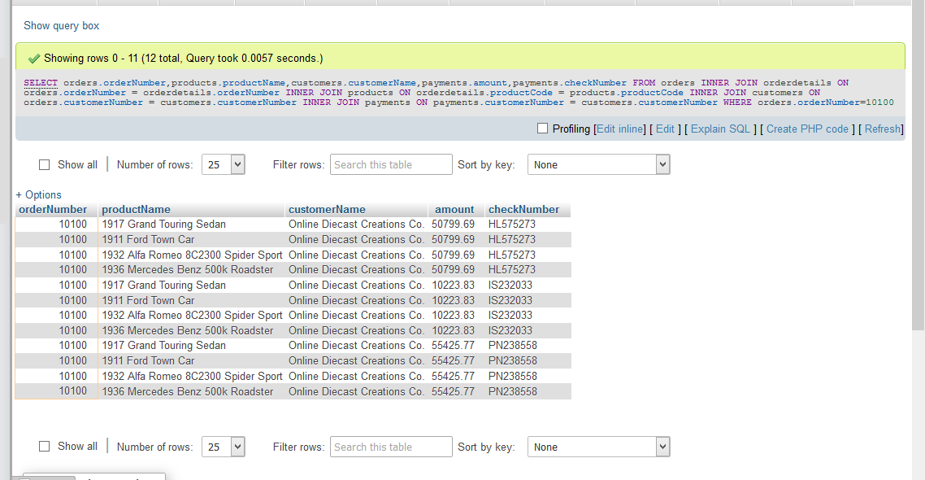

**Question\_2:**

[SELECT](http://localhost/phpmyadmin/url.php?url=https://dev.mysql.com/doc/refman/5.5/en/select.html) orders.orderNumber,[SUM](http://localhost/phpmyadmin/url.php?url=https://dev.mysql.com/doc/refman/5.5/en/group-by-functions.html" \l "function_sum" \t "mysql_doc)(payments.amount)

AS total\_paid\_amount\_for\_the\_order\_10100 FROM orders INNER JOIN

orderdetails ON orders.orderNumber = orderdetails.orderNumber

INNER JOIN products ON orderdetails.productCode = products.productCode

INNER JOIN customers ON orders.customerNumber = customers.customerNumber

INNER JOIN payments ON payments.customerNumber = customers.customerNumber

WHERE orders.orderNumber=10100 ;

Top of Form



Bottom of Form

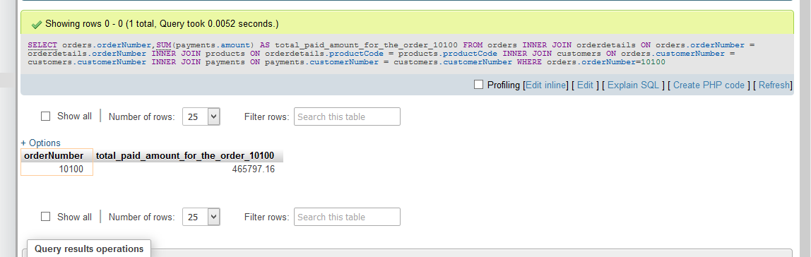

**QUESTION\_3:**

[SELECT](http://localhost/phpmyadmin/url.php?url=https://dev.mysql.com/doc/refman/5.5/en/select.html) DISTINCT orders.orderNumber,payments.checkNumber FROM orders

INNER JOIN orderdetails ON orders.orderNumber = orderdetails.orderNumber

INNER JOIN products ON orderdetails.productCode = products.productCode INNER

JOIN customers ON orders.customerNumber = customers.customerNumber INNER JOIN

payments ON payments.customerNumber = customers.customerNumber WHERE

orders.orderNumber=10100 ;

Top of Form



Bottom of Form

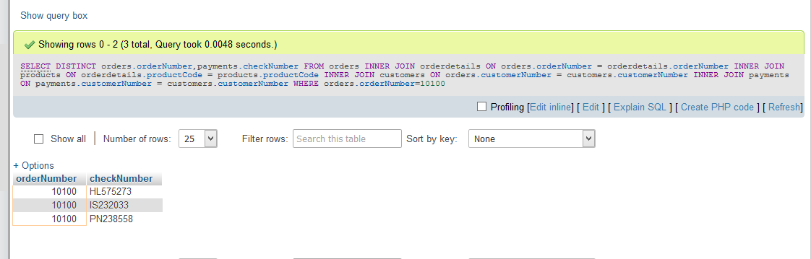

**QUESTION\_4:**

[SELECT](http://localhost/phpmyadmin/url.php?url=https://dev.mysql.com/doc/refman/5.5/en/select.html) [MIN](http://localhost/phpmyadmin/url.php?url=https://dev.mysql.com/doc/refman/5.5/en/group-by-functions.html#function_min)(quantityInStock) AS min\_value,[MAX](http://localhost/phpmyadmin/url.php?url=https://dev.mysql.com/doc/refman/5.5/en/group-by-functions.html#function_max)(quantityInStock)

AS max\_value FROM products ;

Top of Form



Bottom of Form

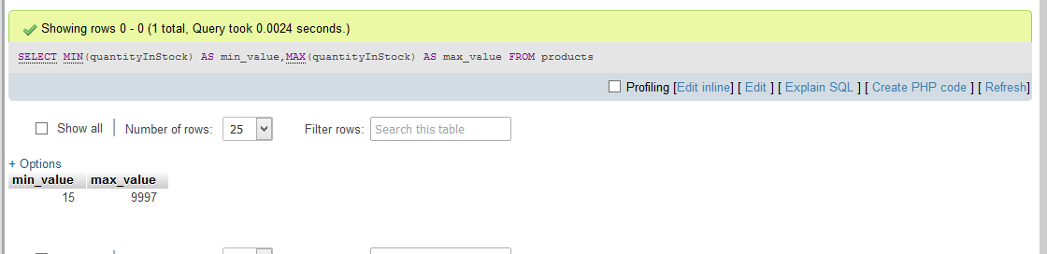

**QUESTION\_NO 5:**

[SELECT](http://localhost/phpmyadmin/url.php?url=https://dev.mysql.com/doc/refman/5.5/en/select.html) products.productCode,products.productLine,productLines.htmlDescription

FROM `products` INNER JOIN productlines

ON products.productLine=productlines.productLine

WHERE products.productLine=([SELECT](http://localhost/phpmyadmin/url.php?url=https://dev.mysql.com/doc/refman/5.5/en/select.html" \t "mysql_doc) productLine FROM productlines

WHERE productLine='Classic Cars') [AND](http://localhost/phpmyadmin/url.php?url=https://dev.mysql.com/doc/refman/5.5/en/logical-operators.html#operator_and) (productCode='S12\_3380'

[OR](http://localhost/phpmyadmin/url.php?url=https://dev.mysql.com/doc/refman/5.5/en/logical-operators.html#operator_or) productCode='S12\_3891' [OR](http://localhost/phpmyadmin/url.php?url=https://dev.mysql.com/doc/refman/5.5/en/logical-operators.html#operator_or) productCode='S12\_3990') ;

Top of Form



Bottom of Form

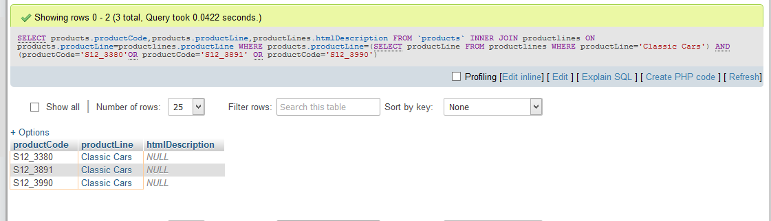

**Question\_no\_6 :**

[SELECT](http://localhost/phpmyadmin/url.php?url=https://dev.mysql.com/doc/refman/5.5/en/select.html) [COUNT](http://localhost/phpmyadmin/url.php?url=https://dev.mysql.com/doc/refman/5.5/en/group-by-functions.html#function_count)(\*)AS NULL\_COUNT FROM productlines WHERE htmlDescription

[IS](http://localhost/phpmyadmin/url.php?url=https://dev.mysql.com/doc/refman/5.5/en/comparison-operators.html#operator_is) NULL ;

Top of Form



Bottom of Form

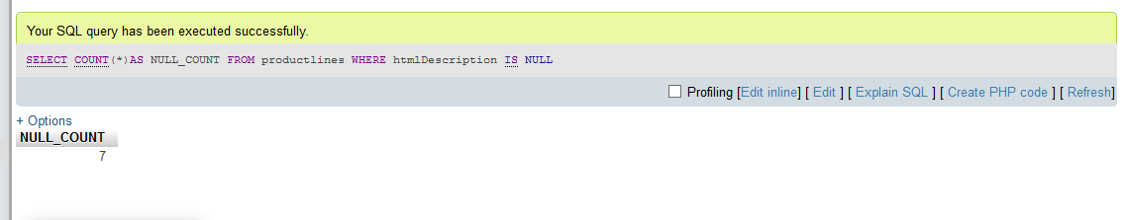

**Question\_no\_7 :**

[SELECT](http://localhost/phpmyadmin/url.php?url=https://dev.mysql.com/doc/refman/5.5/en/select.html) DATE\_FORMAT('2019-07-18 12:49:24' ,'%d %b %a') AS output ;

Top of Form



Bottom of Form

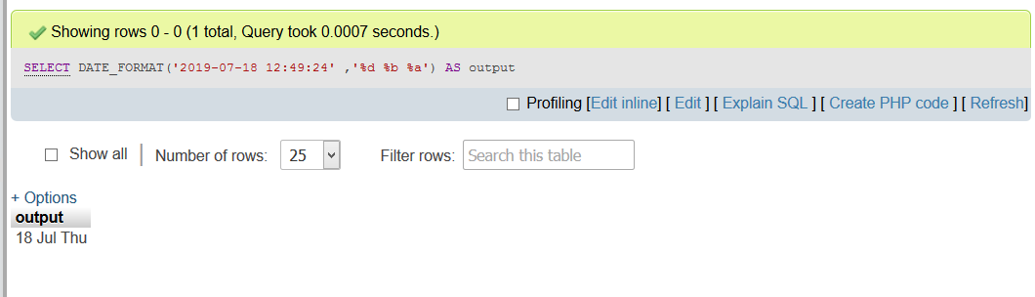

**Question\_no\_8 :**

[SELECT](http://localhost/phpmyadmin/url.php?url=https://dev.mysql.com/doc/refman/5.5/en/select.html) amount FROM payments ORDER BY amount DESC LIMIT 2,1 ;

Top of Form



Bottom of Form

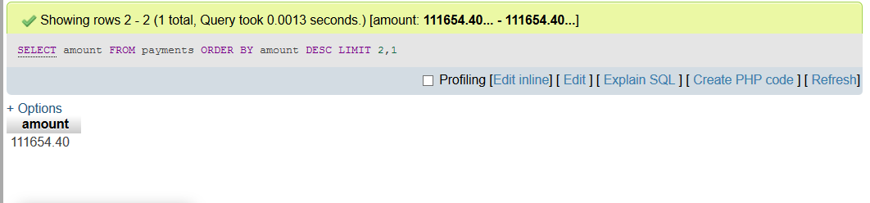

**Question\_no\_9 :**

[SELECT](http://localhost/phpmyadmin/url.php?url=https://dev.mysql.com/doc/refman/5.5/en/select.html) contactFirstName FROM customers WHERE contactFirstName [LIKE](http://localhost/phpmyadmin/url.php?url=https://dev.mysql.com/doc/refman/5.5/en/string-comparison-functions.html#operator_like) 'C%a ';

Top of Form



Bottom of Form

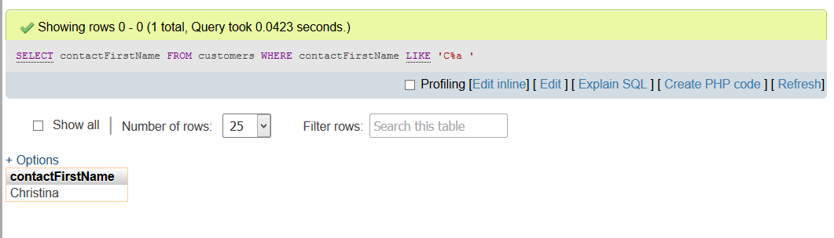

Question\_no\_10 :

[SELECT](http://localhost/phpmyadmin/url.php?url=https://dev.mysql.com/doc/refman/5.5/en/select.html) productLine,textDescription,htmlDescription,image FROM productlines

WHERE productLine [NOT](http://localhost/phpmyadmin/url.php?url=https://dev.mysql.com/doc/refman/5.5/en/logical-operators.html#operator_not) [IN](http://localhost/phpmyadmin/url.php?url=https://dev.mysql.com/doc/refman/5.5/en/comparison-operators.html#function_in)([SELECT](http://localhost/phpmyadmin/url.php?url=https://dev.mysql.com/doc/refman/5.5/en/select.html) productLine FROM products);

Top of Form



Bottom of Form

