**CREATE A CHATBOT IN PYTHON**

**PHASE2: PROJECT SUBMISSION**



**Introduction:**

* Creating a chatbot using Python is an exciting method that leverages the power of programming and natural language processing (NLP) to build interactive conversational agents.
* Chatbots have become increasingly popular in various applications, from customer support and virtual assistants to gaming and education.
* With Python, we can harness the power of natural language processing (NLP) and machine learning to build chatbots that can understand, interpret, and respond to human language.
* By the end we'll have the tools and expertise to create our own chatbot trained to our own interests.

**Content for Phase 2 Project:**

Consider exploring advanced techniques like using pre-trained language models (e.g., GPT-3) to enhance the quality of responses.

**Sample Dataset:**

hi, how are you doing? i'm fine. how about yourself?

i'm fine. how about yourself? i'm pretty good. thanks for asking.

i'm pretty good. thanks for asking. no problem. so how have you been?

no problem. so how have you been? i've been great. what about you?

i've been great. what about you? i've been good. i'm in school right now.

i've been good. i'm in school right now. what school do you go to?

what school do you go to? i go to pcc.

i go to pcc. do you like it there?

do you like it there? it's okay. it's a really big campus.

it's okay. it's a really big campus. good luck with school.

good luck with school. thank you very much.

how's it going? i'm doing well. how about you?

i'm doing well. how about you? never better, thanks.

never better, thanks. so how have you been lately?

so how have you been lately? i've actually been pretty good. you?

i've actually been pretty good. you? i'm actually in school right now.

i'm actually in school right now. which school do you attend?

which school do you attend? i'm attending pcc right now.

i'm attending pcc right now. are you enjoying it there?

are you enjoying it there? it's not bad. there are a lot of people there.

it's not bad. there are a lot of people there. good luck with that.

good luck with that. thanks.

how are you doing today? i'm doing great. what about you?

i'm doing great. what about you? i'm absolutely lovely, thank you.

i'm absolutely lovely, thank you. everything's been good with you?

everything's been good with you? i haven't been better. how about yourself?

i haven't been better. how about yourself? i started school recently.

i started school recently. where are you going to school?

where are you going to school? i'm going to pcc.

i'm going to pcc. how do you like it so far?

how do you like it so far? i like it so far. my classes are pretty good right now.

i like it so far. my classes are pretty good right now. i wish you luck.

it's an ugly day today. i know. i think it may rain.

i know. i think it may rain. it's the middle of summer, it shouldn't rain today.

it's the middle of summer, it shouldn't rain today. that would be weird.

that would be weird. yeah, especially since it's ninety degrees outside.

yeah, especially since it's ninety degrees outside. i know, it would be horrible if it rained and it was hot outside.

i know, it would be horrible if it rained and it was hot outside. yes, it would be.

yes, it would be. i really wish it wasn't so hot every day.

i really wish it wasn't so hot every day. me too. i can't wait until winter.

me too. i can't wait until winter. i like winter too, but sometimes it gets too cold.

i like winter too, but sometimes it gets too cold. i'd rather be cold than hot.

i'd rather be cold than hot. me too.

Import Libraries

**In [1]:**

import tensorflow as tf

import numpy as np

import pandas as pd

import matplotlib.pyplot as plt

import seaborn as sns

from tensorflow.keras.layers import TextVectorization

import re,string

from tensorflow.keras.layers import LSTM,Dense,Embedding,Dropout,LayerNormalization

**In [2]:**

df=pd.read_csv('/kaggle/input/simple-dialogs-for-chatbot/dialogs.txt',sep='**\t**',names=['question','answer'])

print(f'Dataframe size: **{**len(df)**}**')

df.head()

Dataframe size: 3725

**Out[2]:**

|  | question | answer |
| --- | --- | --- |
| 0 | hi, how are you doing? | i'm fine. how about yourself? |
| 1 | i'm fine. how about yourself? | i'm pretty good. thanks for asking. |
| 2 | i'm pretty good. thanks for asking. | no problem. so how have you been? |
| 3 | no problem. so how have you been? | i've been great. what about you? |
| 4 | i've been great. what about you? | i've been good. i'm in school right now. |

Data Preprocessing

Data Visualization

**In [3]:**

df['question tokens']=df['question'].apply(lambda x:len(x.split()))

df['answer tokens']=df['answer'].apply(lambda x:len(x.split()))

plt.style.use('fivethirtyeight')

fig,ax=plt.subplots(nrows=1,ncols=2,figsize=(20,5))

sns.set_palette('Set2')

sns.histplot(x=df['question tokens'],data=df,kde=True,ax=ax[0])

sns.histplot(x=df['answer tokens'],data=df,kde=True,ax=ax[1])

sns.jointplot(x='question tokens',y='answer tokens',data=df,kind='kde',fill=True,cmap='YlGnBu')

plt.show()

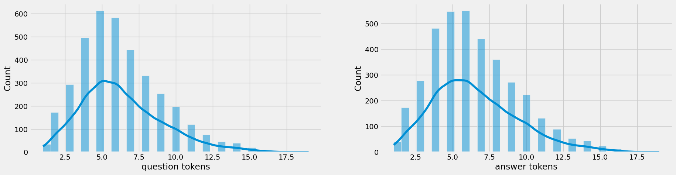

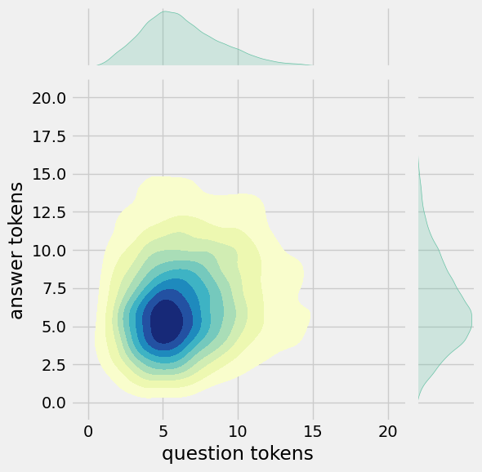

Text Cleaning

**In [4]:**

def clean_text(text):

text=re.sub('-',' ',text.lower())

text=re.sub('[.]',' . ',text)

text=re.sub('[1]',' 1 ',text)

text=re.sub('[2]',' 2 ',text)

text=re.sub('[3]',' 3 ',text)

text=re.sub('[4]',' 4 ',text)

text=re.sub('[5]',' 5 ',text)

text=re.sub('[6]',' 6 ',text)

text=re.sub('[7]',' 7 ',text)

text=re.sub('[8]',' 8 ',text)

text=re.sub('[9]',' 9 ',text)

text=re.sub('[0]',' 0 ',text)

text=re.sub('[,]',' , ',text)

text=re.sub('[?]',' ? ',text)

text=re.sub('[!]',' ! ',text)

text=re.sub('[$]',' $ ',text)

text=re.sub('[&]',' & ',text)

text=re.sub('[/]',' / ',text)

text=re.sub('[:]',' : ',text)

text=re.sub('[;]',' ; ',text)

text=re.sub('[*]',' * ',text)

text=re.sub('[**\'**]',' **\'** ',text)

text=re.sub('[**\"**]',' **\"** ',text)

text=re.sub('**\t**',' ',text)

return text

df.drop(columns=['answer tokens','question tokens'],axis=1,inplace=True)

df['encoder_inputs']=df['question'].apply(clean_text)

df['decoder_targets']=df['answer'].apply(clean_text)+' <end>'

df['decoder_inputs']='<start> '+df['answer'].apply(clean_text)+' <end>'

df.head(10)

**Out[4]:**

|  | question | answer | encoder_inputs | decoder_targets | decoder_inputs |
| --- | --- | --- | --- | --- | --- |
| 0 | hi, how are you doing? | i'm fine. how about yourself? | hi , how are you doing ? | i ' m fine . how about yourself ? <end> | <start> i ' m fine . how about yourself ? <end> |
| 1 | i'm fine. how about yourself? | i'm pretty good. thanks for asking. | i ' m fine . how about yourself ? | i ' m pretty good . thanks for asking . <end> | <start> i ' m pretty good . thanks for asking... |
| 2 | i'm pretty good. thanks for asking. | no problem. so how have you been? | i ' m pretty good . thanks for asking . | no problem . so how have you been ? <end> | <start> no problem . so how have you been ? ... |
| 3 | no problem. so how have you been? | i've been great. what about you? | no problem . so how have you been ? | i ' ve been great . what about you ? <end> | <start> i ' ve been great . what about you ? ... |
| 4 | i've been great. what about you? | i've been good. i'm in school right now. | i ' ve been great . what about you ? | i ' ve been good . i ' m in school right now ... | <start> i ' ve been good . i ' m in school ri... |
| 5 | i've been good. i'm in school right now. | what school do you go to? | i ' ve been good . i ' m in school right now . | what school do you go to ? <end> | <start> what school do you go to ? <end> |
| 6 | what school do you go to? | i go to pcc. | what school do you go to ? | i go to pcc . <end> | <start> i go to pcc . <end> |
| 7 | i go to pcc. | do you like it there? | i go to pcc . | do you like it there ? <end> | <start> do you like it there ? <end> |
| 8 | do you like it there? | it's okay. it's a really big campus. | do you like it there ? | it ' s okay . it ' s a really big campus . <... | <start> it ' s okay . it ' s a really big cam... |
| 9 | it's okay. it's a really big campus. | good luck with school. | it ' s okay . it ' s a really big campus . | good luck with school . <end> | <start> good luck with school . <end> |

df['encoder input tokens']=df['encoder_inputs'].apply(lambda x:len(x.split()))

df['decoder input tokens']=df['decoder_inputs'].apply(lambda x:len(x.split()))

df['decoder target tokens']=df['decoder_targets'].apply(lambda x:len(x.split()))

plt.style.use('fivethirtyeight')

fig,ax=plt.subplots(nrows=1,ncols=3,figsize=(20,5))

sns.set_palette('Set2')

sns.histplot(x=df['encoder input tokens'],data=df,kde=True,ax=ax[0])

sns.histplot(x=df['decoder input tokens'],data=df,kde=True,ax=ax[1])

sns.histplot(x=df['decoder target tokens'],data=df,kde=True,ax=ax[2])

sns.jointplot(x='encoder input tokens',y='decoder target tokens',data=df,kind='kde',fill=True,cmap='YlGnBu')

plt.show()

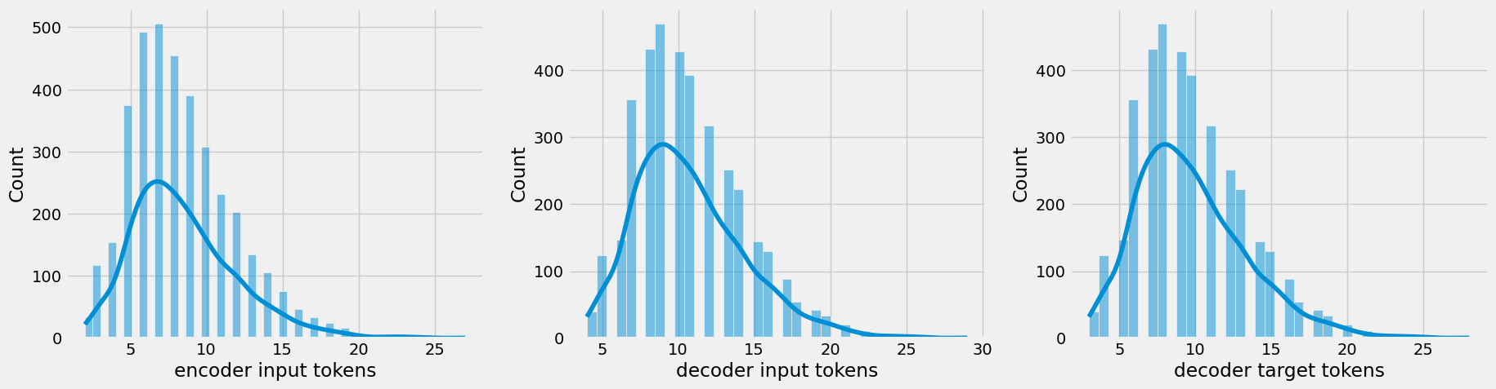

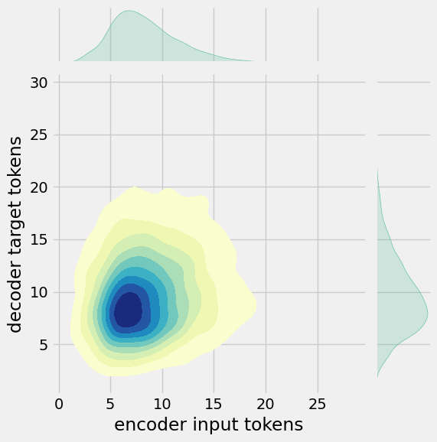

**In [6]:**

print(f"After preprocessing: **{**' '.join(df[df['encoder input tokens'].max()==df['encoder input tokens']]['encoder_inputs'].values.tolist())**}**")

print(f"Max encoder input length: **{**df['encoder input tokens'].max()**}**")

print(f"Max decoder input length: **{**df['decoder input tokens'].max()**}**")

print(f"Max decoder target length: **{**df['decoder target tokens'].max()**}**")

df.drop(columns=['question','answer','encoder input tokens','decoder input tokens','decoder target tokens'],axis=1,inplace=True)

params={

"vocab_size":2500,

"max_sequence_length":30,

"learning_rate":0.008,

"batch_size":149,

"lstm_cells":256,

"embedding_dim":256,

"buffer_size":10000

}

learning_rate=params['learning_rate']

batch_size=params['batch_size']

embedding_dim=params['embedding_dim']

lstm_cells=params['lstm_cells']

vocab_size=params['vocab_size']

buffer_size=params['buffer_size']

max_sequence_length=params['max_sequence_length']

df.head(10)

After preprocessing: for example , if your birth date is january 1 2 , 1 9 8 7 , write 0 1 / 1 2 / 8 7 .

Max encoder input length: 27

Max decoder input length: 29

Max decoder target length: 28

**Out[6]:**

|  | encoder_inputs | decoder_targets | decoder_inputs |
| --- | --- | --- | --- |
| 0 | hi , how are you doing ? | i ' m fine . how about yourself ? <end> | <start> i ' m fine . how about yourself ? <end> |
| 1 | i ' m fine . how about yourself ? | i ' m pretty good . thanks for asking . <end> | <start> i ' m pretty good . thanks for asking... |
| 2 | i ' m pretty good . thanks for asking . | no problem . so how have you been ? <end> | <start> no problem . so how have you been ? ... |
| 3 | no problem . so how have you been ? | i ' ve been great . what about you ? <end> | <start> i ' ve been great . what about you ? ... |
| 4 | i ' ve been great . what about you ? | i ' ve been good . i ' m in school right now ... | <start> i ' ve been good . i ' m in school ri... |
| 5 | i ' ve been good . i ' m in school right now . | what school do you go to ? <end> | <start> what school do you go to ? <end> |
| 6 | what school do you go to ? | i go to pcc . <end> | <start> i go to pcc . <end> |
| 7 | i go to pcc . | do you like it there ? <end> | <start> do you like it there ? <end> |
| 8 | do you like it there ? | it ' s okay . it ' s a really big campus . <... | <start> it ' s okay . it ' s a really big cam... |
| 9 | it ' s okay . it ' s a really big campus . | good luck with school . <end> | <start> good luck with school . <end> |

Tokenization

**In [7]:**

vectorize_layer=TextVectorization(

max_tokens=vocab_size,

standardize=None,

output_mode='int',

output_sequence_length=max_sequence_length

)

vectorize_layer.adapt(df['encoder_inputs']+' '+df['decoder_targets']+' <start> <end>')

vocab_size=len(vectorize_layer.get_vocabulary())

print(f'Vocab size: **{**len(vectorize_layer.get_vocabulary())**}**')

print(f'**{**vectorize_layer.get_vocabulary()[:12]**}**')

Vocab size: 2443

['', '[UNK]', '<end>', '.', '<start>', "'", 'i', '?', 'you', ',', 'the', 'to']

**In [8]:**

def sequences2ids(sequence):

return vectorize_layer(sequence)

def ids2sequences(ids):

decode=''

if type(ids)==int:

ids=[ids]

for id **in** ids:

decode+=vectorize_layer.get_vocabulary()[id]+' '

return decode

x=sequences2ids(df['encoder_inputs'])

yd=sequences2ids(df['decoder_inputs'])

y=sequences2ids(df['decoder_targets'])

print(f'Question sentence: hi , how are you ?')

print(f'Question to tokens: **{**sequences2ids("hi , how are you ?")[:10]**}**')

print(f'Encoder input shape: **{**x.shape**}**')

print(f'Decoder input shape: **{**yd.shape**}**')

print(f'Decoder target shape: **{**y.shape**}**')

Question sentence: hi , how are you ?

Question to tokens: [1971 9 45 24 8 7 0 0 0 0]

Encoder input shape: (3725, 30)

Decoder input shape: (3725, 30)

Decoder target shape: (3725, 30)

**In [9]:**

print(f'Encoder input: **{**x[0][:12]**}** ...')

print(f'Decoder input: **{**yd[0][:12]**}** ...') *# shifted by one time step of the target as input to decoder is the output of the previous timestep*

print(f'Decoder target: **{**y[0][:12]**}** ...')

Encoder input: [1971 9 45 24 8 194 7 0 0 0 0 0] ...

Decoder input: [ 4 6 5 38 646 3 45 41 563 7 2 0] ...

Decoder target: [ 6 5 38 646 3 45 41 563 7 2 0 0] ...

**In [10]:**

data=tf.data.Dataset.from_tensor_slices((x,yd,y))

data=data.shuffle(buffer_size)

train_data=data.take(int(.9*len(data)))

train_data=train_data.cache()

train_data=train_data.shuffle(buffer_size)

train_data=train_data.batch(batch_size)

train_data=train_data.prefetch(tf.data.AUTOTUNE)

train_data_iterator=train_data.as_numpy_iterator()

val_data=data.skip(int(.9*len(data))).take(int(.1*len(data)))

val_data=val_data.batch(batch_size)

val_data=val_data.prefetch(tf.data.AUTOTUNE)

_=train_data_iterator.next()

print(f'Number of train batches: **{**len(train_data)**}**')

print(f'Number of training data: **{**len(train_data)*batch_size**}**')

print(f'Number of validation batches: **{**len(val_data)**}**')

print(f'Number of validation data: **{**len(val_data)*batch_size**}**')

print(f'Encoder Input shape (with batches): **{**_[0].shape**}**')

print(f'Decoder Input shape (with batches): **{**_[1].shape**}**')

print(f'Target Output shape (with batches): **{**_[2].shape**}**')

Number of train batches: 23

Number of training data: 3427

Number of validation batches: 3

Number of validation data: 447

Encoder Input shape (with batches): (149, 30)

Decoder Input shape (with batches): (149, 30)

Target Output shape (with batches): (149, 30)

Build Models

Build Encoder

**In [11]:**

class **Encoder**(tf.keras.models.Model):

def __init__(self,units,embedding_dim,vocab_size,*args,**kwargs) -> None:

super().__init__(*args,**kwargs)

self.units=units

self.vocab_size=vocab_size

self.embedding_dim=embedding_dim

self.embedding=Embedding(

vocab_size,

embedding_dim,

name='encoder_embedding',

mask_zero=True,

embeddings_initializer=tf.keras.initializers.GlorotNormal()

)

self.normalize=LayerNormalization()

self.lstm=LSTM(

units,

dropout=.4,

return_state=True,

return_sequences=True,

name='encoder_lstm',

kernel_initializer=tf.keras.initializers.GlorotNormal()

)

def call(self,encoder_inputs):

self.inputs=encoder_inputs

x=self.embedding(encoder_inputs)

x=self.normalize(x)

x=Dropout(.4)(x)

encoder_outputs,encoder_state_h,encoder_state_c=self.lstm(x)

self.outputs=[encoder_state_h,encoder_state_c]

return encoder_state_h,encoder_state_c

encoder=Encoder(lstm_cells,embedding_dim,vocab_size,name='encoder')

encoder.call(_[0])

**Out[11]:**

(<tf.Tensor: shape=(149, 256), dtype=float32, numpy=

array([[ 0.16966951, -0.10419625, -0.12700348, ..., -0.12251794,

0.10568858, 0.14841646],

[ 0.08443093, 0.08849293, -0.09065959, ..., -0.00959182,

0.10152507, -0.12077457],

[ 0.03628462, -0.02653611, -0.11506603, ..., -0.14669597,

0.10292757, 0.13625325],

...,

[-0.14210635, -0.12942064, -0.03288083, ..., 0.0568463 ,

-0.02598592, -0.22455114],

[ 0.20819993, 0.01196991, -0.09635217, ..., -0.18782297,

0.10233591, 0.20114912],

[ 0.1164271 , -0.07769038, -0.06414707, ..., -0.06539135,

-0.05518465, 0.25142196]], dtype=float32)>,

<tf.Tensor: shape=(149, 256), dtype=float32, numpy=

array([[ 0.34589 , -0.30134732, -0.43572 , ..., -0.3102559 ,

0.34630865, 0.2613009 ],

[ 0.14154069, 0.17045322, -0.17749965, ..., -0.02712595,

0.17292541, -0.2922624 ],

[ 0.07106856, -0.0739173 , -0.3641197 , ..., -0.3794833 ,

0.36470377, 0.23766585],

...,

[-0.2582597 , -0.25323495, -0.06649272, ..., 0.16527973,

-0.04292646, -0.58768904],

[ 0.43155715, 0.03135502, -0.33463806, ..., -0.47625306,

0.33486888, 0.35035062],

[ 0.23173636, -0.20141824, -0.22034441, ..., -0.16035017,

-0.17478186, 0.48899865]], dtype=float32)>)

Build Encoder## Build Decoder

**In [12]:**

class **Decoder**(tf.keras.models.Model):

def __init__(self,units,embedding_dim,vocab_size,*args,**kwargs) -> None:

super().__init__(*args,**kwargs)

self.units=units

self.embedding_dim=embedding_dim

self.vocab_size=vocab_size

self.embedding=Embedding(

vocab_size,

embedding_dim,

name='decoder_embedding',

mask_zero=True,

embeddings_initializer=tf.keras.initializers.HeNormal()

)

self.normalize=LayerNormalization()

self.lstm=LSTM(

units,

dropout=.4,

return_state=True,

return_sequences=True,

name='decoder_lstm',

kernel_initializer=tf.keras.initializers.HeNormal()

)

self.fc=Dense(

vocab_size,

activation='softmax',

name='decoder_dense',

kernel_initializer=tf.keras.initializers.HeNormal()

)

def call(self,decoder_inputs,encoder_states):

x=self.embedding(decoder_inputs)

x=self.normalize(x)

x=Dropout(.4)(x)

x,decoder_state_h,decoder_state_c=self.lstm(x,initial_state=encoder_states)

x=self.normalize(x)

x=Dropout(.4)(x)

return self.fc(x)

decoder=Decoder(lstm_cells,embedding_dim,vocab_size,name='decoder')

decoder(_[1][:1],encoder(_[0][:1]))

**Out[12]:**

<tf.Tensor: shape=(1, 30, 2443), dtype=float32, numpy=

array([[[3.4059247e-04, 5.7348556e-05, 2.1294907e-05, ...,

7.2067953e-05, 1.5453645e-03, 2.3599296e-04],

[1.4662130e-03, 8.0250365e-06, 5.4062020e-05, ...,

1.9187471e-05, 9.7244098e-05, 7.6433855e-05],

[9.6929165e-05, 2.7441782e-05, 1.3761305e-03, ...,

3.6009602e-05, 1.5537882e-04, 1.8397317e-04],

...,

[1.9002777e-03, 6.9266016e-04, 1.4346189e-04, ...,

1.9552530e-04, 1.7106640e-05, 1.0252406e-04],

[1.9002777e-03, 6.9266016e-04, 1.4346189e-04, ...,

1.9552530e-04, 1.7106640e-05, 1.0252406e-04],

[1.9002777e-03, 6.9266016e-04, 1.4346189e-04, ...,

1.9552530e-04, 1.7106640e-05, 1.0252406e-04]]], dtype=float32)>

Build Training Model

**In [13]:**

class **ChatBotTrainer**(tf.keras.models.Model):

def __init__(self,encoder,decoder,*args,**kwargs):

super().__init__(*args,**kwargs)

self.encoder=encoder

self.decoder=decoder

def loss_fn(self,y_true,y_pred):

loss=self.loss(y_true,y_pred)

mask=tf.math.logical_not(tf.math.equal(y_true,0))

mask=tf.cast(mask,dtype=loss.dtype)

loss*=mask

return tf.reduce_mean(loss)

def accuracy_fn(self,y_true,y_pred):

pred_values = tf.cast(tf.argmax(y_pred, axis=-1), dtype='int64')

correct = tf.cast(tf.equal(y_true, pred_values), dtype='float64')

mask = tf.cast(tf.greater(y_true, 0), dtype='float64')

n_correct = tf.keras.backend.sum(mask * correct)

n_total = tf.keras.backend.sum(mask)

return n_correct / n_total

def call(self,inputs):

encoder_inputs,decoder_inputs=inputs

encoder_states=self.encoder(encoder_inputs)

return self.decoder(decoder_inputs,encoder_states)

def train_step(self,batch):

encoder_inputs,decoder_inputs,y=batch

with tf.GradientTape() as tape:

encoder_states=self.encoder(encoder_inputs,training=True)

y_pred=self.decoder(decoder_inputs,encoder_states,training=True)

loss=self.loss_fn(y,y_pred)

acc=self.accuracy_fn(y,y_pred)

variables=self.encoder.trainable_variables+self.decoder.trainable_variables

grads=tape.gradient(loss,variables)

self.optimizer.apply_gradients(zip(grads,variables))

metrics={'loss':loss,'accuracy':acc}

return metrics

def test_step(self,batch):

encoder_inputs,decoder_inputs,y=batch

encoder_states=self.encoder(encoder_inputs,training=True)

y_pred=self.decoder(decoder_inputs,encoder_states,training=True)

loss=self.loss_fn(y,y_pred)

acc=self.accuracy_fn(y,y_pred)

metrics={'loss':loss,'accuracy':acc}

return metrics

**In [14]:**

model=ChatBotTrainer(encoder,decoder,name='chatbot_trainer')

model.compile(

loss=tf.keras.losses.SparseCategoricalCrossentropy(),

optimizer=tf.keras.optimizers.Adam(learning_rate=learning_rate),

weighted_metrics=['loss','accuracy']

)

model(_[:2])

**Out[14]:**

<tf.Tensor: shape=(149, 30, 2443), dtype=float32, numpy=

array([[[3.40592262e-04, 5.73484940e-05, 2.12948853e-05, ...,

7.20679745e-05, 1.54536311e-03, 2.35993255e-04],

[1.46621116e-03, 8.02504110e-06, 5.40619949e-05, ...,

1.91874733e-05, 9.72440175e-05, 7.64339056e-05],

[9.69291723e-05, 2.74417835e-05, 1.37613132e-03, ...,

3.60095728e-05, 1.55378671e-04, 1.83973272e-04],

...,

[1.90027885e-03, 6.92659756e-04, 1.43461803e-04, ...,

1.95525470e-04, 1.71066222e-05, 1.02524005e-04],

[1.90027885e-03, 6.92659756e-04, 1.43461803e-04, ...,

1.95525470e-04, 1.71066222e-05, 1.02524005e-04],

[1.90027885e-03, 6.92659756e-04, 1.43461803e-04, ...,

1.95525470e-04, 1.71066222e-05, 1.02524005e-04]],

[[9.24730921e-05, 3.46553512e-04, 2.07866033e-05, ...,

3.65934626e-04, 7.63039337e-04, 5.52638434e-04],

[8.46863186e-05, 3.65541164e-05, 2.54740953e-05, ...,

7.12379551e-05, 3.62201303e-04, 4.16714087e-04],

[2.30146630e-04, 3.91469621e-06, 2.72463716e-04, ...,

9.26126595e-05, 1.03836363e-04, 1.40792166e-04],

...,

[6.84961735e-04, 9.07644513e-04, 2.86691647e-04, ...,

3.87946144e-04, 6.09236558e-05, 1.12995331e-05],

[6.84961735e-04, 9.07644513e-04, 2.86691647e-04, ...,

3.87946144e-04, 6.09236558e-05, 1.12995331e-05],

[6.84961735e-04, 9.07644513e-04, 2.86691647e-04, ...,

3.87946144e-04, 6.09236558e-05, 1.12995322e-05]],

[[1.19036995e-03, 8.10516722e-05, 2.42324077e-05, ...,

4.99442758e-05, 6.67208573e-04, 9.55566764e-04],

[1.53046989e-04, 9.76863957e-05, 4.96972689e-06, ...,

3.24743196e-05, 2.12563842e-04, 1.18708890e-03],

[9.40205529e-04, 1.80782794e-04, 7.26205144e-06, ...,

1.96355060e-04, 8.16940737e-05, 1.38416886e-03],

...,

[3.52622545e-03, 1.26781175e-03, 1.02695449e-04, ...,

2.35450850e-03, 3.25187625e-06, 9.46984728e-05],

[3.52622545e-03, 1.26781175e-03, 1.02695449e-04, ...,

2.35450850e-03, 3.25187625e-06, 9.46984728e-05],

[3.52622545e-03, 1.26781175e-03, 1.02695449e-04, ...,

2.35450850e-03, 3.25187625e-06, 9.46984728e-05]],

...,

[[9.03617911e-05, 1.57651404e-04, 1.02747028e-04, ...,

2.20922651e-04, 3.61504179e-04, 2.32456136e-03],

[1.55469708e-04, 1.53608169e-04, 1.14945491e-04, ...,

1.88878359e-04, 5.11967926e-04, 5.13108505e-04],

[8.27641197e-05, 2.83437112e-05, 6.29429938e-04, ...,

2.15980137e-04, 3.02832137e-04, 1.77760507e-04],

...,

[2.41102395e-03, 1.29279669e-03, 9.11735406e-05, ...,

4.06600971e-04, 7.58682154e-06, 6.05909081e-05],

[2.41102395e-03, 1.29279669e-03, 9.11735406e-05, ...,

4.06600971e-04, 7.58682154e-06, 6.05909081e-05],

[2.41102395e-03, 1.29279669e-03, 9.11735406e-05, ...,

4.06600971e-04, 7.58682154e-06, 6.05909081e-05]],

[[3.99837241e-04, 2.36026899e-05, 6.89777007e-05, ...,

5.94239136e-05, 4.32556757e-04, 4.60232928e-04],

[3.88111075e-04, 8.31133584e-05, 1.11861555e-04, ...,

3.03280340e-05, 2.54765386e-04, 2.82170397e-04],

[2.12516752e-03, 7.19837190e-05, 1.88700986e-04, ...,

1.86366087e-04, 7.02239413e-05, 2.54370330e-04],

...,

[4.56329063e-03, 2.23812275e-03, 2.37343236e-04, ...,

2.64523784e-04, 4.05454011e-05, 1.55662783e-04],

[4.56329063e-03, 2.23812275e-03, 2.37343236e-04, ...,

2.64523784e-04, 4.05454011e-05, 1.55662783e-04],

[4.56329063e-03, 2.23812275e-03, 2.37343236e-04, ...,

2.64523784e-04, 4.05454011e-05, 1.55662783e-04]],

[[3.24600202e-04, 9.31067043e-05, 4.60048941e-05, ...,

6.66230699e-05, 5.76460850e-04, 1.52416309e-04],

[7.51478728e-05, 7.63997741e-05, 2.09082973e-05, ...,

2.55555002e-04, 2.28998848e-04, 4.37303359e-04],

[1.03114333e-04, 1.55743372e-04, 9.97955431e-06, ...,

1.12485175e-03, 4.80950950e-03, 6.83143327e-04],

...,

[5.20280097e-03, 3.23211338e-04, 2.47709468e-05, ...,

3.07609705e-04, 6.09844255e-06, 8.61325825e-05],

[5.20280097e-03, 3.23211338e-04, 2.47709468e-05, ...,

3.07609705e-04, 6.09844255e-06, 8.61325825e-05],

[5.20280097e-03, 3.23211338e-04, 2.47709468e-05, ...,

3.07609705e-04, 6.09844255e-06, 8.61325825e-05]]], dtype=float32)>

Train Model

**In [15]:**

history=model.fit(

train_data,

epochs=100,

validation_data=val_data,

callbacks=[

tf.keras.callbacks.TensorBoard(log_dir='logs'),

tf.keras.callbacks.ModelCheckpoint('ckpt',verbose=1,save_best_only=True)

]

)

Visualize Metrics

**In [16]:**

fig,ax=plt.subplots(nrows=1,ncols=2,figsize=(20,5))

ax[0].plot(history.history['loss'],label='loss',c='red')

ax[0].plot(history.history['val_loss'],label='val_loss',c = 'blue')

ax[0].set_xlabel('Epochs')

ax[1].set_xlabel('Epochs')

ax[0].set_ylabel('Loss')

ax[1].set_ylabel('Accuracy')

ax[0].set_title('Loss Metrics')

ax[1].set_title('Accuracy Metrics')

ax[1].plot(history.history['accuracy'],label='accuracy')

ax[1].plot(history.history['val_accuracy'],label='val_accuracy')

ax[0].legend()

ax[1].legend()

plt.show()

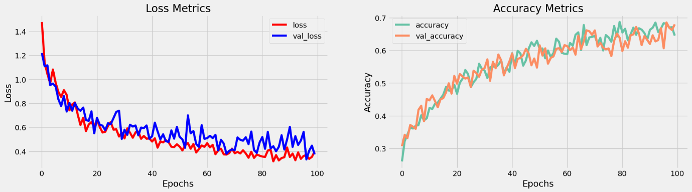

Save Model

**In [17]:**

model.load_weights('ckpt')

model.save('models',save_format='tf')

**In [18]:**

for idx,i **in** enumerate(model.layers):

print('Encoder layers:' if idx==0 else 'Decoder layers: ')

for j **in** i.layers:

print(j)

print('---------------------')

Encoder layers:

<keras.layers.core.embedding.Embedding object at 0x782084b9d190>

<keras.layers.normalization.layer_normalization.LayerNormalization object at 0x7820e56f1b90>

<keras.layers.rnn.lstm.LSTM object at 0x7820841bd650>

---------------------

Decoder layers:

<keras.layers.core.embedding.Embedding object at 0x78207c258590>

<keras.layers.normalization.layer_normalization.LayerNormalization object at 0x78207c78bd10>

<keras.layers.rnn.lstm.LSTM object at 0x78207c258a10>

<keras.layers.core.dense.Dense object at 0x78207c2636d0>

---------------------

Create Inference Model

**In [19]:**

class **ChatBot**(tf.keras.models.Model):

def __init__(self,base_encoder,base_decoder,*args,**kwargs):

super().__init__(*args,**kwargs)

self.encoder,self.decoder=self.build_inference_model(base_encoder,base_decoder)

def build_inference_model(self,base_encoder,base_decoder):

encoder_inputs=tf.keras.Input(shape=(None,))

x=base_encoder.layers[0](encoder_inputs)

x=base_encoder.layers[1](x)

x,encoder_state_h,encoder_state_c=base_encoder.layers[2](x)

encoder=tf.keras.models.Model(inputs=encoder_inputs,outputs=[encoder_state_h,encoder_state_c],name='chatbot_encoder')

decoder_input_state_h=tf.keras.Input(shape=(lstm_cells,))

decoder_input_state_c=tf.keras.Input(shape=(lstm_cells,))

decoder_inputs=tf.keras.Input(shape=(None,))

x=base_decoder.layers[0](decoder_inputs)

x=base_encoder.layers[1](x)

x,decoder_state_h,decoder_state_c=base_decoder.layers[2](x,initial_state=[decoder_input_state_h,decoder_input_state_c])

decoder_outputs=base_decoder.layers[-1](x)

decoder=tf.keras.models.Model(

inputs=[decoder_inputs,[decoder_input_state_h,decoder_input_state_c]],

outputs=[decoder_outputs,[decoder_state_h,decoder_state_c]],name='chatbot_decoder'

)

return encoder,decoder

def summary(self):

self.encoder.summary()

self.decoder.summary()

def softmax(self,z):

return np.exp(z)/sum(np.exp(z))

def sample(self,conditional_probability,temperature=0.5):

conditional_probability = np.asarray(conditional_probability).astype("float64")

conditional_probability = np.log(conditional_probability) / temperature

reweighted_conditional_probability = self.softmax(conditional_probability)

probas = np.random.multinomial(1, reweighted_conditional_probability, 1)

return np.argmax(probas)

def preprocess(self,text):

text=clean_text(text)

seq=np.zeros((1,max_sequence_length),dtype=np.int32)

for i,word **in** enumerate(text.split()):

seq[:,i]=sequences2ids(word).numpy()[0]

return seq

def postprocess(self,text):

text=re.sub(' - ','-',text.lower())

text=re.sub(' [.] ','. ',text)

text=re.sub(' [1] ','1',text)

text=re.sub(' [2] ','2',text)

text=re.sub(' [3] ','3',text)

text=re.sub(' [4] ','4',text)

text=re.sub(' [5] ','5',text)

text=re.sub(' [6] ','6',text)

text=re.sub(' [7] ','7',text)

text=re.sub(' [8] ','8',text)

text=re.sub(' [9] ','9',text)

text=re.sub(' [0] ','0',text)

text=re.sub(' [,] ',', ',text)

text=re.sub(' [?] ','? ',text)

text=re.sub(' [!] ','! ',text)

text=re.sub(' [$] ','$ ',text)

text=re.sub(' [&] ','& ',text)

text=re.sub(' [/] ','/ ',text)

text=re.sub(' [:] ',': ',text)

text=re.sub(' [;] ','; ',text)

text=re.sub(' [*] ','* ',text)

text=re.sub(' [**\'**] ','**\'**',text)

text=re.sub(' [**\"**] ','**\"**',text)

return text

def call(self,text,config=None):

input_seq=self.preprocess(text)

states=self.encoder(input_seq,training=False)

target_seq=np.zeros((1,1))

target_seq[:,:]=sequences2ids(['<start>']).numpy()[0][0]

stop_condition=False

decoded=[]

while **not** stop_condition:

decoder_outputs,new_states=self.decoder([target_seq,states],training=False)

*# index=tf.argmax(decoder_outputs[:,-1,:],axis=-1).numpy().item()*

index=self.sample(decoder_outputs[0,0,:]).item()

word=ids2sequences([index])

if word=='<end> ' **or** len(decoded)>=max_sequence_length:

stop_condition=True

else:

decoded.append(index)

target_seq=np.zeros((1,1))

target_seq[:,:]=index

states=new_states

return self.postprocess(ids2sequences(decoded))

chatbot=ChatBot(model.encoder,model.decoder,name='chatbot')

chatbot.summary()

Model: "chatbot_encoder"

_________________________________________________________________

Layer (type) Output Shape Param #

=================================================================

input_1 (InputLayer) [(None, None)] 0

encoder_embedding (Embedding) (None, None, 256) 625408

layer_normalization (LayerNormalization) (None, None, 256) 512

encoder_lstm (LSTM) [(None, None, 256), 525312

(None, 256),

(None, 256)]

=================================================================

Total params: 1,151,232

Trainable params: 1,151,232

Non-trainable params: 0

_________________________________________________________________

Model: "chatbot_decoder"

_______________________________________________________________________

Layer (type) Output Shape Param # Connected to

=======================================================================

input_4 (InputLayer) [(None, None)] 0 []

decoder_embedding (Embedding) (None, None, 256) 625408['input_4[0][0]']

layer_normalization (LayerNorm (None, None, 256) 51 ['decoder_embedding[0][0]']

alization)

input_2 (InputLayer) [(None, 256)] 0 []

input_3 (InputLayer) [(None, 256)] 0 []

decoder_lstm(LSTM)[(None,None,256),525312['layer_normalization[1][0]',

(None, 256), 'input_2[0][0]',

(None, 256)] 'input_3[0][0]']

decoder_dense (Dense)(None, None, 2443) 627851['decoder_lstm[0][0]']

======================================================================

Total params: 1,779,083

Trainable params: 1,779,083

Non-trainable params: 0

_______________________________________________________________________

**In [20]:**

tf.keras.utils.plot_model(chatbot.encoder,to_file='encoder.png',show_shapes=True,show_layer_activations=True)

**Out[20]:**

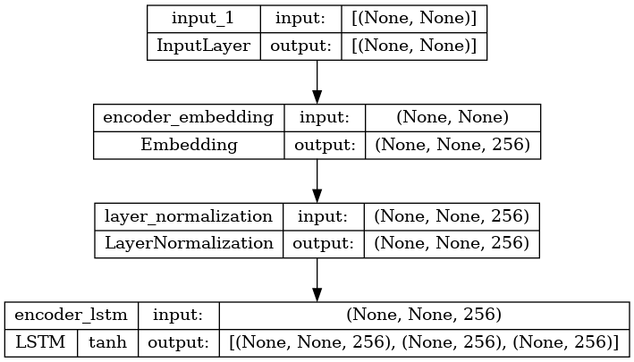

**In [21]:**

tf.keras.utils.plot_model(chatbot.decoder,to_file='decoder.png',show_shapes=True,show_layer_activations=True)

**Out[21]:**

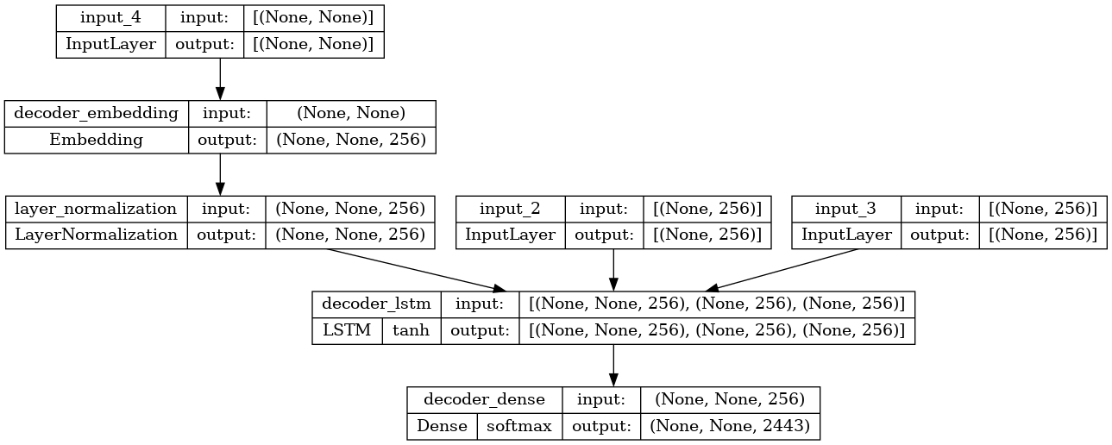

Time to Chat:

Program:

**In [22]:**

def print_conversation(texts):

for text **in** texts:

print(f'You: **{**text**}**')

print(f'Bot: **{**chatbot(text)**}**')

print('========================')

**In [23]:**

print_conversation([

'hi',

'do yo know me?',

'what is your name?',

'you are bot?',

'hi, how are you doing?',

"i'm pretty good. thanks for asking.",

"Don't ever be in a hurry",

*'''I'm gonna put some dirt in your eye '''*,

*'''You're trash '''*,

*'''I've read all your research on nano-technology '''*,

*'''You want forgiveness? Get religion'''*,

*'''While you're using the bathroom, i'll order some food.'''*,

*'''Wow! that's terrible.'''*,

*'''We'll be here forever.'''*,

*'''I need something that's reliable.'''*,

*'''A speeding car ran a red light, killing the girl.'''*,

*'''Tomorrow we'll have rice and fish for lunch.'''*,

*'''I like this restaurant because they give you free bread.'''*

])

You: hi

Bot: i have to go to the bathroom.

========================

You: do yo know me?

Bot: yes, it's too close to the other.

========================

You: what is your name?

Bot: i have to walk the house.

========================

You: you are bot?

Bot: no, i have. all my life.

========================

You: hi, how are you doing?

Bot: i'm going to be a teacher.

========================

You: i'm pretty good. thanks for asking.

Bot: no problem. i'll have to give you the english assignments from my mind.

========================

You: Don't ever be in a hurry

Bot: it's not a great.

========================

You: I'm gonna put some dirt in your eye

Bot: that's a good idea.

========================

You: You're trash

Bot: the tv news is reporting a bank robbery.

========================

You: I've read all your research on nano-technology

Bot: it's the weather. i've gone around the world.

========================

You: You want forgiveness? Get religion

Bot: no, i'll be my.

========================

You: While you're using the bathroom, i'll order some food.

Bot: don't order for me. i've been a cheater.

========================

You: Wow! that's terrible.

Bot: never park your car under the house.

========================

You: We'll be here forever.

Bot: we'll be there in half an hour.

========================

You: I need something that's reliable.

Bot: you need a car with low mileage.

========================

You: A speeding car ran a red light, killing the girl.

Bot: what happened?

========================

You: Tomorrow we'll have rice and fish for lunch.

Bot: i'll make a sandwich.

========================

You: I like this restaurant because they give you free bread.

Bot: well, i think that's a good idea.

========================

Conclusion:

* In this phase2 Submission, creating a project in Python is an essential skill for any aspiring programmer.
* It offers a practical and hands-on way to apply your knowledge of the language and develop real-world solutions.
* From planning and design to coding and testing, the process of project creation not only enhances your coding skills but also fosters problem-solving abilities