MLOps – HANDS-ON PRACTICAL
Implementing Continuous Integration (CI)
with GitHub Actions
Student Practical Documentation
Course | MLOps
Topic | CI Workflow / GitHub Actions
Practical | Automated Python Testing using GitHub Actions
Platform | Ubuntu / WSL2 + Git + GitHub
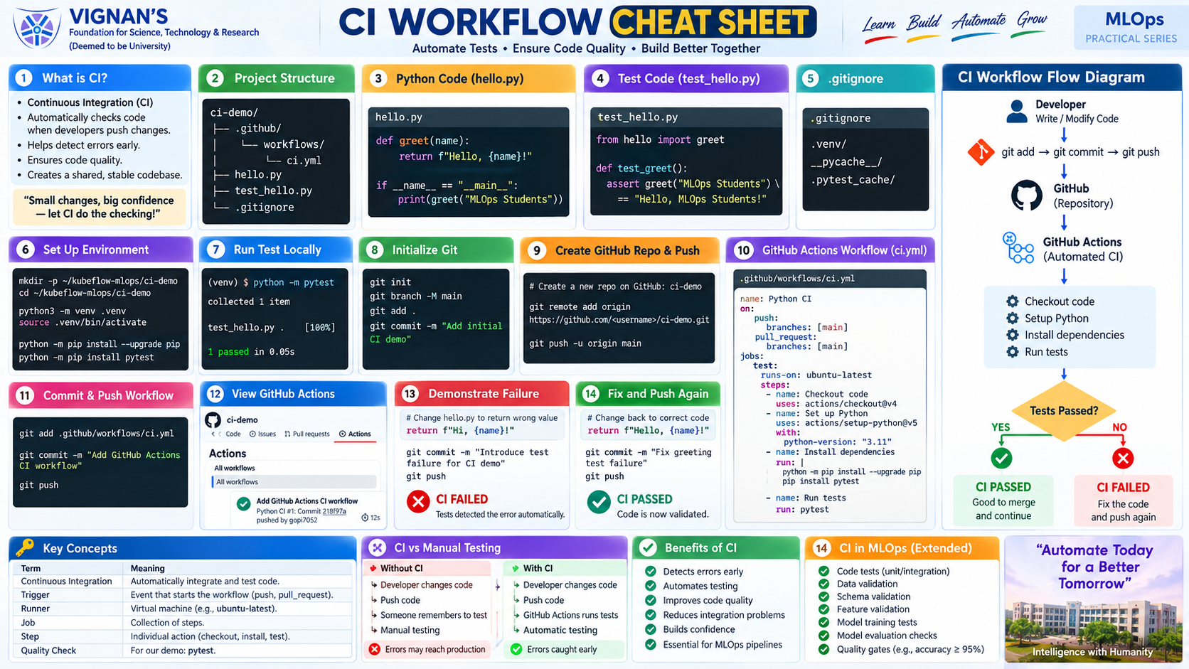
Figure 1. CI Workflow Cheat Sheet

1. Learning Objectives
- Understand Continuous Integration (CI).
- Create a Python project with an automated unit test.
- Use Git and GitHub for version control.
- Create a GitHub Actions workflow using YAML.
- Automatically run tests after a push.
- Demonstrate CI success, failure, and recovery.

2. CI Workflow
CI automatically validates code changes after they are integrated into a shared repository.
Developer → Code → Test → git commit → git push
↓
GitHub
↓
GitHub Actions
↓
Checkout → Python → pytest
↓
PASS ✓ / FAIL ✗

3. Practical Steps
- Create the project and Python virtual environment.
- Install pytest.
- Create hello.py and test_hello.py.
- Run the test locally.
- Initialize Git and commit the project.
- Create the GitHub repository and push the code.
- Create .github/workflows/ci.yml.
- Push the workflow and open GitHub Actions.
- Demonstrate a successful CI run.
- Introduce an intentional test failure.
- Push the failure and observe CI fail.
- Fix the code, push again, and observe CI pass.

4. Create the Project
mkdir -p ~/kubeflow-mlops/ci-demo
cd ~/kubeflow-mlops/ci-demo
python3 -m venv .venv
source .venv/bin/activate
python -m pip install --upgrade pip
python -m pip install pytest

5. Application Code – hello.py
def greet(name):
return f"Hello, {name}!"
if __name__ == "__main__":
print(greet("MLOps Students"))

6. Test Code – test_hello.py
from hello import greet
def test_greet():
assert greet("MLOps Students") == "Hello, MLOps Students!"

7. .gitignore
.venv/
__pycache__/
.pytest_cache/

8. Run Tests Locally
python -m pytest
Expected: 1 passed.

9. Initialize Git
git init
git branch -M main
git status
git add .
git commit -m "Add initial CI demo"

10. Create GitHub Repository
Create a repository named ci-demo on GitHub, then connect and push:
git remote add origin https://github.com/<your-username>/ci-demo.git
git push -u origin main
Security: never share your GitHub Personal Access Token.

11. Create the GitHub Actions Workflow
mkdir -p .github/workflows
nano .github/workflows/ci.yml
name: Python CI
on:
push:
branches: [main]
pull_request:
branches: [main]
jobs:
test:
runs-on: ubuntu-latest
steps:
- name: Checkout code
uses: actions/checkout@v4
- name: Set up Python
uses: actions/setup-python@v5
with:
python-version: "3.11"
- name: Install dependencies
run: |
python -m pip install --upgrade pip
pip install pytest
- name: Run tests
run: |
pytest

12. Meaning of the Workflow
Element | Purpose
push / pull_request | Events that trigger CI
runs-on | Machine used to execute the job
checkout | Downloads repository code
setup-python | Configures Python
pip install pytest | Installs the test dependency
pytest | Runs automated tests

13. Push the CI Workflow
git add .github/workflows/ci.yml
git commit -m "Add GitHub Actions CI workflow"
git push
If a fine-grained PAT is used, repository Workflows permission may need Read and write access.

14. View CI on GitHub
- Open the repository.
- Select Actions.
- Select Python CI.
- Open the latest run.
- Open the test job.
✓ Checkout code
✓ Set up Python
✓ Install dependencies
✓ Run tests
🟢 CI PASSED

15. Demonstrate CI Failure
Temporarily change hello.py from:
return f"Hello, {name}!"
to:
return f"Hi, {name}!"
Run:
python -m pytest
Expected: the test fails because it still expects the original greeting.
AssertionError
1 failed
git add hello.py
git commit -m "Introduce test failure for CI demo"
git push
GitHub Actions should show a failed run: 🔴 CI FAILED.

16. Fix and Re-run CI
return f"Hello, {name}!"
python -m pytest
git add hello.py
git commit -m "Fix greeting test failure"
git push
GitHub Actions runs again and should show: 🟢 CI PASSED.

17. Complete CI Flow
Write/Modify Code
↓
Write Tests
↓
Run Tests Locally
↓
git commit
↓
git push
↓
GitHub
↓
GitHub Actions
↓
Checkout → Setup Python → Install → pytest
↓
┌───────────────┐
│ Tests Passed? │
└───────┬───────┘
YES ↓ ↓ NO
🟢 PASS 🔴 FAIL
↓
Fix Code
↓
git push
↓
🟢 PASS

18. Key CI Concepts
- Continuous Integration: frequently integrate and automatically validate code changes.
- Trigger: event that starts a workflow, such as push or pull_request.
- Runner: machine/environment where the workflow executes.
- Job: a collection of related workflow steps.
- Step: an individual action or command.
- Quality gate: a condition that must be satisfied before continuing.

19. CI in MLOps
Code Tests
↓
Data Validation
↓
Schema / Feature Validation
↓
Pipeline Tests
↓
Model Validation
↓
Quality Gate
↓
Continue / Stop
Example: if model accuracy is below the required threshold, the workflow can stop before delivery/deployment.

20. Quick Command Reference
# Environment
python3 -m venv .venv
source .venv/bin/activate
python -m pip install pytest
# Test
python -m pytest
# Git
git init
git branch -M main
git status
git add .
git commit -m "message"
git push
# Remote
git remote -v

21. Student Exercises
- Add a second test function and verify both tests execute.
- Change the greeting and update the test accordingly.
- Introduce an intentional error and observe CI fail.
- Fix the error and verify CI pass.
- Explain the purpose of each step in ci.yml.
- Draw the CI workflow from git push to PASS/FAIL.

22. Viva / Review Questions
- What is Continuous Integration?
- What triggers this workflow?
- What is a GitHub Actions runner?
- Why is actions/checkout used?
- What does pytest do?
- What happens when a CI test fails?
- How do you fix a failed CI workflow?
- How can CI be extended for an MLOps project?

23. Practical Outcome
After this practical, students should be able to create a simple Python CI pipeline, connect a local Git repository to GitHub, configure GitHub Actions, run automated tests, interpret successful and failed workflow runs, and explain the role of CI in an MLOps lifecycle.

