PREFECT
Workflow Orchestration in MLOps
Module 2 - Unit 1 | Concept, Setup, Examples and MLOps Integration

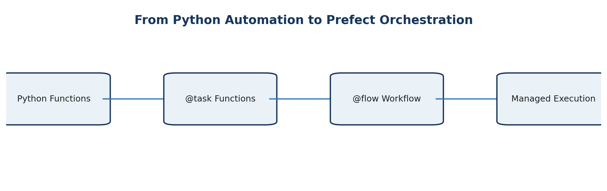
Core idea: Python performs the work. Prefect coordinates, observes, and manages the execution of that work.

Prepared as a clean classroom reference for workflow orchestration.

1. Why Prefect?
A normal Python program can automate a sequence of functions, but production workflows need more than sequential execution. They need visibility, task states, failure handling, retries, scheduling, and execution history.
def main():
load_data()
preprocess_data()
train_model()
evaluate_model()
save_model()
main()
Automation: The functions execute automatically in the order written.

Orchestration: The workflow is managed as a set of observable tasks with dependencies, states, failures, retries, schedules, and execution records.

Need | Plain Python Script | Prefect
Execute functions | Yes | Yes
Task-level state tracking | Manual | Built in
Retries | Custom code required | Configurable per task/flow
Workflow monitoring | Manual logs | Flow/task run visibility
Scheduling | External scheduler/custom setup | Supported through Prefect deployments/serving
Execution history | Custom storage | Tracked by Prefect backend/UI

2. What is Prefect?
Prefect is a Python-native workflow orchestration platform. Existing Python functions can be organized into workflows with minimal changes. Two decorators provide the basic mental model:
Prefect Concept | Python Syntax | Meaning
Task | @task | One unit of work, such as loading data or training a model.
Flow | @flow | The overall workflow that coordinates tasks and normal Python logic.

from prefect import flow, task
@task
def load_data():
...
@flow
def ml_workflow():
load_data()
Remember: The ML logic does not need to be rewritten. Prefect adds an orchestration layer around Python functions.

3. Prerequisites and Setup
The first Prefect practical requires only basic Python knowledge and a working Python environment.
- Python 3 environment (Anaconda or standard Python).
- Basic Python functions and return values.
- Basic use of terminal / Anaconda Prompt.
- Understanding of the existing ML workflow: load → preprocess → train → evaluate → save.
- Internet access only for package installation; local workflow execution itself can run on the machine.

3.1 Installation
pip install prefect
Verify the installation:
prefect version
Expected result: Prefect version and environment information are displayed without an import or command error.

4. First Prefect Program - A Simple Real-World Workflow
A restaurant-order example is useful because the dependency between tasks is obvious: an order must be collected before it can be prepared, and it must be prepared before it can be delivered.
from prefect import flow, task
@task
def collect_order():
print("Order received")
return "Pizza Order"
@task
def prepare_order(order):
print("Preparing:", order)
return "Pizza Ready"
@task
def deliver_order(order):
print("Delivering:", order)
@flow(name="Restaurant Workflow", log_prints=True)
def restaurant_workflow():
order = collect_order()
prepared_order = prepare_order(order)
deliver_order(prepared_order)
if __name__ == "__main__":
restaurant_workflow()
Run the program:
python prefect_basic.py
Dependency: prepare_order() uses the output of collect_order(), and deliver_order() uses the output of prepare_order(). The data movement itself expresses the dependency.

5. Understanding @task and @flow
Element | Role | Example
@task | Marks a function as a managed unit of work. | load_data(), train_model()
@flow | Marks the main workflow boundary. | ml_workflow()
Task input/output | Connects tasks through values. | processed = preprocess(data)
Normal Python logic | Can still be used inside a flow. | if accuracy >= 0.85: ...

A normal Python workflow becomes an orchestrated flow by exposing meaningful stages as tasks.

6. First MLOps Example with Prefect
The same pattern can be applied to a simple ML workflow. The values below are deliberately small so that the orchestration concepts remain the focus.
from prefect import flow, task
import time
@task
def load_data():
print("Loading dataset...")
return [65, 72, 80, 90, 55]
@task
def preprocess_data(data):
print("Preprocessing dataset...")
return [value / 100 for value in data]
@task
def train_model(data):
print("Training model...")
time.sleep(2)
return "Trained_Model"
@task
def evaluate_model(model):
print("Evaluating model...")
return 0.87
@flow(name="ML Training Workflow", log_prints=True)
def ml_workflow():
data = load_data()
processed_data = preprocess_data(data)
model = train_model(processed_data)
accuracy = evaluate_model(model)
print("Final Accuracy:", accuracy)
if __name__ == "__main__":
ml_workflow()
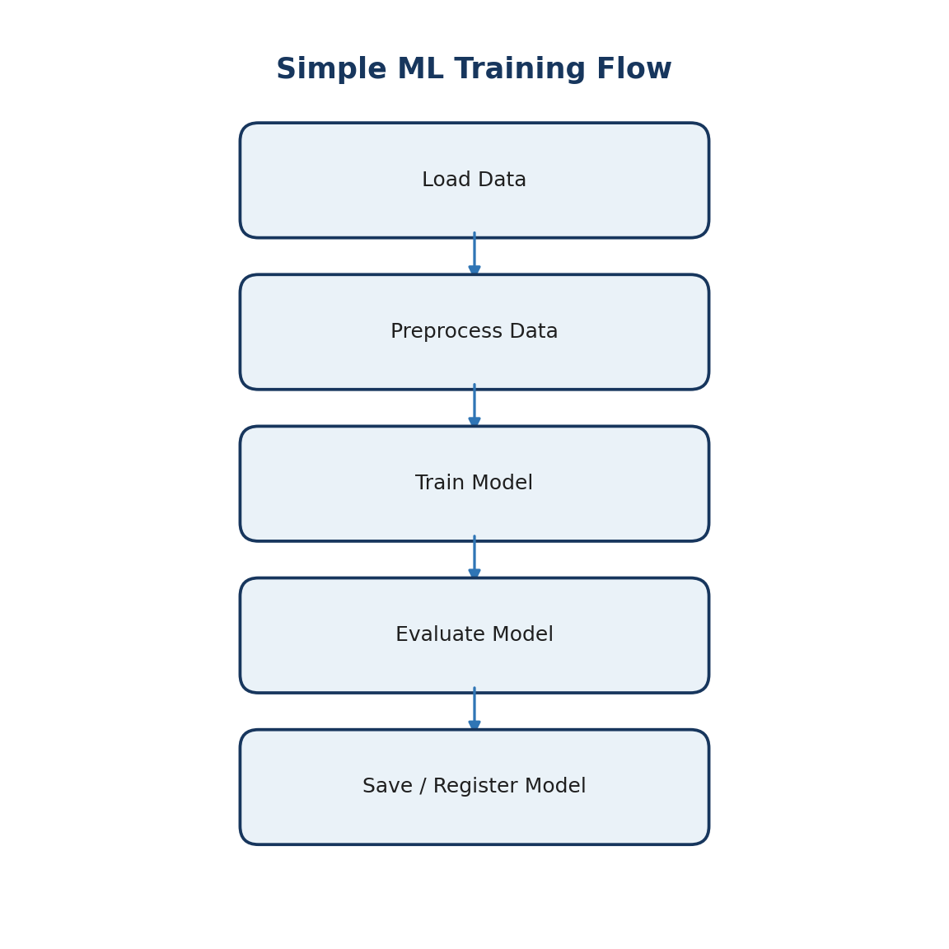
Each major ML stage can be represented as an independently observable task.

7. Dependencies and Task States
A workflow is more than a list of functions. Each task has a lifecycle, and downstream tasks normally depend on successful upstream execution.
State | Meaning
Scheduled / Pending | Waiting to start.
Running | Currently executing.
Completed | Finished successfully.
Failed | Execution ended with an error.
Retrying | A failed task is waiting for or starting another attempt.

load_data → preprocess_data → train_model → evaluate_model
Dependency rule: If a required upstream task fails and no successful result is produced, dependent work should not continue as though the prerequisite succeeded.

8. Failure Handling and Retries
Temporary failures are common in real systems: a database can be unavailable, a network request can time out, or a file may arrive late. Prefect allows retry behaviour to be configured directly on a task or flow.
@task(retries=2, retry_delay_seconds=3)
def load_data():
...
Setting | Meaning
retries=2 | After the initial failure, allow up to two retry attempts.
retry_delay_seconds=3 | Wait three seconds between attempts.

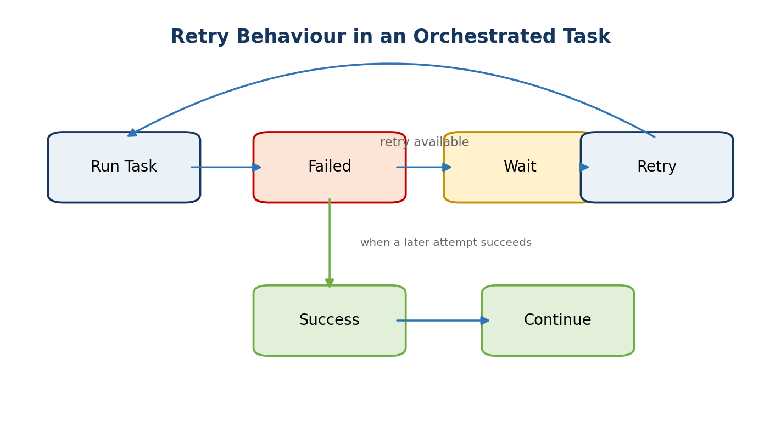

8.1 Demonstration with an Intentional Temporary Failure
from prefect import flow, task
attempt_counter = {"count": 0}
@task(retries=2, retry_delay_seconds=2)
def connect_database():
attempt_counter["count"] += 1
print("Connection Attempt:", attempt_counter["count"])
if attempt_counter["count"] == 1:
raise Exception("Database temporarily unavailable")
return "Hospital Data"
@task
def preprocess_data(data):
print("Preprocessing:", data)
@flow(name="Retry Demo", log_prints=True)
def hospital_workflow():
data = connect_database()
preprocess_data(data)
if __name__ == "__main__":
hospital_workflow()
Demonstration purpose: The first attempt fails intentionally. Prefect records the failure state, waits, retries, and allows the workflow to continue when the next attempt succeeds.

9. Conditional Execution in an ML Workflow
A production workflow may continue only when a model satisfies an acceptance rule. Normal Python conditions can be used inside a Prefect flow.
from prefect import flow, task
@task
def train_model():
return "model"
@task
def evaluate_model(model):
return 0.87
@task
def save_model(model):
print("Model saved")
@flow(name="Model Acceptance Flow", log_prints=True)
def ml_workflow():
model = train_model()
accuracy = evaluate_model(model)
if accuracy >= 0.85:
save_model(model)
print("Model accepted")
else:
print("Model rejected")
if __name__ == "__main__":
ml_workflow()
Train → Evaluate → Accuracy ≥ 0.85 ? → Save/Register : Reject
MLOps interpretation: Training does not automatically imply deployment. Evaluation can act as a quality gate before a model is registered or served.

10. Prefect, MLflow and FastAPI - Different Responsibilities
Tool | Primary Responsibility | Typical Question Answered
Scikit-learn | Build and run ML algorithms/pipelines. | How is the model trained and used for prediction?
MLflow | Track experiments and manage model artifacts/registry. | Which run/model/version performed best?
Prefect | Orchestrate workflow execution. | In what order should tasks run, and what happens on failure?
FastAPI | Expose model functionality through an API. | How can another application request a prediction?

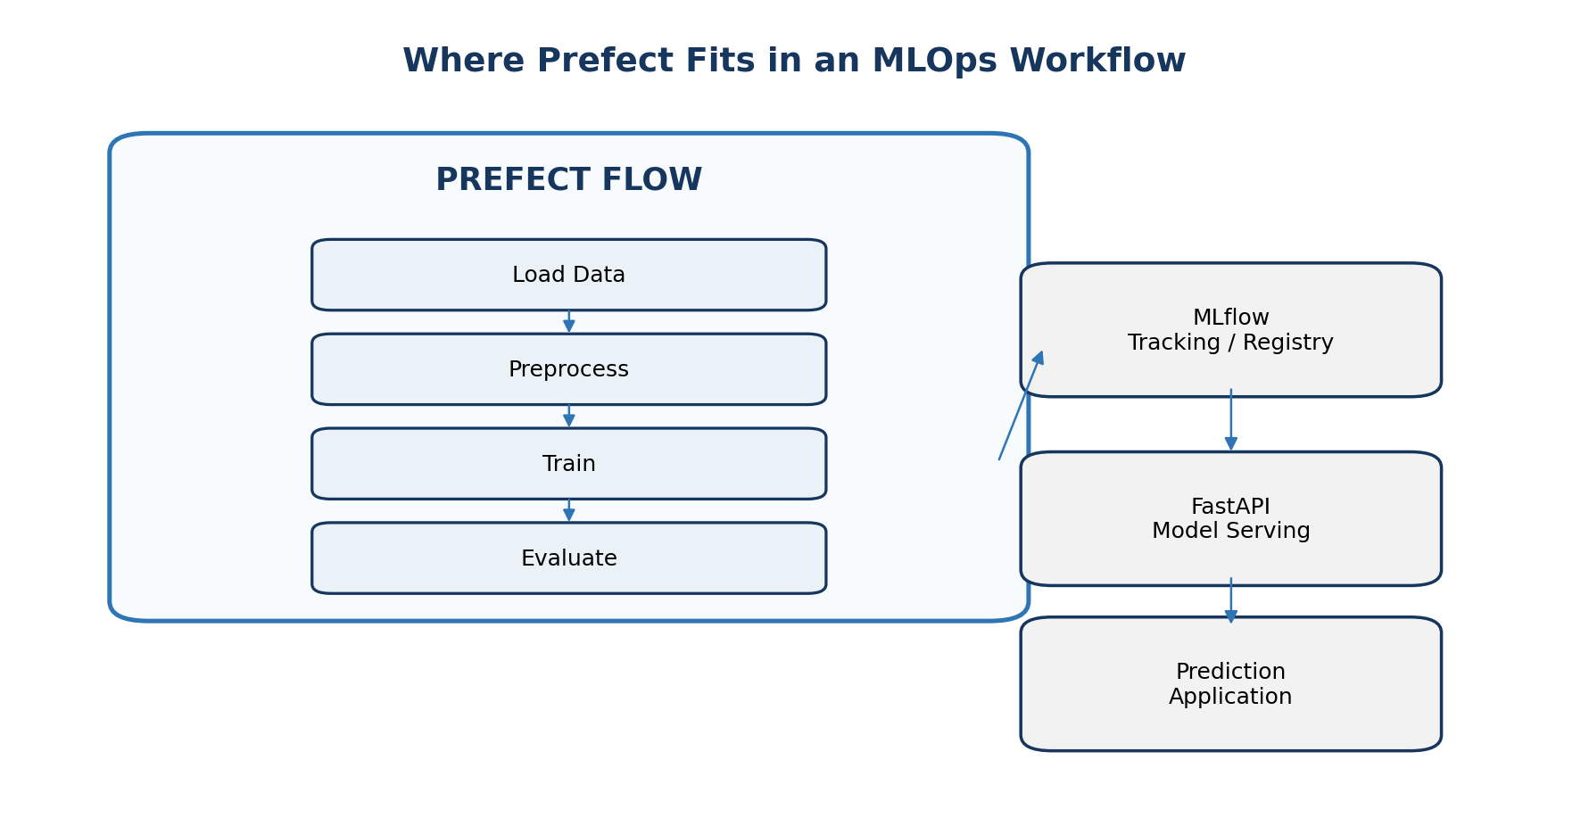

11. Hospital MLOps Example - Complete Orchestrated Flow
The existing hospital ML pipeline can be converted gradually. The underlying functions remain responsible for data preparation and model training; Prefect becomes responsible for managing their execution.
New Hospital Data
↓
Prefect Flow Starts
↓
Load Data
↓
Validate / Prepare
↓
Train Model
↓
Evaluate Model
↓
Quality Rule
┌───────┴───────┐
Pass Fail
↓ ↓
Register Stop
↓
Serve via FastAPI
Key idea: Prefect does not replace the hospital model, MLflow, or FastAPI. It coordinates the sequence that connects them.

12. What Prefect Handles - and What It Does Not Replace
Prefect can manage | Prefect does not replace
Workflow and task execution | Machine-learning algorithms
Dependencies between tasks | Feature engineering logic
Task/flow states | MLflow experiment tracking
Retries and failure handling | FastAPI model serving
Scheduling and deployments | Docker/Kubernetes themselves
Logs and run visibility | Database or storage systems

13. Optional Next Step - Local Prefect UI
For local observability, Prefect can run a self-hosted server and UI. This is useful after the basic @task, @flow, dependency, and retry concepts are understood.
prefect server start
The local server normally exposes the Prefect UI on port 4200. In another terminal, point the client to the local API if required by the environment:
prefect config set PREFECT_API_URL="http://127.0.0.1:4200/api"
http://127.0.0.1:4200
UI purpose: View flow runs, task runs, states, logs, timing, and failures in one place.

14. First Prefect Practical - Recommended Sequence
- Create and run the restaurant workflow using @task and @flow.
- Identify the flow and individual tasks in the console output.
- Run the simple ML workflow and observe the task sequence.
- Add retries to one task.
- Trigger an intentional first-attempt failure and observe recovery.
- Add a simple model-acceptance condition.
- Relate the Prefect workflow to the existing MLflow registry and FastAPI deployment.
- Optionally start the local Prefect server and inspect flow/task runs in the UI.

15. Quick Recap
Question | Answer
What is Prefect? | A Python-native workflow orchestration platform.
What is @task? | A managed unit of work.
What is @flow? | The workflow that coordinates tasks and Python logic.
Why use Prefect instead of only main()? | To add workflow state, failure handling, retries, observability, scheduling, and run history.
Does Prefect train the ML model itself? | No. The ML library performs training; Prefect manages when and how the task executes.
Does Prefect replace MLflow? | No. Prefect orchestrates; MLflow tracks experiments/models.
Does Prefect replace FastAPI? | No. FastAPI serves the model to applications.

One-line summary: ML pipeline = work to be performed. Prefect = management and orchestration of that work.

References
- Prefect Documentation - Workflows and Tasks: https://docs.prefect.io/latest/tutorial/flows
- Prefect Documentation - Official Documentation Home: https://docs.prefect.io/
- Prefect Documentation - Python-native orchestration overview and CLI/API references: https://docs.prefect.io/v3/
Note: Prefect evolves actively. Commands and advanced deployment patterns should be checked against the current official documentation when moving beyond the introductory local examples in this document.

