Akka IDP: Enterprise AI Document Processing

Executive Leadership Presentation

🎯 The Business Problem
What IDP 1.75 delivers
- Config-first IDP across channels: email and paper/scanner ingestion.
- Multi-page classification & extraction using configurable prompts and dynamic schemas.
- Configurable integration payloads and exception endpoints.
- BU-controlled onboarding of document types via prompts/schemas; operating model with KPIs (e.g., STP rate, extraction confidence).
Remaining gaps at scale
- Durability & recovery depend on surrounding pipelines/functions (manual checkpointing & retries).
- Orchestration/scale relies on external tools and custom glue code.
- Time-to-onboard new document types still stretches when changes require code/pipeline updates.
- Vision quality controls and step-level resilience are not uniformly enforced across flows.

The Step-Change: IDP-akka (Akka SDK–based Agentic Architecture)
What changes with IDP-akka
- 🛡️ Durable Workflows — Built-in state persistence and automatic recovery at every step. A failure resumes exactly where it occurred; only the failed step is retried.
- ⚙️ Native Orchestration & Supervision — Akka Workflow<State> coordinates a swarm of agents (Classification, Extraction, Transformation, Publisher + Vision/Evaluation/Clarity). No Celery/Airflow; supervision restarts failed actors automatically; horizontal scale is by design.
- ♻️ Reusable Agents + Zero-Code Configuration — 7 reusable agents plus SPI providers; business teams onboard new document types by editing prompts, schemas, and rules (no Java changes). This collapses onboarding time from months to days.
- 🖼️ First-class Multi-Modal — Text + Vision (OCR/handwriting/layout) handled natively, raising extraction confidence across complex/scanned forms.
- 🏢 Enterprise-grade reliability & security — Integrated with Azure APIM & OAuth2, with observability hooks and event-driven publishing to CMS; automatic retries and fault tolerance are standard.

💡 The Solution: Agentic AI Pattern

What Makes This Different
Akka IDP implements a multi-agent architecture where specialized AI agents collaborate through durable workflows.

Core Innovation: Self-Healing Intelligence
Document → Orchestration → Agent Swarm → Completion
Key Difference: If processing crashes during any step, the system:
- ✅ Automatically saves state
- ✅ Recovers on a new node
- ✅ Retries ONLY the failed step
- ✅ Never loses document data
Traditional systems: Start over or lose data
Akka IDP: Continues exactly where it left off

🏗️ The Architecture: Multi-Agent System

How It Works

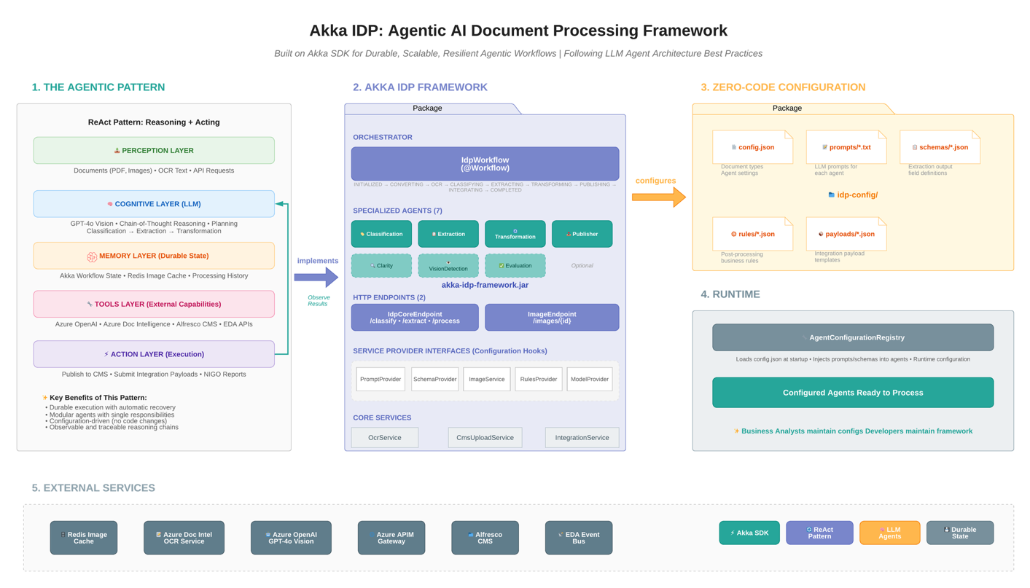

🤖 The 7 Reusable Agents

Specialized AI Workers
Agent | Business Function | Technology
ClassificationAgent | Identifies document type | Vision + OCR
ExtractionAgent | Extracts structured data | Vision + OCR
TransformationAgent | Converts to required format | Text Processing
PublisherAgent | Generates system metadata | Text Processing
VisionDetectionAgent | Detects handwritten corrections | Computer Vision
EvaluationAgent | Scores extraction confidence | Computer Vision
ClarityAgent | Assesses document quality | Computer Vision

Why This Matters
Each agent is reusable across document types.
- Invoice processing uses: Classification → Extraction → Transformation → Publisher
- Contract analysis uses: Classification → Extraction → Evaluation → Clarity
- Same agents, different configurations

🔄 The Workflow: Durable Orchestration

Process Flow
1. Ingestion
- Documents enter via REST API or Event Hub
- System validates and queues for processing
2. Orchestration
- IdpWorkflow (durable workflow) takes ownership
- Persists state at every step
3. Agent Swarm
- Workflow delegates tasks to specialized agents
- Each agent processes independently
- Results flow back to workflow
4. Completion
- All steps verified successful
- Transaction marked complete
- Results published to downstream systems

The Durability Guarantee
"If a process crashes during 'Extraction', the IdpWorkflow automatically recovers state on a new node and retries only the failed step."
This is the fundamental difference from traditional approaches.

💎 The Reusability Model

Traditional vs. Agentic Pattern
Aspect | Traditional Approach | Akka IDP Pattern
New Document Type | Write custom code | Configure existing agents
Time to Deploy | 3-6 months | 2-4 weeks
Failure Handling | Custom retry logic | Automatic recovery
Scaling | Add orchestration layer | Built-in distribution
Maintenance | Per-document codebase | Shared framework

The SDK Pattern
Akka IDP is both a solution AND a framework:
akka-idp-sdk/ # REUSABLE FRAMEWORK
├── agents/ # 7 Pre-built AI Agents
├── workflow/ # Durable Orchestration
├── spi/ # Service Provider Interfaces
└── examples/ # Configuration Templates

akka-idp-bank/ # REFERENCE IMPLEMENTATION
├── config/ # Zero-code business logic
├── prompts/ # LLM instructions
├── schemas/ # Data extraction rules
└── rules/ # Validation logic

🎯 How to Build New Applications

3-Step Pattern for New Use Cases

Step 1: Define Your Agents
@Component(id = "my-agent")
public class MyAgent extends Agent {
public Effect<String> process(MyRequest request) {
return effects()
.model(modelProvider.create())
.systemMessage(getPrompt())
.userMessage(buildMessage(request))
.thenReply();
}
}
Business Impact: Reuse agent framework, focus on business logic

Step 2: Orchestrate with Workflows
@ComponentId("my-workflow")
public class MyWorkflow extends Workflow<MyState> {
@StepName("step-1")
private StepEffect processStep() {
// Call agents, persist state automatically
return stepEffects()
.updateState(state.withResult(result))
.thenTransitionTo(MyWorkflow::nextStep);
}
}
Business Impact: Automatic state management, no data loss

Step 3: Configure via Files (No Code Changes)
my-config/
├── config.json # Document types, settings
├── prompts/*.txt # AI instructions
├── schemas/*.json # Data extraction rules
└── rules/*.json # Business validation
Business Impact: Business users can modify behavior without developers

📊 Technical Advantages

Akka SDK vs. Traditional Python
Capability | Akka SDK Agents | Traditional Python
Durability | Built-in workflow state persistence with automatic recovery | Manual checkpointing, prone to data loss
Orchestration | Native multi-agent workflows with Workflow<State> | Custom orchestration code, complex error handling
Scalability | Distributed by design, automatic scaling | Requires external orchestrators (Celery, Airflow)
Multi-Modal | First-class support for text + image (ImageMessageContent) | Library-dependent implementations
Reliability | Akka's proven actor model with supervision | Manual retry logic, exception handling
Enterprise | Azure APIM, OAuth2, observability built-in | Integration overhead

🏢 Enterprise-Grade Features

Production-Ready Architecture
✅ Native Akka Agents
- Built on akka.javasdk.agent.Agent
- Effect-based responses
- Proven actor model reliability

