CMDB Properties

Overview
The CMDB Properties feature in Virima enables administrators to define and manage the descriptive attributes of Configuration Items (CIs). These properties act as metadata that capture technical, business, and operational details of assets, supporting ITSM processes such as change management, incident resolution, and service impact analysis.
Each property can be grouped, typed, and styled to align with organizational standards, ensuring consistency across the CMDB. By using CMDB Properties, IT teams gain a structured and reliable way to categorize, track, and filter configuration data—improving visibility, accuracy, and integration with broader IT service management activities.

CMDB (Configuration Management System)

Managing CMDB Properties in Virima
- Go to Admin > SACM > CMDB Properties to access the list of all defined properties.
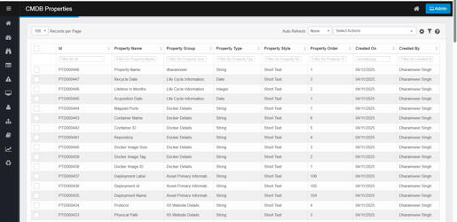

Adding a New CMDB Property
- Click the option to Add a new property (usually a button or link in the CMDB Properties window).
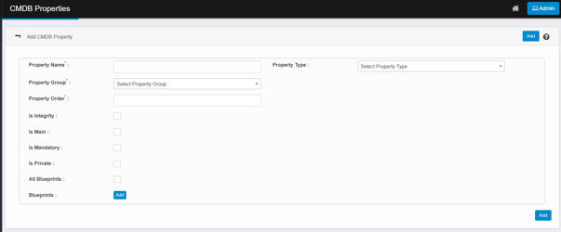
- Fill out the form with the following key elements:
  - Property Name: Name of the field (e.g., Location, Owner).
  - Property Group: Category (e.g., Life Cycle Info, Network Info).
  - Property Type: Data format (String, Date, Integer).
  - Property Order: Determines display order (lower numbers appear higher).
  - Is Integrity: Mark as critical for CI accuracy if needed.
  - Is Main: Show in the main CI view if checked.
  - Is Mandatory: Must be filled before saving.
  - Is Private: Visible only to specific users/roles.
  - All Blueprints / Blueprints: Link to specific or all blueprints (types of configuration templates).
- Click Add to save the new property.

Editing an Existing CMDB Property
- In the CMDB Properties list, click anywhere on the row of the property you want to edit (e.g., “Recycle Date” or “Deployment ID”).
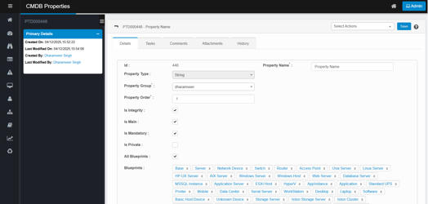
- A new window or dialog will open, showing all details of the property.
- Make the necessary changes to fields like Property Name, Group, Type, Order, or manage linked blueprints and visibility.
- Click Save to update the record.

Deleting a CMDB Property
- In the CMDB Properties list view, click the row of the property you want to delete.
- Open the Select Actions dropdown (top right of the screen).
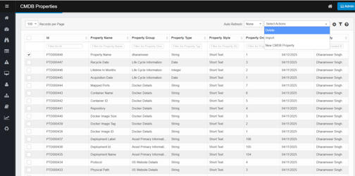
- Select Delete.
- Confirm the action in the prompt (click OK or Continue).

Importing CMDB Properties

1. Prepare Your Import File
- Use CSV or Excel format.
- Each row = one CMDB property.
- Include columns for:
  - Property Name
  - Property Group
  - Property Type (e.g., String, Date, Integer)
  - Property Order
  - Flags (Is Main, Is Private, Is Mandatory, etc.)
  - Blueprints (if applicable)

2. Start the Import Process
- Go to the CMDB Properties window.
- From the Select Actions dropdown, choose Import.
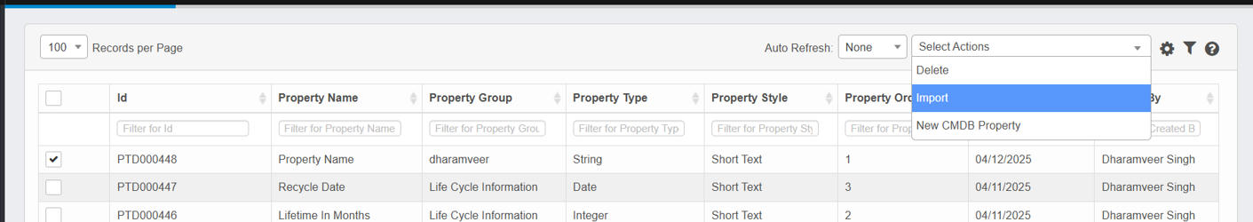
- A dialog box or upload window will appear.

3. Upload Your File
- Select and upload your prepared file.
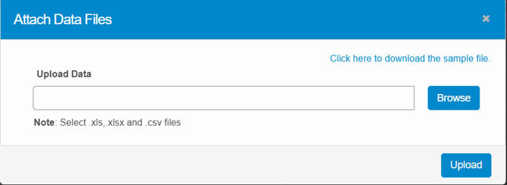
- The system may preview the data or validate the format.

4. Review and Confirm
- Check that the data looks correct in the preview.
- Click Import or Submit to process the records.

5. Results and Error Handling
- Properties are added to the CMDB property list.
- If there are errors (like missing required fields), they will be flagged for your review.

CMDB Property Detail & Edit View

1. Viewing Property Details
When you click on a specific CMDB property (e.g., PTD000448), a detailed view opens with two main panels:
- Primary Details Panel (Left):
  - Shows timestamps: Created On and Last Modified On
  - Displays user info: Created By and Last Modified By
- Details Tab (Right):
  - Displays all current configuration for the selected property, including:
    - Property Type (e.g., String)
    - Property Group
    - Order
    - Flags (Main, Mandatory, Private)
    - Associated Blueprints
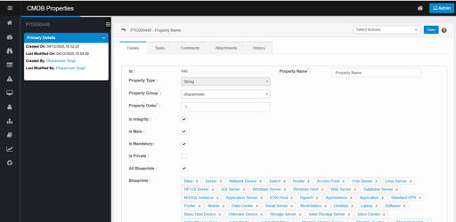

2. Editing the Property
- The screen is editable—you can directly update:
  - Property Name, Group, or Order
  - Toggle checkboxes (e.g., Is Integrity, Is Mandatory, Is Private)
  - Add or remove Blueprints
- After making changes, click the Save button at the top-right to apply updates.

3. Additional Tabs Available
Besides the Details tab, you can switch to:
- Tasks: Add related tasks or actions
- Comments: Leave notes or messages
- Attachments: Upload files/documents
- History: Track all changes made to this property over time (audit trail)
History Tab in CMDB Property Detail & Edit View
The History tab provides a comprehensive audit trail for each CMDB Property. It allows you to:
- Track all changes made to a property, including what was changed, when, and by whom.
- See the type of operation (e.g., Add, Edit) performed on the property.
- View timestamps for each modification (Modified On).
- Identify the user who made each change (Modified By).
- Review detailed change logs showing field names and the old vs. new values (Changes column).

