Confidence Configuration
- Overview
- Accessing the Configuration

Overview
The Confidence Configuration feature in Virima enables organizations to measure the freshness and reliability of Configuration Item (CI) data within the CMDB. By assigning confidence levels—such as Very High, Medium, or Low—based on the age of the last scan, administrators can quickly determine which records are current and which may require revalidation.
This functionality improves trust in CMDB data, helps prioritize re-scanning or cleanup efforts, and ensures decision-making is based on accurate, up-to-date information. With customizable thresholds aligned to organizational policies and discovery cycles, Confidence Configuration provides a flexible, intuitive way to maintain a cleaner and more reliable CMDB.

Accessing the Configuration
- Navigate to Configuration:
  - Go to Admin > SACM > Confidence Configuration.
  - The Confidence Configuration window will open.
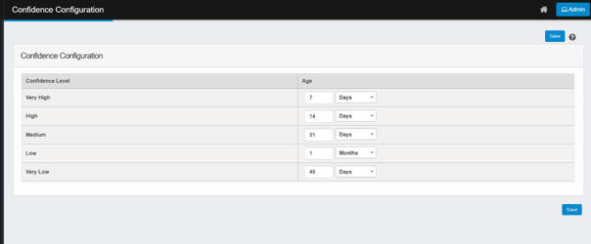
- Set Confidence Levels:
  - In the Confidence Level section, you’ll see five predefined categories: Very High, High, Medium, Low, and Very Low.
  - For each level, define the Age threshold by entering a number and selecting a time unit (Days, Months, or Years). This determines how recent the last discovery scan must be for a CI to fall under that confidence level.
    - For example: A CI scanned within the last 7 days may be marked as Very High confidence, while one scanned over 45 days ago might be Very Low.
- Save Configuration:
  - After setting the values, click Save to apply the configuration.

