Correlation
- Overview
- Correlation
  - Accessing the Correlation Window
  - Managing Blueprint Correlators
    - Adding a New Blueprint Correlator
  - Editing an Existing Correlator
  - Deleting a Correlator

Overview
The Correlator is a CMDB feature that identifies and reconciles applications and devices discovered across your network, then updates the CMDB while preventing duplicates. By applying blueprint-specific correlation rules that rely on unique CMDB properties (which must already be defined), it ensures a single authoritative record for each host—even when multiple scans occur. This guide shows how to access the correlation window and manage blueprint rules so you can maintain clean, accurate configuration data that improves asset management and operational efficiency.

Correlation

Accessing the Correlation Window
- In the main window, go to Admin > Discovery > Correlation.
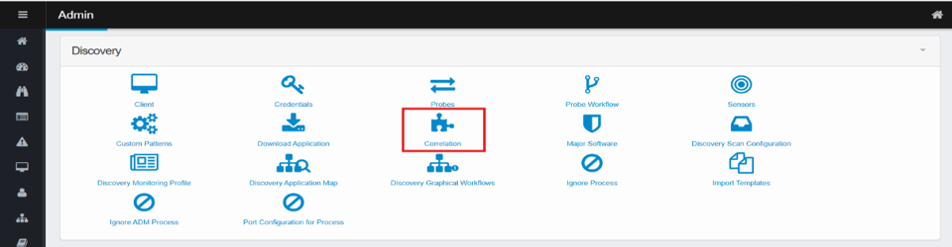
- The Correlation window opens, displaying existing blueprint rules.
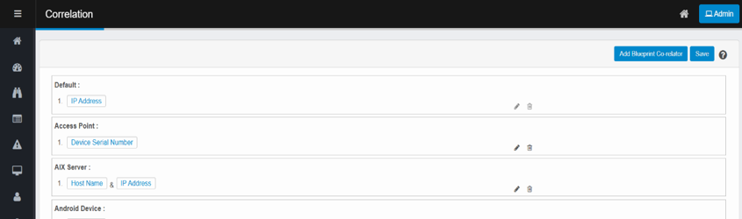

Managing Blueprint Correlators

Adding a New Blueprint Correlator
- Click Add Blueprint Co-relator.
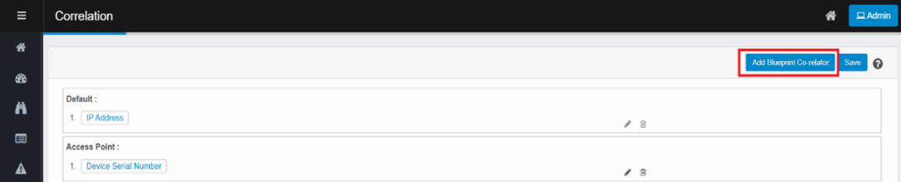
- A new row appears at the bottom of the list.
- In the Select Blueprint dropdown, choose the appropriate blueprint (e.g., DMZ, Router, Website).
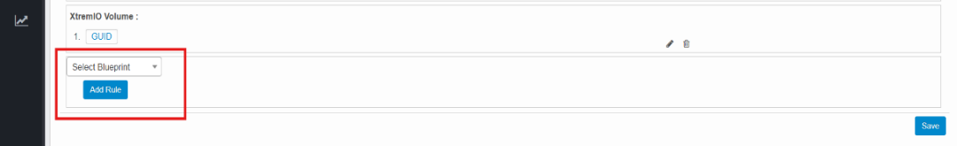
Only one blueprint can be selected. If the blueprint is already in use, an alert will appear.
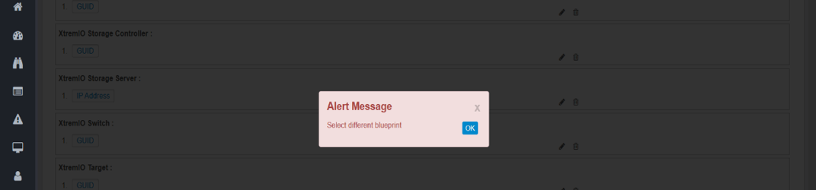
- Click Add Rule to open the rule dialog box.
- Select a property from the dropdown list.
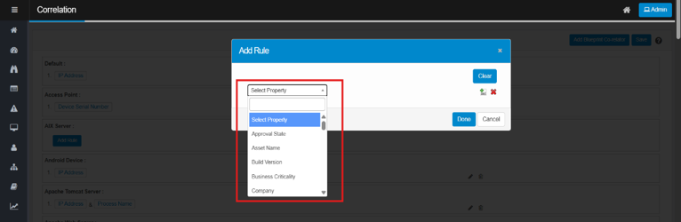
- Use the Add icon to add more properties.
- Use the Cancel icon to remove individual properties.
- Click Clear to remove all selected properties.
- Click Done to finalize the rule.
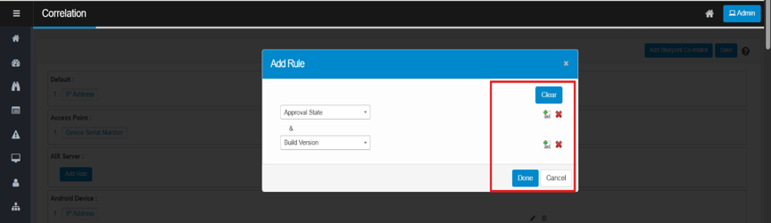

Editing an Existing Correlator
- In the Correlation window, find the blueprint you want to edit.
- Click the pencil icon next to it.
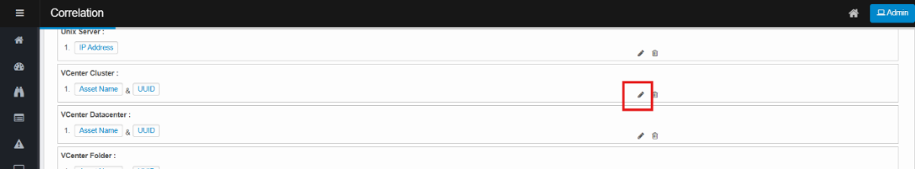
- In the rule dialog, make any required changes.
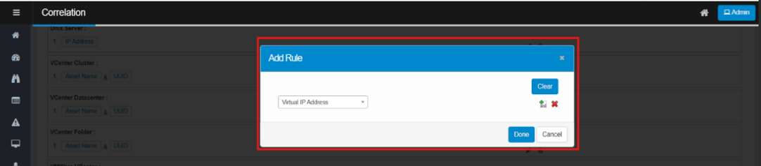
- Click Done to save updates.

Deleting a Correlator
Deleting a rule will revert blueprint to its default matching method (e.g. IP address). There is no confirmation prompt. Deletion is immediate and cannot be undone.
- In the Correlation window, locate the blueprint.
- Click the Delete icon.
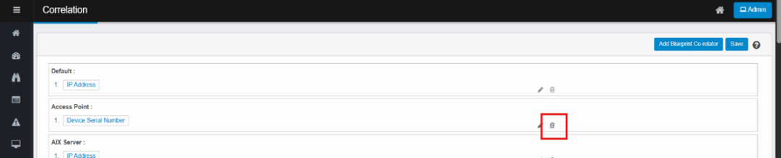
Before navigating away from the Correlation page, make sure to click the Save button to apply all changes.

