Dashboard

Overview
Dashboards in Virima provide a centralized, user-friendly interface for viewing and managing key system information at a glance. They consolidate recent activities, scan results, system health, and other critical metrics into a visual and customizable layout, enabling faster navigation and decision-making.
By offering real-time visibility and interactive data visualization, dashboards help IT teams track performance, detect issues quickly, and collaborate effectively. Whether monitoring assets, compliance, or scan results, dashboards serve as a single pane of glass for operational oversight.

Discovery Dashboard

Accessing the Dashboard
From the navigation menu, go to ITSM > Configuration Management > CMDB Dashboard.
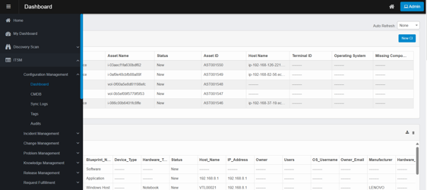
The dashboard is organized for a seamless user experience, presenting insights such as scan statistics, device statuses, and more—all in one place.
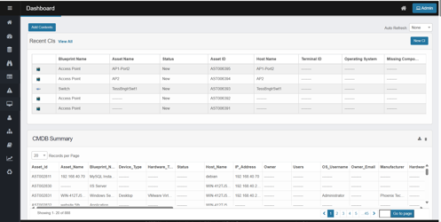

Adding Contents
- Navigate to the Dashboard from the left-hand navigation pane.
- On the Dashboard page, click the Add Contents button located above the Recent CIs section.
  - A Search window will appear.
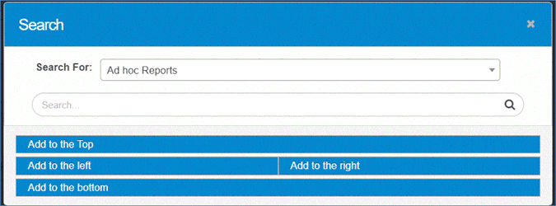
- In the Search For dropdown, select the type of content you want to add (e.g., Ad hoc Reports).
- Use the search bar to refine the results if needed.
- Choose where to place the content by clicking one of the options:
  - Add to the Top
  - Add to the Left
  - Add to the Right
  - Add to the Bottom
- Verify Added Content
  - The selected report or widget will appear in the chosen section of the Dashboard.
  - Rearrange or customize as needed for better visibility.

Example Report Types
- Ad hoc Reports
- KPIs
- DC Migration Metrics
- Discovered Assets Based on Blueprints
- Discovered Items by Date and Type
- Infrastructure Summary
- Master Asset List
- Windows by OS Type
This is not a complete list—these are just a few examples.

Adding a New CI
- On the Dashboard page, locate and click the New CI button in the top-right corner.
- Clicking New CI opens the Add New CI dialog box.
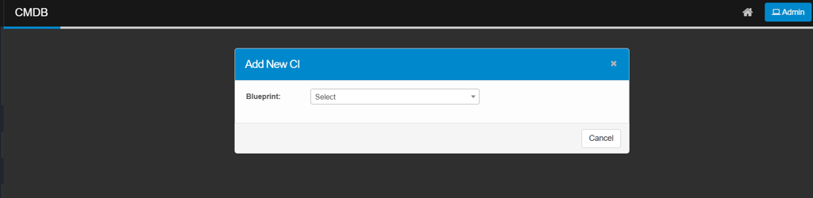
- Click the Blueprint dropdown list.
  - A list of available CI blueprints will appear (e.g., AHV Host, AIX Server, AV Device, AWS AMI, AWS AppRunner, etc.).
  - Scroll through the list or use the search bar to find the appropriate blueprint.
- Select the required blueprint that matches the type of CI you want to create.
- Once the blueprint is selected, the system will guide you to the CI details entry form, where you can input attributes such as Serial Number, Number of Processors, Host Id, Local FQDN, IP Address and Test to Delete.
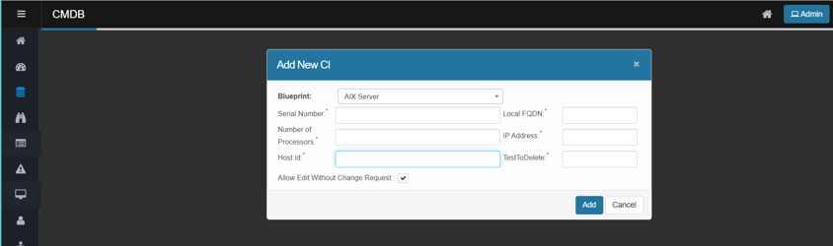
- After entering the required details, click Save to add the CI.
- If you wish to stop the process, click Cancel to exit without making changes.

Dashboard Customization
- Add/Remove Reports: Easily add, remove, or rearrange reports at any time.
- Personalize Layout: Tailor the dashboard to your needs or department.
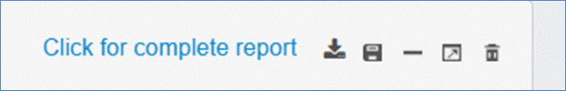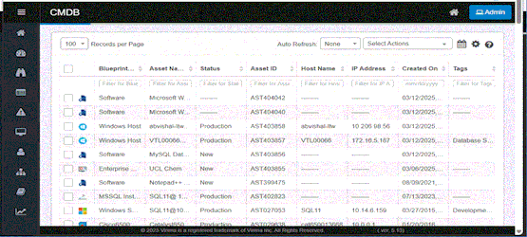
The Virima Dashboard can be personalized to display a wide range of reports based on user needs and preferences. Reports can be added, removed, or rearranged at any time.

Report Widget Controls
Each report widget includes controls in the upper-right corner:
- Click for Complete Report: Located in the top-right corner, this button opens a full, detailed version of the report in a new browser window.
(For example, clicking this on a software report will open a full Software Query Report view.)
- Export: Exports the report as an Excel file and emails a download link to the logged-in user.
- Save Image: Downloads a snapshot of the current report view.
- Collapse/Expand: Minimizes or restores the report’s visibility.
- Maximize/Minimize: Opens the report in a larger window or returns it to the dashboard.
- Remove: Removes the report from the dashboard (confirmation required).

Auto Refresh
The Auto Refresh feature keeps dashboard data current by updating at set intervals.
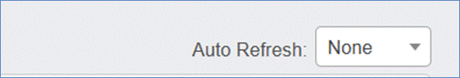
To use:
- Click the Auto Refresh drop-down menu.
- Choose from:
  - None (disable auto-refresh)
  - 20 seconds
  - 40 seconds
  - 60 seconds
  - Custom (specify your own interval)
Use Case: Auto Refresh is especially useful for monitoring real-time scan activity or system changes.

