Departments
- Overview
- Departments
  - Accessing Department Records
    - Table Columns Details
  - Adding a Department Record
  - Deleting a Department Record
  - Exporting Department Records
  - Viewing a Department Details
  - Other Features
    - Auto Refresh
    - Personalized Columns
    - Filters
    - Records Per Page

Overview
The Department module in Virima provides a centralized platform for organizations to structure, manage, and maintain their departments, enabling administrators to assign users and groups to the correct departments for clear organizational alignment. By mapping permissions to departments, it enhances role-based access control, clarifies organizational structure and resource allocation, and streamlines operations through effective categorization of users and groups. This feature ensures consistency, efficiency, and accountability when creating or updating users and groups, supporting administrators in maintaining a well-defined and manageable organizational framework.

Departments

Accessing Department Records
- Go to:
Admin > Organization Details > Departments
- Clicking Departments, opens a page that lists all existing department records.
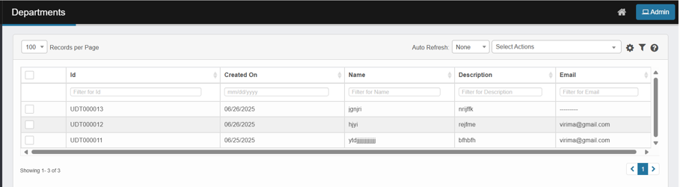

Table Columns Details
- Id
  - Unique identifier for each department record (e.g., "UDT000021").
  - Filterable by entering an Id value.
- Created On
  - The date the department record was created (format: mm/dd/yyyy).
  - Filterable by date.
- Name
  - The name of the department (e.g., "Hr Department").
  - Filterable by entering a department name.
- Description
  - A brief description of the department.
  - Filterable by entering description text.
- Email
  - The email address associated with the department.
  - Filterable by entering an email address.
These columns can be personalized, filtered, and adjusted for display according to your needs.
- To add, delete, or export a department, use the Select Actions tab.

Adding a Department Record
- Go to Select Actions > New Department.
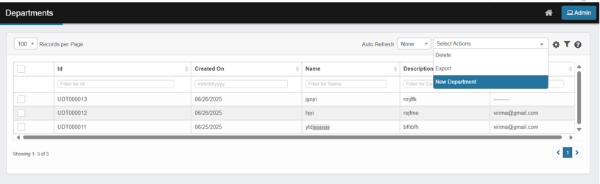
- In the New Department page, fill in:
  - Name (required)
  - Description
  - Email
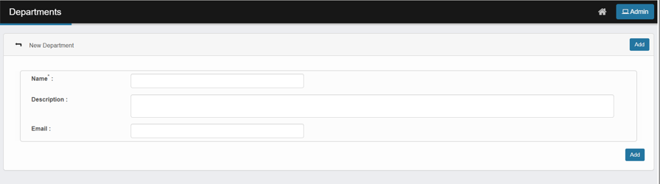
- Click Add.
- The system displays a success message, and the new department appears in the table.
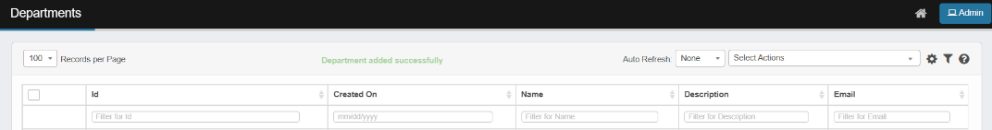
If the user clicks Add with the Name field left blank, the system shows an alert: “Name is mandatory.”
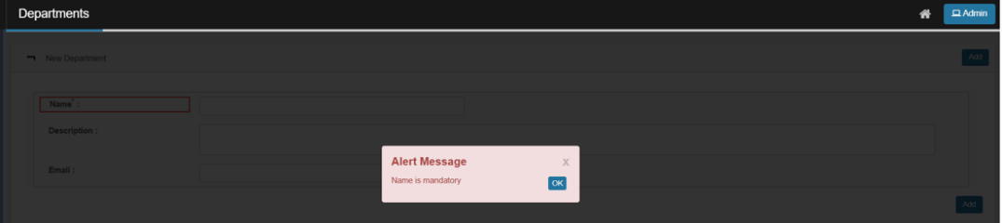

Deleting a Department Record
- Select the checkbox next to the record(s) you want to delete.
  - You must select at least one record; otherwise, an error message will appear.
- Choose Delete from the Select Actions menu.
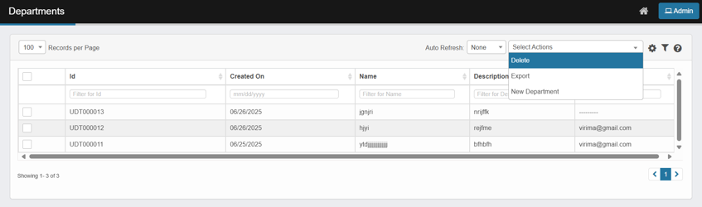
- Type “Delete” and confirm the deletion when prompted.

Exporting Department Records
- Select the checkbox next to the record(s) you want to export.
  - If no records are selected, all records on the current page will be exported.
- Choose Export from the Select Actions menu.
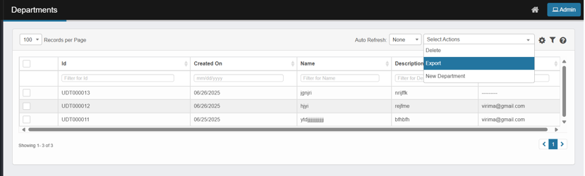
- Click Continue to confirm the export.
- A notification will be sent to your registered email with the exported file.

Viewing a Department Details
- Click any cell in the department’s row—such as the Id or Name—to view its details.
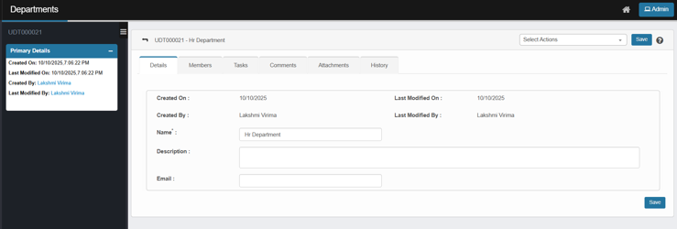
- You’ll enter the Department details page. It includes:
  - Left panel: “Primary Details” (Created On/By, Last Modified On/By).
  - Tabs across the top:
    - Details (fields: Name*, Description, Email + Save button)
    - Members (view/add/remove members)
    - Tasks (view/export/create tasks)
    - Comments (add/view notes)
    - Attachments (upload/download files)
    - History (audit log of changes)
      - Refer the Asset Tab Details to see more information on Tabs.
  - Select Actions menu (top-right) to delete the record.
- Review or edit as needed, then click Save (if you changed fields).

Other Features

Auto Refresh
- Automatically reloads or refreshes the page/data at set intervals.
- Can be set to default or customized as needed to keep content up to date.

Personalized Columns
- Choose which columns or data to display.
- Customize your view to focus on what matters most.
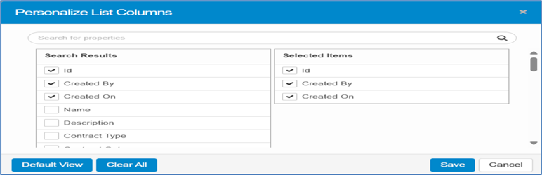
- Click Save to apply your changes.

Filters
- Use filters to narrow down data based on specific criteria, making it easier to find what you need.

Records Per Page
- Controls how many items/rows are displayed on a single page.
- Adjust this setting to view more or fewer records at once.

