Discovery Dashboard

Overview
Dashboards in Virima provide a centralized, user-friendly interface for quick access to key information across the platform. They offer a visual overview to help users monitor system activity, scan results, and other critical metrics at a glance.
Tip: Use the dashboard to enhance navigation and productivity by displaying relevant data widgets in a customizable layout.

Purpose
The main purpose of Dashboards in Virima is to visualize, monitor, and interact with system data efficiently. Each dashboard is tailored to display insights relevant to specific users or functions, helping organizations stay informed and proactive.
Key Objectives:
- Quick Access to Data: Instantly view recent scans, upcoming events, and system health stats.
- Visual Summarization: Interpret complex data with charts and graphs (e.g., pie charts for scan statuses, bar graphs for failure types).
- User Customization: Tailor dashboard views based on user roles or departmental needs.
- Improved Decision Making: Make faster, more informed decisions with real-time visibility into IT activities and trends.

Why Use Dashboards in Virima?
- Centralized Visibility: Get a comprehensive view of your IT environment from a single interface.
- Quick Access to Key Data: Instantly see recent scan results, failure details, and upcoming tasks.
- Improved Decision-Making: Visualize trends and anomalies with interactive charts and graphs.
- Simplified Monitoring: Track device statuses, scan health, and compliance metrics in real-time.
- Faster Issue Detection: Spot potential issues quickly with color-coded indicators and status summaries.
- Supports Collaboration & Oversight: Shared dashboard views help teams stay aligned on priorities and performance.

Discovery Dashboard

Accessing the Dashboard
Navigate to:
Discovery Scan > Dashboard
The dashboard is organized for a seamless user experience, presenting insights such as scan statistics, device statuses, and more—all in one place.
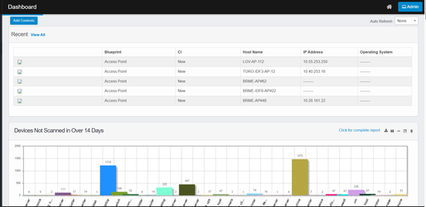

Dashboard Features

Dashboard Contents
The Discovery Scan Dashboard displays a variety of configurable reports to help monitor system activity. Users can add, remove, or rearrange these reports for a personalized monitoring experience.
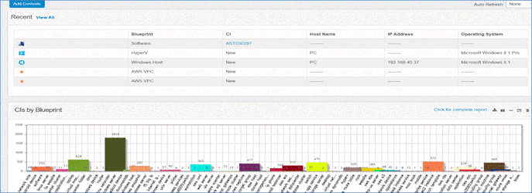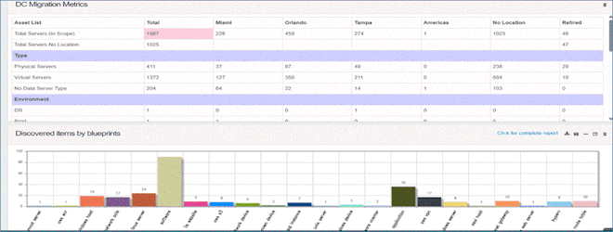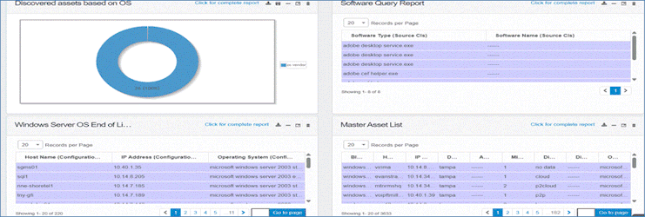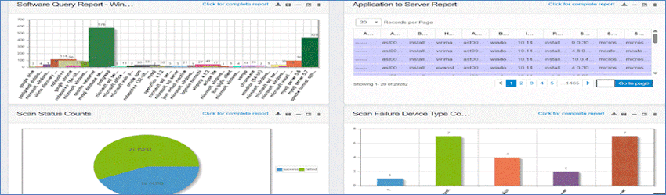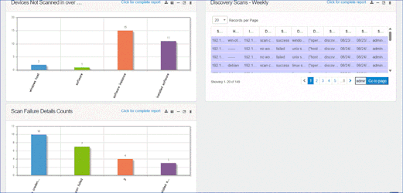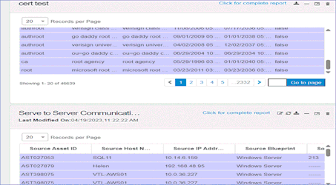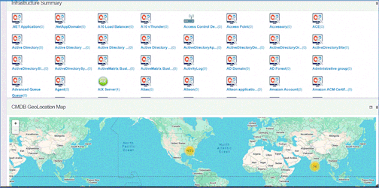

Adding Contents
- Click the Add Contents button.
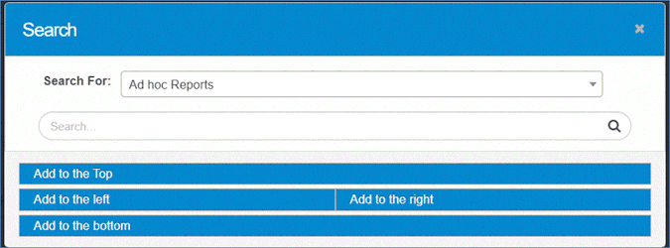
- In the Search window, locate and select available dashboard reports.
- If a text field appears:
  - Enter your search criteria and click the Search icon.
  - Choose a report by clicking the radio button next to it or modify your criteria and search again.
- Choose where you want the report to appear on the dashboard. For example, selecting Add to the Top will place the report above all existing content.

Example Report Types
- Ad hoc Reports
- KPIs
- DC Migration Metrics
- Discovered Assets Based on Blueprints
- Discovered Items by Date and Type
- Infrastructure Summary
- Master Asset List
- Windows by OS Type
This is not a complete list—these are just a few examples.

Dashboard Customization
- Add/Remove Reports: Easily add, remove, or rearrange reports at any time.
- Personalize Layout: Tailor the dashboard to your needs or department.
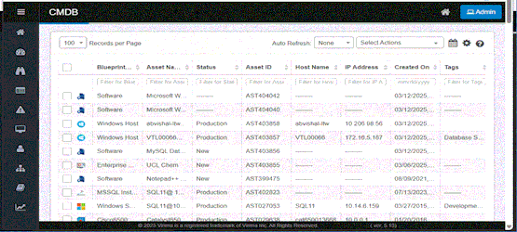
The Virima Dashboard can be personalized to display a wide range of reports based on user needs and preferences. Reports can be added, removed, or rearranged at any time.

Report Widget Controls
Each report widget includes controls in the upper-right corner:
- Click for Complete Report: Located in the top-right corner, this button opens a full, detailed version of the report in a new browser window.
(For example, clicking this on a software report will open a full Software Query Report view.)
- Export: Exports the report as an Excel file and emails a download link to the logged-in user.
- Save Image: Downloads a snapshot of the current report view.
- Collapse/Expand: Minimizes or restores the report’s visibility.
- Maximize/Minimize: Opens the report in a larger window or returns it to the dashboard.
- Remove: Removes the report from the dashboard (confirmation required).

Auto Refresh
The Auto Refresh feature keeps dashboard data current by updating at set intervals.
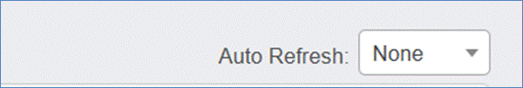
To use:
- Click the Auto Refresh drop-down menu.
- Choose from:
  - None (disable auto-refresh)
  - 20 seconds
  - 40 seconds
  - 60 seconds
  - Custom (specify your own interval)
Use Case: Auto Refresh is especially useful for monitoring real-time scan activity or system changes.

