IPAM Networks

Overview
The IP Address Management (IPAM) functionality in Virima provides a centralized approach to planning, tracking, and managing IP addresses, subnets, and associated assets across the network. By integrating with Infoblox, the platform enables automated updates of IP data, eliminating manual effort and reducing reliance on separate IP management tools.
With IPAM, administrators gain visibility into subnets, address allocations, host associations, and linked hardware or software, ensuring accurate records and streamlined configuration management. This capability strengthens network security, improves efficiency, and optimizes resource utilization by maintaining a clear view of IP usage and topology.

IPAM Procedure
The following steps outline the procedure for performing IP Address Management (IPAM) using Infoblox:
- Infoblox Configuration
Configure Infoblox on the system to enable integration with IPAM for effective management of IP address resources.
  - Navigate to Admin > Integration > Infoblox Configuration.
  - Set up the necessary Infoblox credentials: username, password, and host IP address.
  - Associate the credentials with the appropriate client in the system.
- IPAM
After configuring Infoblox, use the IPAM functionality to manage and track IP addresses, subnets, and related network details.
  - Track the total number of subnets and IP addresses in each subnet.
  - Monitor and associate IP addresses with host names, hardware, and software information.
  - Periodically re-import resource definitions and configurations from Infoblox to maintain an accurate network inventory.

Infoblox Configuration
Navigate to Admin > Integration > Infoblox Configuration
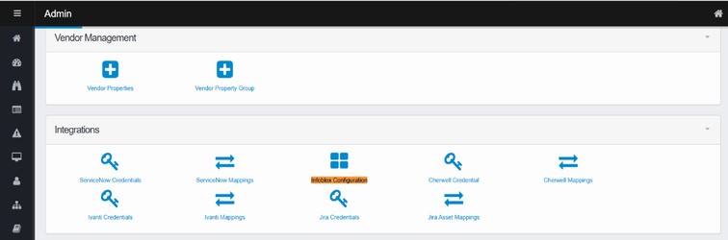
You have two options for adding Infoblox credentials. Please choose one of the following methods:
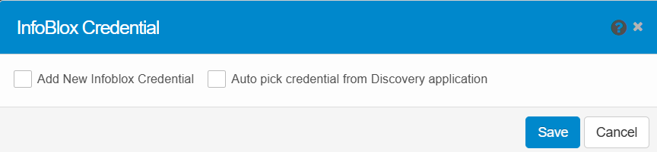
Option 1: Add New Infoblox Credential
Manually add a new Infoblox credential for authenticating the connection between the system and Infoblox. Enter the Infoblox username, password, host IP, and select the applicable client.
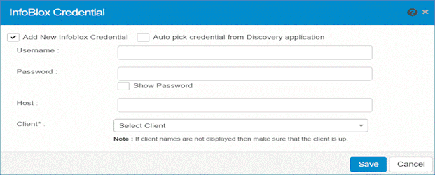
- In the Admin section, navigate to Integration > Infoblox Configuration.
- In the Infoblox Credential dialog box, click Add New Infoblox Credential.
- Enter the following details:
  - Username: Your Infoblox username.
  - Password: Your password.
  - Host: The IP address of the Infoblox machine.
  - Client: Select the client from the drop-down list.
- Click Save to complete the setup.
Option 2: Auto Pick Credential from Discovery Application
Automatically pick credentials from the Discovery application, streamlining the process. The system will fill in the required details, including host IP and client information.
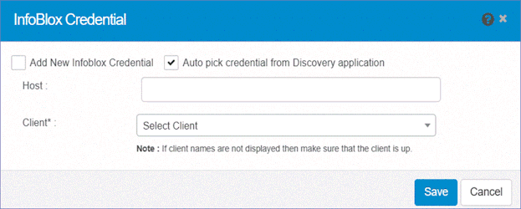
- In the Admin section, navigate to Integration > Infoblox Configuration.
- In the Infoblox Credential dialog box, select Auto pick credential from Discovery application.
- Enter the following details:
  - Host: The IP address of the Infoblox machine.
  - Client: Select the client from the drop-down list.
- Click Save.

IPAM (IP Address Management)
- In the navigation pane, select Discovery Scan > IPAM Networks.
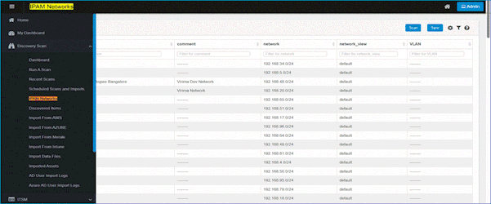
- The IPAM window will display the current status of IP addresses and subnets.
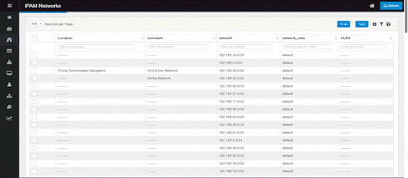

IPAM Functions Overview

Scan Function
The Scan function allows monitoring of devices and network configurations within the environment.
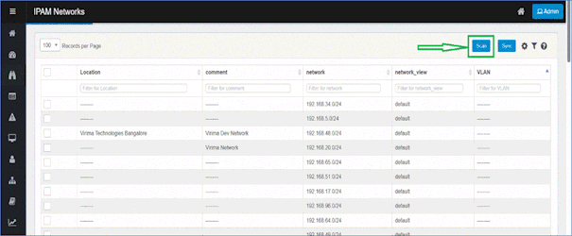
There are two main sections under the Scan function:
- Status Update
- Regular Scan

Status Update
The Status Update section checks the status of devices, typically triggered during a scan.
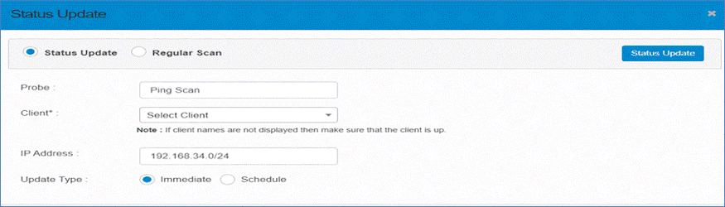
The available settings are:
- Probe: Choose the type of scan, such as Ping Scan.
- Client: Select the client from the list (ensure the client is operational).
- IP Address: Specify the IP address or range to scan (e.g., 192.168.34.0/24).
- Update Type: Choose between Immediate or Scheduled update.
  - Immediate: The scan starts right away.
  - Scheduled: The scan runs at a specified time.

Regular Scan
The Regular Scan section conducts a full network scan and manages the IP address ranges to include or exclude from the scan.
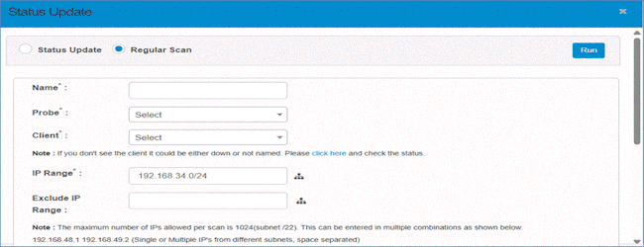
Fields and settings for configuring a Regular Scan:
- Name: Provide a name for the scan.
- Probe: Select the type of probe.
- Client: Select the client to scan (ensure the client is operational).
- IP Range: Specify the IP range to scan (e.g., 192.168.34.0/24).
  - Exclude IP Range: Define specific IP ranges to exclude from the scan.
  - The maximum number of IPs allowed per scan is 1024 (Subnet /22). You can enter IPs in various formats:
    - Single or multiple IPs from different subnets: e.g., 192.168.48.1 192.168.49.2.
    - Multiple IPs from the same subnet: e.g., 192.168.48.1,2,3,4.
    - A range of IPs in the same subnet: e.g., 192.168.48.1-50.
    - A single subnet: e.g., 192.168.48.0/22.
    - Multiple subnets: e.g., 192.168.48.0/23 192.168.49.0/23.
    - Combination of subnet and IPs: e.g., 192.168.48.0/23 192.168.48.1.
  - The total number of IPs should not exceed 1024.
- Location (Optional): Specify the scan location.
- Scan Type: Choose between Immediate or Scheduled scan.
  - Immediate: The scan starts immediately.
  - Scheduled: The scan runs at a scheduled time.
- Send Scan Report To (Optional): Provide an email address for receiving scan results.
After the scan, details will appear in Recent Scans. Upon a successful scan, results will move to Discovered Items for further management.

Sync (Instant and Scheduled)
Use this function to plan, track, and manage information related to IP addresses in the monitored network.
- In the IPAM Networks window, click Sync. The Sync from Infoblox window will display.
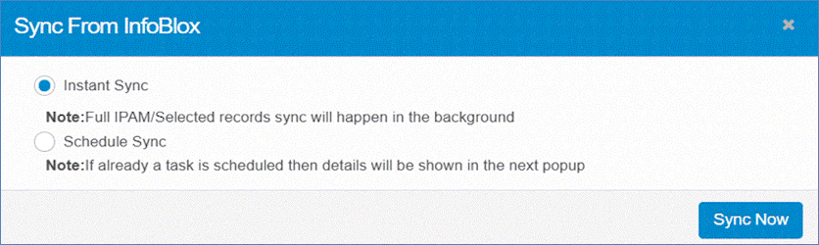
- Select Sync Type:
  - Instant Sync: Click to immediately import records from the Infoblox server.
  - Schedule Sync: Choose this option to import records at a scheduled time.
    - In the Schedule Report Frequency drop-down list, select the desired frequency.
    - Select one or more options based on the schedule: Second, Minute, Hour, Day, Month, Weekday.
    - Click Add to confirm the scheduling details.
- Click Sync Now to execute the operation and sync records immediately.

View & Edit a Network

Details Tab
Navigate to the IPAM window and select any network record to view, such as the network 192.168.48.0/24.
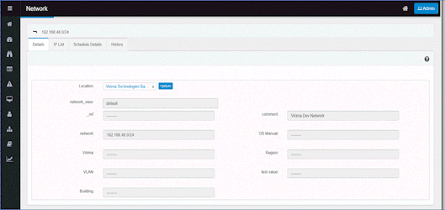
- The Details Tab provides default and static information about the selected network, which is generally not editable. The fields displayed include:
  - Location: The physical or logical location of the network (e.g., Virima Technologies Bangalore).
  - Network View: The view type for the network (e.g., default).
  - _ref: The reference identifier for the network record (typically blank or system-generated).
  - Comment: A description for the network (e.g., Virima Dev Network).
  - Network: The IP address range for the network (e.g., 192.168.48.0/24).
  - OS Manual: Operating system details (if applicable).
  - Virima: A field for Virima-specific information.
  - Region: Geographic region of the network.
  - VLAN: VLAN information, if relevant.
  - Test Value: An extra customizable field.
  - Building: The physical location tied to the network.
This tab displays only static data and doesn't allow editing.

IP List Tab
The IP List tab shows all IP addresses associated with the network, allowing you to view the status of each IP address.
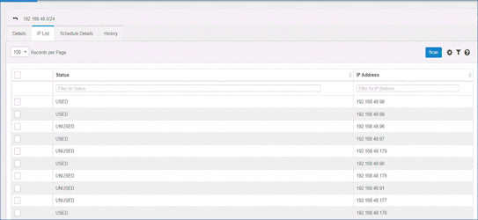
- Example:
  - 100 Records per Page: Number of records displayed per page.
  - Status: The status of each IP (e.g., USED, UNUSED).
  - IP Address: The actual IP address associated with the network.
  - Filter for Status: Filter IP addresses based on their status (e.g., USED or UNUSED).
  - Filter for IP Address: Filter by specific IP addresses.

Schedule Details Tab
The Schedule Details tab shows scheduled tasks for the network, such as automatic syncs or scans.
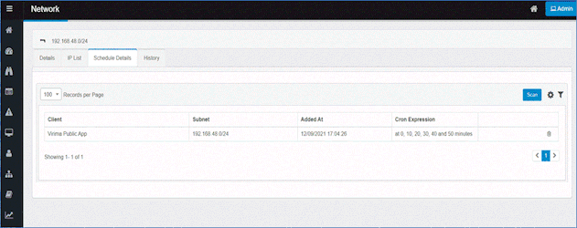
- Example:
  - 100 Records per Page: Number of scheduled records displayed per page.
  - Client: The client associated with the schedule (e.g., Virima Public App).
  - Subnet: The subnet associated with the schedule (e.g., 192.168.48.0/24).
  - Added At: The date and time when the schedule was added (e.g., 12/09/2021 17:04:26).
  - Cron Expression: The scheduling pattern (e.g., at 0, 10, 20, 30, 40 and 50 minutes).

History Tab
The History Tab provides a record of all changes made to the network, including actions such as adding or modifying configurations.
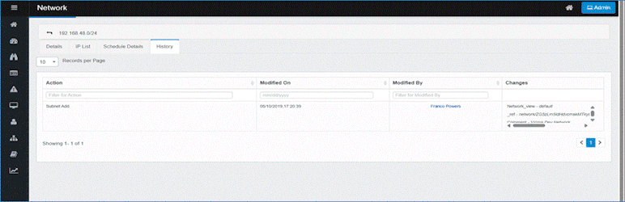
- Example:
  - 10 Records per Page: Number of history records displayed per page.
  - Action: The action performed (e.g., Subnet Add).
  - Modified On: The date and time when the action was performed (e.g., 05/10/2019, 17:20:39).
  - Modified By: The user who made the change (e.g., Franco Powers).
  - Changes: The specific changes made in the action.

Other Functions and Page Elements

Records per Page
Click the drop-down list and select the number of records to display in this window.
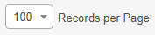
Control | Description
Records per Page dropdown | Click the drop-down and choose how many records to display—only values in the hundreds (e.g., 100, 200, 300). The list refreshes immediately to show that many entries per page.

Auto Refresh
Use this function to update the window at a specific interval.
Click the Auto Refresh drop-down list and select from one of the following: None, 20 seconds, 40 seconds, 60 seconds, or Custom (specify a custom refresh time).
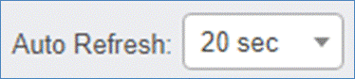

Personalize Columns
Use this function to personalize the columns displayed in the record window:
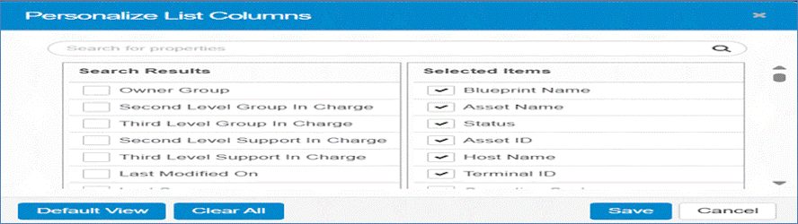
- While viewing a record list, click the Personalize Columns icon.
- In the Search for properties field, type the name of any property to search for, then click the Search icon.
- Under the Search Results column, a list of all available columns is shown. A check mark indicates the column has been selected.
- Under the Selected Items column, a list of currently selected columns is shown. To add an item to this list, click on the column name in the Search Results list.
- Click Default View to load the default settings.
- Click Clear All to remove all selections and return to the default view.
- Click Save to retain the current selections.
- Click Cancel to discard any changes.

Manage Filters
Filters let you narrow down a large data set to just the records you need. Filters are specific to each user.

Apply & Save a Filter
- Under the column header, click in the Filter field.
- Type your search text and press Enter. The list refreshes to show matching records.
- Click Save Filter.
- In the dialog, give your filter a name and click Save.
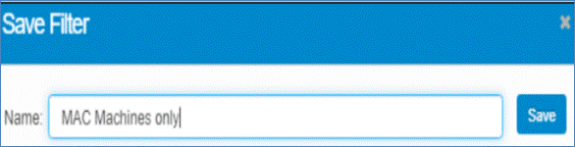
You can repeat these steps to create multiple saved filters.

Apply or Delete a Saved Filter
- Click the Saved Filter icon on the toolbar to open the Filters list.
- Select a filter to apply it to your data.
- (Optional) Click Set as Default to make it the filter that loads automatically.
- To remove a saved filter, click its Delete icon.
