Operational Hours
- Overview
- Operational Hours
  - Accessing Operational Hours
  - Creating New Operational Hours
    - Round the Clock (24/7)
    - Specific Operational Hours
  - Editing Operational Hours
  - Deletion Limitation

Overview
The Operational Hours feature in Virima defines the organization’s official working or business hours, ensuring that all system-driven activities—such as escalations, SLAs, scheduling, and reporting—are aligned with the company’s actual availability. Its primary purpose is to synchronize automated functions with real working timeframes, supporting use cases like incident and request management (where SLA timers run only during operational hours), defining valid windows for system maintenance and updates, and enabling accurate resource planning and reporting. Operational hours cannot be deleted, only updated or modified, which ensures that service delivery and system processes always remain consistent with the organization’s real-world schedule.

Operational Hours

Accessing Operational Hours
- Go to:
Admin > Organization Details > Operational Hours
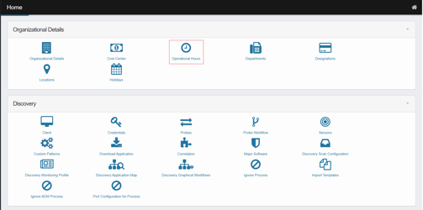
- This opens the Work Schedules window, where you can view, manage, or create operational hour schedules.
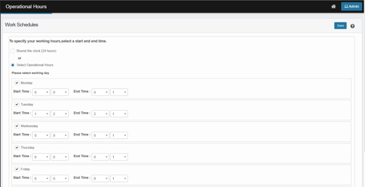

Creating New Operational Hours
You can set schedules in two formats:

Round the Clock (24/7)
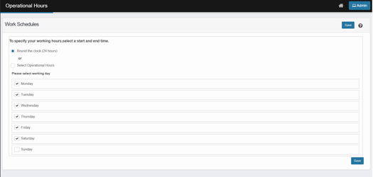
- Select Round the clock (24 hours).
- Choose the applicable days of the week.
- Click Save to apply.
If you click Save without selecting a working day, the system displays an error message,
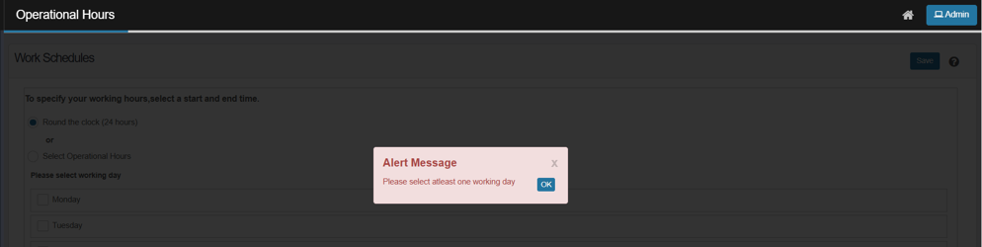

Specific Operational Hours
- Select Select Operational Hours.

- Choose the days of the week.
- Enter Start and End times for each selected day.
- Click Save to finalize the schedule.
Examples:
- Weekday-only hours (e.g., Mon–Fri, 9:00 AM–6:00 PM)
- Shift-based hours (e.g., Night shifts)
- Custom schedules per department

Editing Operational Hours
- Click the line item of the existing schedule you want to modify.
- Update the timing or selected days.
- Click Save or Add as required.
Tip: Some records may allow additional actions like:
- Adding Tasks
- Attaching Comments
- Uploading Attachments
- Viewing History

Deletion Limitation
- Operational hours cannot be deleted once created.
- You can only modify existing records when schedules change.

