Probe
- Overview
- Probe
  - Overview of Probe Functionality
  - Accessing Probes Page
  - Managing Probe
    - Creating a New Probe
    - Deleting a Probe
    - Exporting a Probe
    - Editing a Probe
      - Extra Features When Editing Records
      - Other Functions and Page Elements
        - Auto Refresh
        - Personalize Columns
        - Records per Page
        - Saved Filters

Overview
Virima Probes and Probe Workflows automate deep, context-aware discovery across Windows, Linux, SQL and other platforms to keep the CMDB complete and current. Probes are configurable scripts (PowerShell, WMI, SQL, shell, etc.) that Sensors trigger intelligently to collect targeted system, network, and performance data; Probe Workflows organize these steps into repeatable sequences for consistent, auditable execution. Results—including outputs and timestamps—flow directly into asset records, enabling accurate inventory, faster troubleshooting, and scalable operations. This guide shows how to access and manage probes and workflows, create and customize scripts, associate probes with sensors for dynamic execution, and integrate outcomes with the CMDB for visibility and control.

Probe

Overview of Probe Functionality
A probe is a set of commands executed on a remote host, guided by a Probe Workflow. Probe types include:
Probe Type | Description
Nmap Probe | Network discovery and port scanning
Linux System Probe | Shell commands for OS-level info on Linux hosts
Windows OS Probe | PowerShell/WMI for Windows system data
SQL Probe | Database queries for configuration/status
SNMP Probe | SNMP communication for network device data
Probes are associated with Sensors to determine execution timing and targets.

Accessing Probes Page
Within this section, you can:
- View and filter the list of existing probes
- Create new probes, either from templates or by writing custom scripts
- Assign probes to specific sensors for targeted execution
- Review details such as probe IDs, scripts, outputs, and current statuses
To access and manage probes in Virima:
Navigate to:
Main Menu → Admin → Discovery → Probes
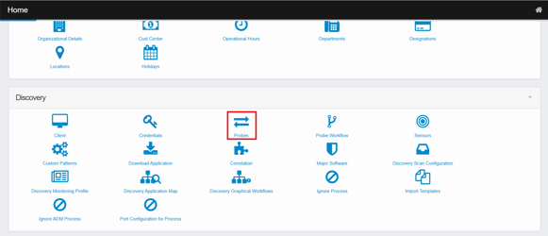
The Probes page opens with columns like Name, Description, Probe Type, and Sensor.
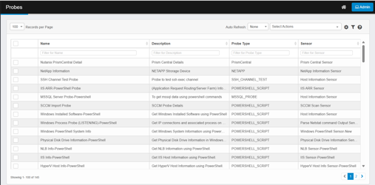

Managing Probe
On the Probes page, use the Select Actions dropdown to create new probes (from scratch or templates and assign a sensor), delete selected probes (after verifying they aren’t used by sensors or workflows), or export selected or filtered probes for download.

Creating a New Probe
- From the Select Actions dropdown, choose New Probe.
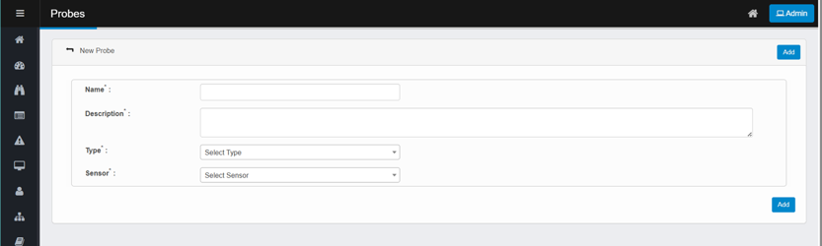
- Enter a Name and Description.
- Select a Type from the dropdown.
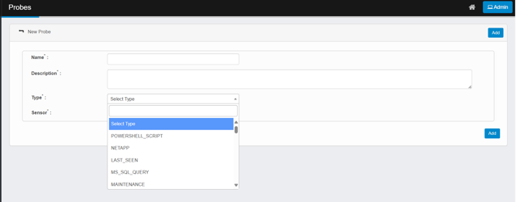
- Select a Sensor from the dropdowns.
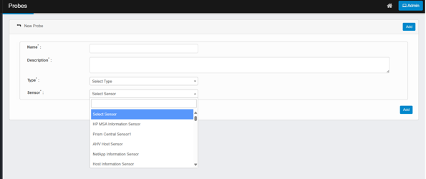
- Enter a Command (for SSH/Native types).
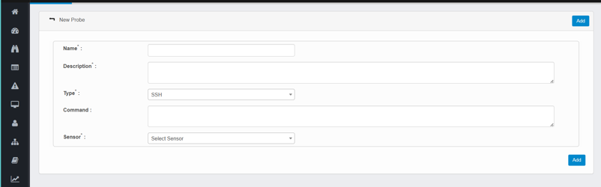
- Click Add to save.

Deleting a Probe
- Select the probe(s) to remove.
- Click Select Actions and choose Delete.
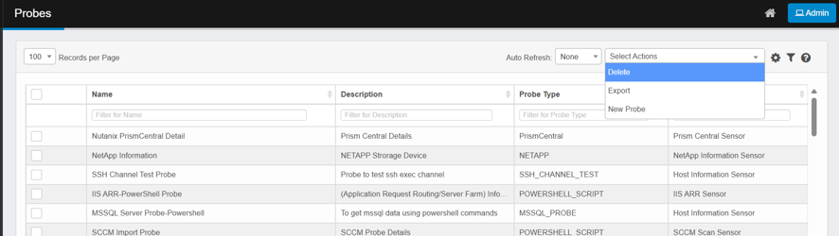
- Type Delete to confirm or click Cancel to abort.
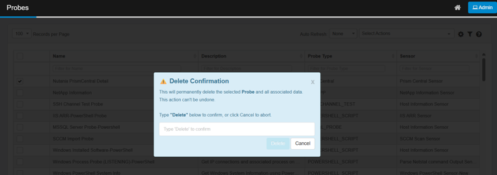
Deletion is irreversible and may impact other parts of the application.

Exporting a Probe
- Use column filters to narrow the list, or tick checkboxes to select specific probes.
- Click Select Actions → Export.
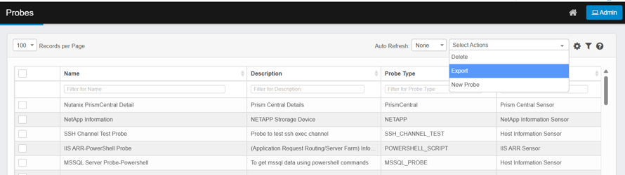
- In the Confirmation dialog, click Continue.
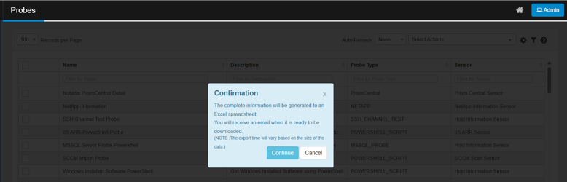
- A Success Message confirms export has started in the background.
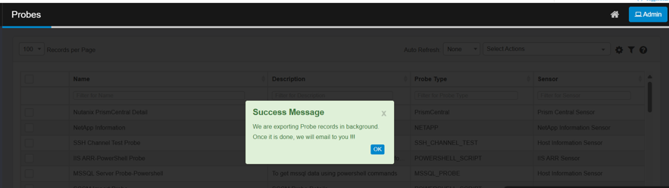
- Open the link in the notification email to download the Excel file.

Editing a Probe
- Select the record to edit (click the line).
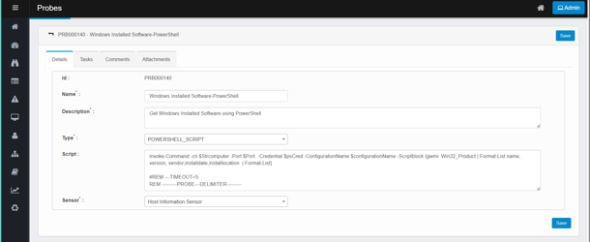
- Make necessary changes in the dialog box.
- Click Save to confirm.

Extra Features When Editing Records
Depending on the screen and record type, you may see additional options such as:
- Adding Tasks, Comments, or Attachments
- Viewing the History of the Record
Not every function will display all these options. The available features depend on the type of record and your current location in the system.
For more information, refer the Tab Details document.

Other Functions and Page Elements

Auto Refresh
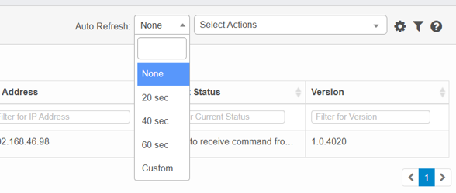
Feature | Details
Purpose | Automatically updates the screen to reflect real-time data changes
Configuration Options | None (manual refresh), 20s, 40s, 60s, Custom (user-defined interval)
Benefit | Ensures users view the most recent data without manual action

Personalize Columns
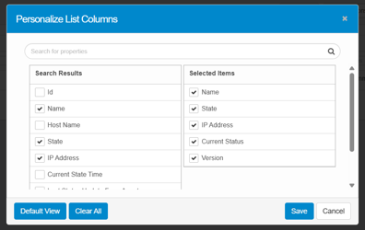
Purpose: Customize which columns appear in record views.
How to Use:
- Click the Personalize Columns icon.
- Search for properties using the search box.
- Move desired fields from "Search Results" to "Selected Items".
- Use Default View to reset to system settings.
- Use Clear All to remove all selections.
- Click Save to apply or Cancel to discard changes.
Column options are predefined by the system and not user-modifiable.

Records per Page
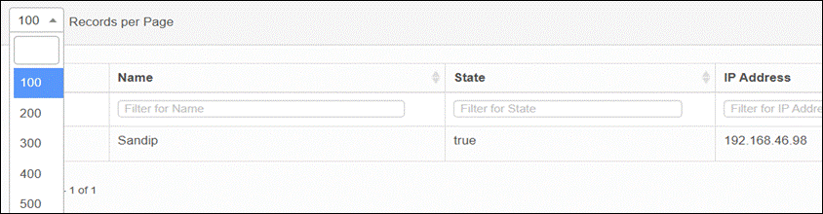
Feature | Details
Function | Sets the number of items shown per page in record views
Options | Typically includes 10, 25, 50, 100, etc.
Usage | Select from the drop-down menu to adjust view size

Saved Filters
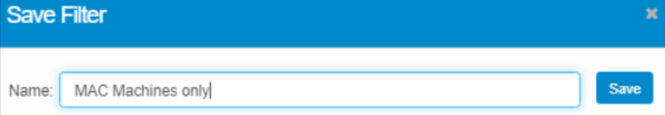
Purpose: Filter data based on specific conditions.
Creating Filters:
- Click a filter field under a column header.
- Type in the condition.
- Press Enter to apply.
- Click Save Filter and provide a name.
Applying and Deleting Filters:
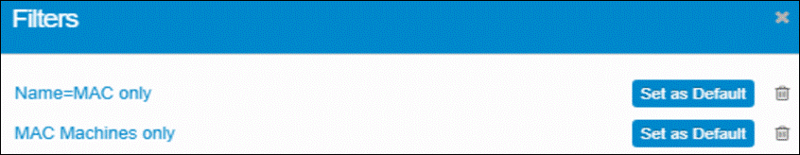
- Open the Saved Filter icon.
- Select from the list.
- Click Set as Default to apply automatically (only one default allowed).
- Use the trashcan icon to delete.
Filters are unique to each user and do not affect others.

