Procurement

Drill-down overview: PO → PO Line Items → Receiving Slip Lines

What you can see
- Purchase Order (PO): header details (vendor, dates, terms, totals).
- PO Line Items: what was ordered (model, part no., qty, unit cost).
- Receiving Slip Lines: the actual items/quantities received against a specific PO line.
- Receiving Slips: each delivery against a PO.
Keys that tie everything together
PO Number → PO Line Item Number → Receiving Slip Line Number
Note: Receiving Slip can be referred from Receiving Slip Line
Steps
Navigation to Purchase Order Screen. Left Nav->Procurement->Purchase Order
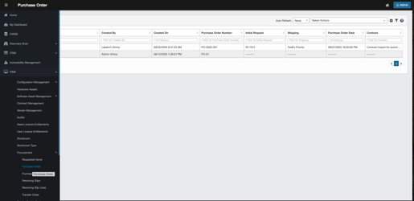
Click on PO Id to view the details of the Purchase Order
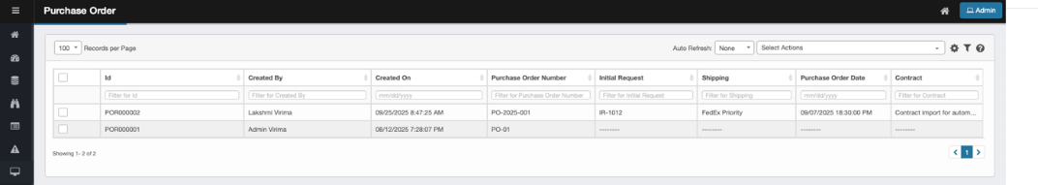
Click on PO Line Items Tab to view the PO Line items associated with the Purchase Order
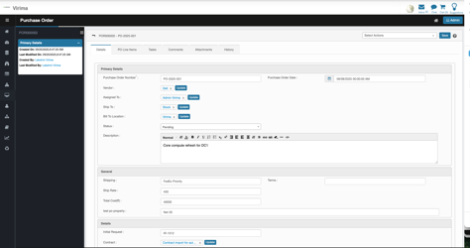
Click on the specific PO Line Item to view the details of the PO Line Item
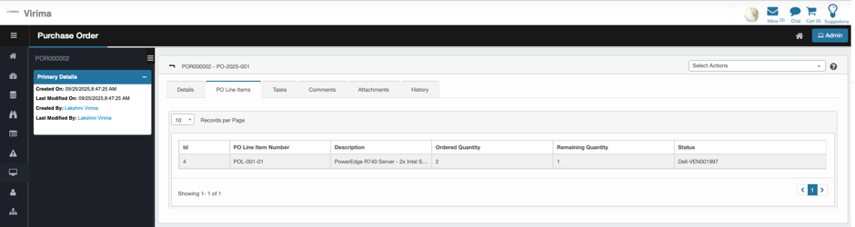
Click on Receiving Slip Lines tab to view the Receiving Slip Lines associated with the selected PO Line Item
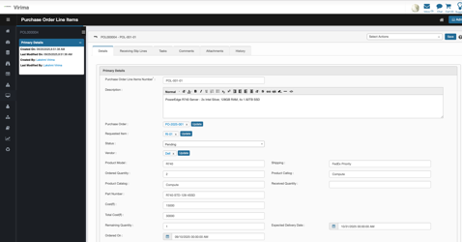
Click on the specific Receiving Slip Line to view the details of the items received against the PO Line Item
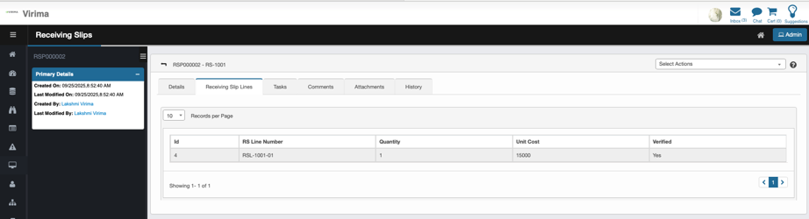
Receiving Slip Lines specific attributes are displayed as below
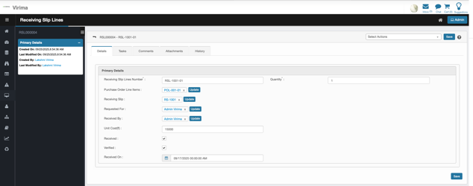
To view the Receiving Slip (Which is parent of Receiving Slip Lines) Click non the Receiving Slip Id in the above screen. The details of the Receiving Slip shall be displayed as below.
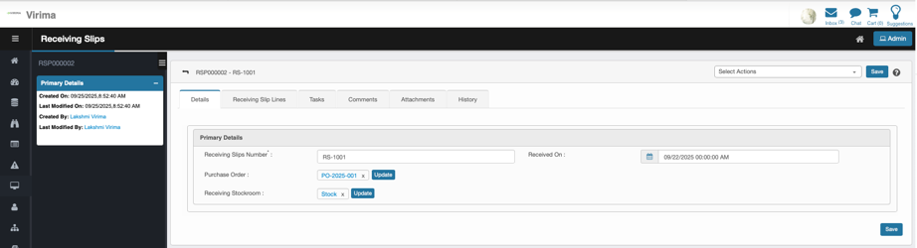

Example user journey (1 minute)
- Open PO-2025-001 → open POL-001-01 (PowerEdge R740).
- Click Receiving Slip Lines → view RSL-1001-01 (Qty 1 on 2025-09-01) and RSL-1002-… (if any).
- Confirm Received Quantity updated; check Remaining Quantity to see if more units are due.

Procurement Properties & Procurement Property Group
The Procurement Custom Properties and Groups system provides a flexible, configurable framework for managing dynamic properties across various procurement entities within the Virima platform. This system enables administrators to define, modify, and organize custom fields for different procurement modules without requiring code modifications, supporting business-specific requirements and evolving organizational needs.

The system encompasses six core procurement entity types: Requested Items, Purchase Orders, Purchase Order Line Items, Receiving Slips, Receiving Slip Lines, and Transfer Orders. Each entity type supports custom properties organized into logical groups, with comprehensive validation, audit trails, and integration capabilities.
Navigate to Custom Property and Property Group Menu
- Click on Admin
- Under Procurement
  - Procurement Properties
  - Procurement Property Group

Procurement Group
A property group is a logical collection of related properties. This helps in organizing fields into meaningful clusters.
View existing Property Group
- Click on Admin
- Under Procurement
- Click on Procurement Property Menu
- Landing Page will display a list of existing Properties
- Click on Existing Property Group to view details of the Property Group
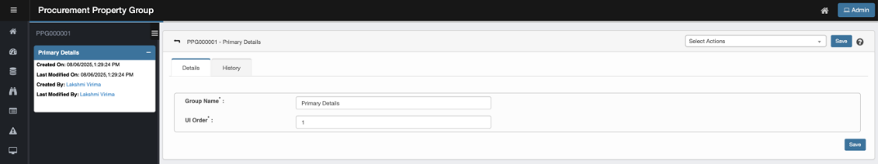
Primary Details
Fields | Description
Created On | Timestamp when record was created
Last Modified On | Timestamp when record was modified
Created By | Logged in User Name
Last Modified By | Logged in User Name
Details
Fields | Description
Group Name | Name of the Group
UI Order | Order in which the Group is displayed in Procurement Module
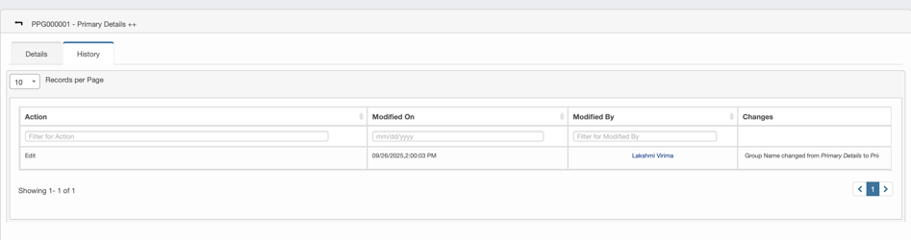
History
Fields | Description
Action | Type of Change executed. Only Edit is applicable
Modified On | Timestamp when records was modified
Modified By | Logged in User Name who Modified the record
Changes | Details of changes made

Add a new Property Group
- Click on Admin
- Under Procurement
- Click on Procurement Property Group Menu
- Landing Page will display a list of existing Property Groups
- Click on Select Actions
- Click on New Procurement Property Group
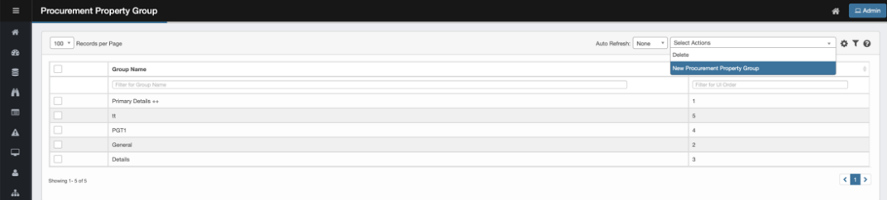
- Following screen shall be displayed
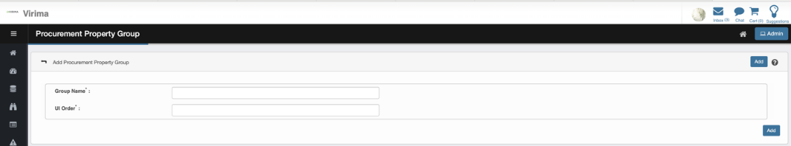
Fields | Description
Group Name | Name of the Group
UI Order | Order in which this group shall be displayed
- Click on Add to save the Group
- The record will appear on the property group list view
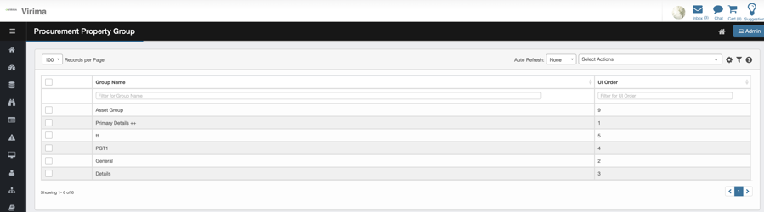

Delete a new Property Group
- Select the record to be deleted
- Click on Select Actions
- Click on Delete
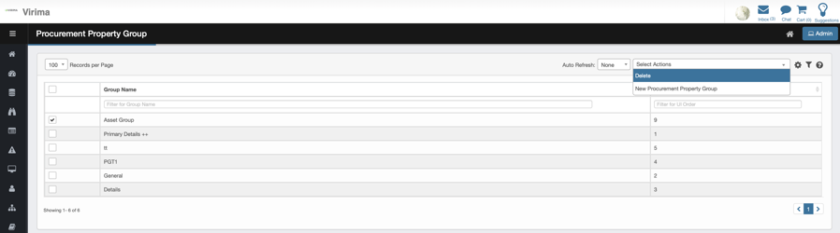
- A confirmation pop-up shall be displayed
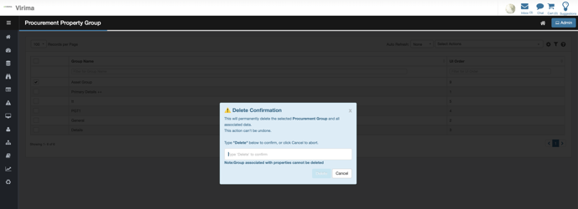
- Type deleted and click on Delete to delete the group
- Click on Cancel to abort the delete operation

Procurement Property

View existing Property Group
- Click on Admin
- Under Procurement
- Click on Procurement Property Group Menu
- Landing Page will display a list of existing Property Groups
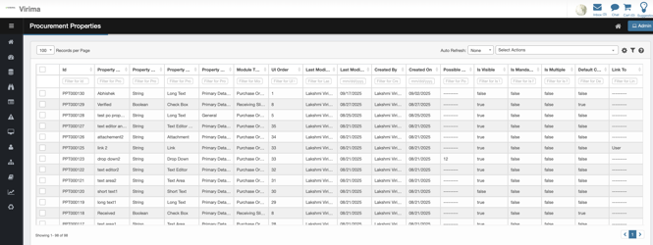
- Click on Existing Property to view details of the Property
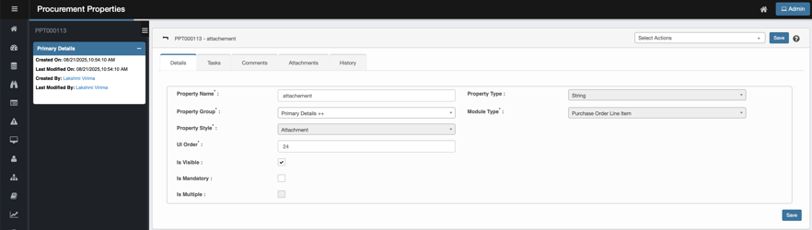
Primary Details
Fields | Description
Created On | Timestamp when record was created
Last Modified On | Timestamp when record was modified
Created By | Logged in User Name
Last Modified By | Logged in User Name
Details
Fields | Description
Property Name | - Text input with validation for uniqueness and naming conventions
Property Type | - Dropdown selection (String, Integer, Long, Boolean, etc.)
Property Group | - Dropdown populated from existing property groups
Module Type | - Dropdown selection from available procurement modules (Requested Item, Purchase Order, Purchase Order Line Item, Receiving Slip, Receiving Slip Line, Transfer Order)
Property Style | - Dropdown for display style configuration (Short Text, Link, Drop Down, Check Box, Cost, Text Editor)
UI Order | - Numeric field for display sequence control
Is Visible | - Checkbox to control property visibility in user interfaces
Is Mandatory | - Checkbox to enforce required field validation
Is Multiple | - Checkbox to enable multiple value selection  - Only applicable for Type Link
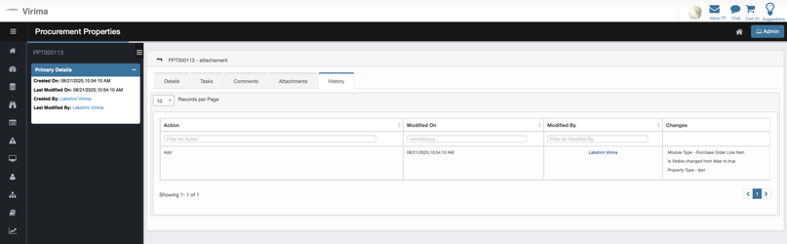
History
Fields | Description
Action | Type of Change executed. Only Edit is applicable
Modified On | Timestamp when records was modified
Modified By | Logged in User Name who Modified the record
Changes | Details of changes made

Add a new Property
- Click on Admin
- Under Procurement
- Click on Procurement Property Menu
- Landing Page will display a list of existing Property
- Click on Select Actions
- Click on New Procurement Property
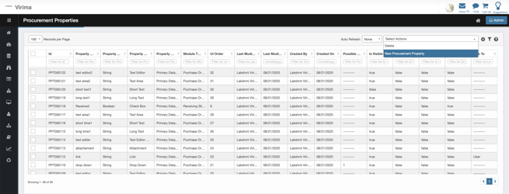
- Following screen shall be displayed
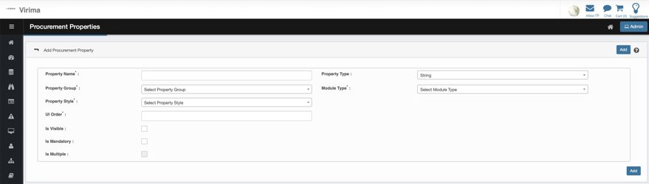
Fields | Description
Property Name | - Text input with validation for uniqueness and naming conventions
Property Type | - Dropdown selection (String, Integer, Long, Boolean, etc.)
Property Group | - Dropdown populated from existing property groups
Module Type | - Dropdown selection from available procurement modules (Requested Item, Purchase Order, Purchase Order Line Item, Receiving Slip, Receiving Slip Line, Transfer Order)
Property Style | - Dropdown for display style configuration (Short Text, Link, Drop Down, Check Box, Cost, Text Editor)
UI Order | - Numeric field for display sequence control
Is Visible | - Checkbox to control property visibility in user interfaces
Is Mandatory | - Checkbox to enforce required field validation
Is Multiple | - Checkbox to enable multiple value selection  - Only applicable for Type Link
- Click on Add to save the Property
- The record will appear on the property group list view


Delete a new Property
- Select the record to be deleted
- Click on Select Actions
- Click on Delete
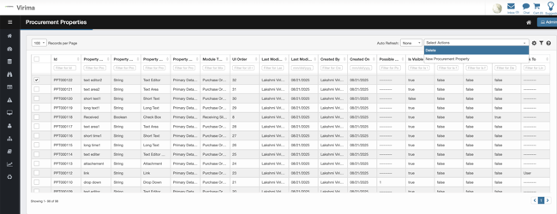
- A confirmation pop-up shall be displayed
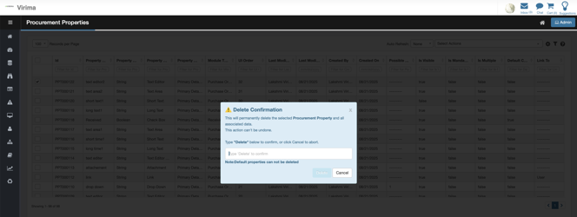
- Type deleted and click on Delete to delete the group
- Click on Cancel to abort the delete operation

