User Groups
- Overview
- User Groups
  - Accessing User groups
  - Managing User Groups
    - Creating a New User Group
    - Editing a User Group
    - Deleting a User Group
    - Exporting Users
    - Using Other Functions and Page Elements

Overview
The User Groups feature in Virima allows administrators to organize application users into structured groups based on roles, departments, and responsibilities. Each group has an assigned Manager and may include associated roles and departments to control access and ensure accountability.
With this module, organizations can streamline collaboration, apply role-based permissions consistently, and manage group memberships efficiently. Administrators can create new groups, add or edit member details, and remove groups when no longer needed.

User Groups

Accessing User groups
The User Groups function in Virima allows administrators to configure and manage groups among existing application users. Groups are defined by assigning a Manager, Department, and Roles, ensuring structured access control and streamlined collaboration across ITSM modules.
Before creating a new user group, ensure the following:
- Manager – Required (must belong to the department assigned).
- Department – Optional but recommended for organizational alignment.
- Role – Optional but recommended to apply role-based access permissions.
Role access permissions must be set up before adding a user group.
Navigation
Go to Admin > Users > User Groups.
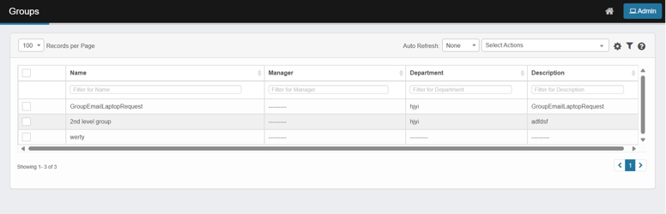
The User Groups window displays all available groups and provides options to:
- Create a new group
- Edit an existing group
- Delete a group
- Assign members to groups

Managing User Groups

Creating a New User Group
- From the Select Actions drop-down list, choose New Group.
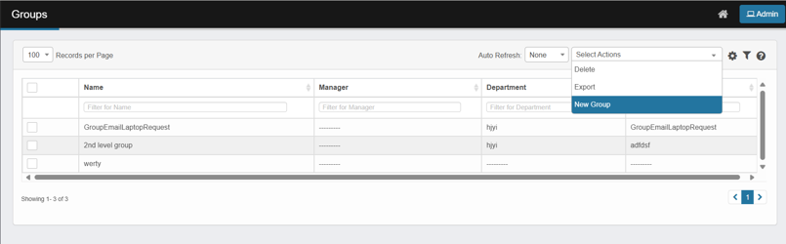
- The New User Group window opens.
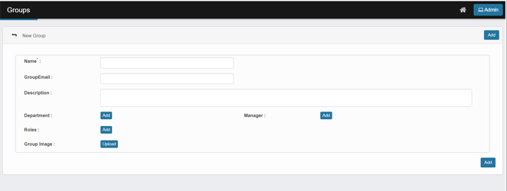
- Complete the required fields:
  - Name – Enter the group name.
  - Group Email – Provide the group email address.
  - Description – Enter the purpose or scope of the group.
- For Department, Manager, and Role, click Add and search for the applicable selections.
The Manager must be a member of the selected Department. Otherwise, an error message displays.
- (Optional) To add a group image, click Upload and select the image file.
- Click Add to save the new User Group.

Editing a User Group
- Navigate to the window containing the group record.
- Click the row containing the record. The group details window opens.
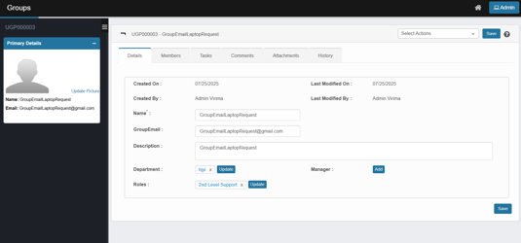
- Make the required modifications.
- Click Save (or Add, if inserting a new entry).
Not all functions include an edit option in the main window.
Tip: When editing, additional options such as Tasks, Comments, Attachments, or History may be available depending on the function.

Deleting a User Group
Deleting a User Group is permanent and cannot be undone.
Deleting may affect reports, selectable fields, or user assignments. Always review dependencies before deletion.
To delete a group:
- Select the checkbox for the applicable group.
- From the Select Actions drop-down, choose Delete.
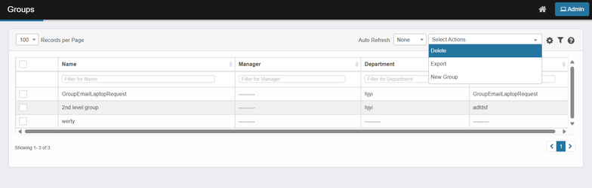
- Confirm the deletion when prompted.
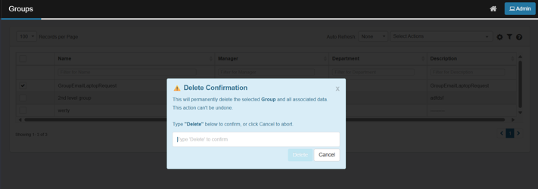

Exporting Users
The Export option allows administrators to download user details into an Excel spreadsheet for reporting, auditing, or backup purposes.
- From the Select Actions dropdown menu, choose Export.
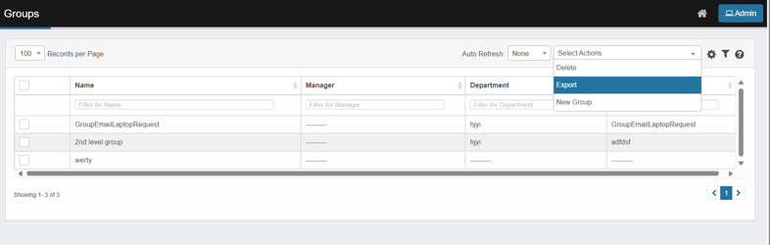
- A confirmation message will appear.
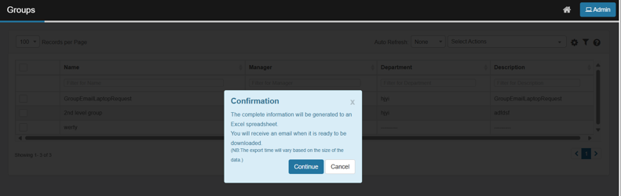
- Click Continue to proceed or Cancel to abort the export.
- Once confirmed, a Success Message is displayed.
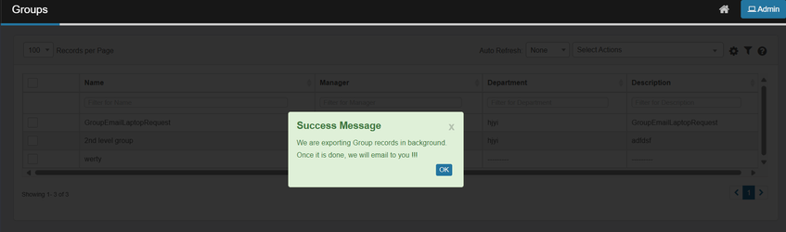
- Click OK to close the message

Using Other Functions and Page Elements
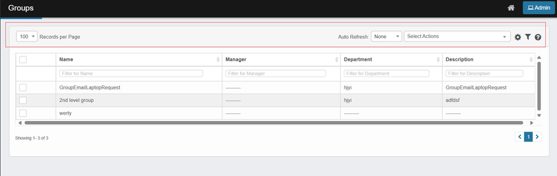
- Records per Page – Adjust the number of entries displayed per page.
- Auto Refresh – Set automatic refresh intervals for the page.
- Personalizing Columns – Customize which columns are visible.
- Using Saved Filters – Apply and save filter preferences for quick access.

