Heart Disease Risk Prediction
MLOps Assignment 1: end-to-end model development, CI/CD and deployment
Name: Gopichand
BITS ID: 2025AE05912
Course: Machine Learning Operations (S1-26_AIMLZG523)
Code repository: https://github.com/gopichand458/heart-disease-mlops-assignment
Demo video: https://drive.google.com/file/d/1-mewSHch97XqMzwaWoFJStdSuROpUnhQ/view?usp=sharing

1. Introduction
The goal of this assignment is to build a classifier that predicts heart disease from patient health data and to deploy it as a monitored API, using MLOps practices: experiment tracking, tests, CI, containers, Kubernetes and monitoring.
I used the UCI Heart Disease dataset (Cleveland subset). It has 303 patients and 13 features such as age, sex, chest pain type, blood pressure, cholesterol and maximum heart rate. The original target runs from 0 to 4, and I turned it into a binary label (0 = no disease, 1 = disease).

2. Setup and installation
Everything runs from a clean environment using the requirements file. I checked this by cloning the repository into a new folder, installing and running the pipeline, which gave the same results as on my own machine.
python3 -m venv .venv
source .venv/bin/activate
pip install -r requirements-dev.txt
python -m src.download_data
python -m src.clean_data
python -m src.train
pytest -q
The download script reads the official UCI zip file. Behind my office network the default library failed with a certificate error, so I wrote the script to use the system certificate store, and it also accepts a manually downloaded zip as a fallback.

Attached the screenshot below. Plzz check.

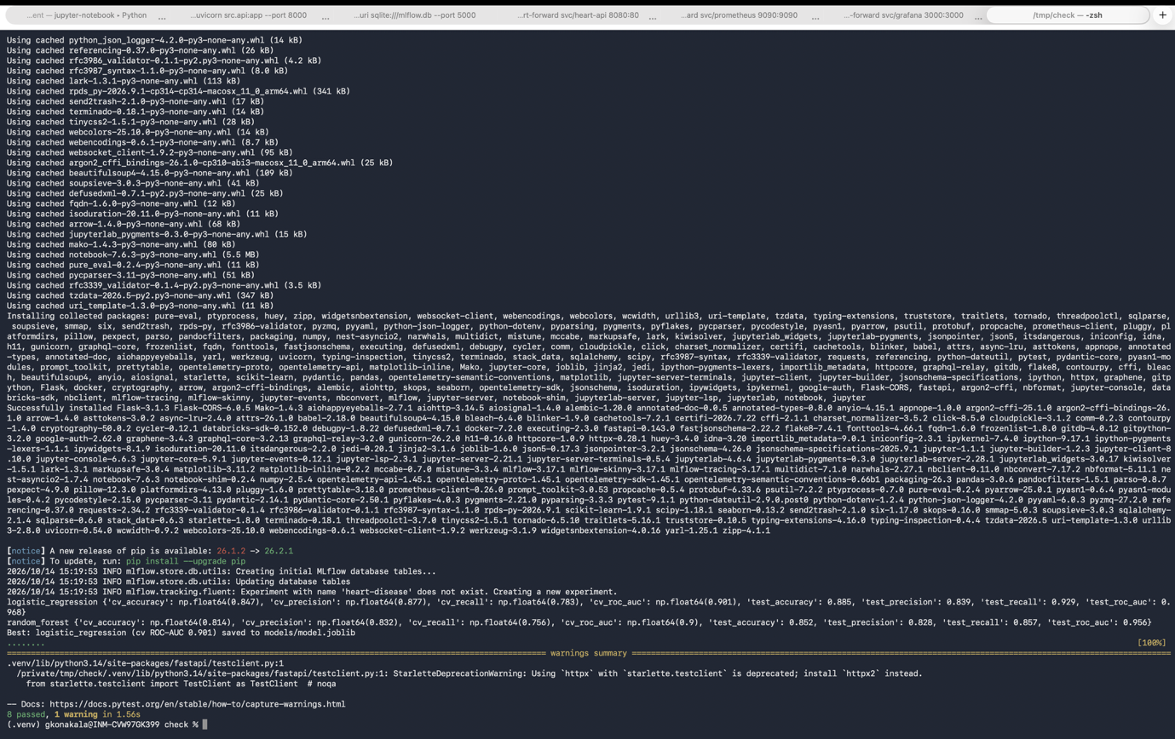

3. Data and exploratory analysis
The raw data has 303 rows. Only two columns have missing values: ca (4 rows) and thal (2 rows). I did not fill them during cleaning. They are filled inside the model pipeline, so the fill values are learned from training data only and nothing leaks from the test folds.
The classes are fairly balanced: 164 patients without disease and 139 with disease.

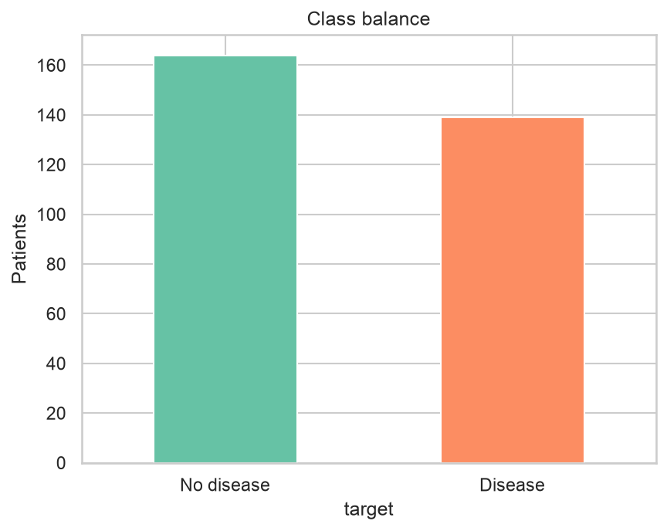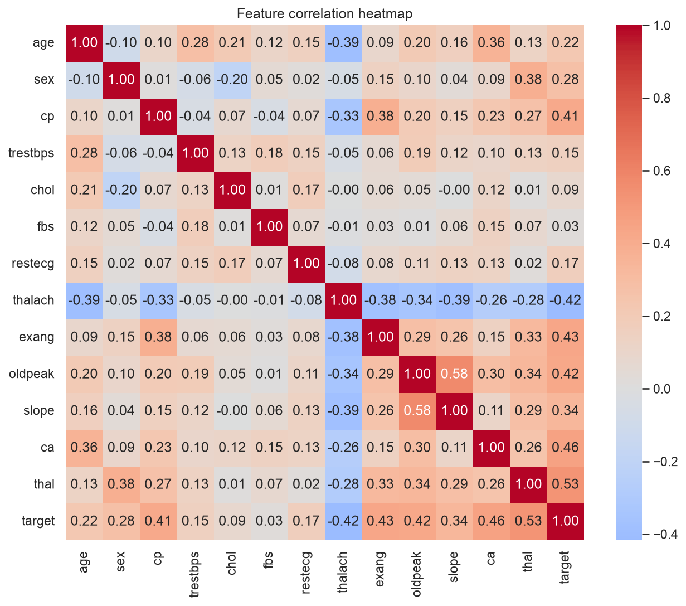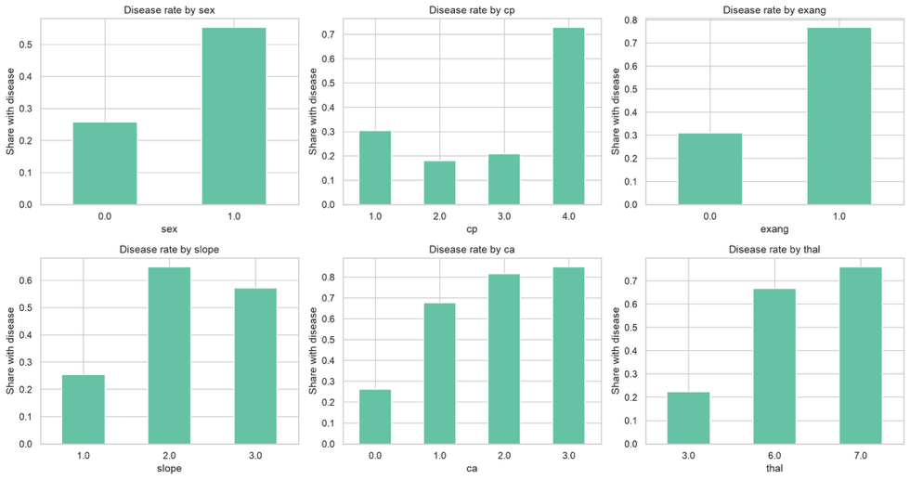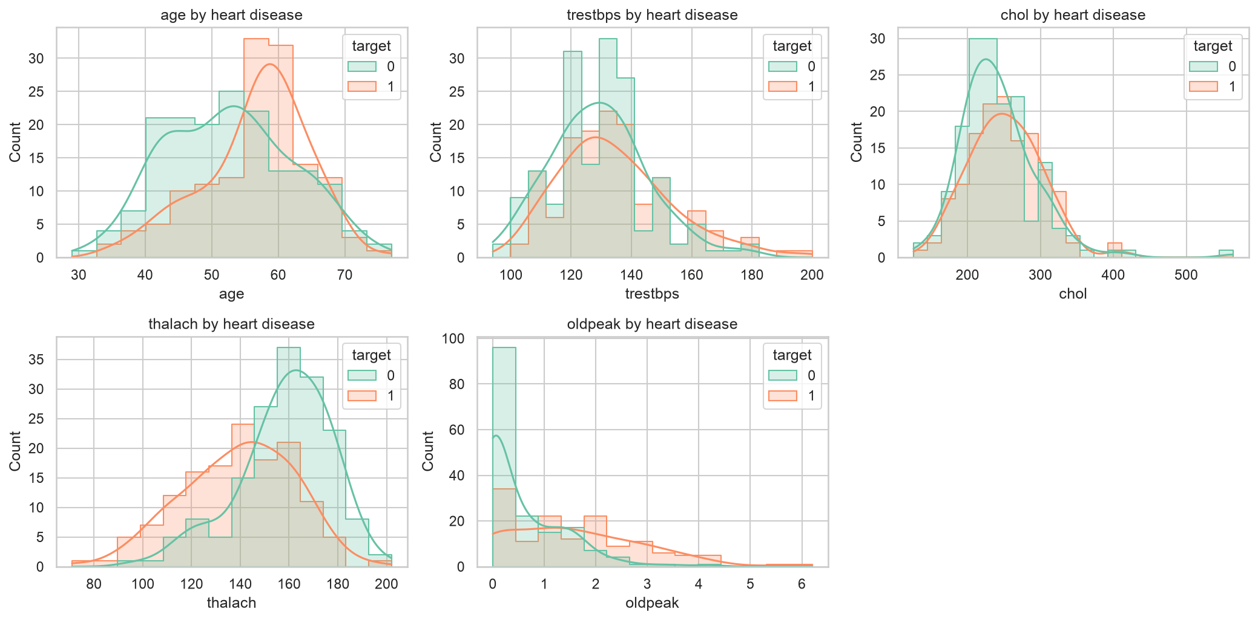

What I observed
- Numeric features: patients with disease tend to have lower thalach (max heart rate) and higher oldpeak. trestbps and chol overlap a lot between the two groups, so they separate the classes less. Check this in your histograms before writing it.
- Heatmap: which features correlate most with target (look for ca, thal, oldpeak, cp, exang, and thalach going the other way). Read the actual numbers from your heatmap.
- Category rates: ca rises from about 0.25 at 0 vessels to over 0.8 at 3. Asymptomatic chest pain (cp = 4), exercise angina, thal 6/7 and male sex all show higher disease rates.
- Caution: some groups are small (for example ca = 3), so those bars are less reliable.
- Take-away: these features will probably carry most of the model’s signal

4. Features and modelling
Preprocessing is one scikit-learn pipeline, so training and the API use exactly the same steps. Numeric columns are median-imputed and standard-scaled. Categorical columns are most-frequent-imputed and one-hot encoded.
I added one engineered feature, hr_reserve = (220 - age) - thalach. It is the gap between the age-predicted maximum heart rate and the rate the patient reached.
I trained two models, logistic regression and random forest, with GridSearchCV on ROC-AUC and stratified 5-fold cross-validation on an 80/20 split (seed 42). Tuned values: logistic regression C in 0.01, 0.1, 1, 10; random forest n_estimators 100 or 300 and max_depth 3, 5 or None.
Model | CV ROC-AUC | Test accuracy | Test precision | Test recall | Test ROC-AUC
Logistic regression | 0.901 | 0.885 | 0.839 | 0.929 | 0.968
Random forest | 0.900 | 0.852 | 0.828 | 0.857 | 0.956

Screenshots are below

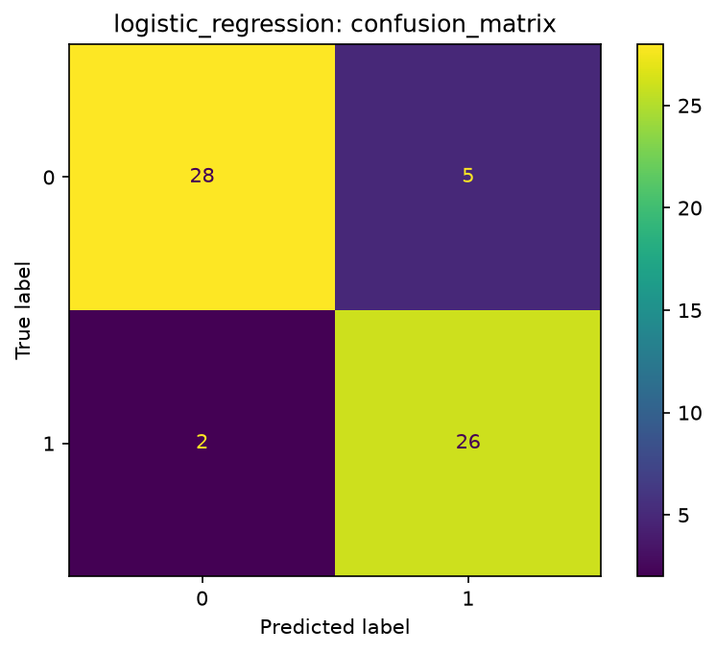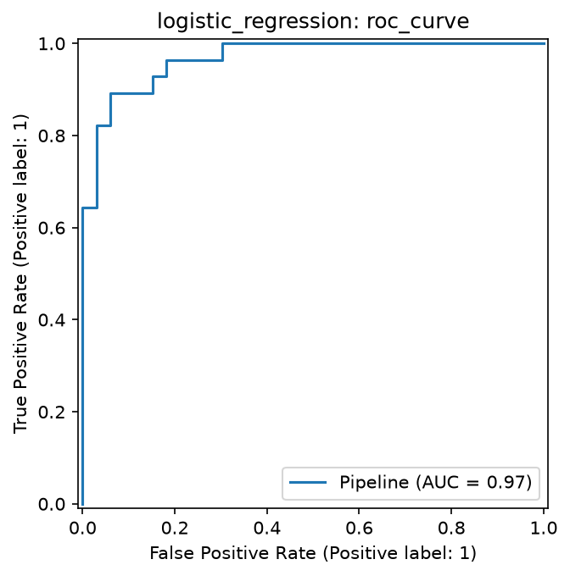

Model choice
- State the two results: CV ROC-AUC 0.901 vs 0.900, so essentially tied.
- Logistic regression has higher test recall (0.929 vs 0.857) and higher test accuracy (0.885 vs 0.852).
- Recall matters here because missing a patient with disease is worse than a false alarm.
- It is simpler, faster and easier to explain than a random forest.
- Caveat: the test set is only 61 patients, so a small difference could be luck. This is why you decided mainly on cross-validation.

5. Experiment tracking
Each training run is logged to MLflow: the model name, best hyperparameters, seed, cross-validation and test metrics, the ROC curve and confusion matrix images, and the fitted pipeline. I compared the two runs in the MLflow UI.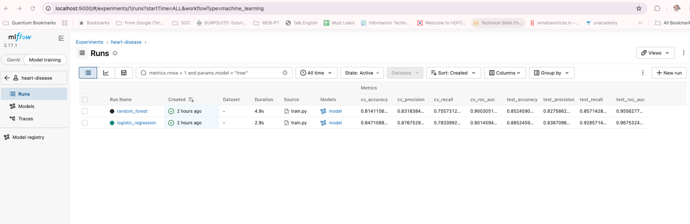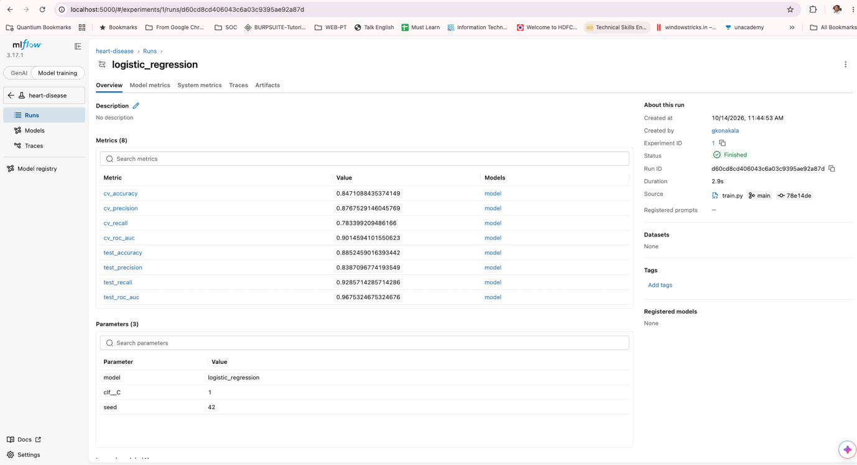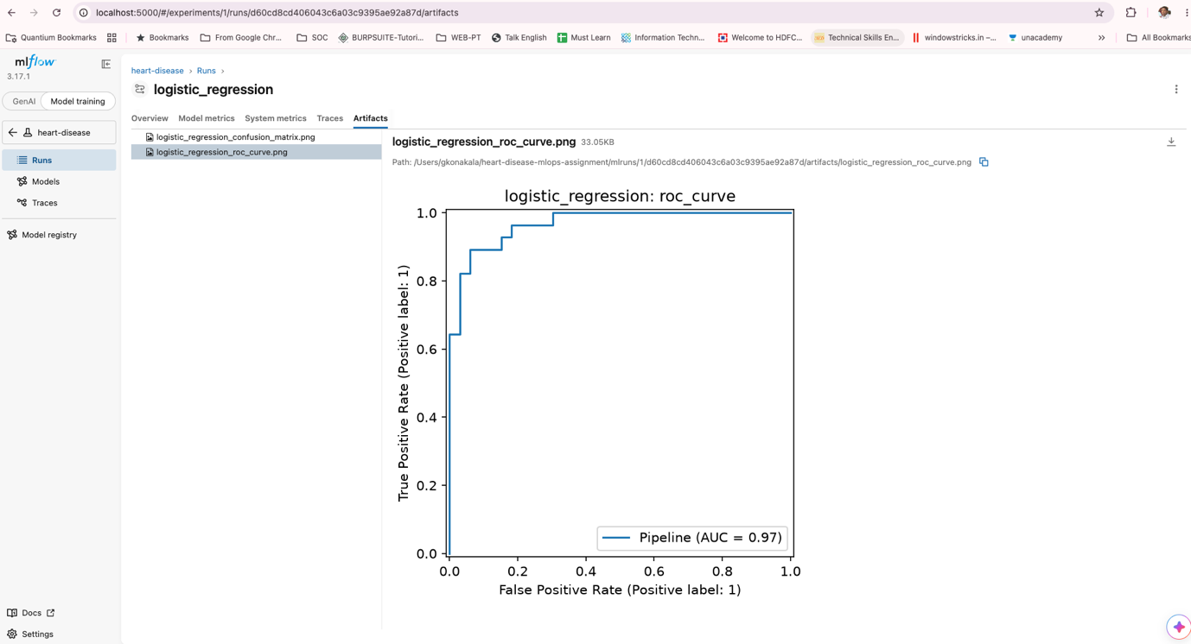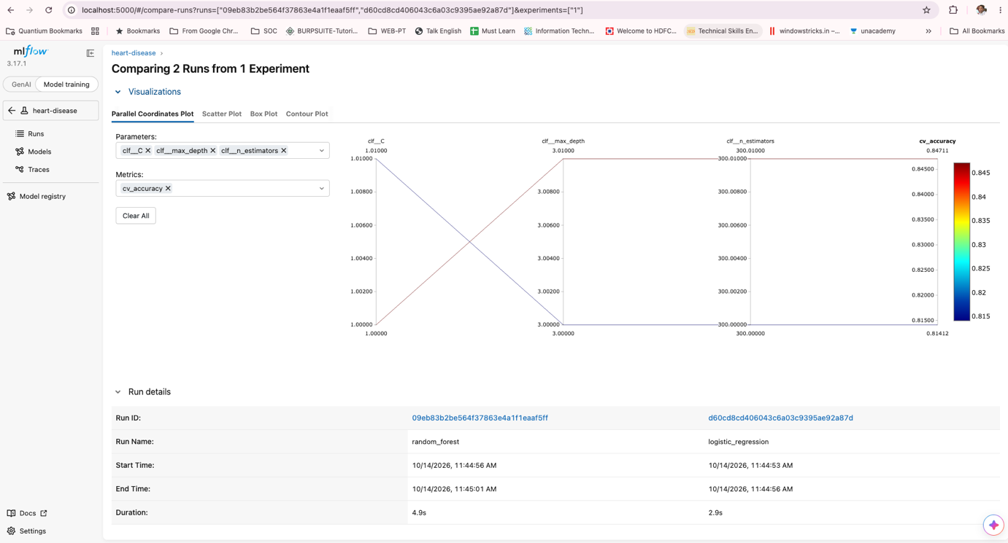A problem I ran into
- Training worked and logistic regression logged, then saving the model to MLflow failed.
- The error said the model contained untrusted types, first numpy.dtype, then sklearn.tree._tree.Tree for the random forest.
- The cause: this MLflow version saves scikit-learn models in the skops format and refuses types it hasn’t been told to trust.
- The fix: pass skops_trusted_types with those two types in train.py.
- Why it is safe: you trained and saved the model yourself. The risk is mainly with files from unknown sources.

6. Packaging and reproducibility
The selected model is saved with joblib as models/model.joblib, together with metadata.json. The preprocessing is part of the saved pipeline, so no separate transformer is needed. Dependencies are in requirements.txt, and the random seed is fixed, so a fresh clone reproduced the same metrics.

7. CI/CD
The GitHub Actions workflow (.github/workflows/ci.yml) runs on every push to main, on Python 3.12: install dependencies, lint with flake8, train the model, run the pytest suite, build the Docker image and upload the artifacts.
There are 8 unit tests: four for the feature code (engineered feature, loading, missing-value handling, feature lists) and four for the API (health, prediction, bad input, metrics).
To check that the pipeline fails properly, I changed one assertion on purpose and pushed it. The unit-test step failed with exit code 1, the Docker build step was skipped, and the log showed the failing assertion. I then reverted the change and the run went green again.
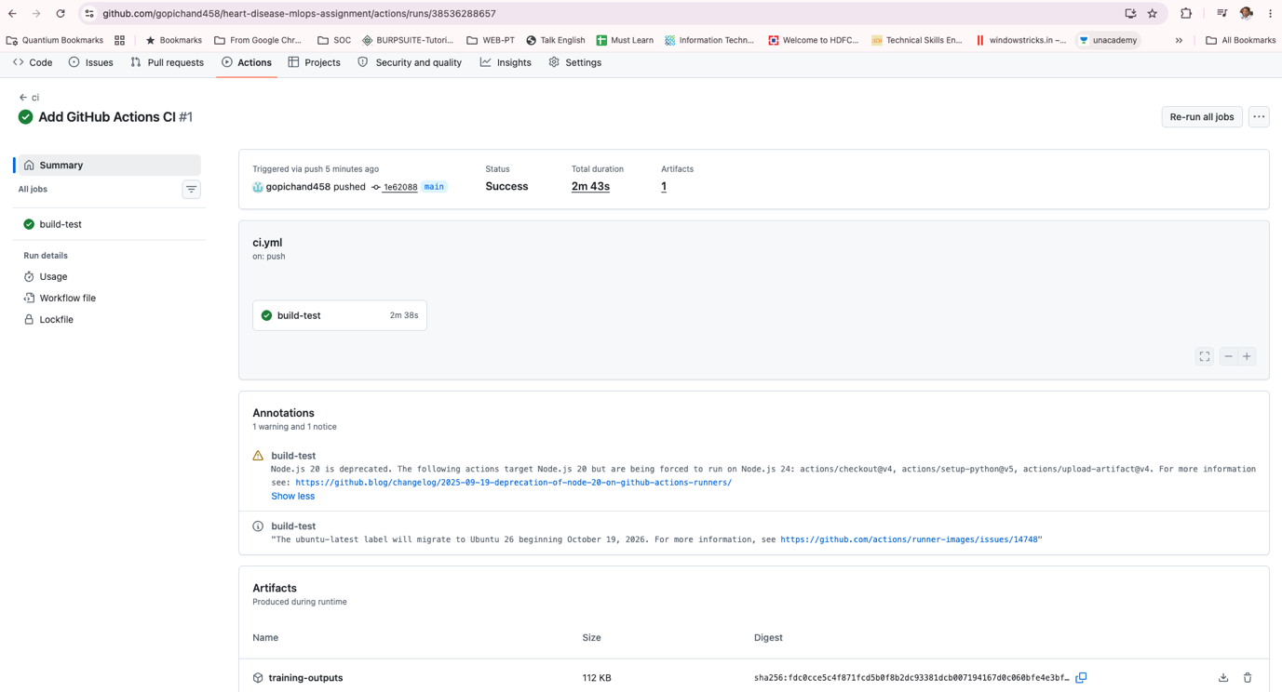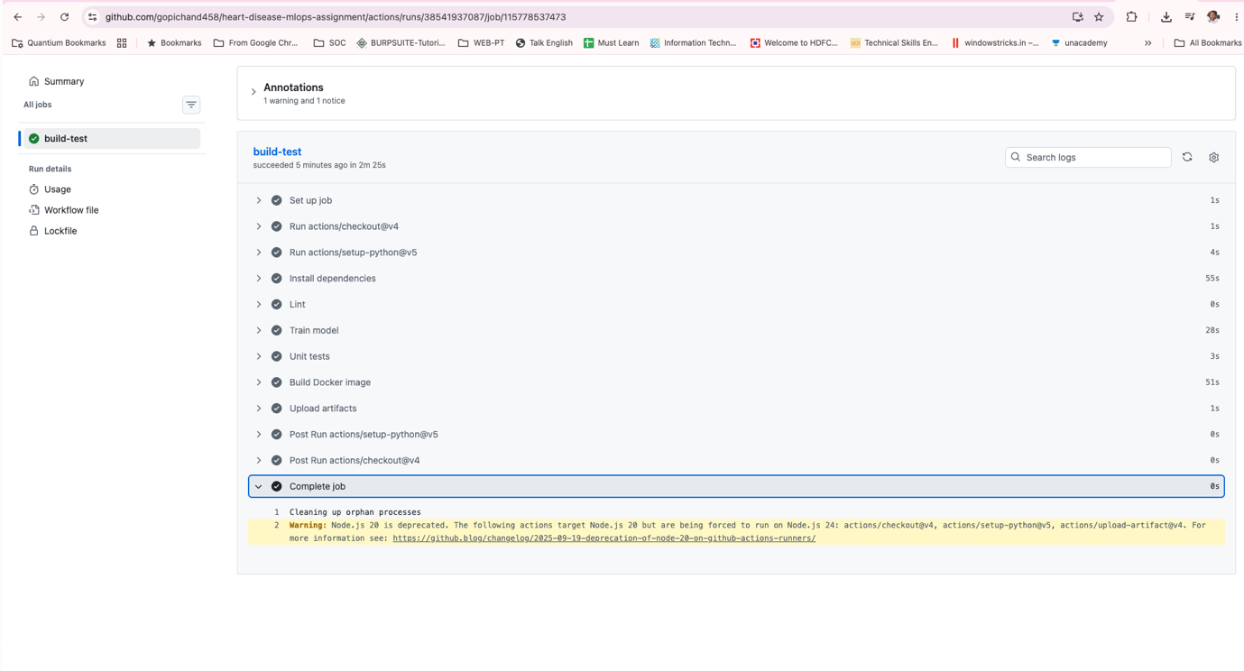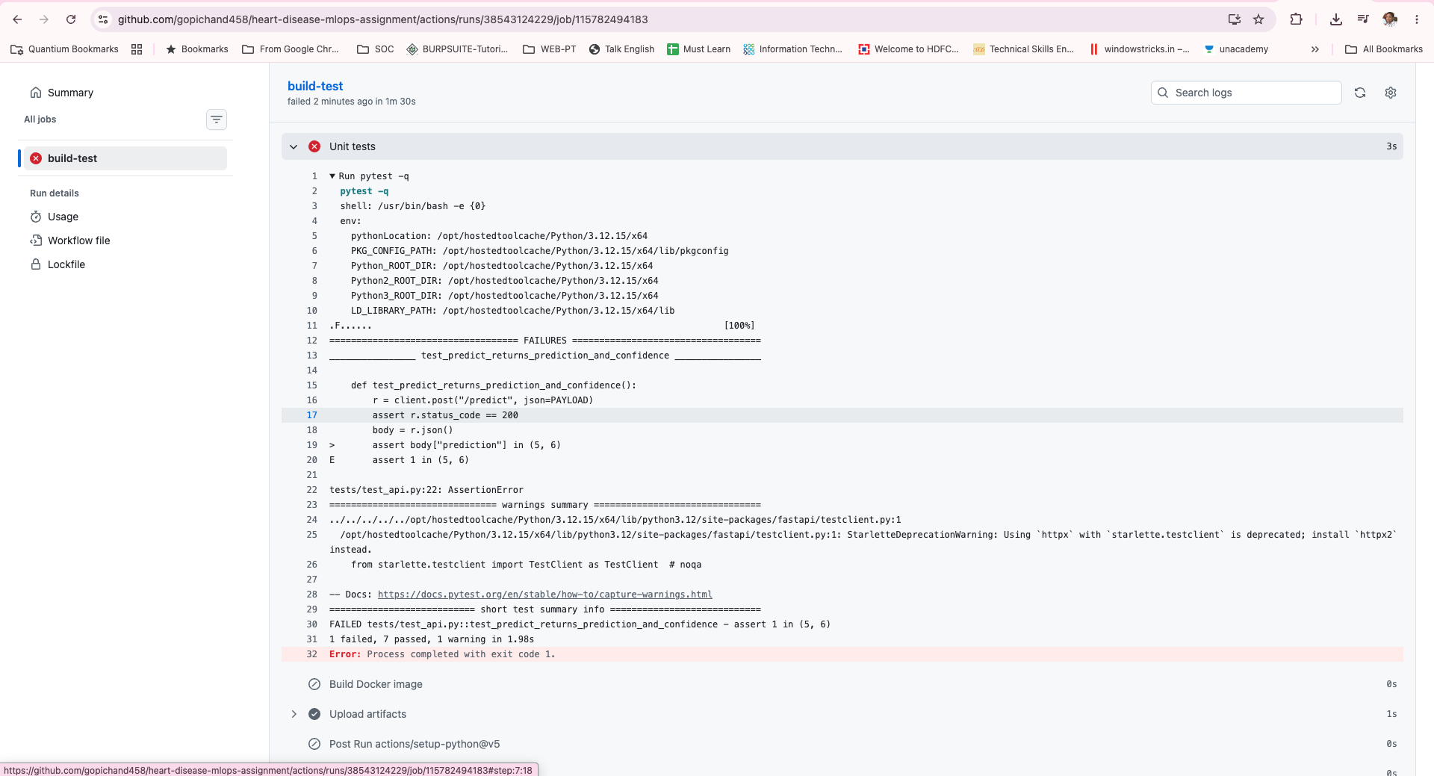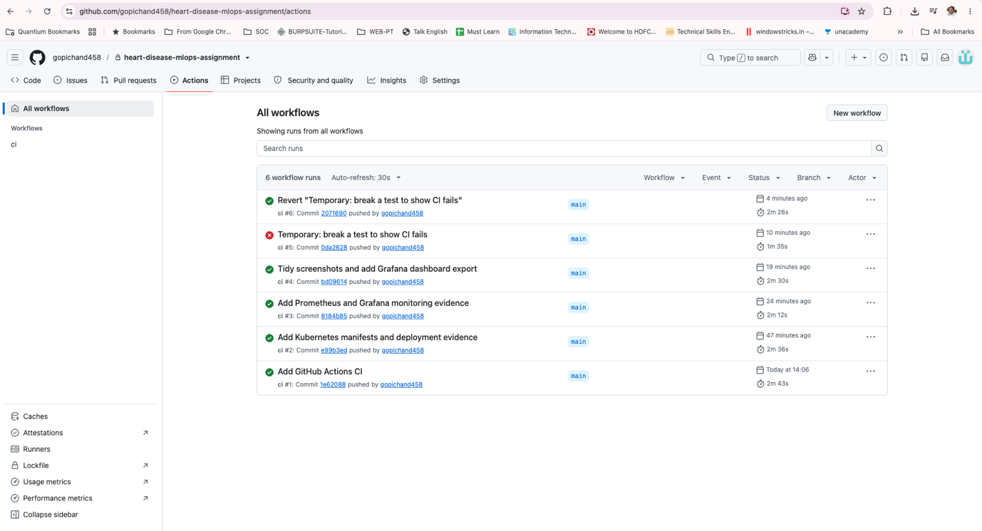

8. API and containerization
The model is served with FastAPI. POST /predict takes the 13 patient fields as JSON and returns the prediction, a label, the confidence and the probability of disease. GET /health is used for the Kubernetes probes and /metrics/ exposes Prometheus metrics. Invalid input returns HTTP 422.
The Dockerfile uses python:3.12-slim, installs the requirements and copies in the source and the model. The container built and ran locally, and returned the same prediction as the local server (confidence 0.6343 for the sample patient).

Screenshot below
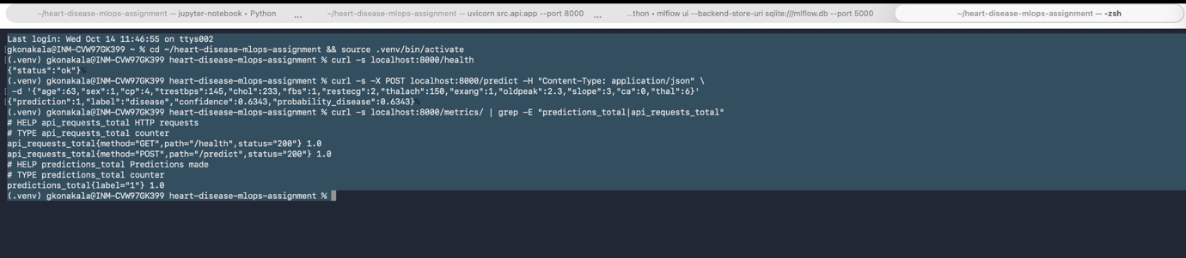
9. Kubernetes deployment
I used the Kubernetes cluster that comes with Docker Desktop. k8s/deployment.yaml runs 2 replicas with readiness and liveness probes on /health and CPU and memory limits. k8s/service.yaml exposes them as a LoadBalancer service.
The cluster runs inside its own container, so it could not see my locally built image. I loaded the image into the node with docker save piped to ctr import, and the pods started normally. The service received an external IP, but from my Mac that address was not reachable, so I used kubectl port-forward to test it.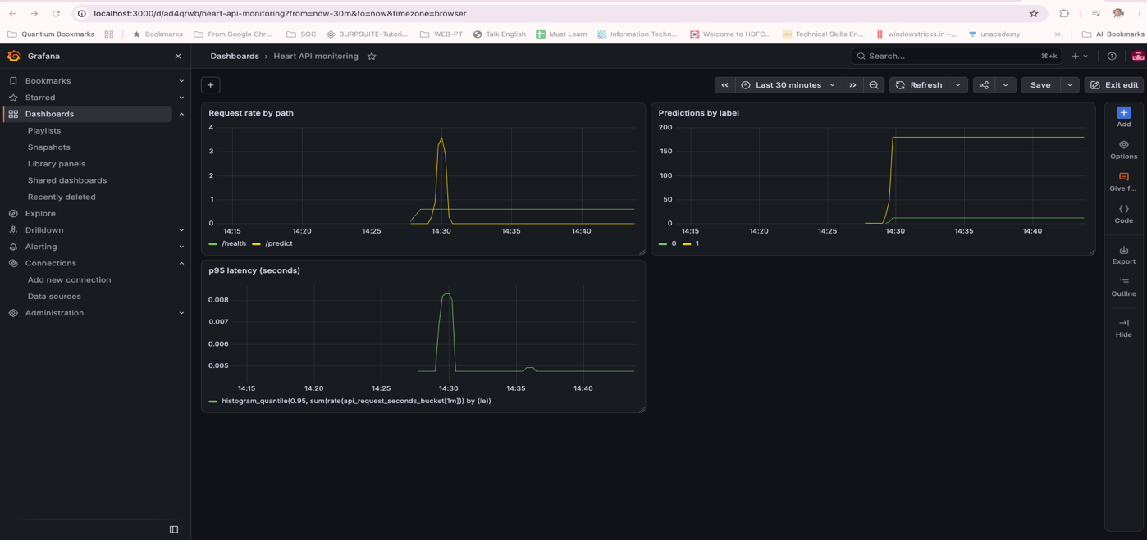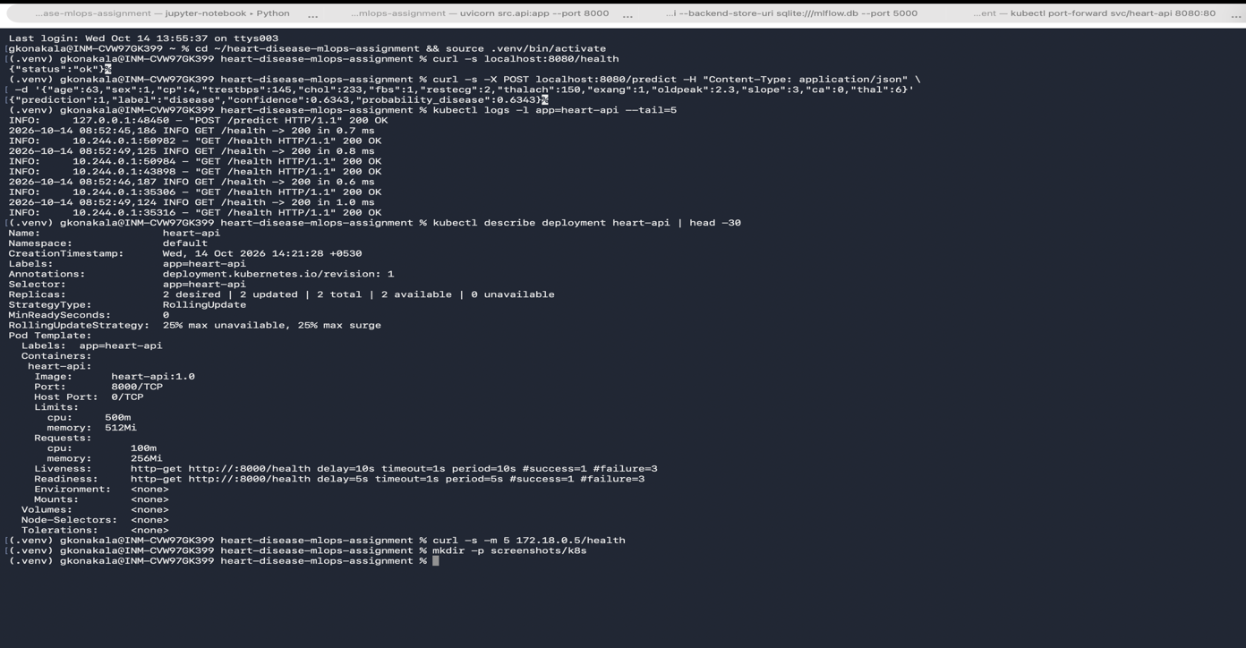

10. Monitoring and logging
The API logs every request with method, path, status code and time taken, and every prediction with its probability. It also exposes Prometheus metrics: a request counter by path and status, a latency histogram and a counter of predictions by label.
k8s/monitoring.yaml deploys Prometheus, which discovers the API pods and scrapes /metrics/ every 10 seconds, and Grafana. The Grafana dashboard has three panels: request rate by path, predictions by label and 95th percentile latency. In my test, after about 15 prediction requests the p95 latency was roughly 5 to 8 ms.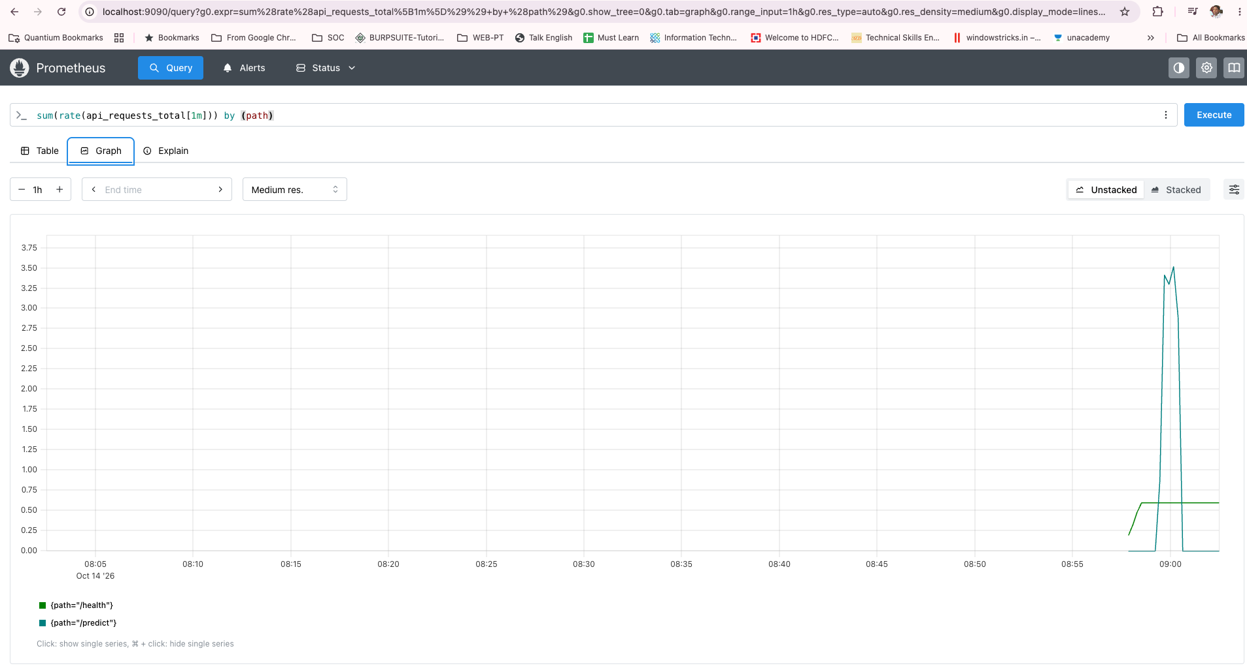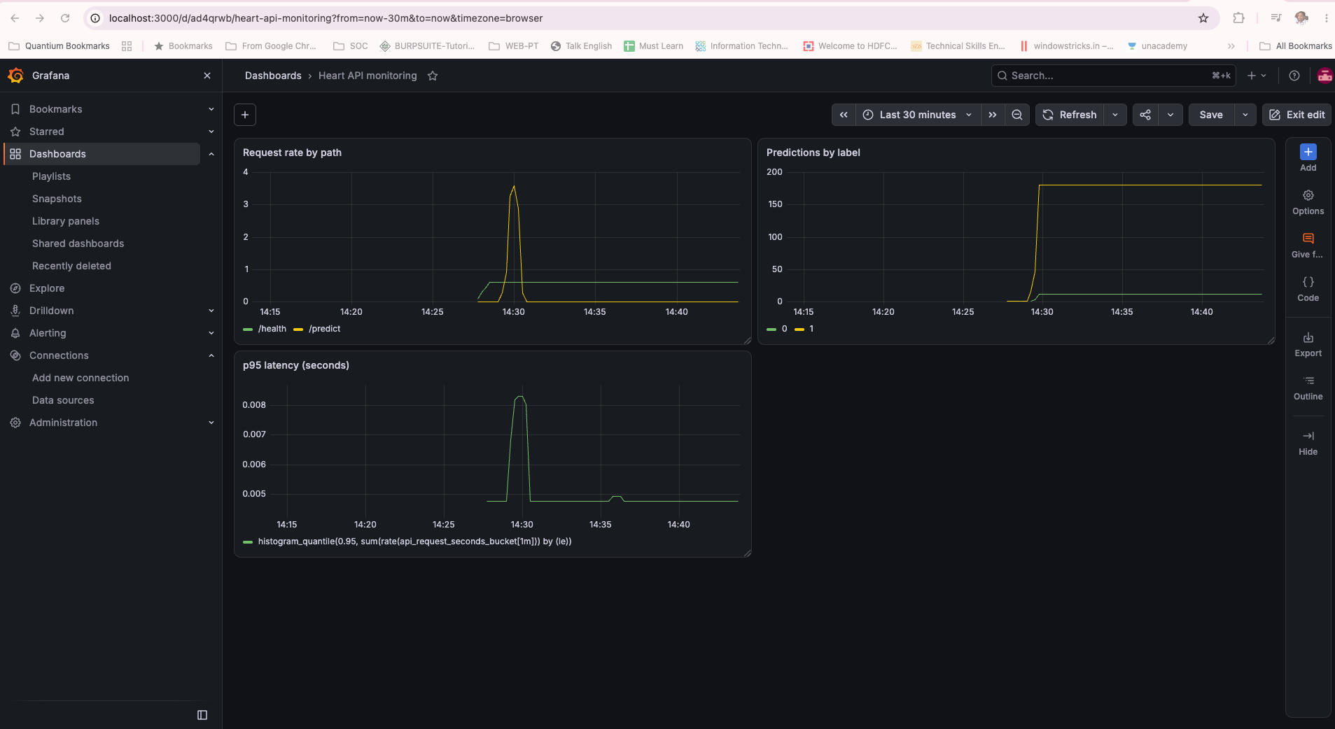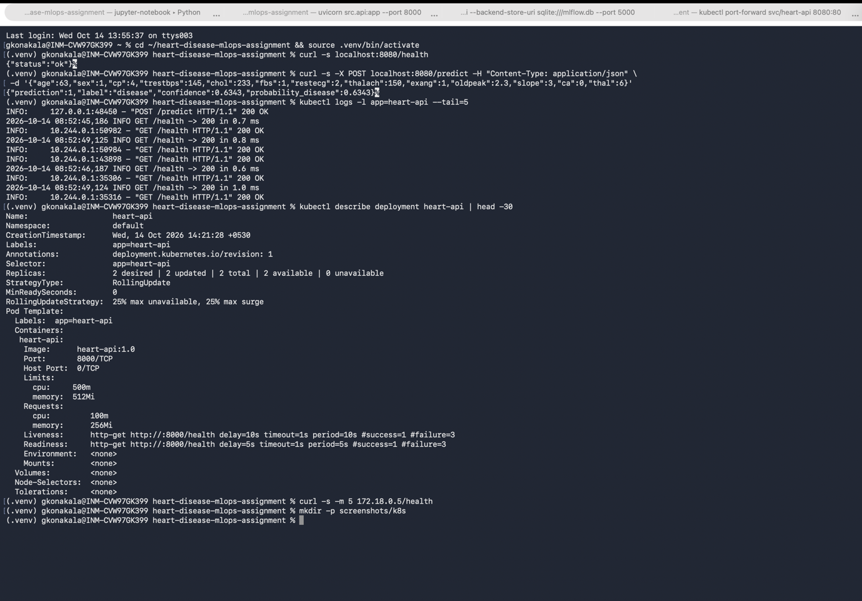

11. Architecture

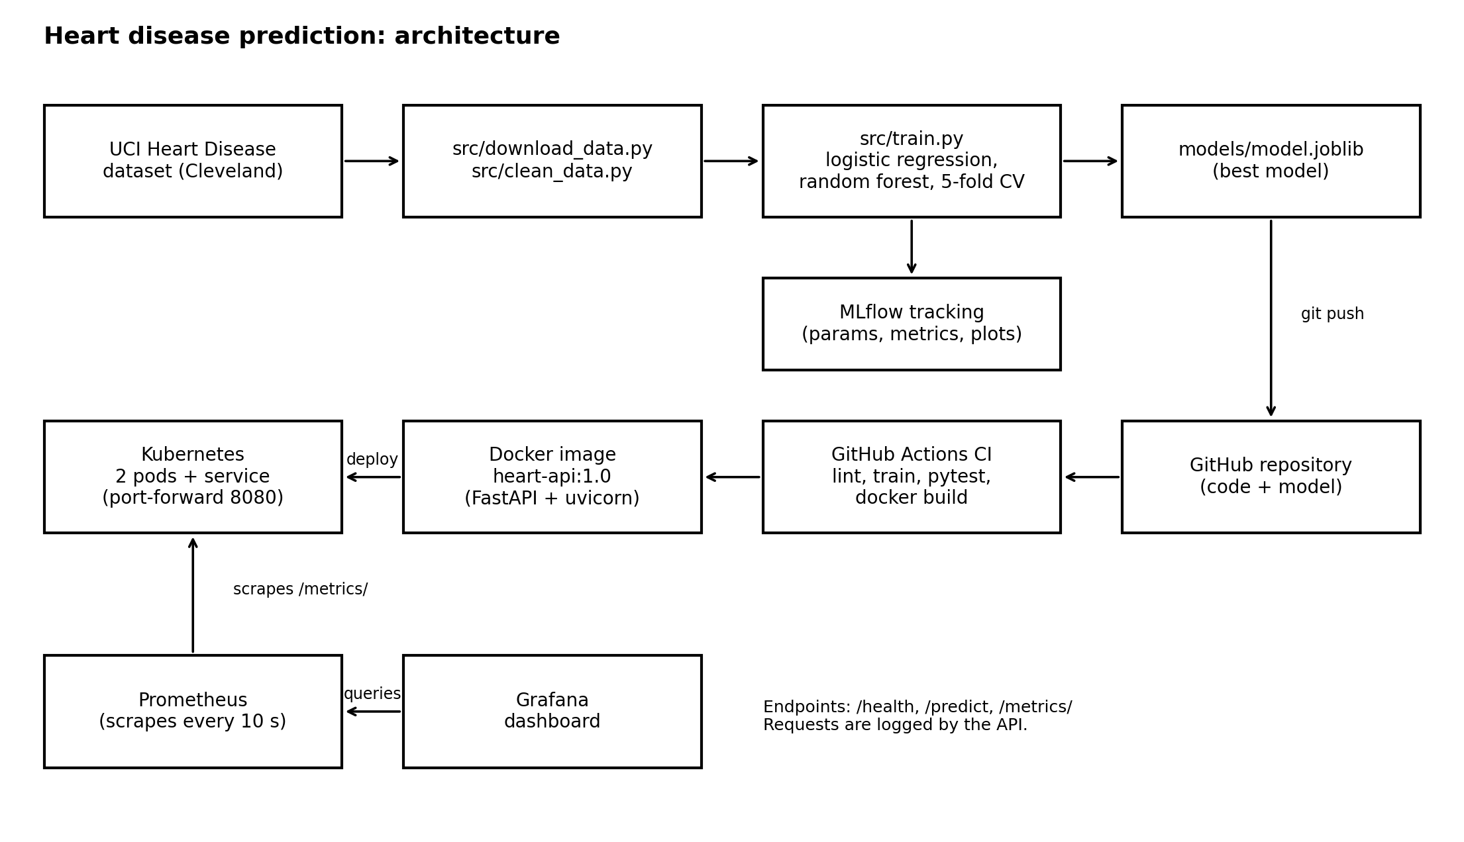
Data is downloaded and cleaned, the models are trained and tracked in MLflow, and the best model is saved. Code and model go to GitHub, where Actions runs the checks. The Docker image is deployed to Kubernetes, and Prometheus and Grafana monitor the running pods.

12. Limitations and conclusion
- Small dataset from one hospital (303 patients), so it may not generalise.
- Small test set, so metrics are indicative.
- It is a learning project, not a medical tool.
- The API has no authentication or HTTPS.
- No automatic retraining and no data drift monitoring.
- Kubernetes ran on a single-node local cluster, not a cloud cluster.

