MLOps Assignment 1

End-to-End ML Model Development, CI/CD and Production Deployment
Heart Disease Risk Prediction (UCI Cleveland dataset)

Name: Gopichand Konakala
ID: 2025AE05912
Code repository: https://github.com/gopichand458/heart-disease-mlops-assignment1

1. Introduction and problem statement
The goal is to predict whether a patient has heart disease from 13 routine clinical measurements and to ship that model as a monitored, containerised API.
The work follows an MLOps lifecycle: reproducible data preparation, tracked experiments, automated testing in CI, a Docker image, a Kubernetes deployment, and runtime monitoring.

2. Setup and installation
Tested on the Linux lab VM (Python 3.12, Docker 28, Minikube 1.35).
git clone https://github.com/gopichand458/heart-disease-mlops-assignment1
cd heart-disease-mlops-pipeline
python -m venv .venv && source .venv/bin/activate
pip install -r requirements-dev.txt
python scripts/download_data.py # downloads + cleans the dataset
python -m src.eda # EDA figures
python -m src.train # train, track in MLflow, save model
pytest # unit tests
make docker-build && make docker-run
bash scripts/deploy_k8s.sh # minikube deployment + monitoring

3. Data acquisition and EDA
The dataset is the Cleveland subset of the UCI Heart Disease data (303 patients, 13 features plus a 0-4 severity label). scripts/download_data.py downloads the file, adds column names and converts '?' to missing values; src/data.py then coerces types, binarises the target (0 = no disease, 1-4 = disease) and removes duplicates. Only 'ca' and 'thal' contain missing values. They are kept as NaN in the cleaned file and imputed inside the sklearn Pipeline so that imputation statistics are learned from training folds only, which prevents leakage into cross-validation.
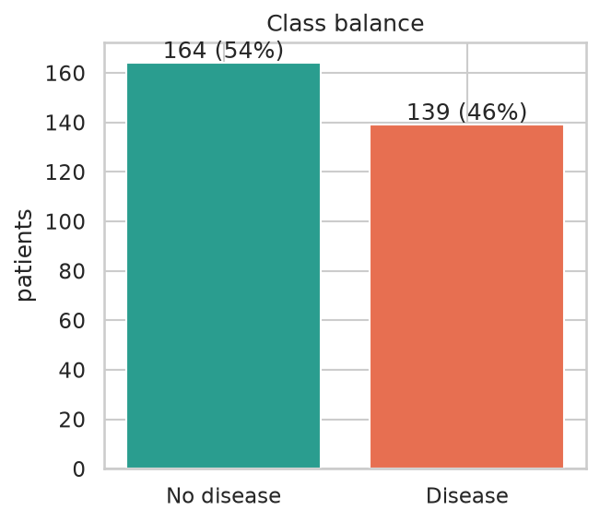
Figure 1 - Class balance
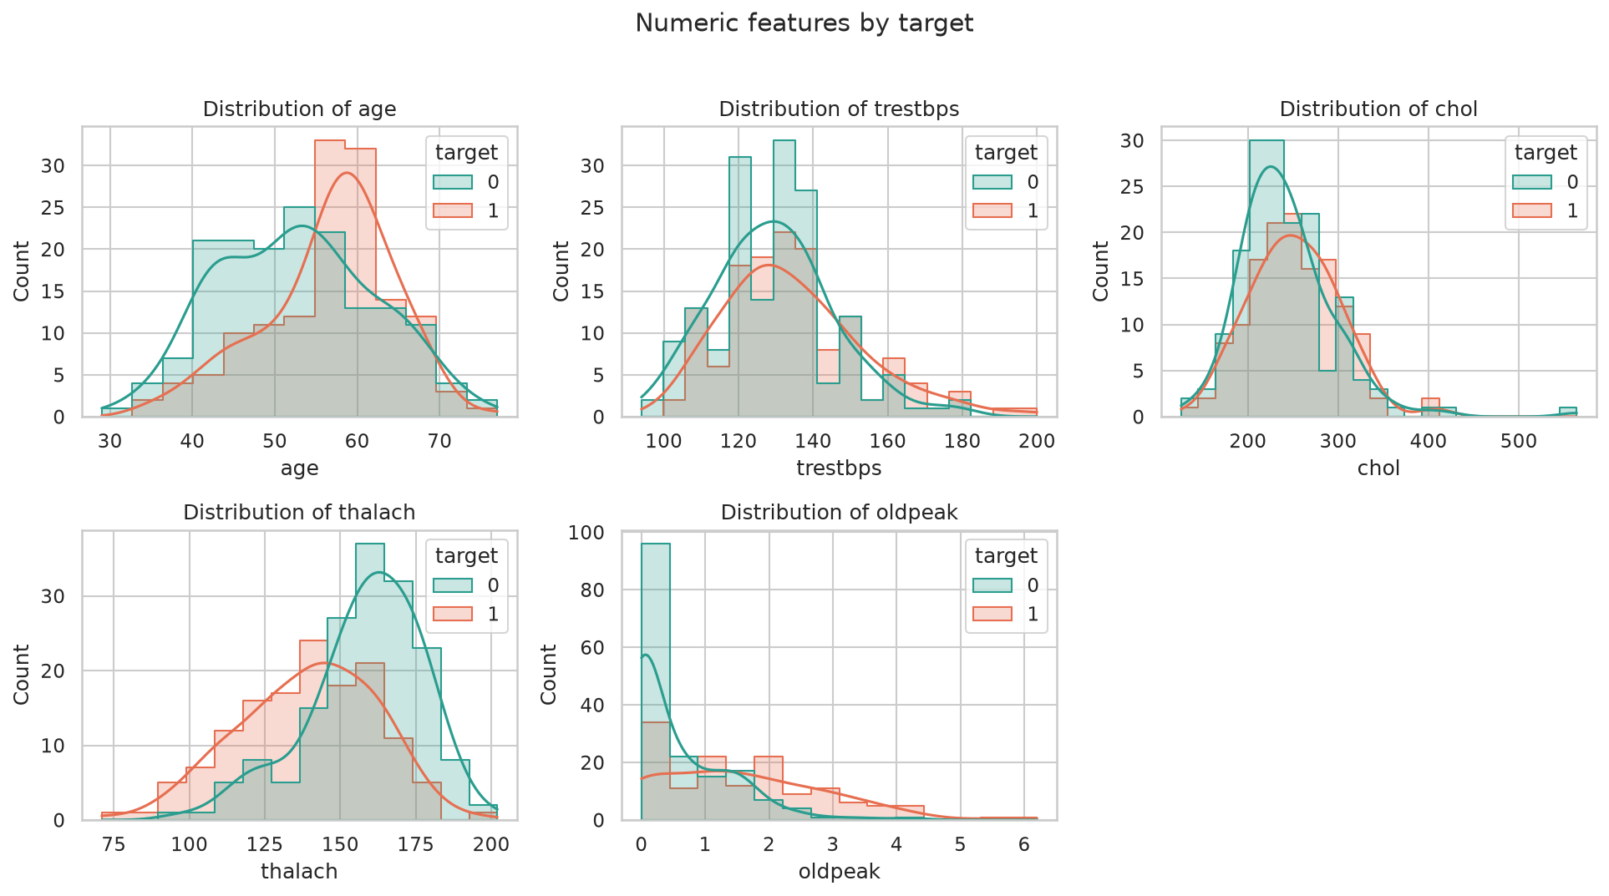
Figure 2 - Numeric feature distributions by target
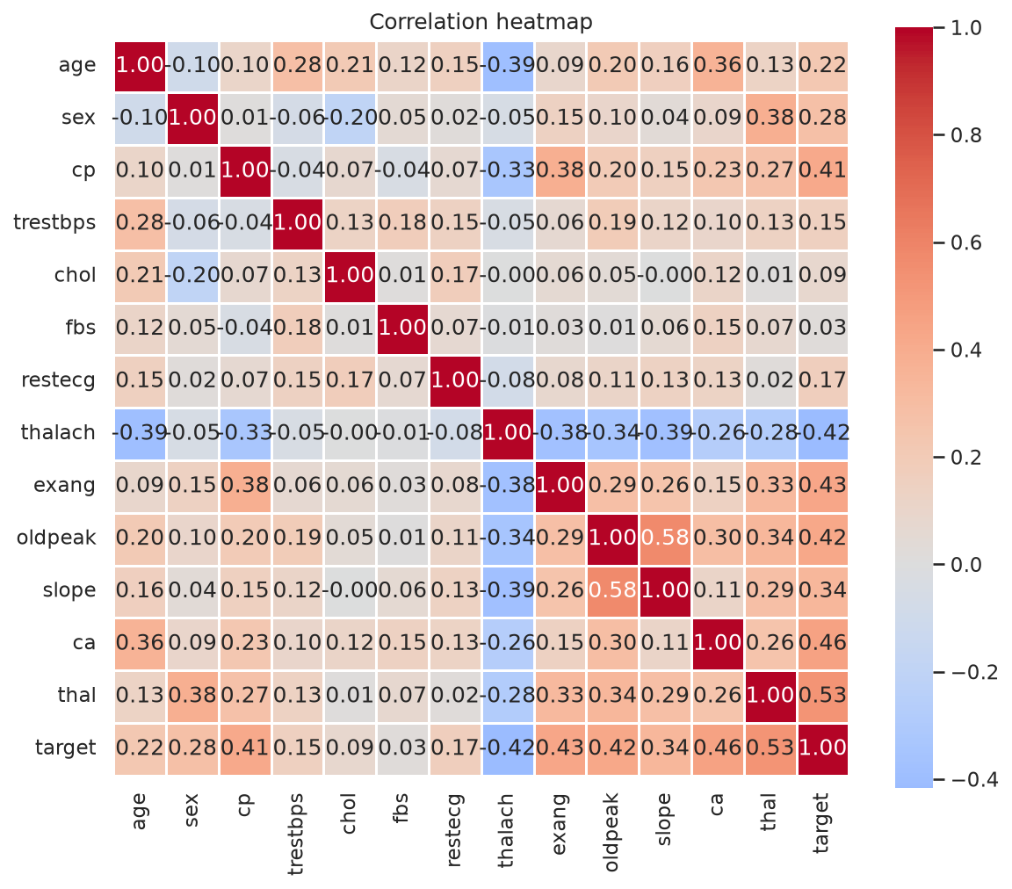
Figure 3 - Correlation heatmap
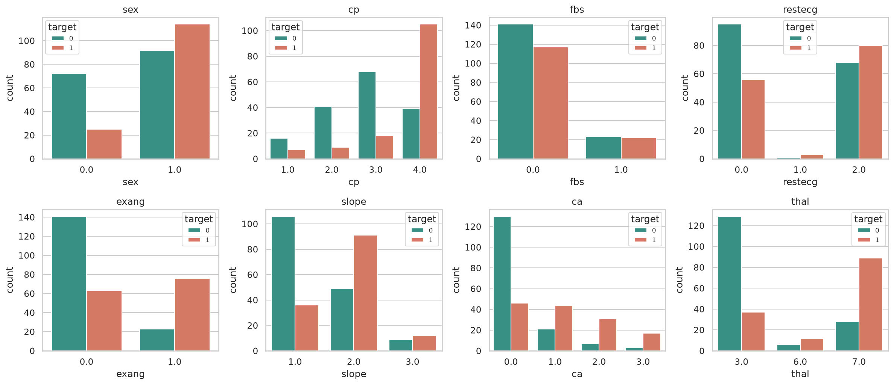
Figure 4 - Categorical features by target
Key observations from the EDA:
- Class balance: after cleaning there are 303 patients, 164 without disease (54%) and 139 with disease (46%). The classes are close to balanced, so accuracy is meaningful and no resampling was needed.
- Missing values: only 6 cells are missing (ca: 4, thal: 2), about 2% of rows, so imputation has very little influence on the results.
- Strongest relationships with the target (correlation): thal 0.53, ca 0.46, exang 0.43, oldpeak 0.42, cp 0.41 and thalach -0.42. Fasting blood sugar (0.03) and cholesterol (0.09) are almost uninformative on their own.
- Patients with disease reach a lower maximum heart rate (mean 139 vs 158 bpm), have more ST depression (oldpeak 1.6 vs 0.6) and are slightly older (56.6 vs 52.6 years).
- Categorical patterns: 73% of patients with asymptomatic chest pain (cp = 4) have disease versus 18-30% for the other chest pain types; 77% of patients with exercise angina have disease versus 31% without; 68-85% of patients with one or more coloured vessels (ca >= 1) have disease versus 26% with ca = 0; and 55% of men have disease versus 26% of women.
- Outliers: cholesterol reaches 564 mg/dl (4 patients above 400) and oldpeak exceeds 4 for 5 patients. These are clinically plausible, so they were kept; standard scaling and tree models limit their influence.
- Age and maximum heart rate are negatively correlated (-0.39), which motivated the engineered feature pct_max_hr (heart rate relative to the age-predicted maximum).

4. Feature engineering and model development
- Numeric features: median imputation then standardisation.
- Categorical features (sex, cp, fbs, restecg, exang, slope, ca, thal): mode imputation then one-hot encoding (unknown categories ignored at inference).
- Engineered feature pct_max_hr = thalach / (220 - age): the heart rate achieved relative to the age-predicted maximum.
- Three models were tuned with GridSearchCV (5-fold stratified, ROC-AUC): Logistic Regression, Random Forest and Gradient Boosting. The whole pipeline (preprocessing + model) is refit inside each fold.
- Evaluation: 5-fold CV on an 80% training split plus an untouched 20% hold-out test set; metrics are accuracy, precision, recall, F1 and ROC-AUC.
- Selection rule: highest cross-validated ROC-AUC. Selected model: random_forest.
Metric | 5-fold CV (train) | Hold-out test
Accuracy | 0.810 | 0.852
Precision | 0.830 | 0.806
Recall | 0.746 | 0.893
F1 | 0.779 | 0.847
ROC-AUC | 0.903 | 0.955

Model selection discussion:
- Cross-validated ROC-AUC was 0.903 for Random Forest, 0.903 for Logistic Regression and 0.881 for Gradient Boosting. Random Forest and Logistic Regression are effectively tied (the difference is 0.0003, far below the fold-to-fold standard deviation of about 0.02), so the choice follows the pre-defined rule of picking the highest CV score on the training data only. The hold-out set was not used to choose the model, which avoids selecting on test data. On the hold-out set Logistic Regression scored slightly higher (0.967 vs 0.955), but with only 61 test patients this gap is within noise.
- On the hold-out set the Random Forest produced 27 true negatives, 6 false positives, 3 false negatives and 25 true positives (precision 0.81, recall 0.89).
- For a screening use case a missed patient (false negative) is more costly than an extra referral (false positive), so recall matters more than precision. Cross-validated recall is lower (0.75, standard deviation 0.10), so in production the decision threshold could be lowered below 0.5 to trade precision for recall; the API also returns the probability and a risk band so that clinicians can apply their own threshold.
- The most important features (Random Forest) are thal, ca, chest pain type 4, the engineered pct_max_hr, thalach and oldpeak. This agrees with the correlations seen in the EDA, and the engineered feature ranks among the top five.
- Limitation: with 303 rows the metrics have wide uncertainty; results should be read as indicative rather than precise.

5. Experiment tracking (MLflow)
Each training invocation creates a parent run 'model-comparison' with one nested run per model. Logged: dataset size and class rate, best hyper-parameters, CV and test metrics, ROC curve, confusion matrix, feature-importance plot, grid-search results CSV and the fitted model with signature and input example. The parent run stores the model comparison chart and the final deployable artifacts.
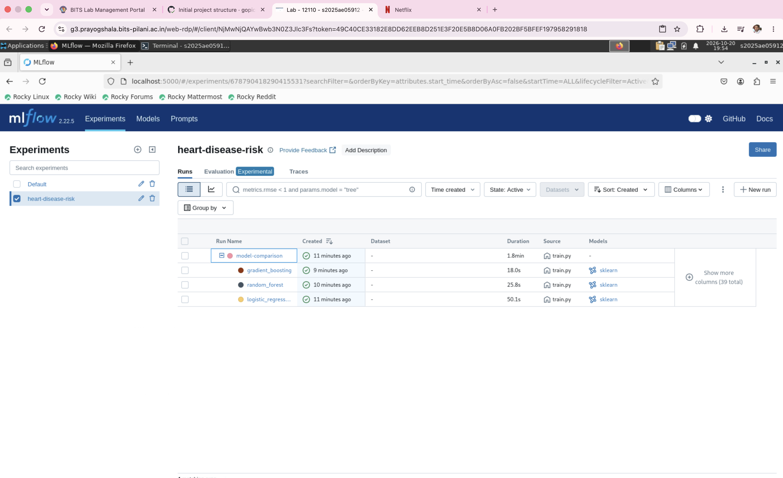
Figure 5 - MLflow experiment runs
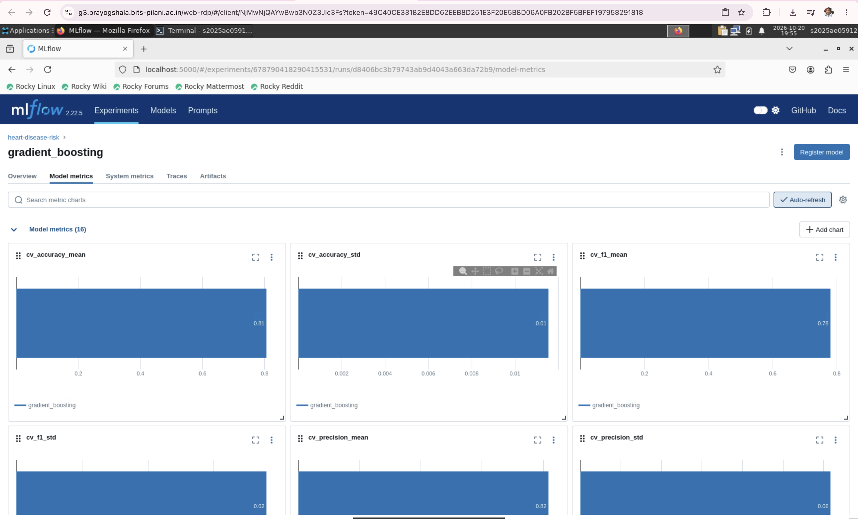
Figure 6 - MLflow run comparison / metrics

6. Model packaging and reproducibility
- A single sklearn Pipeline (preprocessing + model) is saved as models/best_model.joblib and in MLflow format (models/mlflow_model) so raw patient fields can be scored directly.
- models/model_metadata.json records the version, git SHA, library versions, features and metrics.
- requirements.txt (training), requirements-dev.txt (testing/docs), requirements-serve.txt (minimal serving image). Random seeds are fixed.

7. CI/CD pipeline and automated testing
tests/ contains unit tests for data cleaning, the feature pipeline, modelling and metrics, and the API (validation, prediction schema, metrics endpoint, request logging). The GitHub Actions workflow (.github/workflows/ci.yml) runs flake8, pytest with coverage, trains the models, and uploads test reports, the model and MLflow runs as artifacts; a second job builds the Docker image and smoke-tests /predict. Any lint or test failure stops the pipeline.
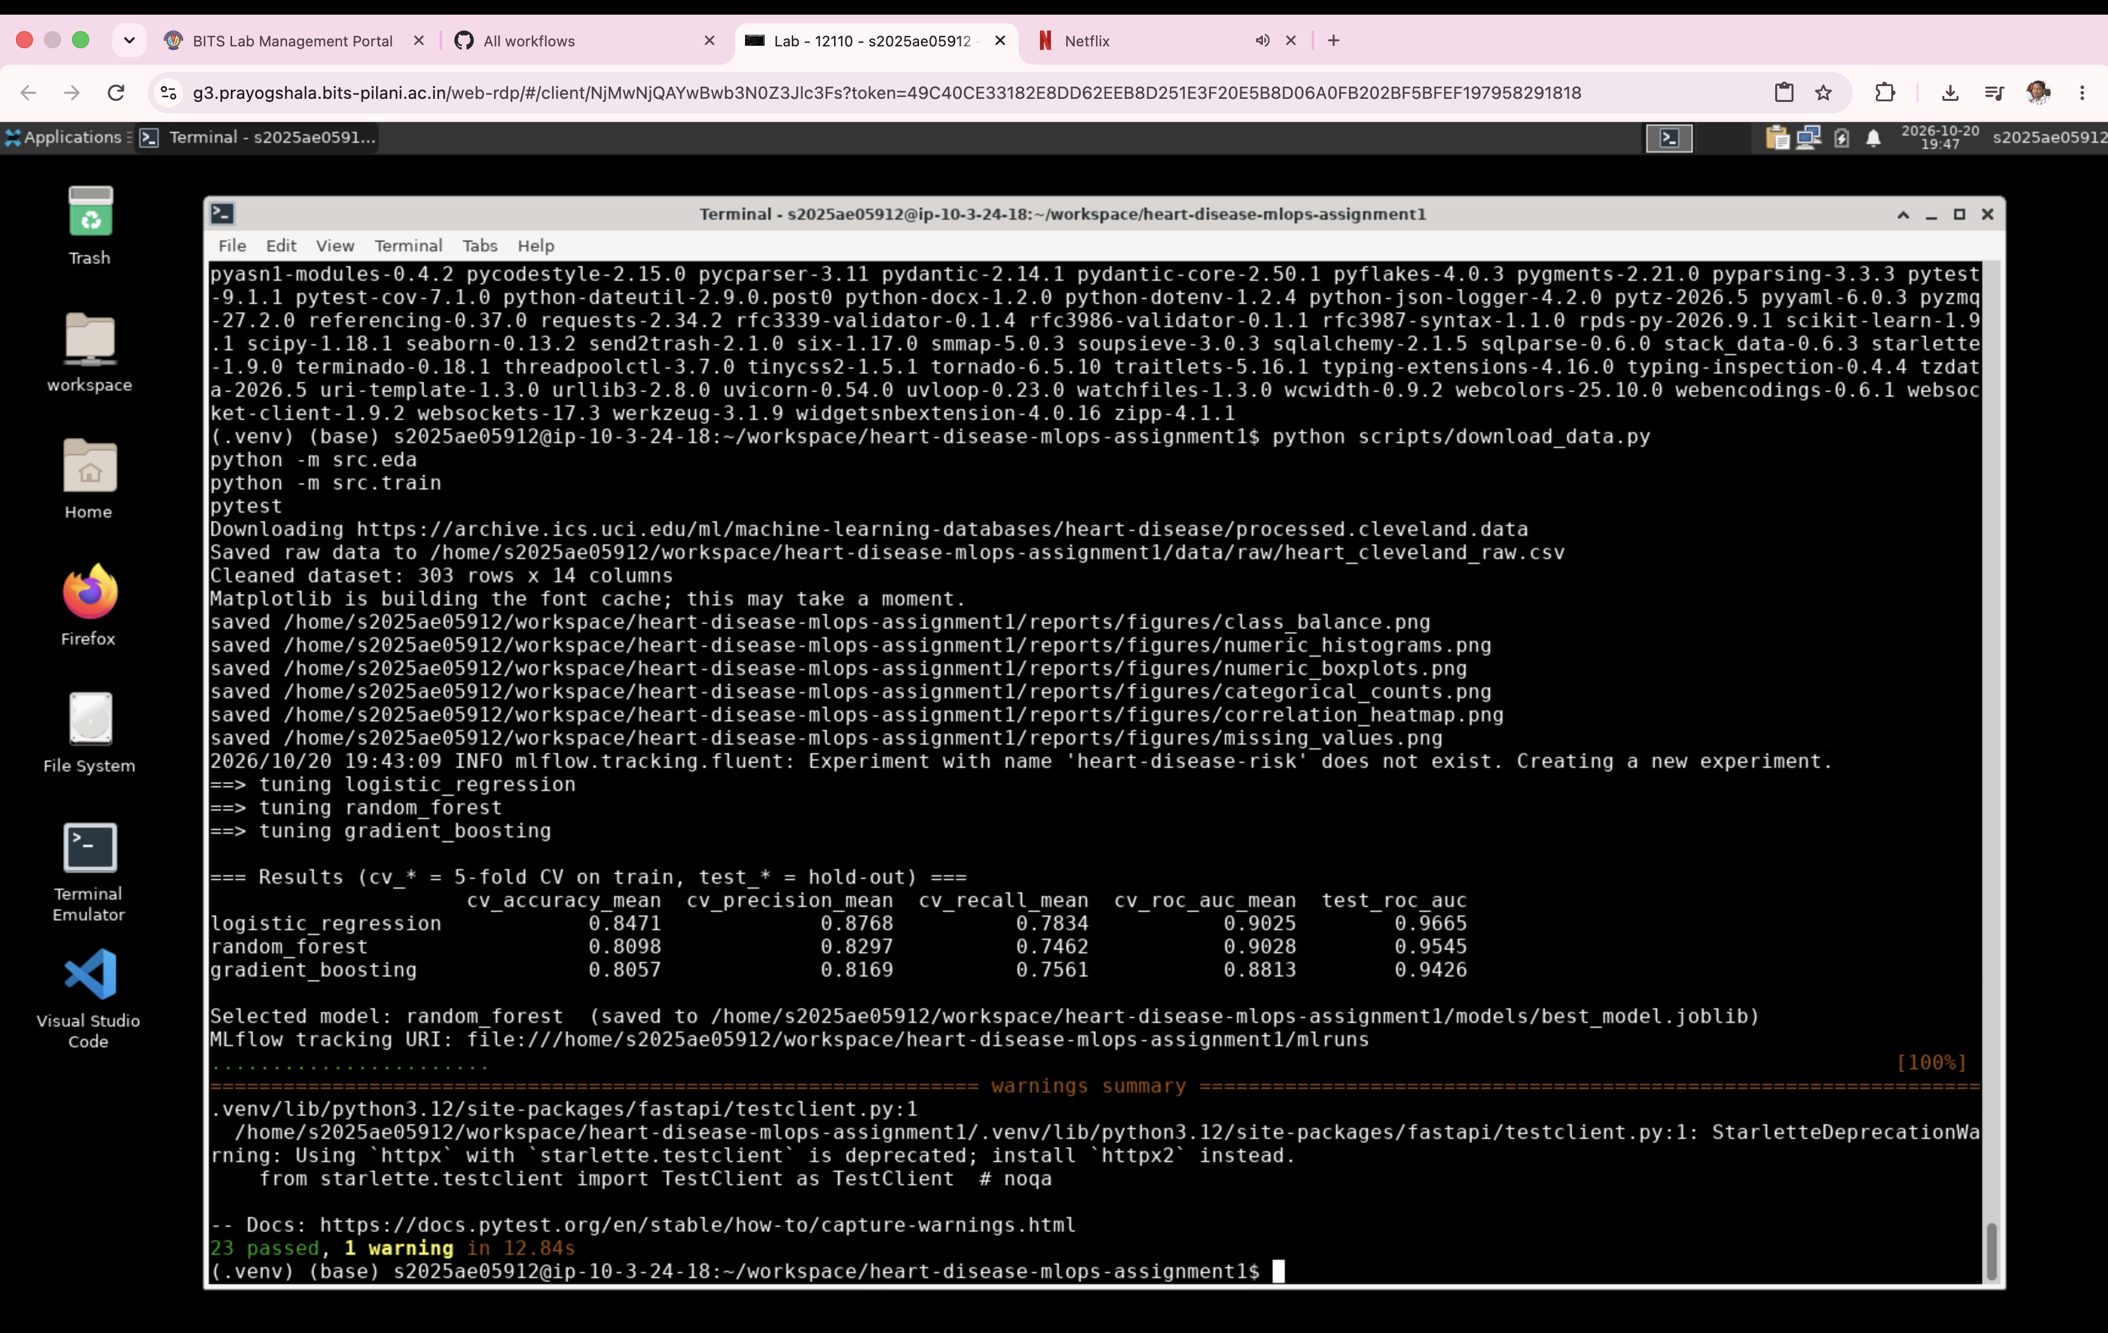
Figure 7 - Local pytest run
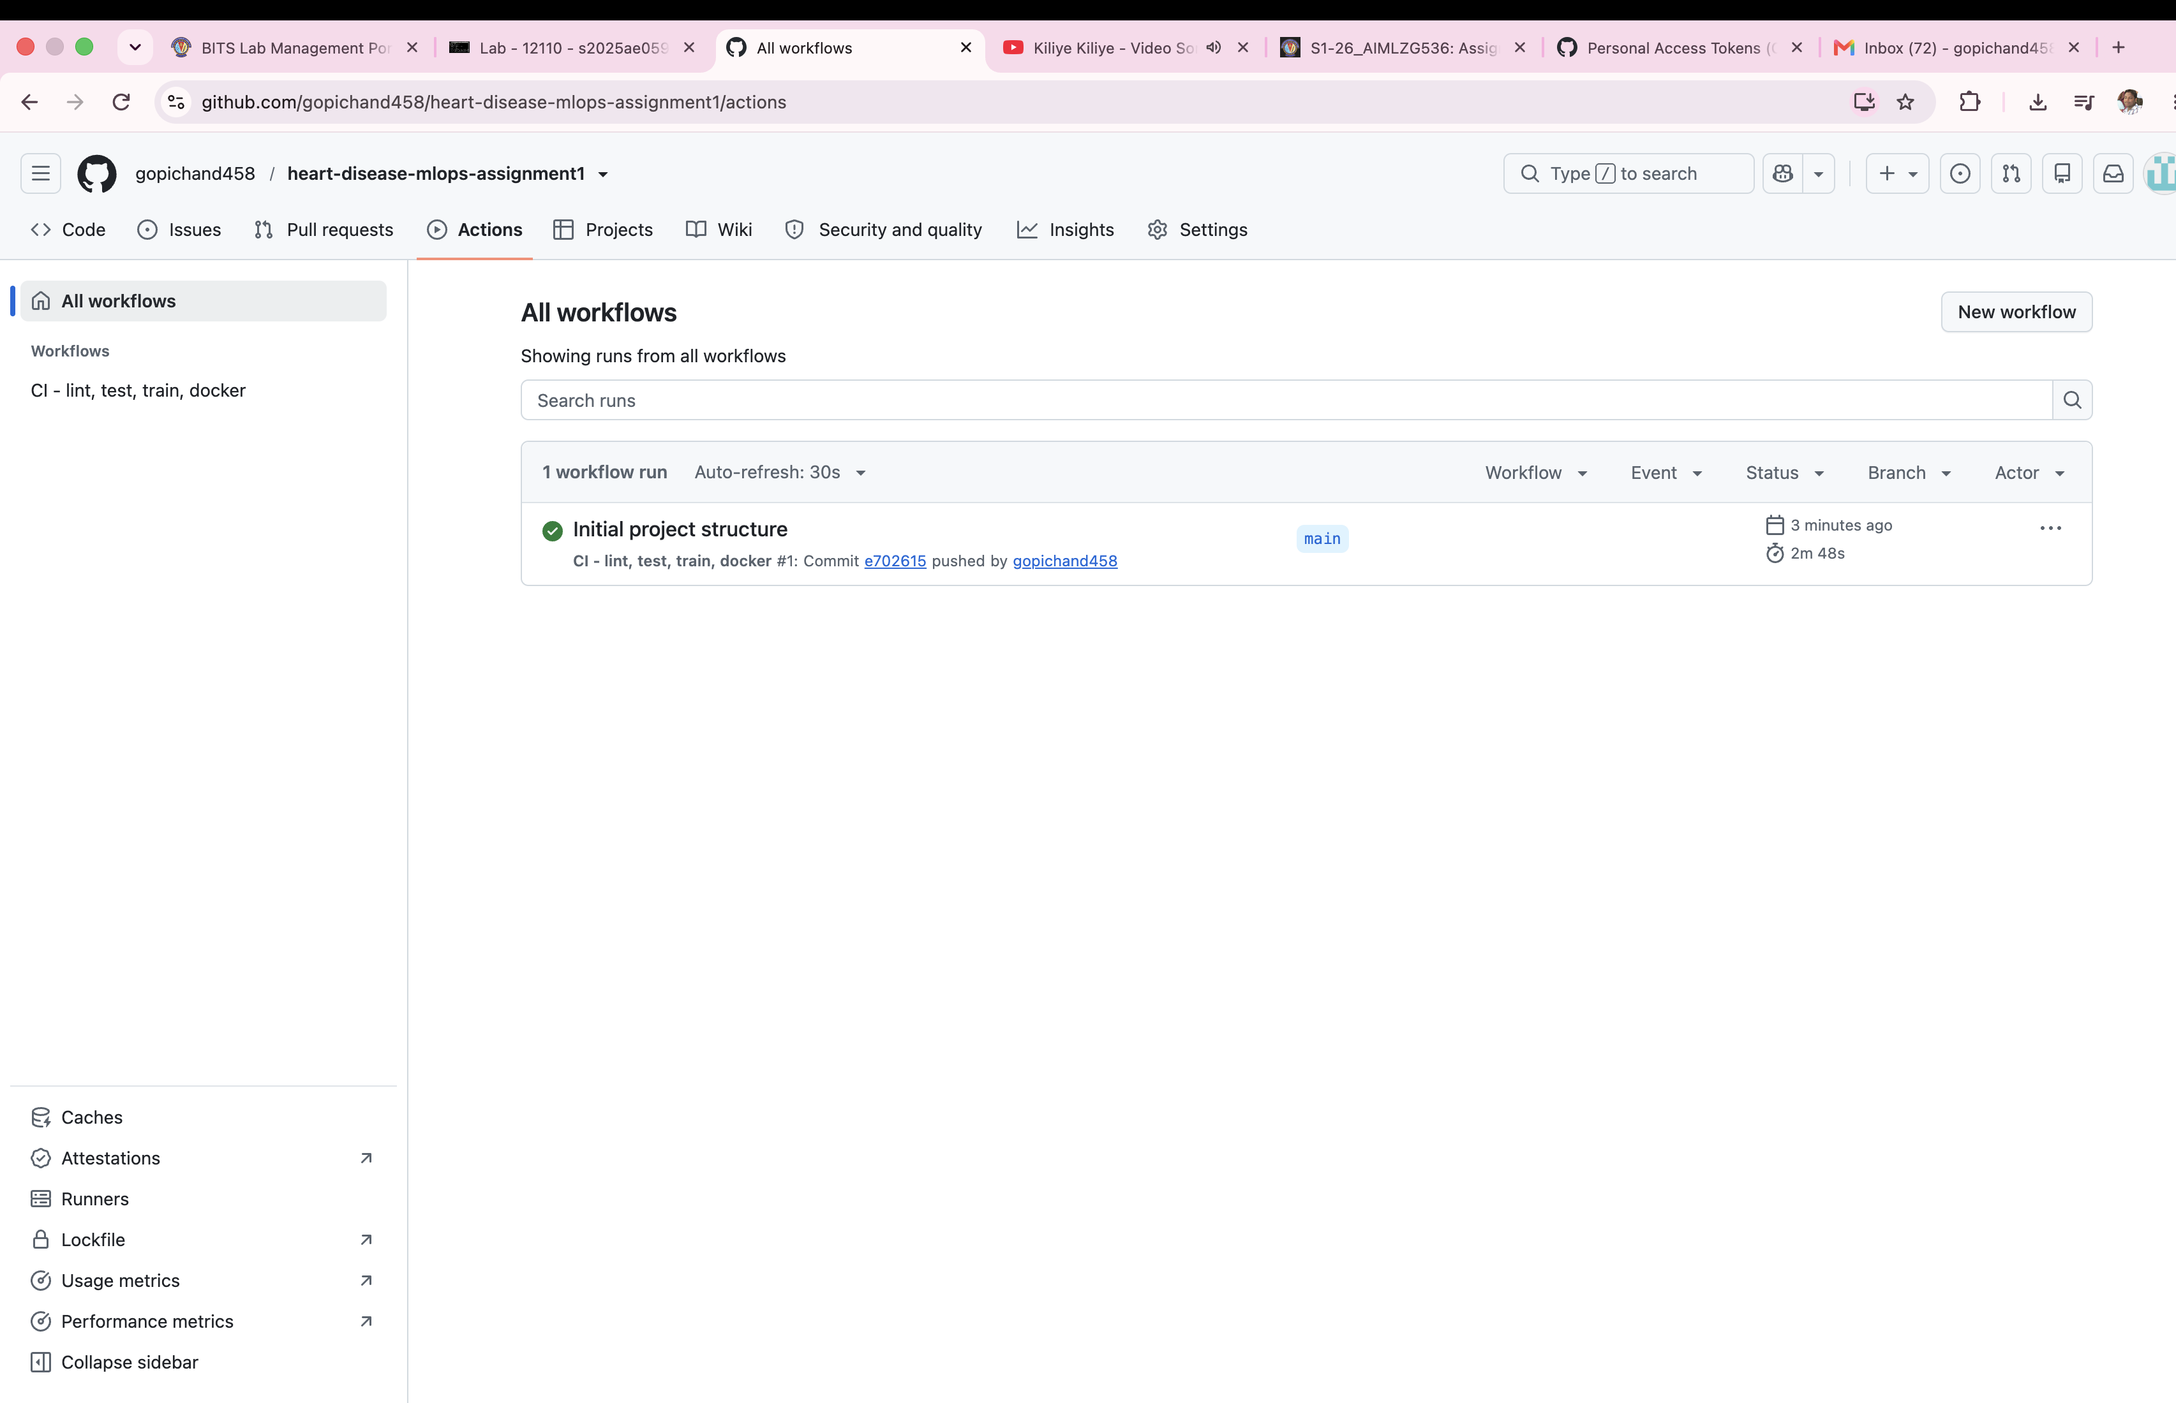
Figure 8 - Successful GitHub Actions run
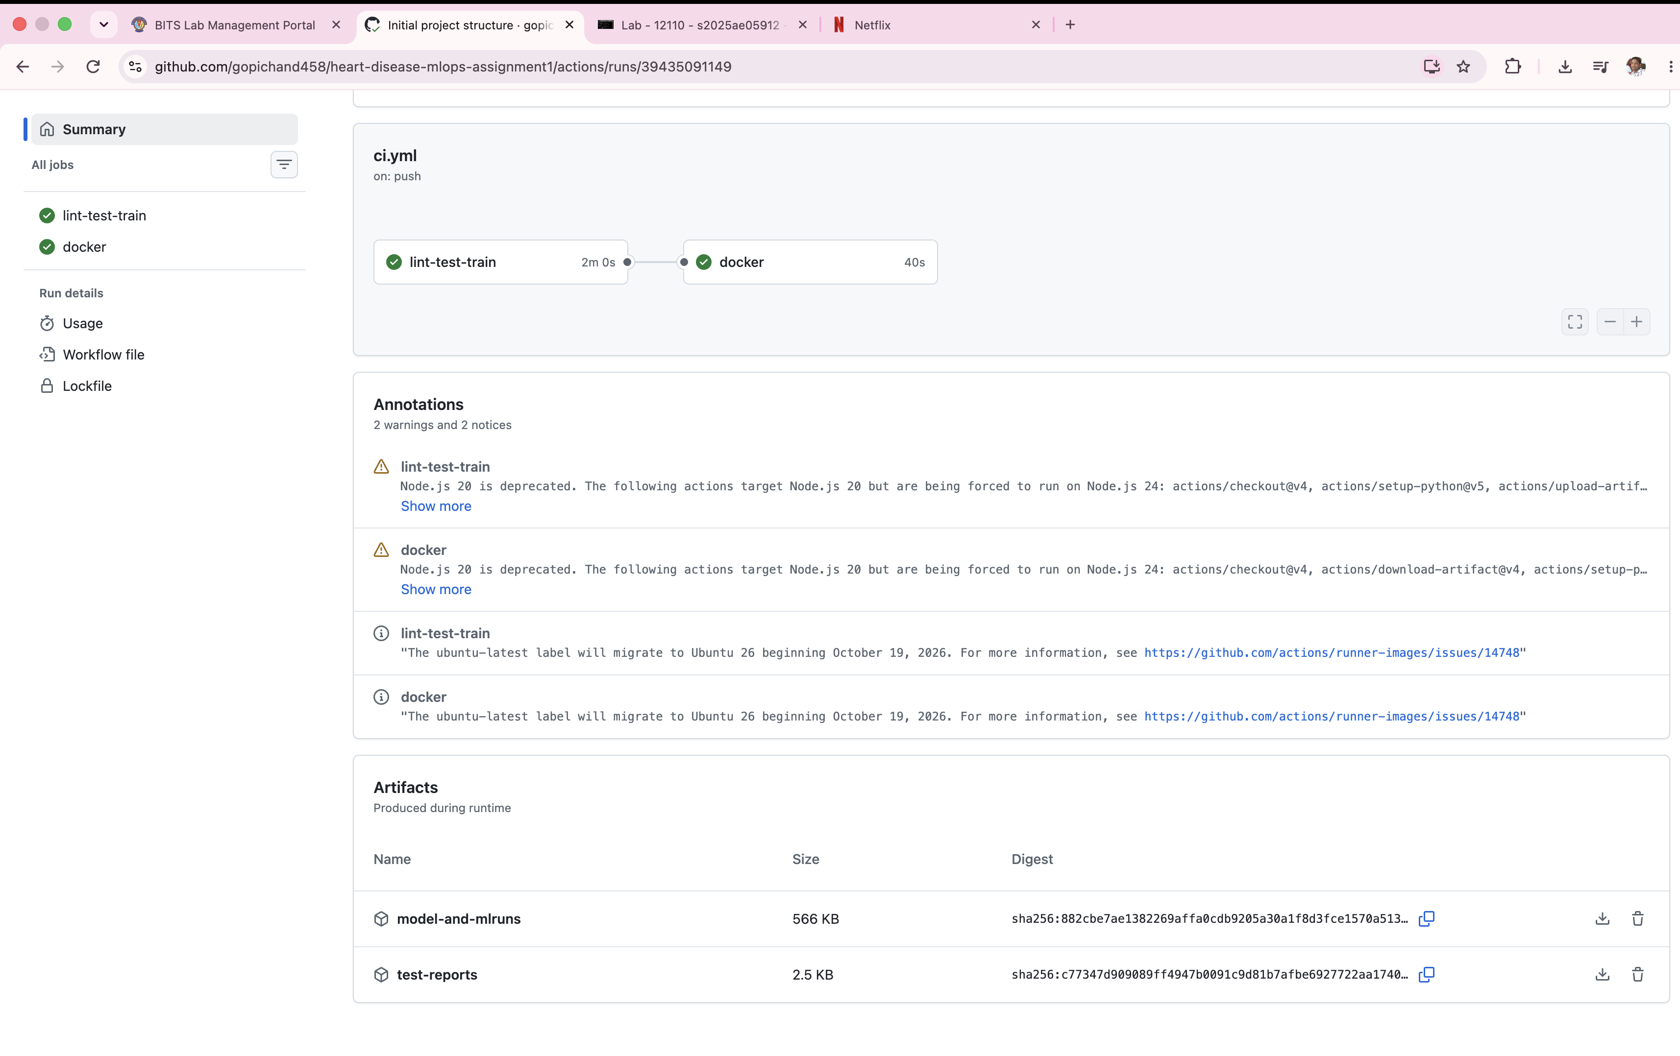
Figure 9 - Workflow artifacts
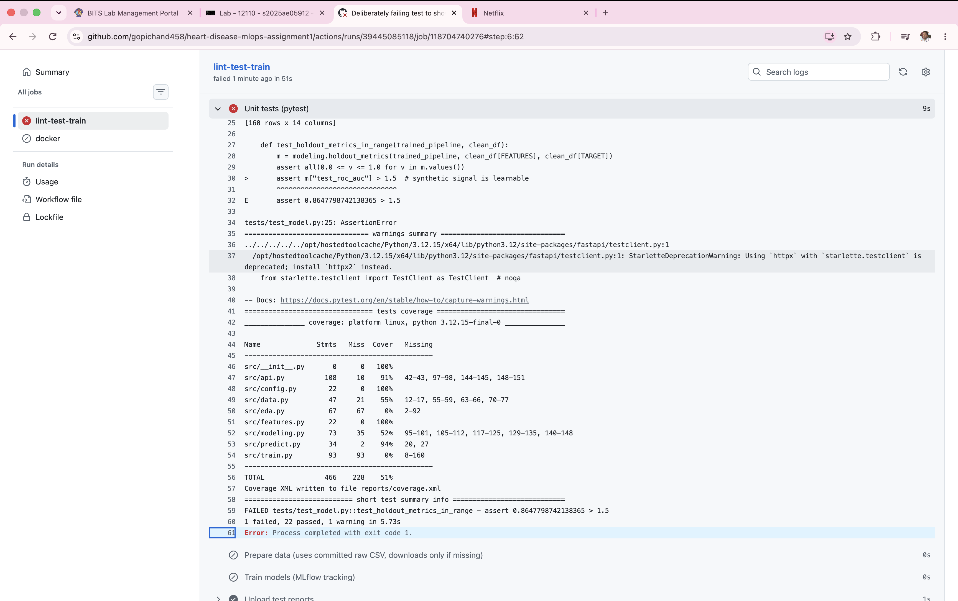
Figure 10 - Pipeline failing on a deliberate error

8. Containerisation
The API (FastAPI) exposes POST /predict (JSON in; prediction, confidence, probability and risk band out), GET /health and GET /metrics. Inputs are validated with Pydantic ranges (invalid data returns HTTP 422). The image uses python:3.12-slim, runs as a non-root user and has a health check.
docker build --build-arg SKLEARN_VERSION=$(python -c 'import sklearn;print(sklearn.__version__)') -t heart-disease-api:1.0 .
docker run -d -p 8000:8000 heart-disease-api:1.0
bash scripts/smoke_test.sh
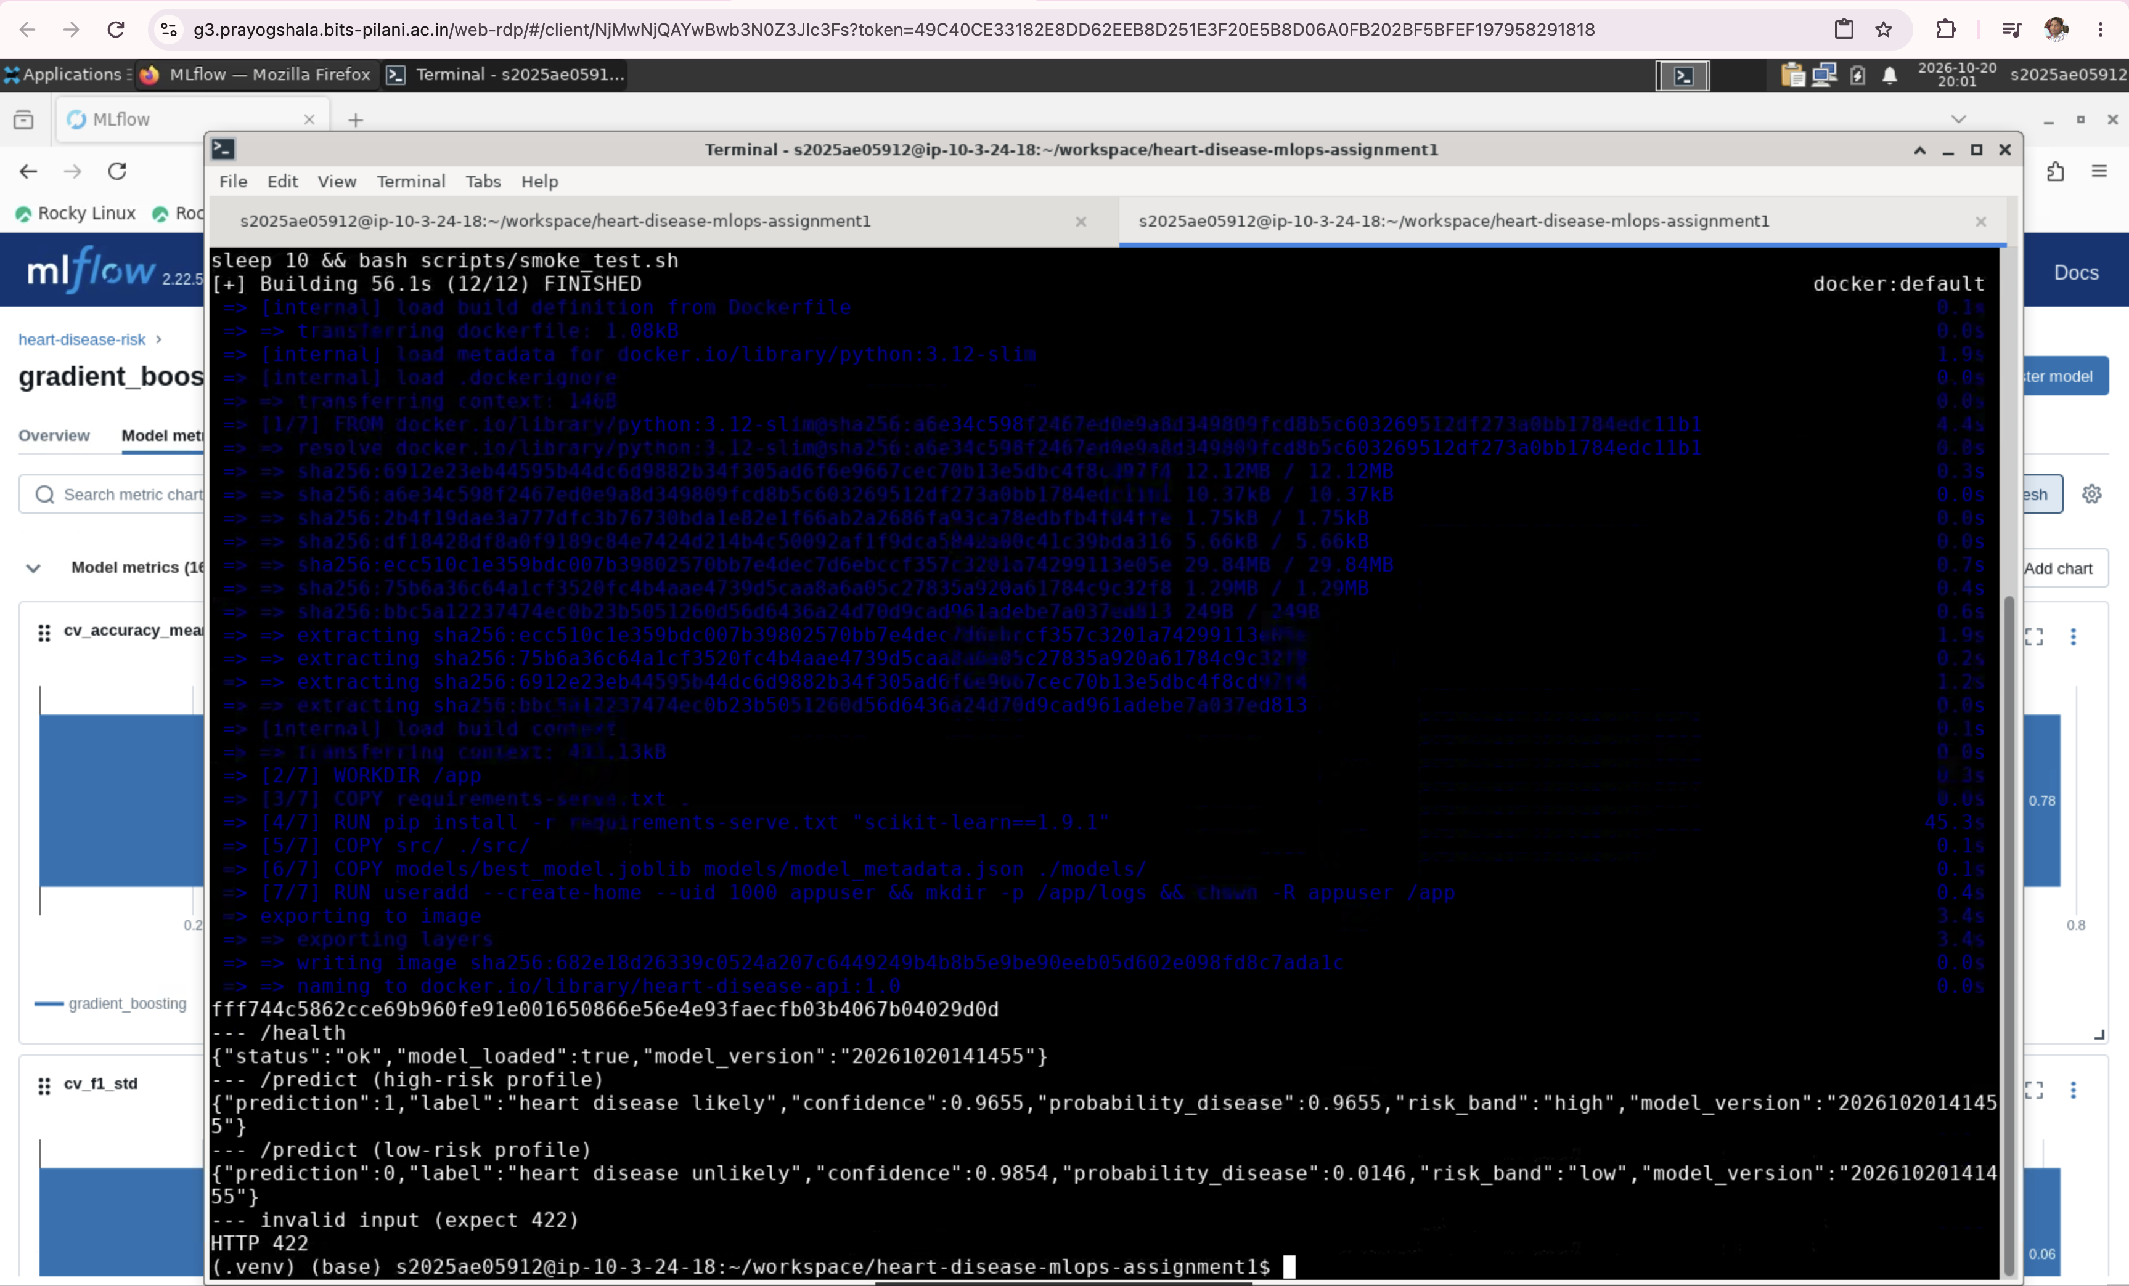
Figure 11 - Container build/run and sample prediction

9. Production deployment (Kubernetes)
The image is deployed to Minikube with k8s/deployment.yaml (2 replicas, readiness and liveness probes, resource requests/limits) and k8s/service.yaml (type LoadBalancer, exposed with 'minikube tunnel'); k8s/ingress.yaml is an optional ingress alternative.
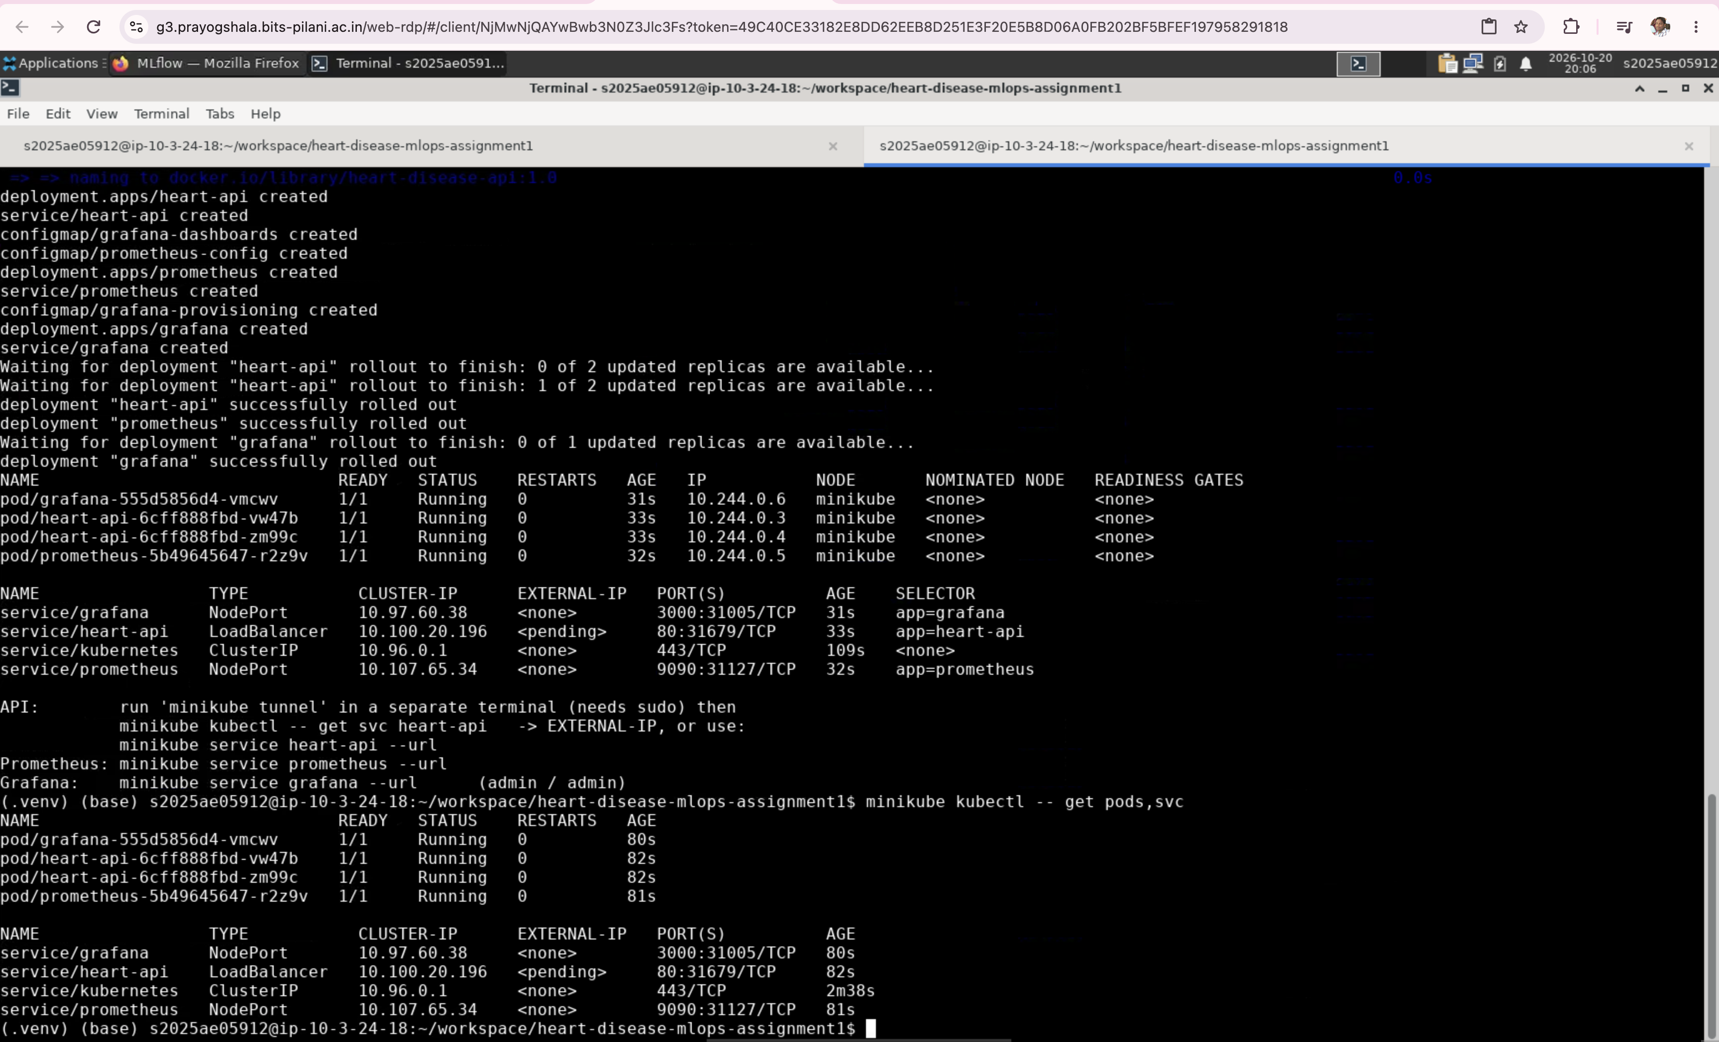
Figure 12 - Pods and service
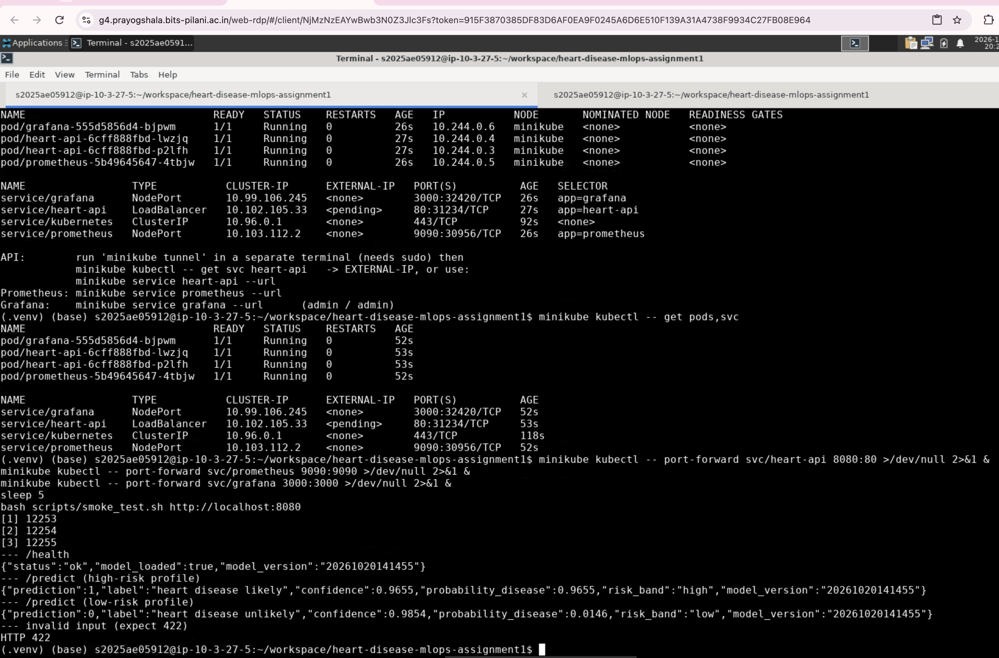
Figure 13 - Endpoint verified through the service

10. Monitoring and logging
Every request is logged as one JSON line (id, method, path, status, latency) to stdout and logs/api.log. Prometheus scrapes /metrics (api_requests_total, api_request_latency_seconds, predictions_total by risk band, prediction_errors_total) and Grafana shows a provisioned dashboard.
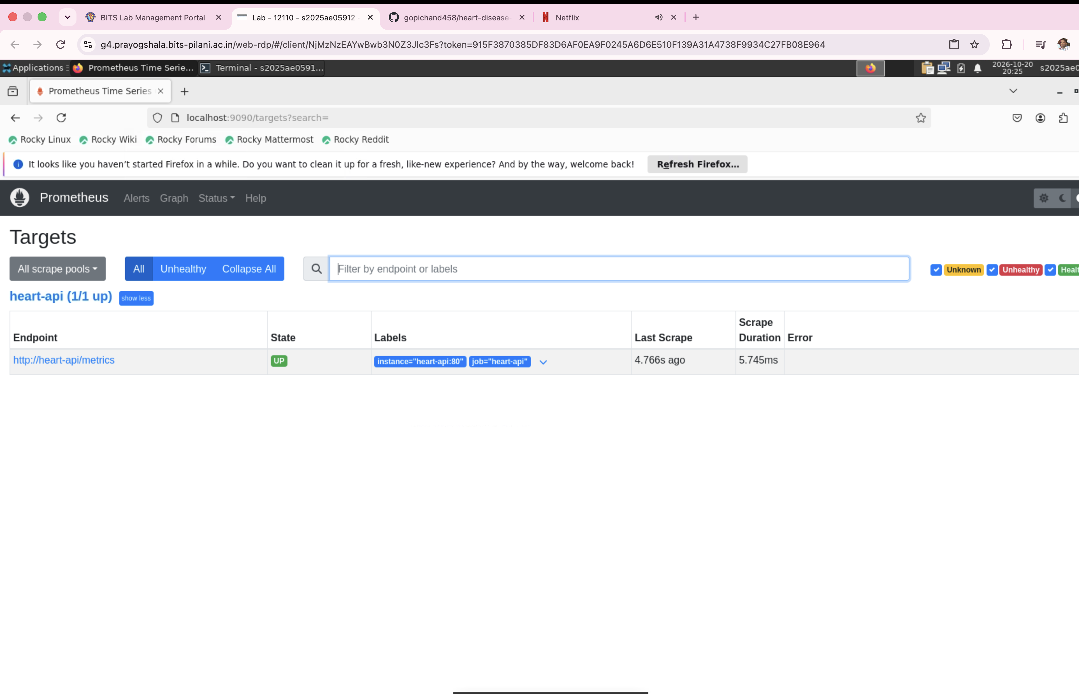
Figure 14 - Prometheus target UP
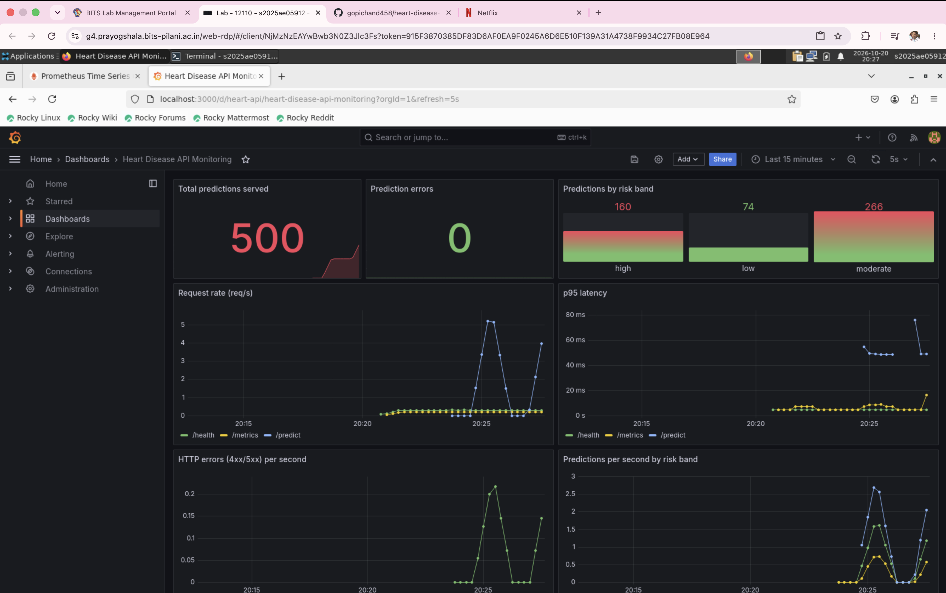
Figure 15 - Grafana dashboard

11. Architecture
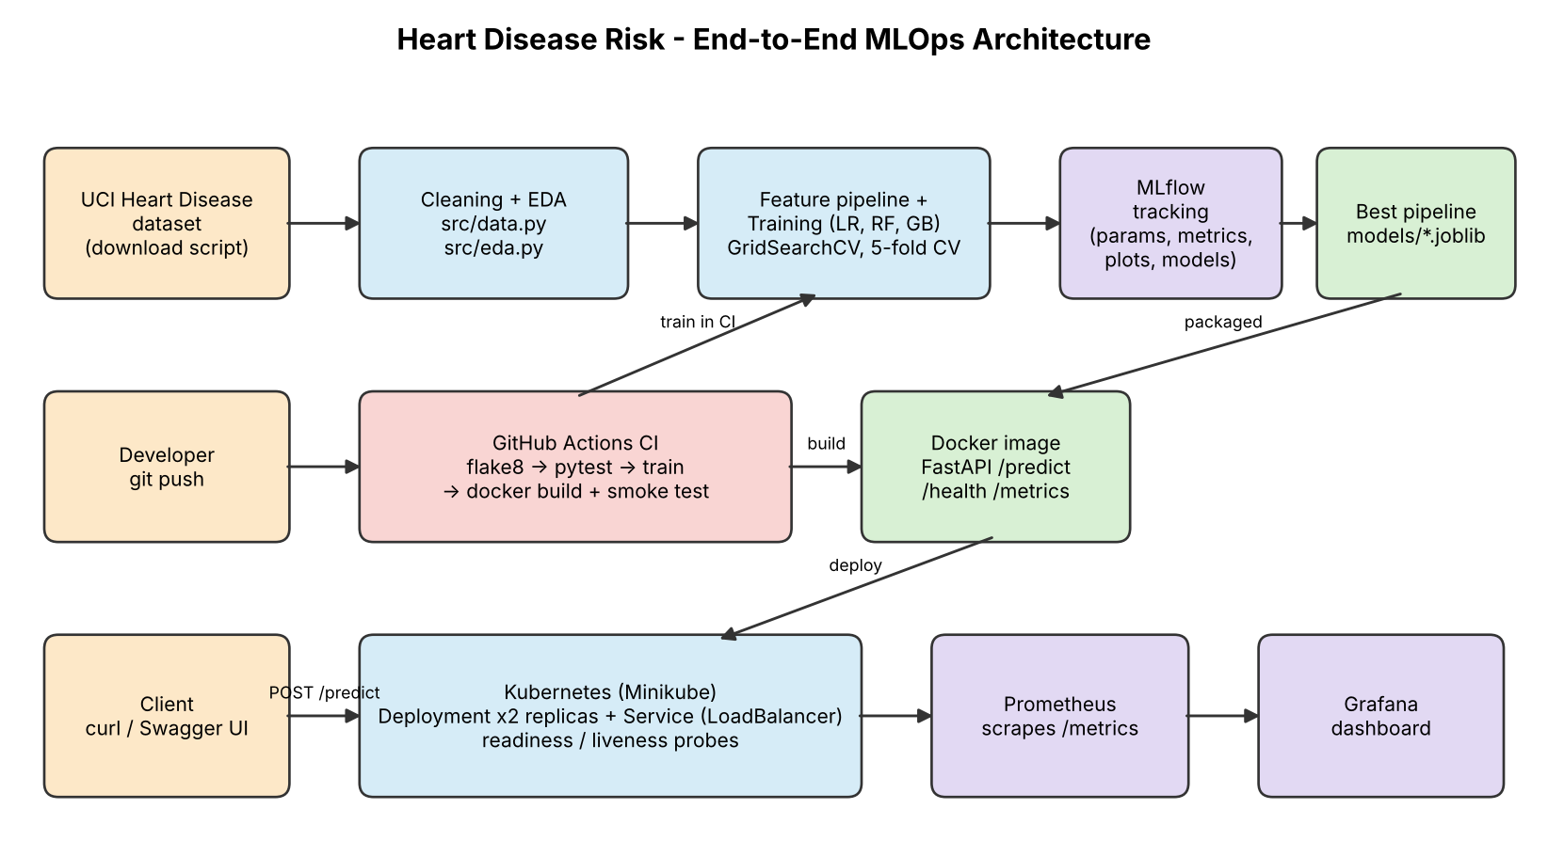
Figure 16 - End-to-end architecture

12. Conclusion, limitations and future work
- The small dataset (303 rows) limits the stability of the metrics; confidence intervals would be wide.
- Future work: model registry and promotion stages, data/prediction drift monitoring, canary deployments, Helm packaging, HPA autoscaling.
- This model is an educational exercise and not a medical device.

References
- UCI Machine Learning Repository - Heart Disease dataset.
- MLflow, scikit-learn, FastAPI, Prometheus and Grafana documentation.
- Repository: https://github.com/gopichand458/heart-disease-mlops-assignment1

