StudySpace
Complete Product & UI/UX Specification
A simple responsive study website for organized learning, progress, and revision.

1. Product Purpose
StudySpace is a simple personal study website for the user and their friend to study together without confusion. Its purpose is to provide a clear line of learning: what should be studied, what has been studied, what has been completed, what remains, how progress is changing, and how topics can be revised.
Keep the implementation simple and focused on the requirements below. Do not add unrelated or unnecessary features.

2. Initial State
[IMPORTANT] The application must start with NO predefined roadmaps, topics, subtopics, study content, or revision images. The user creates all roadmaps and study content.
When there is no content, show a clean empty state with appropriate Add Roadmap / Add Content actions.

3. Basic User Flow
- Open website.
- Log in.
- See roadmaps.
- See personal Study Space.

4. Roadmaps
Roadmaps define the learning structure.
Structure: Roadmap → Main Topic → Subtopics → Study / Revision Content
The same structure and editing behavior applies to every roadmap.

5. User-Created Roadmaps
Users can create their own roadmaps through an Add Roadmap action.
The user enters a roadmap name, saves it, and the new roadmap appears in the roadmap list.

6. Add Content to Any Roadmap
Every roadmap has an Add Content action at the bottom.
- Enter main heading / main topic name.
- Add multiple subtopic names.
- Save.
- Return to the normal roadmap view.
- Show the newly added content immediately.
Example: if a roadmap has 20 topics and the user wants to add 5 more, they use Add Content, enter the main heading and subtopics, save, and the roadmap updates.

7. Dynamic Progress
[IMPORTANT] Progress must be calculated automatically from the actual roadmap content and completion status.
Progress % = (Completed items / Total items) × 100
Example: 10 completed out of 20 = 50%. If 5 unfinished items are added, total becomes 25 and progress becomes 10/25 = 40%. Completing or adding content must automatically update the progress bar.
No manual percentage entry is required.

8. Progress for Every Roadmap
Every roadmap, including user-created roadmaps, must show its own synchronized progress.
- Roadmap name
- Completed / total count
- Progress percentage
- Visual progress bar

9. Personal Study Space
Each logged-in user has a personal Study Space showing their own learning state.
- What I have studied
- What I should study
- What I have completed according to the roadmap
- What I should complete / what remains
- How my progress is going
- Revision cards for topics and subtopics

10. Revision Cards
Revision cards are organized around roadmap topics and subtopics so the user can revise specific learning areas.
Structure: Roadmap → Topic → Subtopic → Revision Cards / Revision Images

11. Revision Images
The user can create an image anywhere outside the application and upload it into StudySpace for revision.
- Upload the image.
- Associate it with the relevant revision/topic area.
- Display the image visibly as a thumbnail/card.
- Click the image to open it large.
- Click X to close the large viewer.
- Return to the previous images page.

12. Responsive Website
[IMPORTANT] The product should be an interactive responsive website.
The same website must work properly on laptop/desktop, tablet, and mobile. The layout should adapt to screen size without changing the core functionality.
- Desktop / laptop preview
- Tablet preview
- Mobile preview

13. UI/UX Design Direction
The interface should be minimal, calm, clean, and focused on studying.
- White as the primary base.
- Gray tones for secondary UI.
- Dark neutral text where needed.
- Restrained glassmorphism only where useful.
- Subtle borders and shadows.
- Clean rounded cards.
- Simple typography.
- Minimal icons.
- Clear spacing and hierarchy.
- No unnecessary colors.
- No excessive gradients or decorative elements.
[IMPORTANT UI RULE] Use color only when it has a clear UI purpose.

14. Approved Visual Reference
The generated preview below is the preferred visual direction. The reference is good and should be retained as the design direction. The written requirements in this document remain the source of truth.
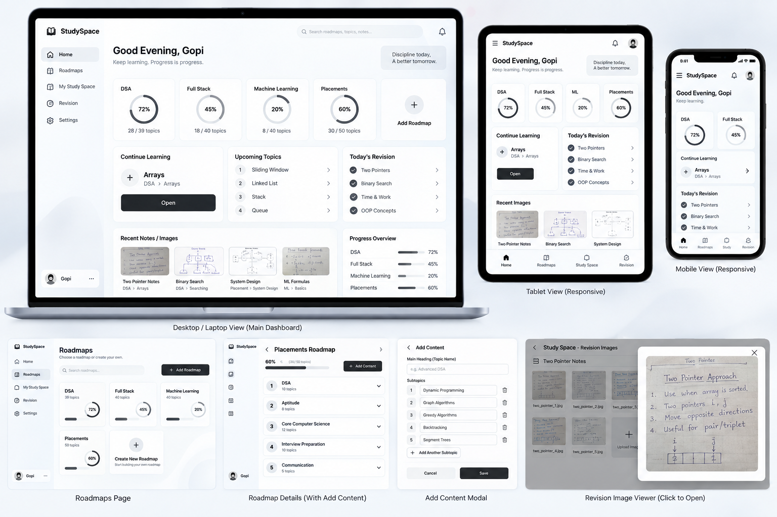
Responsive StudySpace UI reference preview

15. Required Screens / Views
- Login screen
- Roadmaps list
- Empty roadmaps state
- Personal Study Space
- Individual roadmap
- Add Roadmap interface
- Add Content interface
- Updated roadmap after saving
- Revision images page
- Large revision image viewer

16. Interaction Examples

New user
Login → Roadmaps → Empty state → Add Roadmap → Save → Roadmap appears → Add Content → Save → Content appears.

Adding content
Open roadmap → Add Content → Enter main heading → Add subtopics → Save → Return to roadmap → New content appears → total count changes → progress recalculates.

Completing learning
Open roadmap → study topic/subtopic → mark completed → completion state changes → Study Space updates → progress bar updates.

Revision image
Open revision area → upload image → thumbnail appears → click image → large viewer → click X → images page.

17. Functional Requirements
ID | Requirement
FR-01 | User can log in.
FR-02 | User can see roadmaps.
FR-03 | User can create a roadmap.
FR-04 | User can add main topics/content.
FR-05 | User can add subtopics.
FR-06 | Saved content appears in the normal roadmap.
FR-07 | All roadmaps use the same editing behavior.
FR-08 | User has a personal Study Space.
FR-09 | Study Space shows studied, next, completed, remaining, and progress information.
FR-10 | User can mark roadmap items completed.
FR-11 | Progress is calculated dynamically.
FR-12 | Progress bar synchronizes with completion and content changes.
FR-13 | Revision cards are associated with topics/subtopics.
FR-14 | User can upload revision images.
FR-15 | Uploaded images are visibly displayed.
FR-16 | Clicking an image opens a large viewer.
FR-17 | X closes the viewer and returns to the images page.
FR-18 | Website responds across desktop, tablet, and mobile.
FR-19 | Initial application contains no predefined roadmap or study content.

18. Final Build Instruction
Create StudySpace as a simple responsive interactive website. Start with a login. After login, show roadmaps and the user's personal Study Space. Do not pre-populate any roadmap, topic, subtopic, study material, or revision image.
Users create their own roadmaps. Every roadmap supports Add Content, where the user enters a main heading and multiple subtopics, saves, and returns to the updated roadmap. The same behavior applies to all roadmaps.
The Study Space must show what the user has studied, what should be studied, completed items, remaining items, and progress. Progress is dynamically calculated from the current roadmap and completion state, and the progress bar must automatically synchronize whenever content is added or completed.
Provide revision cards for topics and subtopics. Users can upload images created elsewhere. Display those images as interactive thumbnails; clicking one opens a large viewer, and clicking X returns to the images page.
Use a minimal white-and-gray visual system with restrained glassmorphism, subtle borders, soft shadows, and clear typography. Avoid unnecessary colors. Make the website responsive across laptop/desktop, tablet, and mobile. Use the attached generated preview as the visual reference.

