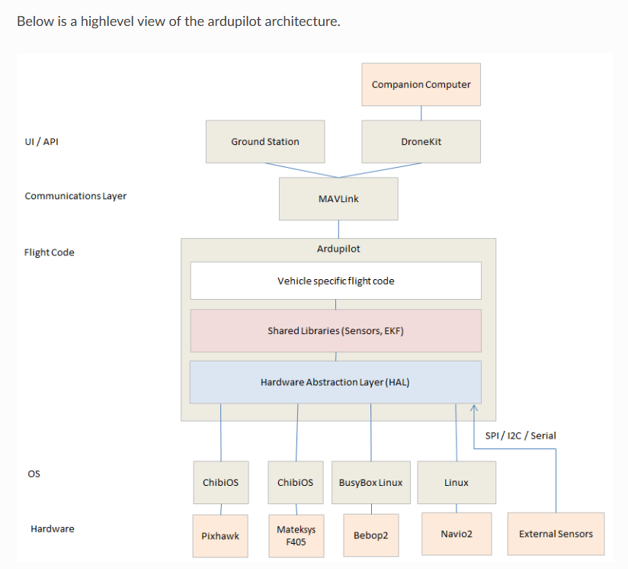
Sensor Drivers

Supported Protocols

I2C, SPI, UART (aka Serial) and CANBUS (in particular UAVCAN/DroneCAN) protocols are supported
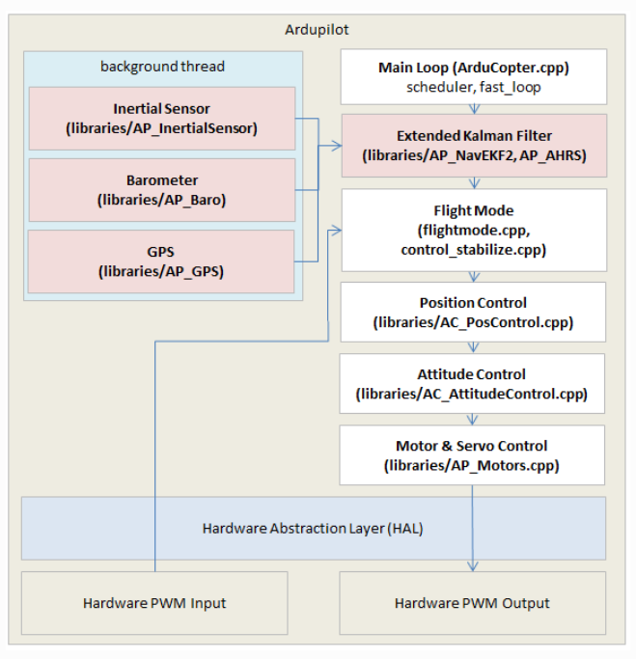

When we modify the fight tasks
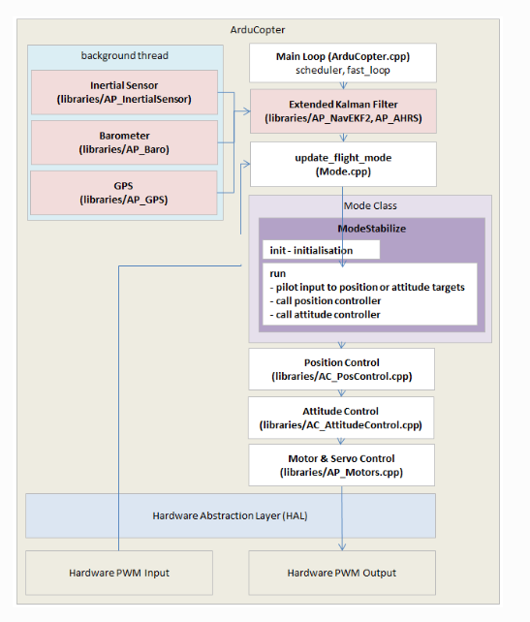
Breakdown of Key Task Groups
The tasks are meticulously prioritized to ensure flight stability and responsiveness come first.

1. High-Frequency / Fast Tasks (Flight Critical)
Ins.update Read Inertial Measurement Unit (IMU) data (gyros/accelerometers). Must run first to feed control loops with fresh data.
Run_rate_controller_main Executes the PID rate controllers (inner loop) that calculate required torque to achieve target angular rates.
Motors_output_main Send commands to the Electronic Speed Controllers (ESCs). This is the final step in the control loop.
read_AHRS Runs the Extended Kalman Filter (EKF) state estimator to calculate attitude (roll/pitch/yaw) and estimate position. This is computationally expensive.
Update_flight_mode Runs the selected flight mode's control code (e.g., Loiter, AltHold, Stabilize), generating new attitude/rate targets for the rate controller.
Update_land_and_crash_detectors Constantly check if the vehicle has landed or experienced a sudden impact.
manual modes
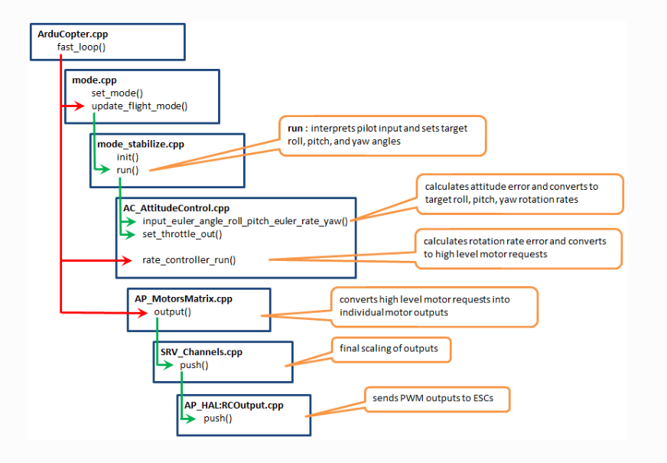
autonomous modes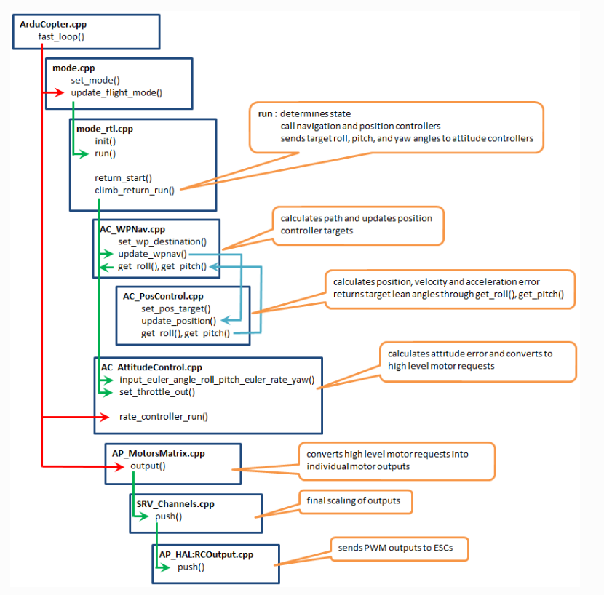
1)Entry Point: ArduCopter.cpp → fast_loop()
This is the main control loop that runs at high frequency (typically 400 Hz).
It orchestrates all core flight control tasks: reading sensors, updating flight modes, computing control outputs.
2)Mode Handling: mode.cpp
set_mode(): Changes the flight mode (e.g., Stabilize, AltHold, Loiter) based on pilot input or autonomous logic.
- update_flight_mode(): Executes the logic for the current mode. For manual modes like Stabilize, it interprets RC inputs to set desired roll, pitch, yaw, and throttle targets.
3) Mode-Specific Logic: mode_stabilize.cpp
Implements the Stabilize mode behavior.
- Converts pilot stick inputs into desired attitude angles (roll, pitch) and yaw rate.
- These targets are passed to the attitude controller.

4)Attitude Control: AC_AttitudeControl.cpp
- input_euler_angle_roll_pitch_euler_rate_yaw():
  - Computes attitude error between current and desired orientation.
  - Converts this into desired angular rates (roll rate, pitch rate, yaw rate).
- rate_controller_run():
  - Compares desired angular rates with actual rates from gyros.
  - Outputs motor throttle requests to correct the error.

5)Motor Mixing: AP_MotorsMatrix.cpp
- output_armed():
  - Translates throttle requests into individual motor outputs.
  - Applies mixing logic based on frame type (e.g., quad-X, hex).
  - Ensures outputs respect constraints like minimum/maximum throttle and failsafe behavior.

6) PWM Output: SRV_Channels.cpp
- output_armed():
  - Prepares final PWM values for each motor channel.
  - These are the actual signals that will be sent to the ESCs (Electronic Speed Controllers).

7) Hardware Abstraction: AP_HAL:RCOuput.cpp
- write():
  - Sends PWM signals to the hardware pins connected to ESCs.
  - This is the final step where control commands reach the motors.

update_flight_mode() is called at 400Hz (Pixhawk) or 100Hz (APM2.x).
It checks control_mode and dispatches to the corresponding <flight mode>_run() function.
Each <flight mode>_run() resides in its own mode_<flight mode>.cpp file.
The flight mode function reads RC inputs like g.rc_1.control_in.
Inputs are converted into lean angles, rotation rates, and climb rates.
AltHold mode maps throttle to climb rate and sticks to lean angles and yaw rate.
These targets are passed to Attitude and/or Position Control libraries.
Attitude Control offers five methods; three are commonly used.
angle_ef_roll_pitch_rate_ef_yaw() uses earth-frame angles and yaw rate.
angle_ef_roll_pitch_yaw() uses earth-frame angles for all three axes.
rate_bf_roll_pitch_yaw() uses body-frame angular rates.
After attitude input, rate_controller_run() computes motor-level commands.
These commands are sent to AP_Motors via set_roll(), set_pitch(), etc.
Position Control handles altitude and 3D position targets.
set_alt_target_from_climb_rate() sets altitude based on climb rate.
set_pos_target() sets position offset from home.
update_z_controller() runs altitude PID and sends throttle to motors.
update_xy_controller() handles horizontal position control if needed.
AP_Motors mixes roll, pitch, yaw, and throttle into motor outputs.
Final PWM values are sent via hal.rcout->write() to ESCs through AP_HAL.
The pilot moves the sticks on the remote. These signals — roll, pitch, yaw, and throttle — are received as raw numbers like g.rc_1.control_in, g.rc_2.control_in
The drone checks its current flight mode — maybe it’s in Stabilize, AltHold, or RTL. Based on that, it calls a specific function like stabilize_run() or rtl_run() from the corresponding file (e.g. mode_stabilize.cpp).
Inside the <mode>_run() function, the drone interprets the pilot’s inputs:
- Roll and pitch sticks become lean angles (how much to tilt).
- Yaw becomes a rotation rate (how fast to spin).
- Throttle becomes a climb rate (how fast to go up or down).
It calls functions in the Attitude Control library:
- angle_ef_roll_pitch_rate_ef_yaw() → “Tilt me this much and spin me this fast.”
- angle_ef_roll_pitch_yaw() → “Point me in this exact direction.”
- rate_bf_roll_pitch_yaw() → “Spin me at these rates.”
These are like giving instructions to a skilled acrobat: “Lean left 10°, pitch forward 15°, spin right at 5°/sec.”
Once the attitude targets are set, the drone runs rate_controller_run() — this is the part that compares what the drone is doing vs. what it should be doing, and figures out how to correct it.
It then sends commands like:
- set_roll(-4500) → “Roll left as hard as you can.”
- set_throttle(600) → “Give me 60% power.”
If the mode involves altitude or position (like AltHold or Loiter), the drone also uses the Position Control library:
- set_alt_target_from_climb_rate() → “I want to climb at 50 cm/s.”
- set_pos_target() → “Move 2 meters north.”
Then it runs update_z_controller() or update_xy_controller() to calculate how much throttle or tilt is needed to reach that position.
Now the drone has roll, pitch, yaw, and throttle values. It hands these to the Motor Mixing system (AP_Motors), which figures out how to distribute power to each motor.
It’s like a chef balancing ingredients: “Motor 1 gets 70%, Motor 2 gets 60%, Motor 3 gets 80%…”
Finally, the drone calls output_armed() which converts those values into PWM signals — the language that ESCs (Electronic Speed Controllers) understand.
These signals are sent via hal.rcout->write() to the actual hardware pins.

ArduPilot Libraries
The libraries are shared with Copter, Plane and Rover. Below is a high level list of libraries and their function.
Core libraries:
- AP_AHRS - attitude estimation using DCM or EKF
- AP_Common - core includes required by all sketches and libraries
- AP_Math - various math functions especially useful for vector manipulation
- AC_PID - PID(Proportional-Integral-Derivative) controller library
- AP_InertialNav - inertial navigation library for blending accelerometer inputs with gps and baro data
- AC_AttitudeControl - ArduCopter’s control library includes various functions of attitude, position control based on PID control.
- AC_WPNav - waypoint navigation library
- AP_Motors - multicopter and traditional helicopter motor mixing
- RC_Channel - a library to more convert pwm input/output from APM_RC into internal units such as angles
- AP_HAL, AP_HAL_ChibiOS, AP_HAL_Linux - libraries to implement the “Hardware abstraction layer” which presents an identical interface to the high level code so that it can more easily be ported to different boards.
Sensor libraries:
- AP_InertialSensor - reads gyro and accelerometer data, perform calibration and provides data in standard units (deg/s, m/s) to main code and other libraries
- AP_RangeFinder - sonar and ir distance sensor interfaced library
- AP_Baro - barometer interface library
- AP_GPS - gps interface library
- AP_Compass - 3-axis compass interface library
- AP_OpticalFlow - optical flow sensor interface library
Other libraries:
- AP_Mount, AP_Camera, AP_Relay - camera mount control library, camera shutter control libraries
- AP_Mission - stores/retrieves mission commands from eeprom

