Tab 1
Raspberry Pi Zero 2 W Drone Vision System with AI Detection capabilities

1. Objective
To design an embedded vision system for drones capable of performing real-time person detection using YOLOv8(or other light weight models) on a Raspberry Pi Zero 2 W(cheaper option)or Raspberry Pi4/5, and streaming annotated video (with bounding boxes) to a ground control system with minimal latency and extended range.

2. System Overview
The drone carries a Raspberry Pi Zero 2 W connected to a camera module and a 4G/5G modem (UNLIMITED RANGE as long as )
The Pi performs on-board inference (YOLOv8-Nano) and overlays bounding boxes on detected persons.
The processed video is then encoded (H.264) and transmitted to a ground system for display on VLC or a browser.

3. System Architecture

3.1 Drone-Side
Component | Description | Function
Raspberry Pi Zero 2 W | Quad-core Cortex-A53, 512 MB RAM | Edge AI inference + video streaming
Camera Module V2 (8 MP) | CSI-2 interface | Capture live video feed
4G/5G USB Modem | Huawei E3372 | Long-range IP communication
Power Supply (5 V 2 A BEC) | From drone Li-Po battery | Stable regulated power
Lightweight Enclosure | 3D-printed | Protect electronics from vibration and fall damage
Software Stack
- OS: Raspberry Pi OS Lite (64-bit)
- Frameworks: PyTorch Lite / Ultralytics YOLOv8
- Video: GStreamer (H.264 hardware encoding)
- Networking: WebRTC for low-latency streaming

3.2 Ground-Side (Receiver)
Component | Description
Laptop / Ground Control Station | Receives and displays stream
VLC / FFplay / Browser (WebRTC) | Playback of annotated live feed
Optional: script for a Logger | Records detections and timestamps

4. Power and Weight
Component | Power (W) | Weight (g)
Pi Zero 2 W | ~2 W | 13 g
Camera V2 | 0.5 W | 3 g
4G Modem | 1–2 W | 25 g
Total | ~4.5 W | ~45 g

5. References
- Raspberry Pi Zero 2 W Documentation – pi_docs
- Ultralytics YOLOv8 Docs – https://docs.ultralytics.com
- GStreamer SRT Streaming Guide – srt

Tab 2
GSRT(GStreamer + SRT):

GStreamer
- GStreamer is a multimedia framework that handles video/audio pipelines.
- It can take input from a camera, encode it, packetize it, and send it over a network using protocols like RTSP, RTP, or SRT.
- 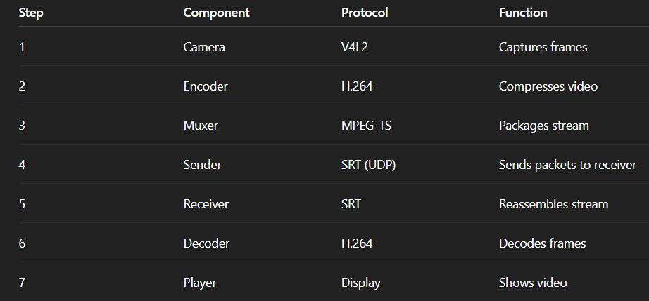

SRT (Secure Reliable Transport)
- A modern video streaming protocol (developed by Haivision).
- Works over UDP, but adds:
  - Error correction (retransmits missing packets),
  - Encryption, and
  - Adaptive latency control.
- It’s built specifically for low-latency video over unreliable networks (like 4G, Wi-Fi, or long-distance links).
#(udp speed+tcp like security)

How It Works for the Drone

On the Drone (Transmitter)
- Camera Feed (appsrc / v4l2src)
  - Captures raw frames from the Pi Camera.
- Convert to H.264
  - Uses the Pi’s GPU hardware encoder (v4l2h264enc) to compress frames efficiently.
- Pack into MPEG-TS
  - Converts raw H.264 frames into a streamable transport format (MPEG-TS).
- Send over SRT
  - The srtsink plugin pushes the video stream to the ground IP and port (for example, srt://192.168.0.10:9999).

On the Ground (Receiver)
- SRT Socket Listening
  - VLC, FFplay, or GStreamer opens the same port (e.g., 9999) to receive packets.
- Automatic Resync
  - SRT handles network jitter, reorders packets, and ensures smooth video.
- Decode H.264 → Display
  - The player decodes and displays the video with low latency (100–200 ms typical).

