Linux Process Management and Scheduling
Name: Gopikashree K R
Register Number: 261100690031

Exercise 1: Process Identification
To display running processes with PID, PPID, owner, CPU and memory usage and command; to list only the current user's processes; and to find the five highest CPU and memory consumers.

Commands
ps -eo pid,ppid,user,%cpu,%mem,comm | head -n 15
ps -u msis -o pid,ppid,user,%cpu,%mem,comm | head -n 15
ps -eo pid,ppid,user,%cpu,%mem,comm --sort=-%cpu | head -n 6
ps -eo pid,ppid,user,%cpu,%mem,comm --sort=-%mem | head -n 6

Explanation of commands

- ps -eo ...: -e selects every process and -o chooses the columns: PID, PPID, owner (user), %CPU, %MEM and command name (comm).
- head -n 15: the list is long, so only the first 15 lines (header included) are shown.
- ps -u msis: shows only processes owned by the user msis.
- --sort=-%cpu / -%mem: the minus sign sorts in descending order. head -n 6 keeps the header plus the top five processes.
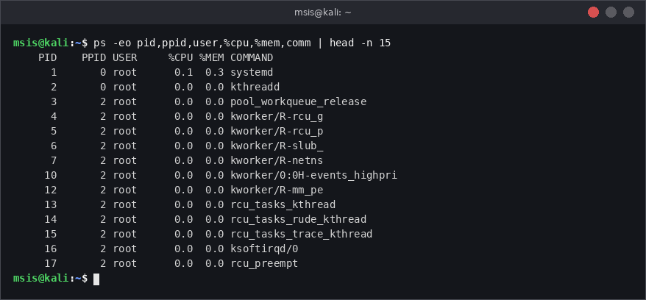
Figure 1: All processes (first 15 lines) with PID, PPID, owner, CPU, memory and command
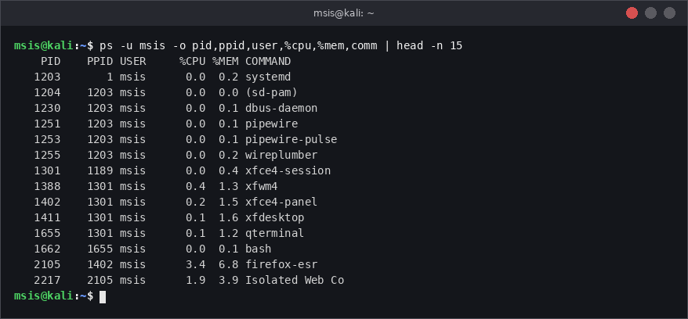
Figure 2: Processes belonging only to the current user msis
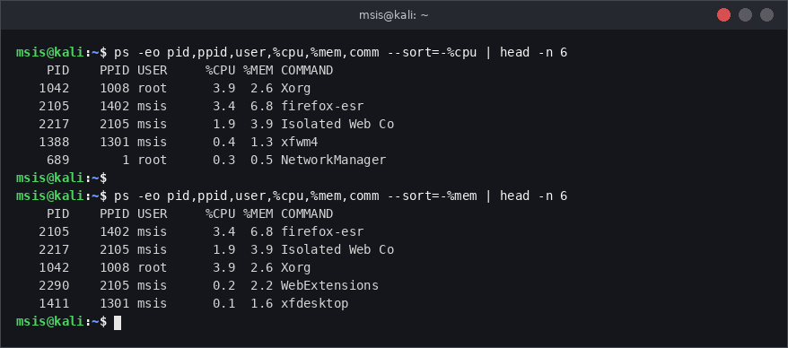
Figure 3: Top five processes by CPU usage and by memory usage

Observations / Results
- PID 1 is systemd with PPID 0; kernel threads such as kthreadd (PID 2) are owned by root.
- The user-only listing shows msis processes such as systemd (user), xfce4-session, qterminal, bash and firefox-esr. bash (PID 1662) is the child of qterminal (PID 1655).
- Top five CPU: Xorg (3.9%), firefox-esr (3.4%), Isolated Web Co (1.9%), xfwm4 (0.4%) and NetworkManager (0.3%).
- Top five memory: firefox-esr (6.8%), Isolated Web Co (3.9%), Xorg (2.6%), WebExtensions (2.2%) and xfdesktop (1.6%).
Why high CPU usage alone does not confirm malicious activity: CPU use only shows how much work a process is doing, not why. Legitimate programs such as browsers, compilers, backups, antivirus scans, software updates and video tools can use a lot of CPU. A malicious process (for example a stealthy backdoor) may use almost no CPU. Also, the %CPU in ps is an average over the life of the process. To judge a process we must also check its owner, parent (PPID), path of the executable, start time, network connections and whether it matches what the system normally runs.

Conclusion
ps with custom columns, sorting and head gives a quick and readable view of processes. The top CPU and memory processes were normal desktop programs. Resource usage is only a starting point; other evidence is needed before calling a process malicious.

Exercise 2: Parent and Child Processes

Objective
To create a script that starts two background processes, find its PID and PPID, list its children, and see what happens to the children when the parent terminates.

Bash script: parent.sh
#!/bin/bash
echo "Parent script PID : $$"
echo "Parent script PPID : $PPID"
sleep 300 &
CHILD1=$!
echo "Child 1 PID : $CHILD1"
sleep 400 &
CHILD2=$!
echo "Child 2 PID : $CHILD2"
wait

Commands
chmod +x parent.sh
./parent.sh &
ps -o pid,ppid,stat,cmd -p 3120
ps -o pid,ppid,stat,cmd --ppid 3120
pstree -p 3120
kill 3120
ps -o pid,ppid,stat,cmd -C sleep

Explanation
- $$: special variable holding the PID of the current shell/script (here 3120).
- $!: PID of the most recent background process; it is saved in CHILD1 and CHILD2.
- &: runs a command in the background so the script can continue.
- wait: makes the parent wait until its background children finish. Without it the script would end at once.
- $PPID: PID of the parent of the script (the interactive bash, 1662). ps --ppid lists the children of a PID and pstree -p draws the tree with PIDs.
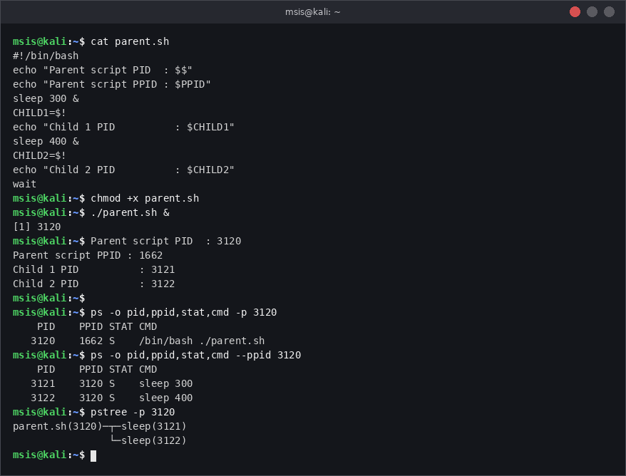
Figure 4: Script output, PID/PPID of the script and its two child processes
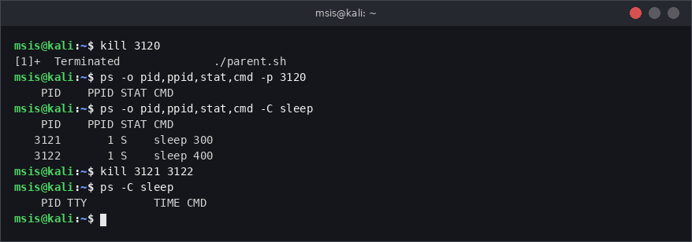
Figure 5: Children after the parent script is terminated (now adopted by PID 1)

Observations / Results
- Script PID is 3120 and PPID is 1662 (the bash shell). The children sleep 300 and sleep 400 have PIDs 3121 and 3122 and PPID 3120.
- When the parent (3120) was terminated with SIGTERM, the shell reported Terminated. The children were not killed: SIGTERM was sent only to the parent.
- The children became orphans and were adopted by PID 1 (systemd), so their PPID changed from 3120 to 1. Then they were cleaned up with kill 3121 3122.

Signals used in this report
Signal | Number | Meaning
SIGSTOP | 19 | Suspends (pauses) a process. Cannot be caught or ignored.
SIGCONT | 18 | Resumes a stopped process.
SIGTERM | 15 | Polite request to terminate. The process can catch it and clean up (default for kill).
SIGKILL | 9 | Forced termination by the kernel. Cannot be caught, blocked or ignored.

Conclusion
The PID/PPID relationships form a tree: bash (1662) → parent.sh (3120) → sleep (3121, 3122). Killing a parent does not automatically kill its children; they continue running and are re-parented to init. This is why leftover background processes must be checked after stopping a parent.

Exercise 3: Process Control Using kill

Objective
To suspend, resume and terminate a background process using signals and verify its state at each step.

Commands
sleep 600 &
PID=$!
echo "Recorded PID = $PID"
ps -o pid,ppid,stat,cmd -p $PID
kill -SIGSTOP $PID # suspend
ps -o pid,ppid,stat,cmd -p $PID
kill -SIGCONT $PID # resume
ps -o pid,ppid,stat,cmd -p $PID
kill -SIGTERM $PID # graceful termination
ps -p $PID > /dev/null; echo "ps exit status: $?"

Explanation
- sleep 600 & starts a harmless process in the background; $! gives its PID which is stored in PID.
- The STAT column of ps shows the state: S = sleeping (normal), T = stopped.
- kill -SIGSTOP / -SIGCONT / -SIGTERM send the named signals. ps -p checks only that PID; exit status 1 means the PID no longer exists.
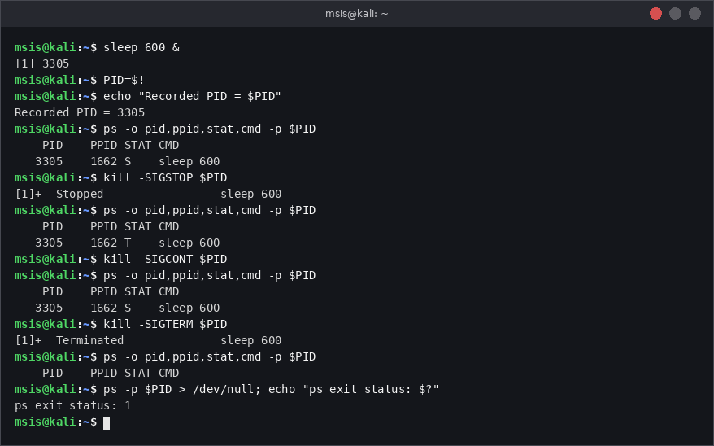
Figure 6: Suspend (T), resume (S) and terminate a background process

Signal explanation
- SIGSTOP (19): pauses the process; it stays in memory in state T. It cannot be caught or ignored.
- SIGCONT (18): continues a stopped process.
- SIGTERM (15): asks the process to terminate. The process may catch it, save data and exit cleanly. It is the default signal of kill.
- SIGKILL (9): the kernel ends the process immediately. It cannot be caught, blocked or ignored, so no cleanup is done. Use it only when SIGTERM fails.

Observations / Results
The process (PID 3305) was in state S, changed to T after SIGSTOP, returned to S after SIGCONT, and disappeared after SIGTERM (the shell printed Terminated and ps returned exit status 1).

Conclusion
Signals give full control over a running process. The correct order for a misbehaving process is to suspend it if needed, try SIGTERM first and use SIGKILL only as a last resort.

Exercise 4: Graceful and Forced Termination

Objective
To write a monitoring script that logs timestamps, record a shutdown message on SIGTERM, and compare this with SIGKILL.

Bash script: monitor.sh
#!/bin/bash
LOG=/home/msis/monitor.log

cleanup() {
echo "$(date "+%F %T") - SIGTERM received. Shutting down gracefully." >> "$LOG"
exit 0
}
trap cleanup SIGTERM

echo "$(date "+%F %T") - Monitor started (PID $$)" >> "$LOG"
while true; do
echo "$(date "+%F %T") - Monitor running" >> "$LOG"
sleep 5 &
wait $!
done

Commands
chmod +x monitor.sh
rm -f monitor.log
./monitor.sh &
cat monitor.log
kill -SIGTERM 3412
cat monitor.log
./monitor.sh & # restart
kill -SIGKILL 3441
cat monitor.log

Explanation
- trap cleanup SIGTERM tells the script to run the function cleanup when SIGTERM arrives; the function writes the shutdown message and exits.
- sleep 5 & followed by wait $! is used so that bash can run the trap immediately. If a foreground sleep were running, bash would delay the trap until the sleep ended.
- The log uses >> so that new lines are appended and the old lines are kept.
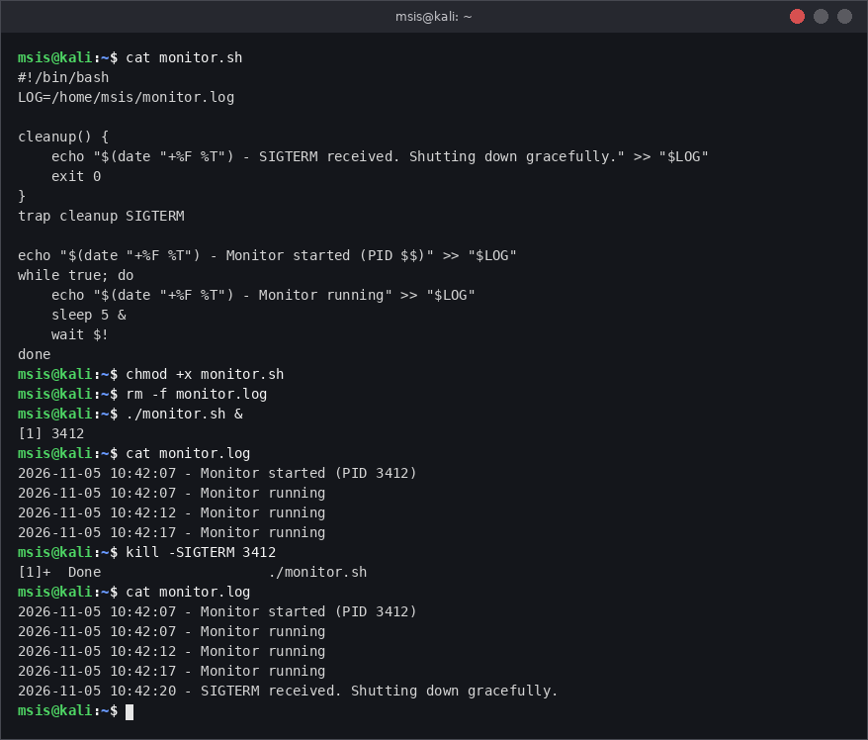
Figure 7: Script, normal logging and graceful shutdown with SIGTERM
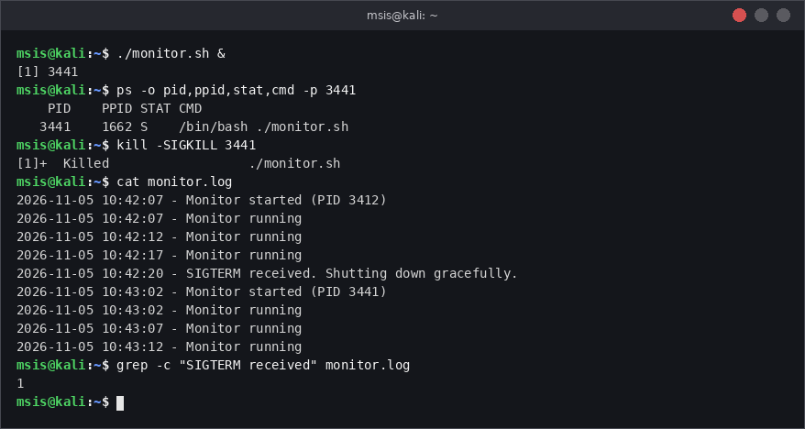
Figure 8: Restart and forced termination with SIGKILL; comparison of the log

Observations / Results
Feature | SIGTERM (PID 3412) | SIGKILL (PID 3441)
Shell message | Done (exit status 0) | Killed
Shutdown message in log | Yes, at 10:42:20 | No
Trap executed | Yes | No
Last log line | SIGTERM received... | Monitor running (10:43:12)

Difference: SIGTERM can be caught by a trap, so the script cleaned up and logged its shutdown. SIGKILL is handled by the kernel and cannot be caught, blocked or ignored by any script, so no trap ran and the log has no shutdown message; the last entry is just the last periodic line. The grep count of 1 shows only one shutdown message exists.

Conclusion
SIGTERM allows graceful shutdown and cleanup; SIGKILL stops the process at once without cleanup. For this reason SIGTERM should be tried first.

Exercise 5: Multiple Processes Using killall

Objective
To start three instances of a uniquely named lab program, terminate one by PID and the rest with killall, and verify that none remain.

Commands
cp /usr/bin/sleep ~/labworker # unique process name
./labworker 600 &
./labworker 700 &
./labworker 800 &
ps -C labworker -o pid,ppid,user,cmd
kill 3561
ps -C labworker -o pid,ppid,user,cmd
killall labworker
pgrep -a labworker; echo "Exit status: $?"

Explanation
- A copy of the harmless sleep program is named labworker, so the process name is unique and cannot be mixed with real system programs.
- ps -C labworker lists processes by command name and shows PID, PPID and owner (user).
- kill 3561 ends one instance by PID. killall labworker sends SIGTERM to every process named labworker owned by the user.
- pgrep prints nothing and returns exit status 1 when no process matches.
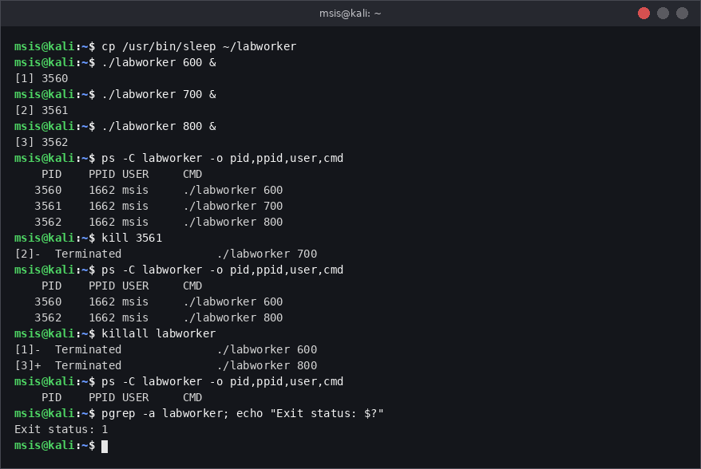
Figure 9: Three labworker instances, killing one by PID, then killall and verification

Observations / Results
Three instances (PIDs 3560, 3561, 3562), all owned by msis with PPID 1662, were created. After killing 3561, two remained. killall labworker ended the other two, and pgrep returned nothing with exit status 1, confirming termination.
Risk of killall with a common process name: killall works on names, not PIDs. If the name is common (for example python, bash, sleep, java or firefox), it will kill every process with that name, including important or unrelated ones. When run as root it can stop system services or other users' work and cause data loss or an outage. Also, on some Unix systems (for example Solaris) killall kills all processes. Therefore verify with pgrep -a or ps first, prefer a unique name or the specific PID, and avoid running killall as root unless necessary.

Conclusion
kill targets a single PID and killall targets all processes by name. killall is convenient for several instances but must be used carefully with unique names.

Exercise 6: Recurring Process Monitoring Using cron

Objective
To schedule a script with cron that records date, time, user name and the number of the user's processes every minute, observe changes, change the schedule to every five minutes and remove only this entry.

Bash script: process_monitor.sh
#!/bin/bash
LOG=/home/msis/process_monitor.log
USER_NAME=$(whoami)
COUNT=$(ps -u "$USER_NAME" --no-headers | wc -l)
echo "$(date '+%Y-%m-%d %H:%M:%S') | user=$USER_NAME | processes=$COUNT" >> "$LOG"

Commands
sudo systemctl enable --now cron # sudo required
systemctl status cron --no-pager
chmod +x process_monitor.sh && ./process_monitor.sh
(crontab -l 2>/dev/null; echo '* * * * * /home/msis/process_monitor.sh') | crontab -
crontab -l
sudo journalctl -u cron --no-pager | grep CMD | tail -n 3
for i in 1 2 3; do sleep 900 & done
crontab -l > mycron.txt
sed -i 's#^\* \* \* \* \*#*/5 * * * *#' mycron.txt
crontab mycron.txt
crontab -l | grep -v 'process_monitor.sh' | crontab -

Explanation
- cron must be running; systemctl enable --now starts it now and at every boot (needs sudo). systemctl status confirms that it is active (running).
- The script is tested manually first. The cron entry is added with (crontab -l; echo ...) | crontab -, which keeps existing entries and appends the new one.
- The entry * * * * * means every minute. */5 * * * * means every five minutes.
- Verification is done with the log file and with the cron entries in the journal (CMD lines).
- To remove only this job, crontab -l | grep -v 'process_monitor.sh' | crontab - rewrites the crontab without lines containing the script name. The other entry (uptime) stays.
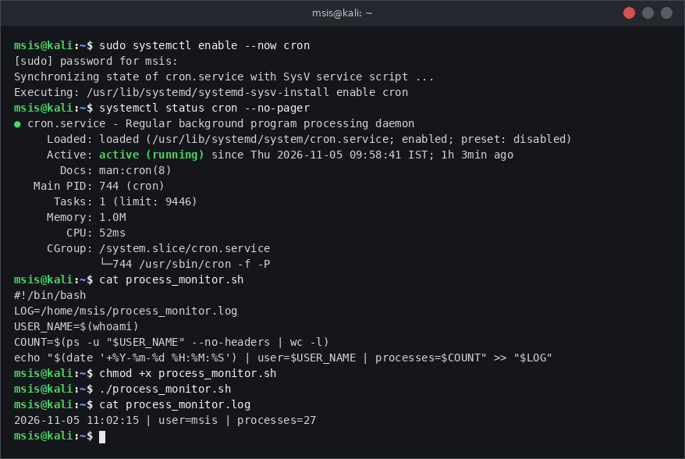
Figure 10: cron service status, script and manual test run
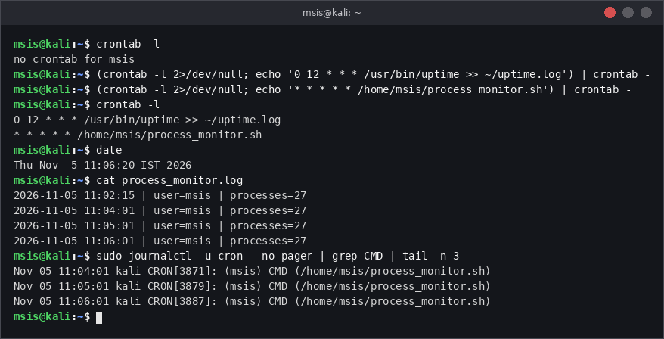
Figure 11: Scheduling every minute and verifying execution (log and cron journal)
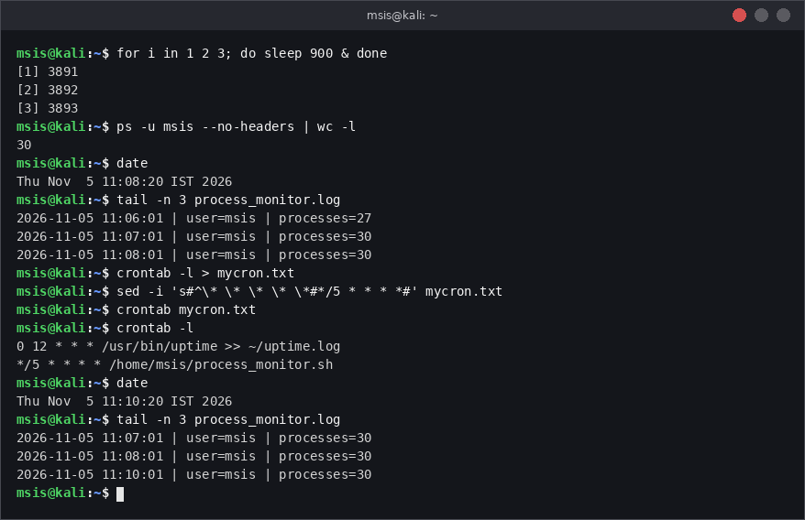
Figure 12: Extra background processes change the count; schedule changed to every five minutes
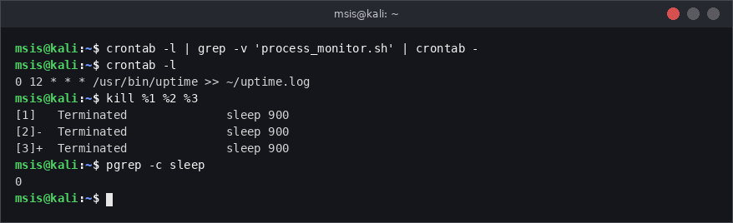
Figure 13: Removing only the exercise cron entry; the other entry remains

Observations / Results
- The cron service was active (running). The log shows one line every minute at 11:04:01, 11:05:01 and 11:06:01, matching the CMD lines in the journal.
- The process count was 27. After three extra sleep processes were started at about 11:06:30 it became 30 from 11:07:01 onwards.
- After changing to */5, the next record was written at 11:10:01 (no 11:09 entry).
- After removal, crontab -l shows only the unrelated uptime entry, so other entries were not deleted.

Conclusion
cron can run a monitoring script at regular intervals. Editing a crontab through a pipeline or a temporary file lets us change or remove a single entry safely without losing others.

Exercise 7: Cron Scheduling

Objective
To write and explain valid cron expressions for seven security and monitoring tasks.

Cron format
minute hour day-of-month month day-of-week command
(0-59) (0-23) (1-31) (1-12) (0-7; 0 and 7 = Sunday)

Cron expressions (saved in lab7_cron.txt)
No | Task | Cron expression | Meaning
1 | Failed-login check every 5 minutes | */5 * * * * | Every 5th minute of every hour/day
2 | Process snapshot every hour | 0 * * * * | Minute 0 of every hour
3 | Security-log backup daily at 2:30 AM | 30 2 * * * | 02:30 every day
4 | Security report every weekday at 9:00 AM | 0 9 * * 1-5 | 09:00, Monday (1) to Friday (5)
5 | File-integrity check Sunday 3:00 AM | 0 3 * * 0 | 03:00 on day-of-week 0 (Sunday)
6 | Monitoring script every 15 minutes | */15 * * * * | Minutes 0, 15, 30 and 45
7 | Weekly report Monday 8:30 AM | 30 8 * * 1 | 08:30 on day-of-week 1 (Monday)

Explanation and setup
- */N in a field means every N units; a dash gives a range (1-5 = Monday to Friday); * means every value.
- In a crontab the % character has a special meaning, so it is written as \% inside date +\%F_\%H\%M.
- Task 3 reads /var/log, so it is placed in root's crontab (sudo crontab -e). If /var/log/auth.log is missing on a journald-only Kali system, install rsyslog (sudo apt install rsyslog). Task 5 needs a baseline file created earlier with sha256sum.
- The cron service must be running (sudo systemctl enable --now cron) and each script must be executable (chmod +x).
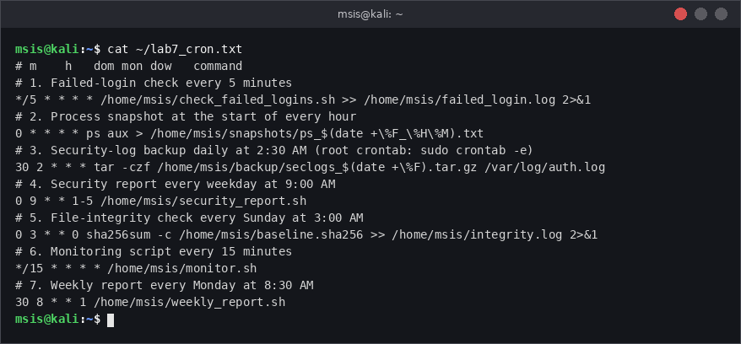
Figure 14: Contents of lab7_cron.txt with all seven cron expressions

Observations / Results
All seven schedules were written with the five time fields in the correct order. The step value (*/5, */15), the range (1-5) and fixed values (0, 3, 30 2, 30 8) cover every required timing.

Conclusion
Cron expressions can express simple repeating, hourly, daily, weekday and weekly tasks. Knowing the field order is the key to writing them correctly.

Exercise 8: One-Time Scheduling Using at

Objective
To schedule a one-time task that records the date and process list two minutes from now, inspect the pending job and verify its output.

Commands
sudo apt install -y at # sudo required
sudo systemctl enable --now atd
systemctl is-active atd
echo 'date > ~/at_snapshot.txt; ps -u msis >> ~/at_snapshot.txt' | at now + 2 minutes
atq
at -c 3 | tail -n 5
atq # after execution
ls -l ~/at_snapshot.txt
head -n 8 ~/at_snapshot.txt

Explanation
- at needs the atd service. It is installed with apt and started with systemctl.
- at now + 2 minutes reads the command from the pipe and queues it as a one-time job; the shell prints the job number (3) and run time.
- atq lists pending jobs (number, date, queue letter, user). at -c 3 prints the job's saved environment followed by its commands, so the last lines show the real commands.
- The job runs under /bin/sh at 11:32 and creates ~/at_snapshot.txt.
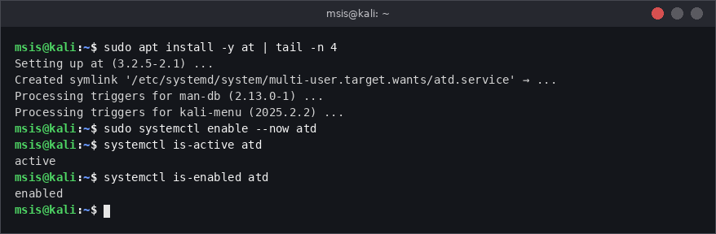
Figure 15: Installing and starting the at service
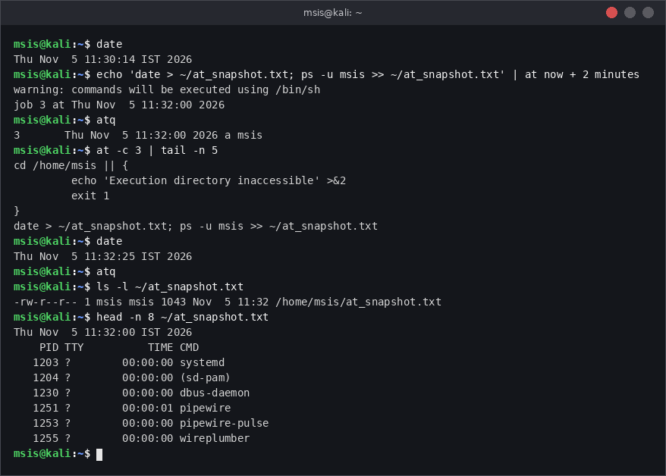
Figure 16: Scheduling, listing, inspecting and verifying the at job

Observations / Results
At 11:30:14 the job was queued as job 3 for 11:32:00. atq listed it, and at -c 3 showed the command. At 11:32:25 atq printed nothing, and ~/at_snapshot.txt existed with the date on the first line and the process list of msis below it.
Why completed jobs disappear: an at job is one-time. After atd runs it, the job file is deleted from the spool directory (/var/spool/cron/atjobs), so atq, which only reads the queue of pending jobs, no longer shows it. The result remains in the output file. Cron entries, in contrast, stay until they are removed.

Conclusion
at is suitable for one-time tasks. The job can be verified before the run (atq, at -c) and after it (the output file).

Exercise 9: Cancelling Scheduled Jobs

Objective
To schedule a harmless task ten minutes ahead, identify its job number, cancel it and verify removal.

Commands
echo 'echo "harmless test" >> ~/at_cancel_test.txt' | at now + 10 minutes
atq
atrm 4
atq
ls ~/at_cancel_test.txt

Explanation
- The job only appends a text line to a file, so it is harmless.
- atq shows the job number in the first column (4). atrm 4 (same as at -r 4) removes that job.
- An empty atq and a missing output file prove that the task was cancelled and never ran.
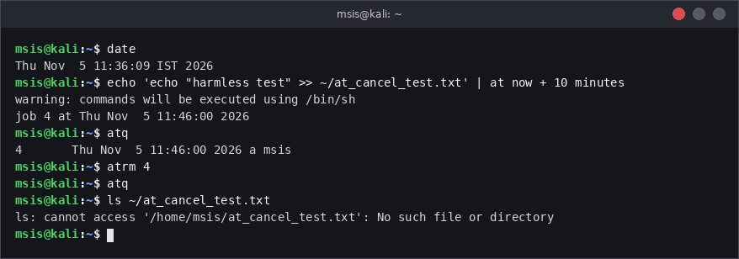
Figure 17: Scheduling job 4, cancelling it with atrm and verifying removal

Observations / Results
The job was created as number 4 for 11:46:00. After atrm 4, atq returned nothing and the file at_cancel_test.txt was not created (No such file or directory).

Difference between cancelling an at job and removing a cron entry
Point | at job | cron entry
Type | One-time job | Repeating schedule
Identified by | Job number (from atq) | Line in the crontab
Cancel with | atrm N or at -r N | crontab -e (delete line) or crontab -l | grep -v ... | crontab -
After running | Removed automatically | Stays and runs again
Effect of removal | Cancels that single run | Stops all future runs

Conclusion
Pending at jobs can be cancelled quickly by job number. Cron jobs have no job number; they must be removed by editing the crontab.

Exercise 10: Incident-Response Scenario

Scenario
An unfamiliar lab process (lab_unknown) is running with multiple instances, and a scheduled task will restart it. The lab setup copies the harmless sleep program to ~/lab_unknown, starts three instances and adds a cron watchdog that restarts it if it is not running. (Setup is shown for completeness; it plays the role of the unknown process.)

Commands
# Lab setup (to create the scenario)
cp /usr/bin/sleep ~/lab_unknown
for i in 1 2 3; do (~/lab_unknown 1000 &); done
CMD='*/10 * * * * pgrep -x lab_unknown >/dev/null || /home/msis/lab_unknown 1000 &'
(crontab -l; echo "$CMD") | crontab -

# Investigation and response
ps -C lab_unknown -o pid,ppid,user,stat,etime,cmd
kill -SIGSTOP 4622
ps -o pid,ppid,user,stat,cmd -p 4622
kill -SIGCONT 4622
killall lab_unknown
crontab -l
atq
crontab -l | grep -v lab_unknown | crontab -
crontab -l | grep -c lab_unknown

Explanation
- ps -C lists all instances with PID, PPID, owner (USER), state, elapsed time and full command. The PPID is 1 because the instances were started in a subshell that exited, so init adopted them.
- SIGSTOP / SIGCONT test control of one instance (state T then S). killall lab_unknown terminates all instances with SIGTERM (only the user's own, as no sudo is used).
- The scheduled restart is found in the user's crontab with crontab -l (and atq is checked for at jobs). It is removed with grep -v so that the uptime entry is preserved.
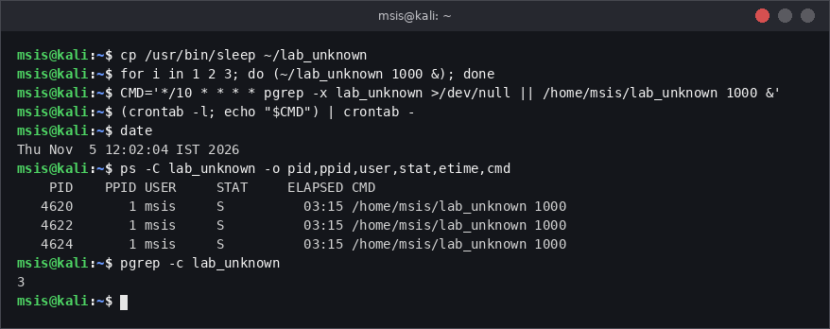
Figure 18: Identification of all lab_unknown instances with PID, PPID and owner
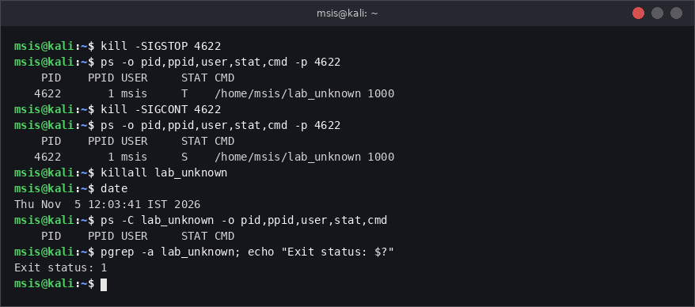
Figure 19: Suspend and resume one instance, then terminate all instances
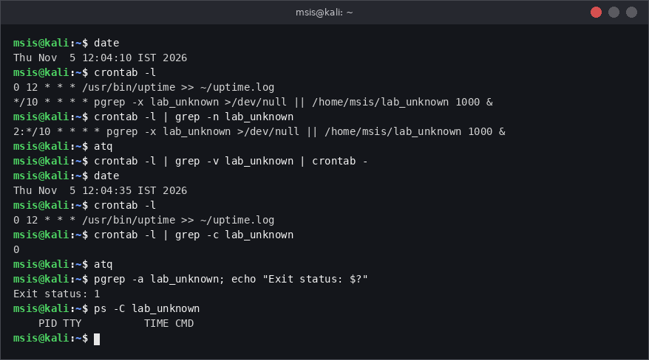
Figure 20: Inspecting and cancelling the scheduled restart, then final verification

Observations / Results
- Three instances were found: PIDs 4620, 4622 and 4624, owner msis, PPID 1, state S, running for about 3 minutes 15 seconds.
- Instance 4622 changed to state T after SIGSTOP and back to S after SIGCONT.
- killall lab_unknown at 12:03:41 ended all instances; pgrep returned exit status 1.
- The restart task was found in the crontab: */10 * * * * pgrep -x lab_unknown ... || /home/msis/lab_unknown 1000 &. No at jobs existed. It was removed at 12:04:35, before its next run at 12:10.
- Final check: crontab shows only the uptime entry, atq is empty, and ps/pgrep find no lab_unknown process.

Incident Report
Field | Details
Incident title | Unfamiliar process lab_unknown with multiple instances and a scheduled restart
Date / analyst | 05 Nov 2026 / msis (GOPIKASHREE K R, 261100690031)
Detection (12:02) | ps -C lab_unknown showed 3 instances: PIDs 4620, 4622, 4624; owner msis; PPID 1; command /home/msis/lab_unknown 1000; running 03:15.
Containment test (12:02-12:03) | Instance 4622 suspended with SIGSTOP (state T), verified, then resumed with SIGCONT (state S).
Eradication (12:03:41) | All instances terminated with killall lab_unknown; verified with pgrep (exit status 1) and ps.
Persistence found (12:04:10) | Crontab entry */10 * * * * ... pgrep -x lab_unknown || /home/msis/lab_unknown 1000 & would restart the process every 10 minutes. No at jobs (atq empty).
Persistence removed (12:04:35) | Entry removed with crontab -l | grep -v lab_unknown | crontab -. Other cron entry (uptime) kept.
Verification | crontab -l has no lab_unknown line (grep count 0); atq empty; no lab_unknown process; pgrep exit status 1.
Recommendations | Remove the restart mechanism first or immediately after killing the process; check crontab, atq, /etc/cron.d and systemd timers; inspect the binary path and start time; use SIGTERM before SIGKILL; monitor for reappearance.

Conclusion
The incident was handled in the correct order: identify, test control, terminate, find the persistence mechanism, remove it and verify. Killing only the processes is not enough because a scheduled task can bring them back.

Overall Conclusion
This assignment covered the full life cycle of Linux process management. Using ps, pgrep and pstree we identified processes and their parent-child relationships (Exercises 1 and 2). Using signals we suspended, resumed and terminated processes, and we compared graceful termination (SIGTERM, which a script can trap) with forced termination (SIGKILL, which cannot be caught) (Exercises 3 to 5). Using cron and at we automated recurring and one-time tasks, learned the cron expression format and cancelled scheduled jobs safely (Exercises 6 to 9). Finally, the incident-response scenario combined all these skills: identify, control, terminate, remove persistence and verify (Exercise 10).
The main lessons are: high resource usage alone does not prove malicious activity; always try SIGTERM before SIGKILL; use unique process names or PIDs instead of common names with killall; and always check scheduled jobs when a process keeps coming back.

