1. create a cl  program which acts like a utility to copy data between files.  
   There should be one setup file which has fromfile  and tofile as fields and cl program should read records from  
   this file and do cpyf between from file and tofile.   If file doesn't exist it should create destination file with same name FROMFILE field.

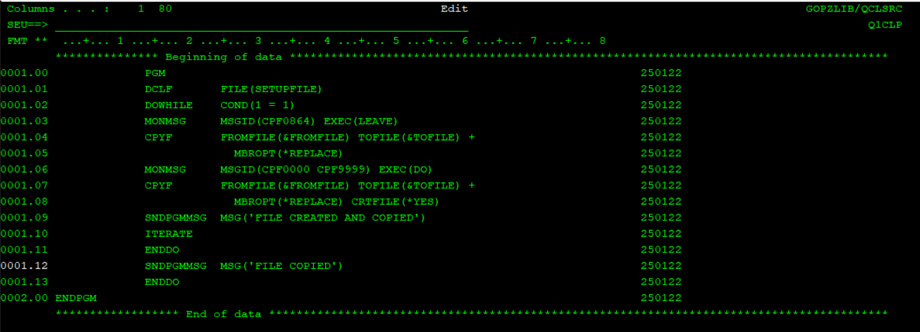

1. Create a cl program to take date as input and select all purchase orders for that date and then rpgle program should generate a report. Use purchase order master and detail file created before.

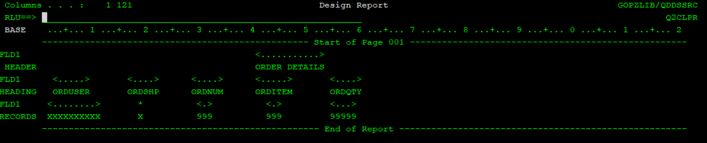

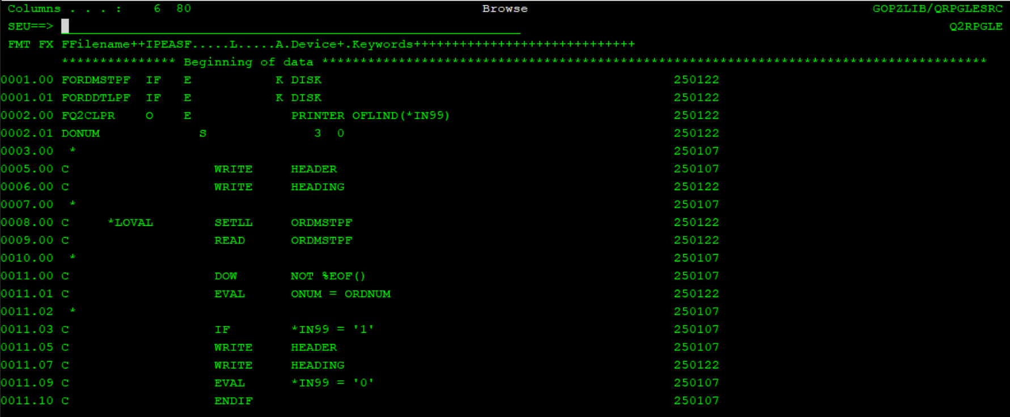

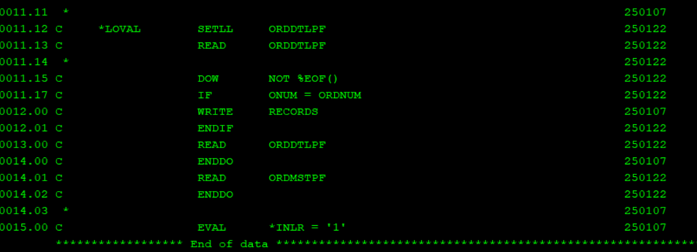

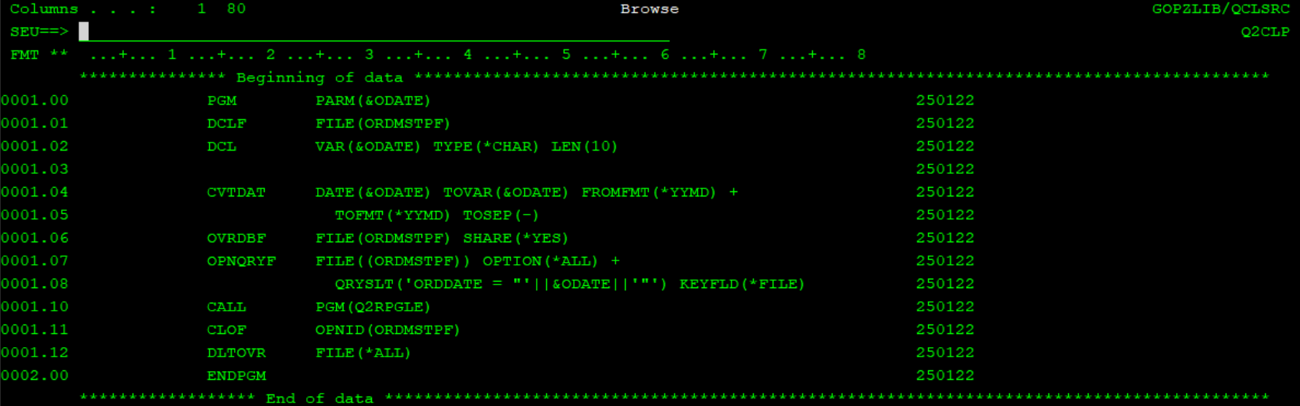

3. Revisit same student assignment to take input as roll no and display marks for each subject and total/subtotal /percentage at end.

This should be ILE program , we should have module which take 2 values as input and returns percentage as o.p.

In this case it will take total marks obtained and total marks as input and will return percentage.

once f7 is pressed it should generate a report showing marksheet for student , this report program should be separate module and will be called on pressing f7

4.we have different applications sending item data to system.

create different item file for each application and one dummy file matching structure.

create a cl program to take application id as input and it should override appropriate application file to dummy file before calling rpgle program .

rpgle program will have dummy file in f-spec and it should just copy these items into item master pf

fields present in these files will be item no , item description , perunit price

5. repeat same 4th question using member concept , instead of different files add members to item file for each app and it should override those.

6. Create a cl program to take date as input and select all purchase orders for that date and create a output extract file in cl itself , This file will have order no , itemno , qty,date as fields. It should select records for that date and ship flag as 'Y'

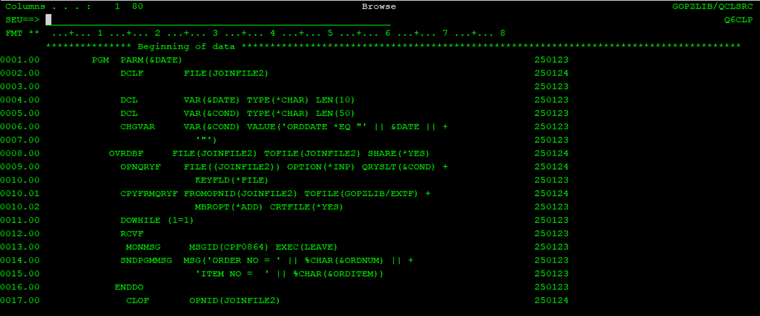



7. Create a cl program to take department no as input and retrieve department name and display using sndpgmmsg .

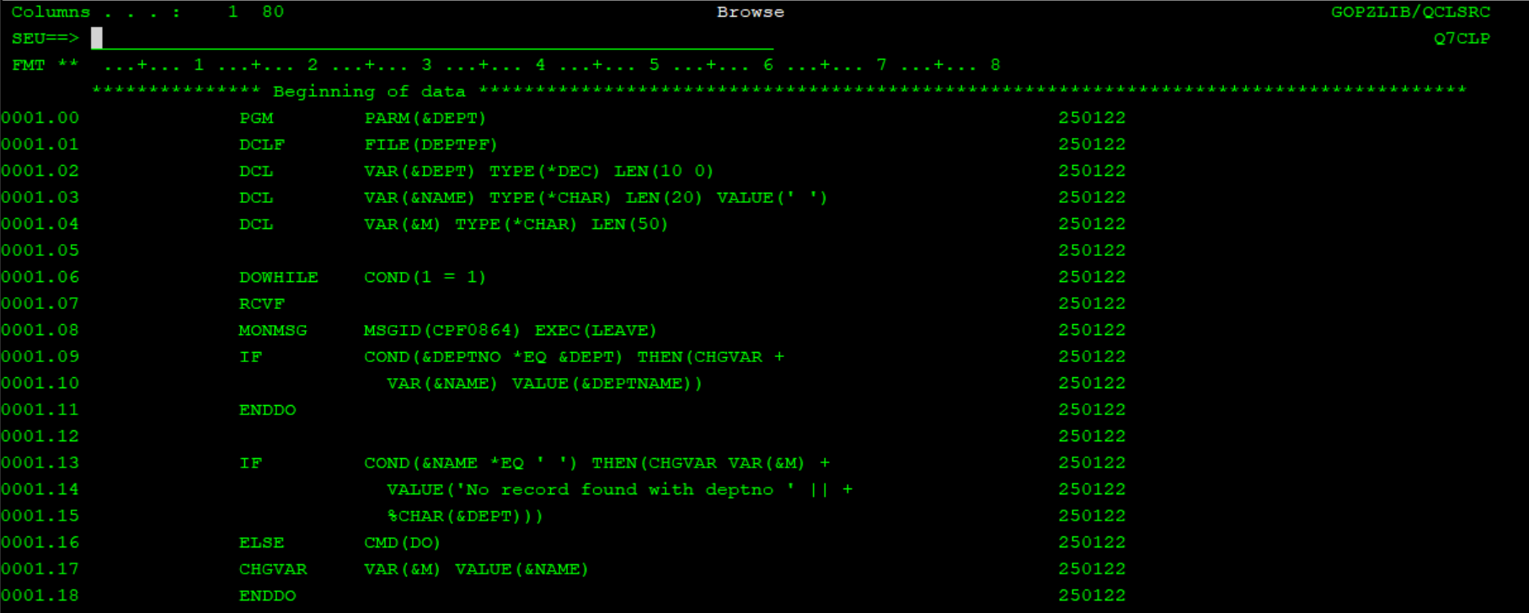

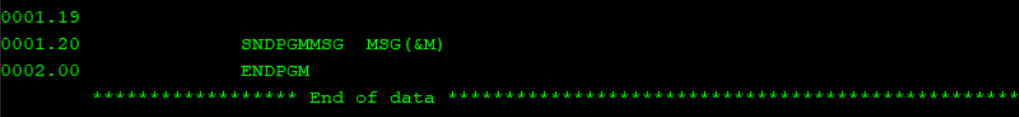

OR

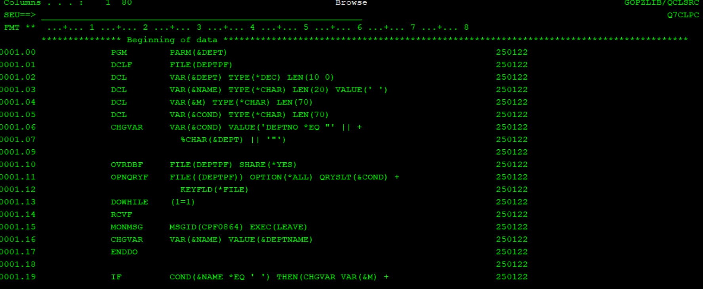

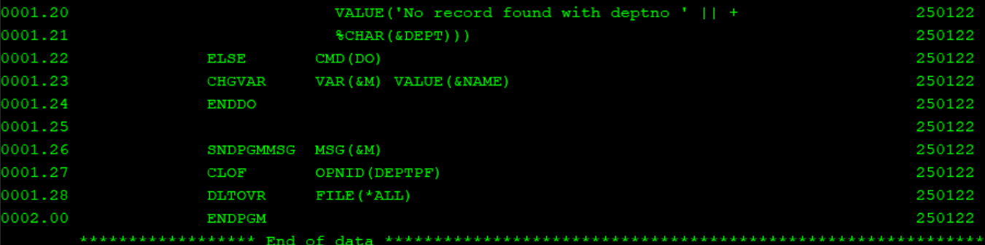

8. Create cl program to take file name as input and delete complete data of that file .

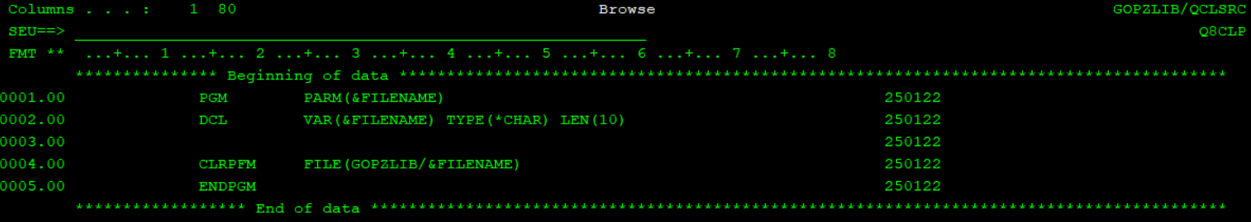

9. Repeat question 8 using sql query in clp.

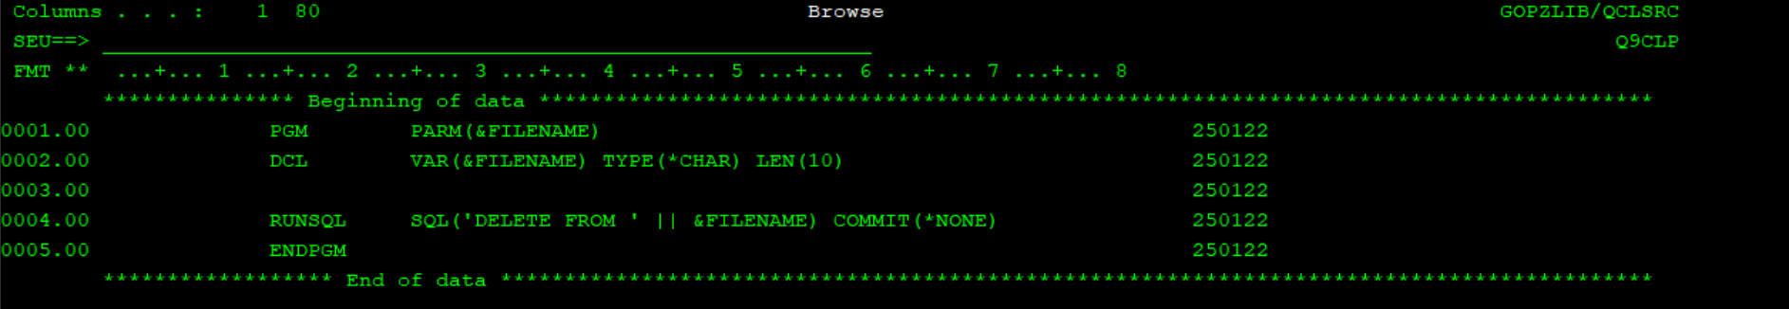

10. Create an EMPMASTER (employee master) PF with the fields employee ID, employee name and employee department. Add 10 records to this file of which 6 records

should be for employees in department "PAYROLL", 2 for department "FINANCE" and 2 for department "HR"

Create an EMPDETAIL (employee details) PF with the fields employee ID, employee designation and employee salary. This file should hold the details for the 10 employee records in the employee master file. Out of the 6 employees in PAYROLL department, 4 should have salary > 10,000 and 2 should have salary < 10,000.

Create an EMPFEEDBK (employee feedback) PF with the fields employee ID and employee rating. This file should hold the details for all the 10 employees with 3 employees whose salary>10,000 holding the rating as Outstanding and all others having different ratings.

Next create a data area from the command prompt to store Employee Names . The data area name should be "EMPNAMEDTA" The minimum length of the data area should be such that it can store minimum 3 Names as per the definition of your file field with an additional margin of 3 spaces in between.

Create a service procedure which accepts employee ID as input and returns a flag with the value as TRUE if the salary of the employee > 10,000 else FALSE.

Create another service procedure that accepts employee ID as input and returns a flag with the value as TRUE if the rating of the employee is Outstanding else FALSE.

Create a CL program to first filter your employee master file with records only from PAYROLL department.

Create an RPGLE program which will be called from the CL program. Read the employee master file to sequentially read the records from PAYROLL dept. one by one(sequentially) until end of the file(please note that you are not allowed to do the filtering in RPGLE program, this should be handled in CL itself). Next you need to write the corresponding employee name of the employees in the data area "EMPNAMEDTA" from Payroll department, who has Outstanding rating and their salary > 10,000. Use the service procedures to identify these records.

Technical specifications to be considered.

The service procedures should be written as external procedures using RPG opcode style programing. Both the procedures should be written in seperate modules and they should be binded to a service program.

11. Recreate program using sqlrpgle (Cursors)

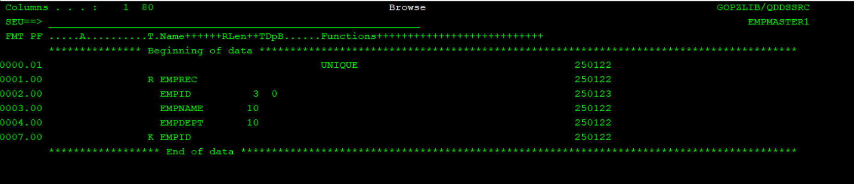

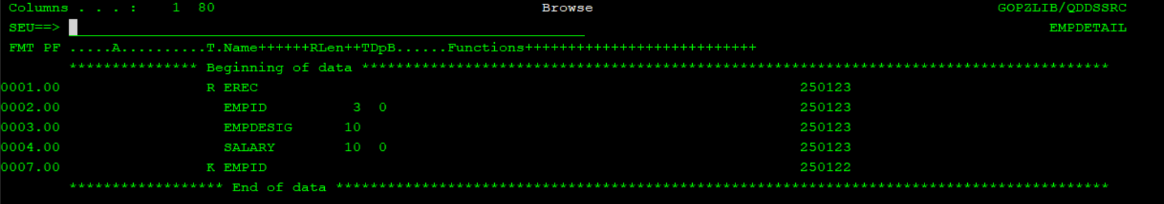

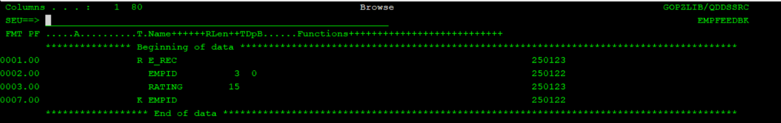

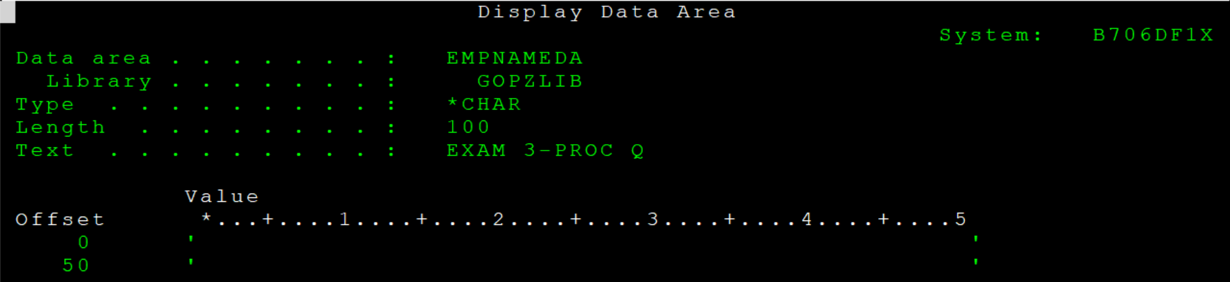

EMPMASTER1

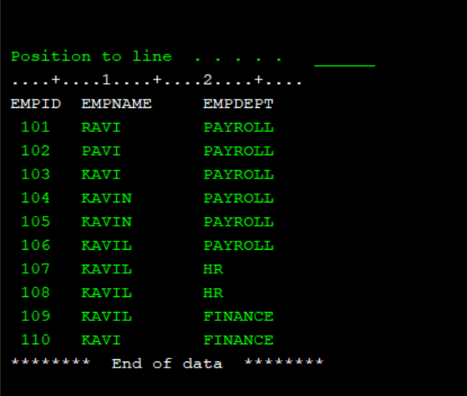

EMPDETAIL

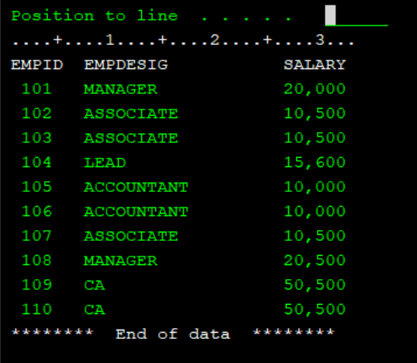

EMPFEEDBK

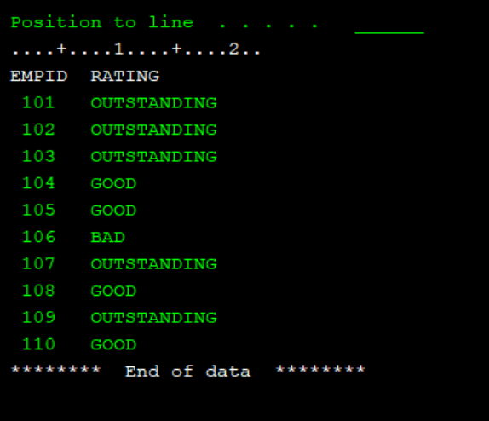

MAIN PROGRAM

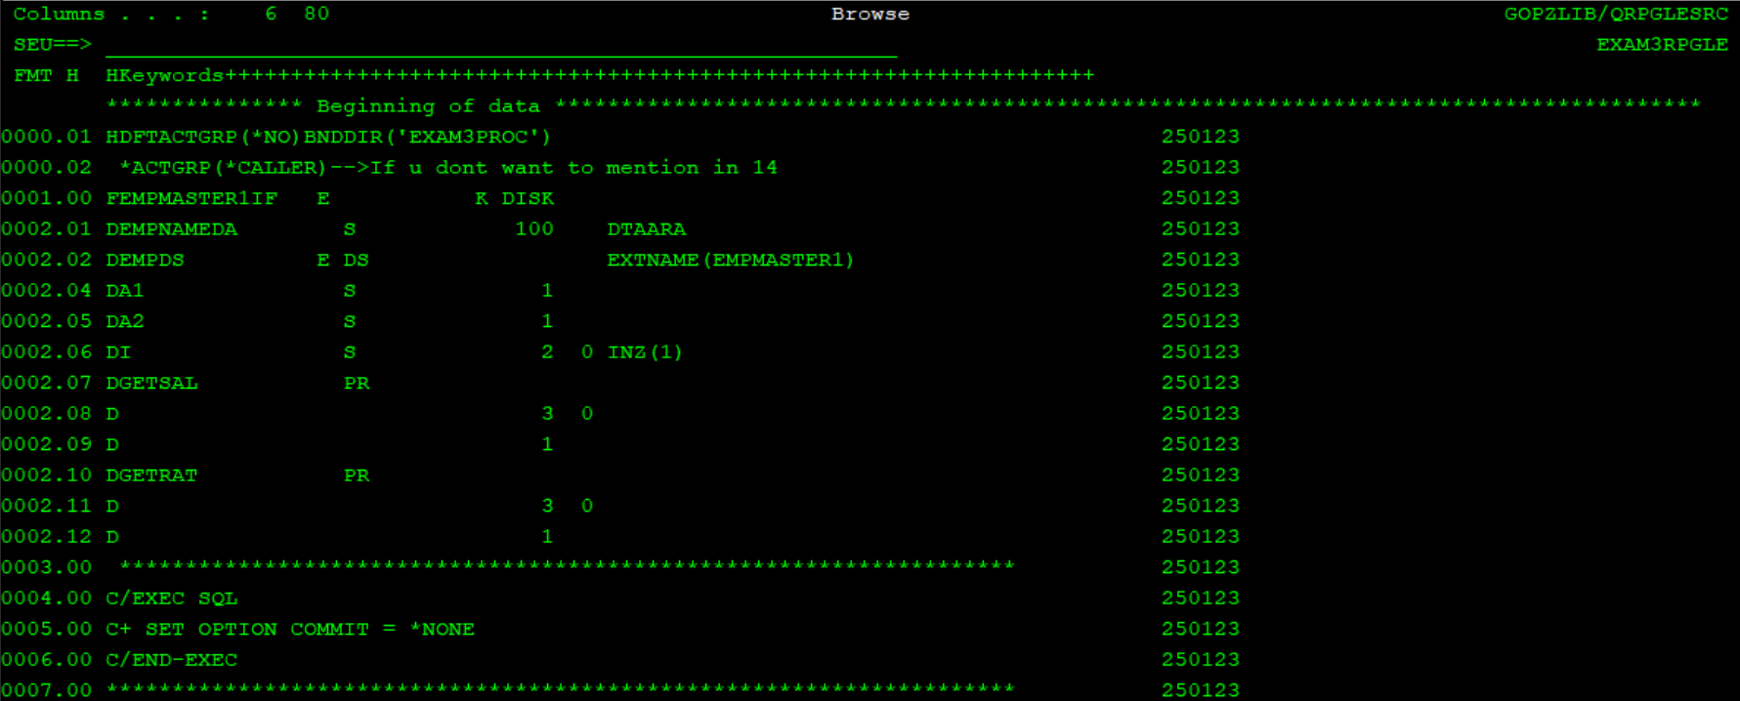

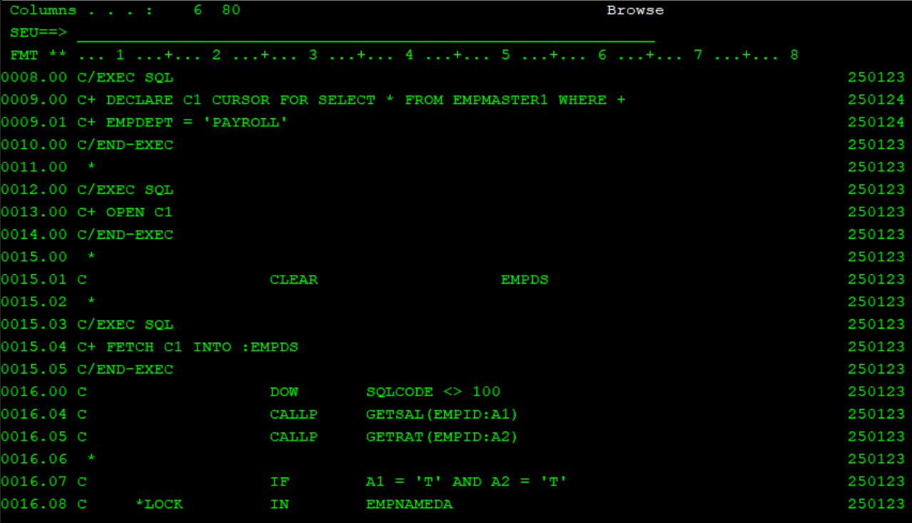

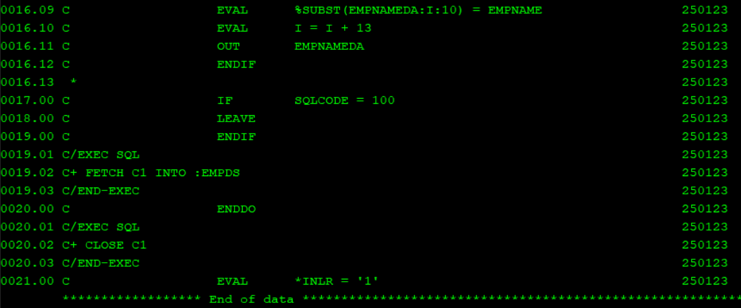

PROCEDURE MODULE

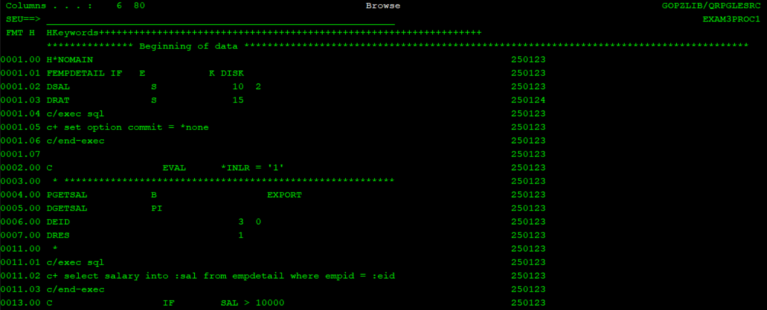

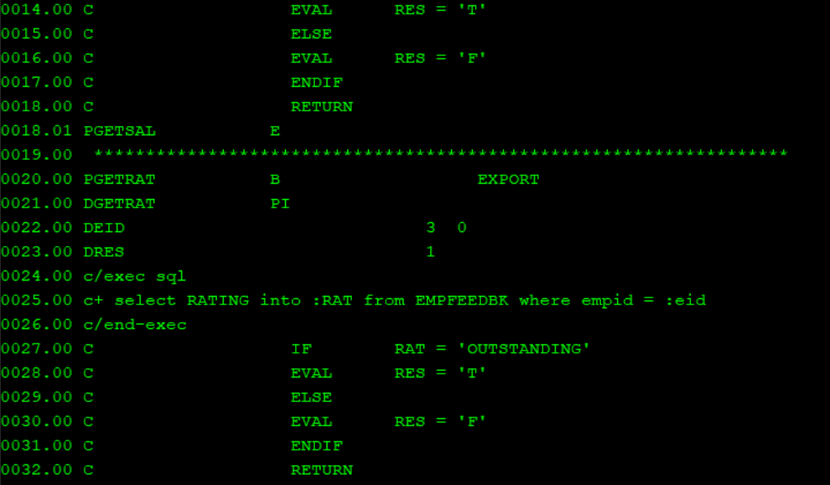



12. Create a view between emppf and deptpf , fields empno , empname , deptno , deptname . Create sqlrpgle program to take department no as input and display data in subfile for all employess in this department , data should be sorted by empnoi

