GOPIKA ANILRAJ

1. Create order header table with fields orderno, orderdate, customer name... Order number can be key. ...

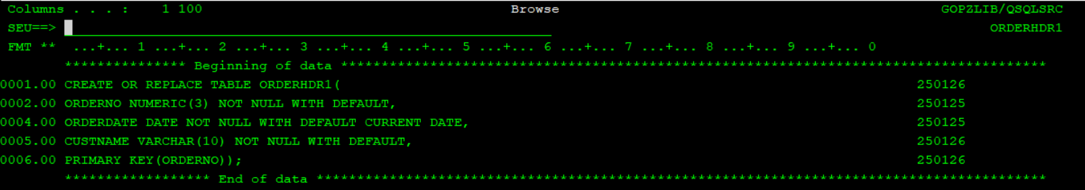

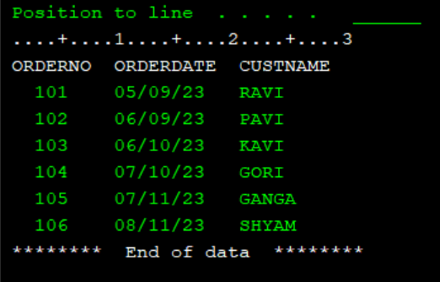

1. Create order detail table with order no, item no, item qty and per unit item price as fields.

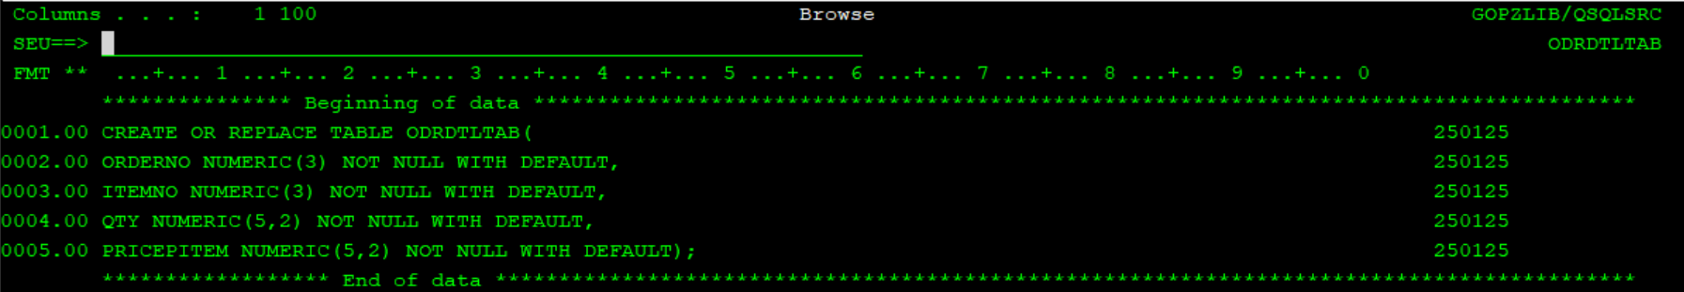

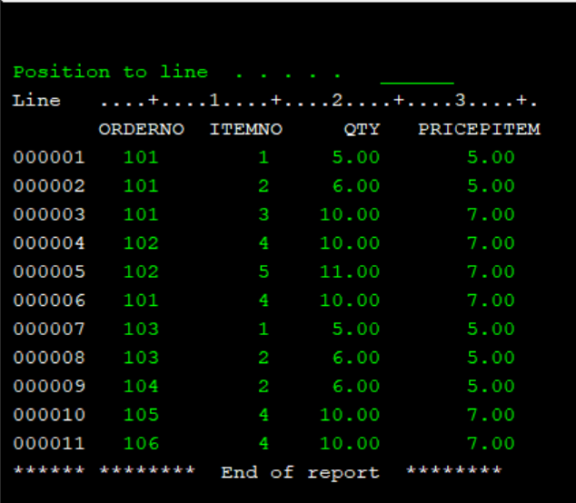

1. Create billing detail table with billno (format :BL_ orderno), itemno, item quantity and total line price as fields.

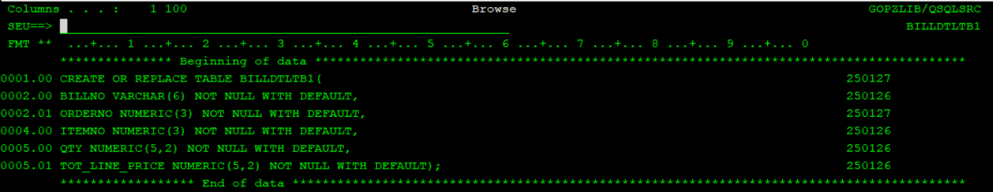

1. Create billing header table with bill no, total bill value and customer name as fields

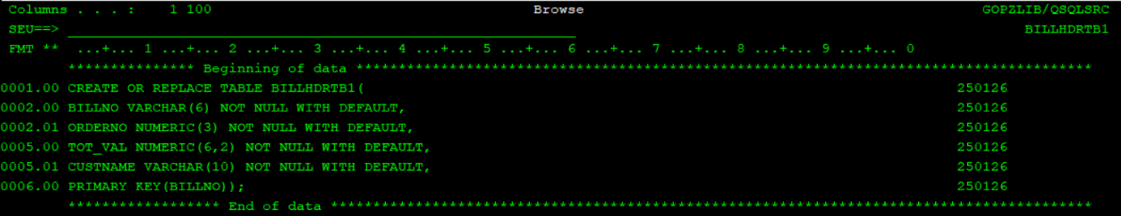

1. Create sql rpgle program to take order no as input and generate billing header and detail records for this

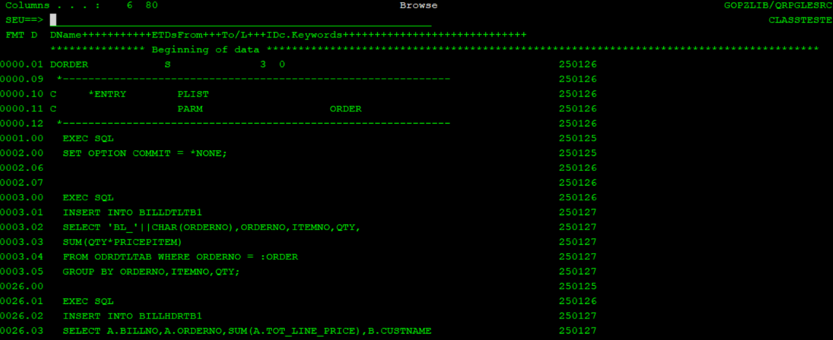

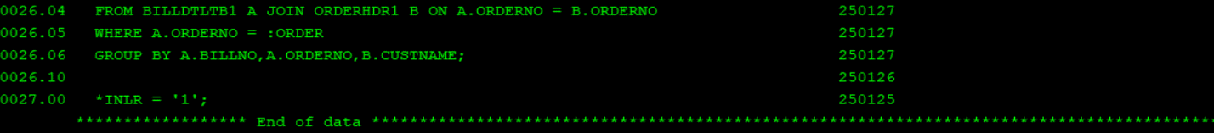

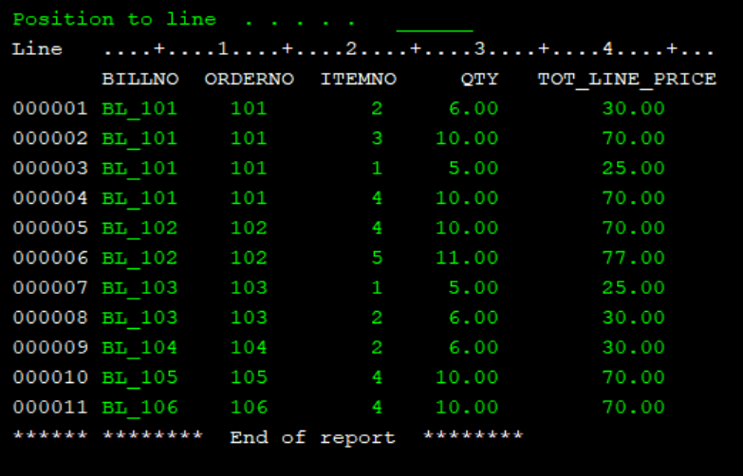

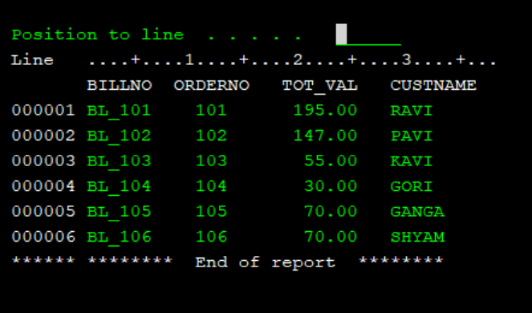

1. Create one more sql rpgle program to take order no as input and generate bill (report) for that order no, header should have customer name and bill no, detail should have item details and total price per line(from bill detail) and footer can have total billing amount

