**SCROLLABLE_CURSOR**

**Display last 5 transactions of a particular account number.**

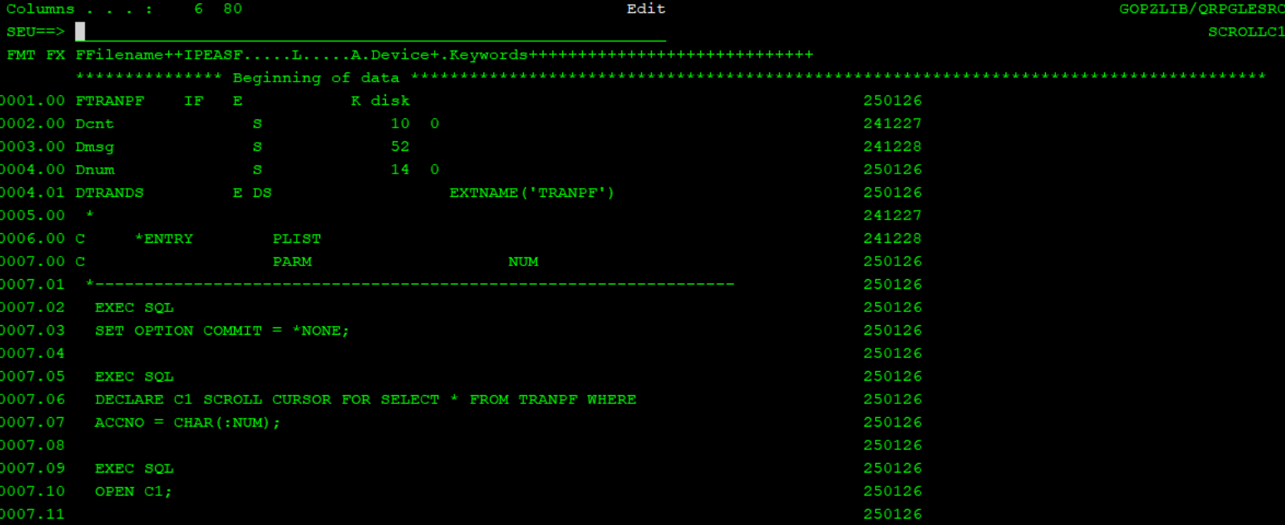

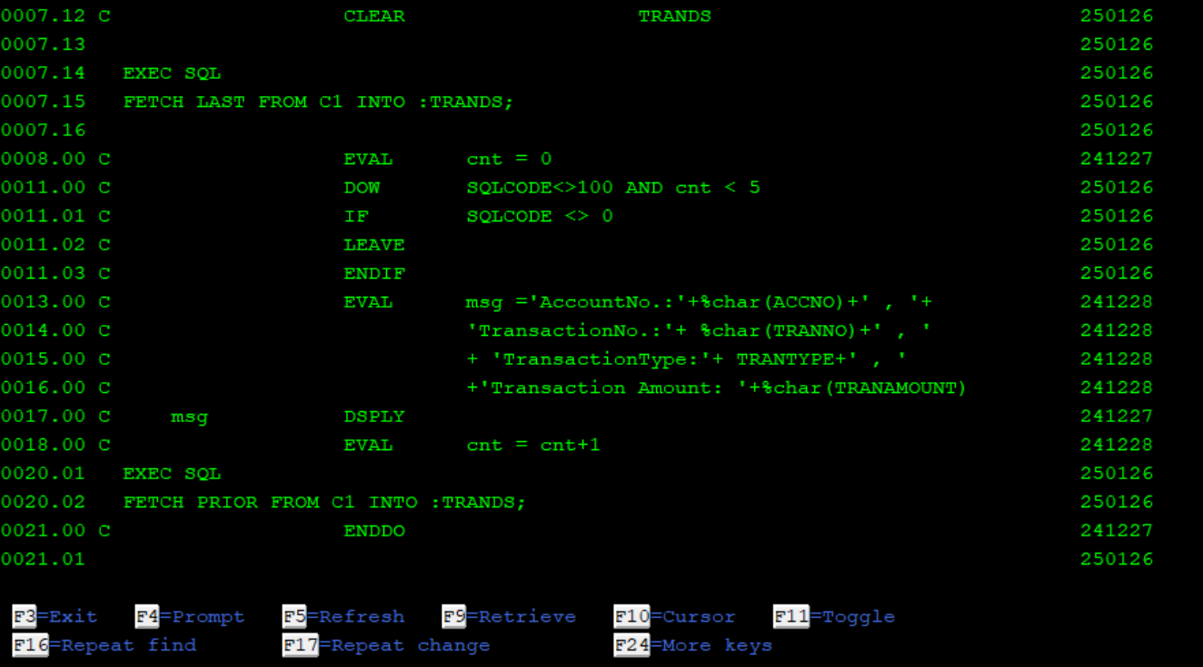

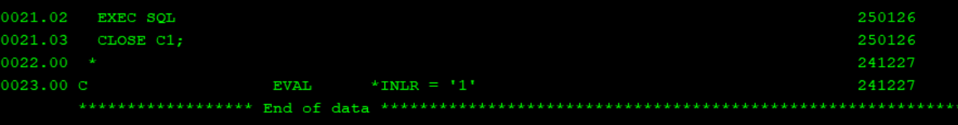

Date should be a proper date, else data mapping error will come at runtime.

In subfile

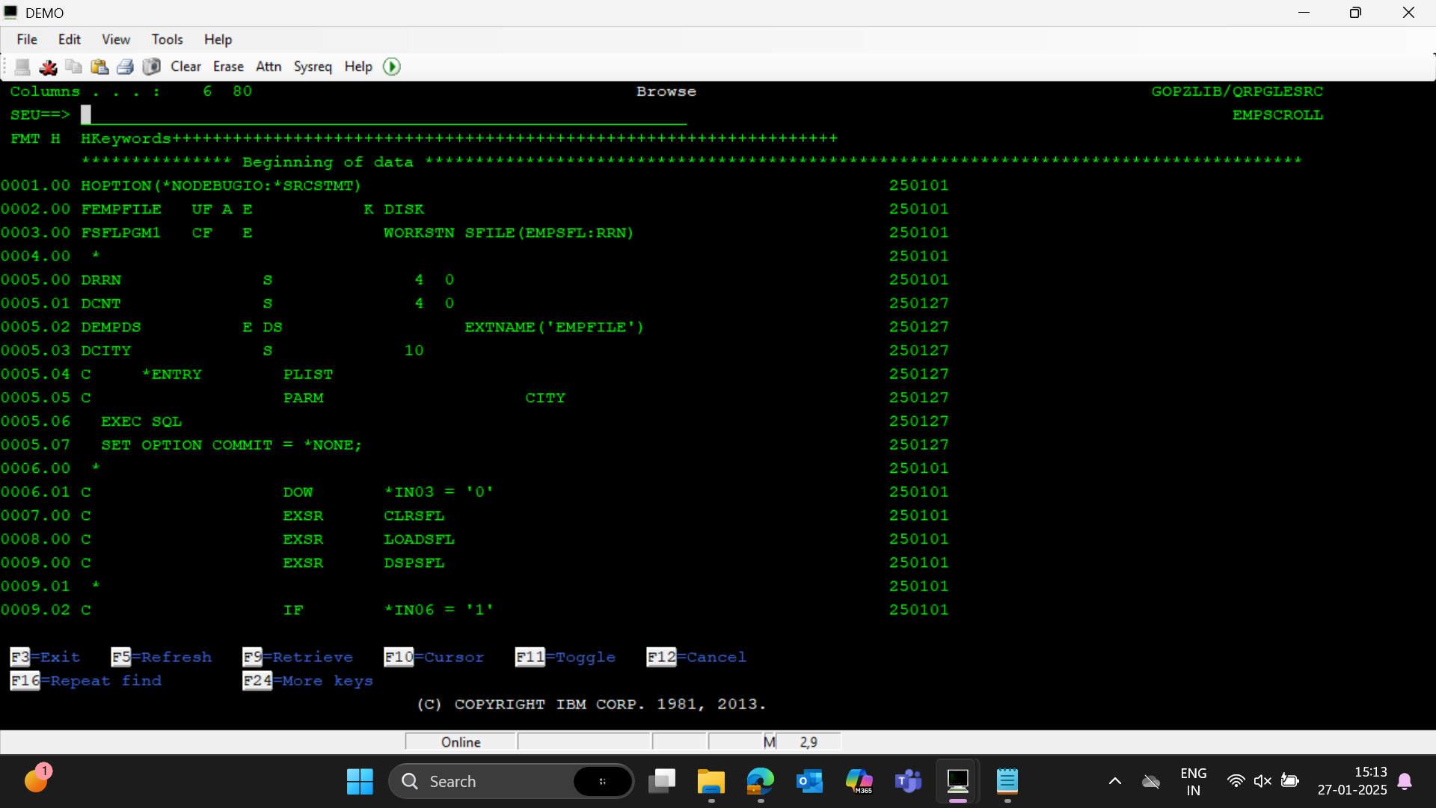

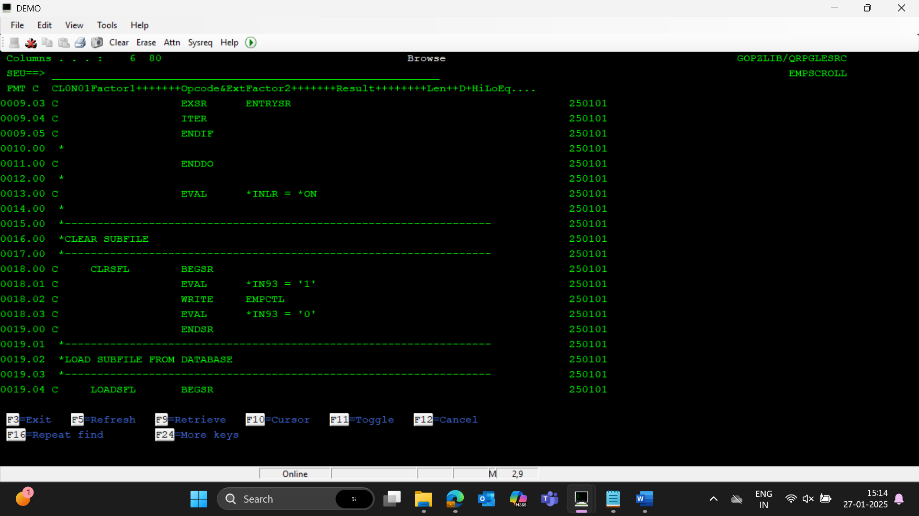

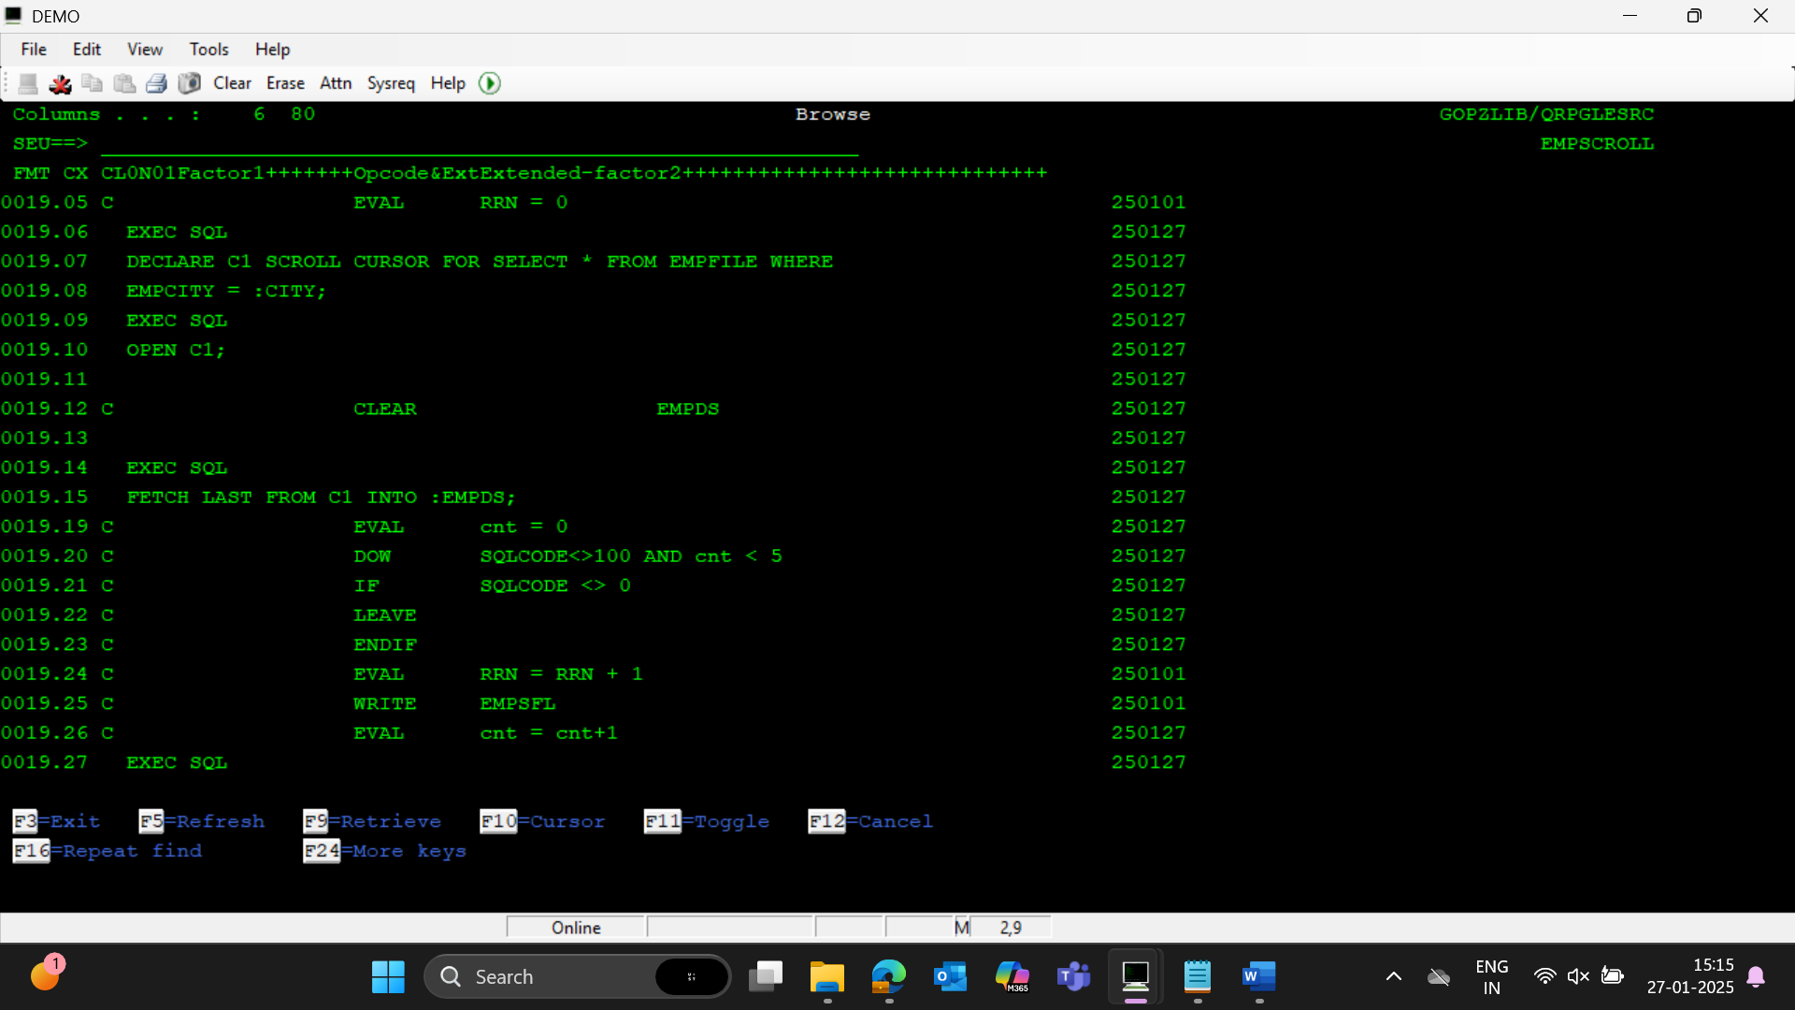

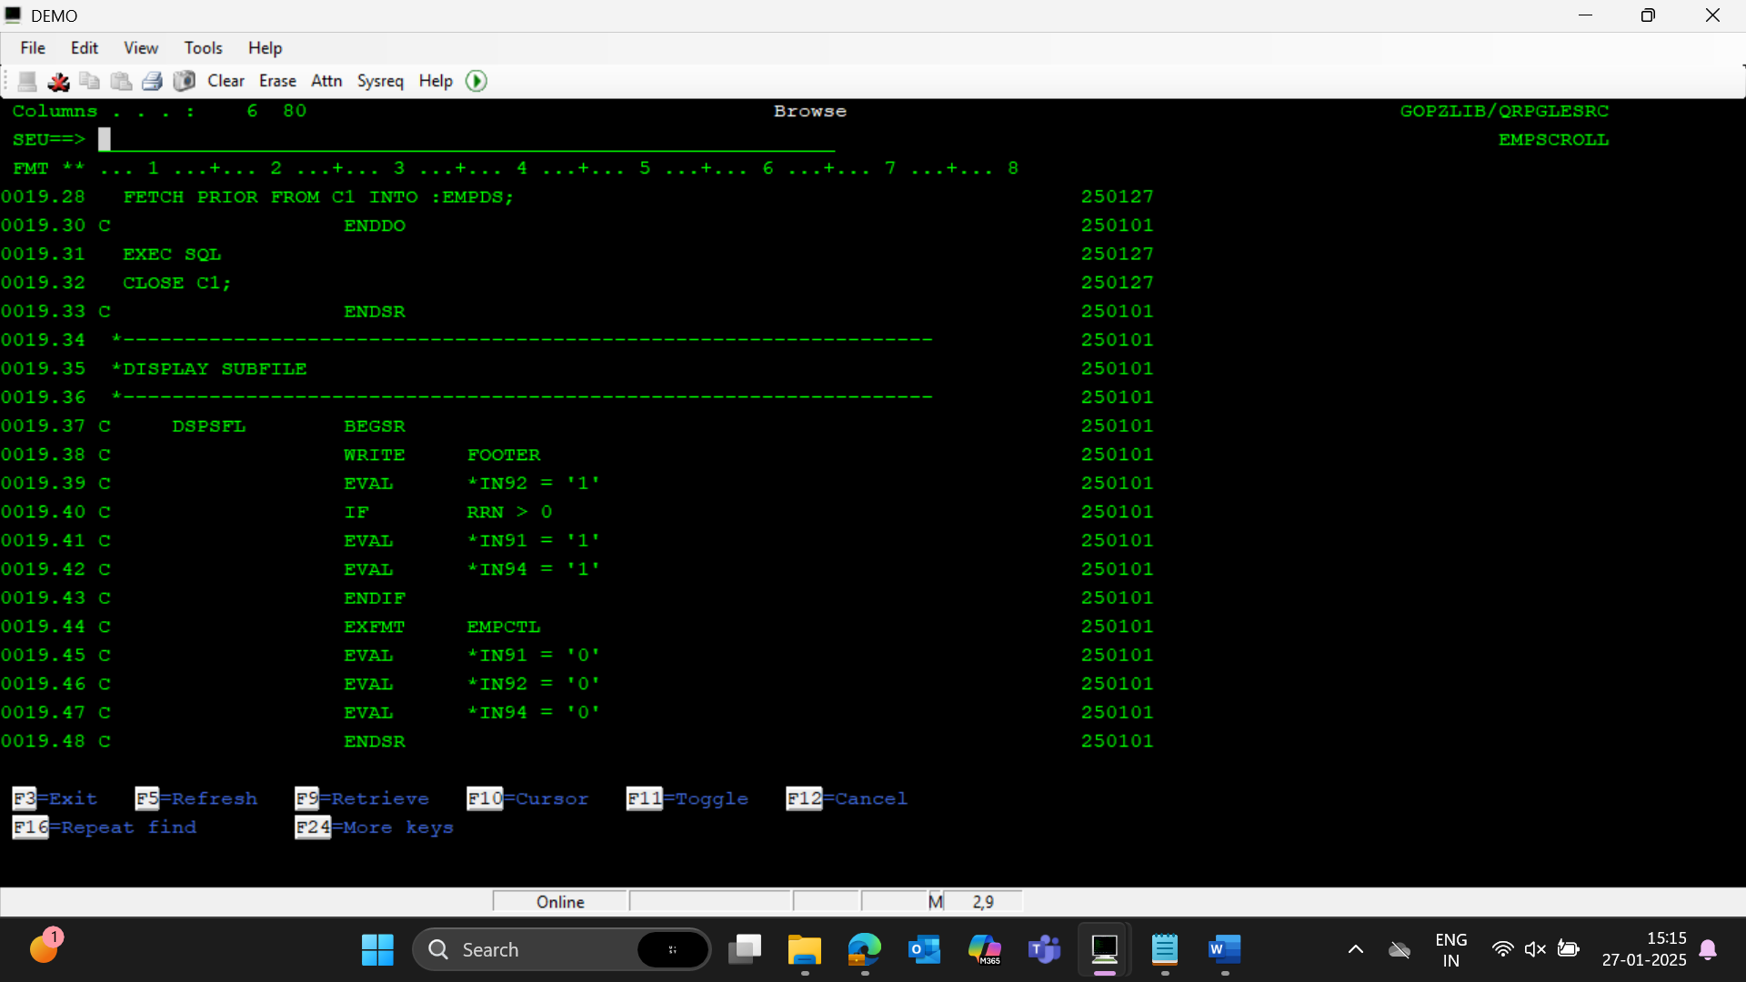

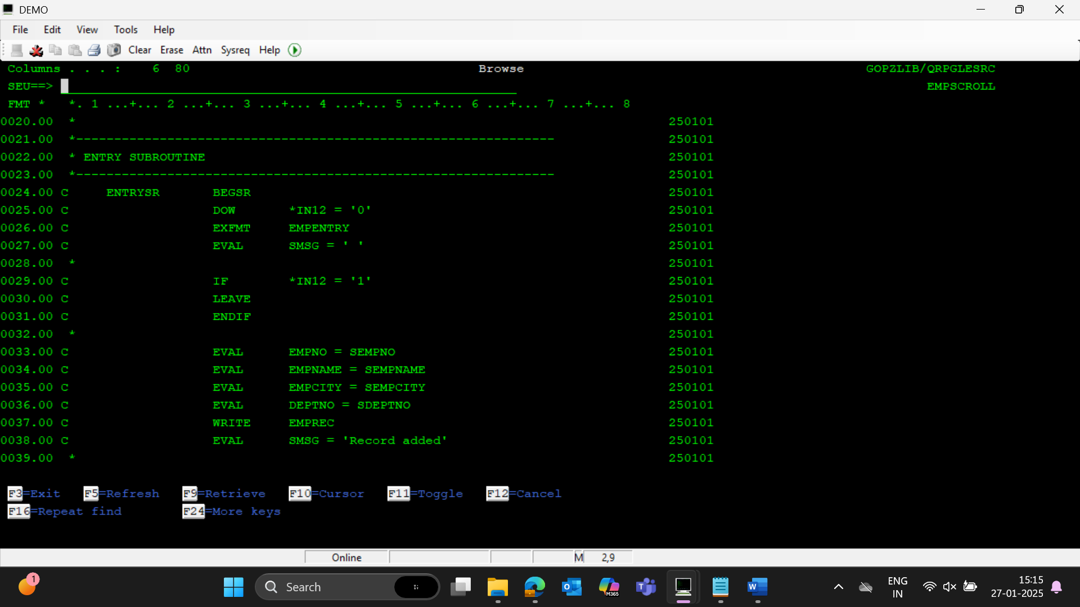

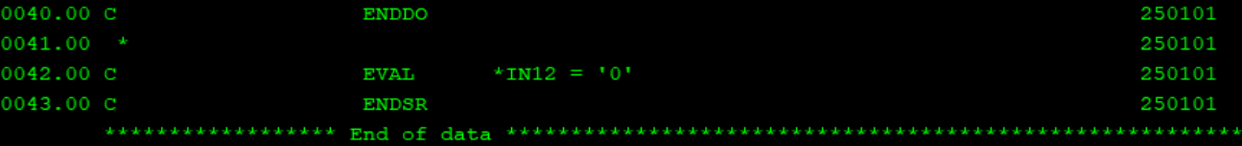

**JOURNALING**

STEP1 : Create journal receiver using CRTJRNRCV command

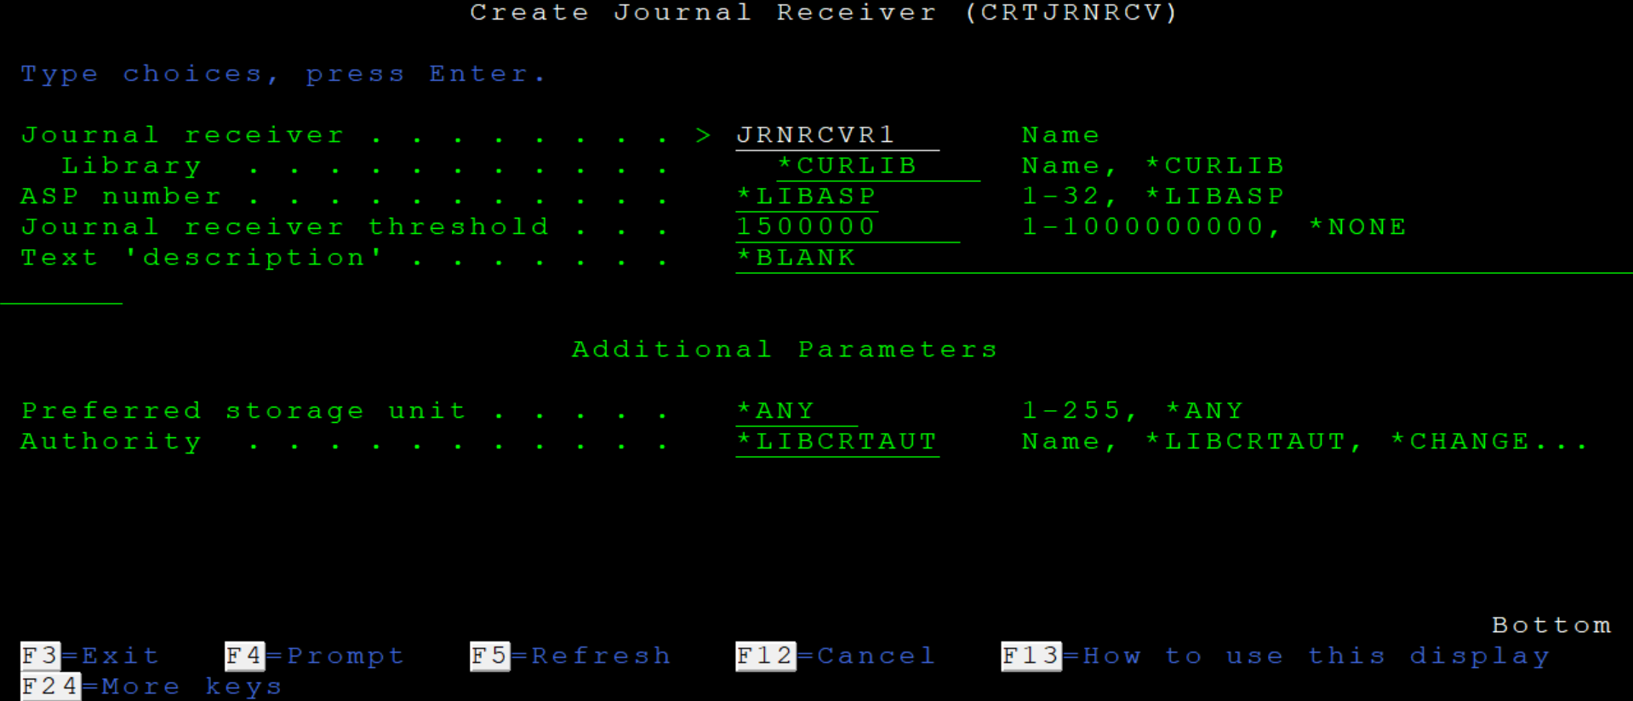



STEP2 : Create journal using CRTJRN command

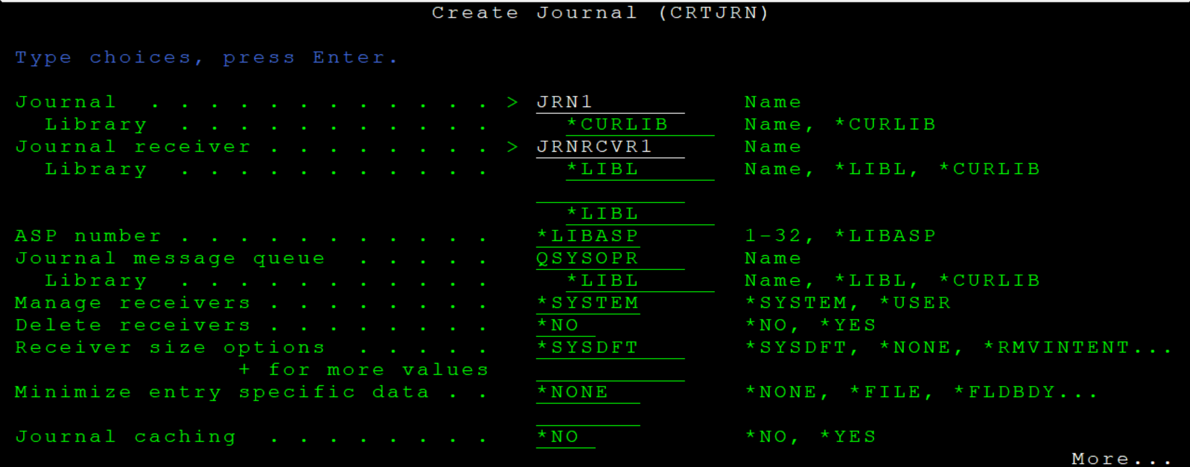 

STEP 3 : Jornal the required pf file using STRJRNPF command

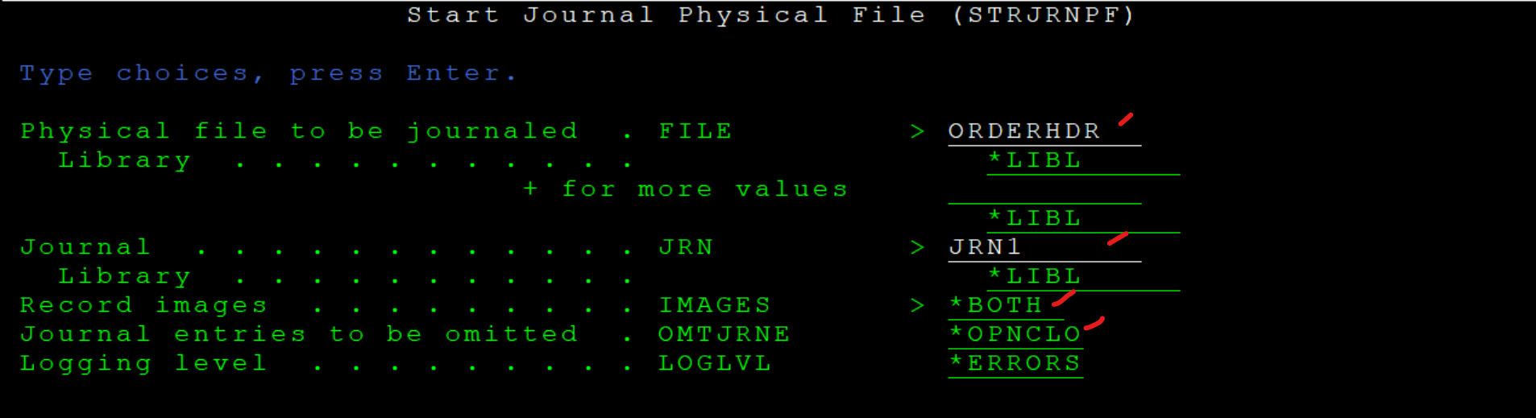



In case, to end journaling of all the files attached to a particular journal:

ENDJRNPF command

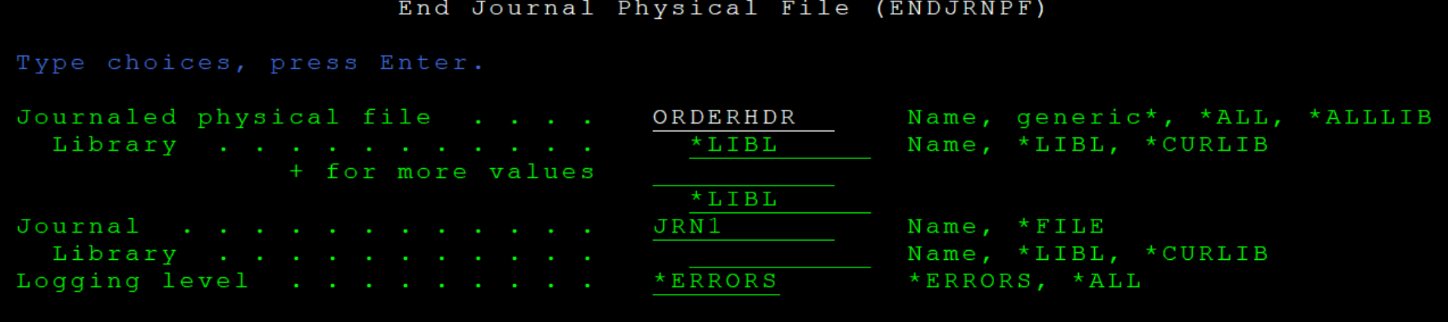



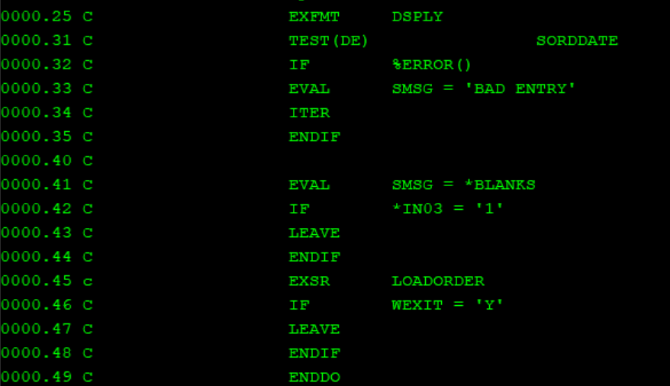

If we give ITER then it will skip that particular iteration and then starts the next iteration of the loop.

If we give LEAVE the entire program will be exited.

If we do not give anything and the date is invalid it will continue with the iteration and on reaching the sqlstring , checking with the invalid date will make the job to end abnormally

**INSENSITIVE SCROLLABLE CURSOR**

Cursor will not reflect any changes.

By default scroll-cursor will sensitive-when using cursor if any changes happen it will be reflected

within sensitive also - 2 types---sensitive static scroll cursor --reflect only updates and deletes not inserts, dynamic -- shows everything

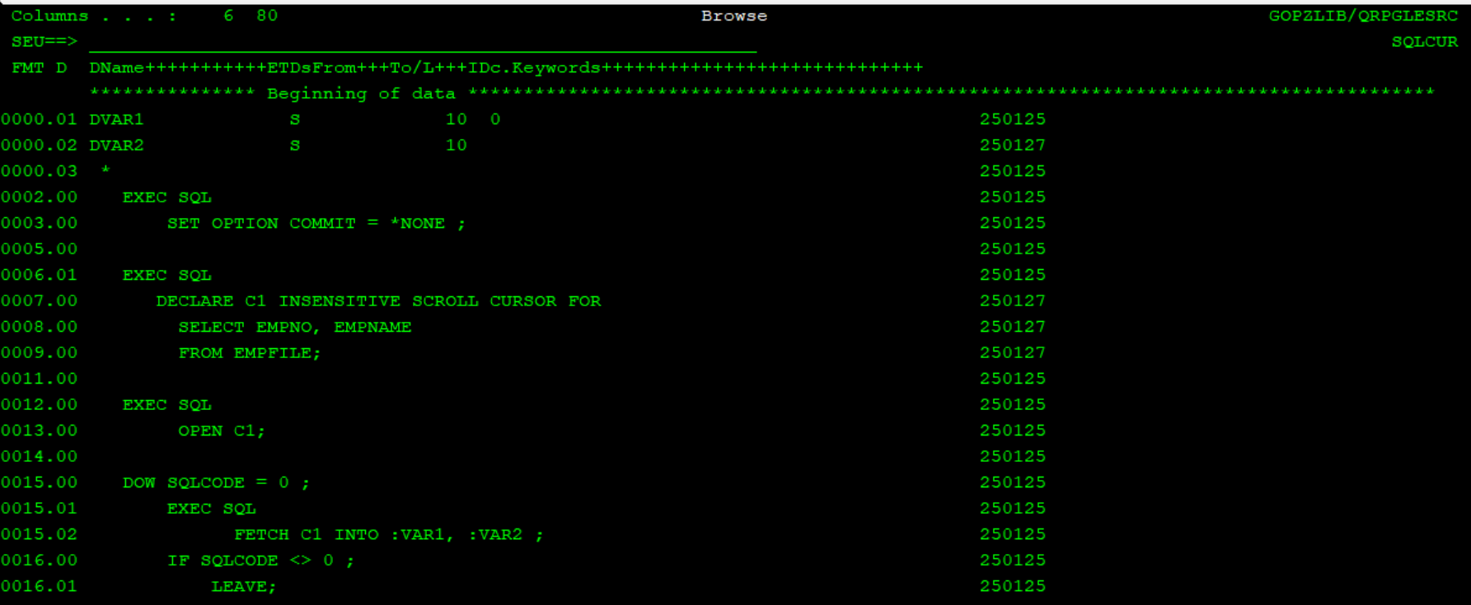

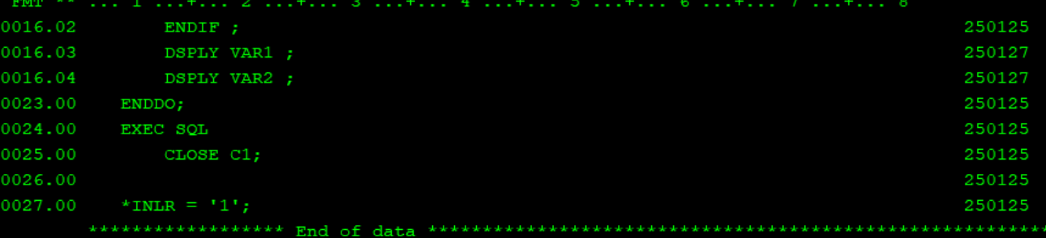

Here, while calling this program , simultaneously update or insert a record into the file(table/pf) from strsql. You can see that the changes are not reflected back in the cursor.

**SERVICE PROGRAMS**

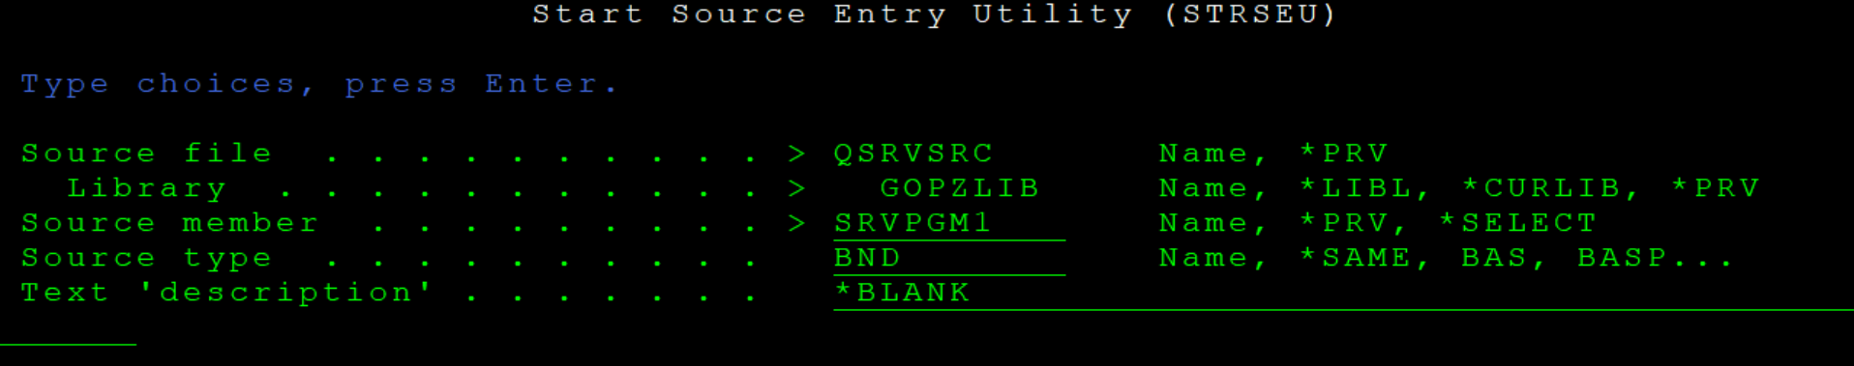

Type should be bnd

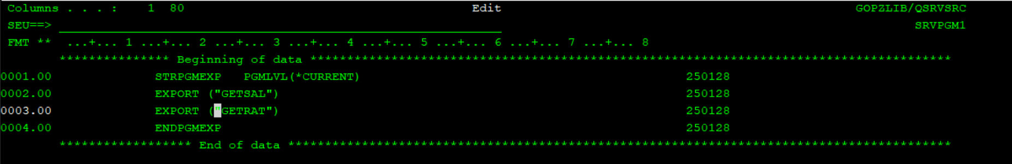

Do not compile this

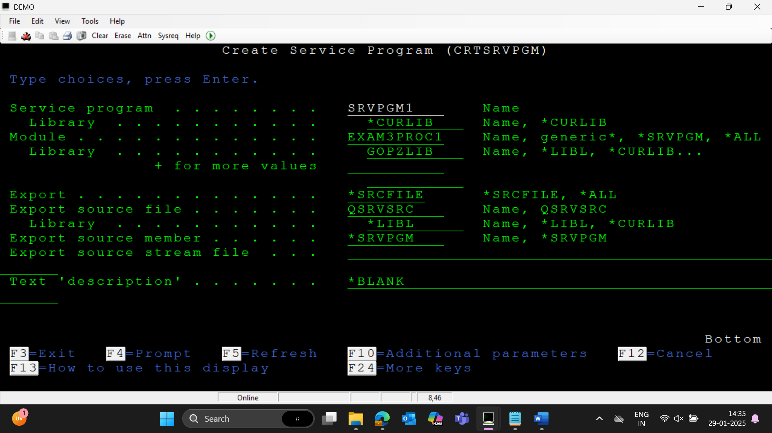



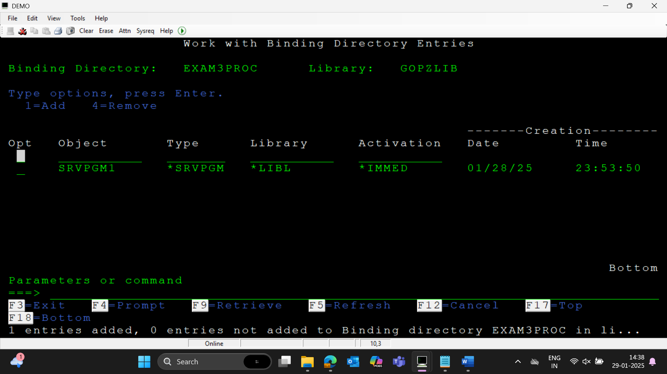

The procedure names and all in service pgm is case sensitive—if created in caps give caps itself in service binder pgm

Signature will change only if export procedures gets changed – like parameter list or attributes, adding new procedure etc

If logic is changed just use UPDSRVPGM command—no need to recompile the main pgm, only compile the modules—since it is bind by reference

UPDSRVPGM – This will only work for existing modules

If a new module is added the service pgm should be created again

If you are adding a new export /proc into service binder then you need to create the service pgm again.